
程序设计报告
（ 2017 /2018 学年 第 1 学期）

题 目：房屋租售管理系统

专 业 通信工程
组长 学号姓名 曹佳丽 B16010808
组员 学号姓名 哈孜杂·加拿提 B16010807

指 导 教 师 许棣华
指 导 单 位 计算机软件教学中心
日 期 2017 年9 月 7日
成员分工 | 组长（曹佳丽） | 分析需求，初步明确框架，针对各功能编写代码，修改系统bug，修改逻辑错误，调试程序，完善各功能分支。
成员分工 | 组员（哈孜杂·加拿提） | 讨论框架结构，搜集函数资料，编写文件读写部分代码，并给出其功能定义，修改bug，调试程序，编写流程图。
成员分工 | 组员（）
评分细则 | 评分项 | 优秀 |  | 良好 | 中等 |  | 差
评分细则 | 遵守机房规章制度
评分细则 | 上机时的表现
评分细则 | 学习态度
评分细则 | 程序准备情况
评分细则 | 程序设计能力
评分细则 | 团队合作精神
评分细则 | 课题功能实现情况
评分细则 | 算法设计合理性
评分细则 | 用户界面设计
评分细则 | 报告书写认真程度
评分细则 | 内容详实程度
评分细则 | 文字表达熟练程度
评分细则 | 回答问题准确度
简短评语 | 教师签名：  年 月 日
评分等级 | 曹佳丽 B16010808 |  | 哈孜杂·加拿提B16010807
备注 | 评分等级共五种：优秀、良好、中等、及格、不及格
程序设计题三： 房屋租售管理系统
（题目格式：宋体，三号，加粗，居中对齐）
- 课题内容和要求
房屋租售中介管理系统
（标题格式：宋体，四号，加粗，两端对齐，下同）
房屋租售中介管理系统系统是用来管理房屋中介中所需要的资料的，需要做到储存、管理、查询门店、楼盘、员工、客户信息，整理销售情况，将本系统的所有相关信息内容存为文件。其用户群体大致分为普通员工、管理者、客户。所以本系统首先让用户输入口令进入房屋租售管理系统，再根据用户的具体身份决定其浏览权限，进行分层操作。
（中文字体：宋体，英文字体：Times New Roman，小四号，不加粗，两端对齐，1.5倍行距，首行缩进2字符，段前段后距为0）
- 需求分析
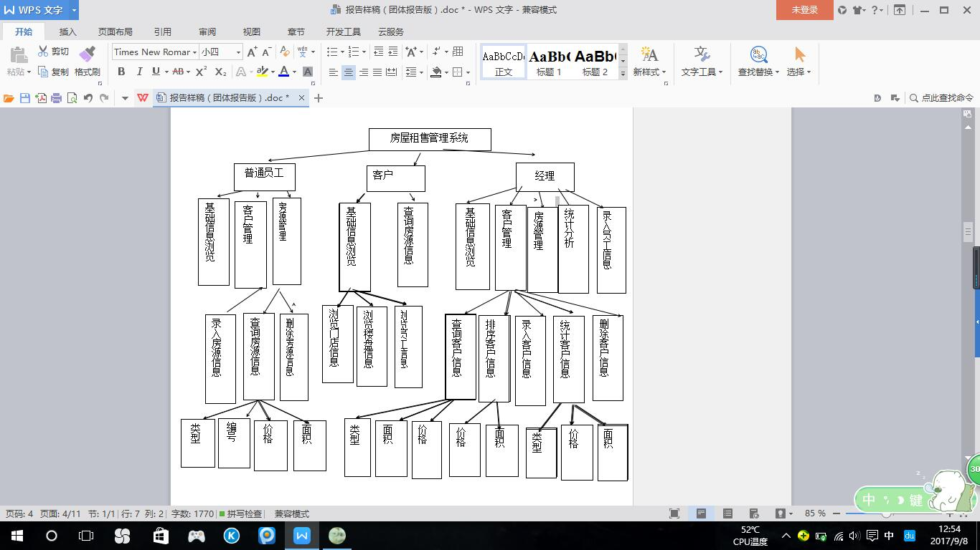
房屋租售管理系统的功能框架图如图1所示（重复使用的功能省略）。
录入销售业绩
查询销售情况
图1 功能框架图

（1）提供可操作的主菜单：输出个菜单，面向普通员工、客户、管理者，用于显示从文件中加载的总客户、房源、员工、门店、销售情况信息和若干个可选的功能选项。根据用户输入的选项来运行不同的功能，运行不同的函数。
（2）进行文本信息的录入：将文本信息录入到结构体节点中。
（3）查找客户功能：分类型（所需户型、价格区间、面积区间）查找客户具体资料。
（4）浏览：浏览门店、楼盘、客户信息。
（5）排序：按类型（理想面积、理想价格）正向排序。
（6）统计：按类型（所需户型、价格区间、面积区间）统计客户、房源数量。
（7）删除：输入房源或客户的具体信息
（8）文件读写：将文件内容读入结构体节点，主函数结束前将其修改保存进文件。
（9）密码：使用密码进入系统。

三、概要设计
1 主要结构体
（二级标题格式：宋体，小四号，不加粗，两端对齐，不缩进，下同）
struct type
{ //客户帐单结构
int custbillid; //客户帐单编码
char custname[50]; //客户名称
double localfee; //市话费用
double idfee; //长话费用
char latnname[20]; //本地网名称
char regionname[30]; //营业区名称
struct type *next; //指针
}*head,*p1; //全局指针

typedef struct ClientBuyer //客户信息结构
{
char Name[20]; //客户名称
long Tele; //客户电话号码
char Type[10]; //客户想要的户型
int Price[2]; //客户对于房屋的理想价格区间
int Size[2]; //客户对于房屋的理想面积区间
}ClientBuyer;
（struct Seller //非主要结构体
{
char Name[20];
long Tele;
};

typedef struct Seller Seller;）

struct House //房屋结构体
{
char Address[40]; //房屋地址
char Type[20]; //房屋户型
int Price; //房屋价格
int Size; //房屋面积
Seller OriOwner; //房屋原主人
long Number; //房屋编号
};
typedef struct House House;
struct Sell //销售情况结构体
{
int Price; //最终售出价格
int Interest; //最终获得利润
char StaName[20]; //售出房屋员工
char ShopName[20]; //售出房屋店名
int Time[3]; //售出房屋时间
};
typedef struct Sell Sell;

（struct Shop //非重要结构体
{
char Name[20],Address[40];
long Tele;
};
typedef struct Shop Shop;
struct Staff //员工结构体
{
char Name[20]; //员工姓名
long Tele; //员工电话
Shop ShopBelong; //员工所属店
};
typedef struct Staff Staff;
2 主要函数流程图
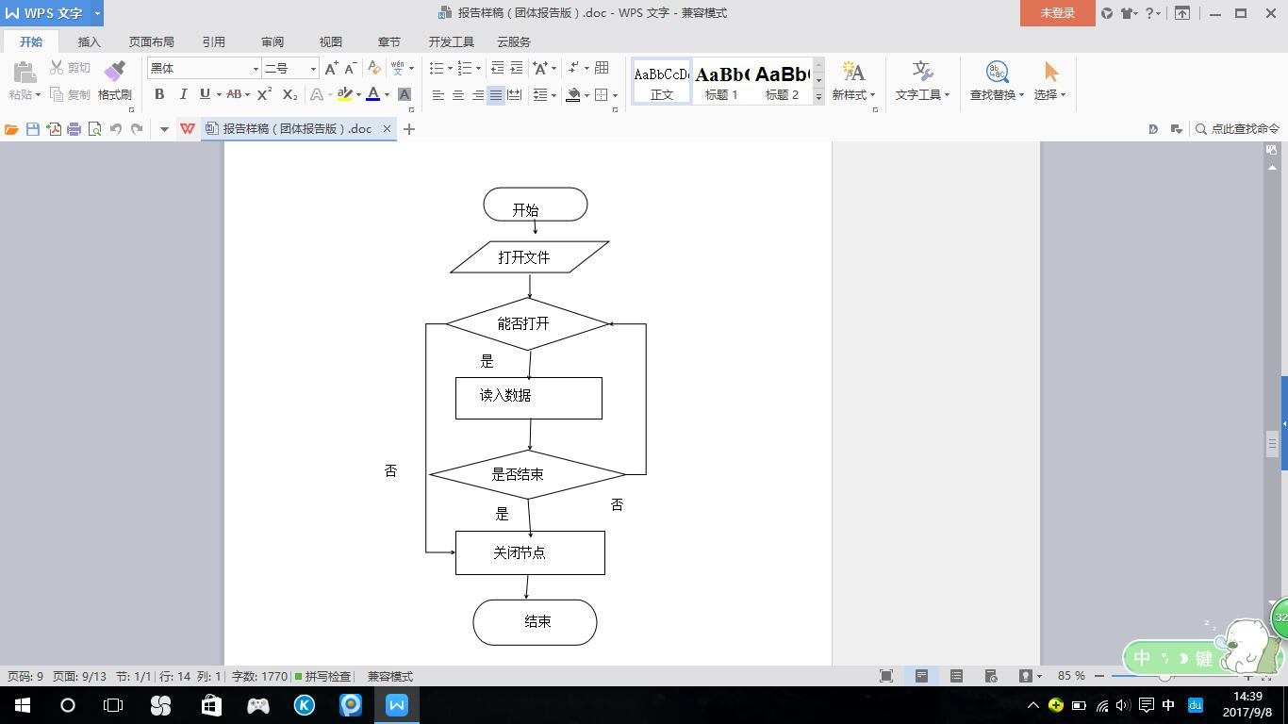
- 装载函数：用于从文本中载入信息并以一个结构体内容作为一个结点, 将文本内容装载入节点中，以便进行其他的操作，函数流程图如图2所示。
图2 装载函数

图2 装载函数

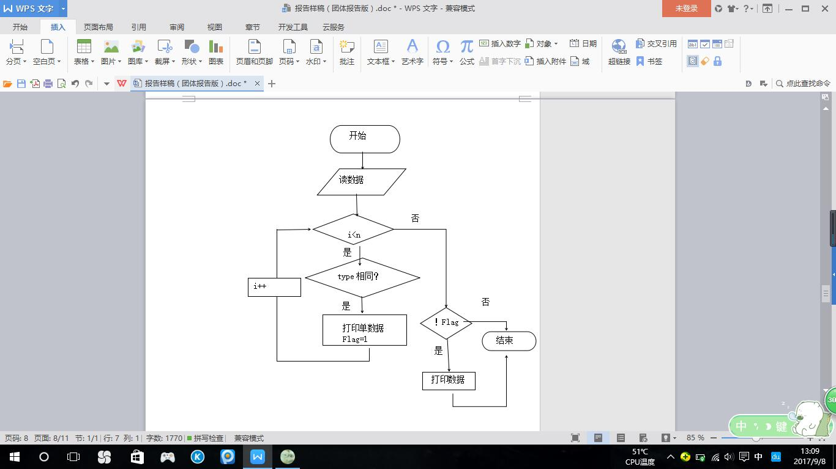
（2）查找函数：利用用户输入的类型进行顺序查找并将找到的客户信息输出，流程图如图3所示。
图3 查找函数

（3）录入函数：根据键盘输入的客户人数录入信息，流程图如图4所示。
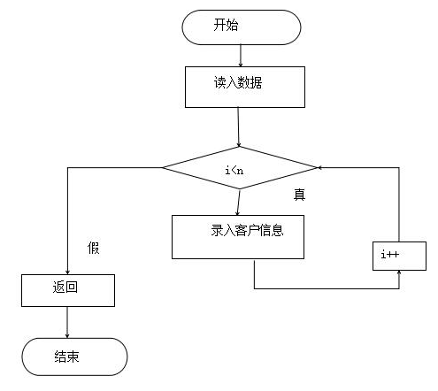
图4 录入函数

（4）删除函数：根据读入的数据删除结构体节点中的一个数据，返回此结构体数组删除后的长度，流程图如图5所示。
j++
开始
读入数据
i<n
是
数组中有符合输入条件的内容
是
i==n
打印记录不存在
i++
否
否
j<n-1
用j+1数据覆盖j
否
n--
结束
返回n值

图5 删除函数

（5）统计函数：根据读入的条件：类型、价格区间、面积区间进行统计，返回该类型的结构体对象的个数，流程图如图6所示。
结束
开始
读入数据
i<n
是
类型是否相同
是
count++
否
返回count
否
图6 统计函数

（6）排序函数：根据读入的类型：价格、面积进行正序排序，流程图如图7所示。

结束
否
开始
读入数据
i<n
是
j<n
比较后将j到n-1间的最小坐标赋给minpos
minpos ！=i
否
是
交换顺序
是
i++
否
图7 排序函数

四、源程序代码
#include<stdio.h>
#include<string.h>
#include<stdlib.h>
#define NUM 1000
#define sizeClient sizeof(ClientBuyer)
#define sizeHouse sizeof(House)
#define sizeSell sizeof(Sell)
#define sizeStaff sizeof(Staff)
#define sizeShop sizeof(Shop)
#include <conio.h>

struct Sell
{
int Price;
int Interest;
char StaName[20];
char ShopName[20];
int Time[3];
};
typedef struct Sell Sell;

struct Shop
{
char Name[20],Address[40],Tele[20];
};

typedef struct Shop Shop;

struct Staff
{
char Name[20],Tele[20];
Shop ShopBelong;
};

typedef struct Staff Staff;

struct Seller
{
char Name[20],Tele[20];
};

typedef struct Seller Seller;

struct House
{
char Address[40];
char Type[20];
int Price;
int Size;
Seller OriOwner;
int Number;
};
typedef struct House House;

typedef struct ClientBuyer
{
char Name[20],Tele[20];
char Type[10];
int Price[2];
int Size[2];
}ClientBuyer;

int logClientBuyer(ClientBuyer *buyer,int n)
{
int i;
for (i=0;i<n;i++)
{
printf("Input one buyer\'s information\n");
printf("name: ");
getchar();
scanf("%s",buyer[i].Name);
printf("telephone: ");
scanf("%s",&buyer[i].Tele);
getchar();
printf("type: ");
scanf("%s",buyer[i].Type);
do
{
printf("price between:(small)");
scanf("%d",&buyer[i].Price[0]);
printf("price between:(large)");
scanf("%d",&buyer[i].Price[1]);
}while(buyer[i].Price[0]>buyer[i].Price[1]);
do{
printf("size between:(small)");
scanf("%d",&buyer[i].Size[0]);
printf("size between:(large)");
scanf("%d",&buyer[i].Size[1]);
}while(buyer[i].Size[0]>buyer[i].Size[1]);
}
return i;
}

void printClient(ClientBuyer *client,int n)
{
int i;
printf("%15s%15s%15s%20s%20s\n","客户姓名","客户电话","所需类型","理想价格区间","理想面积区间");
for(i=0;i<n;i++)
{
printf("%15s%15s%15s%10d-%10d%10d-%10d\n",client[i].Name,client[i].Tele,client[i].Type,client[i].Price[0],client[i].Price[1],client[i].Size[0],client[i].Size[1]);
}
}

int calCliType(ClientBuyer *client,int n,char type[],int m)
{
int i,count=0;
for(i=0;i<n;i++)
{
if(strcmp(client[i].Type, type)==0)
count++;
}
return count;
}
int calCliPrice(ClientBuyer *client,int n,int price1,int price2)
{
int i,count=0;
for(i=0;i<n;i++)
{
if(price1<=client[i].Price[0] && price2>=client[i].Price[1])
count++;
}
return count;
}
int calCliSize(ClientBuyer *client,int n,int size1,int size2)
{
int i,count=0;
for(i=0;i<n;i++)
{
if(size1<=client[i].Size[0] && size2>=client[i].Size[1])
count++;
}
return count;
}
void inquireClientType(ClientBuyer *client,int n,char type[],int m)
{
int i,flag=0;
for(i=0;i<n;i++)
{
if(strcmp(client[i].Type,type)==0)
{
printClient(&client[i],1);
flag=1;
}
}
if(!flag)
{
printf("there is no client fits your need\n");
}
}
void inquireClientPrice(ClientBuyer *client,int n,int price[],int two)
{
int i,flag=0;
for(i=0;i<n;i++)
{
if(price[0]<=client[i].Price[0]&&price[1]>=client[i].Price[1])
{
printClient(&client[i],1);
flag=1;
}
}
if(!flag)
{
printf("there is no client fits your need\n");
}
}
void inquireClientSize(ClientBuyer *client,int n,int size[],int two)
{
int i,flag=0;
for(i=0;i<n;i++)
{
if(size[0]<=client[i].Size[0]&&size[1]>=client[i].Size[1])
{
printClient(&client[i],1);
flag=1;
}
}
if(!flag)
{
printf("there is no client fits your need\n");
}
}

int larger(ClientBuyer c1,ClientBuyer c2,int condition)//1:price 2:size
{
if(condition == 1)
{
if(c1.Price[0]==c2.Price[0])
return c1.Price[1]>c2.Price[1];
return c1.Price[0]>c2.Price[0];
}
if(condition == 2)
{
if(c1.Size[0]==c2.Size[0])
return c1.Size[1]>c2.Size[1];
return c1.Size[0]>c2.Size[0];
}
else
{
printf("your input is wrong.\n");
return 2;
}
}
void sortClient(ClientBuyer client[],int n,int condition)
{
int i,j,minpos;
ClientBuyer cli;
for(i=0;i<n;i++)
{
minpos = i;
for(j=i+1;j<n;j++)
{
if(larger(client[minpos],client[j],condition))
minpos=j;
}
if(i!=minpos)
{
cli = client[i];
client[i]=client[minpos];
client[minpos]=cli;
}
}
}
int equalClient(ClientBuyer c1,ClientBuyer c2)
{
if ((strcmp(c1.Name,c2.Name)==0)&&(strcmp(c1.Type,c2.Type)==0)&&
c1.Price[0]==c2.Price[0]&&c1.Price[1]==c2.Price[1]&&c1.Size[0]==c2.Size[0]&&c1.Size[1]==c2.Size[1]&&(strcmp(c1.Tele,c2.Tele)==0))
return 1;
return 0;
}
int deleClient(ClientBuyer client[],int n,ClientBuyer cb)
{
int i,j;
for(i=0;i<n;i++)
if (equalClient(client[i],cb))
break;
if (i==n)
{
printf("This record does not exist!\n");
return n;
}
for(j=i;j<n-1;j++)
client[j]=client[j+1];
n--;
return n;
}

int logHouse(House *house,int n)
{
int i;
for (i=0;i<n;i++)
{
printf("Input one house\'s information\n");
printf("number:");
scanf("%d",&house[i].Number);
printf("address: ");
scanf("%s",house[i].Address);
getchar();
printf("type: ");
scanf("%s",house[i].Type);
getchar();
printf("price: ");
scanf("%d",&house[i].Price);
printf("size: ");
scanf("%d",&house[i].Size);
printf("original owner's name: ");
scanf("%s",house[i].OriOwner.Name);
getchar();
printf("original owner's telephone: ");
scanf("%s",&house[i].OriOwner.Tele);
}
return i;
}
void printHouse(House *house,int n)
{
int i;
printf("%20s%15s%15s%15s%15s%15s\n","楼盘编号","楼盘地址","楼盘类型","楼盘价格","楼盘面积","原主姓名","原主电话");
for(i=0;i<n;i++)
{
printf("%8d%20s%15s%15d%15d%15s%15s\n",house[i].Number,house[i].Address,house[i].Type,house[i].Price,house[i].Size,house[i].OriOwner.Name,house[i].OriOwner.Tele);
}
}
void inquireHouseType(House *house,int n,char type[],int m)
{
int i;
for(i=0;i<n;i++)
{
if(strcmp(house[i].Type,type)==0)
printHouse(&house[i],1);
}
}
void inquireHouseNum(House *house,int n,int number)
{
int i,flag=0;
for(i=0;i<n;i++)
{
if(house[i].Number==number)
{
printHouse(&house[i],1);
flag=1;
}
}
if (!flag)
{
printf("sorry,there is no house fits your need\n");
}
}
void inquireHousePrice(House *house,int n,int price1,int price2)//范围
{
int i,flag=0;
for(i=0;i<n;i++)
{
if(house[i].Price>=price1&&house[i].Price<=price2)
{
printHouse(&house[i],1);
flag=1;
}
}
if (!flag)
{
printf("sorry,there is no house fits your need\n");
}
}
void inquireHouseSize(House *house,int n,int size1,int size2)
{
int i,flag=0;
for(i=0;i<n;i++)
{
if(house[i].Size>=size1&&house[i].Size<=size2)
{
printHouse(&house[i],1);
flag=1;
}
}
if (!flag)
{
printf("sorry,there is no house fits your need\n");
}
}
int equalHouse(House h1,House h2)
{
if (h1.Number==h2.Number)
return 1;
return 0;
}
int deleHouse(House house[],int n,House h)
{
int i,j;
for(i=0;i<n;i++)
if (equalHouse(house[i],h)) break;
if (i==n)
{
printf("This record does not exist!\n");
return n;
}
for(j=i;j<n-1;j++)
house[j]=house[j+1];
n--;
return n;
}
int logSell(Sell *sell,int n)
{
int i,j;
for (i=0;i<n;i++)
{
printf("Input one deal\'s information\n");
printf("time: ");
for(j=0;j<3;j++)
{
scanf("%d",&sell[i].Time[j]);
}
printf("price: ");
scanf("%d",&sell[i].Price);
printf("interest: ");
scanf("%d",&sell[i].Interest);
printf("staff's name: ");
scanf("%s",&sell[i].StaName);
printf("shop's name: ");
getchar();
scanf("%s",&sell[i].ShopName);
}
return i;
}
void printSell(Sell *sell,int n)
{
int i,j;
printf("%18s%15s%15s%15s%15s\n","售出时间","所得利润","售出总价","售出员工","售出店名");
for(i=0;i<n;i++)
{
for(j=0;j<3;j++)
{
printf("%6d",sell[i].Time[j]);
}
printf("%15d%15d%15s%15s\n",sell[i].Interest,sell[i].Price,sell[i].StaName,sell[i].ShopName);
}
}

int calInterest(Sell *sell,int n,int time[],int m)//输入的是一个时间段
{
int i,count=0,flag=1;
for(i=0;i<n;i++)
{
if(time[0]>sell[i].Time[0]||sell[i].Time[0]>time[3])//比小的小 或 比大的大
{
flag=0;
}
if(time[0]<=sell[i].Time[0]&&sell[i].Time[0]<=time[3])
{
if(time[1]>sell[i].Time[1]||sell[i].Time[1]>time[4])
{
flag=0;
}
}
if(time[0]<=sell[i].Time[0]&&sell[i].Time[0]<=time[3]&&time[1]<=sell[i].Time[1]&&sell[i].Time[1]<=time[4])
{
if(time[2]>sell[i].Time[2]||sell[i].Time[2]>time[5])
{
flag=0;
}
}
if(flag)
{
printSell(&sell[i],1);
count+=sell[i].Interest;
}
}
return count;
}
void inquireSellTime(Sell *sell,int n,int time[],int m)
{
int i,flag=1;
for(i=0;i<n;i++)
{
if(time[0]>sell[i].Time[0]||sell[i].Time[0]>time[3])//比小的小 或 比大的大
{
flag=0;
}
if(time[0]<=sell[i].Time[0]&&sell[i].Time[0]<=time[3])
{
if(time[1]>sell[i].Time[1]||sell[i].Time[1]>time[4])
{
flag=0;
}
}
if(time[0]<=sell[i].Time[0]&&sell[i].Time[0]<=time[3]&&time[1]<=sell[i].Time[1]&&sell[i].Time[1]<=time[4])
{
if(time[2]>sell[i].Time[2]||sell[i].Time[2]>time[5])
{
flag=0;
}
}
if(flag)
{
printSell(&sell[i],1);
}
}
if (!flag)
printf("wrong input\n");
}
void inquireSellShop(Sell *sell,int n,char shopname[],int m)
{
int i,flag=0;
for(i=0;i<n;i++)
{
if(strcmp(sell[i].ShopName,shopname)==0)
{
printSell(&sell[i],1);
flag=1;
}
}
if (!flag)
printf("wrong input\n");
}
void printShop(Shop *shop,int n)
{
int i;
printf("%20s%20s%15s\n","店名","地址","电话");
for(i=0;i<n;i++)
{
printf("%20s%20s%15s\n",shop[i].Name,shop[i].Address,shop[i].Tele);
}
}
int logStaff(Staff *staff,int n)
{
int i;
for (i=0;i<n;i++)
{
printf("Input one staff\'s information\n");
printf("name: ");
getchar();
scanf("%s",staff[i].Name);
getchar();
printf("telephone: ");
scanf("%s",&staff[i].Tele);
printf("the shop\'s name one staff belongs to: ");
getchar();
scanf("%s",staff[i].ShopBelong.Name);
getchar();
printf("the shop\'s address one staff belongs to: ");
scanf("%s",staff[i].ShopBelong.Address);
getchar();
printf("the shop\'s phone one staff belongs to: ");
scanf("%s",&staff[i].ShopBelong.Tele);
}
return i;
}
void printStaff(Staff *staff,int n)
{
int i;
printf("%15s%15s%15s%15s%15s\n","店员名","店员电话","所在店名","所在店址","所在店电话");
for(i=0;i<n;i++)
{
printf("%15s%15s%15s%15s%15s\n",staff[i].Name,staff[i].Tele,staff[i].ShopBelong.Name,staff[i].ShopBelong.Address,staff[i].ShopBelong.Tele);
}
}
int logShop(Shop *shop,int n)
{
int i;
for (i=0;i<n;i++)
{
printf("Input one shop\'s information\n");
printf("name: ");
getchar();
scanf("%s",shop[i].Name);
printf("phone: ");
getchar();
scanf("%s",&shop[i].Tele);
printf("address: ");
getchar();
scanf("%s",shop[i].Address);
}
return i;
}
int createClient(ClientBuyer h[])
{
FILE *fp;
int n;
if((fp=fopen("e:\\client.dat","wb+"))==NULL)
{
printf("can not open the file!\n");
exit(0);
}
printf("input the number of client you want to input:\n");
scanf("%d",&n);
printf("input clients\' information:\n");
n=logClientBuyer(h,n);
fwrite(h,sizeClient,n,fp);
fclose(fp);
return n;
}

int readClient(ClientBuyer h[])
{
FILE *fp;
int i=0;
if((fp=fopen("e:\\client.dat","rb"))==NULL)
{
printf("file does not exist,create it first:\n");
return 0;
}
fread(&h[i],sizeClient,1,fp);
while(!feof(fp))
{
i++;
fread(&h[i],sizeClient,1,fp);
}
fclose(fp);
return i;
}

void saveClient(ClientBuyer h[],int n)
{
FILE *fp;
if((fp=fopen("e:\\client.dat","wb"))==NULL)
{
printf("can not open file!\n");
exit(0);
}
fwrite(h,sizeClient,n,fp);
fclose(fp);
}
int createHouse(House h[])
{
FILE *fp;
int n;
if((fp=fopen("e:\\house.dat","wb+"))==NULL)
{
printf("can not open the file!\n");
exit(0);
}
printf("input the number of houses you want to input:\n");
scanf("%d",&n);
printf("input houses\' information:\n");
n=logHouse(h,n);
fwrite(h,sizeHouse,n,fp);
fclose(fp);
return n;
}

int readHouse(House h[])
{
FILE *fp;
int i=0;
if((fp=fopen("e:\\house.dat","rb"))==NULL)
{
printf("file does not exist,create it first:\n");
return 0;
}
fread(&h[i],sizeHouse,1,fp);
while(!feof(fp))
{
i++;
fread(&h[i],sizeHouse,1,fp);
}
fclose(fp);
return i;
}

void saveHouse(House h[],int n)
{
FILE *fp;
if((fp=fopen("e:\\house.dat","wb"))==NULL)
{
printf("can not open file!\n");
exit(0);
}
fwrite(h,sizeHouse,n,fp);
fclose(fp);
}
int createSell(Sell h[])
{
FILE *fp;
int n;
if((fp=fopen("e:\\sell.dat","wb+"))==NULL)
{
printf("can not open the file!\n");
exit(0);
}
printf("input the number of deals you want to input:\n");
scanf("%d",&n);
printf("input deals\' information:\n");
n=logSell(h,n);
fwrite(h,sizeSell,n,fp);
fclose(fp);
return n;
}

int readSell(Sell h[])
{
FILE *fp;
int i=0;
if((fp=fopen("e:\\sell.dat","rb"))==NULL)
{
printf("file does not exist,create it first:\n");
return 0;
}
fread(&h[i],sizeSell,1,fp);
while(!feof(fp))
{
i++;
fread(&h[i],sizeSell,1,fp);
}
fclose(fp);
return i;
}

void saveSell(Sell h[],int n)
{
FILE *fp;
if((fp=fopen("e:\\sell.dat","wb"))==NULL)
{
printf("can not open file!\n");
exit(0);
}
fwrite(h,sizeSell,n,fp);
fclose(fp);
return ;
}
int createStaff(Staff h[])
{
FILE *fp;
int n;
if((fp=fopen("e:\\staff.dat","wb+"))==NULL)
{
printf("can not open the file!\n");
exit(0);
}
printf("input the number of staff you want to input:\n");
scanf("%d",&n);
printf("input staffs\' information:\n");
n=logStaff(h,n);
fwrite(h,sizeStaff,n,fp);
fclose(fp);
return n;
}

int readStaff(Staff h[])
{
FILE *fp;
int i=0;
if((fp=fopen("e:\\staff.dat","rb"))==NULL)
{
printf("file does not exist,create it first:\n");
return 0;
}
fread(&h[i],sizeStaff,1,fp);
while(!feof(fp))
{
i++;
fread(&h[i],sizeStaff,1,fp);
}
fclose(fp);
return i;
}

void saveStaff(Staff h[],int n)
{
FILE *fp;
if((fp=fopen("e:\\staff.dat","wb"))==NULL)
{
printf("can not open file!\n");
exit(0);
}
fwrite(h,sizeStaff,n,fp);
fclose(fp);
}

int createShop(Shop h[])
{
FILE *fp;
int n;
if((fp=fopen("e:\\shop.dat","wb+"))==NULL)
{
printf("can not open the file!\n");
exit(0);
}
printf("input the number of shop you want to input:\n");
scanf("%d",&n);
printf("input shops\' information:\n");
n=logShop(h,n);
fwrite(h,sizeShop,n,fp);
fclose(fp);
return n;
}

int readShop(Shop h[])
{
FILE *fp;
int i=0;
if((fp=fopen("e:\\shop.dat","rb"))==NULL)
{
printf("file does not exist,create it first:\n");
return 0;
}
fread(&h[i],sizeShop,1,fp);
while(!feof(fp))
{
i++;
fread(&h[i],sizeShop,1,fp);
}
fclose(fp);
return i;
}

void saveShop(Shop h[],int n)
{
FILE *fp;
if((fp=fopen("e:\\shop.dat","wb"))==NULL)
{
printf("can not open file!\n");
exit(0);
}
fwrite(h,sizeShop,n,fp);
fclose(fp);
}

void menuBase()
{
printf("***** 1.浏览门店信息 *****\n");
printf("***** 2.浏览楼盘信息 *****\n");
printf("***** 3.浏览员工信息 *****\n");
printf("***** 0.返回上层菜单 *****\n");
}
void swiBase(Shop *shop,int sh,Staff *staff,int st,House *house,int h)
{
int choice;
menuBase();
printf("choose one operation you want to do:\n");
scanf("%d",&choice);
switch(choice)
{
case 1:printShop(shop,sh);
break;
case 2:printHouse(house,h);
break;
case 3:printStaff(staff,st);
break;
case 0:return;
default:printf("wrong input\n");
}
}

void menuClient()
{
printf("***** 1.录入客户信息 *****\n");
printf("***** 2.查询客户信息 *****\n");
printf("***** 3.排序客户信息 *****\n");
printf("***** 4.统计客户信息 *****\n");//按价格 类型 大小统计switch二级菜单
printf("***** 5.删除客户信息 *****\n");
printf("***** 0.返回上层菜单 *****\n");
}
void swiClient(ClientBuyer client[],int c)
{
int choice,inqutype,inttype,price[2],size[2],sortChoice,count,c2,size1,size2,price1,price2;
char type[20],caltype[20];
ClientBuyer cli;
menuClient();
printf("choose one operation you want to do:\n");
scanf("%d",&choice);
switch(choice)
{
case 1: printf("how many clients do you want to input?\n");
scanf("%d",&c2);
logClientBuyer(&client[c],c2);
c += c2;
saveClient(client,c);
break;
case 2:printf("choose one type to inquire the detailed information:1(type)/2(price)/3(size)\n");
scanf("%d",&inqutype);
switch(inqutype)
{
case 1:printf("input the type of clients you want to search:\n");
scanf("%s",type);
inquireClientType(client,c,type,strlen(type));
break;
case 2:
do{printf("input the price the clients want you want to search between (small) and (large):\n");
scanf("%d",&price[0]);
scanf("%d",&price[1]);
}while(price[0]>price[1]);
inquireClientPrice(client,c,price,2);//why???
break;
case 3:
do{printf("input the size the clients want you want to search between (small) and (large):\n");
scanf("%d",&size[0]);
scanf("%d",&size[1]);
}while(size[0]>size[1]);
inquireClientSize(client,c,size,2);
break;
default:printf("wrong input\n");
}break;
case 3:printf("input the way of sorting the clients by their needs:1(price)/2(size)\n");
scanf("%d",&sortChoice);
sortClient(client,c,sortChoice);
printClient(client,c);
saveClient(client,c);
break;
case 4:printf("choose one type to inquire the statistics:1(type)/2(price)/3(size)\n");
scanf("%d",&inttype);
switch(inttype)
{
case 1:printf("input the type of clients you want to calculate:\n");
scanf("%s",caltype);
count=calCliType(client,c,caltype,strlen(caltype));
printf("there are(is) %d client(s) want(s) this type of house\n",count);
break;
case 2:
do{printf("input the price the clients want you want to calculate between (small) and (large):\n");
scanf("%d",&price1);
scanf("%d",&price2);
}while(price1>price2);
count=calCliPrice(client,c,price1,price2);
printf("there are(is) %d client(s) want(s) this price of house\n",count);
break;
case 3:
do{printf("input the size the clients want you want to calculate between (small) and (large):\n");
scanf("%d",&size1);
scanf("%d",&size2);
}while(size1>size2);
count=calCliSize(client,c,size1,size2);
printf("there are(is) %d client(s) want(s) this size of house\n",count);
break;
default:printf("wrong input\n");
}break;
case 5:printf("input the detailed information about the client to be deleted\n");
logClientBuyer(&cli,1);
c=deleClient(client,c,cli);
saveClient(client,c);
break;
case 0:return;
default:printf("wrong input\n");
}
}
void menuHouse()
{
printf("***** 1.录入房源信息 *****\n");
printf("***** 2.查询房源信息 *****\n");
printf("***** 3.删除房源信息 *****\n");
printf("***** 0.返回上层菜单 *****\n");
}
void inquireHouse(House house[],int h)
{
int inqutype,number,price1,price2,size1,size2;
char type[20];
printf("choose one type to inquire the detailed information:1(type)/2(number)/3(price)/4(size)\n");
scanf("%d",&inqutype);
switch(inqutype)
{
case 1:printf("input the type you desire:\n");
scanf("%s",type);
inquireHouseType(house,h,type,20);
break;
case 2:printf("input the house\'s number:\n");
scanf("%d",&number);
inquireHouseNum(house,h,number);
break;
case 3:
do{
printf("input the house\'s price between (small) and (large): \n");
scanf("%d",&price1);
scanf("%d",&price2);
}while(price1>price2);
inquireHousePrice(house,h,price1,price2);
break;
case 4:
do{
printf("input the house\'s size between (small) and (large): \n");
scanf("%d",&size1);
scanf("%d",&size2);
}while(size1>size2);
inquireHouseSize(house,h,size1,size2);
break;
default:printf("wrong input\n");
}
}
void swiHouse(House house[],int h)
{
int choice,n;
menuHouse();
House hou;
printf("choose one operation you want to do:\n");
scanf("%d",&choice);
switch(choice)
{
case 1:printf("input the number of houses you want to input:");
scanf("%d",&n);
h +=logHouse(&house[h],n);
saveHouse(house,h);
break;
case 2:inquireHouse(house,h);
break;
case 3:printf("input the detailed information about the house to be deleted:\n");
logHouse(&hou,1);
h=deleHouse(house,h,hou);
saveHouse(house,h);
break;
case 0:return;
default:printf("wrong input\n");
}
}

void menuManage()
{
printf("***** 1.录入销售业绩 *****\n");
printf("***** 2.查询销售情况 *****\n");
printf("***** 0.返回上层菜单 *****\n");
}
void swiManage(Sell sell[],int m)
{
int i,choice,time[6],count,type,n,flag=1;
char shopName[20];
menuManage();
printf("choose one operation you want to do:\n");
scanf("%d",&choice);
switch(choice)
{
case 1: printf("input the number of deals you want input:\n");
scanf("%d",&n);
logSell(&sell[m],n);
m += n;
saveSell(sell,m);
break;
/* case 2:
printf("input the time from (year/month/day) to (year/month/day):\n"); //判断时间段的输入是否正确
for(i=0;i<6;i++)
{
scanf("%d",&time[i]);
}
/* if(time[0]>sell[i].Time[0]||sell[i].Time[0]>time[3])//比小的小 或 比大的大
{
flag=0;
}
if(time[0]<=sell[i].Time[0]&&sell[i].Time[0]<=time[3])
{
if(time[1]>sell[i].Time[1]||sell[i].Time[1]>time[4])
{
flag=0;
}
}
if(time[0]<=sell[i].Time[0]&&sell[i].Time[0]<=time[3]&&time[1]<=sell[i].Time[1]&&sell[i].Time[1]<=time[4])
{
if(time[2]>sell[i].Time[2]||sell[i].Time[2]>time[5])
{
flag=0;
}
}
}while(!flag);
count=calInterest(sell,m,time,6);
printf("the total interest during this time is:%d\n",count);
break;*/
case 2: /*printf("choose one type to inquire the detailed information:1(time)/2(shop)\n");
scanf("%d",&type);
switch(type)
{
case 1:
printf("input the time from (year/month/day) to (year/month/day):\n"); //判断时间段的输入是否正确 错了
for(i=0;i<6;i++)
{
scanf("%d",&time[i]);
}
inquireSellTime(sell,m,time,6);
break;
case 2:*/printf("input the shop\'s name:\n");
scanf("%s",shopName);
inquireSellShop(sell,m,shopName,strlen(shopName));
break;
// default:printf("wrong input\n");
// }break;
case 0:return;
default:printf("wrong input\n");
}
}
void menuStaff()
{
printf("***** 1.基础信息浏览 *****\n");
printf("***** 2.客户管理 *****\n");
printf("***** 3.房源管理 *****\n");
printf("***** 0.返回上层菜单 *****\n");
}
void swiStaff(Shop *shop,int sh,Staff *staff,int st,House *house,int h,ClientBuyer client[],int c)
{
int choice;
menuStaff();
printf("choose one operation you want to do:\n");
scanf("%d",&choice);
switch(choice)
{
case 1:swiBase(shop,sh,staff,st,house,h);
break;
case 2:swiClient(client,c);
break;
case 3:swiHouse(house,h);
break;
case 0:return;
default:printf("wrong input\n");
}
}
void menuClientPower()
{
printf("***** 1.基础信息浏览 *****\n");
printf("***** 2.查询房源信息 *****\n");
printf("***** 0.返回上层菜单 *****\n");
}
void swiClient(Shop *shop,int sh,Staff *staff,int st,House *house,int h)
{
int choice;
menuClientPower();
printf("choose one operation you want to do:\n");
scanf("%d",&choice);
switch(choice)
{
case 1:swiBase(shop,sh,staff,st,house,h);
break;
case 2:inquireHouse(house,h);
break;
case 0:return;
default:printf("wrong input\n");
}

}
void menuManager()
{
printf("***** 1.基础信息浏览 *****\n");
printf("***** 2.客户管理 *****\n");
printf("***** 3.房源管理 *****\n");
printf("***** 4.统计分析 *****\n");
printf("***** 5.录入员工信息 *****\n");
printf("***** 0.返回上层菜单 *****\n");
}
void swiManager(Shop *shop,int sh,Staff *staff,int st,House *house,int h,ClientBuyer client[],int c,Sell sell[],int m)
{
int choice,n;
menuManager();
printf("choose one operation you want to do:\n");
scanf("%d",&choice);
switch(choice)
{
case 1:swiBase(shop,sh,staff,st,house,h);
break;
case 2:swiClient(client,c);
break;
case 3:swiHouse(house,h);
break;
case 4:swiManage(sell,m);
break;
case 5:printf("input the number of staff you want to input:\n");
scanf("%d",&n);
st+=logStaff(&staff[st],n);
saveStaff(staff,st);
break;
case 0:return;
default:printf("wrong input\n");
}
}
void menu()//录入文件
{
printf("***** 1.普通员工 *****\n");
printf("***** 2.客户 *****\n");
printf("***** 3.经理 *****\n");
printf("***** 0.退出 *****\n");
}
void swiMenu(Shop *shop,int sh,Staff *staff,int st,House *house,int h,ClientBuyer client[],int c,Sell sell[],int m)
{
int choice;
menu();
printf("choose one operation you want to do:\n");
scanf("%d",&choice);
switch(choice)
{
case 1:swiStaff(shop,sh,staff,st,house,h,client,c);
break;
case 2:swiClient(shop,sh,staff,st,house,h);
break;
case 3:swiManager(shop,sh,staff,st,house,h,client,c,sell,m);
break;
case 0:return;
default:printf("wrong input\n");
}
}
int check(char *ps)
{
char passwd[]="PASS";
int i=0,flag=1;
for(;*ps!='\0'&&flag;ps++)
{
if (*ps>='a'&&*ps<='z')
*ps=*ps-32+2;
if(*ps!=passwd[i])
flag=0;
else
i++;
}
return flag;
}
int main()
{
int sh,st,h,c,m,i=0;
char str[10];
system("color 1e");
printf("$$$$$$$$$$$$$$$$$$$$$$$$$欢迎进入住房租售系统$$$$$$$$$$$$$$$$$$$$\n");
printf("input the password:(end with #)\n");
while((str[i]=getch())!='#')
{
putchar('*');
}
str[i]='\0';
if(check(str))
printf("\nright password，pass\n");
else
printf("\nerror\n");
Staff staff[NUM];
st=readStaff(staff);
if(!st)
{
st=createStaff(staff);
}

//printStaff(staff,st);

Shop shop[NUM];
sh=readShop(shop);//把文件中读出的数据存到shop里
if(!sh)
{
sh=createShop(shop);
}

//printShop(shop,sh);

House house[NUM];//ok
h=readHouse(house);
if(!h)
{
h=createHouse(house);
}

//printHouse(house,h);

ClientBuyer client[NUM];//乱码
c=readClient(client);//问题：读不进来 每次都自动清空
if(!c)
{
c=createClient(client);
}

//printClient(client,c);

Sell sell[NUM];//ok
m=readSell(sell);
if(!m)
{
m=createSell(sell);
}

//printSell(sell,m);

swiMenu(shop,sh,staff,st,house,h,client,c,sell,m);

return 0;
}
- 测试数据及其结果分析
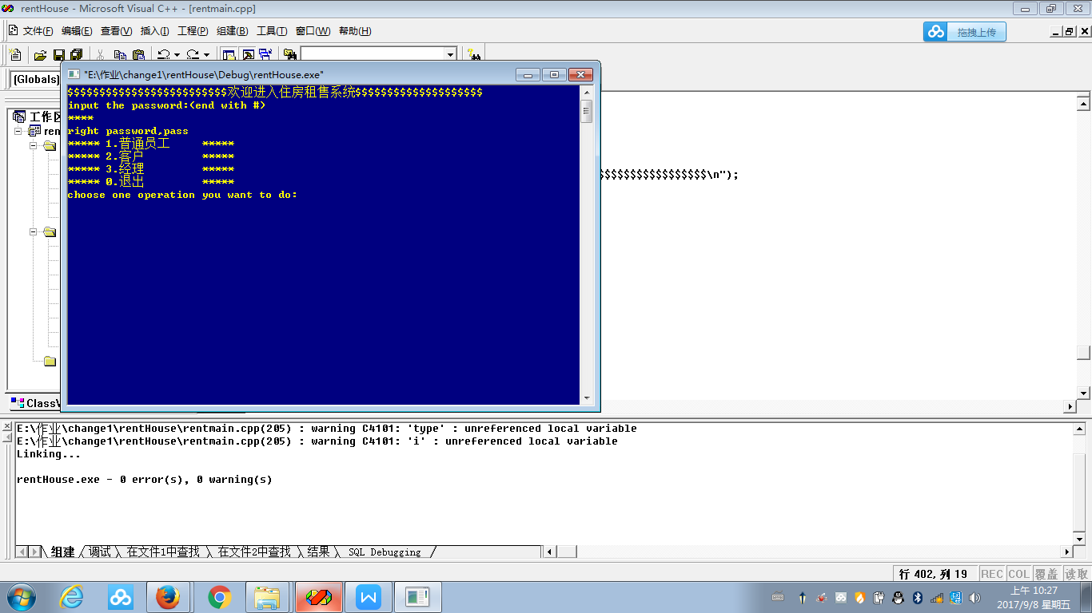
运行后，程序的主菜单界面如下。
图1 输入密码 进入系统

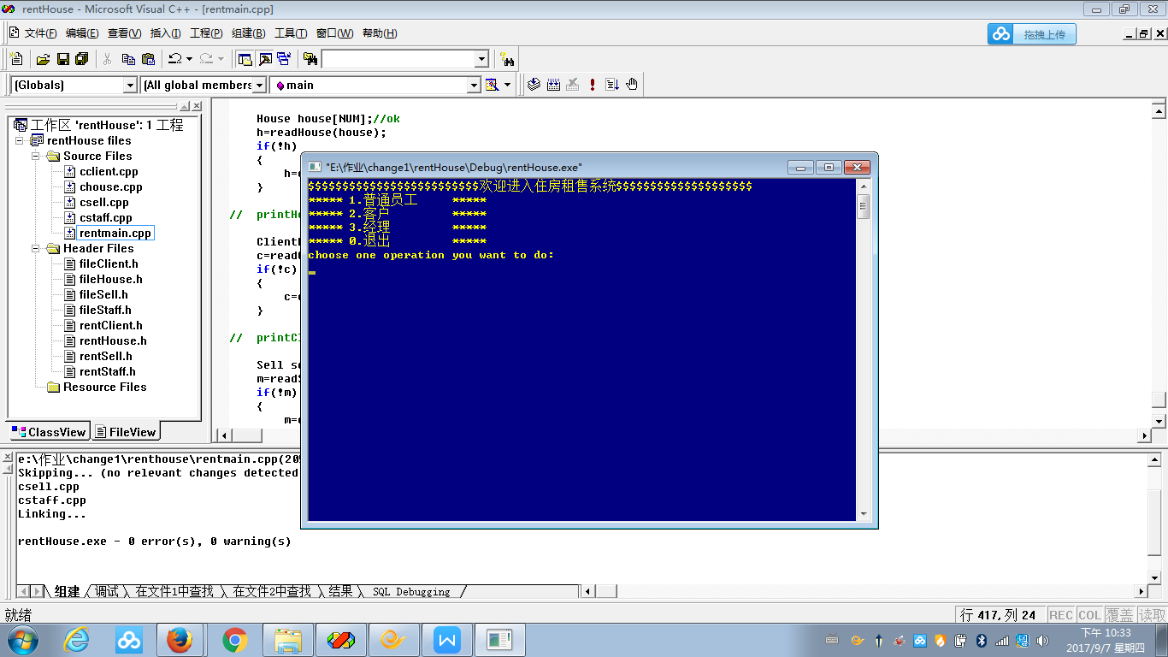
图1 主要界面

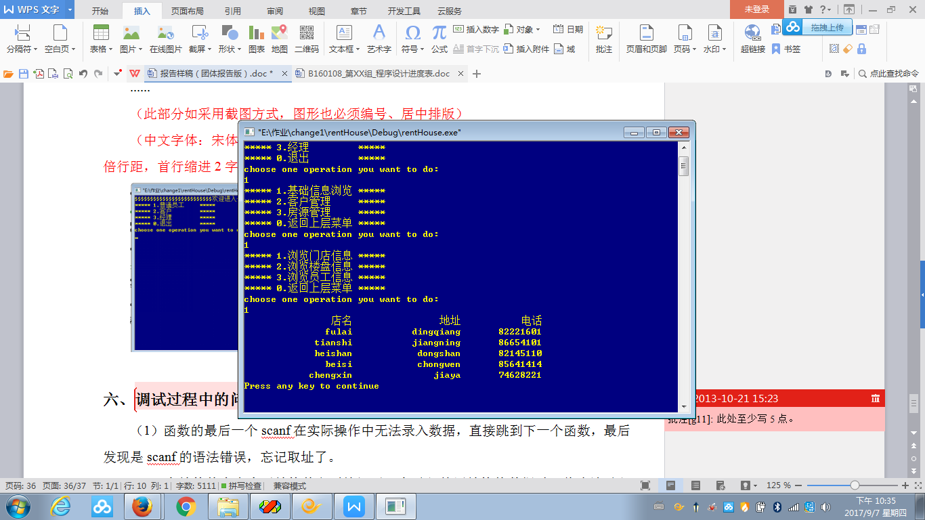
图2 浏览信息

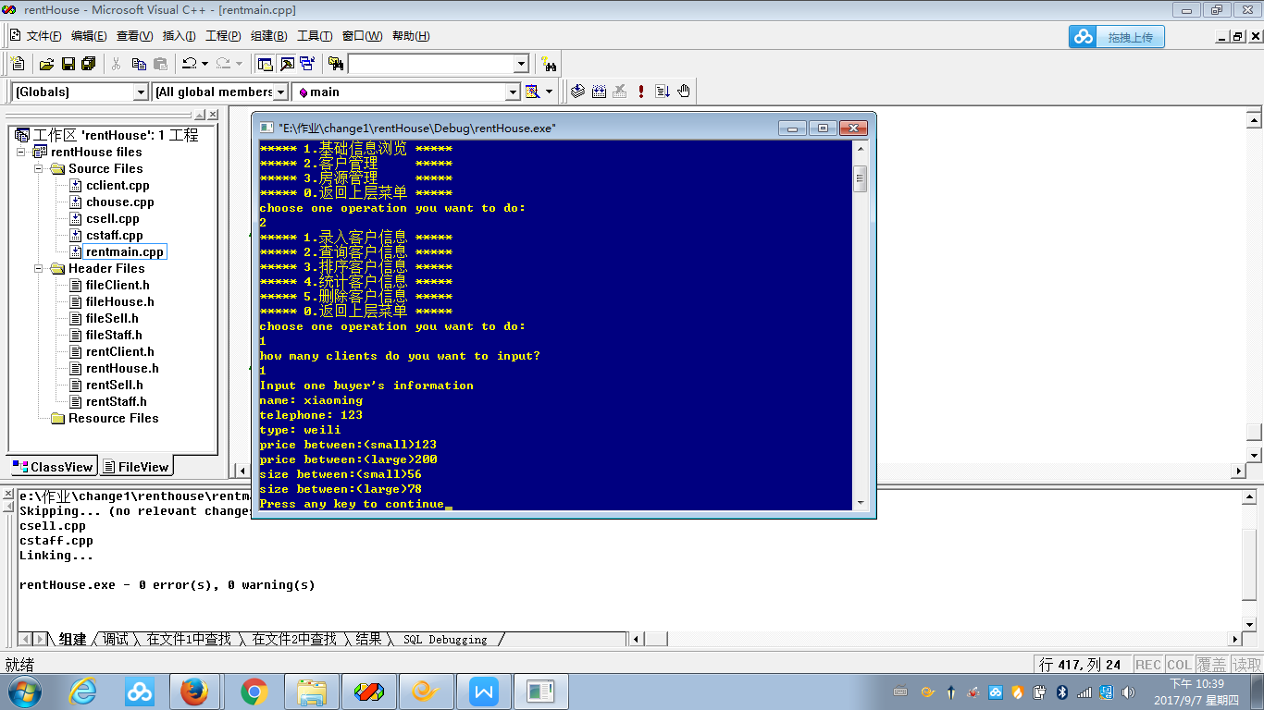
图3 录入信息

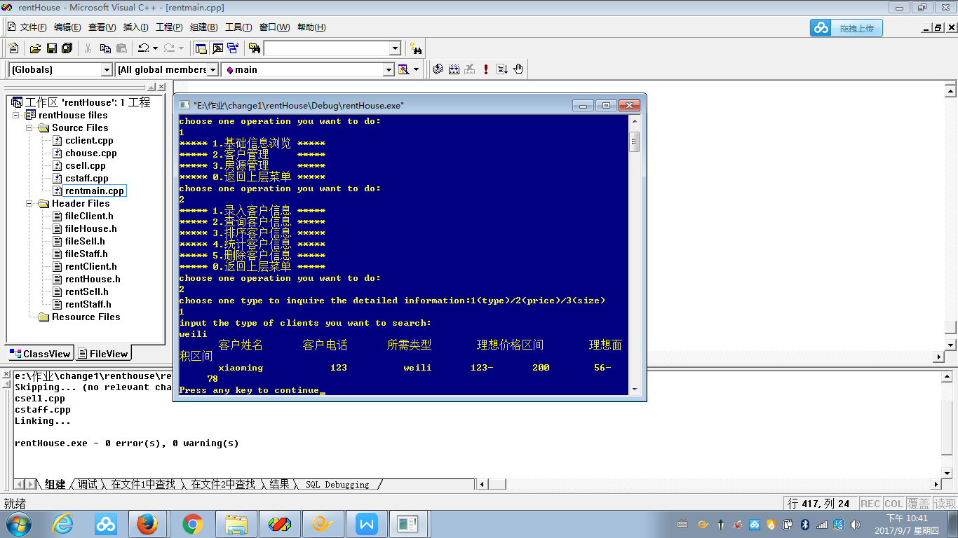
图4 查询信息

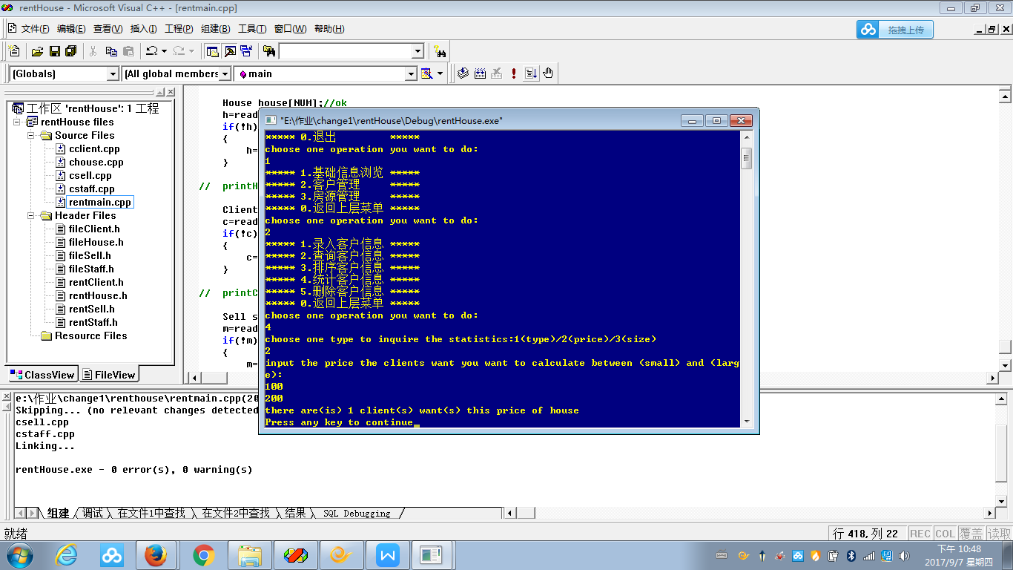
图5 分类统计信息

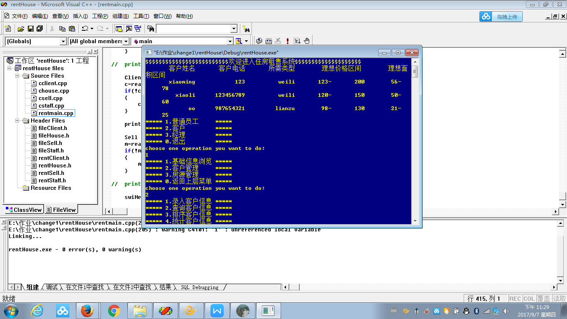
图6 排序信息（原）

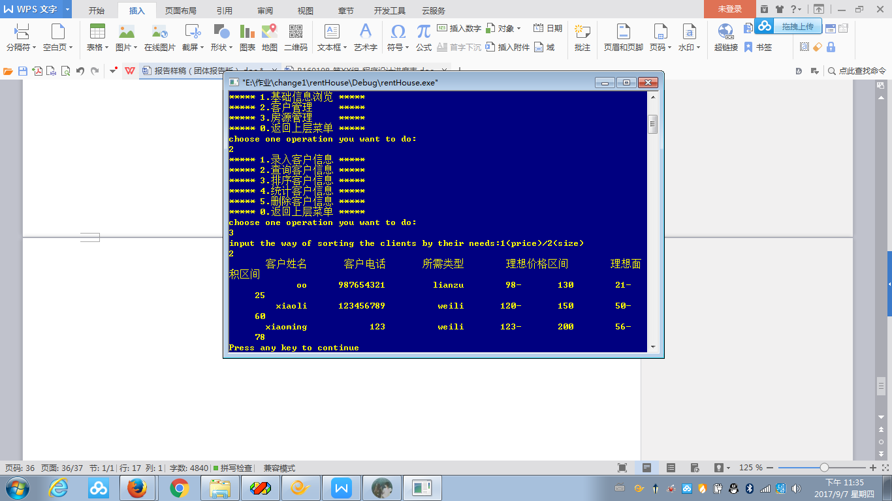
图7 排序信息（后）

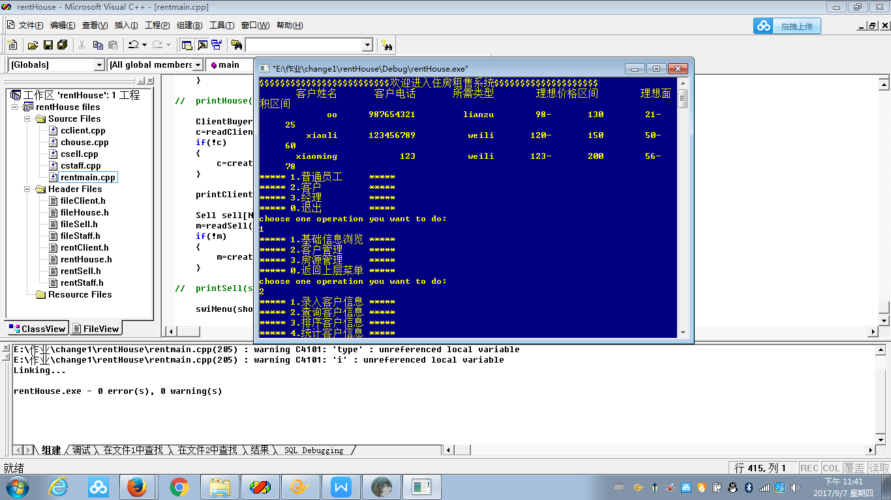
图8 删除信息（原信息）

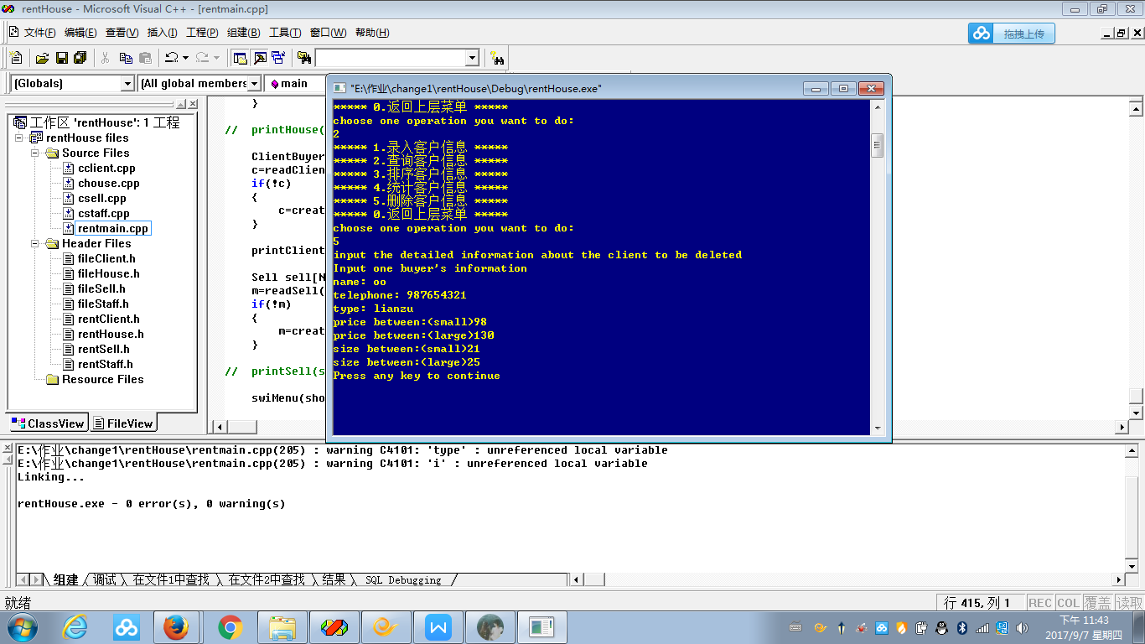
图9 删除信息（过程）

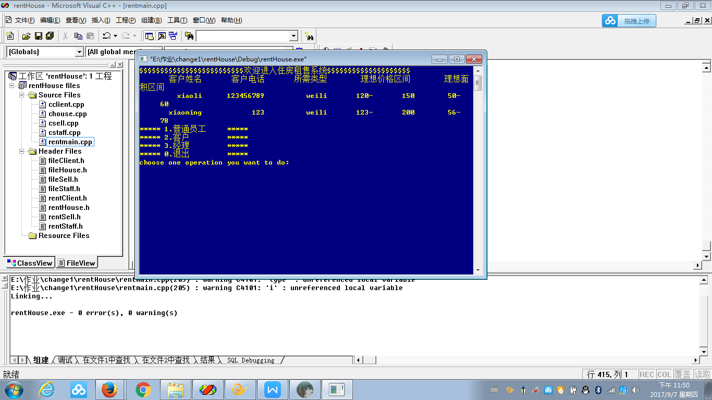
图10 删除信息（结果）

结果分析如下。
- 在输入菜单选项时如果输入的内容不是0-3之间的数字，而是其他数字，系统将显示wrong input
- 在需要输入所须查找的名称处如店名不在系统中，系统提示错误并退出系统。
- 在输入理想价格区间以及理想面积区间的时候，如果先输入大的数字再输入小的数字，系统将自动循环，一直到输入的数字顺序正确为止。
- 在输入密码时，如果密码错误，将不能进入系统。
- 调试过程中的问题
- 函数的最后一个scanf在实际操作中无法录入数据，直接跳到下一个函数，最后发现是scanf的语法错误，忘记取址了。
printf("Input one house\'s information\n");
printf("number:");
scanf("%d",&house[i].Number);
printf("address: ");
scanf("%s",house[i].Address);
getchar();
printf("type: ");
scanf("%s",house[i].Type);
getchar();
printf("price: ");
scanf("%d",&house[i].Price); //之前忘了加&
printf("size: ");
scanf("%d",&house[i].Size);
printf("original owner's name: ");
scanf("%s",house[i].OriOwner.Name);
getchar();
printf("original owner's telephone: ");
scanf("%s",&house[i].OriOwner.Tele);
- 在结构体中嵌套了结构体之后搞混了，在录入外层结构体数据时，将应该录入的外层结构体中给内层结构体取的成员名直接写成内层结构体的类名，结果系统显示没有该结构体。
printf("the shop\'s name one staff belongs to: ");
getchar();
scanf("%s",staff[i].ShopBelong.Name);
getchar();
printf("the shop\'s address one staff belongs to: ");
scanf("%s",staff[i].ShopBelong.Address);
getchar();
printf("the shop\'s phone one staff belongs to: ");
scanf("%s",&staff[i].ShopBelong.Tele); //原来写成了&staff[i].Shop.Tele，
Shop ShopBelong是结构体Staff的成员变量

- 由于数据过于复杂，在同一个函数中将不同类型的对象取成了一个名字，使用时产生混乱。将switch括号中的int的名字和一个char[]的名字取成一样的了。
case 4:printf("choose one type to inquire the statistics:1(type)/2(price)/3(size)\n");
scanf("%d",&inttype);//定义的时候重名了
switch(inttype)
{
case 1:printf("input the type of clients you want to calculate:\n");
scanf("%s",caltype);//重名了
count=calCliType(client,c,caltype,strlen(caltype));
printf("there are(is) %d client(s) want(s) this type of house\n",count);
break;
- 将两个函数名取成一样的了，在编译后显示此函数已有函数体了。
void menuClient()
{
printf("***** 1.录入客户信息 *****\n");
printf("***** 2.查询客户信息 *****\n");
printf("***** 3.排序客户信息 *****\n");
printf("***** 4.统计客户信息 *****\n");//按价格 类型 大小统计switch二级菜单
printf("***** 5.删除客户信息 *****\n");
printf("***** 0.返回上层菜单 *****\n");
}
void menuClientPower()//修改函数名
{
printf("***** 1.基础信息浏览 *****\n");
printf("***** 2.查询房源信息 *****\n");
printf("***** 0.返回上层菜单 *****\n");
}
（5）有一个四个参数的函数，在使用时总显示此函数不能使用4个参数，在与函数原型比对时发现函数原型也是4个参数。后来才找到，在头文件的定义里，该函数有三个参数，是在一开始定义的时候写进去的，最后改过来了。
int calCliPrice(ClientBuyer *client,int n,int price1,int price2);//之前修改了函数的原型和引用之后忘了修改头文件里的函数声明。
int calCliSize(ClientBuyer *client,int n,int size1,int size2);
- 在使用scanf的过程中，录入数据时，发现几行一起跳出来了，后来发现是在录入字符串的时候没有加getchar（）吸收多余的字符。
getchar();
scanf("%s",buyer[i].Name);
printf("telephone: ");
scanf("%s",buyer[i].Tele);
getchar();
printf("type: ");
scanf("%s",buyer[i].Type);

七、课程设计总结
本次课程设计时间紧，任务重，而我们组的任务又比较多，在三四天的编程过程中我们遇到了不少难题，在解决问题的过程中，我们也收获了许多经验。
在第一天时，老师让我们针对题目先进行需求分析，让我们得以有一个好的开始。因为制作这样较大的系统我们很多人都是第一次，如果不先列好一个大概的框架，而是像原来一样想到哪儿做到哪儿的话，很可能会大大降低我们的效率，造成许多不必要的精力浪费。这让我们了解到了做事情要有事先的规划。在写程序的过程中，我们遇到了很多的bug，有很大一部分原因是因为我们将一个个小的函数模块做好之后没有进行调试就将其贸然地组合在一起，导致bug的牵扯很多，难以修改。后来在老师的指导下我们将组合好的函数再次根据对象先拆分成一个单独的函数，先在这个函数里把bug修改好，再用修改好的经验推广到其他的几个模块中，用成功的函数模块经验和失败的进行比对，修改错误。在最后的逻辑bug修改的过程中，我们利用了注释，将错误的范围一步步缩小，通过和其他模块相同功能的成功函数的对比找出了一些错误。
在此次的程序设计中，我们在短时间内要完成大量的程序，让平时较为懒散的我们更加高效地利用了时间。我们不但更加深入地理解了c语音的用法，也在第一个系统设计的实践中领悟到了一些平时做单个小程序的时候不能明白的道理。在完成一个较大的系统时，我们需要首先根据客户需求制定一个明确的框架。在完成了每个小函数后都要将其结果打印出来观察其实际使用效果。要善用注释，会用printf打印中间变量进行观测。要对每个函数的功能及步骤都很熟悉，遇到比较复杂的函数或者功能可以在旁边注释一下其作用，在用的时候传进去的每一个参数都要明白是什么意思。
本次的程序设计为我忙碌的大二开了一个好头，让我学会了更好地规划学习与生活的时间，并在做事之前先确立好明确的目标。

