**Problem assignment 7**

**Problem 1. Bayesian belief networks**

Assume the Bayesian belief network in the figure below. Assume that every variable in the network is binary representing T,F values, except variable D that can take on three possible values T,F,X (X stands for undecided).

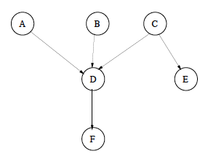

Assume you want to compute P(B = T,E = T).

**Part a.** Assess the computational cost of the (blind) solution that

(1) calculates P(B =T,E = T) from the full joint

# of the parameters of the full joint: (2^5)*3 = 96

# of free parameters: 96 -1 = 95

(2) uses the BBN representation to express the full joint, in terms of the number of additions and multiplications and report the results in the report.

**Part b.** Show how would you compute the expression more efficiently by interleaving products and sums. Provide a new expression for calculating P(B = T,E = T) and show its computational cost in terms of the number of additions and multiplications. Compare the two solutions and discuss the results in your report.