Problem assignment 4

Due: Thursday, February 15, 2018

**Linear Regression**

In this problem set we use the Boston Housing dataset from the CMU StatLib Library that concerns prices of housing in Boston suburbs. A data sample consists of 13 attribute values (indicating parameters like crime rate, accessibility to major highways etc.) and the median value of housing in thousands we would like to predict.

The data are in the file *housing.txt*, the description of the data is in the file housing desc.txt on the course web page.

Part 1. Exploratory data analysis.

Examine the dataset *housing.txt* using Matlab. Answer the following questions.

(a) How many binary attributes are in the data set? List the attributes.

1 binary attribute in the dataset: column 4: CHAS

(b) Calculate and report correlations in between the first 13 attributes (columns) and

the target attribute (column 14). What are the attribute names with the highest

positive and negative correlations to the target attribute?

The correlation between feature 1-13 with target attribute:

cor_vec =

Columns 1 through 9

-0.3883 0.3604 -0.4837 0.1753 -0.4273 **0.6954** -0.3770 0.2499 -0.3816

Columns 10 through 13

-0.4685 -0.5078 0.3335 **-0.7377**

The largest positive correlation is: attribute 6 (RM: average number of rooms per dwelling)

The highest negative correlation is: attribute 13 (MEDV Median value of owner-occupied homes in $1000's)

(c) Note that the correlation is a linear measure of similarity. Examine scatter plots

for attributes and the target attribute using the function you wrote in problem set 1.

Which scatter plot looks the most linear, and which looks the most nonlinear? Plot

these scatter plots and briefly (in 1-2 sentences) explain your choice.

As correlation examined the linear similarity, so attribute 6 (RM) should most likely have the linear relationship with the median price, as demonstrated in the plot below

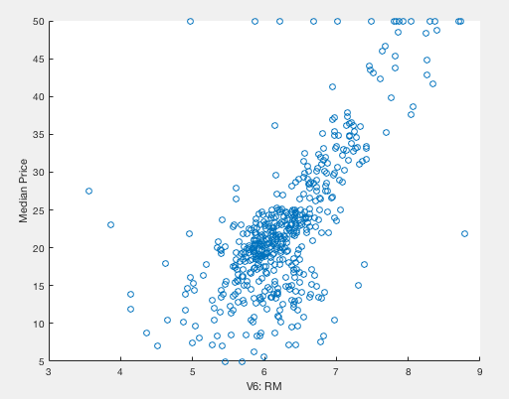

The attribute 13 (LSTAT: % lower status of the population) seems to be non-linear as demonstrated in the following plot, which seems to be curve instead of a line.

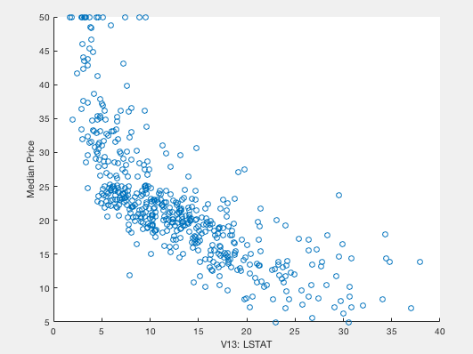

(d) Calculate all correlations between the 14 columns (using the corrcoef function).

Which two attributes have the largest mutual correlation in the dataset?