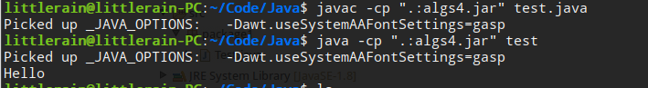
Java命令行中当前目录不用./ 替换为.:

