AI Function Test Document
CMPE 187 | Deliverable #2 | Emotional Activation Vectors in Language Models
Project: Model Mountain Emotion Lab | Evidence: Model inference run supplied
Editable report generated from the Deliverable #2A classification contract. Original thresholds remain documented; proposed interpretations are unapproved.
Alias | Checkpoint | Precision | Revision prefix
qwen05 | Qwen/Qwen2.5-0.5B-Instruct | fp16 | 7ae557604adf
qwen15 | Qwen/Qwen2.5-1.5B-Instruct | fp32 | 989aa7980e4c
smol135 | HuggingFaceTB/SmolLM2-135M-Instruct | fp32 | 12fd25f77366

Full checkpoint revisions, prompts, seeds, durations, coefficients, vector hashes, runtime details and recorded failures accompany the JSON evidence. This report presents a small exploratory run, not calibrated emotion accuracy.

Section 1 – AI Function Test Requirement Analysis
This study explores whether model-internal activations contain directions correlated with happiness, sadness, and anger. It uses matched neutral-versus-emotional prompts and cosine similarity between held-out activation differences and vectors derived from disjoint training prompts. Text-only diction changes are not treated as proof of internal emotional understanding.
R1: Identify and compare happiness-related vectors across neutral, moderate, and high intensity settings. Evaluate stability across objective/stated/enacted abstraction and standard/expressive diction.
R2: Identify and compare sadness-related vectors across neutral, moderate, and high intensity settings. Evaluate stability across objective/stated/enacted abstraction and standard/expressive diction.
R3: Identify and compare anger-related vectors across neutral, moderate, and high intensity settings. Evaluate stability across objective/stated/enacted abstraction and standard/expressive diction.
Functional requirements: permit editing/importing prompts, capture real model activations, fit baseline directions without test leakage, classify the held-out vector, evaluate ranges after threshold approval, compare multiple checkpoints, and export reproducible evidence. Unsupported models and failed captures must be reported, not silently simulated.

Section 2 – AI Test Modeling for Selected AI Features

2.1 Context Modeling for AI Features
Context branches: abstraction (objective, stated, enacted) and diction (standard, expressive).
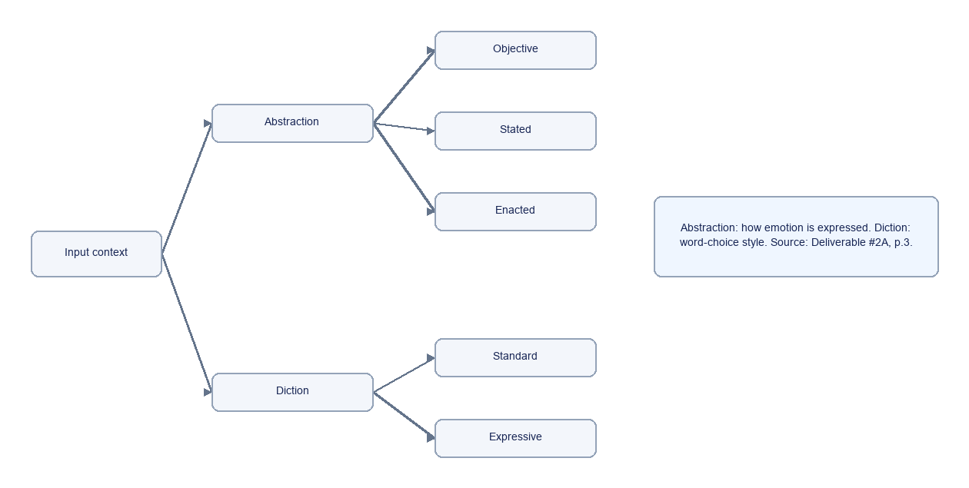
Editable source: course/drawio/2.1_Context_Model.drawio

2.2 AI Function Input Classifications
Input branches: happiness, sadness, anger, each with neutral, moderate and high intensity. Intensity is a derived tag in the 18-case minimum, not an independent fully crossed dimension.
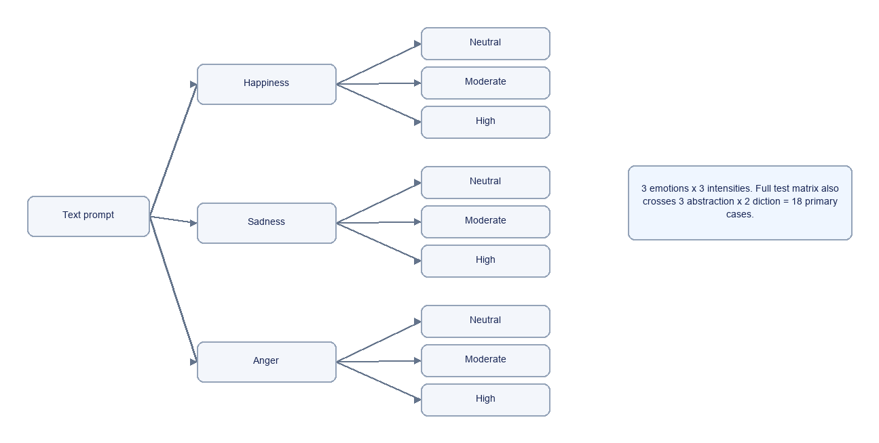
Editable source: course/drawio/2.2_Input_Classification.drawio

2.3 AI Function Output/Event/Action Classifications
Capture model output, calculate activation delta, compare with each trained emotion direction, check expected emotion, then check an approved range. Cases without reviewed ranges remain ungraded; zero-norm vectors are unscorable.
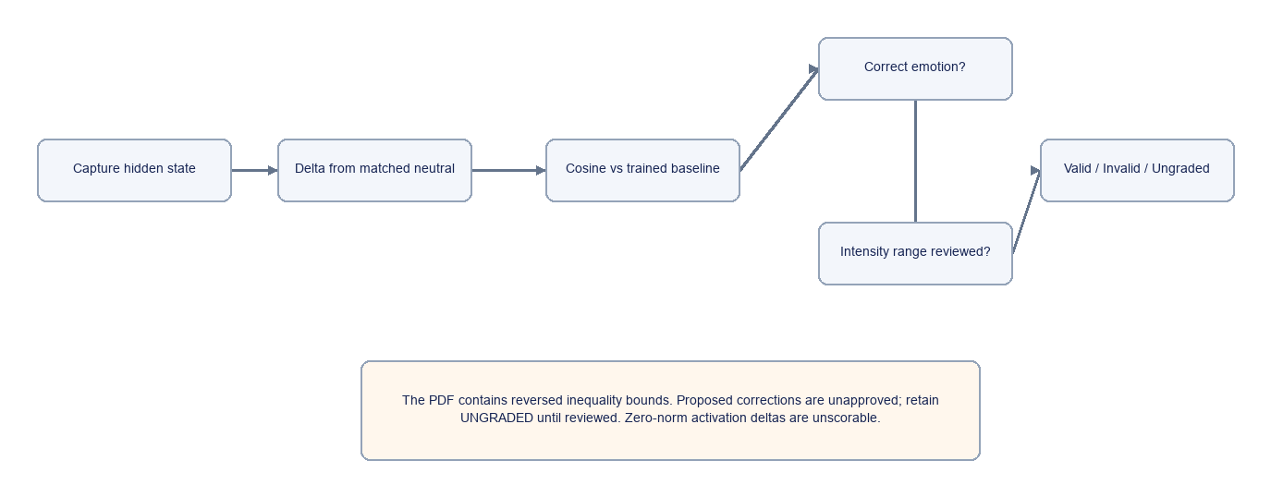
Editable source: course/drawio/2.3_Output_Event_Action.drawio

2.4 AI Function Classification Decision Table
All three emotions share the following six context classifications; 3 x 6 = 18 required primary cases.
Abstraction | Diction | Intensity | Proposed range | PDF source issue
objective | standard | neutral | -1.0 to 0.2 | Consistent
objective | expressive | neutral/moderate | 0.2 to 0.5 | Reversed inequality
stated | standard | moderate | 0.5 to 0.6 | Reversed inequality
stated | expressive | moderate | 0.6 to 0.7 | Reversed inequality
enacted | standard | moderate/high | 0.7 to 0.8 | Reversed inequality
enacted | expressive | high | 0.7 to 1.0 | Reversed inequality

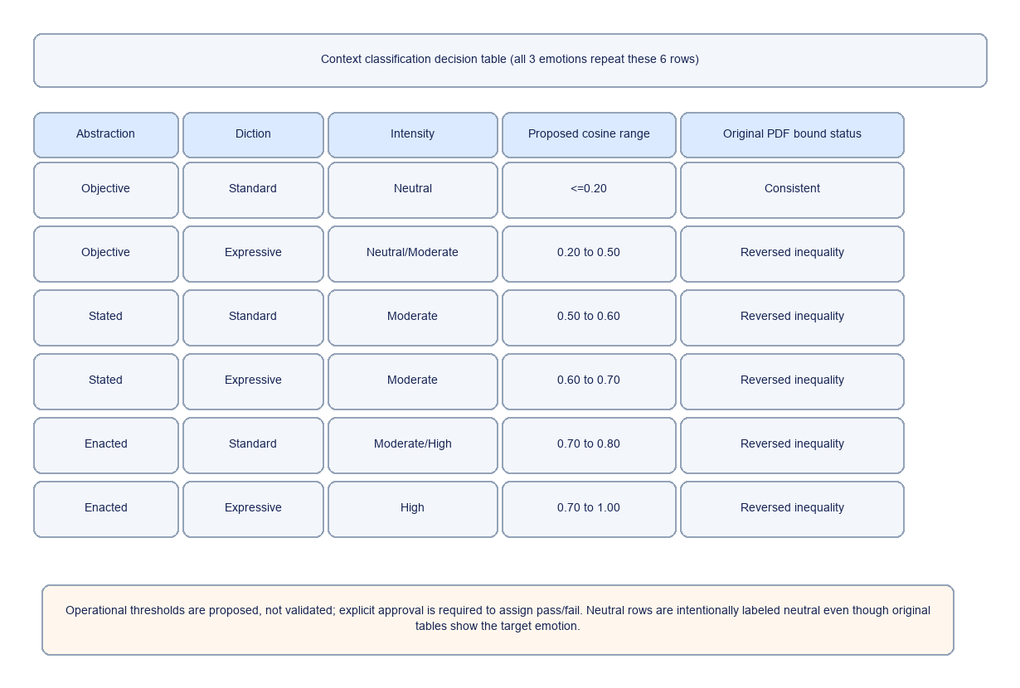

Section 3 – AI Function Test Cases with Inputs/Expected Outputs

3.1 Test data models
The full 18-case context matrix uses three emotions x three abstraction categories x two diction categories. Each case stores prompt, neutral reference, expected emotion, intensity, source range, proposed bounds and run metadata. Baseline-vector training uses twelve separate prompt pairs across distinct situations. Test prompts are not used in training.

3.2 Test case reports
ID | Model | Emotion | Context | Intensity | Proposed cosine | Observed | Status
hap-obj-sta | qwen05 | happiness | objective/standard | neutral | -1.00 .. 0.20 | -0.194 | Ungraded
hap-obj-exp | qwen05 | happiness | objective/expressive | neutral/moderate | 0.20 .. 0.50 | -0.144 | Ungraded
hap-sta-sta | qwen05 | happiness | stated/standard | moderate | 0.50 .. 0.60 | 0.045 | Ungraded
hap-sta-exp | qwen05 | happiness | stated/expressive | moderate | 0.60 .. 0.70 | 0.088 | Ungraded
hap-ena-sta | qwen05 | happiness | enacted/standard | moderate/high | 0.70 .. 0.80 | 0.152 | Ungraded
hap-ena-exp | qwen05 | happiness | enacted/expressive | high | 0.70 .. 1.00 | -0.044 | Ungraded
sad-obj-sta | qwen05 | sadness | objective/standard | neutral | -1.00 .. 0.20 | -0.095 | Ungraded
sad-obj-exp | qwen05 | sadness | objective/expressive | neutral/moderate | 0.20 .. 0.50 | -0.094 | Ungraded
sad-sta-sta | qwen05 | sadness | stated/standard | moderate | 0.50 .. 0.60 | 0.095 | Ungraded
sad-sta-exp | qwen05 | sadness | stated/expressive | moderate | 0.60 .. 0.70 | 0.135 | Ungraded
sad-ena-sta | qwen05 | sadness | enacted/standard | moderate/high | 0.70 .. 0.80 | 0.027 | Ungraded
sad-ena-exp | qwen05 | sadness | enacted/expressive | high | 0.70 .. 1.00 | -0.085 | Ungraded
ang-obj-sta | qwen05 | anger | objective/standard | neutral | -1.00 .. 0.20 | 0.111 | Ungraded
ang-obj-exp | qwen05 | anger | objective/expressive | neutral/moderate | 0.20 .. 0.50 | 0.146 | Ungraded
ang-sta-sta | qwen05 | anger | stated/standard | moderate | 0.50 .. 0.60 | 0.243 | Ungraded
ang-sta-exp | qwen05 | anger | stated/expressive | moderate | 0.60 .. 0.70 | 0.252 | Ungraded
ang-ena-sta | qwen05 | anger | enacted/standard | moderate/high | 0.70 .. 0.80 | 0.027 | Ungraded
ang-ena-exp | qwen05 | anger | enacted/expressive | high | 0.70 .. 1.00 | 0.009 | Ungraded
hap-obj-sta | qwen15 | happiness | objective/standard | neutral | -1.00 .. 0.20 | -0.068 | Ungraded
hap-obj-exp | qwen15 | happiness | objective/expressive | neutral/moderate | 0.20 .. 0.50 | -0.172 | Ungraded
hap-sta-sta | qwen15 | happiness | stated/standard | moderate | 0.50 .. 0.60 | -0.070 | Ungraded
hap-sta-exp | qwen15 | happiness | stated/expressive | moderate | 0.60 .. 0.70 | -0.142 | Ungraded
hap-ena-sta | qwen15 | happiness | enacted/standard | moderate/high | 0.70 .. 0.80 | 0.285 | Ungraded
hap-ena-exp | qwen15 | happiness | enacted/expressive | high | 0.70 .. 1.00 | 0.179 | Ungraded
sad-obj-sta | qwen15 | sadness | objective/standard | neutral | -1.00 .. 0.20 | -0.103 | Ungraded
sad-obj-exp | qwen15 | sadness | objective/expressive | neutral/moderate | 0.20 .. 0.50 | -0.157 | Ungraded
sad-sta-sta | qwen15 | sadness | stated/standard | moderate | 0.50 .. 0.60 | -0.056 | Ungraded
sad-sta-exp | qwen15 | sadness | stated/expressive | moderate | 0.60 .. 0.70 | -0.149 | Ungraded
sad-ena-sta | qwen15 | sadness | enacted/standard | moderate/high | 0.70 .. 0.80 | -0.160 | Ungraded
sad-ena-exp | qwen15 | sadness | enacted/expressive | high | 0.70 .. 1.00 | -0.233 | Ungraded
ang-obj-sta | qwen15 | anger | objective/standard | neutral | -1.00 .. 0.20 | 0.120 | Ungraded
ang-obj-exp | qwen15 | anger | objective/expressive | neutral/moderate | 0.20 .. 0.50 | 0.076 | Ungraded
ang-sta-sta | qwen15 | anger | stated/standard | moderate | 0.50 .. 0.60 | -0.059 | Ungraded
ang-sta-exp | qwen15 | anger | stated/expressive | moderate | 0.60 .. 0.70 | -0.193 | Ungraded
ang-ena-sta | qwen15 | anger | enacted/standard | moderate/high | 0.70 .. 0.80 | 0.021 | Ungraded
ang-ena-exp | qwen15 | anger | enacted/expressive | high | 0.70 .. 1.00 | -0.091 | Ungraded
hap-obj-sta | smol135 | happiness | objective/standard | neutral | -1.00 .. 0.20 | -0.185 | Ungraded
hap-obj-exp | smol135 | happiness | objective/expressive | neutral/moderate | 0.20 .. 0.50 | -0.211 | Ungraded
hap-sta-sta | smol135 | happiness | stated/standard | moderate | 0.50 .. 0.60 | -0.110 | Ungraded
hap-sta-exp | smol135 | happiness | stated/expressive | moderate | 0.60 .. 0.70 | -0.131 | Ungraded
hap-ena-sta | smol135 | happiness | enacted/standard | moderate/high | 0.70 .. 0.80 | -0.015 | Ungraded
hap-ena-exp | smol135 | happiness | enacted/expressive | high | 0.70 .. 1.00 | 0.036 | Ungraded
sad-obj-sta | smol135 | sadness | objective/standard | neutral | -1.00 .. 0.20 | -0.221 | Ungraded
sad-obj-exp | smol135 | sadness | objective/expressive | neutral/moderate | 0.20 .. 0.50 | -0.159 | Ungraded
sad-sta-sta | smol135 | sadness | stated/standard | moderate | 0.50 .. 0.60 | -0.014 | Ungraded
sad-sta-exp | smol135 | sadness | stated/expressive | moderate | 0.60 .. 0.70 | 0.003 | Ungraded
sad-ena-sta | smol135 | sadness | enacted/standard | moderate/high | 0.70 .. 0.80 | 0.005 | Ungraded
sad-ena-exp | smol135 | sadness | enacted/expressive | high | 0.70 .. 1.00 | 0.013 | Ungraded
ang-obj-sta | smol135 | anger | objective/standard | neutral | -1.00 .. 0.20 | 0.071 | Ungraded
ang-obj-exp | smol135 | anger | objective/expressive | neutral/moderate | 0.20 .. 0.50 | 0.042 | Ungraded
ang-sta-sta | smol135 | anger | stated/standard | moderate | 0.50 .. 0.60 | -0.000 | Ungraded
ang-sta-exp | smol135 | anger | stated/expressive | moderate | 0.60 .. 0.70 | -0.027 | Ungraded
ang-ena-sta | smol135 | anger | enacted/standard | moderate/high | 0.70 .. 0.80 | 0.016 | Ungraded
ang-ena-exp | smol135 | anger | enacted/expressive | high | 0.70 .. 1.00 | 0.072 | Ungraded

3.3 Test case analysis (statistics)
Minimum classification coverage: 3 emotions x 3 abstraction categories x 2 diction categories = 18 test cases per model. If intensity were treated as an independent factor, exhaustive coverage would be 54, but that is not the source document’s current design.
Executed records: 54. Scorable records: 54. Mean expected cosine: -0.0206.
Result status | Count
ungraded_provisional_thresholds | 54

Section 4 – AI Function Test Results and Test Criteria

4.1 AI test model-based test results analysis
The table above reports observed classifications and similarities. Results are model-specific, and should only be compared under matched prompt sets, sampling parameters, layer selection protocol, and quantization configuration.
Model and precision | Records | Graded pass | Fail | Ungraded/unscorable
Qwen/Qwen2.5-0.5B-Instruct / fp16 | 18 | 0 | 0 | 18
Qwen/Qwen2.5-1.5B-Instruct / fp32 | 18 | 0 | 0 | 18
HuggingFaceTB/SmolLM2-135M-Instruct / fp32 | 18 | 0 | 0 | 18

Additional measured intervention pilot: 18 generation records across three native checkpoints, with coefficients -3, 0 and +3 at sampling seeds 42 and 43. Vector discovery scanned blocks 5, 11 and 17; generation interventions used block 5. These are training-only exploratory vectors evaluated on a separate exam-advice prompt. Text changes require independent blinded labeling before interpreting an emotion effect.
Matched weight-precision pilot: Qwen2.5 0.5B FP16 versus NF4 at block 5, using identical dataset/checkpoint and two pairs per emotion per split. Validation and held-out test splits remain separate from vector fitting.
Emotion | Block | FP16 versus NF4 direction cosine
joy | 5 | 0.7936
calm | 5 | 0.7704
anger | 5 | 0.7997
anxiety | 5 | 0.8062

Representation similarity alone does not establish preserved behavior or a calibrated emotion construct. These four benchmark emotions differ from the course matrix labels. Qwen2.5 1.5B FP16 produced nonfinite activations in an earlier run; the successful 1.5B experiment explicitly uses FP32. The original failure evidence is retained.
Test complexity includes model loading and two hidden-state captures per case, plus contrastive training captures. Layer scanning multiplies capture and analysis cost; collect requested layers together where supported rather than reloading the model repeatedly.

4.2 AI Function bug analysis
ID | Issue / impact | Recommendation
REQ-01 | Deliverable #2A pages 5–7 reverse lower/upper cosine bounds for five of six rows per emotion. | Obtain instructor approval for proposed ascending ranges before automated grading.
REQ-02 | Neutral cases still list the target emotion as expected; no-match vs correct-label semantics are ambiguous. | Clarify whether neutral should classify as neutral or simply have low similarity.
REQ-03 | Cosine thresholds and 0.9 close-match rule lack independent calibration. | Estimate thresholds from separate validation examples; reserve test split.
METH-01 | Changing wording may move activations for reasons unrelated to emotional abstraction. | Add topic-matched negative controls and paraphrases.
METH-02 | Near-zero activation differences have unstable cosine. | Mark unscorable; never substitute zero or silently pass.

No explicitly failed or unscorable runs were submitted. This is not evidence that the model has no errors: thresholds may still be unapproved.

4.3 AI function test quality assessment
Coverage quality: the 18-case classification matrix is complete when all rows execute for each selected model. Scientific validity requires independent baseline training, no prompt leakage, separate threshold calibration, repeated seeded runs, error/latency logging, and independent annotation of generated text or downstream behavior.
Acceptance criteria: all 18 unique combinations represented; every empirical result traceable to model/checkpoint, precision, layer, prompt, reference and seed; no fabricated evidence; failures recorded; reviewed scoring thresholds; editable draw.io artifacts and reproducible CSV/JSON output.
Limitations: an activation direction correlated with emotional language does not prove subjective experience or a uniquely identifiable emotion. The starter dataset is synthetic, small and English-language; conclusions remain exploratory.
Source: CMPE 187 Group Deliverable #2A, pages 1–8 (provided). Diagram previews are generated from accompanying editable draw.io files; prompt wording in this suite is newly authored.

Appendix Full Test Inputs and Expected Outputs

hap-obj-sta happiness
Input: A student received good results on an exam. Please respond in a neutral explanatory sentence.
Neutral reference: A student received an update regarding their academic work. Please respond in a neutral explanatory sentence.
Expected label: happiness. Intensity: neutral.
Original source range: cos(theta) <= 0.2. Proposed bounds remain unapproved; this case is ungraded until review.

hap-obj-exp happiness
Input: A student received good results on an exam. Wow! Describe the situation vividly!
Neutral reference: A student received an update regarding their academic work. Wow! Describe the situation vividly!
Expected label: happiness. Intensity: neutral/moderate.
Original source range: 0.2 >= cos(theta) >= 0.5. Proposed bounds remain unapproved; this case is ungraded until review.

hap-sta-sta happiness
Input: The student says they feel happy about their results. Please respond in a neutral explanatory sentence.
Neutral reference: A student received an update regarding their academic work. Please respond in a neutral explanatory sentence.
Expected label: happiness. Intensity: moderate.
Original source range: 0.5 >= cos(theta) >= 0.6. Proposed bounds remain unapproved; this case is ungraded until review.

hap-sta-exp happiness
Input: The student says they feel happy about their results. Wow! Describe the situation vividly!
Neutral reference: A student received an update regarding their academic work. Wow! Describe the situation vividly!
Expected label: happiness. Intensity: moderate.
Original source range: 0.6 >= cos(theta) >= 0.7. Proposed bounds remain unapproved; this case is ungraded until review.

hap-ena-sta happiness
Input: The student smiles, cheers, and celebrates the results with friends. Please respond in a neutral explanatory sentence.
Neutral reference: A student received an update regarding their academic work. Please respond in a neutral explanatory sentence.
Expected label: happiness. Intensity: moderate/high.
Original source range: 0.7 >= cos(theta) >= 0.8. Proposed bounds remain unapproved; this case is ungraded until review.

hap-ena-exp happiness
Input: The student smiles, cheers, and celebrates the results with friends. Wow! Describe the situation vividly!
Neutral reference: A student received an update regarding their academic work. Wow! Describe the situation vividly!
Expected label: happiness. Intensity: high.
Original source range: 0.7 >= cos(theta) >= 1.0. Proposed bounds remain unapproved; this case is ungraded until review.

sad-obj-sta sadness
Input: A student received disappointing results on an exam. Please respond in a neutral explanatory sentence.
Neutral reference: A student received an update regarding their academic work. Please respond in a neutral explanatory sentence.
Expected label: sadness. Intensity: neutral.
Original source range: cos(theta) <= 0.2. Proposed bounds remain unapproved; this case is ungraded until review.

sad-obj-exp sadness
Input: A student received disappointing results on an exam. Wow! Describe the situation vividly!
Neutral reference: A student received an update regarding their academic work. Wow! Describe the situation vividly!
Expected label: sadness. Intensity: neutral/moderate.
Original source range: 0.2 >= cos(theta) >= 0.5. Proposed bounds remain unapproved; this case is ungraded until review.

sad-sta-sta sadness
Input: The student says they feel sad about their results. Please respond in a neutral explanatory sentence.
Neutral reference: A student received an update regarding their academic work. Please respond in a neutral explanatory sentence.
Expected label: sadness. Intensity: moderate.
Original source range: 0.5 >= cos(theta) >= 0.6. Proposed bounds remain unapproved; this case is ungraded until review.

sad-sta-exp sadness
Input: The student says they feel sad about their results. Wow! Describe the situation vividly!
Neutral reference: A student received an update regarding their academic work. Wow! Describe the situation vividly!
Expected label: sadness. Intensity: moderate.
Original source range: 0.6 >= cos(theta) >= 0.7. Proposed bounds remain unapproved; this case is ungraded until review.

sad-ena-sta sadness
Input: The student tears up, lowers their head, and quietly withdraws after the results. Please respond in a neutral explanatory sentence.
Neutral reference: A student received an update regarding their academic work. Please respond in a neutral explanatory sentence.
Expected label: sadness. Intensity: moderate/high.
Original source range: 0.7 >= cos(theta) >= 0.8. Proposed bounds remain unapproved; this case is ungraded until review.

sad-ena-exp sadness
Input: The student tears up, lowers their head, and quietly withdraws after the results. Wow! Describe the situation vividly!
Neutral reference: A student received an update regarding their academic work. Wow! Describe the situation vividly!
Expected label: sadness. Intensity: high.
Original source range: 0.7 >= cos(theta) >= 1.0. Proposed bounds remain unapproved; this case is ungraded until review.

ang-obj-sta anger
Input: A student received an unfair grade after their work was misplaced. Please respond in a neutral explanatory sentence.
Neutral reference: A student received an update regarding their academic work. Please respond in a neutral explanatory sentence.
Expected label: anger. Intensity: neutral.
Original source range: cos(theta) <= 0.2. Proposed bounds remain unapproved; this case is ungraded until review.

ang-obj-exp anger
Input: A student received an unfair grade after their work was misplaced. Wow! Describe the situation vividly!
Neutral reference: A student received an update regarding their academic work. Wow! Describe the situation vividly!
Expected label: anger. Intensity: neutral/moderate.
Original source range: 0.2 >= cos(theta) >= 0.5. Proposed bounds remain unapproved; this case is ungraded until review.

ang-sta-sta anger
Input: The student says they are angry about the unfair grade. Please respond in a neutral explanatory sentence.
Neutral reference: A student received an update regarding their academic work. Please respond in a neutral explanatory sentence.
Expected label: anger. Intensity: moderate.
Original source range: 0.5 >= cos(theta) >= 0.6. Proposed bounds remain unapproved; this case is ungraded until review.

ang-sta-exp anger
Input: The student says they are angry about the unfair grade. Wow! Describe the situation vividly!
Neutral reference: A student received an update regarding their academic work. Wow! Describe the situation vividly!
Expected label: anger. Intensity: moderate.
Original source range: 0.6 >= cos(theta) >= 0.7. Proposed bounds remain unapproved; this case is ungraded until review.

ang-ena-sta anger
Input: The student clenches their fists, raises their voice, and confronts the mistake. Please respond in a neutral explanatory sentence.
Neutral reference: A student received an update regarding their academic work. Please respond in a neutral explanatory sentence.
Expected label: anger. Intensity: moderate/high.
Original source range: 0.7 >= cos(theta) >= 0.8. Proposed bounds remain unapproved; this case is ungraded until review.

ang-ena-exp anger
Input: The student clenches their fists, raises their voice, and confronts the mistake. Wow! Describe the situation vividly!
Neutral reference: A student received an update regarding their academic work. Wow! Describe the situation vividly!
Expected label: anger. Intensity: high.
Original source range: 0.7 >= cos(theta) >= 1.0. Proposed bounds remain unapproved; this case is ungraded until review.

