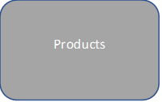

Productvariations

Customers

Orders

Orderitem