# 实验五：单工厂模式

### (1) 单例模式（必做80分）

建立一个界面，不管创建多少次主席，都只能创建一个“毛泽东”对象，并验证获取的主席都是“毛泽东”。

#### 1.1 UML图

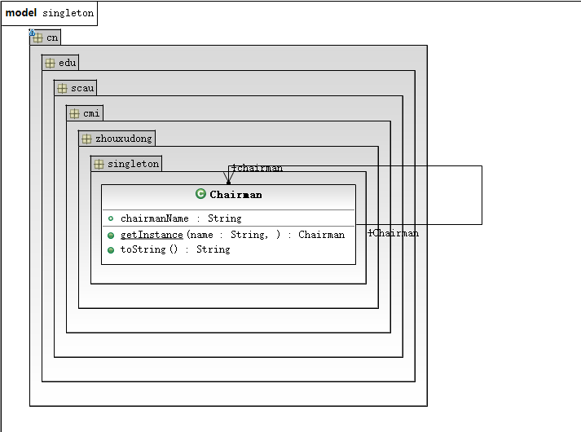

#### 1.2 代码

Chairman类

package cn.edu.scau.cmi.zhouxudong.singleton;

public class Chairman {

private static Chairman chairman;

private String chairmanName =null;

private Chairman() {

}

private Chairman(String name){

chairmanName = name;

}

public static Chairman getInstance(String name) {

if (chairman == null && !name.equals(null)) {

chairman = new Chairman(name);

return chairman;

} else

return chairman;

}

@Override

public String toString() {

// TODO Auto-generated method stub

return "我是"+chairmanName +"主席";

}

}

SingletonClient类

package cn.edu.scau.cmi.zhouxudong.client;

import cn.edu.scau.cmi.zhouxudong.singleton.Chairman;

public class SingletonClient {

public static void main(String[] args) {

System.out.println(Chairman.getInstance("毛泽东").toString());

System.out.println(Chairman.getInstance("邓小平").toString());

System.out.println(Chairman.getInstance("江泽民").toString());

System.out.println(Chairman.getInstance("胡锦涛").toString());

System.out.println(Chairman.getInstance("习近平").toString());

}

}

# 程序运行截图

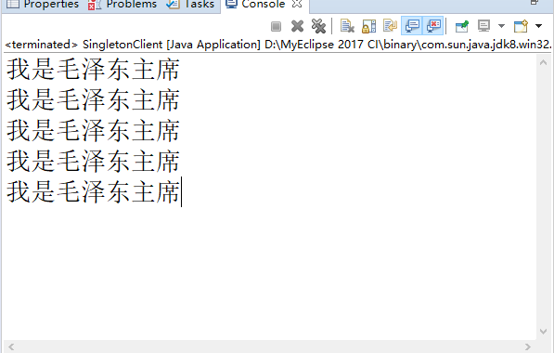

### (2) 多例模式（选做20分）

使用单例模式的思想实现多例模式，确保系统中某个类的对象只能存在有限个，如中华人民共和国十大元帅，设计并实现。

#### 2.1 UML图

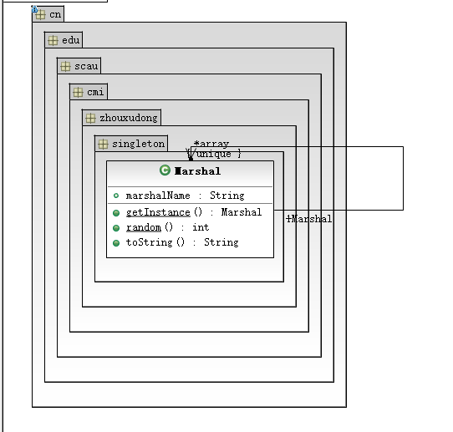

#### 2.2 代码

Marshal类

package cn.edu.scau.cmi.zhouxudong.singleton;

import java.util.Random;

public class Marshal {

private String marshalName = null;

private Marshal(String name){marshalName = name;}

private Marshal(){}

private static Marshal[] array ={

new Marshal("朱德"),new Marshal("彭德怀"),new Marshal("林彪"),new Marshal("罗荣桓"),new Marshal("叶剑英"),

new Marshal("刘伯承"),new Marshal("贺龙"),new Marshal("陈毅"),new Marshal("徐向前"),new Marshal("聂荣臻")

};

public static Marshal getInstance(){

return array[random()];

}

public static int random(){

Random random = new Random();

int value = Math.abs(random.nextInt());

value =value%10;

return value;

}

@Override

public String toString() {

// TODO Auto-generated method stub

return "我是"+marshalName+"元帅";

}

}

MultionClient类

package cn.edu.scau.cmi.zhouxudong.client;

import cn.edu.scau.cmi.zhouxudong.singleton.Marshal;

public class MultionClient {

public static void main(String args[]){

System.out.println(Marshal.getInstance());

System.out.println(Marshal.getInstance());

System.out.println(Marshal.getInstance());

System.out.println(Marshal.getInstance());

System.out.println(Marshal.getInstance());

System.out.println(Marshal.getInstance());

System.out.println(Marshal.getInstance());

System.out.println(Marshal.getInstance());

System.out.println(Marshal.getInstance());

System.out.println(Marshal.getInstance());

System.out.println(Marshal.getInstance());

}

}

# 运行截图

