**6种stakeholders，从他们的视角，关注的系统的重点是什么，在系统开发中扮演的角色**

system owner：信息系统的出资人

system user：使用系统或者受系统影响

system analysis：分析问题，如何实现业务需求

system designer：business 需求 —> 技术需求 technical solution

system builder：建造系统的构件 components 和system designer可能是同一个人

IT vender and consultant：外部顾问

**3个building block : DATA PROCESS INTERFACE**

·知识(Knowledge)—用于生成有用信息的原始材料。

·过程(Process )—实现企业任务的活动(包括管理)。

·通信(Communication)—系统如何同用户和其他信息系统交互。

**从6个stakeholder的视角，他们关注这3个buinding block的什么地方**

|  |  |  |  |
| --- | --- | --- | --- |
|  | Data | Processes | Communication |
| System owner | business knowledge | Business functions | Business location |
| system user | Data requirements | Process requirements | communication requirements |
| system designer | database schema | application schema | network architecture |
| system builder | database program  /DBMS | Application programs | networking software |

**系统分析师的职责、需要的技能**

信息技术工作知识

计算机编程经验和专业知识

一般业务知识

解决问题的技能

人际沟通技能

人际关系技能

灵活性和适应性

品格和道德

系统分析和设计技能

**data和information的区别**

֍ Data are raw facts（未经处理的原始事实） about the organization（通常指的是企业或集团） and its business transactions（商务交易）. Most data items have little meaning and use by themselves.Information：

֍ Information is data that has been refined（被精制的） and organized by processing and purposeful intelligence. The latter, purposeful intelligence（目的明确的智能）, is crucial to the definition—People provide the purpose and the intelligence that produces true information.

**front – and back-office的区别（前台系统和后台系统）**

Front-office information systems support business functions that reach out to customers (or constituents （委托人）).

面向客户，主要支持与客户直接交互的企业功能，如市场信息系统、销售信息系统、客户信息系统等。

Back-office information systems support internal business operations and interact with suppliers (of materials, equipment, supplies, and services).

后台系统：系统内部商业运行，主要处理与内部运营和管理相关的任务，如人力资源信息系统、财务信息系统、生产信息系统、库存信息系统等。

**5类不同系统，稍微了解每一类系统的特点**

****交易处理系统**** transaction processing systems

交易处理系统是信息系统应用程序，****可捕获和处理有关业务交易的数据****（切断业务使命的事件）。航班预定，银行存取款，课程注册，订单处理等。

****管理信息系统MIS**** management information systems

是一种信息系统应用，提供面向管理的报告。

管理信息系统（MIS）是一种提供面向管理的报告的信息系统应用程序。这些报告通常按照预先确定的时间表生成，并以预先安排的格式出现。输出是以报表为主。

例如预算预测与分析、生产调度。

****决策支持系统**** decision support systems

为用户提供面向决策的信息：计算机分析，给人提供决策方案。计算机自动模拟实现各个选择的后果。

****专家系统**** expert systems

需要专业知识作为数据储备，需要大量知识。专家系统是一种程序化决策信息系统，它捕捉并再现问题解决专家或决策者的知识和专长，然后模拟专家的 “思维 ”或 “行动”。

****办公自动化系统**** Office automation systems

改善工作流程和员工之间的沟通，无论这些员工是否在同一办公室工作

关键是****工作流转 work flow****

**介绍系统开发的基本原则**

**CMM**

⚫Level 1—Initial（初始级）: System development projects follow no

process.

⚫ Level2—Repeatable（可重复级）: Project management

processes and practices are established to track project costs, schedules, and functionality.

⚫ Level 3—Defined（已定义级）: A standard system development process (sometimes called a “methodology”) is purchased or developed, and integrated throughout the information systems/services unit of the organization. The process is stable, predictable and repeatable.

⚫ Level 4—Managed（已管理级）: Measurable goals for quality and productivity are established.

⚫ Level 5—Optimizing（优化级）: The standardized system development process is continuously monitored and improved based on measures and data analysis established in Level 4.

**系统开发的生存周期**

divides the life of an information system into two stages, systems development and systems operation and support.

**系统开发的8条基本原则**

֍ Get the owners and users involved. (以人为本)

֍ Use a problem-solving approach. (有理有据)

֍ Establish phases and activities. (分步实施)

֍ Establish standards. (建立标准)

֍ Justify systems as capital investments. (最优决策)

֍ Don’t be afraid to cancel or revise scope. (悬崖勒马)

֍ Divide and conquer. (分而治之)

֍ Design systems for growth and change. (高瞻远瞩)

**FAST框架(Framework for the Application of Systems Techniques)**

* Preliminary Investigation****初始研究阶段****
* Problem Analysis****问题分析阶段****
* Requirements Analysis****需求分析阶段****
* Decision Analysis****决策分析阶段****
* Design****系统设计阶段****
* Construction****构造和测试****；
* Implementation****安装和发布****
* Operation and Support Stage****系统支持和持续改进阶段****

**了解PIECES框架这6个单词的内涵**

* P the need to improve performance（性能）
* I the need to improve information（信息） (and data)
* E the need to improve economics（经济性）, control costs, or increase
* profits
* C the need to improve control（可控制程度） or security
* E the need to improve efficiency（效率） of people and processesS the need to improve service（服务质量） to customers, suppliers, partners, employees, etc.

**系统开发的不同的路线、方法，一些模型。典型的比如生存周期模型，理解**

* Model-Driven Development 模型驱动开发

-Structured systems analysis and design — process-centered

-Information engineering (IE) — data-centered, process-sensitive

-Object-oriented analysis and design (OOAD) — object-centered

* Rapid Application Development 快速应用开发 (RAD)
* Commercial Off-The-Shelf 商用现货 (COTS) software

**了解CASE、ADE是什么**

* Computer-Aided Systems Engineering 计算机辅助系统工程
* Application Development Environments 应用开发环境 (ADEs)

**项目开发失败的原因**

֍ Failure to establish upper-management commitment（高层管理义务）to the project – 自觉或不自觉地改变了项目的义务

֍ Lack of organization’s commitment to the system development methodology – 组织或企业没有将应有的义务赋予开发过程

֍ Taking shortcuts through or around the system development methodology 在时间、预算或人员技能等方面出了问题时，就在开发过程上偷工减料

֍ Poor expectations management – 对项目的期望随着时间而改变，以至于范围和/或技术特性超出了时间和预算能够支撑的程度

֍ Premature commitment to a fixed budget and schedule – 没有经过充分的分析就草率地确定了预算和时间表

֍ Poor estimating techniques – 没有采用科学方法来估计项目指标

֍ Overoptimism – 对项目中出现的问题过分乐观，总认为以后能够解决而不及时解决

֍ The mythical man-month – 认为有了问题时增加人力就可以解决，实际上人多不一定好办事

֍ Inadequate people management skills – 责任不明确，按管理者的主观意愿行事

֍ Failure to adapt to business change – 项目适应不了业务所发生的变化

֍ Insufficient resources – 对资源要求估计不足

֍ Failure to “manage to the plan” – 许多因素使得管理者自觉或不自觉地偏离了原来的项目计划

**分清楚什么是project management，什么是process management**

֍ Project management 项目管理 is the process of scoping, planning, staffing, organizing, directing, and controlling the development of an acceptable system at a minimum cost within a specified time frame.

（在规定的时间框架内以最低成本确定、规划、人员配备、组织、指导和控制一个可接受的系统开发的过程。）

֍ Process management 过程管理 is an ongoing activity that documents, manages the use of, and improves an organization’s chosen methodology (the “process”) for system development. Process management is concerned with the activities, deliverables, and quality standards to be applied to all projects.

（一种正在进行的活动，它记录、管理使用和改进一个组织的系统开发所选择的方法（“过程”）。过程管理涉及到适用于所有项目的活动、可交付成果和质量标准。）

**项目管理的8个功能（在项目管理中要做的8件事情）**

֍ Scoping 确定项目的边界

֍ Planning认定需要完成的任务

֍ Estimating评估所需资源

֍ Scheduling任务进度安排

֍ Organizing确保人员理解角色和职责

֍ Directing指挥项目组成员的活动

֍ Controlling控制项目开发过程

֍ Closing总结经验和教训

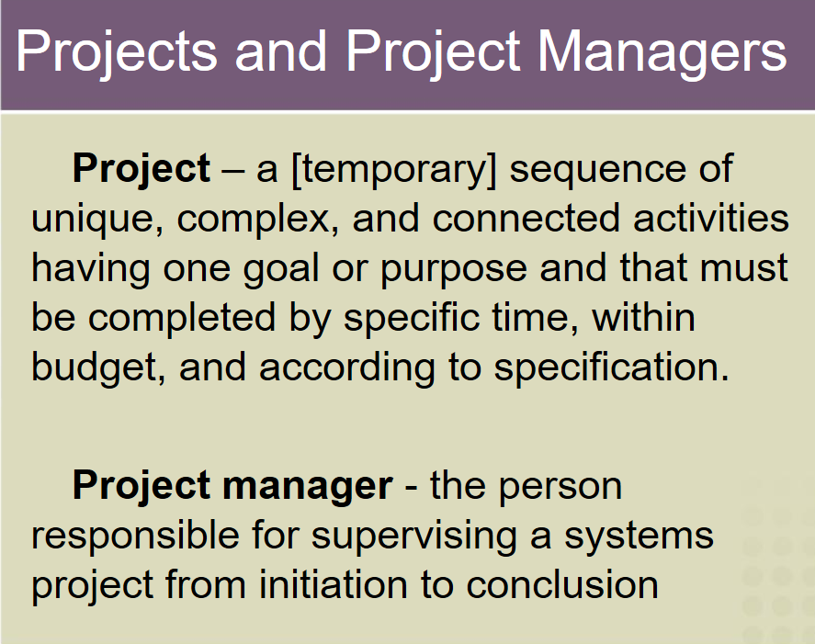

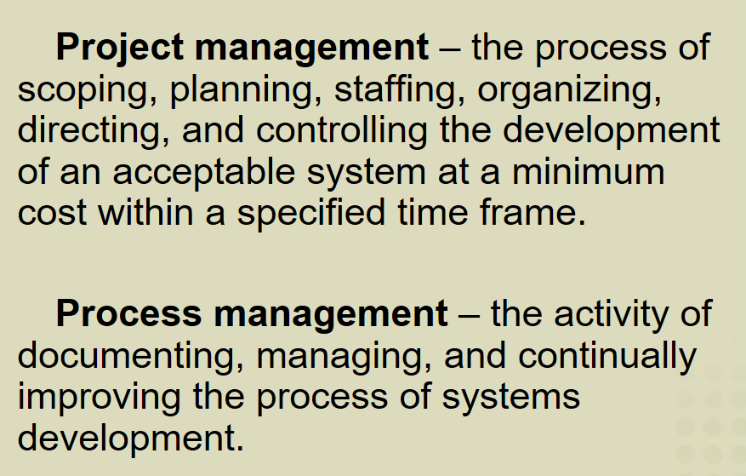

**必须会画PERT图 Gantt图，必须知道这两个图的作用。**

Gantt图可以表达出**每一个任务的持续时间**，并且可以非常清晰的表达出**任务之间的重叠关系**。（Overlap relationship.）

PERT图是一个基于网络的图，它能够表达的是**不同任务之间的依赖（Dependencies between the different tasks）**关系，所以在PERT图上要做关键路径分析。

**决策分析中牵扯到可行性分析**

⚫ Technical feasibility（技术可行性）.

⚫ Operational feasibility（操作可行性）. Will the solution fulfill the users’ requirements? To what degree? How will the solution change the users’ work environment? How do users feel about such a solution?

⚫ Economic feasibility（经济可行性）.

⚫ Schedule feasibility（进度可行性）.

**系统分析阶段要做的非常非常重要的事情——需求分析**

需求分为两大类：功能需求、非功能需求

֍ A functional requirement 功能性需求 is a function（功能） or feature（特性） that must be included in an information system in order to satisfy the business need and be acceptable to the users.

֍ A nonfunctional requirement 非功能需求 is a description of the features（特性）, characteristics（特征）, and attributes（属性） of the system as well as any constraints（约束） that may limit the boundaries of the proposed solution.

非功能性需求用PIECES框架描述。

Ishikawa(fishbone)(鱼骨图)，用来做问题分析，了解基本概念，不用会画。

use case，这是用来描述功能需求的一种方式。

**7种非常重要的发现需求的方法，不用死记硬背，要去理解，能用自己的话说出来意思。**

⚫ Sampling of existing documentation, forms, and databases.

⚫ Research and site visits.

⚫ Observation of the work environment.

⚫ Questionnaires.

⚫ Interviews.

⚫ Prototyping.

⚫ Joint requirements planning (JRP).

⚫对现有文档、表单和数据库的抽样。

⚫研究和现场访问。

⚫对工作环境的观察。

⚫问卷。

⚫采访。

⚫原型。

⚫联合需求规划（JRP）。

**数据建模和分析**

描述系统对数据有哪些要求 正式给出了model的概念 在本书里介绍了三种方法：结构化的 信息工程的 面向对象的，这三种方法都是模型驱动的，也就是说他们用来表达需求、设计的，最重要的工具就是model。

**Model分两种：logical physical。**

系统分析阶段使用的所有模型都是logical model，在设计阶段使用physical model。Logical model表达的是有什么(what)，physical model 表达的是怎么做(how)。

用结构化的方法绘制的模型——**数据流图（DFD）一定要会画。根据需求背景的描述，绘制出DFD是必须要掌握的，structured english（结构化英语）不考。**DFD不能代表结构化分析的所有结果，DFD+数据字典才可以。

**系统分析方法，需要理解**

֍ Model-driven（模型驱动的）Analysis Approaches:

⚫ Structured Analysis

⚫ Information Engineering

⚫ Object-oriented Analysis

֍ Accelerated（加速的）Analysis Approaches:

⚫ Discovery Prototyping

⚫ Rapid Architecture Analysis

**系统设计方法**

֍ Model-Driven

⚫ Modern structured design

⚫ Information engineering

⚫ Prototyping

⚫ Object-oriented design

֍ JAD (Joint Application Development)

֍ RAD (Rapid application development)

Modern Structured Design is a **process-oriented** technique for breaking up a large program into **a hierarchy of modules** that result in a computer program that is easier to implement and maintain (change). Synonyms (although technically inaccurate) are **top-down program design and structured programming**.

Information Engineering is a model-driven and **data-centered,** but process-sensitive technique to plan, analyze, and design information systems. The primary tool of IE is a data model diagram.

The prototyping approach is an **iterative process** involving a close working relationship between the designer and the users.

Object-oriented design is the newest design strategy and is an extension of object-oriented analysis. Object-Oriented Design (OOD) techniques are used to refine the object requirements definitions identified earlier during analysis, and to define design specific objects.

Rapid Application Development (RAD) is the merger of various structured techniques (especially the data-driven information engineering) with prototyping techniques and joint application development techniques to accelerate systems development.

Joint Application Development (JAD) is a technique that complements other systems analysis and design techniques by emphasizing participative development among system owners, users, designers, and builders.

**系统架构：**集中的（不用管这个）、分布式的

将系统划分成5层，这5层在分布的时候，有5种方式，就形成了不同的体系结构的模式，比较经典的是c/s(2层、3层) 、b/s。需要搞清楚这5层是哪5层——数据、数据操作、应用逻辑、显示逻辑、显示层，每一层是干什么的，在分布的时候，这些层怎么分就形成了不同的分布式系统的架构，怎么把一个logical的DFD转换成physical的DFD。

Presentation layer—the user interface

Presentation logic layer—such as input editing

Application logic layer—the business rules, policies, and procedures

Data manipulation layer—to store and retrieve data to and from the database

Data layer—the actual business data

**输出种类：**internal external turnaround

֍ Internal outputs are intended for the internal system owners and system users within an organization.

⚫ Detailed reports present information with little or no filtering.

⚫ Summary reports categorize information for managers who do not want to wade through details. Increasingly presented in graphical formats using charts.

⚫ Exception reports filter detailed information before presenting it. Only include exceptions to some condition or standard.

֍ External outputs leave an organization.

⚫ Intended for customers, suppliers, partners, or regulatory agencies.

⚫ Turnaround（回转）documents are external outputs that eventually re-enter the system as inputs

**输出设计时的基本原则**

֍ Outputs should be simple to read and interpret.

֍ The timing of outputs is important.

֍ The distribution of (or access to) outputs must be sufficient to assist all relevant users.

**知道不同控件能用来解决什么输入就行**

֍ Data capture is the identification and acquisition of new data

(at its source).

in terms of data that describe those transactions.

֍ Data entry is the process of translating the source data or

document (above) into a computer readable format.

֍ Data processing is all processing that occurs on the data after it

is input from a machine readable form.

⚫ In batch processing, the entered data is collected into files called

batches and processed as a complete batch.

⚫ In on-line processing, the captured data is processed immediately

⚫ In remote batch processing, data is entered and edited on-line, but

collected into batches for subsequent processing.

**控件**

Text boxes 、Radio buttons、Check boxes、List boxes 、Drop down lists、Combination boxes 、Spin boxes、Button、Drop down calendars、Slider（滑块） edit controls 、Masked edit controls 、Ellipsis controls、Alternate numerical spinners、Internet hyperlink、Check list boxes、Check tree boxes

**了解UI设计的基本原则**

**OO概念比如什么是类、对象、方法、继承、多态等等**

**一些参数**

* Inheritance means that methods and/or attributes defined in an object class can be inherited or reused by another object class.
* Generalization/specialization is a technique wherein the attributes and behaviors that are common to several types of object classes are grouped into their own class, called a supertype. The attributes and methods of the supertype object class are then inherited by those object classes.
* Multiplicity（重复度） defines how many instances of one object/class can be associated with one instance of another object/class.
* Cardinality（基数） defines the minimum and maximum number of occurrences of one entity that may be related to a single occurrence of the other entity.
* Polymorphism means “many forms.” Applied to object-oriented techniques, it means that a behavior may be completed differently for different objects/classes.

**建模** UML 两个图：**use case图 、类图 必考。**

**可能也考状态图、活动图，这些图的基础概念得知道，比如干什么事要选什么模型、主要构成元素是什么、每个元素的内涵是什么、这个图是对系统的哪些内容建模的。**

**֍ Use Case diagram（用例图）outer system & user**

描述参与者（Actor）与用例以及用例与用例之间关系

**֍ Class diagram（类图）static structure**

描述类、接口、协作以及它们之间关系的图，用来显示系统中各个类的静态结构

**֍ Object diagram（对象图）valued snapshot**

参与交互的各个对象在交互过程中某一时刻的状态，是某一时间上系统的快照

**֍ Sequence diagram（序列图）interaction**

描述了对象之间传递消息的时间顺序，它用来表示用例的行为顺序

**֍ Collaboration diagram（协同图） net structure**

强调的是发送和接收消息的对象之间的组织结构，使用协作图来说明系统的动态情况，描述的是对象间的交互过程及对象间的关联关系。。

**֍ State diagram（状态图）state transition**

描述一个实体基于事件反应的动态行为，显示了该实体如何根据当前所处的状态对不同的事件做出反应，通过建立对象的生存周期模型来描述对象随时间变化的动态行为.

**֍ Activity diagram（活动图）perform result**

它描述活动的顺序，展现从一个活动到另一个活动的控制流,活动图在本质上是一种流程图

**֍ Component diagram（组件图） modules**

组件图本质上是类图，它们关注系统的组件，这些组件通常用于对系统的静态实现视图进行建模

**֍ Deployment diagram（部署图） physical structure**

是用来显示系统中软件和硬件的物理架构

**entity object interface object control object**

得知道他们是什么，用来刻画什么样的对象的职责。也需要UML模型。

֍ The objects that represent actual data within the business domain in which the user is interested in storing are called entity objects.

֍ Objects that represent a means through which the user will interface with the system are called interface objects.

֍ Objects that hold application or business rule logic are called control objects.

**用例描述表格**

