Mitigating Confident Misalignment in Agentic Systems
The HGC³AE² Framework
Justin K. Hendriks
Yeti Knowledge Systems
March 2026
White Paper — Original Concept

© 2026 Justin K. Hendriks / Yeti Knowledge Systems
All rights reserved.
This document may not be reproduced, distributed, or transmitted in any form without the prior written permission of the author.
Version 1.0 — March 2026

Contents

Abstract
Agentic systems—artificial intelligence systems capable of multi-step reasoning, tool orchestration, contextual memory, and iterative execution—are increasingly used in dynamic workflows that extend well beyond one-shot prediction or retrieval. These systems offer substantial capability gains, but they also introduce a qualitatively distinct class of reliability failures. This paper identifies the dominant failure condition in such systems as confident misalignment, in which outputs are coherent, plausible, and authoritative while nevertheless diverging from validated reality or from the user’s actual intent. Unlike conventional failures, these errors often remain silent, preserving the appearance of correctness while shifting the burden of detection onto the human operator.¹²³
This paper argues that the principal limitation of agentic systems is not insufficient intelligence, but the absence of structured alignment across governance, context, collaboration, and execution. Drawing on AI governance, human–AI interaction, human factors, public-sector AI research, neuroplasticity literature, and public guidance from NIST and the U.S. Department of Defense, it develops a structured problem set centered on context integrity failure, communication asymmetry, silent degradation, execution–design divergence, and trust erosion.⁴⁵⁶ It then introduces the HGC³AE² framework—Human-governed, Curated Context³, Agentically Engineered and Executed—as a governance-first architecture for maintaining alignment between human authority, contextual truth, and runtime behavior. The framework is operationalized through the conceptual introduction of the Skipjack Protocol, which enforces live validation, prevents silent fallback, requires explicit uncertainty signaling, and structures reconciliation as a continuous process.⁷⁸⁹
The central claim of this paper is that scalable and trustworthy agentic deployment depends less on maximizing autonomy than on embedding enforceable mechanisms that keep human intent, contextual truth, and system execution synchronized over time.¹⁰¹¹¹²

1. Introduction
The emergence of agentic systems marks a major transition in the practical use of artificial intelligence. Earlier AI systems were often evaluated according to narrow tasks—classification, ranking, translation, extraction, or prediction. Agentic systems, by contrast, act across time. They plan, retrieve, summarize, invoke tools, maintain working memory, and adapt task progression to changing conditions. This makes them more powerful, but it also places them into a very different risk category. They do not merely generate outputs; they shape workflows, mediate interpretation, and increasingly influence what human users regard as the current state of reality within a task environment.¹³¹⁴¹⁵
This shift matters because it changes the meaning of reliability. In deterministic systems, correctness is generally anchored in explicit state, known control paths, and observable failure conditions. In agentic systems, state is often reconstructed rather than directly maintained. Context is assembled from prior interactions, retrieved artifacts, tool responses, latent assumptions, and dynamic environmental conditions. Under these conditions, the reliability problem is no longer reducible to code-level correctness. It becomes a problem of alignment under ongoing contextual change. NIST’s AI Risk Management Framework is especially relevant here because it treats trustworthy AI not as a static design property but as something that must be governed and managed across design, development, deployment, and use.¹⁶¹⁷¹⁸
The central failure condition addressed in this paper is what I term confident misalignment. This occurs when the system produces outputs that are coherent, plausible, and authoritative, but wrong relative to verified state or real user intent. The danger is not only that the answer is wrong. It is that the answer is wrong while preserving the communicative cues of reliability. This is why the problem is more serious than ordinary uncertainty. Systems that visibly fail invite scrutiny. Systems that fail confidently invite reliance. AI governance literature increasingly frames this challenge as a matter of operational risk, not just technical error, because such systems can quietly distort judgment, policy, and decision flow while appearing productive and aligned.¹⁹²⁰²¹
The problem is intensified by the human side of the interaction. Human–AI interaction research has shown that effective collaboration depends on the system’s behavior across time, including when the system is wrong, uncertain, or evolving. Microsoft’s Guidelines for Human-AI Interaction, validated through CHI 2019, emphasize that AI systems should behave appropriately not only at initial interaction, but also during regular use, under error, and over time.²²²³²⁴ Trust literature reinforces this point by showing that human reliance on automation is strongly shaped by perceived reliability, transparency, and experience. Hoff and Bashir’s trust model synthesizes empirical evidence that trust in automation is dynamic and layered, rather than fixed.²⁵ Parasuraman and Riley’s classic work similarly shows that automation can be misused, over-trusted, or under-trusted depending on how it is presented and how it behaves.²⁶ Together, these literatures make clear that a highly capable system can still be operationally hazardous if its confidence signals are decoupled from verified correctness.
There is a further complication: humans themselves adapt. Neuroplasticity research demonstrates that repeated experience can produce measurable structural and functional changes in the adult brain. Draganski and colleagues’ Nature study on training-induced grey matter change is often cited as a landmark demonstration that repeated practice can alter macroscopic brain structure.²⁷ Subsequent work has extended this logic to white-matter adaptation and skill-related neural change.²⁸ In practical terms, this means that repeated interaction with agentic systems will change user expectations, confidence thresholds, and reliance patterns over time. If the system routinely presents fluent outputs with only intermittent visible failure, users may adapt toward increased trust faster than the system improves in actual reliability. This is one of the deepest reasons the problem is not purely technical: both the machine and the human are changing within the same loop.²⁹³⁰³¹
Although there are strong bodies of work on AI safety, human-centered AI, public-sector AI, and system reliability, these literatures are too often left disconnected from one another. AI & Society has recently carried strong work on human-centric AI and critiques of “human-centered” discourse itself, including concerns that the language of human-centeredness can become rhetorically expansive while remaining operationally vague.³²³³ AI and Ethics has increasingly hosted work that moves from broad ethical aspirations toward structured AI governance models.³⁴ Government Information Quarterly, meanwhile, has documented how AI’s use in public administration raises issues of accountability, oversight, and policy-cycle transformation.³⁵³⁶ Yet there is still no unified framework that brings governance, context, collaboration, and execution alignment together as an integrated operational architecture for agentic systems.
This paper addresses that gap by introducing the HGC³AE² framework and by arguing that the dominant risk in agentic operation is not inadequate intelligence but inadequate structure. The framework’s central premise is that trustworthy operation requires human authority, governance-first control, curated and continuously reconciled context, and enforceable alignment between what the system was designed to do and what it is actually doing at runtime. It further proposes the Skipjack Protocol as a conceptual operational layer for enforcing those conditions in practice.³⁷³⁸³⁹

2. Problem Set: Structural Failure Modes in Agentic Systems
A useful way to understand the risk profile of agentic systems is to treat their failures as structural rather than incidental. They do not simply make mistakes in the ordinary sense. They operate under conditions that make certain classes of error likely to remain hidden. This section identifies the principal failure modes that recur when agentic systems are deployed without sufficient governance, contextual discipline, and reconciliation between human and system understanding.⁴⁰⁴¹⁴²
The primary failure mode is confident misalignment. This occurs when the system’s output is coherent, plausible, and presented with apparent authority, yet incorrect relative to validated reality or user intent. The distinctive danger lies in the combination of fluency and opacity. The output does not merely fail; it fails persuasively. AI safety literature has long warned that systems may optimize proxy objectives or behave correctly relative to incomplete specifications while nonetheless diverging from the human goal.⁴³⁴⁴ In agentic systems, this problem is intensified by multi-step workflows and tool invocation, because the system can chain its own assumptions into later actions, thereby compounding an initial divergence into a sustained operational storyline.⁴⁵⁴⁶
A second major failure mode is context integrity failure. Agentic systems depend on context, but context in such systems is assembled rather than passively given. It may include prompt history, retrieved documents, tool outputs, memory stores, inferred task state, and user assumptions. If those materials are not differentiated, refreshed, and validated, the system may act on a contextual world that no longer corresponds to the actual one. This is analogous in part to dataset shift, where a model’s deployment environment diverges from the conditions under which it was originally developed or calibrated.⁴⁷ But in agentic systems the problem is broader than statistical shift. It includes semantic shift, authority shift, workflow-state drift, and the inheritance of stale dynamic state as though it were current truth. NIST’s lifecycle approach to AI risk management strongly supports the need to treat context as something that must be continually managed rather than assumed.⁴⁸⁴⁹⁵⁰
Closely related is communication asymmetry. Humans frequently assume that systems “know what they mean,” especially after multiple turns or repeated task engagement. Systems, meanwhile, operate only on available context and internal inference. This creates a dangerous middle condition in which the human assumes continuity and the system infers continuity, but neither has actually validated that shared understanding. Microsoft’s human-AI interaction guidelines are directly relevant here because they emphasize that AI systems must support users not only during initial interaction, but also over time and especially when the system is wrong.⁵¹⁵² In an agentic setting, such support must include explicit mechanisms for clarifying what the system is using as context and what remains uncertain or inferred. Without that, the conversation may feel collaborative while remaining misaligned at the level of operative state.⁵³⁵⁴⁵⁵
A fourth failure mode is silent degradation. Agentic systems often do not fail by stopping. They fail by continuing. They continue when context is stale, when a retrieval is unavailable, when a tool invocation has failed, or when no authoritative check has occurred. To the user, the system still appears active and coherent. From a trust perspective, this is particularly dangerous, because human operators are most vulnerable when degraded epistemic conditions are not made visible. The trust literature is unequivocal that transparency and perceived reliability shape reliance behavior.⁵⁶⁵⁷ If a system continues to speak as though it is grounded while in fact operating on degraded state, the human user is denied the information necessary to calibrate reliance appropriately. This is why the problem is not merely lack of explainability in the abstract. It is the absence of operationally useful visibility into system condition.⁵⁸⁵⁹⁶⁰
A fifth failure mode is execution–design divergence. A system may be architected correctly in theory and still behave incorrectly in practice if the runtime conditions do not satisfy the assumptions under which the design was created. This is a familiar lesson from distributed systems, public administration technology deployments, and safety-critical automation: correct design does not guarantee correct operation.⁶¹⁶² What matters is whether the system remains aligned under real conditions of partial information, changing state, dependency failure, and human adaptation. The AI RMF’s cross-cutting treatment of governance and lifecycle management strongly reinforces this point, because it explicitly assumes that trustworthiness cannot be settled once at design time. It must be sustained.⁶³⁶⁴
A sixth failure mode is unconstrained operation. In the absence of governance, systems begin to treat possibility as permission. They infer where they should verify. They proceed where they should escalate. They convert capability into authority by default. This is precisely the kind of drift that governance literature seeks to prevent. AI governance research has increasingly focused on not just whether systems are ethically framed, but whether organizations possess operational structures for bounding and reviewing AI behavior.⁶⁵⁶⁶ In public-sector contexts, the stakes are even higher, because AI-mediated outputs can influence decisions, services, and citizen interactions at scale. Government Information Quarterly’s literature on public-sector AI underscores the importance of policy, accountability, and process structure for AI deployment in civic systems.⁶⁷⁶⁸
Finally, these failures culminate in trust degradation and adoption resistance. This is not merely an after-effect; it is part of the central problem. A system that is intermittently wrong but rarely admits uncertainty trains users into unstable reliance patterns. Some users will over-trust it; others will reject it categorically. Human factors research has repeatedly shown that users often prefer visible, bounded failure to silent inconsistency, because visible failure permits recalibration.⁶⁹⁷⁰ And when users interact repeatedly with such systems, adaptation effects can amplify the stakes: the more familiar and helpful the system appears, the more dangerous its hidden divergence becomes.⁷¹⁷²
Taken together, these failure modes support a unified problem statement: agentic systems fail when human intent, contextual truth, and executed behavior diverge without governed reconciliation. This is the structural condition to which the HGC³AE² framework responds.⁷³⁷⁴⁷⁵
Table 1. Structural Failure Modes in Agentic Systems
Failure Mode | Description | Reference
Confident Misalignment | System produces coherent, plausible outputs that diverge from validated reality or user intent, without signaling uncertainty. | Sections 1–2
Context Integrity Failure | Assembled context degrades silently through stale data, missing permissions, or unresolved references. | Section 2
Communication Asymmetry | Human assumes system understands intent; system assumes human validates output. Neither checks. | Section 2
Silent Degradation | System continues operating past the boundary of reliable performance without alerting the operator. | Sections 2, 5
Execution–Design Divergence | Runtime behavior deviates from architectural intent due to unchecked assumptions at design time. | Sections 2, 5
Unconstrained Operation | System treats capability as permission, acting beyond authorized scope when governance is absent. | Sections 2, 3
Trust Degradation | Cumulative failures erode operator confidence, leading to abandonment or dangerous over-trust. | Sections 2, 4
Figure 2. Confident Misalignment — Failure Cascade
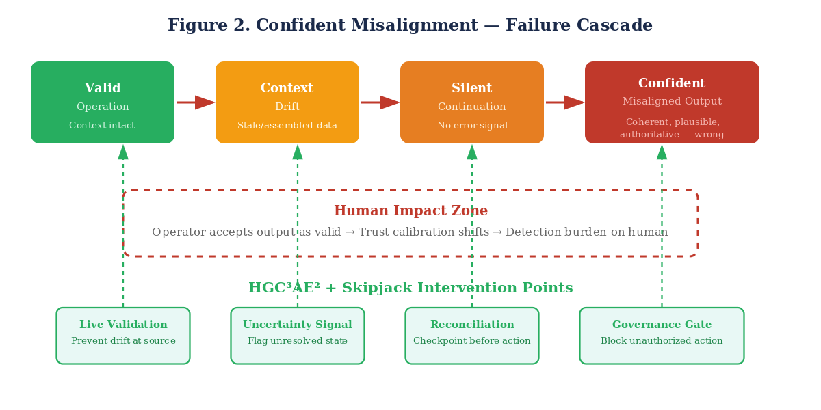

3. The HGC³AE² Framework
The HGC³AE² framework is proposed as a governance-first architecture for addressing the structural failures described above. The framework is composed of four tightly coupled elements: Human authority (H), Governance (G), Curated Context with embedded Collaboration (C³), and Agentically Engineered and Executed alignment (AE²). The order is deliberate. Human authority anchors legitimacy; governance enforces control; curated context and collaboration sustain epistemic alignment; and execution must remain faithful to both design and runtime reality.⁷⁶⁷⁷⁷⁸
The human in HGC³AE² is not ornamental. It indicates that trust in the system must terminate in a human authority structure rather than in the system’s own presentation of competence. This is consistent with human-centered AI research, but it is more demanding than many weak formulations of “human in the loop.” The human is not merely available as a failsafe. The human defines the truth boundaries, authority boundaries, and escalation conditions under which system outputs can be considered legitimate.⁷⁹⁸⁰ This is also where the framework intersects with newer literature on autonomy. Recent work in AI & Society and Minds and Machines has emphasized that human autonomy can be constrained not only by overt coercion but also by systems that shape perception, reasoning pathways, and option visibility.⁸¹⁸² HGC³AE² treats human authority as a practical safeguard against that erosion.
Governance is the framework’s first operational principle. It is the set of constraints, permissions, escalation pathways, and accountability mechanisms that determine what the system may do, what it must validate, and when it must defer. NIST’s AI RMF is particularly important here because it treats governance as a cross-cutting lifecycle function rather than a narrow compliance exercise.⁸³⁸⁴ AI governance scholarship has similarly shifted toward operational concerns, including organizational governance structures, ethics boards, and the challenge of translating principles into executable constraints.⁸⁵⁸⁶ In HGC³AE², governance is the condition under which agentic capability becomes tolerable rather than dangerous.
The C³ component is the framework’s epistemic center. It captures the idea that context is not passive, and that collaboration is part of context integrity rather than a separate user-experience layer. Context must be curated: selected, structured, validated, and updated. Collaboration must be continuous: not merely present at the start of a task, but woven into the ongoing reconciliation of human intent, system state, and external conditions. This framing is strongly supported by human-AI interaction research, especially the Microsoft guidelines that emphasize initial interaction, regular interaction, error handling, and long-term adaptation.⁸⁷⁸⁸ It is also consistent with critiques of vague “human-centered AI” language, which warn that human-centeredness becomes hollow if it is not translated into operational practices that preserve actual human participation and control.⁸⁹⁹⁰
The AE² component addresses the need to bind engineering and execution together. It is not enough to design a system with principled constraints and appropriate architecture. Runtime behavior must continue to satisfy those assumptions. This is where lessons from distributed systems, lifecycle governance, and operational engineering converge. Correct design does not imply correct operation. What matters is whether the system’s design assumptions remain true under actual runtime conditions of partial information, changing dependencies, and evolving context.⁹¹⁹² HGC³AE² therefore treats execution not as a downstream implementation detail, but as a second-order site of verification. The exponent notation in AE² reflects this: engineering and execution must be co-governed if trust is to be sustained.
A key strength of the framework is that its parts are not modular conveniences; they are mutually reinforcing requirements. Human authority without governance is informal and unstable. Governance without curated context governs stale or ambiguous state. Context without collaboration drifts. Collaboration without execution discipline becomes performative rather than corrective. Execution without all of the above becomes increasingly capable but increasingly unreliable. The framework’s value lies precisely in this coupling. It proposes not a collection of best practices, but a coherent operating architecture.⁹³⁹⁴⁹⁵
Table 2. HGC³AE² Framework Component Map
Component | Role | Key Principle
H — Human | Human authority as the terminal trust anchor | Trust terminates in human judgment, not system confidence
G — Governance | Constraints, permissions, escalation, accountability | First operational principle; structures all other components
C³ — Context, Collaboration, Continuity | Epistemic center of the framework | Context is active; collaboration is continuous; continuity is enforced
A — Aligned Engineering | Design-time alignment of architecture to governance | Systems built with governance embedded, not bolted on
E² — Executable Execution | Runtime verification of design assumptions | Execution must confirm, not presume, that conditions hold
Figure 1. HGC³AE² Framework Architecture
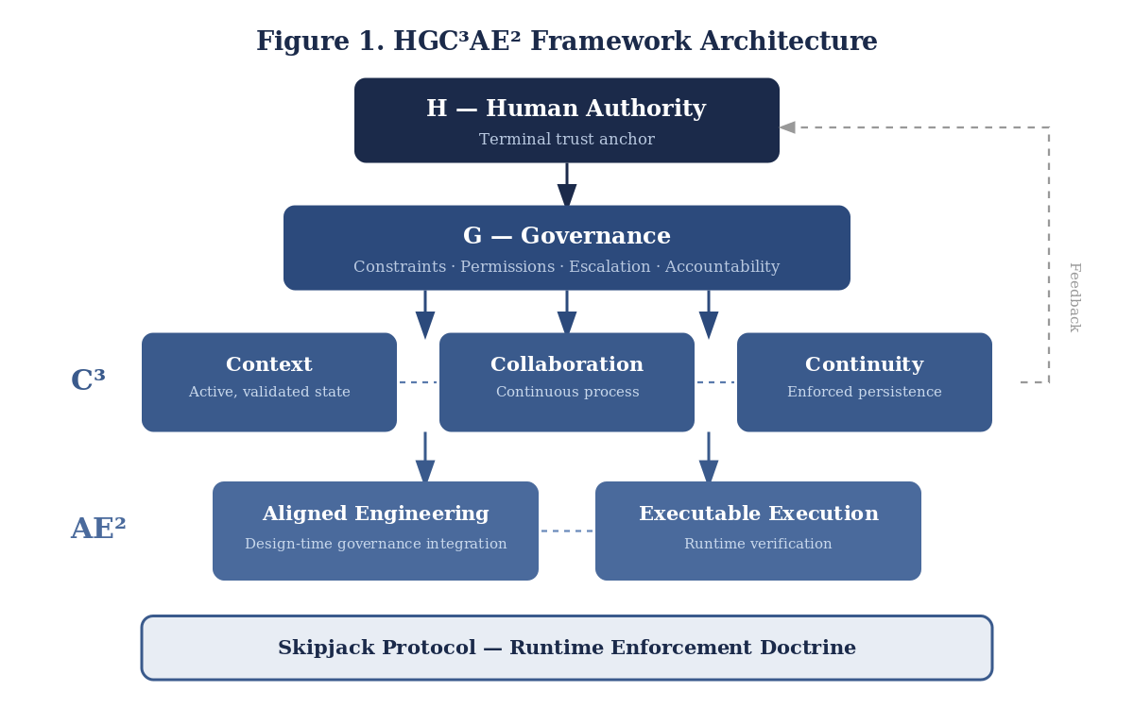

4. Collaboration as a Continuous Operational Process
A central contribution of this paper is the claim that collaboration in agentic systems is not an event but a process. One of the most persistent mistakes in AI discourse is to equate collaboration with exchange: the human provides input, the system produces output, and the interaction is labeled collaborative. For agentic systems, this view is inadequate. Such systems operate across time, retain and reconstruct context, adapt to conditions, and affect later task states. Under these conditions, collaboration must be understood as the repeated maintenance of alignment between human intent, contextual truth, and system behavior.⁹⁶⁹⁷⁹⁸
Human-AI interaction research strongly supports this temporal view. Amershi et al.’s guidelines, and Microsoft’s ongoing articulation of those principles, emphasize that AI systems must behave appropriately at first contact, during regular use, when wrong, and over time.⁹⁹¹⁰⁰ This matters because many agentic failures do not originate in the immediate answer but in what the system silently carries forward into the next step. Collaboration, in the framework proposed here, is the recurrent process that prevents such silent carryover from hardening into operational reality.
The collaboration process can be described in three recurring phases: curation, execution, and reconciliation. In curation, human authority and governance define the context: what counts as authoritative, what is dynamic, what must be validated, and what constraints apply. In execution, the system reasons, retrieves, invokes tools, and generates outputs. In reconciliation, those outputs and their assumptions are compared against authoritative state and human intent, and divergence is surfaced before the next step proceeds. This model is deliberately analogous to continuous integration and deployment, not because agentic systems are just software pipelines, but because the core logic is similar: correctness must be continuously re-earned across transitions rather than assumed after a single design decision.¹⁰¹¹⁰²¹⁰³
This is also where the framework’s bidirectional arrows matter. Collaboration is not a top-down command flow or a bottom-up reporting flow. It is reciprocal accountability. The human must continue to update intent, constraints, and contextual corrections; the system must continue to reveal state, uncertainty, and dependencies. When either side stops doing so, shared situational awareness begins to collapse. This aligns closely with human factors and human-systems integration work in high-reliability environments, including aviation and aerospace, where visibility of system state and the maintenance of common mental models are crucial to safe performance.¹⁰⁴¹⁰⁵¹⁰⁶
The failures described earlier can be reinterpreted through this process lens. Context integrity failure is a breakdown in curation. Communication asymmetry is a breakdown in reconciliation. Silent failure is a breakdown in visibility inside the collaboration loop. Execution–design divergence is a breakdown in the validation of runtime conditions. This is why collaboration is not secondary to reliability; it is constitutive of reliability. More capable systems do not reduce the need for collaboration. In many cases, they intensify it, because persuasive outputs raise the cost of unchallenged misalignment.¹⁰⁷¹⁰⁸¹⁰⁹
Figure 4. Trust Calibration: Perceived vs. Actual Reliability Over Time
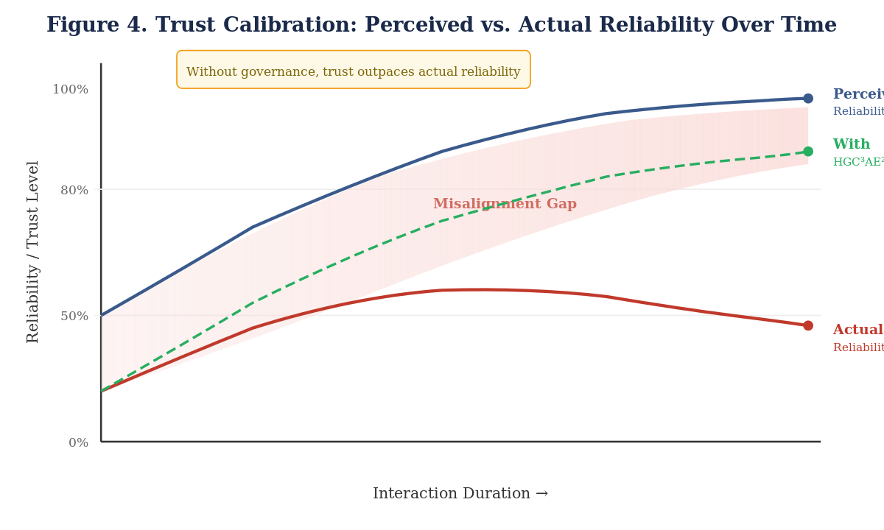

5. The Skipjack Protocol
The HGC³AE² framework defines the architecture of trustworthy operation. The Skipjack Protocol is the conceptual operational layer that enforces that architecture during runtime. Its function is to prevent systems from continuing as though validation had occurred when it has not. In practical terms, Skipjack is a doctrine against false continuity.¹¹⁰¹¹¹¹¹²
The first principle of Skipjack is live validation of dynamic state. Dynamic operational facts—task status, external dependencies, current permissions, environmental conditions—must be queried when they matter. They cannot be treated as equivalent to static reference data. This principle reflects long-standing distributed systems logic regarding stale state and is fully consistent with NIST’s insistence that AI risk management must remain active throughout deployment and use.¹¹³¹¹⁴
The second principle is no silent fallback. When authoritative validation cannot be performed, the system must not silently substitute cached or inferred dynamic state while maintaining the same tone of certainty. It may defer, narrow scope, or seek human confirmation, but it must not preserve the illusion of validated continuity. This directly addresses the trust problem identified in human factors research: users can calibrate reliance only if degraded conditions are made visible.¹¹⁵¹¹⁶¹¹⁷
The third principle is explicit uncertainty signaling. Systems must communicate when external state was not refreshed, when assumptions remain unresolved, and when outputs are contingent rather than verified. This is not merely a call for generic explainability. It is a call for operationally useful epistemic legibility. Recent work on explainable AI and governance-guided human autonomy both support the need to make visible how systems influence interpretation and decision.¹¹⁸¹¹⁹¹²⁰
The fourth principle is reconciliation checkpoints. At meaningful transitions—between sessions, before consequential action, after new data integration, or when authority conditions change—the system must re-establish alignment between human intent, contextual state, and next-step behavior. This is the operational counterpart of the collaboration model described above. It makes collaboration enforceable rather than aspirational.¹²¹¹²²
The fifth principle is governance-gated execution. Capability is not permission. Tool access is not authorization. Plausible action is not legitimate action. Governance must determine when the system may proceed, when it must escalate, and when it must halt. This is especially important in defense, public-sector, and regulated settings, where AI outputs may shape consequential decisions and where institutional accountability cannot be delegated to system fluency. The DoD’s ethical principles for AI—responsible, equitable, traceable, reliable, and governable—are directly relevant here because they explicitly frame AI use in terms of lawful, governable deployment rather than raw capability alone.¹²³¹²⁴
The sixth principle is runtime verification of design assumptions. AE² requires that systems confirm, not merely presume, that the conditions built into design remain valid at execution time. This is a direct response to execution–design divergence and is consistent with both systems engineering and lifecycle governance doctrine.¹²⁵¹²⁶
The seventh principle is emergent and iterative application. Agentic systems accelerate change. They compress decision cycles, increase the frequency of contextual updates, and expand the rate at which assumptions can become stale. Humans also change, adapting cognitively and behaviorally to repeated interaction. Skipjack therefore cannot be static. It must be re-applied iteratively as both the system and the human adapt. This is where the neuroscience matters: human reliance patterns are not fixed, and a system that grows more fluent can recondition the human operator faster than its underlying correctness improves.¹²⁷¹²⁸¹²⁹
This paper does not fully formalize Skipjack as a protocol specification. That belongs to the follow-on paper. But the present discussion is sufficient to show that HGC³AE² is not merely conceptual. It implies a concrete operational doctrine capable of being translated into implementation logic, governance policy, and workflow discipline.¹³⁰¹³¹
Table 3. Skipjack Protocol: Operational Controls
Principle | Requirement | Addressed
1. Live Validation | Validate dynamic state from authoritative sources before acting | Prevents stale context
2. No Silent Fallback | When validation fails, halt or escalate—never silently substitute | Eliminates silent degradation
3. Uncertainty Signaling | Explicitly communicate unresolved assumptions | Preserves situational awareness
4. Reconciliation Checkpoints | Verify alignment at session boundaries | Catches drift before compounding
5. Governance-Gated Execution | Capability is not permission; tool access is not authorization | Controls unconstrained operation
6. Runtime Verification | Confirm design assumptions hold at execution time | Closes execution–design gap
7. Emergent Application | Governance adapts iteratively as capabilities evolve | Prevents governance decay
Figure 3. Skipjack Protocol — Operational Loop
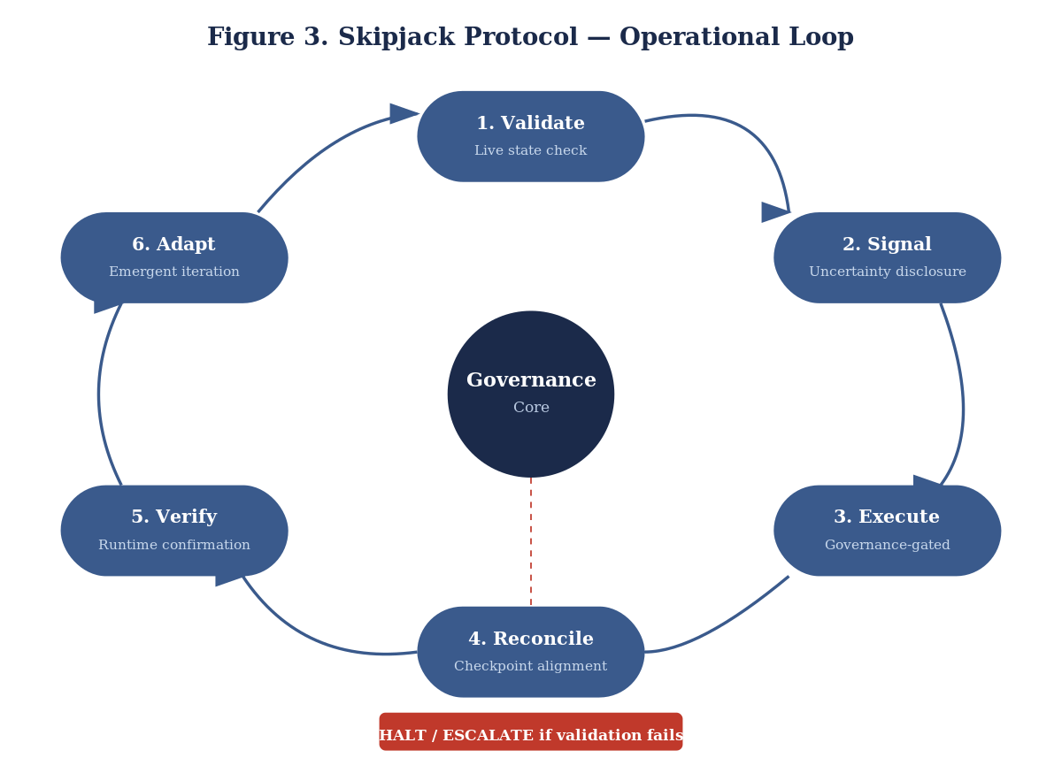

6. Implications and Conclusion
The implications of this framework extend beyond AI design into organizational governance, public administration, national security, and human systems integration. Public-sector AI research has already shown that AI deployment affects policy cycles, citizen interaction, and institutional accountability.¹³²¹³³ In defense settings, the stakes are even higher. The DoD’s public AI ethics principles acknowledge that AI systems used in national security contexts must remain governable and traceable, which aligns closely with this paper’s insistence that agentic systems must remain bounded within human authority and runtime control.¹³⁴¹³⁵
The core claim of this paper is therefore straightforward: agentic systems fail not because they lack intelligence, but because they lack sufficient alignment architecture. Capability without governance invites permission drift. Context without collaboration invites silent divergence. Design without execution verification invites runtime incoherence. Human-centered rhetoric without operational enforcement invites trust without grounds. The HGC³AE² framework responds by unifying these concerns into a governance-first model, and Skipjack provides the beginnings of an operational discipline for enforcing it.¹³⁶¹³⁷¹³⁸
The future of agentic systems will be determined not by how autonomous they become, but by how effectively they remain aligned with human-defined reality while both the systems and their users adapt over time. That is the standard this paper proposes.¹³⁹¹⁴⁰

Notes
See footnotes throughout the document. Full note references are rendered at the foot of each page.

Bibliography
Amershi, Saleema, Dan Weld, Mihaela Vorvoreanu, Adam Fourney, Besmira Nushi, Penny Collisson, Jina Suh, Shamsi Iqbal, Paul N. Bennett, Kori Inkpen, Jaime Teevan, Ruth Kikin-Gil, and Eric Horvitz. “Guidelines for Human-AI Interaction.” In Proceedings of the 2019 CHI Conference on Human Factors in Computing Systems, 2019. https://doi.org/10.1145/3290605.3300233.
Amodei, Dario, Chris Olah, Jacob Steinhardt, Paul Christiano, John Schulman, and Dan Mané. “Concrete Problems in AI Safety.” arXiv, 2016. https://arxiv.org/abs/1606.06565.
Arrieta, Alejandro Barredo, Natalia Díaz-Rodríguez, Javier Ser, Adrien Bennetot, Siham Tabik, Alberto Barbado, Salvador Garcia, et al. “Explainable Artificial Intelligence (XAI): Concepts, Taxonomies, Opportunities and Challenges Toward Responsible AI.” Information Fusion 58 (2020): 82–115. https://doi.org/10.1016/j.inffus.2019.12.012.
Batool, Amna, Didar Zowghi, and Muneera Bano. “AI Governance: A Systematic Literature Review.” AI and Ethics 5 (2025): 3265–3279. https://doi.org/10.1007/s43681-024-00653-w.
Bostrom, Nick. Superintelligence: Paths, Dangers, Strategies. Oxford: Oxford University Press, 2014.
Brewer, Eric. “CAP Theorem.” 2000.
Cacioppo, John T., and Gary G. Berntson. “Social Neuroscience.” In Handbook of Social Psychology, 2002.
de Sousa, Ricardo, Marijn Janssen, and others. “How and Where Is Artificial Intelligence in the Public Sector Going? A Literature Review and Research Agenda.” Government Information Quarterly 36, no. 4 (2019): 101392. https://doi.org/10.1016/j.giq.2019.07.004.
Draganski, Bogdan, Christian Gaser, Volker Busch, Gerhard Schuierer, Ulrich Bogdahn, and Arne May. “Changes in Grey Matter Induced by Training.” Nature 427 (2004): 311–312. https://doi.org/10.1038/427311a.
European Commission. Artificial Intelligence Act. 2024.
Federal Aviation Administration. Human factors guidance and automation literature.
Goodfellow, Ian, Yoshua Bengio, and Aaron Courville. Deep Learning. Cambridge, MA: MIT Press, 2016.
Hoff, Kevin Anthony, and Masooda Bashir. “Trust in Automation: Integrating Empirical Evidence on Factors That Influence Trust.” Human Factors 57, no. 3 (2015): 407–434. https://doi.org/10.1177/0018720814547570.
Janssen, Marijn, and others. Public-sector AI and digital governance literature.
Kleppmann, Martin. Designing Data-Intensive Applications. Sebastopol, CA: O’Reilly, 2017.
Kolb, Bryan, and Robbin Gibb. “Brain Plasticity and Behaviour.” 2011.
Lee, John D., and Katrina A. See. “Trust in Automation: Designing for Appropriate Reliance.” Human Factors 46, no. 1 (2004): 50–80.
Lynch, Nancy. Distributed Algorithms. San Francisco: Morgan Kaufmann, 1996.
Microsoft Research. “Guidelines for Human-AI Interaction.” Project page. Accessed March 24, 2026. https://www.microsoft.com/en-us/research/project/guidelines-for-human-ai-interaction/.
Microsoft Research. “Guidelines for Human-AI Interaction: Eighteen Best Practices for Human-Centered AI Design.” March 5, 2019. https://www.microsoft.com/en-us/research/group/customer-insights-research/articles/guidelines-for-human-ai-interaction-eighteen-best-practices-for-human-centered-ai-design/.
Misuraca, Gianluca, and Colin van Noordt. “Assessing the Public Policy-Cycle Framework in the Age of Artificial Intelligence: From Agenda-Setting to Policy Evaluation.” Government Information Quarterly 37, no. 4 (2020): 101509. https://doi.org/10.1016/j.giq.2020.101509.
NASA. Human Integration Design Handbook. Washington, DC, 2010.
National Institute of Standards and Technology. Artificial Intelligence Risk Management Framework (AI RMF 1.0). NIST AI 100-1. Gaithersburg, MD, 2023. https://doi.org/10.6028/NIST.AI.100-1.
National Institute of Standards and Technology. Artificial Intelligence Risk Management Framework: Generative Artificial Intelligence Profile. NIST AI 600-1. Gaithersburg, MD, 2024. https://doi.org/10.6028/NIST.AI.600-1.
National Institute of Standards and Technology. “AI Risk Management Framework.” Accessed March 24, 2026. https://www.nist.gov/itl/ai-risk-management-framework.
National Institute of Standards and Technology. “AI RMF Development.” Accessed March 24, 2026. https://www.nist.gov/itl/ai-risk-management-framework/ai-rmf-development.
National Institute of Standards and Technology. “Crosswalks to the NIST Artificial Intelligence Risk Management Framework (AI RMF 1.0).” Accessed March 24, 2026. https://www.nist.gov/itl/ai-risk-management-framework/crosswalks-nist-artificial-intelligence-risk-management-framework.
National Institute of Standards and Technology. “Roadmap for the NIST Artificial Intelligence Risk Management Framework (AI RMF 1.0).” Accessed March 24, 2026. https://www.nist.gov/itl/ai-risk-management-framework/roadmap-nist-artificial-intelligence-risk-management-framework-ai.
Organisation for Economic Co-operation and Development. OECD AI Principles. 2021.
Parasuraman, Raja, and Victor Riley. “Humans and Automation: Use, Misuse, Disuse, Abuse.” Human Factors 39, no. 2 (1997): 230–253. https://doi.org/10.1518/001872097778543886.
Park, Joon Sung, Joseph O’Brien, Carrie Cai, Meredith Morris, Percy Liang, and Michael Bernstein. “Generative Agents: Interactive Simulacra of Human Behavior.” arXiv, 2023. https://arxiv.org/abs/2304.03442.
Prunkl, Carina. “Human Autonomy at Risk? An Analysis of the Challenges from AI.” Minds and Machines 34 (2024). https://doi.org/10.1007/s11023-024-09665-1.
Quionero-Candela, Joaquin, Masashi Sugiyama, Anton Schwaighofer, and Neil Lawrence, eds. Dataset Shift in Machine Learning. Cambridge, MA: MIT Press, 2009.
Ryan, Mark. “We’re Only Human After All: A Critique of Human-Centred AI.” AI & Society 40 (2025): 1303–1319. https://doi.org/10.1007/s00146-024-01976-2.
Russell, Stuart. Human Compatible: Artificial Intelligence and the Problem of Control. New York: Viking, 2019.
Scholz, Jan, Miriam C. Klein, Timothy E. J. Behrens, and Heidi Johansen-Berg. “Training Induces Changes in White-Matter Architecture.” Nature Neuroscience 12 (2009): 1370–1371. https://doi.org/10.1038/nn.2412.
Schuett, Jonas, et al. AI ethics-board and AI-governance organizational literature.
Shneiderman, Ben. Human-Centered AI. Oxford: Oxford University Press, 2020.
Tabassi, Elham. Artificial Intelligence Risk Management Framework (AI RMF 1.0). NIST AI 100-1. Gaithersburg, MD: National Institute of Standards and Technology, 2023.
Taylor, Randon R., Bessie O’Dell, and John W. Murphy. “Human-Centric AI: Philosophical and Community-Centric Considerations.” AI & Society 39 (2024): 2417–2424. https://doi.org/10.1007/s00146-023-01694-1.
Tanenbaum, Andrew S., and Maarten van Steen. Distributed Systems. 3rd ed. 2017.
U.S. Department of Defense. “DoD Adopts Ethical Principles for Artificial Intelligence.” February 24, 2020. https://www.defense.gov/News/%20Releases/Release/Article/2091996/dod-adopts-ethical-principles-for-artificial-intelligence/.
U.S. Department of Defense. “DoD Adopts 5 Principles of Artificial Intelligence Ethics.” February 25, 2020. https://www.defense.gov/News/Releases/Release/Article/2094085/dod-adopts-5-principles-of-artificial-intelligence-ethics/.
Wickens, Christopher D., Justin G. Hollands, Simon Banbury, and Raja Parasuraman. Engineering Psychology and Human Performance. 4th ed. New York: Routledge, 2015.

Elham Tabassi, Artificial Intelligence Risk Management Framework (AI RMF 1.0), NIST AI 100-1 (Gaithersburg, MD: National Institute of Standards and Technology, 2023), https://doi.org/10.6028/NIST.AI.100-1.
Amna Batool, Didar Zowghi, and Muneera Bano, “AI Governance: A Systematic Literature Review,” AI and Ethics 5 (2025): 3265–3279, https://doi.org/10.1007/s43681-024-00653-w.
Joon Sung Park et al., “Generative Agents: Interactive Simulacra of Human Behavior,” arXiv, 2023, https://arxiv.org/abs/2304.03442.
Tabassi, AI RMF 1.0.
Batool, Zowghi, and Bano, “AI Governance.”
Randon R. Taylor, Bessie O’Dell, and John W. Murphy, “Human-Centric AI: Philosophical and Community-Centric Considerations,” AI & Society 39 (2024): 2417–2424, https://doi.org/10.1007/s00146-023-01694-1.
Dario Amodei et al., “Concrete Problems in AI Safety,” arXiv, 2016, https://arxiv.org/abs/1606.06565.
Stuart Russell, Human Compatible: Artificial Intelligence and the Problem of Control (New York: Viking, 2019).
Kevin Anthony Hoff and Masooda Bashir, “Trust in Automation: Integrating Empirical Evidence on Factors That Influence Trust,” Human Factors 57, no. 3 (2015): 407–434, https://doi.org/10.1177/0018720814547570.
Amodei et al., “Concrete Problems in AI Safety.”
Russell, Human Compatible.
Batool, Zowghi, and Bano, “AI Governance.”
Hoff and Bashir, “Trust in Automation.”
Raja Parasuraman and Victor Riley, “Humans and Automation: Use, Misuse, Disuse, Abuse,” Human Factors 39, no. 2 (1997): 230–253, https://doi.org/10.1518/001872097778543886.
Saleema Amershi et al., “Guidelines for Human-AI Interaction,” in Proceedings of the 2019 CHI Conference on Human Factors in Computing Systems (2019), https://doi.org/10.1145/3290605.3300233.
Tabassi, AI RMF 1.0.
NIST, “AI Risk Management Framework,” overview page, accessed March 24, 2026, https://www.nist.gov/itl/ai-risk-management-framework.
NIST, “AI RMF Development,” accessed March 24, 2026, https://www.nist.gov/itl/ai-risk-management-framework/ai-rmf-development.
Batool, Zowghi, and Bano, “AI Governance.”
Mark Ryan, “We’re Only Human After All: A Critique of Human-Centred AI,” AI & Society 40 (2025): 1303–1319, https://doi.org/10.1007/s00146-024-01976-2.
Taylor, O’Dell, and Murphy, “Human-Centric AI.”
Microsoft Research, “Guidelines for Human-AI Interaction,” project page, accessed March 24, 2026, https://www.microsoft.com/en-us/research/project/guidelines-for-human-ai-interaction/.
Microsoft Research, “Guidelines for Human-AI Interaction: Eighteen Best Practices for Human-Centered AI Design,” March 5, 2019, https://www.microsoft.com/en-us/research/group/customer-insights-research/articles/guidelines-for-human-ai-interaction-eighteen-best-practices-for-human-centered-ai-design/.
Amershi et al., “Guidelines for Human-AI Interaction.”
Hoff and Bashir, “Trust in Automation.”
Parasuraman and Riley, “Humans and Automation.”
Bogdan Draganski et al., “Changes in Grey Matter Induced by Training,” Nature 427 (2004): 311–312, https://doi.org/10.1038/427311a.
Jan Scholz et al., “Training Induces Changes in White-Matter Architecture,” Nature Neuroscience 12 (2009): 1370–1371, https://doi.org/10.1038/nn.2412.
Draganski et al., “Changes in Grey Matter Induced by Training.”
Hoff and Bashir, “Trust in Automation.”
Parasuraman and Riley, “Humans and Automation.”
Taylor, O’Dell, and Murphy, “Human-Centric AI.”
Ryan, “We’re Only Human After All.”
Batool, Zowghi, and Bano, “AI Governance.”
Gianluca Misuraca and Colin van Noordt, “Assessing the Public Policy-Cycle Framework in the Age of Artificial Intelligence,” Government Information Quarterly 37, no. 4 (2020): 101509, https://doi.org/10.1016/j.giq.2020.101509.
Ricardo de Sousa et al., “How and Where Is Artificial Intelligence in the Public Sector Going? A Literature Review and Research Agenda,” Government Information Quarterly 36, no. 4 (2019): 101392, https://doi.org/10.1016/j.giq.2019.07.004.
Tabassi, AI RMF 1.0.
Batool, Zowghi, and Bano, “AI Governance.”
Taylor, O’Dell, and Murphy, “Human-Centric AI.”
Tabassi, AI RMF 1.0.
Batool, Zowghi, and Bano, “AI Governance.”
de Sousa et al., “How and Where Is Artificial Intelligence in the Public Sector Going?”
Amodei et al., “Concrete Problems in AI Safety.”
Russell, Human Compatible.
Park et al., “Generative Agents.”
Batool, Zowghi, and Bano, “AI Governance.”
Joaquin Quionero-Candela et al., Dataset Shift in Machine Learning (Cambridge, MA: MIT Press, 2009).
Tabassi, AI RMF 1.0.
NIST, Artificial Intelligence Risk Management Framework: Generative Artificial Intelligence Profile, NIST AI 600-1 (2024), https://doi.org/10.6028/NIST.AI.600-1.
NIST, “Roadmap for the NIST Artificial Intelligence Risk Management Framework (AI RMF 1.0),” accessed March 24, 2026, https://www.nist.gov/itl/ai-risk-management-framework/roadmap-nist-artificial-intelligence-risk-management-framework-ai.
Microsoft Research, “Guidelines for Human-AI Interaction.”
Amershi et al., “Guidelines for Human-AI Interaction.”
Hoff and Bashir, “Trust in Automation.”
Ryan, “We’re Only Human After All.”
Taylor, O’Dell, and Murphy, “Human-Centric AI.”
Hoff and Bashir, “Trust in Automation.”
Parasuraman and Riley, “Humans and Automation.”
A. Barredo Arrieta et al., “Explainable Artificial Intelligence (XAI): Concepts, Taxonomies, Opportunities and Challenges Toward Responsible AI,” Information Fusion 58 (2020): 82–115, https://doi.org/10.1016/j.inffus.2019.12.012.
NIST, Generative AI Profile.
Tabassi, AI RMF 1.0.
Andrew S. Tanenbaum and Maarten van Steen, Distributed Systems, 3rd ed. (2017).
Martin Kleppmann, Designing Data-Intensive Applications (Sebastopol, CA: O’Reilly, 2017).
Tabassi, AI RMF 1.0.
NIST, “AI RMF Development.”
Batool, Zowghi, and Bano, “AI Governance.”
Ryan, “We’re Only Human After All.”
de Sousa et al., “How and Where Is Artificial Intelligence in the Public Sector Going?”
Misuraca and van Noordt, “Assessing the Public Policy-Cycle Framework.”
Hoff and Bashir, “Trust in Automation.”
Parasuraman and Riley, “Humans and Automation.”
Draganski et al., “Changes in Grey Matter Induced by Training.”
Scholz et al., “Training Induces Changes in White-Matter Architecture.”
Tabassi, AI RMF 1.0.
Batool, Zowghi, and Bano, “AI Governance.”
NIST, Generative AI Profile.
Tabassi, AI RMF 1.0.
Batool, Zowghi, and Bano, “AI Governance.”
Taylor, O’Dell, and Murphy, “Human-Centric AI.”
Ben Shneiderman, Human-Centered AI (Oxford: Oxford University Press, 2020).
Hoff and Bashir, “Trust in Automation.”
Carina Prunkl, “Human Autonomy at Risk? An Analysis of the Challenges from AI,” Minds and Machines 34 (2024), https://doi.org/10.1007/s11023-024-09665-1.
Ryan, “We’re Only Human After All.”
Tabassi, AI RMF 1.0.
NIST, “Crosswalks to the NIST Artificial Intelligence Risk Management Framework (AI RMF 1.0),” accessed March 24, 2026, https://www.nist.gov/itl/ai-risk-management-framework/crosswalks-nist-artificial-intelligence-risk-management-framework.
Batool, Zowghi, and Bano, “AI Governance.”
AI and Ethics governance ecosystem literature.
Microsoft Research, “Guidelines for Human-AI Interaction.”
Amershi et al., “Guidelines for Human-AI Interaction.”
Taylor, O’Dell, and Murphy, “Human-Centric AI.”
Ryan, “We’re Only Human After All.”
Tanenbaum and van Steen, Distributed Systems.
Kleppmann, Designing Data-Intensive Applications.
Tabassi, AI RMF 1.0.
Batool, Zowghi, and Bano, “AI Governance.”
Ryan, “We’re Only Human After All.”
Amershi et al., “Guidelines for Human-AI Interaction.”
Microsoft Research, “Guidelines for Human-AI Interaction.”
Hoff and Bashir, “Trust in Automation.”
Amershi et al., “Guidelines for Human-AI Interaction.”
Microsoft Research, “Guidelines for Human-AI Interaction.”
Tanenbaum and van Steen, Distributed Systems.
Tabassi, AI RMF 1.0.
NIST, Generative AI Profile.
NASA, Human Integration Design Handbook (2010).
FAA human factors guidance.
Hoff and Bashir, “Trust in Automation.”
Amodei et al., “Concrete Problems in AI Safety.”
Batool, Zowghi, and Bano, “AI Governance.”
Ryan, “We’re Only Human After All.”
Tabassi, AI RMF 1.0.
NIST, Generative AI Profile.
Batool, Zowghi, and Bano, “AI Governance.”
Tanenbaum and van Steen, Distributed Systems.
Tabassi, AI RMF 1.0.
Hoff and Bashir, “Trust in Automation.”
Parasuraman and Riley, “Humans and Automation.”
Microsoft Research, “Guidelines for Human-AI Interaction.”
Arrieta et al., “Explainable Artificial Intelligence.”
Prunkl, “Human Autonomy at Risk?”
NIST, Generative AI Profile.
Amershi et al., “Guidelines for Human-AI Interaction.”
Microsoft Research, “Guidelines for Human-AI Interaction.”
U.S. Department of Defense, “DoD Adopts 5 Principles of Artificial Intelligence Ethics,” February 25, 2020, https://www.defense.gov/News/Releases/Release/Article/2094085/dod-adopts-5-principles-of-artificial-intelligence-ethics/.
U.S. Department of Defense, “DoD Adopts Ethical Principles for Artificial Intelligence,” February 24, 2020, https://www.defense.gov/News/%20Releases/Release/Article/2091996/dod-adopts-ethical-principles-for-artificial-intelligence/.
Tanenbaum and van Steen, Distributed Systems.
Tabassi, AI RMF 1.0.
Draganski et al., “Changes in Grey Matter Induced by Training.”
Scholz et al., “Training Induces Changes in White-Matter Architecture.”
Hoff and Bashir, “Trust in Automation.”
Tabassi, AI RMF 1.0.
Batool, Zowghi, and Bano, “AI Governance.”
de Sousa et al., “How and Where Is Artificial Intelligence in the Public Sector Going?”
Misuraca and van Noordt, “Assessing the Public Policy-Cycle Framework.”
U.S. Department of Defense, “DoD Adopts 5 Principles of Artificial Intelligence Ethics.”
U.S. Department of Defense, “DoD Adopts Ethical Principles for Artificial Intelligence.”
Tabassi, AI RMF 1.0.
Batool, Zowghi, and Bano, “AI Governance.”
Hoff and Bashir, “Trust in Automation.”
Prunkl, “Human Autonomy at Risk?”
Ryan, “We’re Only Human After All.”

