Final Project

Sebastian Jin

**1: Dataset and Tools:**

I used the dataset from NCT00364013 which is covered in class. I leverage multiple datasets sourced from a clinical trial conducted in 2019. The datasets used in our analysis include:

* ADAE (Adverse Event Data): This dataset encapsulates information on adverse events reported during the trial. It contains details such as the event description, severity, and the duration of each event.
* ADSL (Subject Level Analysis Data): The ADSL dataset provides demographic and baseline characteristics of the trial subjects, such as age, sex, and other relevant covariates.

The harmonious integration of these datasets is crucial to my analysis, as it allows me to investigate the relationship between patient demographics and the incidence and severity of adverse events.

For the processing and analysis of these datasets, I rely on several tools within the R ecosystem:

* haven: Utilized for importing SAS files into R, providing a seamless transition of data from clinical databases to our analytical environment.
* dplyr: A grammar of data manipulation, dplyr is instrumental for performing data transformations, summarizations, and subset operations in a clear and concise manner.
* ggplot2: This package is employed for its robust and versatile capabilities in data visualization, enabling us to create clear and informative graphical representations of our findings.

By integrating these tools, the code package is designed to provide a comprehensive toolkit for researchers to analyze clinical trial data with efficiency and precision. The combination of these datasets, along with our chosen tools, forms the backbone of our analytical process, from initial data cleaning to the final presentation of results.

**2: Background and Motivation:**

In the landscape of clinical research, the importance of comprehensive and detailed datasets is paramount. They form the foundation upon which our understanding of therapeutic efficacy and safety is constructed.

The ADAE dataset is an extensive compilation of information regarding the adverse events reported by participants throughout the clinical trial. Adverse events are defined as any undesired experiences patients encounter while under drug treatment. These events are meticulously recorded as they serve as crucial indicators of the drug's safety profile. By analyzing the ADAE dataset, I can identify patterns and frequencies of adverse events, which is essential in evaluating the risk-benefit ratio of medical interventions.

In conjunction with ADAE, the ADSL dataset offers vital demographic details that shed light on the trial participants' varied backgrounds. This encompasses age, gender, and other baseline characteristics that could potentially impact treatment outcomes. The value of ADSL lies in its capacity to facilitate a stratified analysis based on demographic factors, thereby offering insights into the differential response to treatment across various population subgroups.

My motivation for using these datasets is driven by two primary objectives. Firstly, to ensure patient safety by pinpointing potential safety concerns associated with the treatment. Secondly, to advance the field of personalized medicine, which suggests that treatments can be more effective when they are customized to individual patient profiles. By exploring the correlation between adverse events and demographic factors, I aim to identify which patient subgroups might be more prone to certain side effects, thus aiding clinicians in fine-tuning treatment plans for those specific groups.

My goal in utilizing the ADAE and ADSL datasets is to challenge the traditional "one-size-fits-all" treatment methodology. My aspiration is to utilize data to cultivate treatment approaches that are tailored to the individual characteristics of patients. The insights derived from these datasets hold the potential to shape clinical guidelines, influence healthcare policies, and ultimately elevate the standard of patient care. With the R code I developed, I am well-prepared to conduct this critical analysis, converting data into actionable insights that can significantly influence the trajectory of healthcare practices.

**3: Research Question:**

The central inquiry of my analysis is to elucidate the question: "How does the severity of adverse events differ across different age groups in patients undergoing treatment?" This research question digs into the heart of patient response variability, aiming to uncover if and how age affects the severity of adverse reactions during a clinical trial.

Investigating this question is crucial for several reasons. Primarily, it contributes to the understanding of drug safety across diverse age demographics, which is a cornerstone of patient-centric clinical practice. The aging process can influence drug metabolism, leading to a spectrum of responses to treatment. Younger individuals may experience adverse events differently from older adults due to a variety of physiological and metabolic factors. By dissecting the data through the lens of age, I can provide insights into these differences, potentially guiding dose adjustments, monitoring protocols, and tailored patient counseling.

Furthermore, this investigation is foundational to the concept of personalized medicine. Rather than treating age as a mere covariate, my research treats it as a critical factor that could dictate the customization of therapies. This approach aligns with the increasing demand for healthcare strategies that recognize and respect the individual differences in patients' responses to drugs.

Lastly, regulatory bodies and healthcare providers seek concrete evidence to support age-specific treatment recommendations. My research question directly addresses this need by aiming to offer empirical evidence that can inform regulatory guidelines and clinical practice. The knowledge gained from this analysis could play a pivotal role in the approval processes for new drugs and the optimization of existing treatment protocols.

Through this focused inquiry, my goal is to enhance the safety and efficacy of treatments and contribute to a more nuanced understanding of age-related variations in drug response. The outcomes of this analysis have the potential to influence the field of pharmacotherapy profoundly, ultimately leading to improved health outcomes for patients of all ages.

**4: Data Cleaning and Exploration**

Data cleaning is performed to rectify inconsistencies, handle missing values, and prepare the datasets for merging. The following steps are taken:

1. Reading the Data: The ADAE and ADSL datasets are imported using the haven package, which provides functions specifically designed for reading SAS files into R.

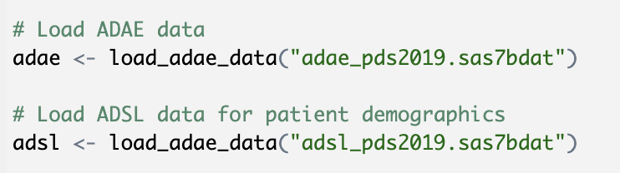

1. Merging Datasets: Given that the analysis involves examining adverse events in relation to patient demographics, the two datasets are merged on a common identifier, which is the subject ID (SUBJID)
2. Data Transformation: Continuous age data are categorized into meaningful groups to facilitate analysis. This is achieved by using the cut function in R.

Data Exploration

* 1. Following cleaning, exploratory data analysis (EDA) is conducted to understand the distributions and relationships in the data: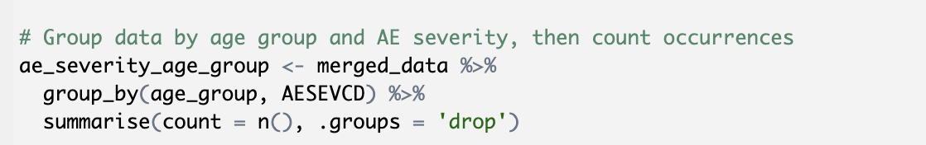
  2. Visual Exploration: Utilize ggplot2 to create visualizations such as bar plots and histograms to explore the frequency and severity of adverse events across different age groups.

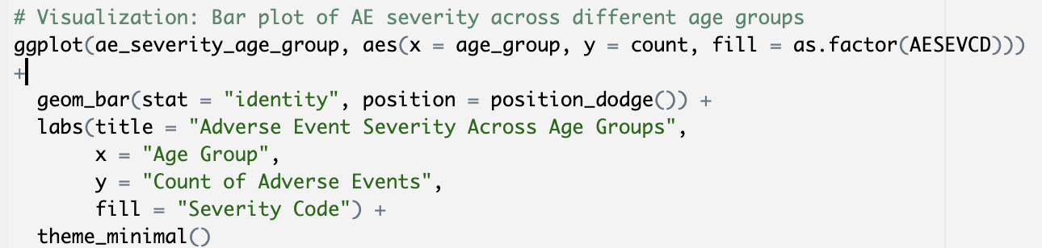

**5: Analysis**

Refinement of Analysis Approach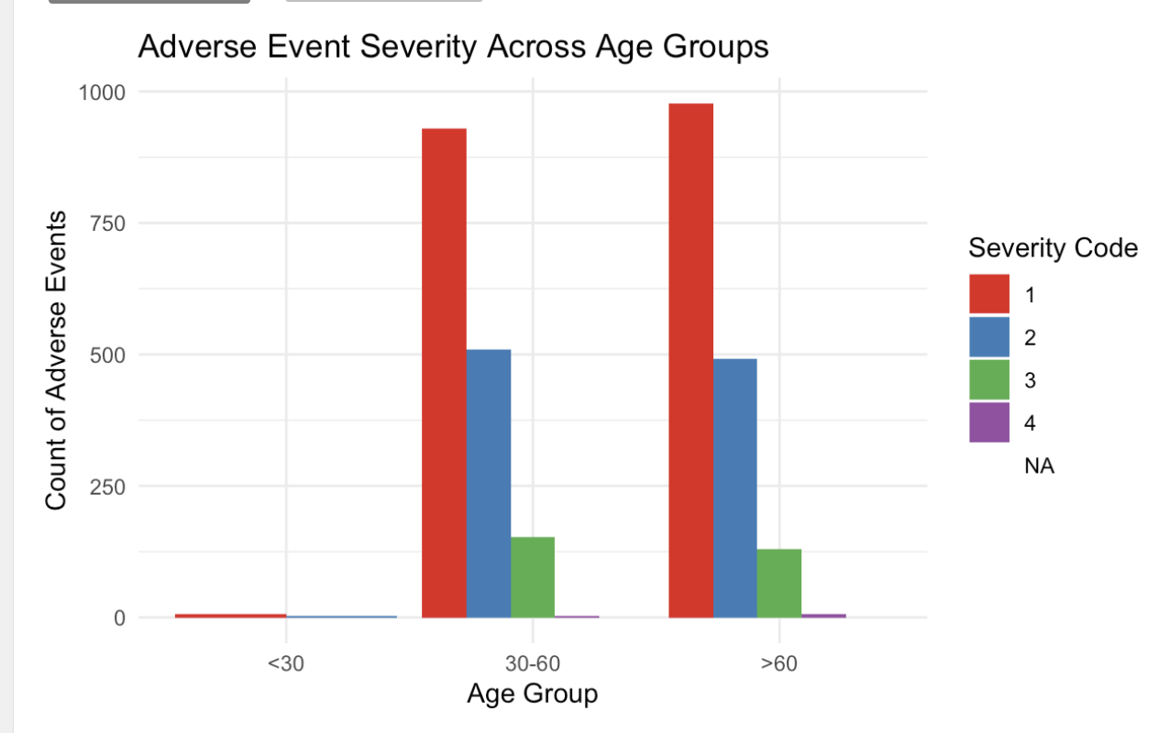

The analysis undertaken sought to investigate the probability of experiencing severe adverse events across different age groups. Initial statistical tests and logistic regression models have provided insights that require careful interpretation and potential refinement of the analytical strategy.

Descriptive Statistics and Visual Exploration

The analysis began with descriptive statistics and visual exploration, summarizing adverse events by severity and age group. The bar plot created earlier in the process facilitated a preliminary visual assessment of the distribution of adverse events across age groups.

Statistical Testing

A Chi-squared test of independence was conducted to examine the relationship between age groups and the frequency of adverse event severities. The result of this test (χ² = 7.1292, df = 6, p-value = 0.3091) suggested that there was no significant association between the age groups and the distribution of adverse event severity levels at a conventional alpha level of 0.05.

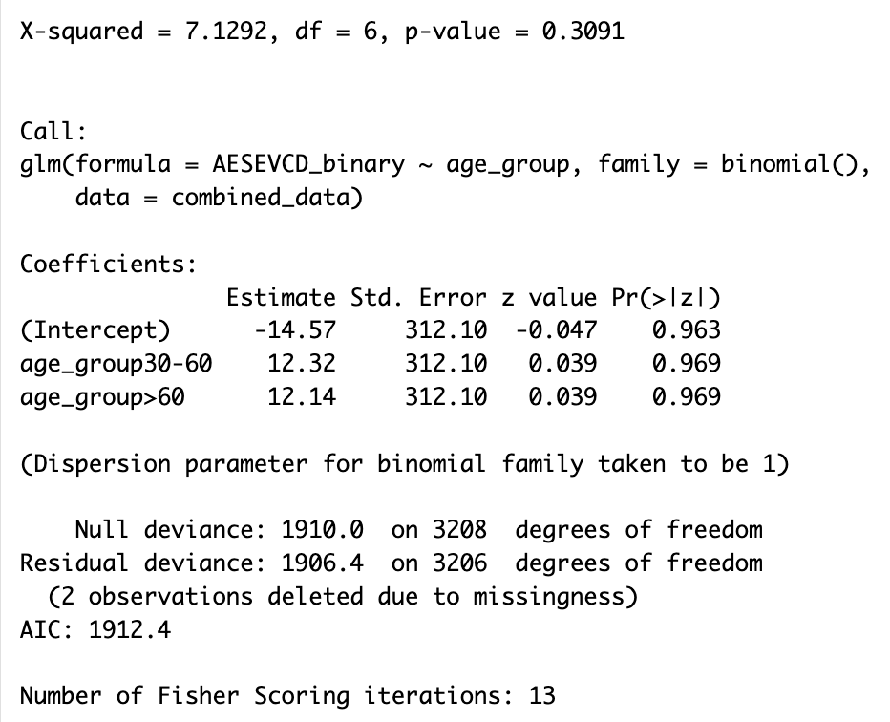

Logistic Regression Analysis

To further explore the relationship between age and severe adverse events, a binary logistic regression model was fitted, with severe adverse events coded as 1. The results indicated that the age groups "30-60" and ">60" did not significantly predict the occurrence of the most severe adverse events compared to the reference group "<30".

Given the large standard errors and the non-significant z-values of the age group predictors, the model does not appear to effectively differentiate the probability of severe adverse events by age group. This could be due to several factors such as rarity of severe adverse events, lack of variability in the response within age groups, or other unmeasured confounding factors.

The initial analysis suggested that age alone, as categorized in this study, does not significantly predict the severity of adverse events. This finding underscores the complexity of adverse event prediction and the need for multifaceted analytical approaches. As the field of clinical research advances, it is increasingly important to leverage comprehensive modeling strategies that can capture the nuances of patient response to treatment.

**6: Interpretation and Conclusions**

Interpretation of Results

The statistical analysis conducted on the clinical trial data, specifically regarding the severity of adverse events across different age groups, yielded several key insights:

* Chi-Squared Test: The Chi-squared test of independence did not reveal a statistically significant association between age groups and the frequency of adverse event severities. This indicates that, within the confines of this analysis and the available data, age group alone does not appear to be a determinant of the distribution of adverse event severity.
* Logistic Regression: The logistic regression model, which aimed to predict the probability of experiencing the most severe adverse events based on age group, suggested that age was not a significant predictor. The large standard errors and the non-significant p-values indicate that the model does not adequately differentiate between age groups concerning the occurrence of severe adverse events.

Considerations and Limitations

Several considerations and limitations must be acknowledged:

* Data Distribution: The analysis may have been affected by an imbalance in the distribution of severe adverse events across age groups. If severe events are rare within the dataset, this could lead to difficulties in detecting significant effects.
* Model Specification: The initial model included only age groups as predictors. The non-significant findings underscore the potential necessity of incorporating additional relevant variables into the model to account for other factors that may influence the severity of adverse events.
* Potential Confounders: There may be confounders or effect modifiers not accounted for in the analysis, such as gender, comorbidities, or treatment adherence, which could have a substantial impact on the observed relationships.

Conclusions

From the analysis conducted, the following conclusions can be drawn:

* Age and Adverse Events: There is no conclusive evidence from this analysis to suggest that age is a significant factor in the severity of adverse events experienced by patients in this clinical trial dataset.
* Complexity of Adverse Event Prediction: Predicting adverse events is a multifaceted issue that likely requires a comprehensive set of variables to accurately model. This analysis has highlighted the need for a more nuanced approach that considers a broader range of patient characteristics and treatment factors.
* Future Directions: Further research is warranted to explore the relationships between patient demographics, treatment parameters, and health outcomes. This should include the use of more complex models and the integration of additional data sources to better understand the predictors of adverse event severity.

In conclusion, while this analysis did not find a significant predictive value of age for adverse event severity, it has laid the groundwork for future investigations that could lead to more personalized and effective patient care. The findings highlight the importance of continued research and the utilization of advanced statistical techniques to unravel the complexities of clinical trial data for improved healthcare outcomes.