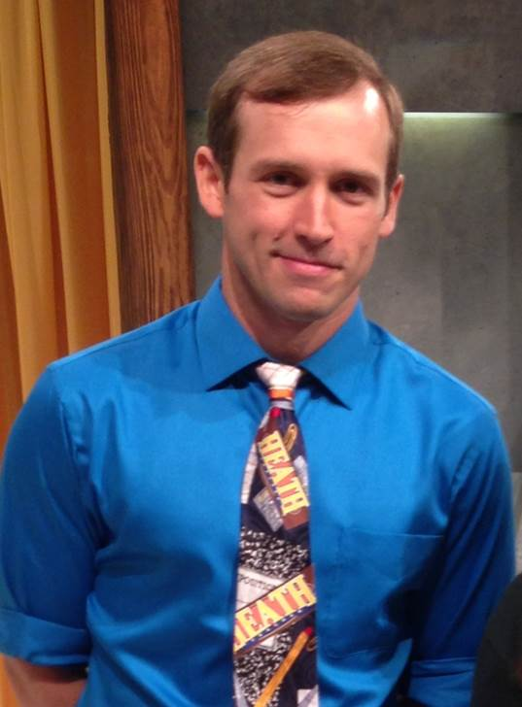**I’m Jeromie Heath and I am extremely elated to participate in the CE tour of Greater China. I am a National Board Certified Teacher currently teaching 5th grade in Kent, WA. I have taught grades 1-5 and am in my 10th year teaching.  I have a passion for making learning exciting and engage students with songs (music videos), costumes, unique décor, leveled games, and stimulating innovative strategies like blacklights and 3d.  I continuously collect ideas from colleagues, trainings, book studies, online sources, and more that** unleash engagement, imagination, enthusiasm, motivation, and overall fun in the classroom. I believe that a happy student is a student that learns more. I also believe that engaging a student by customizing the learning experience to meet their needs leads to a better education. I am always on the search to engage my students, and I know that this travel experience will help me even further with tapping into my students’ academic, social, behavioral, and cultural needs.

Ultimately, I am participating in this travel opportunity for my students. Our school is rich with diversity. Our school’s students speak over 19 different languages and we have many bilingual (and some trilingual) students who come from a plethora of different backgrounds and countries. Some are newly emigrated from their homeland countries and are learning about American culture and how to be successful learners. The more I can learn about the world, the better equipped I am as an educator to help them for their student and adult lives.  I’m looking forward to learning new ways to reach my ELL students and enhance their learning experiences. I will have experiences similar to my newly immigrated students in that I will know what it feels like to be emerged in a culture and learn about the food, religion, art, language, customs, and more. I plan to use these experiences to gain new insights, ideas, and lessons that will enrich all of my students’ knowledge of Chinese culture- and ultimately study our own cultures in the process.