Game Design Document

Fill up the following document

1. Write the title of your project.

Space racer

1. What is the goal of the game?

To reach the end before you oponent and collect points

1. Write a brief story of your game.

There will be to spce ships comtroled by two diffferent people you should reach the end befor your oponet without colliding with any of the astroids , you should collect the coins and keep on collecting fuels to make it to the end of the game.

1. Which are the playing characters of this game?

* Playing characters are the ones who respond to the user based on the input from the user.
* Cars, monkeys, dinos, wizards, etc., are the playing characters in the game.

|  |  |  |
| --- | --- | --- |
| Number | Character Name | What can this character do? |
| 1 | space ship 1 | Move,collectpoints and collide |
| 2 | Space ship 2 | Move,collectpoints and collide |
| 3 |  |  |
| 4 |  |  |
| 5 |  |  |
| 6 |  |  |
| 7 |  |  |
| 8 |  |  |

1. Which are the Non-Playing Characters of this game?

* Non-Playing characters are the ones that don't have an action or behavior when the user interacts with the game.
* Hurdles, stones, bananas, coins, etc., are non-playing characters in the game.

|  |  |  |
| --- | --- | --- |
| Number | Character Name | What can this character do? |
| 1 | astroids | Appper at random places on the screen and destroy the spaceship when collided |
| 2 | Point coins | Apppera at random places on the screen and give points to the players |
| 3 | Fuel tank | Apppera at random places on the screen and increase the fuel capacity for the spaceship |
| 4 |  |  |
| 5 |  |  |
| 6 |  |  |
| 7 |  |  |
| 8 |  |  |

Draw your imagination of this game. What does this game look like?

* Draw the game either on your computer or on paper.
* Add images of the game scenes to show each of the playing and non-playing characters at least once.

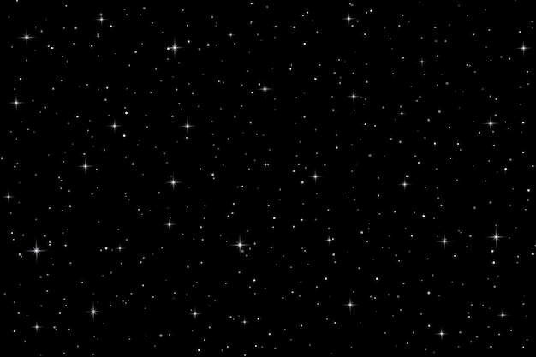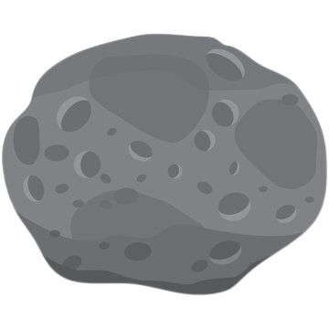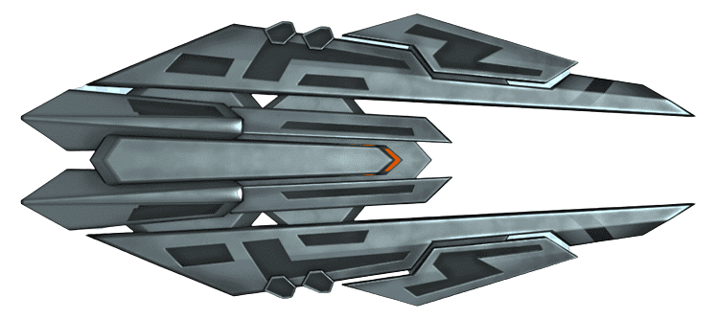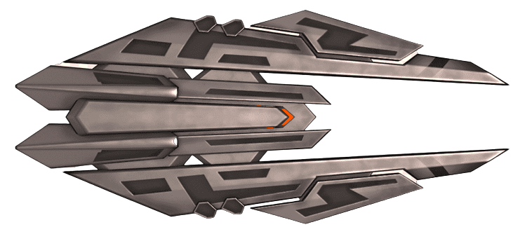

How do you plan to make your game engaging?

I will make the game engaging by adding fuel,points and obstacles in it