EBU6304 Software Engineering Group Project
2025-26
Final Short Report — Group 68

Group number | 68
member 1 | QM no: 231226532 | Name: Shuo Liu
member 2 | QM no: 231226495 | Name: Yueyang Sun
member 3 | QM no: 231226406 | Name: Junyi Zhu
member 4 | QM no: 231226370 | Name: Shaoyang Zhu
member 5 | QM no: 231226439 | Name: Puze Wang
member 6 | QM no: 231226347 | Name: Yilin Fang

1 Design

1.1 Architecture Overview
The TA Recruitment System is a Java web application for BUPT International School that manages teaching assistant recruitment, application, review, and workload assignment. It supports three roles—TA, MO, and Administrator—each with dedicated interfaces and access controls. The system follows a three-tier layered architecture separating presentation, business logic, and data persistence.

Layer | Components | Technology
Presentation | 32 Servlets (5 packages), 34 JSP views, shared layout | Servlet 4.0, JSP/JSTL
Cross-cutting | AuthFilter via @WebFilter("/*"), 403.jsp | Servlet Filter, RBAC
Service | 8 interfaces + impls: Resume, Recommendation, Profile, Job, Application, Analytics, Notification, Auth | DI via ServiceRegistry
Data Access | 7 JSON file repositories extending JsonFileRepositorySupport | Gson, synchronised file I/O
Special Modules | Resume (PDFBox + structuring), AI Matching (LLM + rule fallback), Notifications | PDFBox 3.0.2, OpenAI API

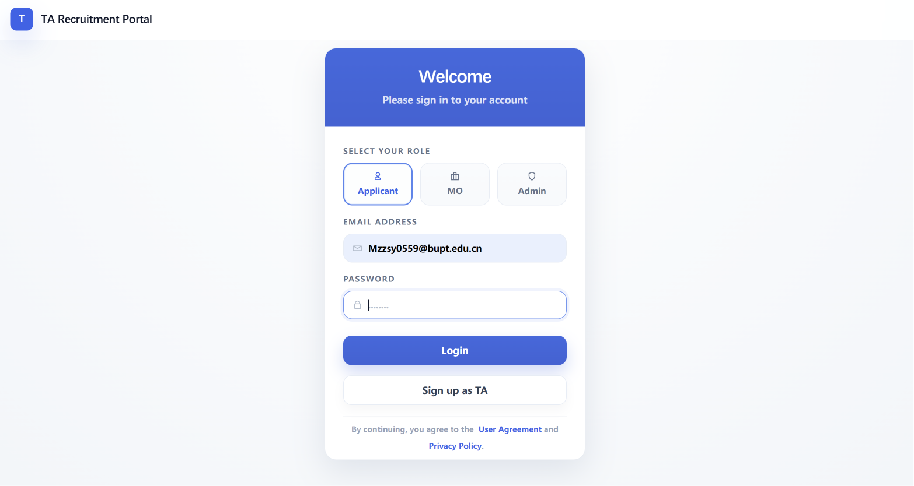
Figure 1: Login page with role-based authentication

The system models five core entities: User (authentication/role), TAProfile (candidate info including resume and timetable), JobPosting (position with required skills and schedule), Application (linking TA to posting with status and AI match score), and Notification (event-driven messages). These are persisted as JSON arrays under data/ with cross-references via ID fields. ServiceRegistry.java is the central DI container, creating seven repository and seven service singletons at class-load time with explicit constructor injection. Controllers access services via static methods (e.g. ServiceRegistry.resumeService()). JSON file storage is a course-mandated constraint; all data files use Gson with pretty-printing. JsonFileRepositorySupport provides unified read/write with synchronised methods. Seed data (TA001, MO001, POST001–003, APP001) is pre-populated.

1.2 Core Components
Service Registry. Instantiates repositories in dependency order, then services with constructor injection. Explicit wiring makes the dependency graph visible and prevents circular dependencies. Controllers never call new on services—they depend on ServiceRegistry static methods, ensuring one shared instance per service.
AuthFilter. Intercepts all requests via @WebFilter("/*") with a three-stage pipeline: (1) whitelist public paths (login, register, assets); (2) redirect unauthenticated requests to /auth/login; (3) enforce role-based path prefixes—/ta/* requires Role.TA, /mo/* requires Role.MO, /admin/* requires Role.ADMIN. Unauthorised access forwards to 403.jsp. The Role enum provides type-safe compile-time checking.
Application Lifecycle Engine. ApplicationServiceImpl.java (~760 lines) implements a six-state lifecycle (ApplicationStatus enum): SUBMITTED, UNDER_REVIEW, ACCEPTED, REJECTED, WITHDRAWN, REVOCATION_REQUESTED. A six-condition eligibility gate evaluates: (1) profile complete (studentId, programme, year); (2) resume uploaded; (3) no duplicate application; (4) deadline not passed; (5) job status OPEN; (6) no timetable conflict (minute-based interval overlap comparison, lines 485–510). After passing checks, the application is created with an AI match score and NEW_APPLICATION notification emitted to the MO. The revocation flow: an accepted TA requests revocation (→ REVOCATION_REQUESTED), creating an unresolved notification for the MO, who approves (→ WITHDRAWN) or declines (→ ACCEPTED), notifying the TA.
Figure 2: Application State Transitions
From | Action | Actor | To
SUBMITTED | MO begins review | MO | UNDER_REVIEW
UNDER_REVIEW | Accept / Reject | MO | ACCEPTED / REJECTED
UNDER_REVIEW | TA withdraws | TA | WITHDRAWN
ACCEPTED | Revocation request | TA | REVOCATION_REQUESTED
REVOCATION_REQUESTED | Approve / Decline | MO | WITHDRAWN / ACCEPTED
SUBMITTED | Auto-withdraw expired | System | WITHDRAWN

Notification System. Six event types: NEW_APPLICATION, APPLICATION_ACCEPTED, APPLICATION_REJECTED, APPLICATION_AUTO_WITHDRAWN, REVOCATION_REQUEST, REVOCATION_APPROVED/REJECTED. Each notification carries recipient ID, entity ID, timestamp, and resolved flag. Revocation notifications remain unresolved until the MO responds.
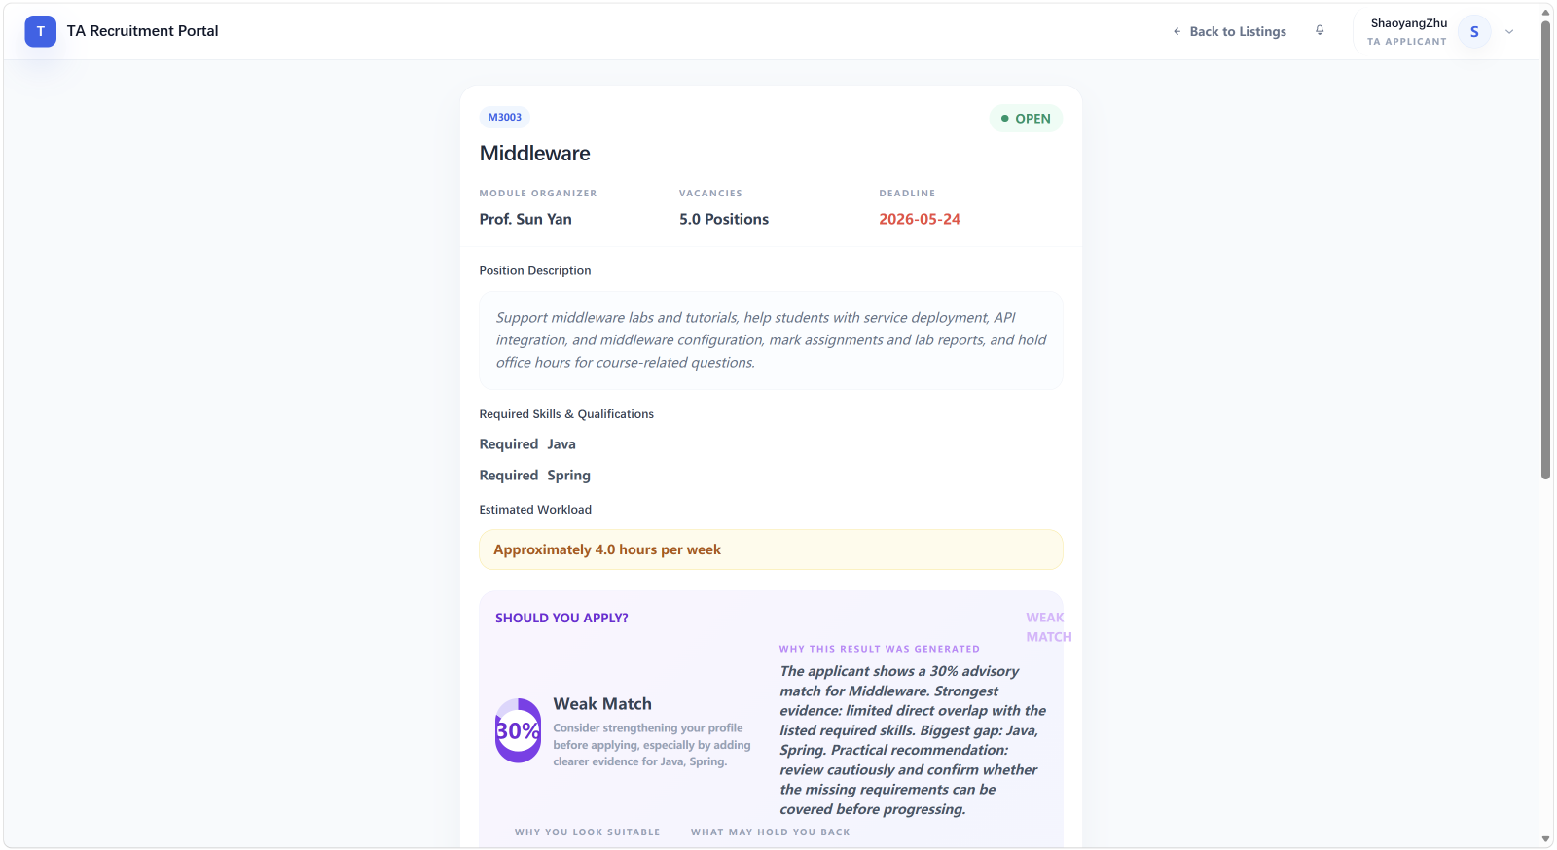
Figure 3: AI matching results showing skill match score and explanation for MO review

1.3 Design Principles and Patterns

Pattern | Location | Purpose
Service Registry | config/ServiceRegistry.java | Central DI without framework; 7 repos + 7 services wired at load time
Repository | repository/file/ (7 classes) | Abstract data access; hides Gson/file I/O from consumers
Filter | filter/AuthFilter.java | Cross-cutting auth/authorisation via Servlet Filter
Strategy | match/ (LLM vs LocalRule) | Dual-path matching; LLM primary with automatic rule-based fallback
Template Method | BaseServlet.java | Shared session access and error hooks for all 32 Servlets
Enum State Machine | ApplicationStatus.java | Type-safe lifecycle; compile-time valid transition guarantee

The Strategy pattern in the matching module dynamically selects between OpenAiCompatibleMatcher (LLM-based, via .env.local config) and LocalRuleMatcher (deterministic). If the LLM endpoint is unavailable or throws an exception, the system automatically falls back to local rule matching—ensuring the system always produces a result regardless of external service availability.

1.4 View Layer
Views use a shared layout template (layout.jsp). Controllers set bodyPage and pageTitle; the layout includes the body within a shell providing header, role-specific sidebar, and footer. CSS is modular: base.css, components.css, layout.css plus 19 page-specific files. JavaScript: common.js, toast.js plus 9 per-page scripts. All views use JSTL for conditional rendering and iteration, avoiding Java scriptlet code in the presentation layer. Error pages (403.jsp, error.jsp) are shared across modules. This template-based architecture allowed team members to develop their assigned views independently while maintaining visual consistency across all three role modules.
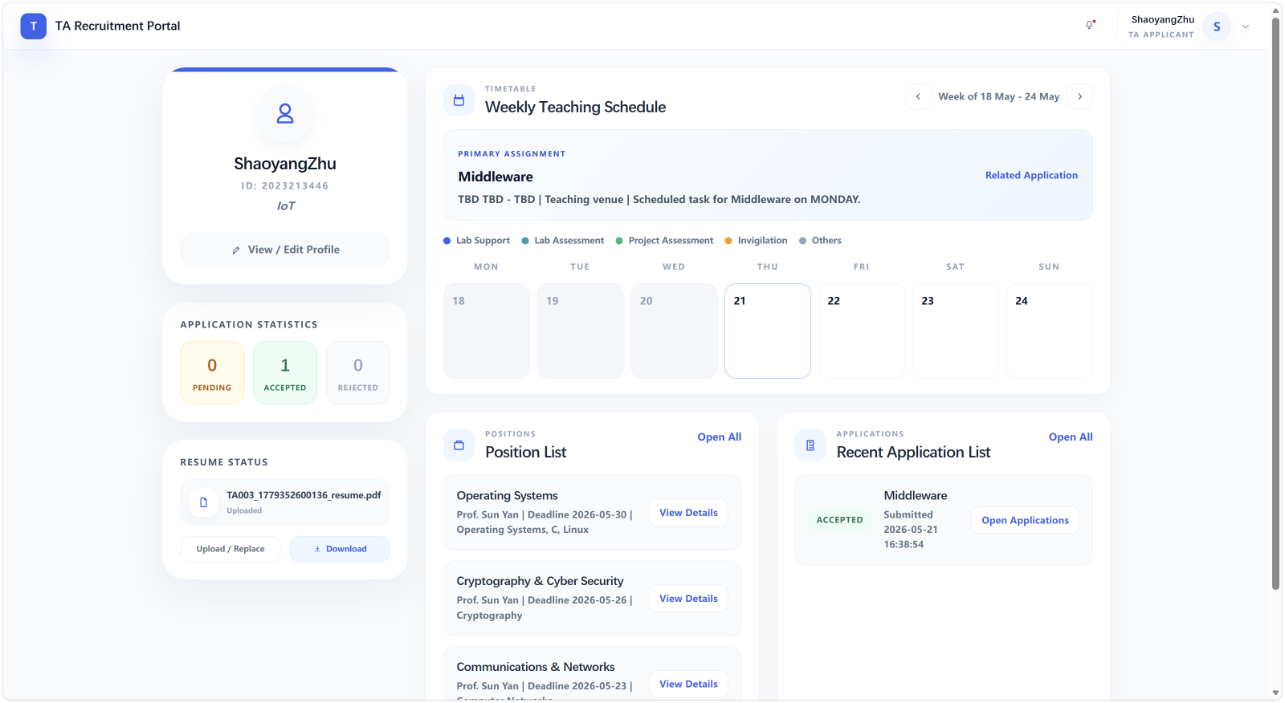
Figure 4: TA dashboard with shared layout template, sidebar navigation, and notification panel

1.5 Data Model
The system models five core entities persisted as JSON arrays in separate files under data/. Cross-entity references use ID fields (e.g. Application.postingId → JobPosting.postingId, Application.taId → User.userId).

Entity | Key Fields | Relationships
User | userId, username, password (hashed), role (enum) | Base entity for authentication; linked to TA/MO profiles
TAProfile | taId, studentId, programme, year, extractedResume, skills[], timetableEntries[] | 1:1 with User; references Applications via taId
JobPosting | postingId, moId, title, department, requiredSkills[], deadline, schedule[], status | 1:N with Applications via postingId; 1:N with MO via moId
Application | applicationId, taId, postingId, status (enum), skillMatchScore, submittedAt | N:1 with TAProfile and JobPosting; triggers Notifications
Notification | notificationId, recipientId, entityType, entityId, eventType, resolved, createdAt | References User via recipientId; linked to Application/Posting events

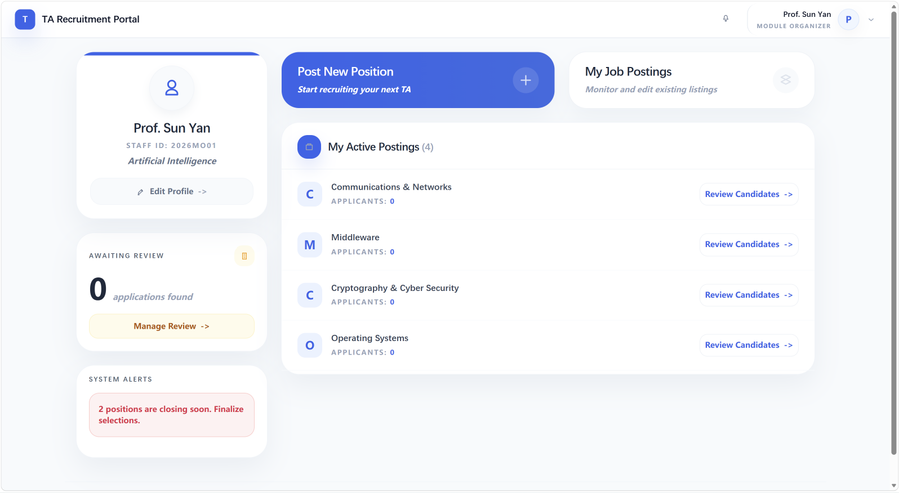
Figure 5: MO dashboard aggregating posting, application, and notification data
The ApplicationStatus enum (SUBMITTED, UNDER_REVIEW, ACCEPTED, REJECTED, WITHDRAWN, REVOCATION_REQUESTED) provides type-safe state management. The Role enum (TA, MO, ADMIN) enforces compile-time role checking. TAProfile.extractedResume stores the structured output from the resume pipeline (seven fields: education, experience, skills, publications, certifications, courses, languages), enabling the AI matching engine to evaluate candidates without re-processing PDFs. JobPosting.schedule[] stores time blocks as {dayOfWeek, startTime, endTime} objects, used by the timetable conflict detection algorithm in ApplicationServiceImpl.

2 Implementation

2.1 Implementation Strategy
The project used modular incremental delivery across four phases, each independently testable before integration:

Phase 1: Console prototypes (Phase1ConsoleApp, MOConsoleApp) validating data model and JSON persistence. Seven admin console runners tested CRUD in isolation.
Phase 2: Static JSP pages and navigation design (34 views, 19 CSS files). The 694-line interface-design.md was authored, defining all API contracts and data conventions.
Phase 3: Servlet integration: each developer implemented their module's Servlets following BaseServlet and interface-design.md contracts. ServiceRegistry wired repos to services. AuthFilter enforced RBAC. Integration proceeded auth → TA → MO → admin.
Phase 4: AI matching engine (dual-path LLM + rule fallback), resume processing pipeline (PDFBox extraction + heuristic structuring), and notification system wired into ApplicationServiceImpl.
Build uses direct javac compilation via PowerShell (no Maven/Gradle). JARs (pdfbox-app-3.0.2, gson-2.11.0, servlet-api-4.0.1) are committed in lib/ for reproducible builds. Runtime: JDK 21, Tomcat (Servlet 4.0). The decision to avoid a build framework was driven by simplicity: every developer needed to build consistently without learning Maven or Gradle, and committing JARs eliminated dependency resolution issues across different environments.
Technology / Library | Version | Role in System
JDK | 21 | Runtime; language features (records, switch expressions, var)
Apache Tomcat | 9.x | Servlet container; deployment target for webapp
Servlet API | 4.0.1 | Core web framework; @WebServlet, @WebFilter annotations
JSP / JSTL | 2.3 / 1.2 | View layer; server-side rendering with tag libraries
Apache PDFBox | 3.0.2 | PDF text extraction for resume processing pipeline
Google Gson | 2.11.0 | JSON serialisation/deserialisation for file persistence
OpenAI / DeepSeek API | N/A (REST) | LLM-based candidate matching via OpenAiCompatibleMatcher

The technology stack was chosen for maturity and simplicity. Servlet 4.0 with annotation-based configuration eliminated the need for verbose XML routing, allowing rapid iteration on routes as features evolved. Gson was selected over Jackson because its lighter API surface better suited the project's straightforward serialisation needs. PDFBox 3.0.2 provided reliable text extraction across varied resume PDF formats, including those with multi-column layouts and embedded fonts. The decision to commit JAR dependencies directly into the repository rather than using a package manager ensured that every developer could compile and run the project immediately, without resolving dependency conflicts or configuring private registries.

2.2 Build and Deployment
deploy-to-local-tomcat.ps1 executes four stages: (1) create staging directory under Tomcat webapps; (2) copy web/ (JSPs, CSS, JS, images) to staging; (3) compile Java sources with javac, outputting .class files to WEB-INF/classes; (4) verify deployment structure. run-web-app.ps1 provides single-command startup. DevSessionLoginServlet enables /dev/login-as?role=TA|MO shortcuts creating sessions with pre-seeded users for rapid testing. Seven console runners enable headless service-layer testing without a web server.
web.xml configures session timeout, welcome file, and AuthFilter. All routes use @WebServlet annotations, avoiding XML maintenance as routes changed during development.

2.3 Version Control and Collaboration
Git feature-branch workflow on GitHub: 106+ commits, 20+ PR merges. Each developer used a dedicated branch (dev-wpz/Admin, dev-zjy/MO, dev-zsy/architecture, dev-syy/Servlet, dev-fyl/TA), merging via PRs for code review. Conventional commit messages (feat:, fix:, refactor:, docs:) enabled quick change understanding. PR-based integration kept main deployable throughout development.
PR | Description | Module
#106 | Workload search optimisation | Admin
#104 | Admin module — MO management, job oversight | Admin
#102 | TA application withdrawal + notification integration | TA
#93 | Seed default admin, fix JsonUserRepository | Auth
#87 | MO interface fixes and styling | MO
#85 | Initial architecture merge | Architecture

Documentation artefacts: README.md (594 lines), interface-design.md (694 lines), page-navigation.md, Chinese module manuals, and docs/AI协作开发提示词.md (AI prompt documentation). These served as the shared reference keeping six developers aligned on interfaces and conventions.

2.4 Project Management and Team Coordination
The project followed a lightweight agile process adapted to a six-person student team. Weekly synchronisation meetings reviewed module progress, identified integration blockers, and adjusted task assignments. The interface-design.md specification (694 lines) served as the team's shared contract, updated collaboratively when new features required API changes. Each developer owned their module's full stack—Servlets, JSP views, CSS, and integration testing—which minimised cross-module dependencies and merge conflicts.
Risk management was built into the development process. The decision to prototype with console applications in Phase 1 before committing to the web architecture allowed the team to validate the data model and JSON persistence early. The dual-path AI matching design (LLM primary + rule fallback) was an explicit risk mitigation: the team acknowledged LLM API unreliability upfront and designed for graceful degradation. The interface-design.md specification reduced integration risk by defining field names, request/response formats, and error conventions before any cross-module code was written. These practices kept the project on track despite the complexity of coordinating six parallel development streams.
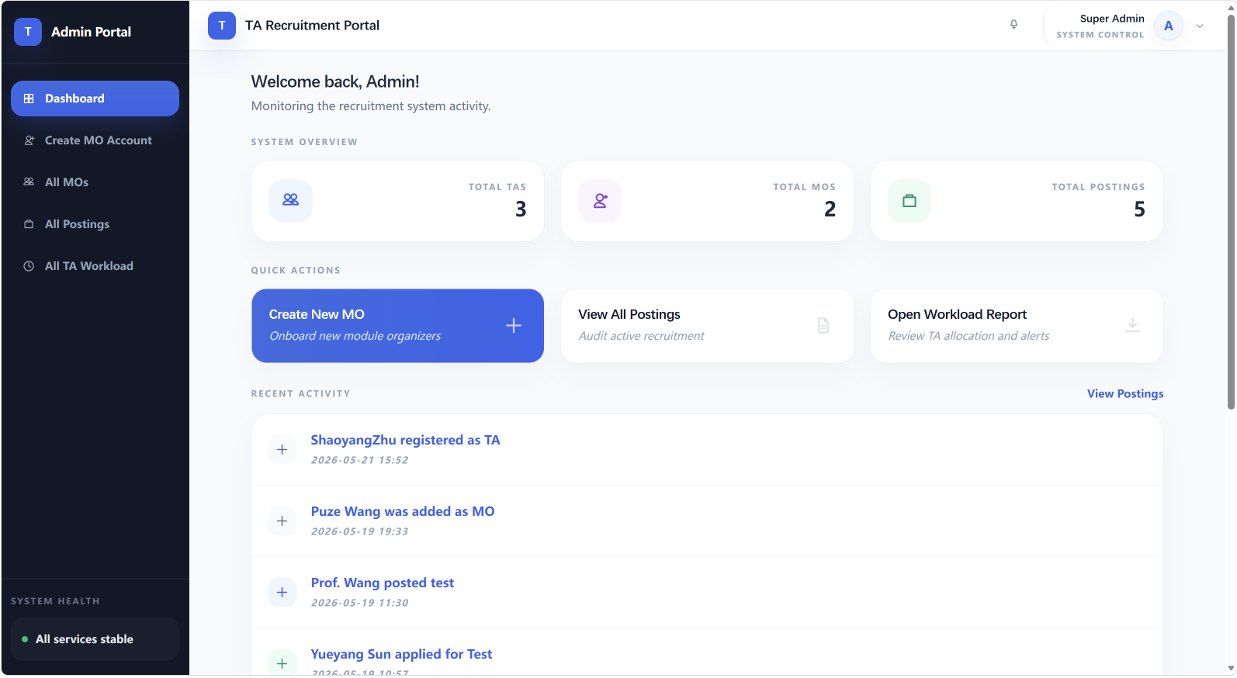
Figure 6: Admin dashboard providing system-level oversight across all modules

3 Testing

3.1 Testing Strategy
A four-level approach adapted to no formal test framework (JUnit). Each level builds on the previous: isolated service calls → scripted integration → PDF pipeline validation → full end-to-end browser testing.
Level 1 — Console smoke tests: Phase1ConsoleApp, MOConsoleApp, 7 admin runners exercise service layer directly. Quick validation of JSON persistence and data model serialisation.
Level 2 — Scripted integration: PowerShell scripts (test-admin-*.ps1, test-phase1-backend.ps1) automate compilation and execution for reproducible regression testing.
Level 3 — PDF pipeline: SampleResumePdfGenerator creates test PDFs from templates for controlled resume extraction validation.
Level 4 — Web manual testing: Dev login shortcuts + seed data (TA001, MO001, POST001–003, APP001) for end-to-end UI validation against interface-design.md.
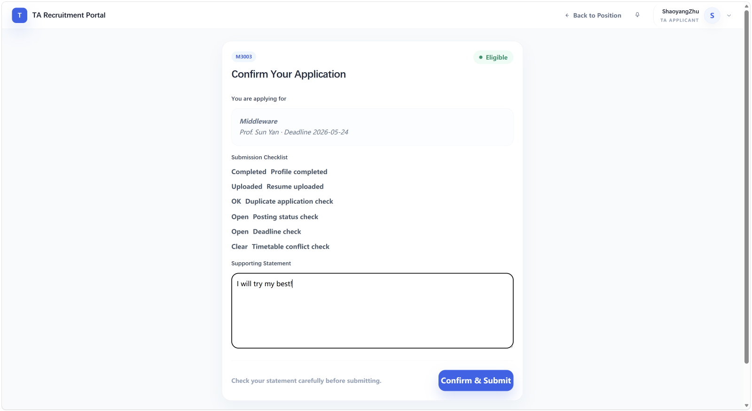
Figure 7: Six-condition eligibility gate validating application submission in the TA module

3.2 Test Cases

Table A: Resume Upload Pipeline
Step | Input | Expected | Result
Upload valid PDF | 2MB PDF | Saved, text extracted, 7 fields in ta.json | Pass
Invalid format | .docx file | Rejected — only PDF accepted | Pass
Oversized file | 6MB PDF | Rejected — exceeds 5MB limit | Pass
Structure extraction | Extracted text | 7 fields populated, persisted to ta.json | Pass
Empty PDF | No extractable text | Handled gracefully, empty fields stored | Pass

Table B: Application Eligibility (6-Condition Gate)
Condition | Test | Expected | Result
Profile complete | Empty studentId | Blocked | Pass
Resume present | No resume uploaded | Blocked | Pass
No duplicate | Re-apply POST001 | Blocked | Pass
Deadline | Expired posting | Blocked | Pass
Job open | CLOSED posting | Blocked | Pass
No conflict | WED 10:00–12:00 vs 10:30–12:30 | Blocked (90min overlap) | Pass

Table C: AI Matching Fallback
Configuration | Expected Method | Observed | Result
No .env.local | local-rule | LocalRuleMatcher: base 30pts + skill overlap bonuses | Pass
Valid LLM config | api-llm | OpenAiCompatibleMatcher: 5-dimension LLM evaluation | Pass
Invalid API key | local-rule-fallback | LLM exception caught, fallback to LocalRuleMatcher | Pass

Table D: Notification Workflow
Event | Recipient | Notification Type | Resolved | Result
TA submits application | MO | NEW_APPLICATION | Auto-resolved on view | Pass
MO accepts application | TA | APPLICATION_ACCEPTED | Auto-resolved | Pass
MO rejects application | TA | APPLICATION_REJECTED | Auto-resolved | Pass
TA requests revocation | MO | REVOCATION_REQUEST | Unresolved until MO responds | Pass
MO approves revocation | TA | REVOCATION_APPROVED | Auto-resolved | Pass
System auto-withdraws | TA | APPLICATION_AUTO_WITHDRAWN | Auto-resolved | Pass

The notification workflow tests verified that each lifecycle event generated the correct notification with proper recipient routing. The revocation flow was particularly important to validate: when a TA requests revocation, the MO receives an unresolved notification that remains visible on the MO dashboard until explicitly approved or declined. Only then does the TA receive a follow-up notification with the outcome. This multi-step, multi-role interaction required careful testing to ensure no notification was lost and state transitions were consistent across all parties.
Table E: AuthFilter Security Validation
Test | Role | Path | Expected | Result
TA accesses dashboard | TA | /ta/dashboard | Allowed | Pass
TA attempts MO panel | TA | /mo/dashboard | Blocked — 403.jsp | Pass
TA attempts admin | TA | /admin/dashboard | Blocked — 403.jsp | Pass
MO accesses postings | MO | /mo/job/list | Allowed | Pass
MO attempts TA profile | MO | /ta/profile | Blocked — 403.jsp | Pass
Unauthenticated access | None | /ta/dashboard | Redirect to /auth/login | Pass
Public path | None | /auth/login | Allowed | Pass

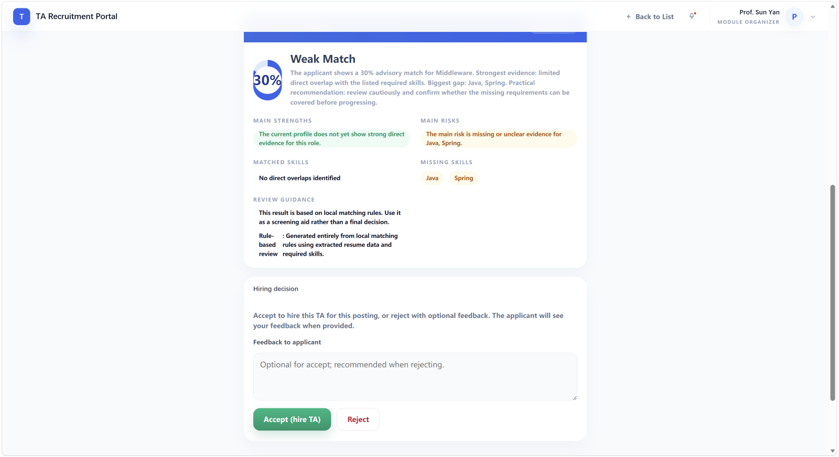
Figure 8: AI-generated match score, confidence indicators, and skill breakdown for MO review

3.3 Test Results Summary
All critical paths verified: Resume pipeline (PDF → text extraction via PDFBox → structured fields → JSON persistence) — pass. Application flow (six-condition eligibility gate → creation → AI match scoring → MO notification) — pass. Timetable conflict (WED 10:00–12:00 vs 10:30–12:30, 90-minute overlap detected) — pass. AuthFilter (all cross-role access blocked, 403.jsp displayed) — pass. AI matching (local rule scoring + LLM 5-dimension evaluation + fallback on API failure) — pass. Notification generation at each lifecycle transition with MO unresolved-until-responded semantics — pass.

3.4 Known Limitations
The testing approach has acknowledged limitations due to project constraints. Without a formal unit test framework (JUnit), test coverage is not quantified—testing was manual and focused on critical paths rather than exhaustive branch coverage. Concurrent write testing was limited to sequential console runner invocations rather than true multi-threaded simulation. JSON file persistence lacks transactional guarantees, and while synchronised methods prevent most corruption, race conditions under high concurrent load remain a theoretical risk. Load and performance testing were not conducted—the system was validated for functional correctness with seed data at single-user scale. These limitations are acceptable for a course project but would need to be addressed in a production deployment.

4 The Use of Generative AI (GenAI)

4.1 GenAI Tools Used at Different Stages
GenAI was employed throughout the development lifecycle. The handout required all AI-assisted work to be explainable and the team to justify each AI use with specific descriptions. All AI prompts were documented in docs/AI协作开发提示词.md to maintain transparency.

Requirements & Design: Claude/ChatGPT brainstormed the three-role architecture and mapped requirements to features. Team refined AI suggestions into interface-design.md (694 lines) defining all API contracts. AI also assisted in designing notification event types and the application state machine.
In-Product Matching: OpenAiCompatibleMatcher.java (305 lines) uses an OpenAI/DeepSeek-compatible API with five-dimension rubric: D1 skill overlap (40pts), D2 education (15pts), D3 teaching experience (20pts), D4 responsibility fit (15pts), D5 evidence quality (10pts), deductions −35. Prompt constraints: "Do not assume facts not in input. Advisory only." Returns score (0–100), explanation, matched/missing skills, method "api-llm". Provides MOs with richer assessments than rule-based fallback.
Code Generation: Claude/Copilot produced Servlet skeletons, JSP templates, repository CRUD, and CSS. The 32 Servlets share a BaseServlet pattern—AI reliably generated consistent doGet/doPost, session validation, service calls, and JSP forwarding. CSS scaffolding for 19 stylesheets was similarly accelerated.
Documentation: README.md (594 lines), Chinese module manuals, API specs. AI bilingual (EN/ZH) output was particularly valuable. AI also suggested edge cases for eligibility gate and timetable testing.

Stage | Tool | Purpose | Effectiveness
Requirements & Design | Claude / ChatGPT | Architecture, API design, entity modelling | High
In-Product Matching | OpenAI / DeepSeek | 5-dimension candidate evaluation | High (with fallback)
Code Generation | Claude / Copilot | Servlets, JSPs, repos, CSS | High
Test Design | Claude | Edge cases, eligibility testing | Medium
Documentation | Claude / ChatGPT | README, manuals, bilingual docs | High

4.2 Critical Evaluation
GenAI was highly effective for boilerplate—the 32 Servlets share a common architecture AI reliably reproduced, and CSS scaffolding for 19 stylesheets was similarly accelerated. The in-product matching engine provides richer evaluations than the rule-based fallback; the LLM identifies nuanced skill matches (e.g. "Spring Boot" as relevant to "Java backend") that keyword matching misses. The structured prompt constraints ensure the AI does not fabricate qualifications.
However, GenAI had clear limitations. Complex business logic (eligibility-timetable-revocation interactions) required substantial human review. AI occasionally produced inconsistent JSON field names ("postingId" vs "jobId"), necessitating enforced conventions via interface-design.md. ResumeStructurer deliberately retained a rule-based approach because AI heuristics introduced false positives on varied resume formats. LLM JSON parsing required five regex patterns and fallback inference (inferMatchedSkills) because LLM output was not always well-formed.

4.3 Limitations and Challenges
Explainability: AI scoped to matching layer only—never reads raw PDFs, never makes hiring decisions. Response metadata (confidenceHint, methodLabel, methodHint) explicitly informs users whether results came from LLM, rule fallback, or API failure fallback.
No-database constraint: JSON files lack ACID guarantees. Mitigated with synchronised methods and atomic writes. Concurrent writes remain a known limitation for production.
LLM fragility: External LLM APIs are unreliable (network, rate limits, model deprecation). Dual-path Strategy pattern ensures results. .env.local gitignored; EnvConfigLoader validates all three env vars before LLM call. On failure, fallback to LocalRuleMatcher with explanation.
Team coordination: Six developers using AI tools required consistent style. ServiceRegistry and BaseServlet provided structural guardrails; interface-design.md served as API contract source of truth. 20+ PR merges reflect code review as the final quality gate.

4.4 Prompt Engineering and AI Guardrails
The OpenAiCompatibleMatcher prompt was carefully engineered to constrain LLM behaviour and ensure explainable output. Key design decisions included:

Structured input only: The LLM receives only the structured resume data (seven extracted fields) and job posting requirements—never raw PDF text. This prevents the LLM from hallucinating qualifications not present in the source document and ensures all evaluations are traceable to specific data fields.
Explicit constraints: The prompt includes: "Do not assume facts not in input. Do not use external knowledge. Advisory only." These constraints prevent the LLM from drawing on its training data to invent candidate qualifications or make unsupported inferences about fit.
Five-dimension rubric: Skill overlap (40pts), education (15pts), teaching experience (20pts), responsibility fit (15pts), evidence quality (10pts), deductions (−35). This structured rubric forces the LLM to evaluate each dimension separately rather than producing an opaque holistic score, enabling MOs to understand exactly where a candidate is strong or weak.
Defensive output parsing: LLM JSON responses are parsed with five distinct regex patterns and a fallback inference function (inferMatchedSkills) because the LLM does not always produce well-formed JSON. This defensive parsing ensures the system can extract meaningful results even from partially malformed responses.
Transparency metadata: Every response includes confidenceHint (how much to trust the result), methodLabel (human-readable origin label), and methodHint (technical description of how the result was produced). These fields ensure users can distinguish AI-generated results from rule-based fallbacks and understand the reliability of each evaluation.

4.5 Lessons Learned from AI Integration
The project's extensive use of GenAI across both the development process and the product itself yielded several insights that would inform future AI-assisted software projects.

AI excels at structure, struggles with nuance. AI reliably generated consistent code for pattern-driven tasks—32 Servlets following the BaseServlet template, 19 CSS stylesheets following a shared convention, repository CRUD implementations. However, complex business logic requiring contextual understanding—such as the interaction between the eligibility gate, timetable conflict detection, and revocation workflow—required substantial human refinement. AI-generated edge cases for timetable testing occasionally missed boundary conditions that manual testing caught.
Defensive design is non-negotiable. The decision to implement a rule-based fallback for the LLM matching engine was the single most important architectural decision for AI integration. Without it, any LLM API outage would have broken the core application flow. This pattern—AI enhancement with deterministic fallback—should be considered a best practice for any production system relying on external AI services.
Conventions must be enforced structurally. When six developers each used AI tools independently, the resulting code exhibited inconsistent naming, error handling, and JSON field conventions. ServiceRegistry and BaseServlet provided structural guardrails that absorbed much of this variation, but the team still relied heavily on interface-design.md and code review to maintain consistency. Future projects should consider code-generation templates or linting rules to enforce conventions automatically.
Bilingual documentation was a key advantage. AI-generated bilingual documentation (English/Chinese) allowed the team to maintain comprehensive documentation without duplicating effort. README.md, Chinese module manuals, and the AI prompt documentation were all produced with AI assistance, enabling effective communication across team members with varying language preferences.
AI as accelerator, not replacement. Across all stages—design, coding, testing, and documentation—AI functioned as an accelerator that amplified developer productivity, but never as a replacement for human judgment on architecture, business logic, or quality assurance. The 20+ PR merges through code review served as the ultimate quality gate, catching issues that neither AI nor individual developers identified.
5 Individual Contribution and Reflection
Each member provides their key contribution (agreed by the group) and a reflective statement.
QM 231226439 — Sun Yueyang
Main contribution:
I designed the overall system architecture and established code standards across the project. I implemented the three-tier layered architecture, the Service Registry pattern (config/ServiceRegistry.java) for dependency injection wiring seven repositories and seven services at class-load time, and AuthFilter (filter/AuthFilter.java) for role-based access control with its three-stage authentication/authorisation pipeline. I created BaseServlet.java as the abstract template for all 32 concrete Servlets, providing shared session access and error handling through the Template Method pattern. I authored the comprehensive 694-line interface-design.md defining all API contracts, request/response formats, data model conventions, and error handling patterns. I designed the CSS architecture (base.css, components.css, layout.css, 19 page-specific stylesheets) and the shared JSP layout template system (layout.jsp) ensuring visual consistency across all 34 views. Throughout development, I conducted code reviews across all modules to ensure architectural consistency.

Reflective statement:
This project deepened my understanding of software architecture in a constrained environment. Implementing dependency injection without a framework like Spring taught me the fundamental problems DI frameworks solve—circular dependencies, lifecycle management, and configuration complexity. Establishing conventions early through interface-design.md proved essential for consistency across six parallel developers. I learned that early architectural decisions have compounding effects on development velocity and code quality. My skills in code review, architectural documentation, and technical leadership improved significantly through coordinating design decisions and resolving integration challenges. Balancing architectural purity with delivery constraints gave me a nuanced perspective on engineering trade-offs.

QM 231226370 — Zhu Shaoyang
Main contribution:
I implemented the core Servlet infrastructure and managed the Tomcat deployment pipeline. I developed the authentication subsystem: LoginServlet (credential validation, session creation), LogoutServlet (session invalidation), RoleSelectServlet (role selection), and TARegisterServlet (account creation with validation). I configured web.xml with session timeout, welcome file mapping, AuthFilter registration, and Servlet context parameters. I created deployment automation: deploy-to-local-tomcat.ps1 (four-stage pipeline: stage, copy, compile, verify) and run-web-app.ps1 (single-command startup). I implemented DevSessionLoginServlet for /dev/login-as dev shortcuts bypassing authentication for rapid testing. I developed seven console runner scripts for headless service-layer testing, essential for debugging business logic before Servlet integration. My work ensured consistent compilation, deployment, and testing across all six team members' environments.

Reflective statement:
I gained extensive experience with Java Servlet programming, Tomcat configuration, and deployment automation. Working with Servlet 4.0 annotation-based configuration (@WebServlet, @WebFilter) taught me the advantages of declarative over XML-based setup and the limitations when complex filter ordering is needed. Debugging deployment issues across six different environments—with varying JDK installations, Tomcat versions, and OS paths—taught me the critical importance of reproducible builds. I developed strong skills in PowerShell scripting, classpath management, server lifecycle management, and troubleshooting Servlet container runtime errors.

QM 231226532 — Liu Shuo
Main contribution:
I developed the resume input pipeline and AI matching engine. The input module handles PDF upload through TAResumeUploadServlet (multipart form data, file type validation, 5MB size limit), text extraction via PdfResumeExtractor (Apache PDFBox 3.0.2), and heuristic structuring through ResumeStructurer (regex patterns and section header detection populating seven fields: education, experience, skills, publications, certifications, courses, languages). The AI matching engine (RecommendationServiceImpl) implements the Strategy pattern: OpenAiCompatibleMatcher (305 lines, five-dimension rubric: D1 skill overlap 40pts, D2 education 15pts, D3 teaching experience 20pts, D4 responsibility fit 15pts, D5 evidence quality 10pts, deductions −35) with automatic fallback to LocalRuleMatcher on LLM failure. I implemented EnvConfigLoader for secure API config from .env.local and MatchResult for unified output. I also assisted Fang Yilin with TA module integration.

Reflective statement:
The dual-path matching architecture was a response to LLM API unreliability—the system must always produce a result. Writing constrained prompts ("Do not assume facts not in input. Advisory only.") taught me prompt engineering for production systems. I learned that rule-based approaches can be more predictable than AI for PDF parsing—ResumeStructurer's decision to stay rule-based was a direct result of AI introducing false positives. Implementing five regex patterns for potentially malformed LLM JSON output taught me that AI integration requires robust defensive programming. This project enhanced my skills in API integration, error handling, graceful degradation design, and AI vs deterministic trade-offs.

QM 231226347 — Fang Yilin
Main contribution:
I developed the complete TA module with integration support from Liu Shuo. I implemented eight Servlets: TADashboardServlet (dashboard with application statistics, timetable events, unread notifications), TAProfileServlet (profile editing with studentId/programme/year validation), TAJobListServlet (position browsing with department/status filters), TAJobDetailServlet (detailed posting with AI match score and explanation), TAMyApplicationsServlet (application history with status tracking and withdrawal), TAApplyConfirmServlet (pre-submission eligibility check showing six-condition gate results), TAApplySubmitServlet (application creation with real-time AI match scoring), and TAApplicationWithdrawServlet (withdrawal/revocation submission). I developed all corresponding JSP views and CSS stylesheets. The module integrates data from ProfileService, ResumeService, JobService, ApplicationService, RecommendationService, TATimetableDataRepository, and NotificationService.

Reflective statement:
I gained comprehensive full-stack experience with Servlet/JSP. Aggregating data from multiple services into the TA dashboard taught me about designing interfaces for complex, multi-source data presentation. The AI matching integration taught me the importance of clear interface contracts—the RecommendationService returns structured results my views render as score bands, matched skills, and confidence hints. The six-condition eligibility validation was valuable practice in implementing complex business rules with user-friendly error messages. I improved my skills in HTML/CSS, form validation, session management, and multipart file handling. Coordinating with Liu Shuo on matching integration taught me effective inter-module communication practices.

QM 231226406 — Zhu Junyi
Main contribution:
I developed the complete MO module: nine Servlets and seven JSP views. MODashboardServlet (analytics dashboard with posting stats, application counts by status, notification summaries), MOProfileServlet (profile editing), MOJobCreateServlet (job posting with multipart form handling), MOJobListServlet (posting management with search/filtering/status toggle), MOJobApplicantsServlet (applicant listing with AI match scores and score bands), MOApplicantDetailServlet (full profile with AI analysis: matched skills, missing skills, score band, confidence hint, method label), MOApplicationStatusUpdateServlet (accept/reject with notification generation), MORevocationResponseServlet (revocation approval workflow), and MOReviewQueueServlet (aggregated pending applications). The MO module is the primary consumer of AI matching results, requiring careful presentation of scores, confidence indicators, and method explanations to support informed decision-making.

Reflective statement:
Building the MO module taught me about designing interfaces that support decision-making under uncertainty. Presenting AI-generated match scores alongside confidence hints, method labels, and explanations required careful information architecture—MOs need to understand not just the score but how it was computed and how much to trust it. The revocation workflow (TA requests → REVOCATION_REQUESTED → unresolved MO notification → MO approves/declines → state transition → TA notification) was an interesting multi-step, multi-role stateful interaction challenge. I gained skills in JSP/JSTL development, CSS for data-dense dashboards, multipart form handling, and notification-driven workflow design.

QM 231226495 — Wang Puze
Main contribution:
I developed the Admin module: eight Servlets and five JSP views providing system-level oversight. AdminDashboardServlet (system overview with aggregate stats on users, postings, applications, workload distribution), AdminMOCreateServlet (MO account creation with validation and password generation), AdminMOListServlet (MO listing with search/filtering), AdminMODetailServlet (MO profiles with associated postings), AdminMOPasswordResetServlet (password reset), AdminJobListServlet (all postings across MOs with status filtering), AdminTAWorkloadServlet (workload overview showing accepted application distribution across TAs), and AdminTAWorkloadDetailServlet (per-TA breakdown with accepted applications, timetable assignments, total committed hours). I implemented AnalyticsServiceImpl for system-wide statistics (user counts by role, posting/application counts by status, workload distributions). I later optimised the workload search functionality for improved filtering and sorting performance.

Reflective statement:
The Admin module gave me a system-level perspective, aggregating data across all entities—users, postings, applications, and timetable assignments—which required understanding and integrating with every service in the system. The TA workload analytics feature was particularly challenging: computing distributions from accepted applications, correlating with timetable data for total committed hours, and presenting results in a sortable dashboard. I learned about data aggregation patterns, analytics computation over file-based sources, and presenting multi-dimensional data in admin interfaces. The workload search optimisation taught me about query performance even in file-based systems—efficient in-memory filtering and sorting over JSON data.

