- Login / Role Selection Page
Page where users select their role (TA, MO, or Admin) and enter their email and password to access the system. Displays error messages for invalid credentials.
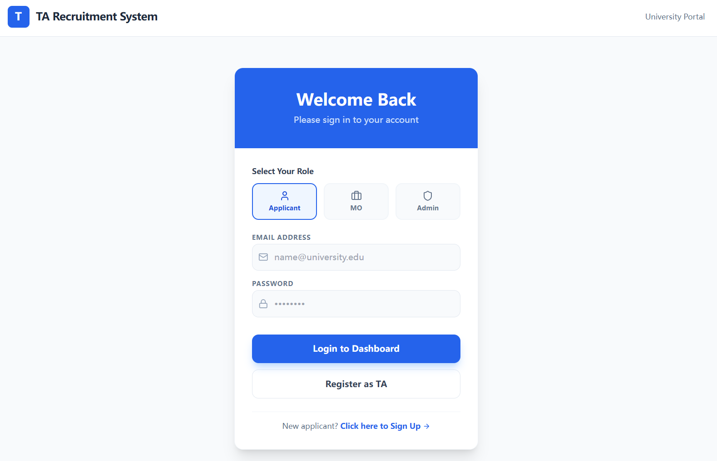
- TA Registration Page
Registration form for TA applicants to create an account. Includes fields for name, student ID, major, year of study, email, and password. Users must agree to terms before submitting.
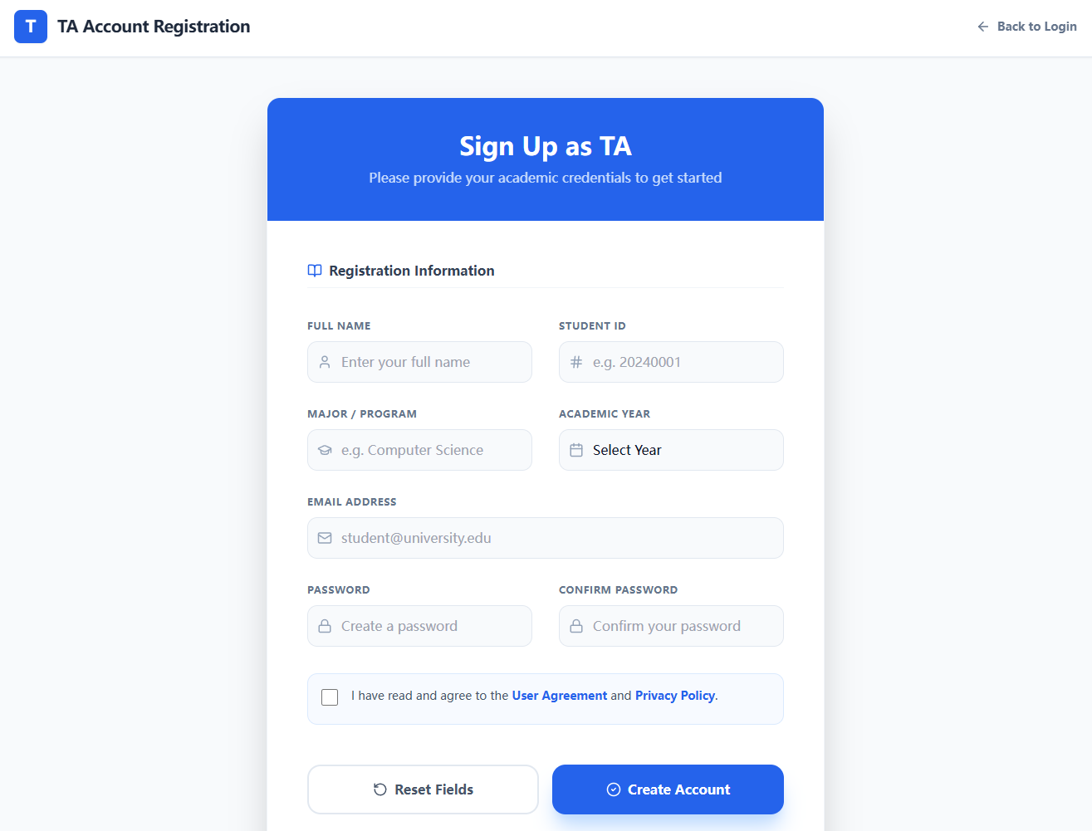
- TA Dashboard (Home)
Main landing page for TA after login. Displays profile summary, application status statistics, CV status, recent notifications, and shortcuts to browse jobs, edit profile, and check applications.
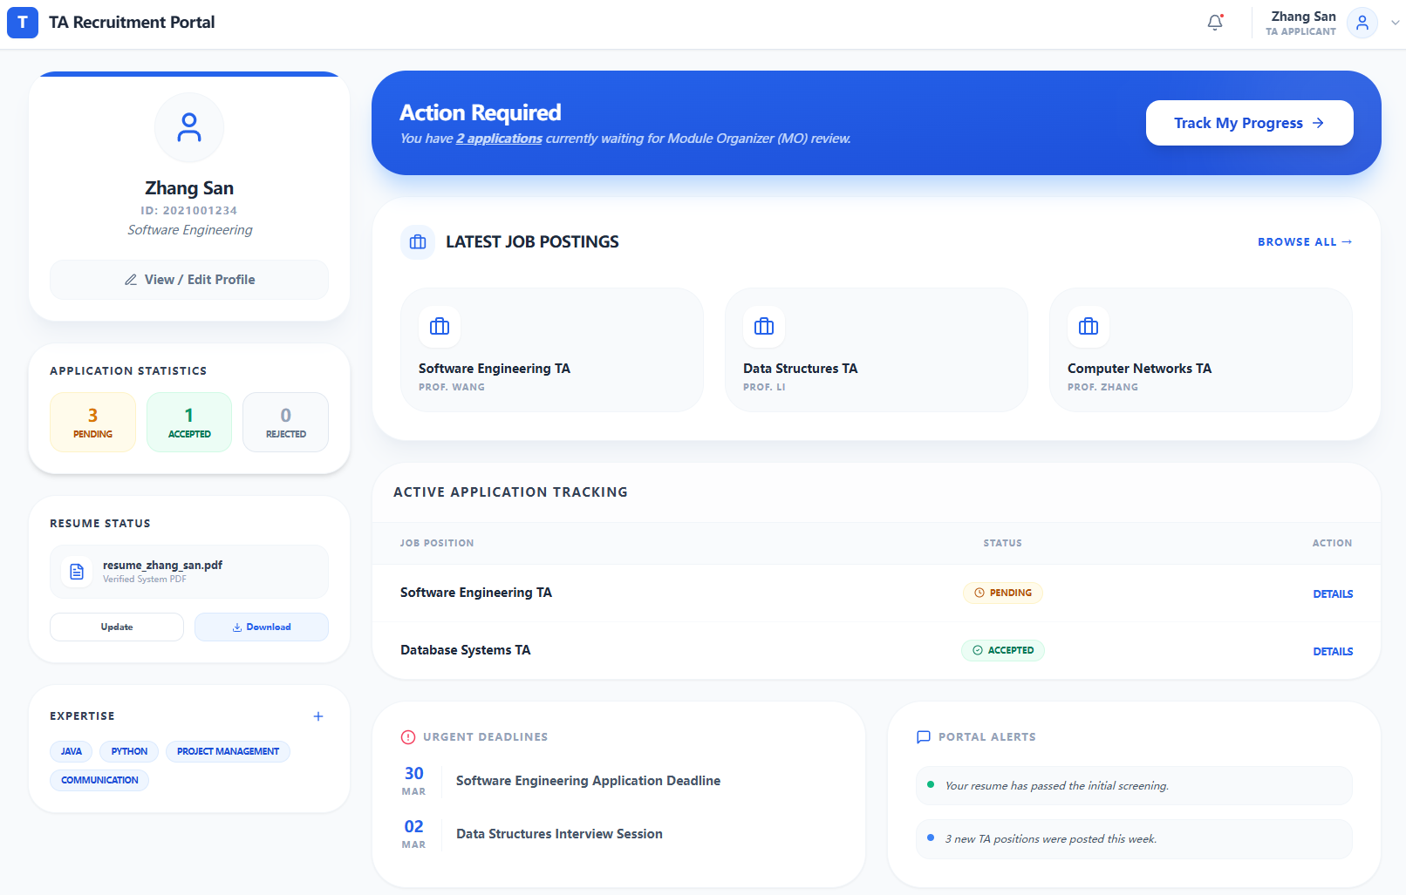
- TA Profile / CV Management Page
Page for TA to view and edit personal information, manage skill tags, and upload or replace CV (PDF only, with size validation). Student ID is locked from editing.
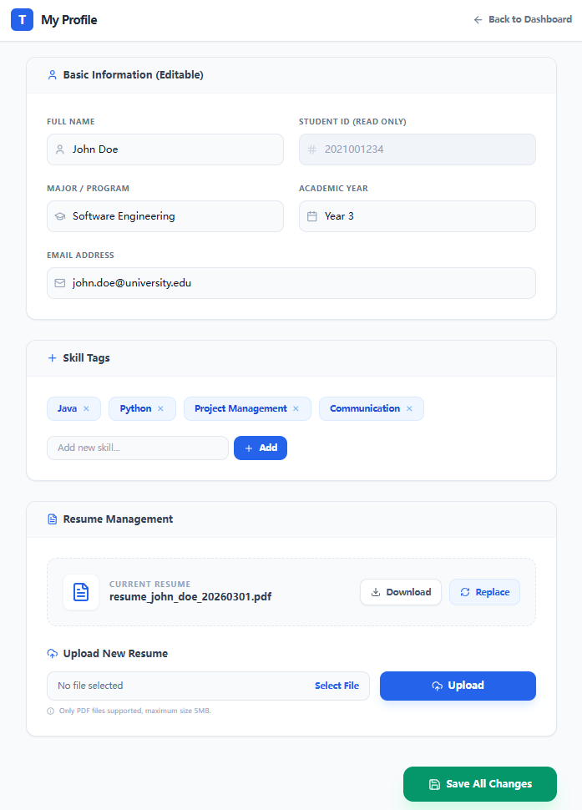
- Job Listings Page (TA view)
Displays all available TA vacancies in a list or card view. Includes search by keyword, filter by criteria, and sort options. Each item shows key details like module name, deadline, and available positions.
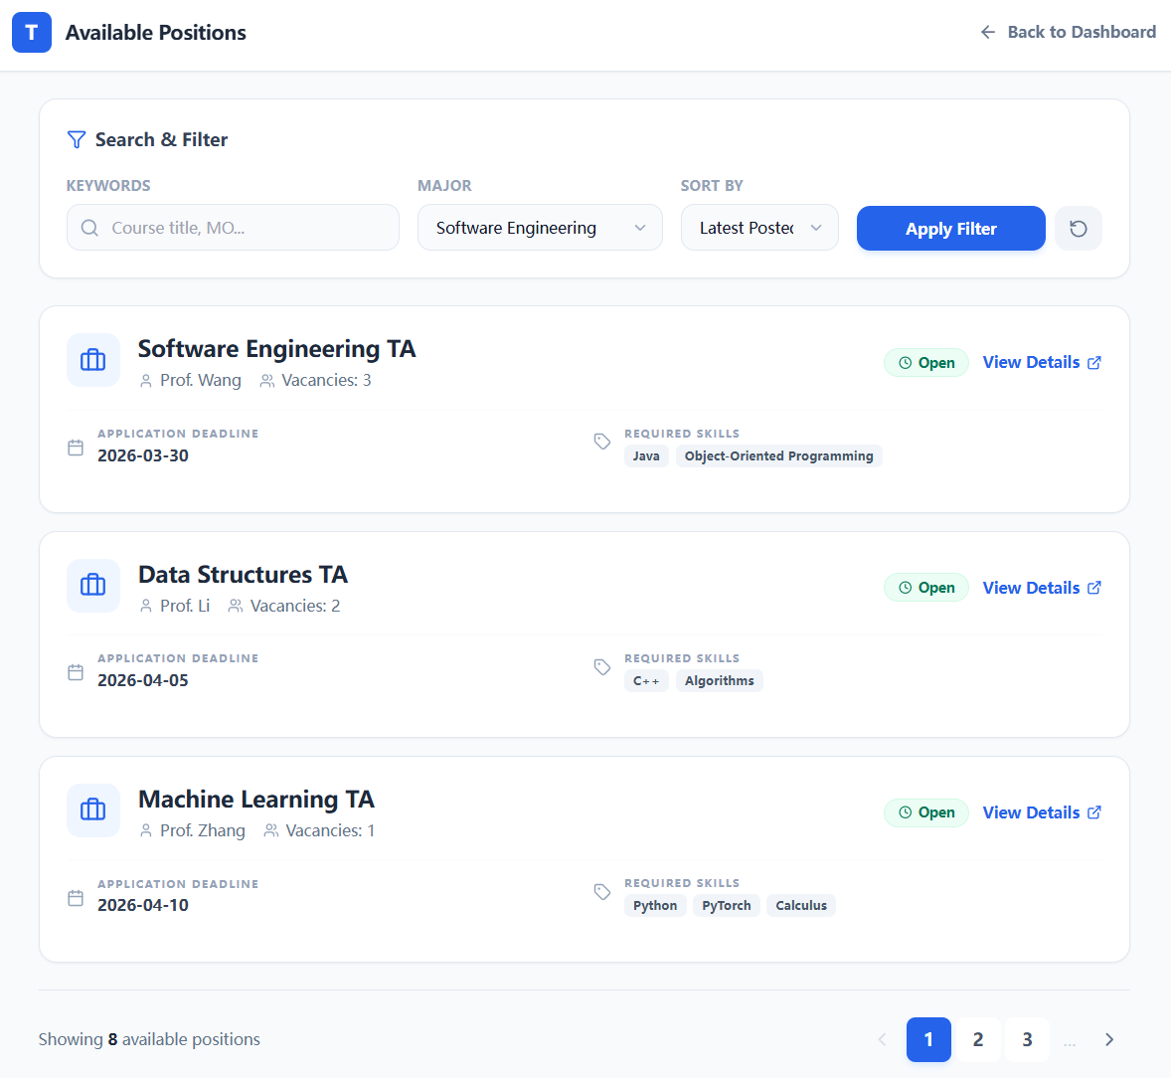
- Job Details Page (TA view)
Shows full information of a selected vacancy including description, requirements, workload, and deadline. Includes an "Apply Now" button and show skill matching information by AI smart matching.
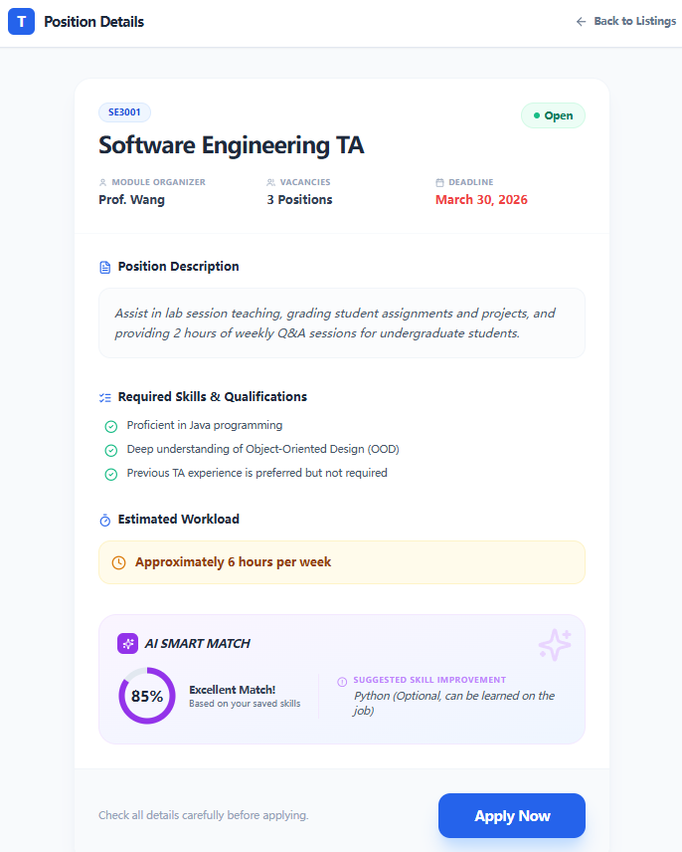
- Application Confirmation Page
Allows TA to review their application before final submission. Checks if profile is complete and CV is uploaded. Prevents duplicate applications and submissions after deadline.
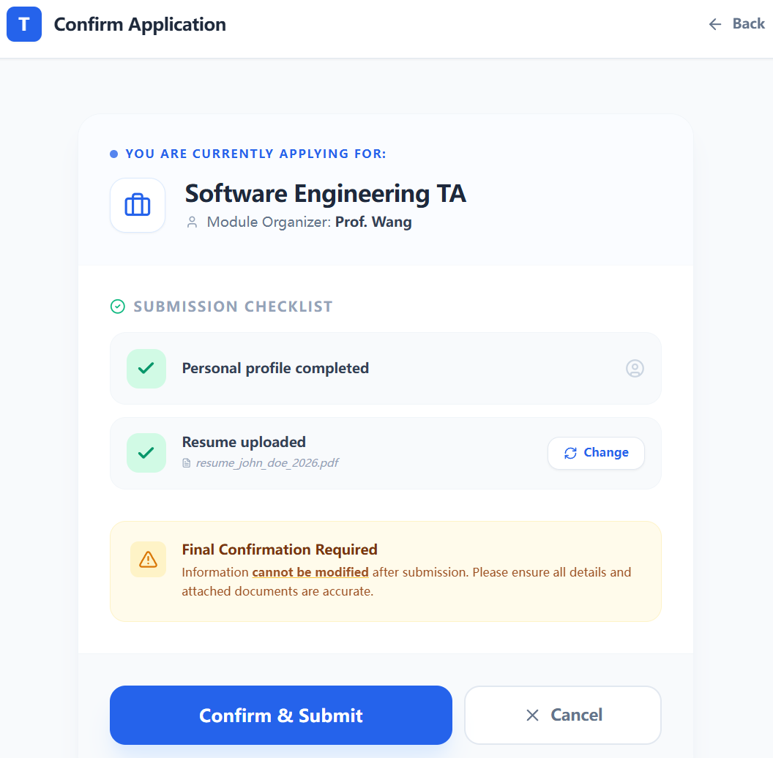
- My Applications Page
Lists all applications submitted by the TA with details such as job title, submission date, and current status (pending, accepted, rejected). Includes filter by status option.
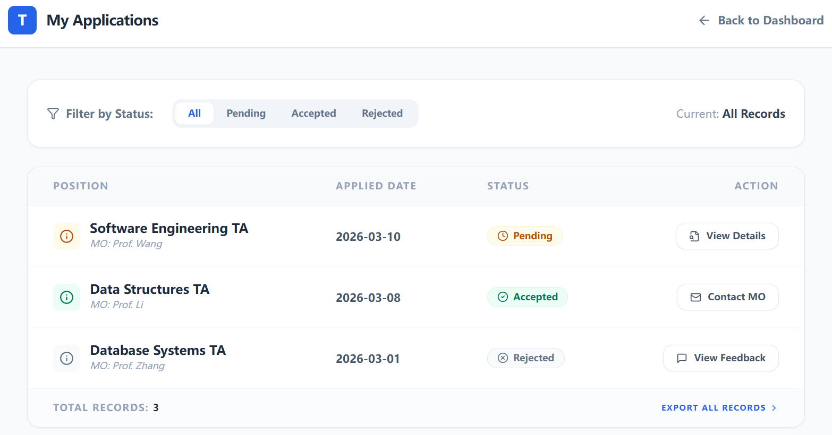
- MO Dashboard (Home)
Main page for Module Organiser after login. Displays profile summary, pending applications count, quick actions (post job, view my jobs), and a list of recent job postings with applicant numbers.
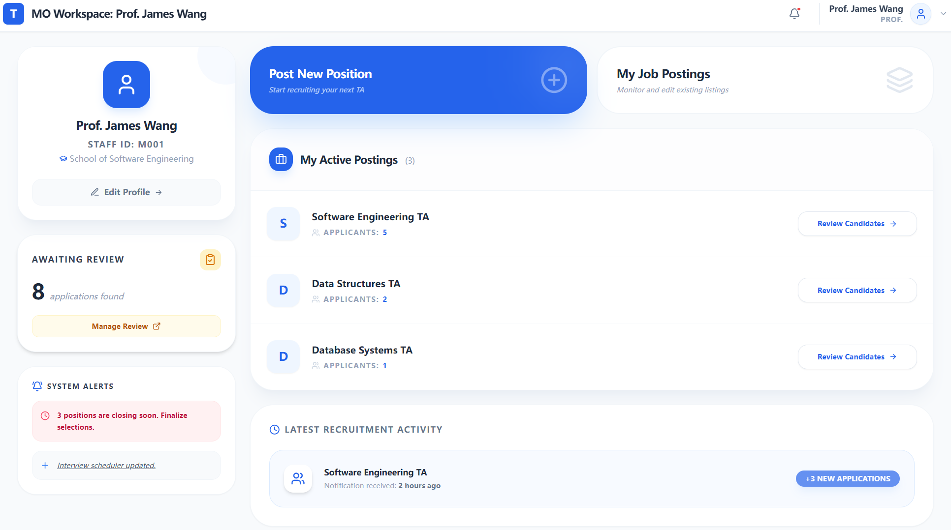
- MO Profile Edit Page
Page for MO to edit personal information including name, email, department, and contact number. Includes a text area for personal description. Password change option is also available.
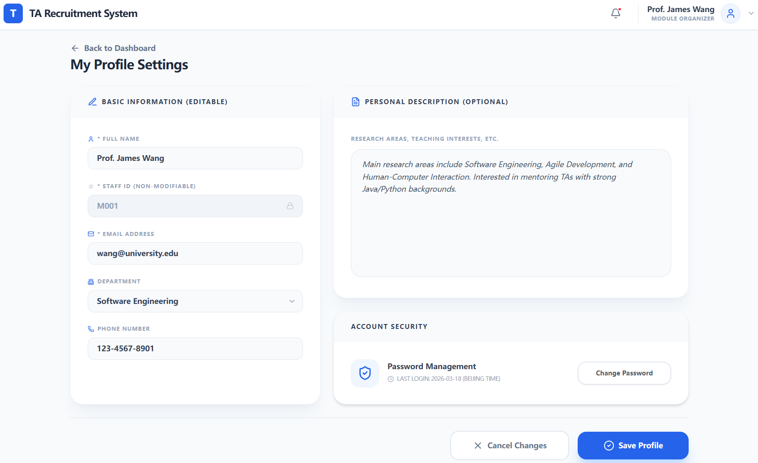
- Post Job Page
Form for MO to create and publish a new TA vacancy. Includes fields for course name, description, required skills, deadline, number of positions, and workload information with validation.
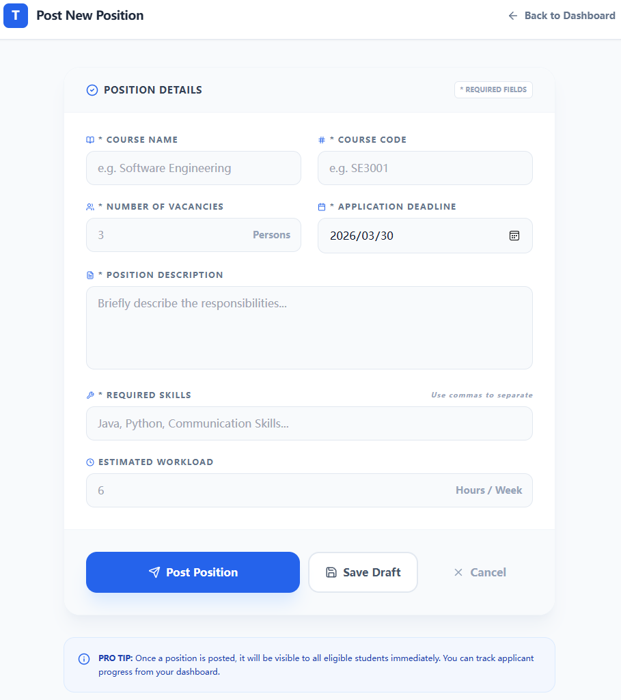
- My Job Postings Page
Lists all jobs posted by the MO with details like course name, deadline, applicant count, and status. Includes action buttons to view applicants, edit, or close the posting.
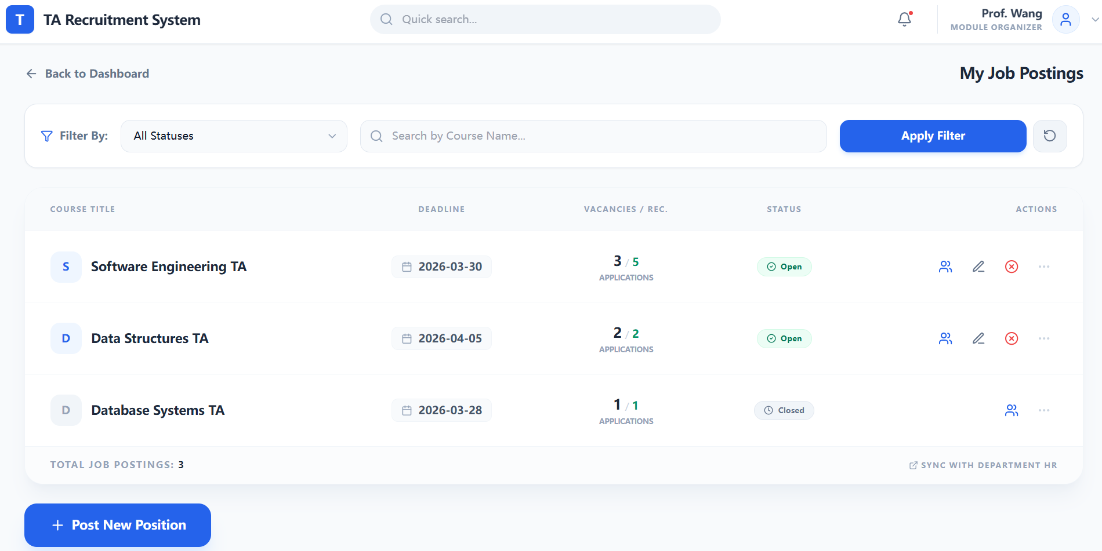
- Applicants List Page
Shows all applicants for a specific job posting in a table format. Displays applicant name, major, year, skill match (if applicable), and status. Includes buttons to view details and make decisions.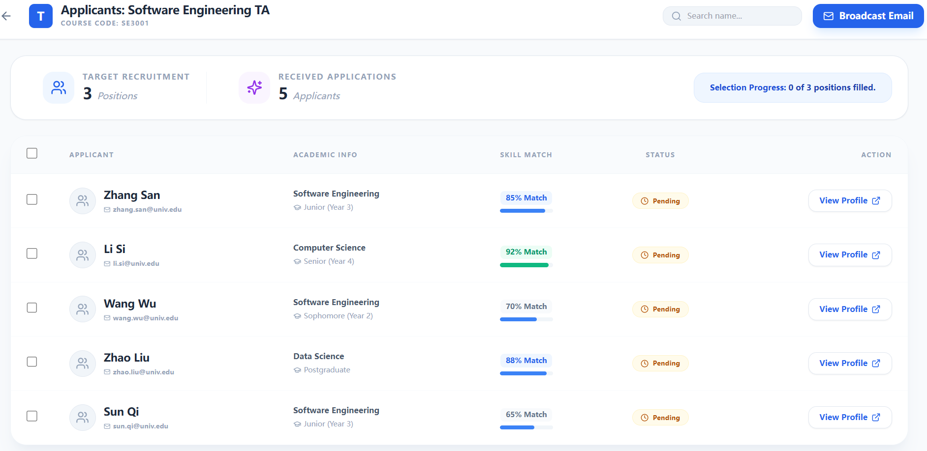
- Applicant Details Page
Displays detailed profile and CV of a specific applicant. Includes personal information, skill tags, CV preview/download, and skill match analysis. Provides Accept/Reject decision buttons.
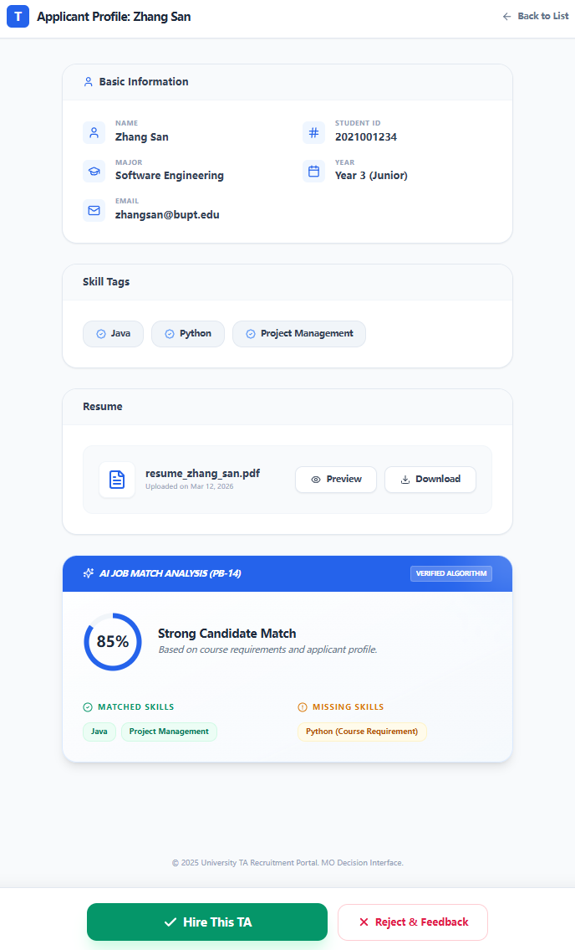
- Admin Dashboard
Overview page for Admin showing system statistics (total TAs, MOs, jobs). Includes quick action buttons for creating MO accounts, viewing all jobs, and exporting reports. Sidebar navigation to all admin functions.
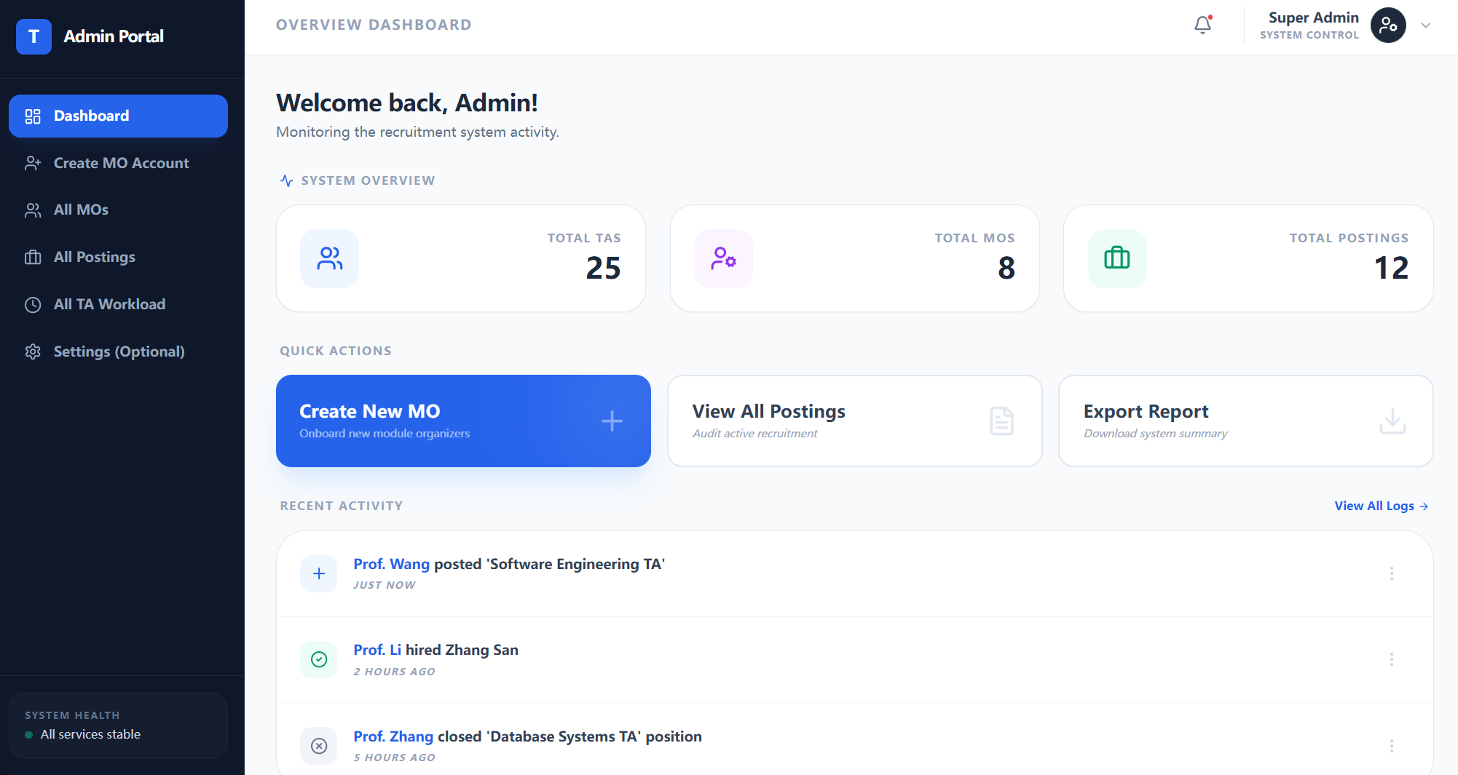
- Create MO Account Page
Form for Admin to create a new Module Organiser account. Includes fields for name, employee ID, email, department, and initial password. Option to generate random password.
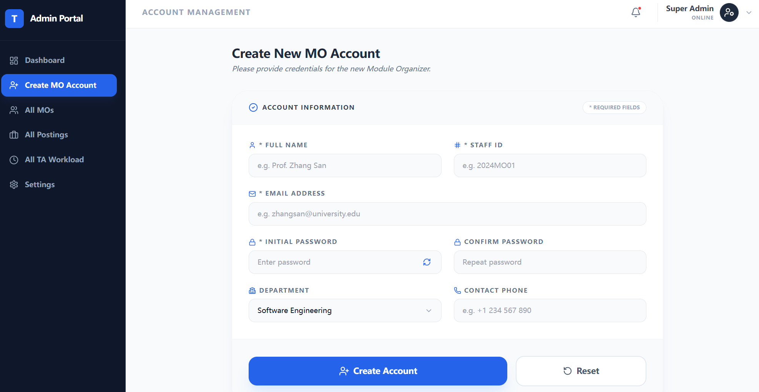
- View All MOs Page
Lists all Module Organiser accounts in a table with details like name, employee ID, email, department. Includes search/filter and action buttons for viewing details and resetting password.
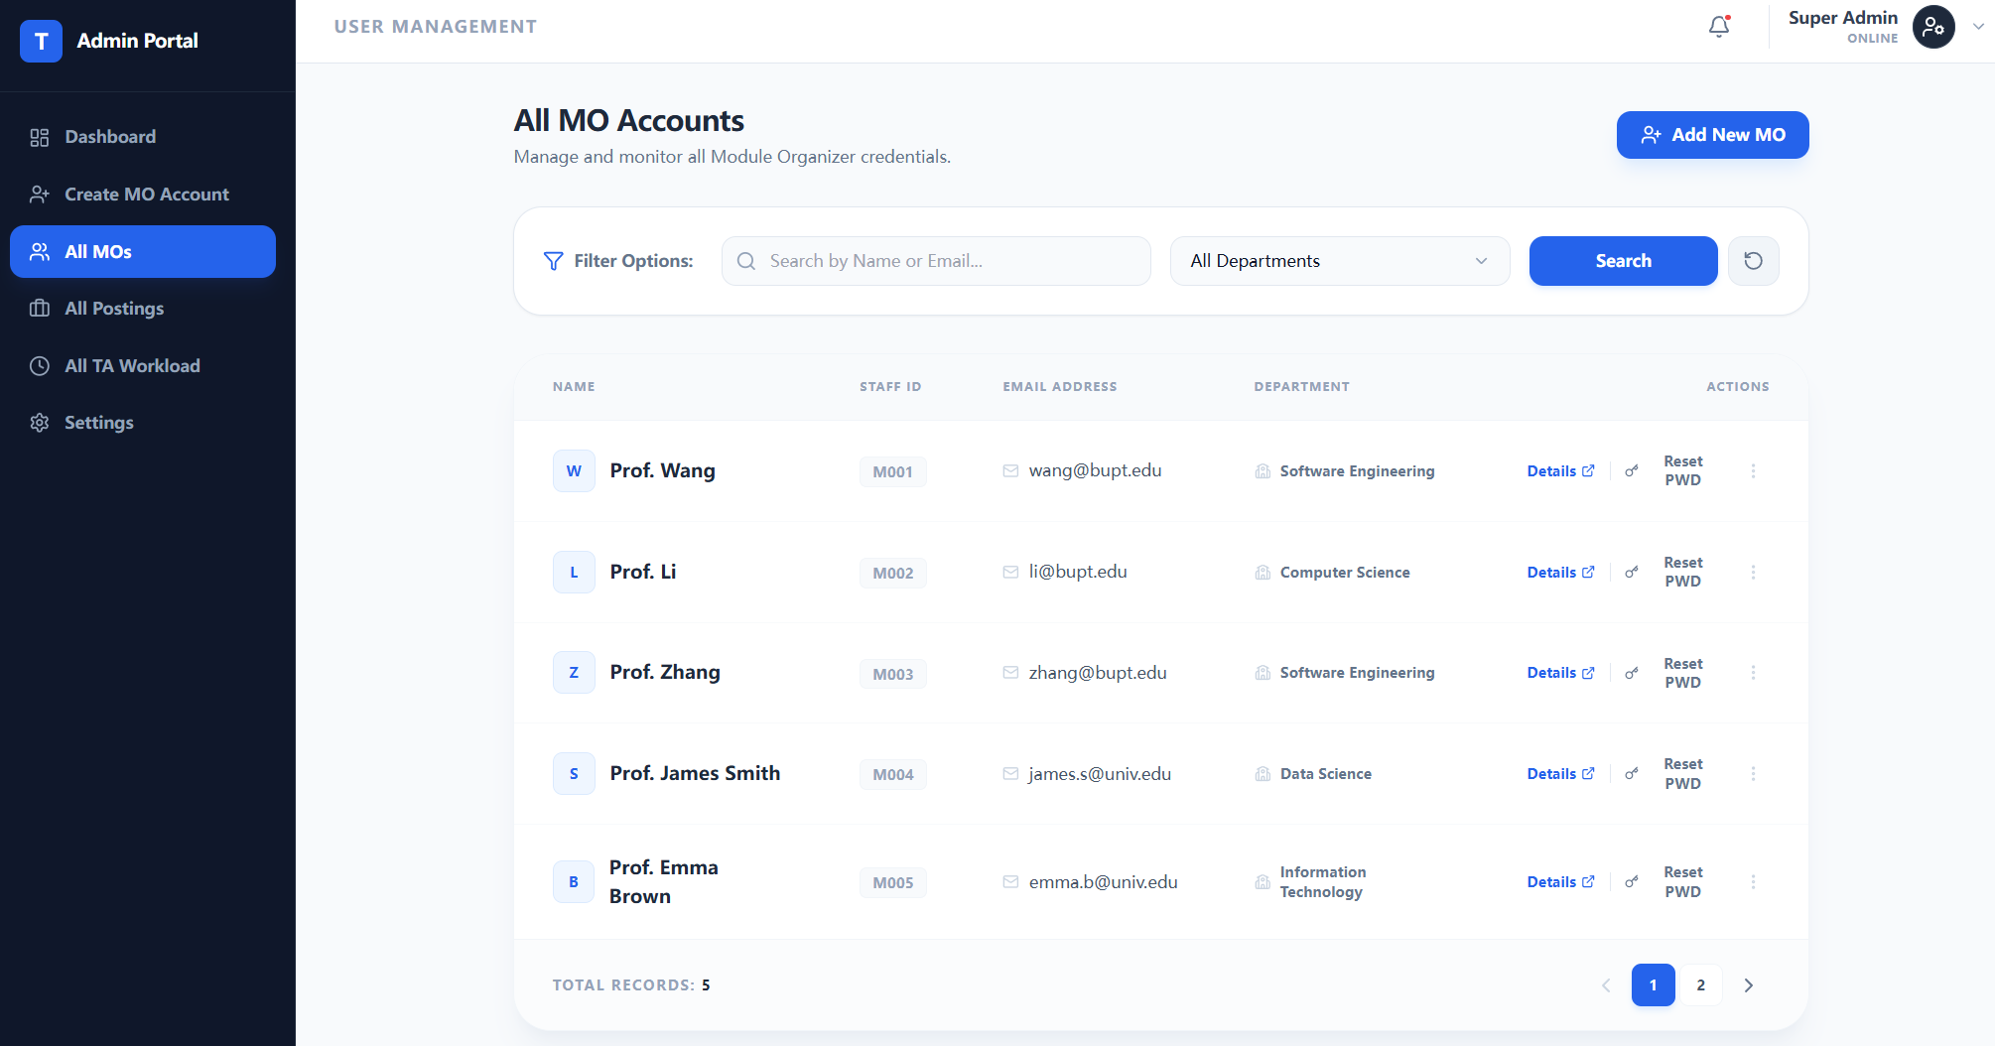
- View All Jobs Page
Lists all job vacancies across the system with details such as course name, posting MO, deadline, application count, and status. Includes filtering options by course, MO, and status.
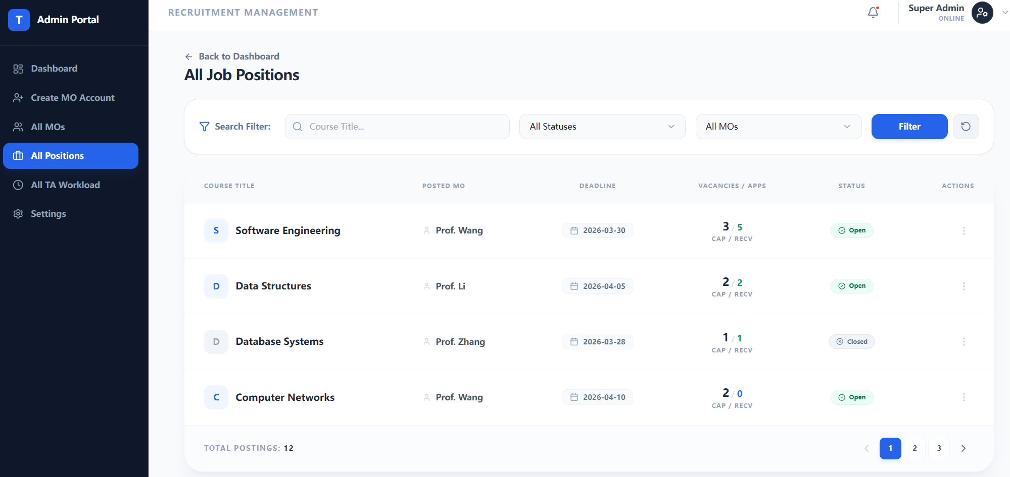
- TA Workload Analysis Page
Displays all TAs with their application counts, total workload hours, and status indicators. Includes search/filter by name, major, and workload level. Option to export report.
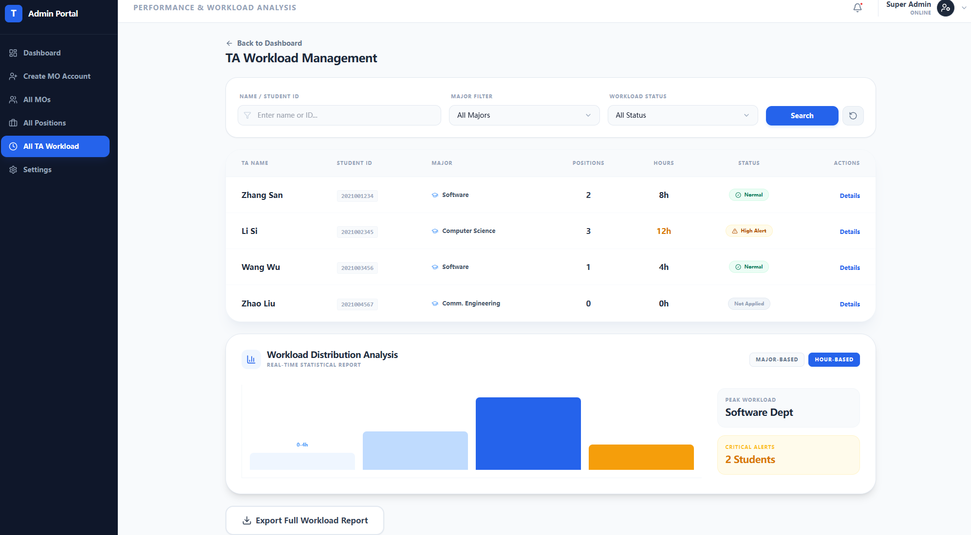
- MO Details Page (Admin view)
Displays detailed information of a specific MO with all fields editable. Includes name, employee ID, email, department, contact number, and personal description. Password reset options available.
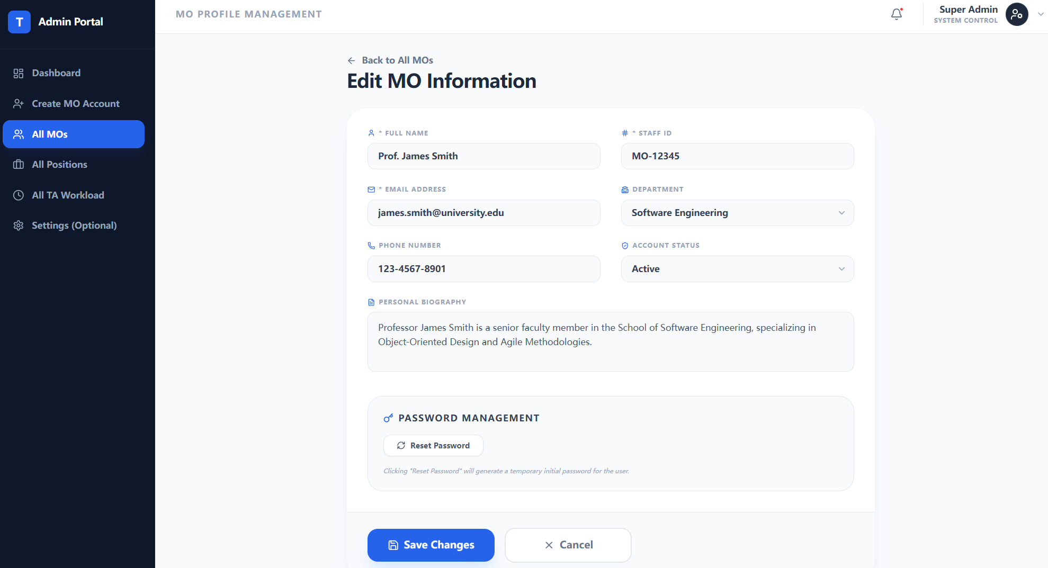
- Access Denied / Error Page
Shown when a user attempts to access a page without proper permissions. Provides options to return to home page or switch accounts. Also used for general system errors.
