Supervised BERT Baselines for Argumentation Tasks

1. Motivation
Our LLM-based experiments on two argumentation tasks — argument relation classification (Persuasive Essays) and tort prediction (JTD) — show that performance on these subtasks remains limited. To contextualize these results, we finetune BERT models as supervised baselines. The goal is twofold:
- Gauge the difficulty of each subtask by measuring how well a model with direct access to labeled training data can perform.
- Identify the nature of the bottleneck: if a supervised model with full training data still underperforms LLMs (which operate zero/few-shot), this indicates the task requires reasoning beyond statistical pattern matching.

2. Task 1: Essay Argument Relation Classification

2.1 Task Formulation
Given an essay and a pair of gold argument spans, classify the directed relation between them as support, attack, or none. This isolates relation classification from argument identification, matching the gold_fs / gold_zs conditions in our LLM experiments.
- Dataset: Persuasive Essays v2 (AAEC). 322 train / 80 test essays.
- Training pairs: All ordered pairs of gold arguments per essay, with none-class subsampling (ratio 3:1).
- Class distribution (test): 96.0% none, 3.8% support, 0.2% attack — extreme imbalance.

2.2 Model Design: Entity-Marker BERT
A critical design insight emerged from our initial experiments: argument position within the essay is a strong discriminative feature (related pairs are 2.8x closer in character distance than unrelated pairs). A naive input format that places the essay in one segment and the arguments in another prevents BERT from exploiting this signal, since it cannot easily perform cross-segment substring matching.
We adopt the entity-marker approach from NLP relation extraction (Baldini Soares et al., 2019): arguments are marked in-place within the essay using special tokens [E1]/[/E1] and [E2]/[/E2].
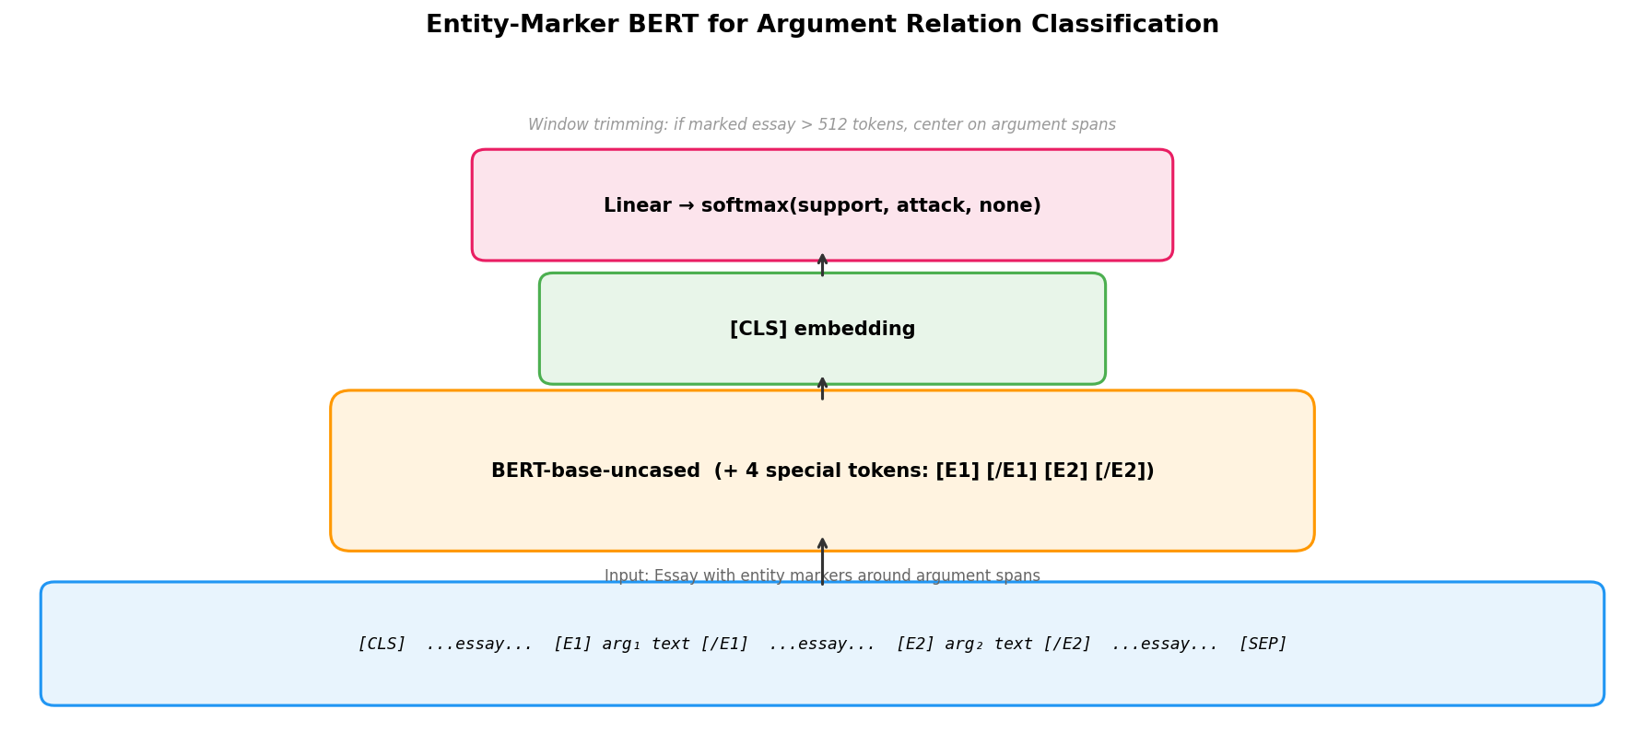
Entity-Marker BERT Architecture
Input format:
[CLS] ...essay text... [E1] arg₁ text [/E1] ...essay text... [E2] arg₂ text [/E2] ...essay... [SEP]
Key design choices: - Window trimming: When the marked essay exceeds 512 tokens, we trim to a window centered on the two argument spans, preserving the discourse context between them. - Inverse-frequency class weights: Without class weighting, the model collapses to always predicting the majority class (none). An ablation (entity markers + no class weights) confirmed this: the model achieved 0.000 relation macro F1 across all 10 epochs. - Special tokens: [E1], [/E1], [E2], [/E2] are added to the vocabulary and BERT’s embedding matrix is resized accordingly.

2.3 Results
Metric: Relation Macro F1 = mean(Support F1, Attack F1), micro-aggregated (pool TP/FP/FN across all 80 test essays, then compute per-type F1).
Method | Support F1 | Attack F1 | Rel Macro F1
Random (always-support) | 0.073 | 0.000 | 0.037
BERT (entity markers, no weights) | 0.000 | 0.000 | 0.000
BERT (entity markers, weighted) | 0.233 | 0.110 | 0.172
LLM: GPT-5 mini (gold_fs) | 0.379 | 0.113 | 0.246
LLM: GPT-5.2 (gold_fs) | 0.439 | 0.169 | 0.304
LLM: Claude Haiku 4.5 (gold_fs) | 0.452 | 0.214 | 0.333
LLM: Claude Sonnet 4.5 (gold_fs) | 0.485 | 0.238 | 0.362
LLM: Gemini 3 Flash (gold_fs) | 0.526 | 0.259 | 0.392
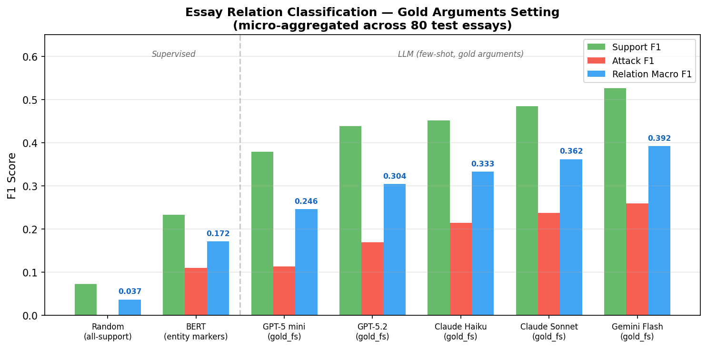
Essay Results Comparison
Training dynamics: The entity-marker BERT model trained properly — val macro F1 improved from 0.000 (epoch 1) to 0.226 (epoch 9), with attack F1 appearing from epoch 6 onwards. The model learned to use positional cues to discriminate related from unrelated pairs, but with limited precision (13.9% for support).

2.4 Discussion
The supervised BERT baseline (0.172) substantially outperforms random (0.037, 4.6x improvement), confirming that entity markers enable learning of positional and contextual features. However, all LLMs outperform BERT by a wide margin (best LLM: 0.392, 2.3x BERT).
This result is notable because BERT has a supervised advantage (282 labeled training essays) while LLMs operate with only 3 few-shot examples. The gap indicates that argument relation classification relies heavily on semantic understanding of argumentation — recognizing that “lack of adequate controls” supports “negative impacts” requires world knowledge about causal reasoning that BERT cannot acquire from ~10K training pairs.
The BERT result does not serve as a performance ceiling. Instead, it establishes a lower bound for what positional pattern matching alone can achieve, highlighting that the LLMs’ advantage comes from genuine discourse reasoning.

3. Task 2: JTD Tort Prediction

3.1 Task Formulation
Given a Japanese tort case (undisputed facts, plaintiff claims, defendant claims), predict whether the tort is affirmed or denied (binary classification). As a multi-task objective, we also predict per-claim acceptance (rationale extraction, RE).
- Dataset: 6,508 cases. 39.5% affirmed, 60.5% denied.
- Split: Stratified 80/10/10 → 5,206 train / 651 val / 651 test.
- Note: LLM experiments used a 100-case subsample with 5-fold CV. The comparison is informative but not directly head-to-head due to different data scales.

3.2 Model Design A: Hierarchical Claim-Level BERT
The key challenge is that 42% of cases exceed BERT’s 512-token limit when concatenated as flat text, systematically truncating defendant claims (which appear last). We address this with a hierarchical architecture that encodes each claim independently.
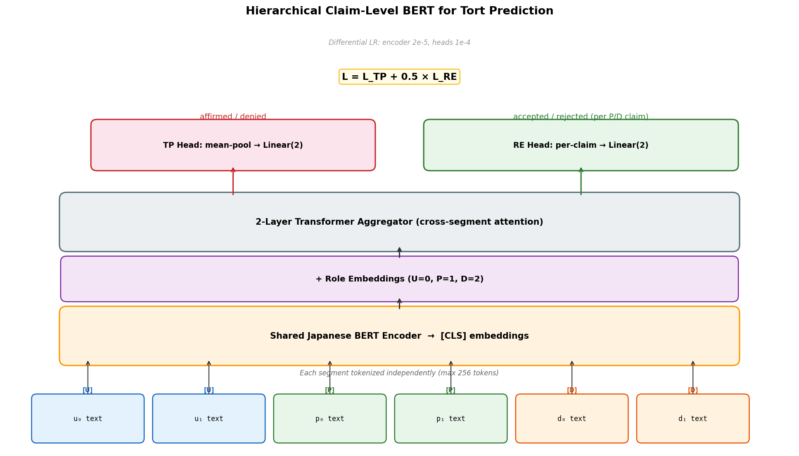
Hierarchical BERT Architecture
Architecture: 1. Segment encoder: cl-tohoku/bert-base-japanese-v3 encodes each claim/fact independently (max 256 tokens). Only 2.1% of individual segments exceed this limit. 2. Role embedding: Learned embeddings for U/P/D roles, added to segment [CLS] vectors. 3. Transformer aggregator: 2-layer Transformer encoder with cross-segment attention. 4. TP head: Mean-pool all segment embeddings → Linear(2) for tort prediction. 5. RE head: Per-claim embeddings → Linear(2) for acceptance prediction. 6. Multi-task loss: L = L_TP + 0.5 L_RE.
Key design choices: - Differential learning rate: Encoder at 2e-5, aggregator/heads at 1e-4. - Gradient accumulation (8 steps) for effective batching across variable-length cases. - bf16 mixed precision for memory efficiency.

3.3 Model Design B: Flat BERT with Interleaved Claims
As a simpler alternative, we use standard BertForSequenceClassification with a carefully designed input encoding to mitigate truncation bias.
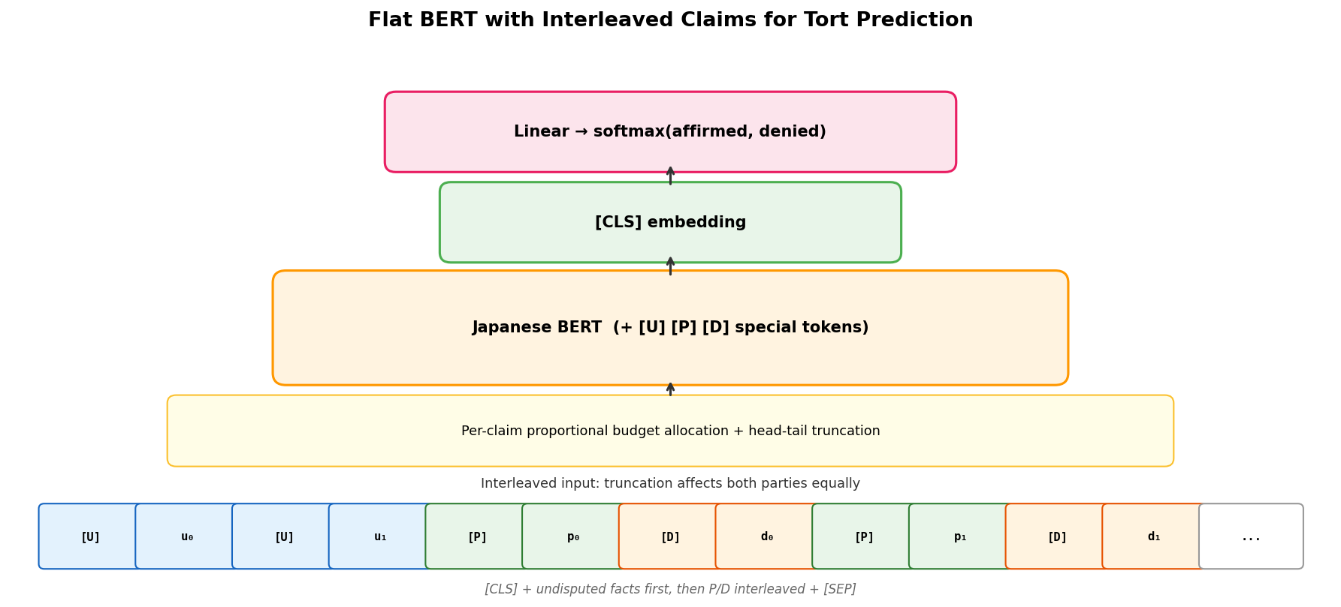
Flat BERT Architecture
Truncation strategy: 1. Undisputed facts placed first (background context). 2. Plaintiff and defendant claims interleaved (p₀, d₀, p₁, d₁, …) so truncation affects both parties equally. 3. Role markers [U], [P], [D] as special tokens. 4. Proportional per-claim budget with head-tail truncation: each claim gets a fair share of the 512-token budget; both the beginning and end of each claim are preserved (important for legal text where conclusions often appear at the end).

3.4 Results
Method | Data Setting | RE Micro-F1 | TP Accuracy | TP Macro-F1
Random (stratified) | — | 0.514 | 0.500 | 0.500
LLM: Kimi K2.5 B0 | 100 cases, 5-fold | 0.722 | 0.618 | 0.611
LLM: Gemini B1 | 100 cases, 5-fold | 0.700 | 0.627 | 0.610
LLM: Kimi K2.5 B2 (Strat B) | 100 cases, 5-fold | 0.470 | 0.640 | 0.597
BERT Flat | 6508 cases, split | — | 0.704 | 0.682
BERT Hierarchical | 6508 cases, split | 0.681 | 0.707 | 0.692
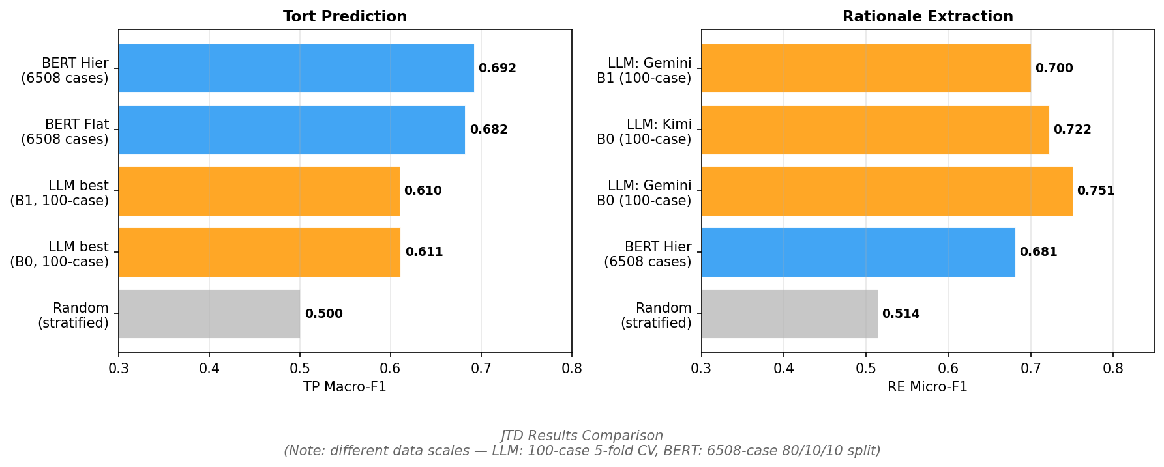
JTD Results Comparison
Training dynamics (hierarchical): Loss decreased steadily from 1.01 to 0.20 over 9 epochs. Validation metrics improved smoothly to TP Macro-F1 = 0.72 before early stopping — proper convergence with no oscillation, in stark contrast to the unstable training observed with the earlier 100-case setup.

3.5 Discussion
TP performance: BERT with full training data (0.692 Macro-F1) outperforms the best LLM (0.611) by 8 points. However, this gap is expected given the ~50x data advantage (5,206 vs ~80 effective training cases per fold). The more informative comparison is the BERT ceiling against the inherent difficulty: at 0.692, there is meaningful room above random (0.500) but well below perfect, suggesting tort prediction from claim text alone is a fundamentally hard task.
RE performance: Notably, LLM B0 (Gemini, 0.751) outperforms the BERT RE head (0.681) despite the massive data disadvantage. This suggests that per-claim acceptance prediction benefits from LLMs’ legal reasoning capabilities — understanding whether a legal argument is likely to be accepted by a court requires domain knowledge that supervised training on 5,206 cases does not fully capture.
Hierarchical vs Flat: Nearly identical TP performance (0.692 vs 0.682, = 0.010). The flat model’s interleaved truncation strategy effectively mitigates the systematic defendant-truncation bias that motivated the hierarchical design. The hierarchical model’s advantage is its ability to also produce RE predictions, making it a multi-task model.
TP from RE (hierarchical only): The TP-from-RE strategy (deriving tort prediction from aggregated claim-level predictions) achieves 0.667 Macro-F1, slightly below the direct TP head (0.692). The RE-to-TP consistency is 89.2%, indicating the two prediction paths largely agree.

4. Summary
Task | Supervised BERT | Best LLM | Who wins?
Essay Relation Classification | 0.172 | 0.392 (Gemini, gold_fs) | LLM by 2.3x
JTD Tort Prediction | 0.692 | 0.611 (Kimi, B0) | BERT by 0.08*
JTD Rationale Extraction | 0.681 | 0.751 (Gemini, B0) | LLM by 0.07*
* Different data scales: BERT uses 6,508 cases; LLMs use 100-case subsample.
Key insights:
- Argument relation classification is not a pattern-matching task. Even with entity markers that encode positional information and supervised training on 282 essays, BERT achieves less than half the performance of few-shot LLMs. This validates the premise of using LLM-based methods for argumentation framework construction — the task genuinely requires reasoning that goes beyond statistical associations.
- Tort prediction benefits from training data. With sufficient labeled data, supervised methods outperform zero-shot LLMs on the binary prediction task. This suggests that scaling the LLM experiments to the full dataset (or incorporating few-shot retrieval from training cases) could improve LLM TP performance.
- Legal reasoning for RE remains an LLM strength. Per-claim acceptance prediction appears to require understanding of legal merit and precedent that even 5,206 training cases cannot teach BERT. This is the most promising direction for AF-based methods that leverage LLMs’ domain knowledge.

