Snapshot Week 06 of Group PG02

Project of ATSYS

No-Code Solution for InfluxDB

LeStartUP
Zilin Song - a1833935
Jen-Hao Liu - a1893169
Dang Quy Duong - a1893592
Baojing Li - a1894836
Shih-Han Lin - a1900715
Feinan Guo - a1903270
Xiaoqing Zhao - a1904344
Hao Jiang - a1907177
Ziqi Zhang – a1909438
Product Backlog and Task Board

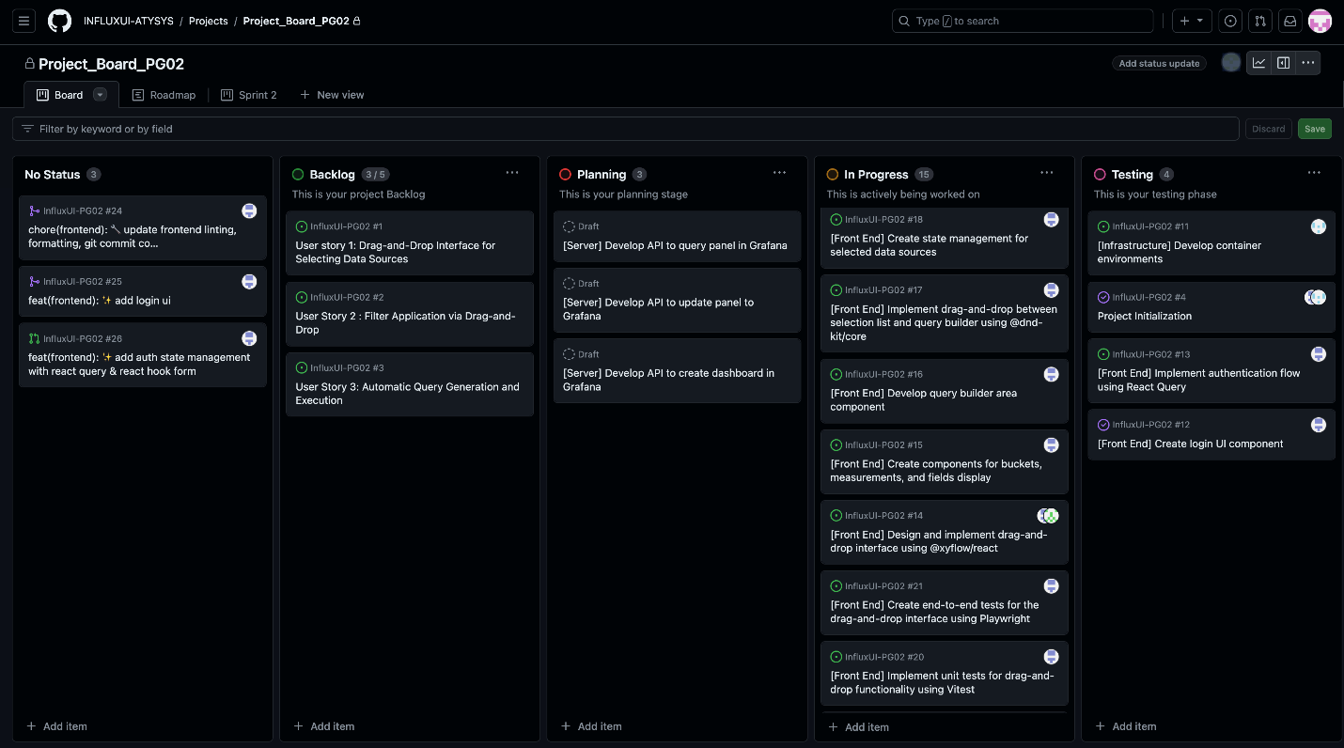
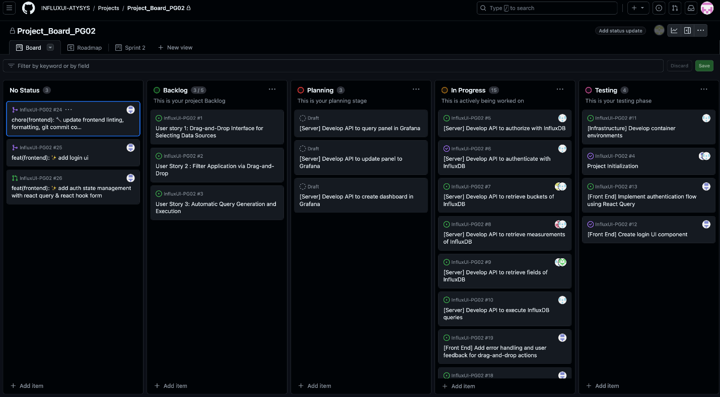Based on the characteristics of this project, our group splits into frontend and backend (server) sub teams to develop the backlog items discussed during sprint 2.

Sprint Backlog and User Stories
Commit changes for sprint 2
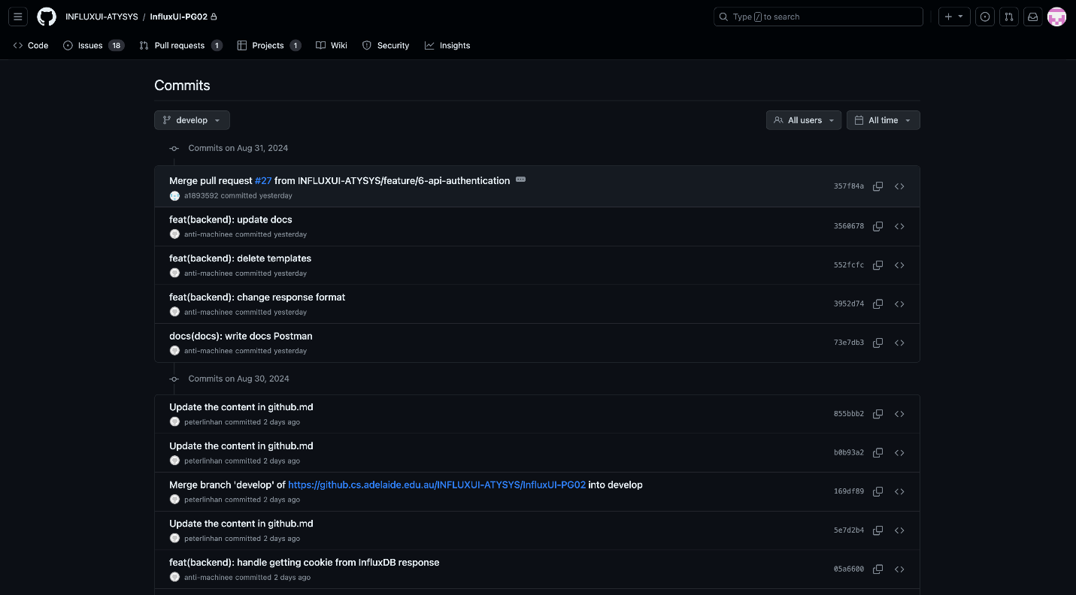
Postman API testing
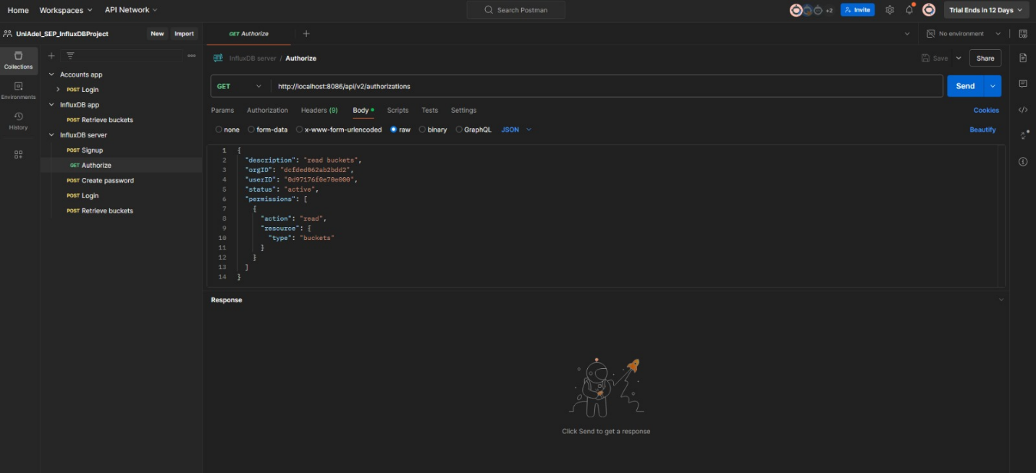

Frontend development
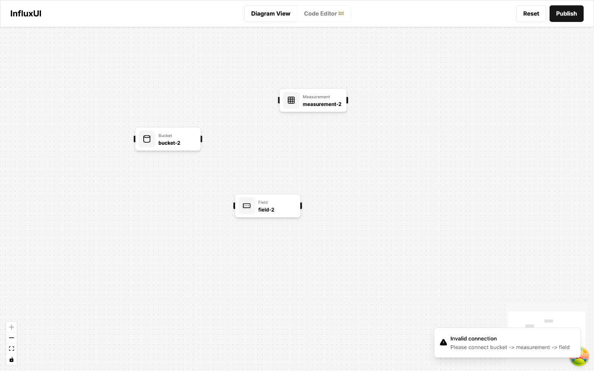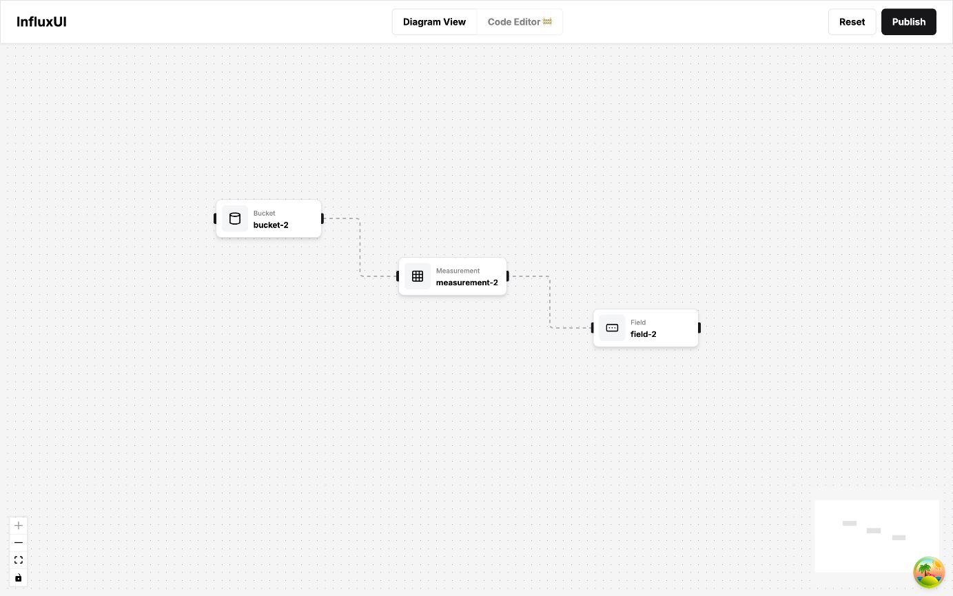
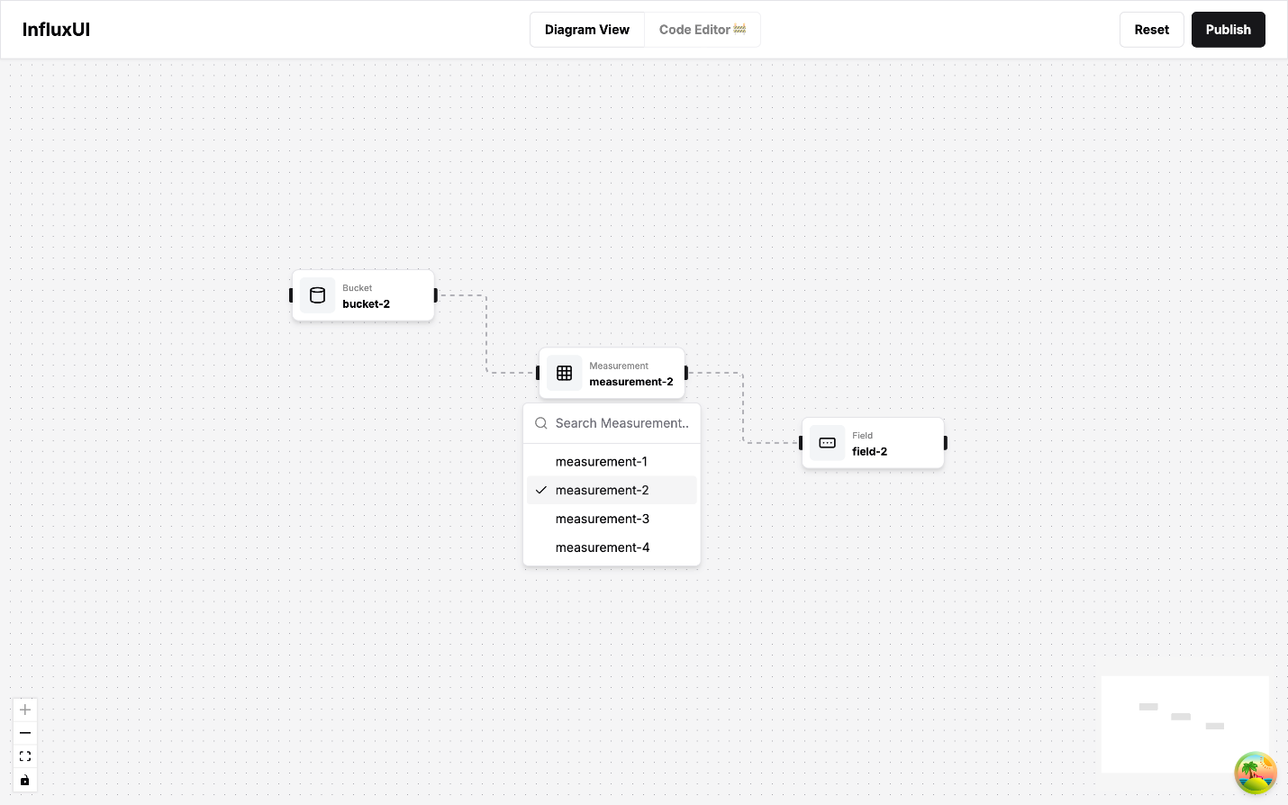
User story 1 and 2 is selected for the current sprint. While the backend team focuses on achieving the same level of authentication from InfluxDB with data integration to our application, frontend mainly based its development on drag-and-drop feature. Also, the hierarchy between bucket, measurement, and field is being handled and filter functionality is being explored.

Definition of Done
- Drag-and-drop functionality is fully implemented and intuitive for users.
- The interface is optimized for clarity and ease of use
- Filters work seamlessly with the drag-and-drop feature and the hierarchy navigation
- The features pass usability tests and validate the correct operations to ensure accuracy and performance

Summary of Changes
In the current sprint, we implemented secure authentication with InfluxDB, ensuring proper user roles and permissions while integrating real-time data seamlessly into our application. On the frontend, we developed an accessible drag-and-drop feature, making the user interface more approachable. We also mapped out and integrated the hierarchy between bucket, measurement, and field, and added filter functionality to refine data views effectively.
All code changes were thoroughly reviewed by team members, meeting the team’s coding standards, and documentation was updated to include user guides, API docs, and technical specs timely. Finally, the application was successfully deployed to a staging environment, with all the new features functioning as expected currently, bringing InfluxDB and Grafana closer to a more user-friendly system.

