Snapshot Week 10 of Group PG02

Project of ATSYS

No-Code Solution for InfluxDB

LeStartUP
Zilin Song - a1833935
Jen-Hao Liu - a1893169
Dang Quy Duong - a1893592
Baojing Li - a1894836
Shih-Han Lin - a1900715
Feinan Guo - a1903270
Xiaoqing Zhao - a1904344
Hao Jiang - a1907177
Ziqi Zhang – a1909438

Product Backlog and Task Board
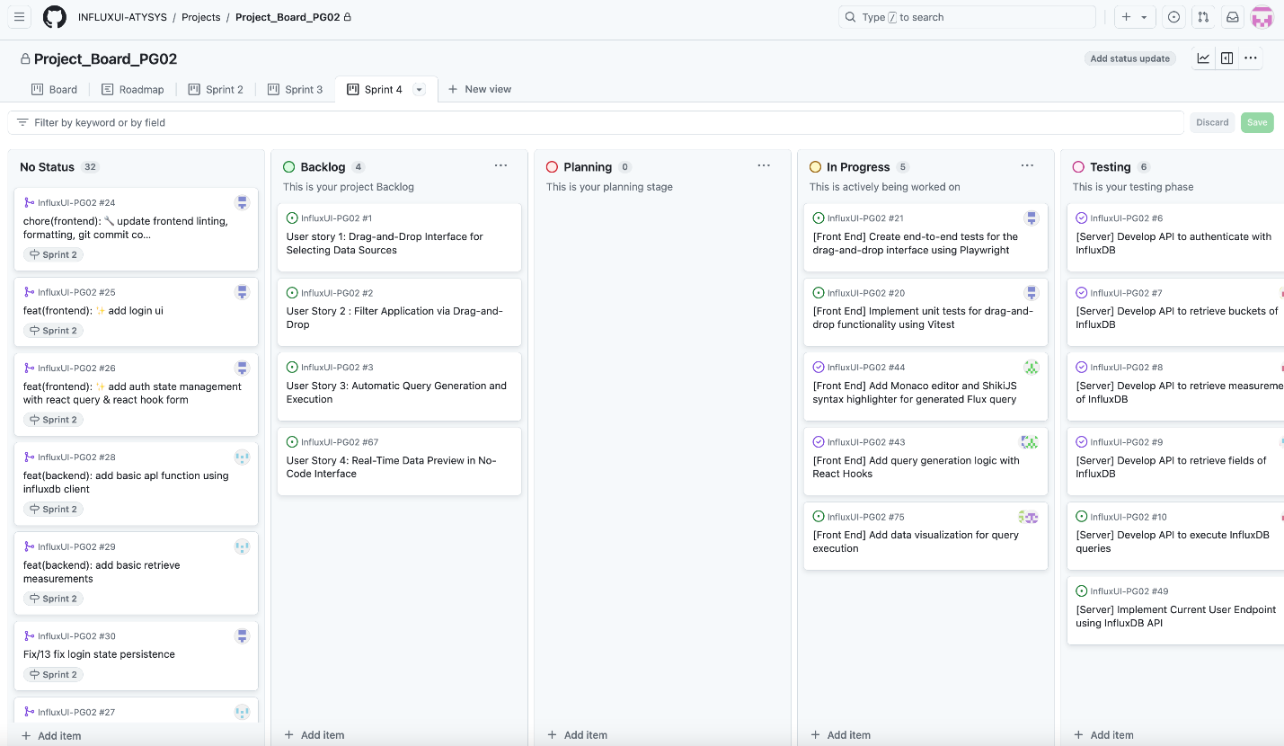
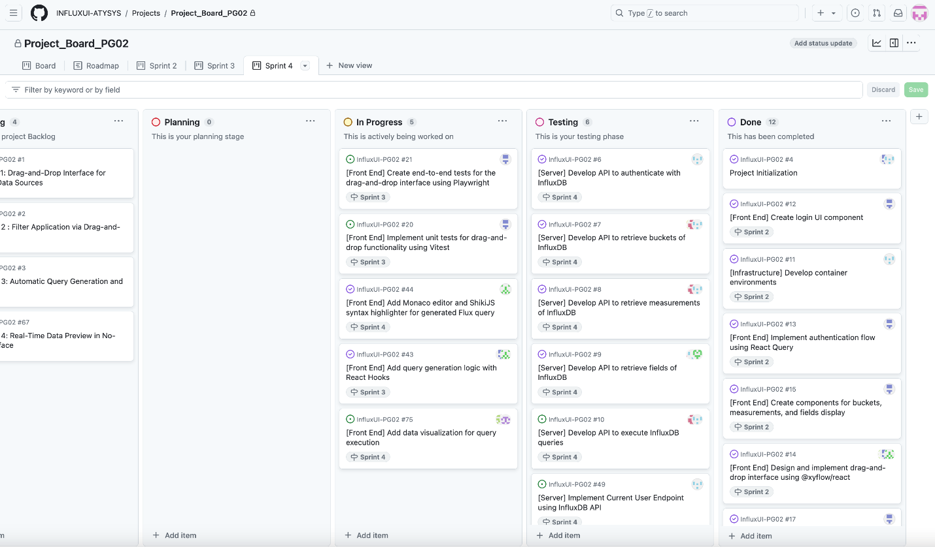

Sprint Backlog and User Stories

- Milestones of the end of sprint 4 and beginning of sprint 5:
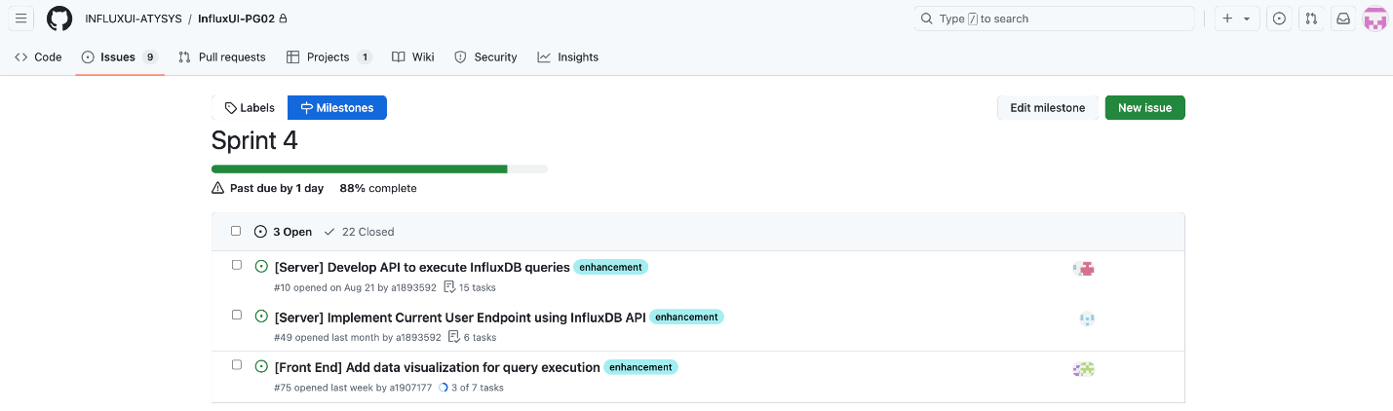

- Sprint issues we are working on:
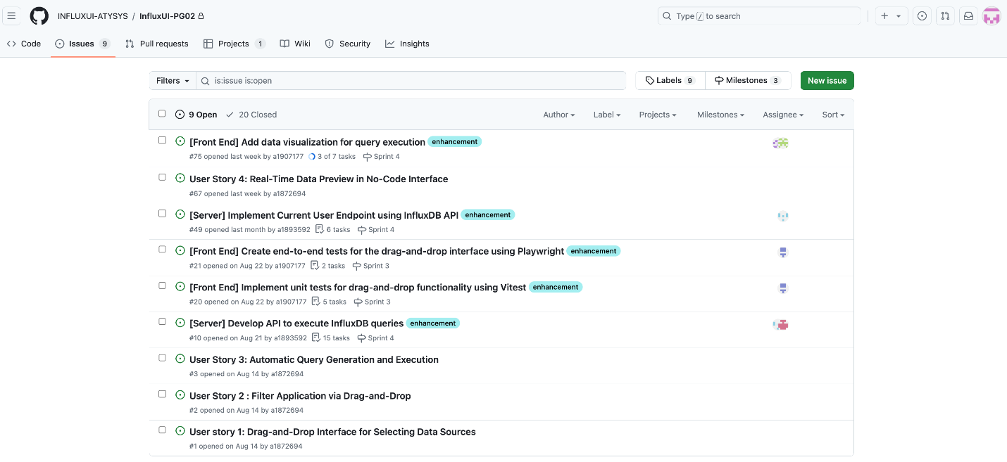

- UI: design a light mode and dark mode for user experience
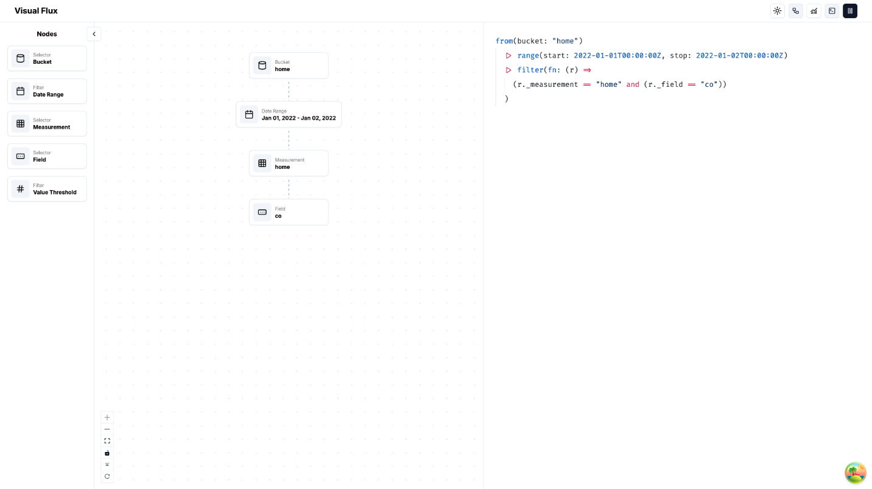

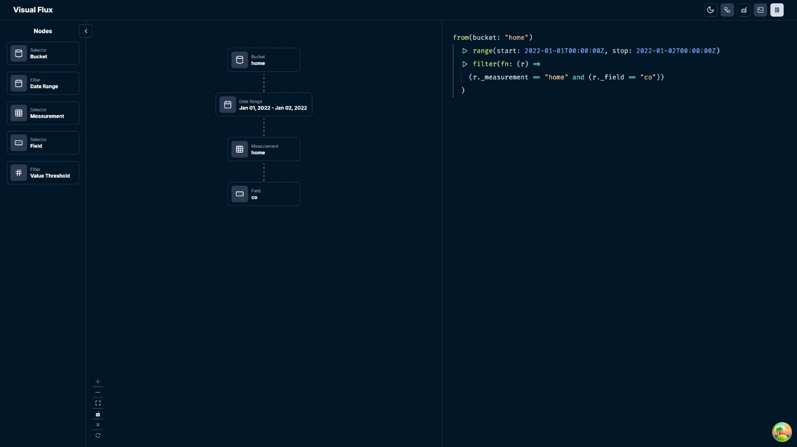

- UI: multiple-selection of drag-and-drop
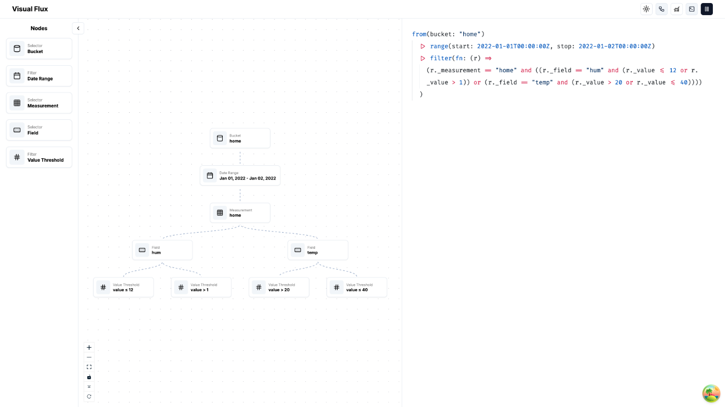

- UI: export the data to the local with a csv file
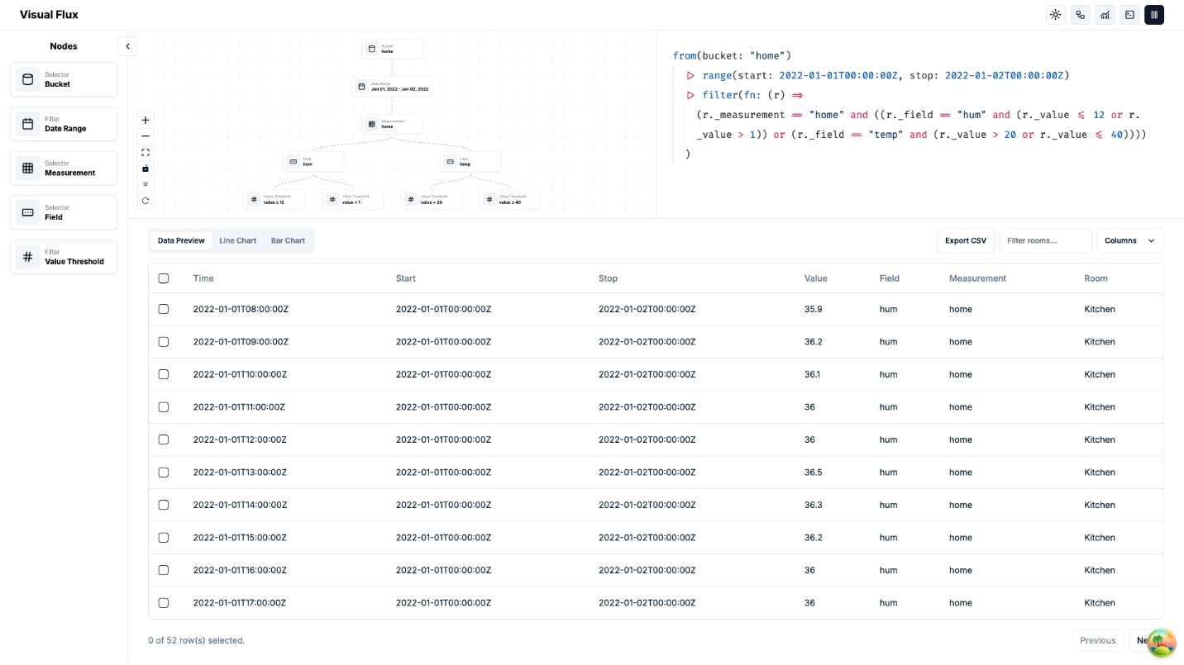
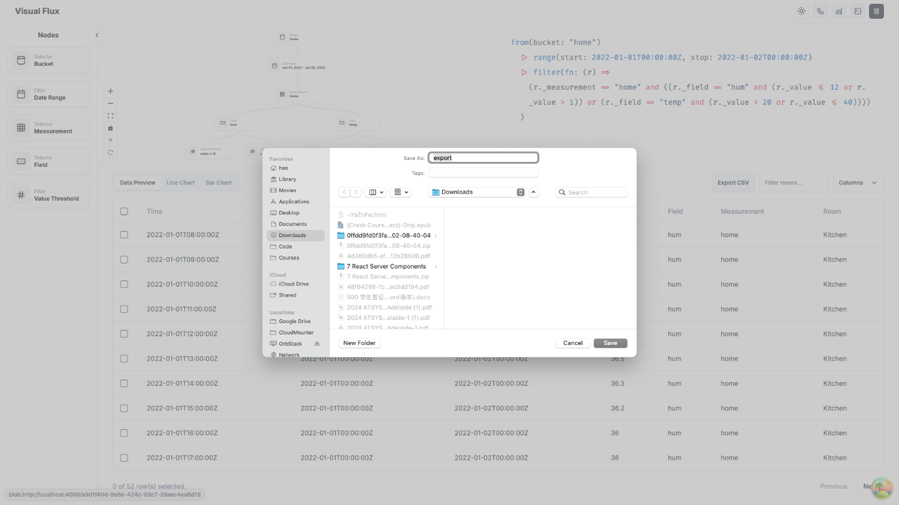

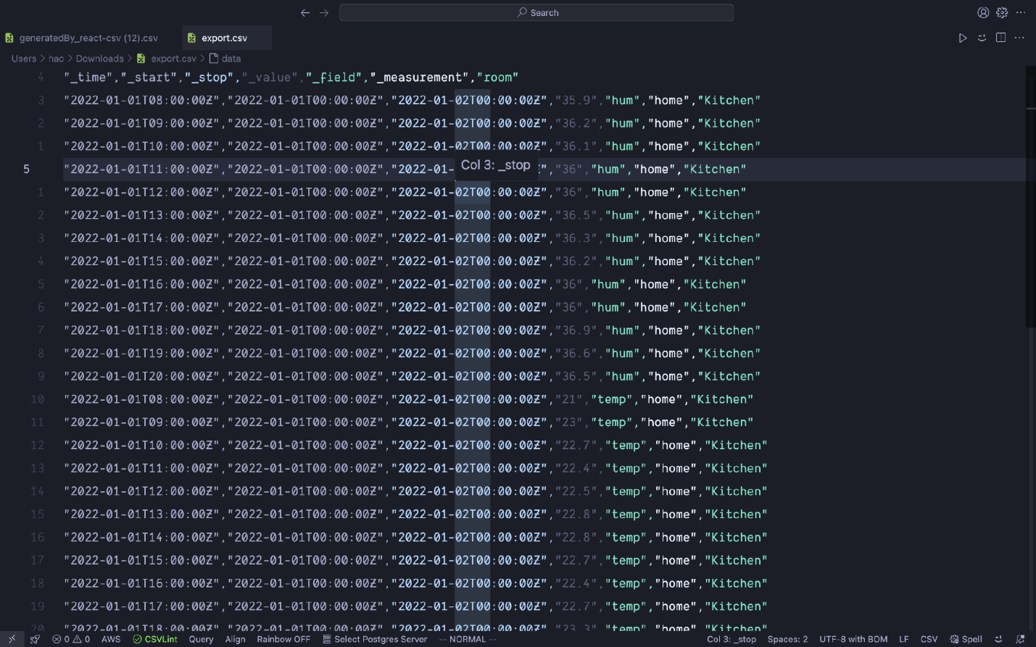

On the frontend, our team successfully modified and finalised the main user interface: top left section for drag-and-drop function, top right for code editor, bottom section for table and visualisation. Meanwhile, we also implemented multiple-selection of drag-and-drop node, with the ability to export data
As for the backend, our team completed a test plan overview and listed test case followed by specific testing process. We continued to work on final integration of frontend and server source code.
Definition of Done
- Frontend:
  - features for the current sprint are fully implemented, tested, and confirmed to function without critical bugs.
  - Schedule for final code integration is set after debugging and testing.
- Backend:
  - Test plans creation and corresponding documentation per process to record progress.
  - Dynamic source code integration in final production
Summary of Changes

- Improve user experience with a more intuitive and flexible UI, including multi-selection design and ability to export data
- Bug fixed and testing schedules to enhance the product’s overall integration progress

