Snapshot Week 11 of Group PG02

Project of ATSYS

No-Code Solution for InfluxDB

LeStartUP
Zilin Song - a1833935
Jen-Hao Liu - a1893169
Dang Quy Duong - a1893592
Baojing Li - a1894836
Shih-Han Lin - a1900715
Feinan Guo - a1903270
Xiaoqing Zhao - a1904344
Hao Jiang - a1907177
Ziqi Zhang – a1909438

Product Backlog and Task Board

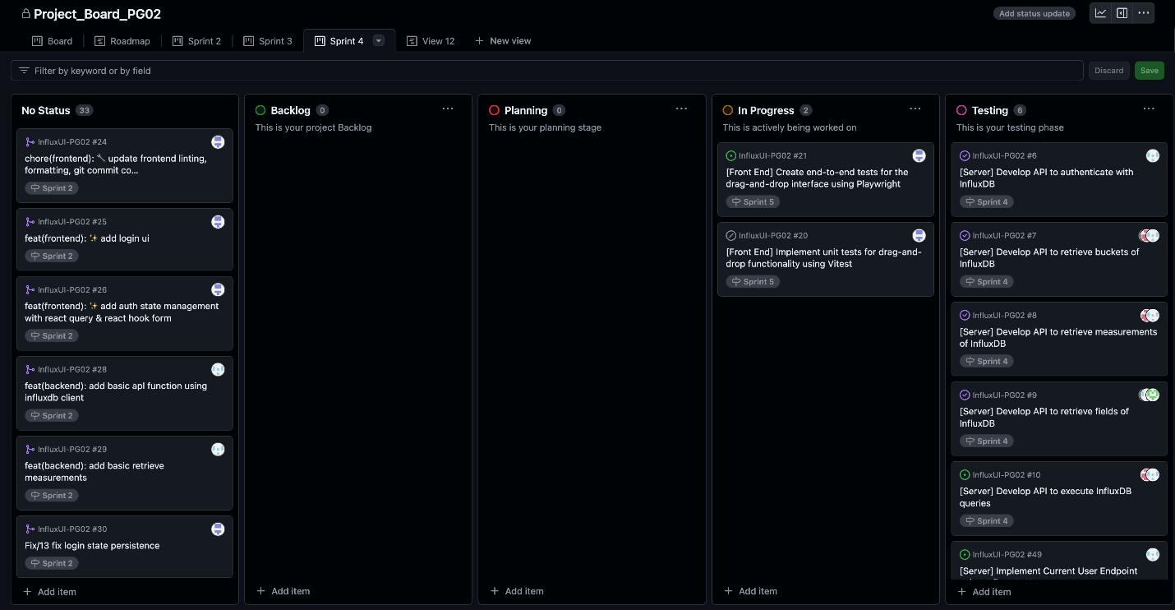
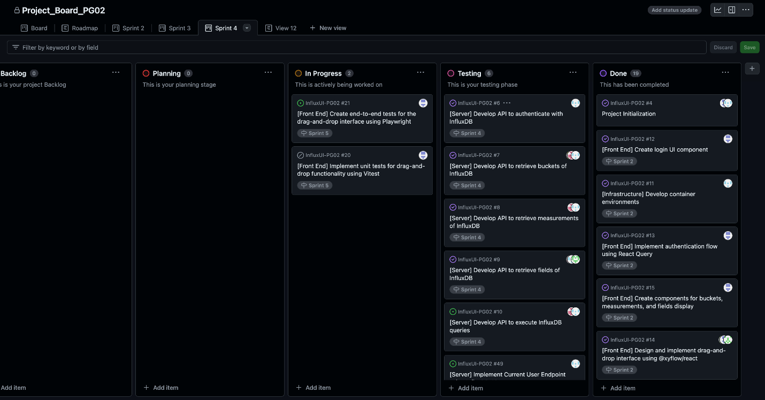

Sprint Backlog and User Stories
- Milestones of the end of sprint 5:
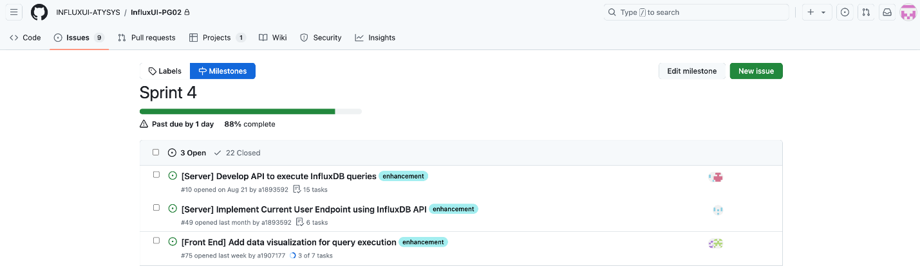

- UI: dark mode feature with all panels
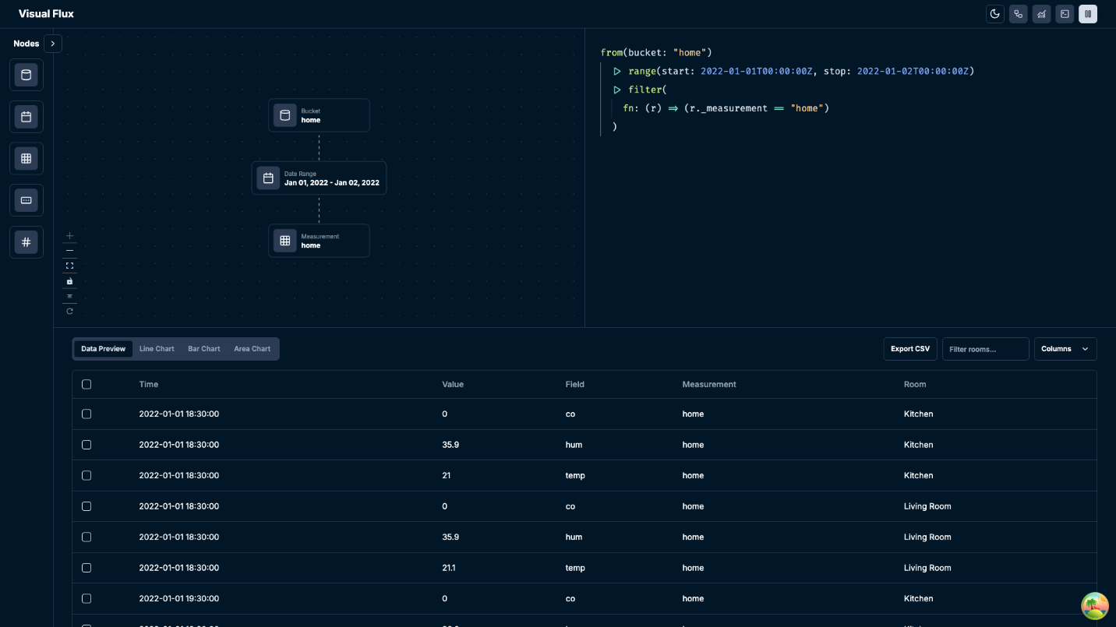

- UI: data visualisation – line chart
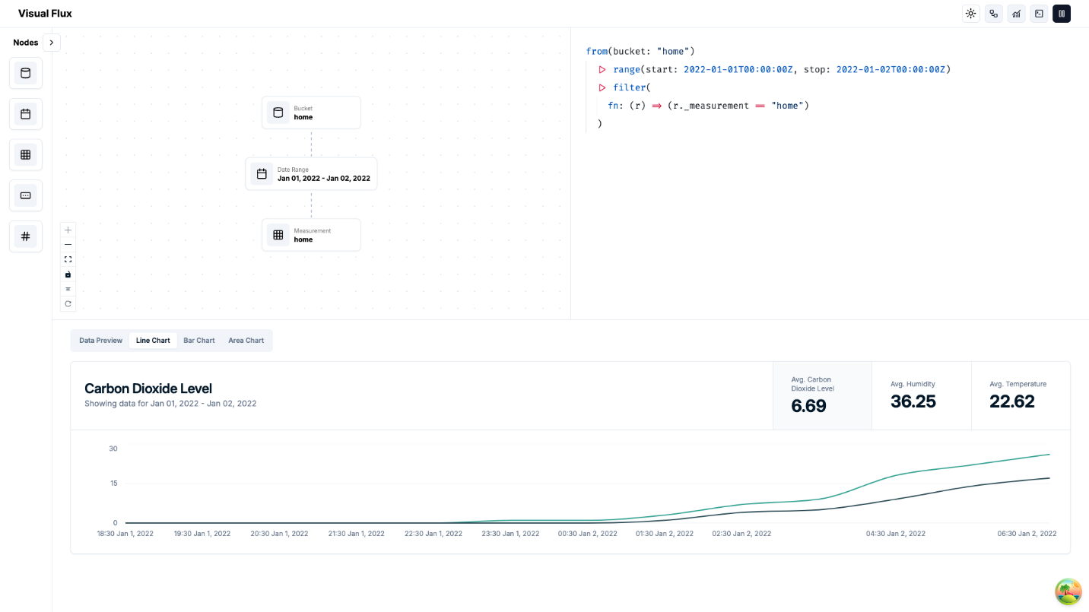

- UI: data visualisation – bar chart
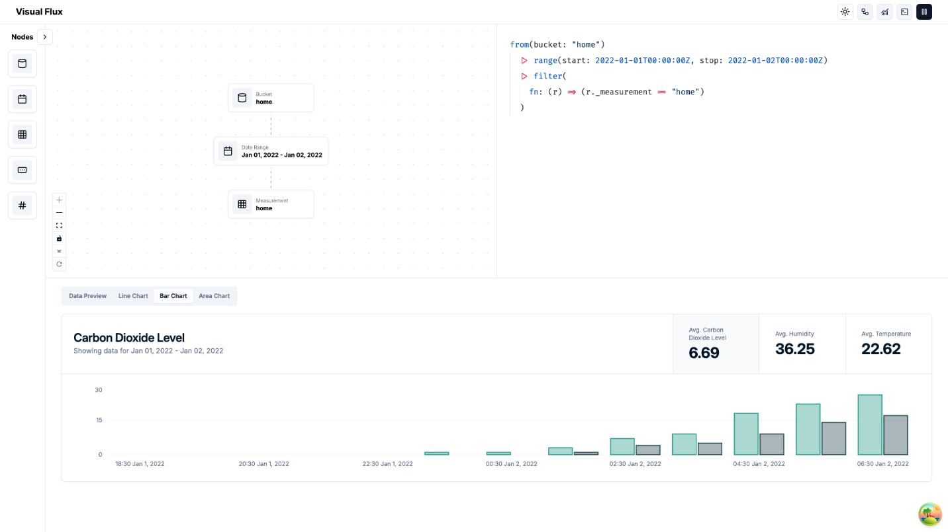
- UI: data visualisation – area chart
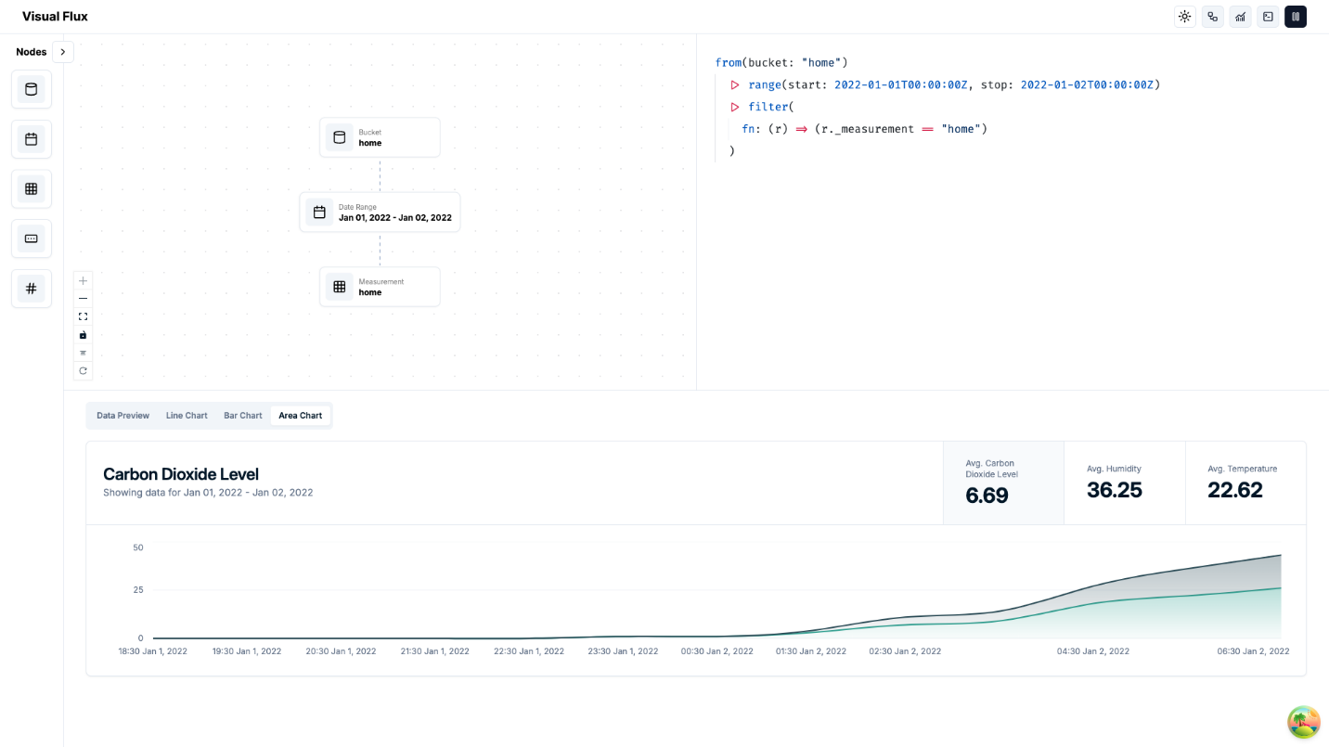

- UI: data visualisation – area chart with multi-selection

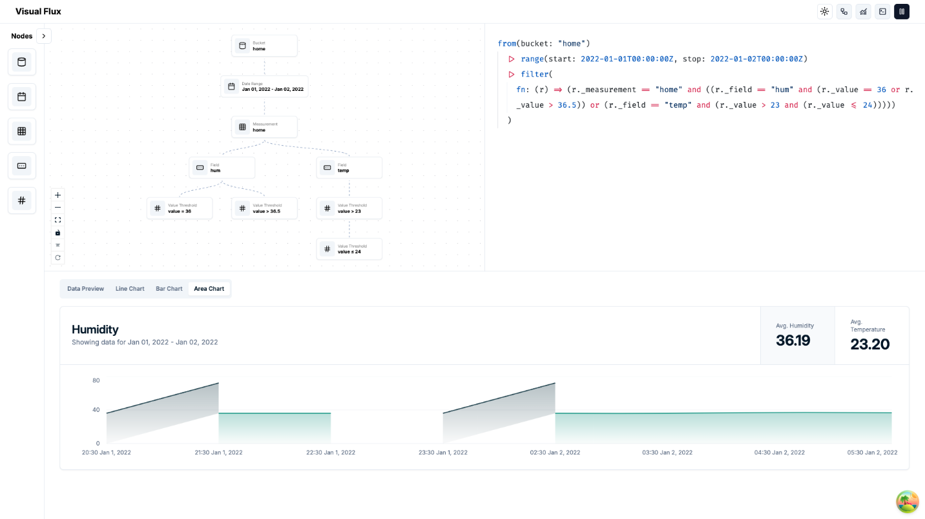
- UI: data visualisation – bar chart with multi-selection
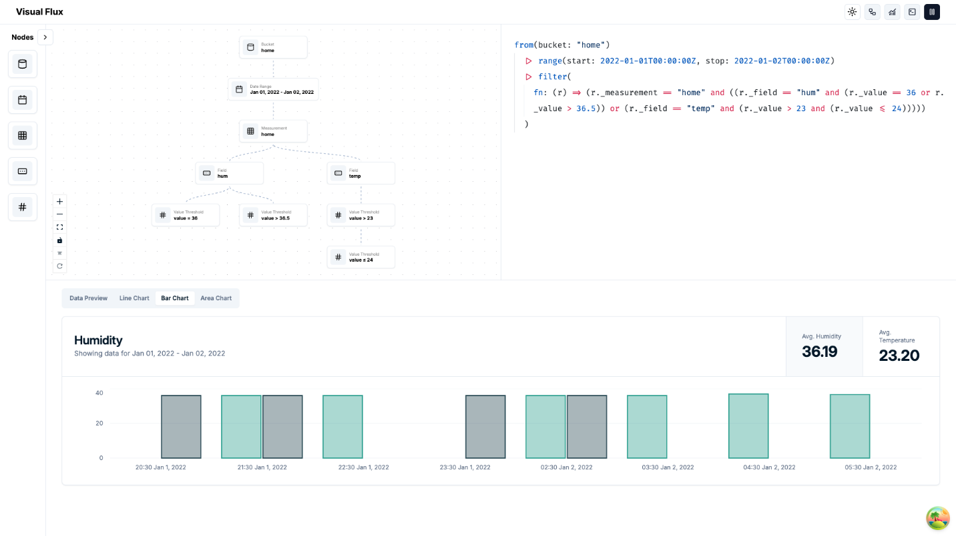
Our team successfully completed the main user interface with a selection of light and dark mode for user experience. Meanwhile, we also refined the multiple-selection of drag-and-drop node, with the ability to timely visualize data in three different charts.

Definition of Done
- User interface in both light and dark mode is fully functional.
- Data is accurately represented in all chart types.
- Charts can update in real-time when data changes.

Summary of Changes

- Three different types of charts are implemented with multiple selection of nodes for visualisation.

