Snapshot Week 12 of Group PG02

Project of ATSYS

No-Code Solution for InfluxDB

LeStartUP
Zilin Song - a1833935
Jen-Hao Liu - a1893169
Dang Quy Duong - a1893592
Baojing Li - a1894836
Shih-Han Lin - a1900715
Feinan Guo - a1903270
Xiaoqing Zhao - a1904344
Hao Jiang - a1907177
Ziqi Zhang – a1909438
Product Backlog and Task Board

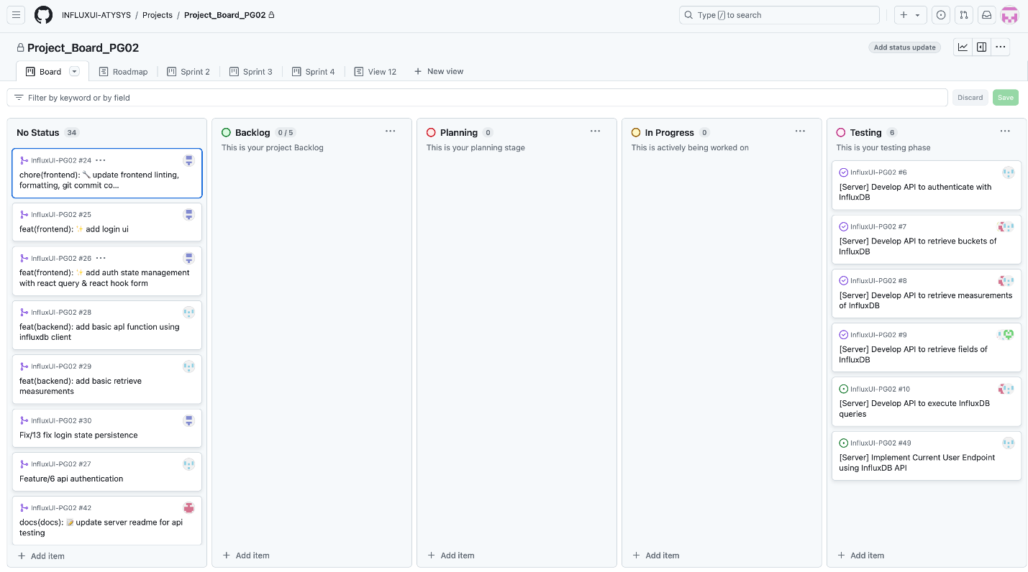
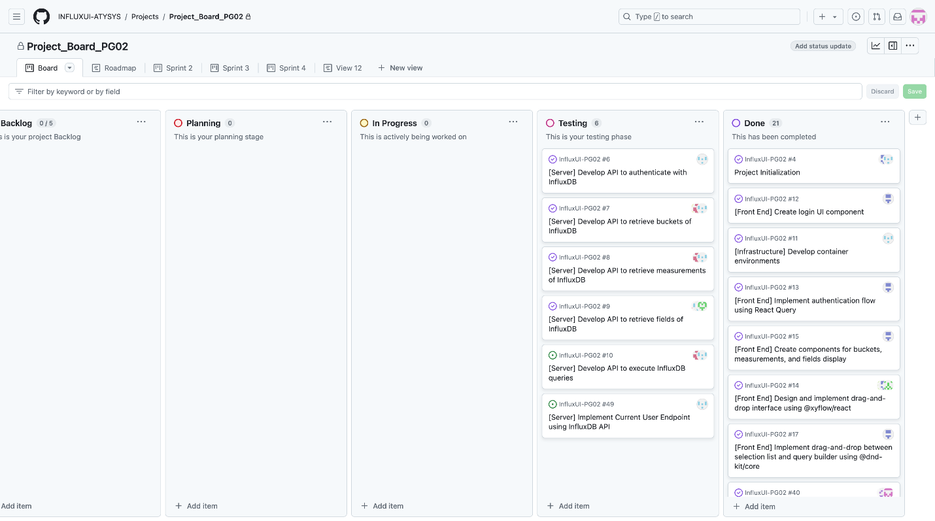

Documentation for meeting record
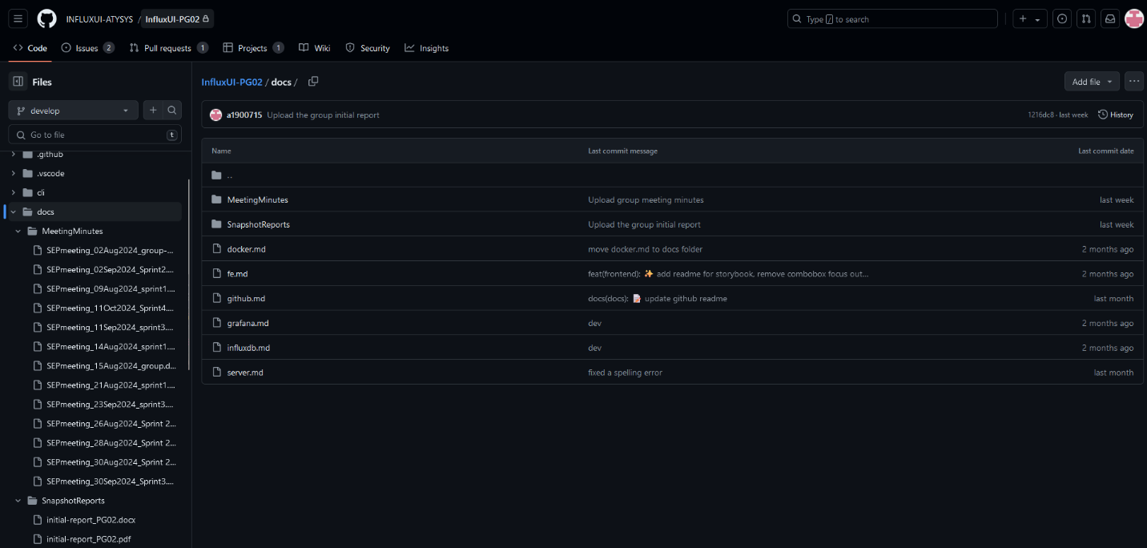

Sprint Backlog and User Stories
- Accessibility mode: screen reader
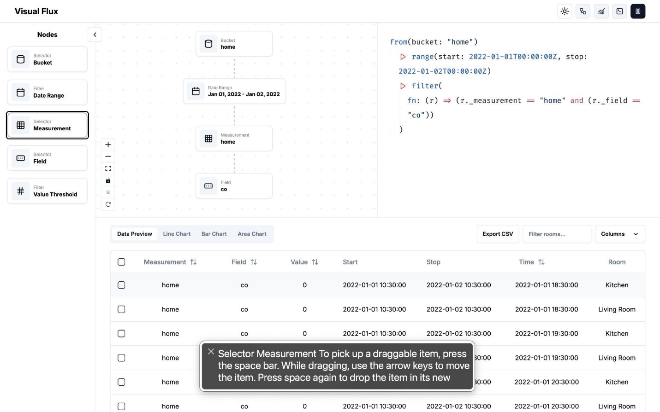
- UI: data filtering with customisable labels
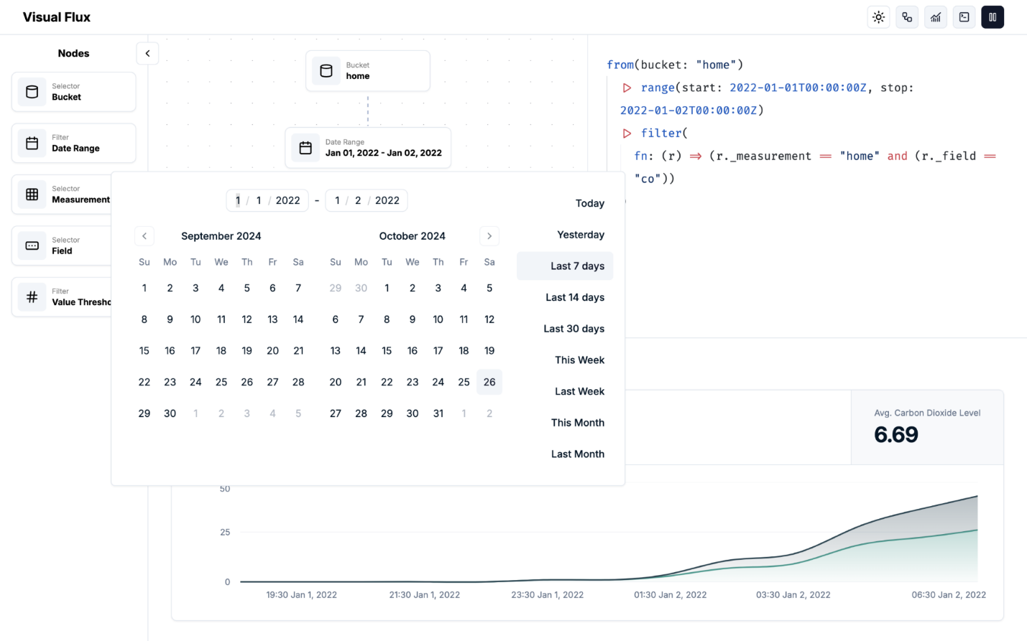

- Testing: log in
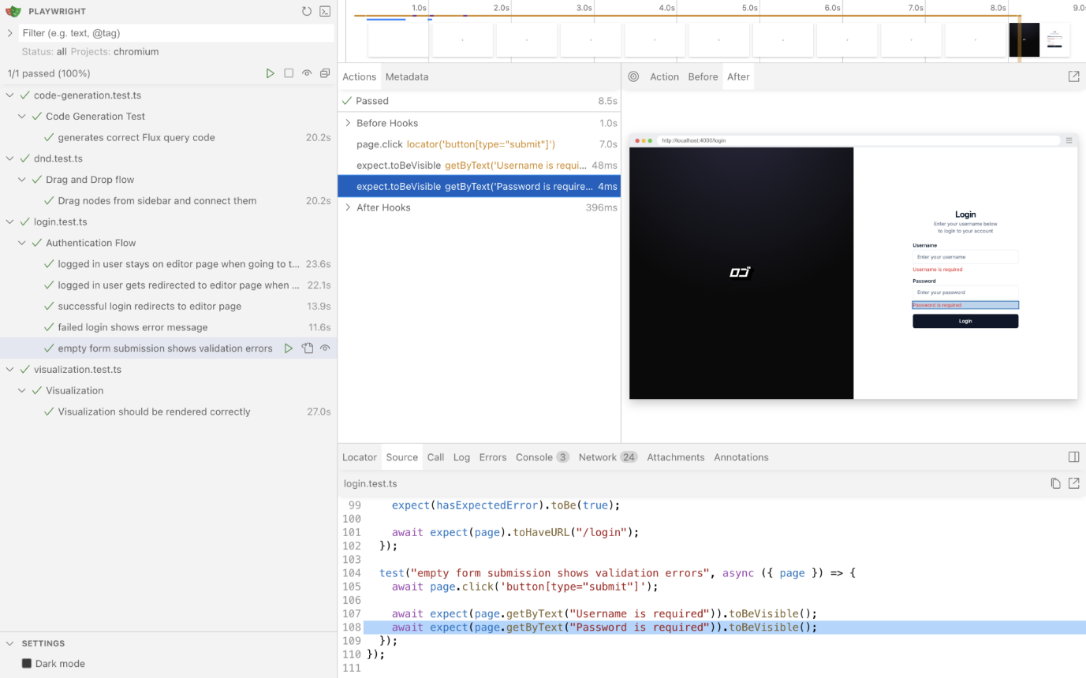

- Testing: drag and drop flow
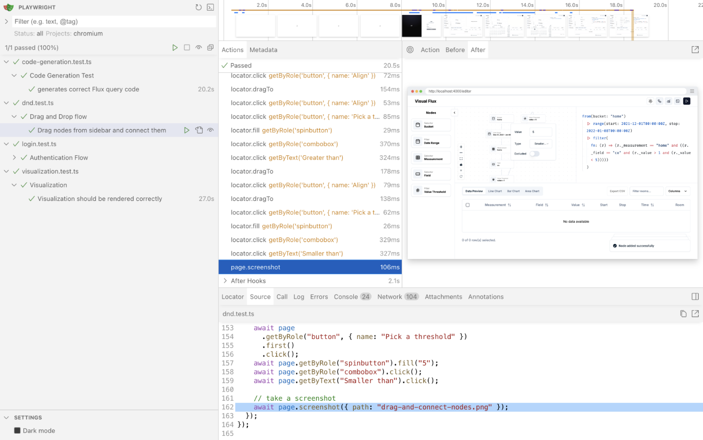

- Testing: visualisation of queries
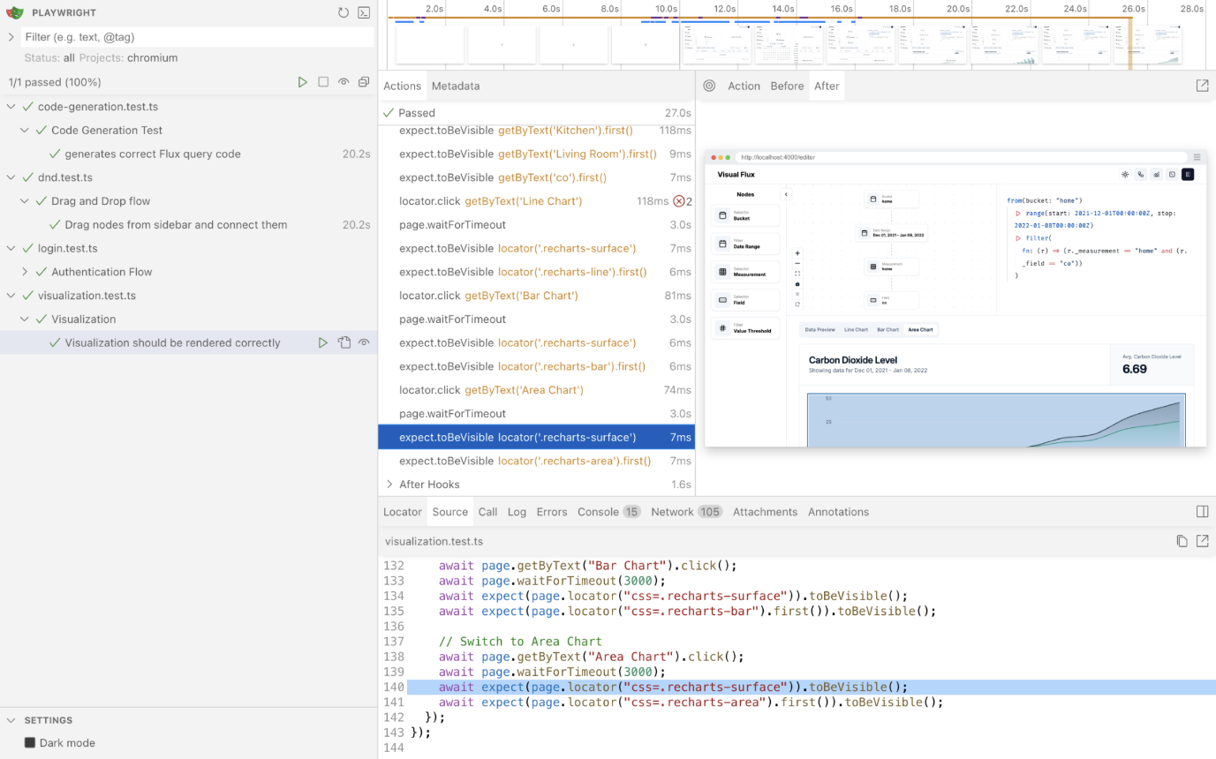
- Testing: code generation
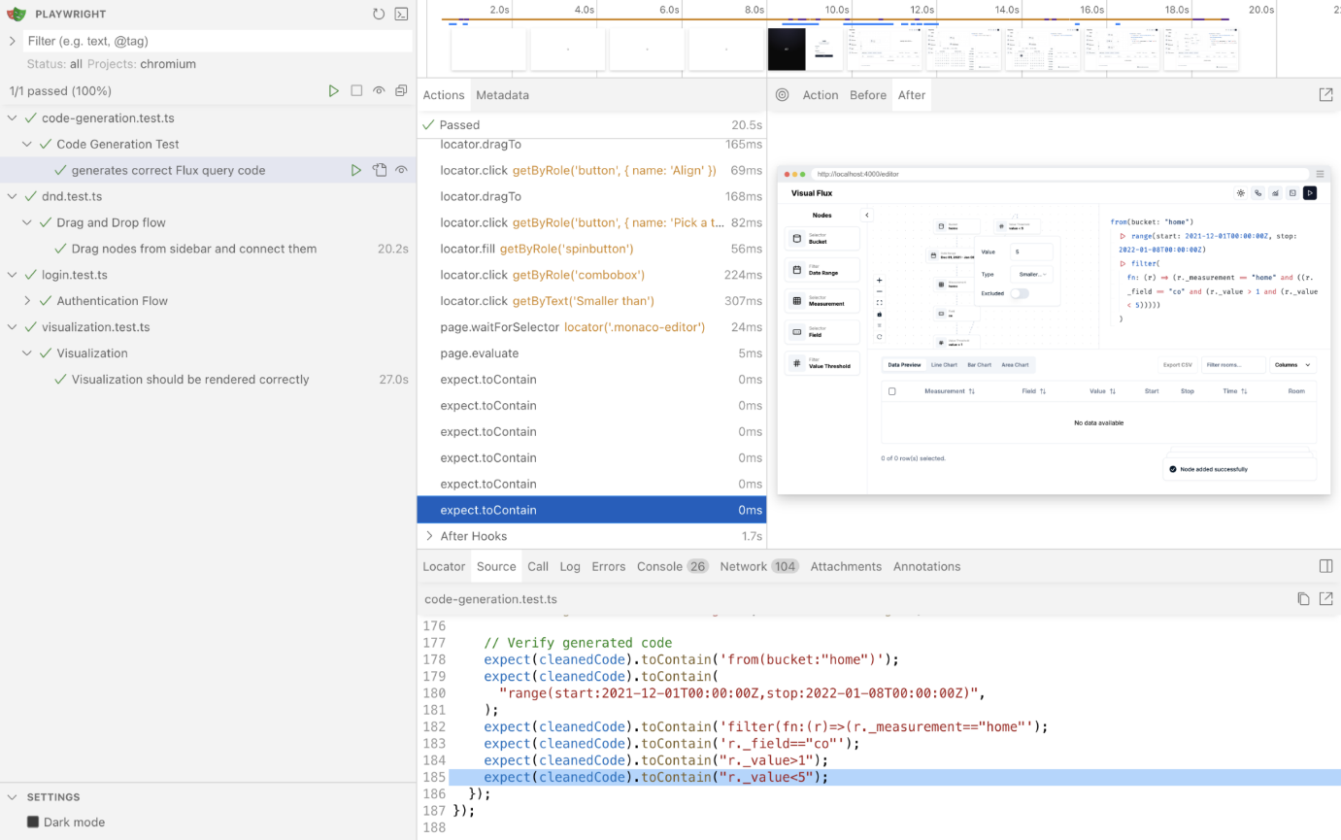
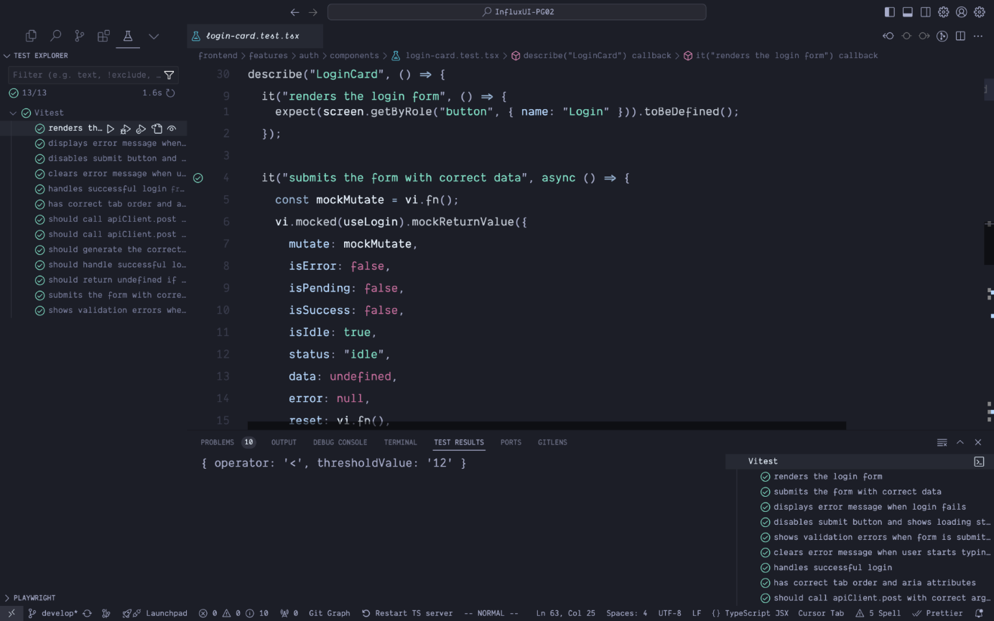
Our team successfully completed multiple-selection of drag-and-drop node in the main user interface with a selection of light and dark mode for user experience. Meanwhile, we also added an additional accessibility mode for visually impaired users.

Definition of Done
- Testing plans are thoroughly followed to ensure the workflow is seamless without critical bugs
- Addition of accessibility function to take different users’ experiences into consideration
Summary of Changes

- Additional accessibility mode for visually impaired users
- Possibility of integration of Grafana for more seamless visualisation experience
- Code editing function for more advanced user dynamically interacting with generated code
- Disable selection for data-absent date range to ensure accuracy and performance

