沪市B股

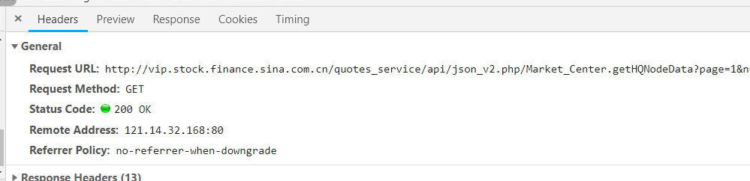

<http://vip.stock.finance.sina.com.cn/quotes_service/api/json_v2.php/Market_Center.getHQNodeData>?

page: 1

num: 40

sort: symbol

asc: 1

node: sh_b

symbol:

_s_r_a: init

<http://vip.stock.finance.sina.com.cn/quotes_service/api/json_v2.php/Market_Center.getHQNodeData>?

page: 2

num: 40

sort: symbol

asc: 1

node: sh_b

symbol:

_s_r_a: page

股票数量

<http://vip.stock.finance.sina.com.cn/quotes_service/api/json_v2.php/Market_Center.getHQNodeStockCount>?

B股信息：

<http://vip.stock.finance.sina.com.cn/quotes_service/api/json_v2.php/Market_Center.getHQNodeData>?

page: 1

num: 40

sort: symbol

asc: 1

node: sh_a

symbol:

_s_r_a: init