

Course report

Course Name : Multi-Functional Troop Transport Ship

Term : Second Semester of 2024-2025

Major : Prototyping

ZJSU Student ID: 299083

Name : Liu moxin

​

1. System Architecture Overview​​
The system integrates servo control, environmental sensing (ultrasonic ranging, temperature/humidity monitoring), and human-machine interaction (joystick input) on the Arduino platform. Core components include:
Execution Unit: 3 servos (independently parameterized)
​​Sensing Unit: Ultrasonic sensor (obstacle detection)
DHT11 (temperature/humidity monitoring)
​​Interaction Unit:Joystick (manual servo control), RGB light (status indication), buzzer (alarm)
​​Control Core: Arduino UNO (manages servos via Servo library)
Reference Models:
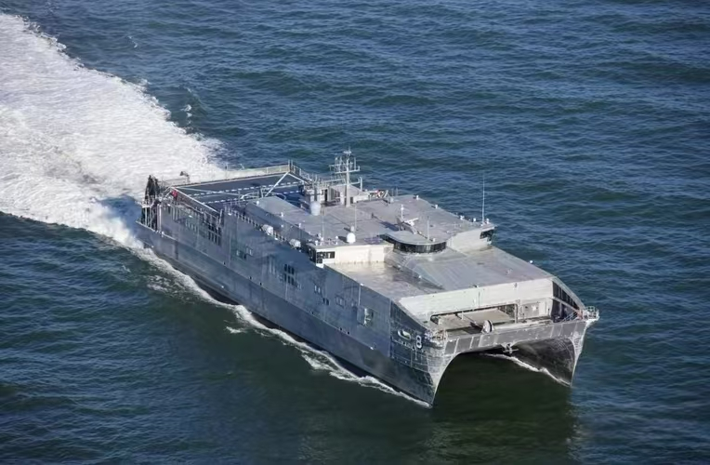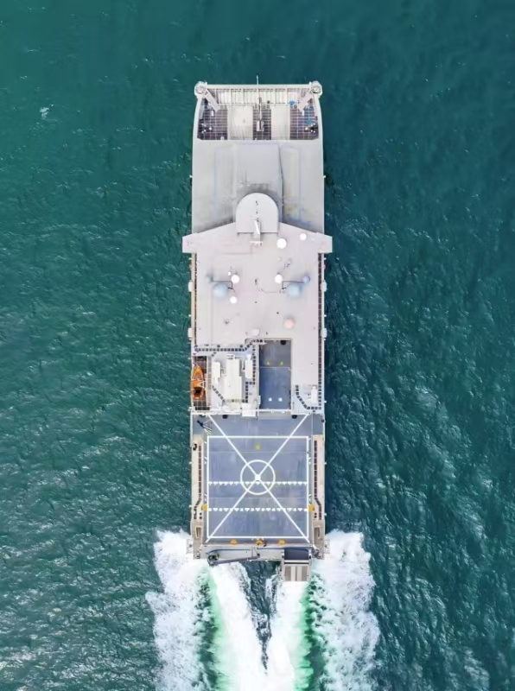
  - Reference object

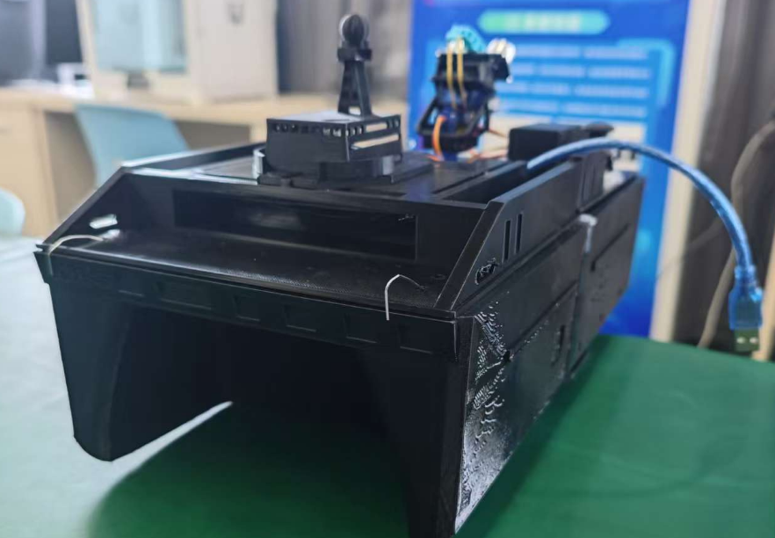
1-2 Final completion result

In this report, I would like to emphasize that the design of my 3D-printed boat is entirely my own work. I independently sourced reference models, created the drawings from scratch, purchased essential components such as motors and actuators, conducted hands-on measurements, and then completed the 3D modeling process. This comprehensive approach ensures that every aspect of the 3D-printed hull design reflects my personal efforts and technical skills.
2. Hardware Architecture Analysis​​
2.1 Servo Control Subsystem​

Servo ID | Control Pin | Angle Range | Step Size | Update Delay (ms) | Control Mode
myservo1 | 9 | 0°-100° | Dynamic | 15 | Auto reciprocating
myservo2 | 10 | 0°-30 | Dynamic | 20 | Auto reciprocating
myservo3 | 13 | 40°-90° | Fixed | 15 | Joystick manual control
Innovations:​​
​​Dynamic Speed Compensation: Adjusts step size via map(angleDiff, 0, sc.maxAngle, 1, ) for smooth start/stop.
​​Joystick Dead Zone: ±50 deadzone (DEADZONE) to prevent micro-jitter misoperation.
2.2 Sensor Subsystem​​
​​Ultrasonic Ranging:Filter: filteredDistance = filteredDistance * 0.85 + rawDistance * 0.15 (1st-order lag)
Timeout: 29ms (≈5m detection limit)
​​DHT11:Async read: Updates every 2s (currentTime - lastDHTRead > 2000)
Alarm: Triggers buzzer when humidity ≥100% (water ingress detection).
Relevant module:
dht11 (Temperature and humidity detection module)
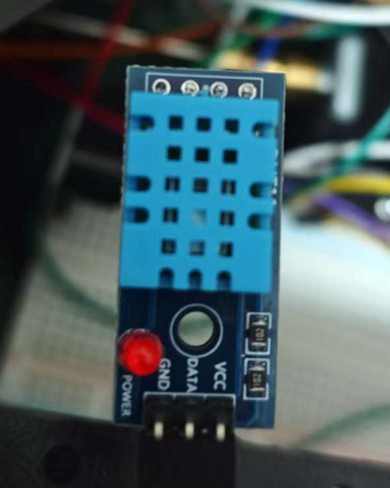
Automatic scanning mine：
(it will stop and the buzzer will sound continuously when an obstacle is detected)
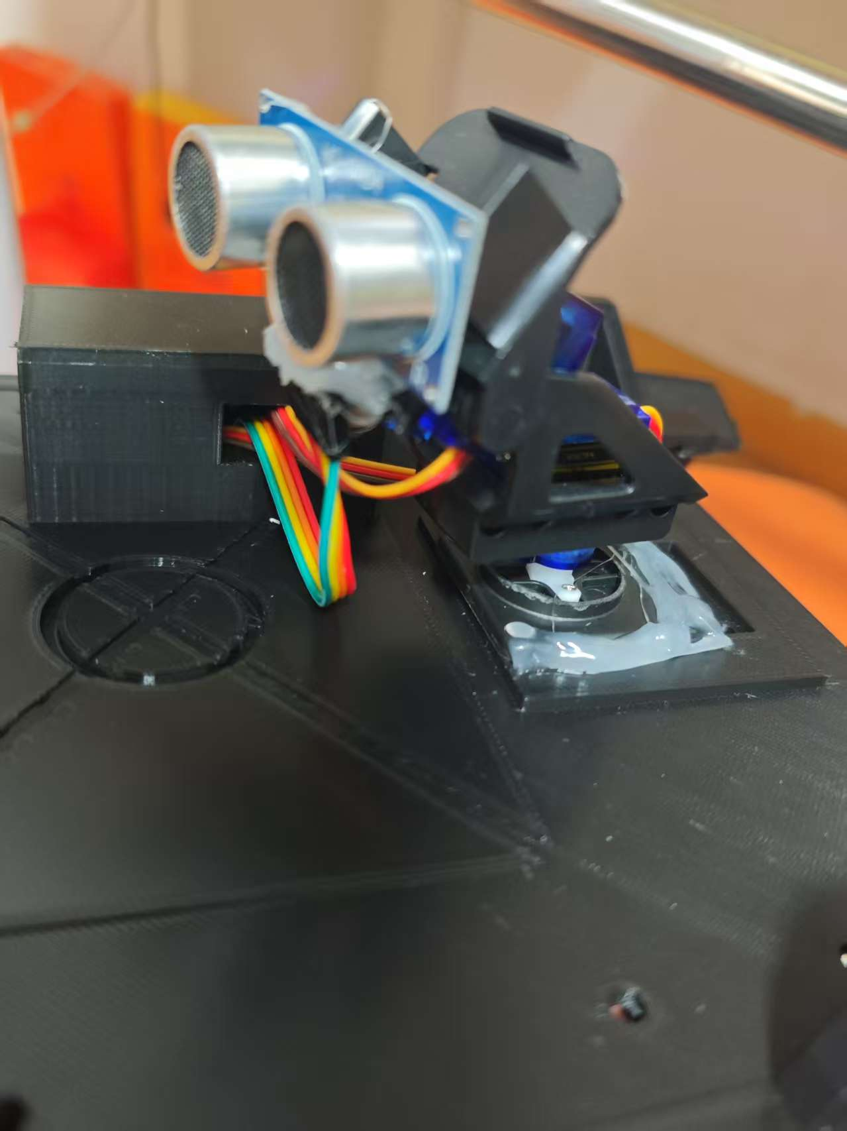

Steering servo design：

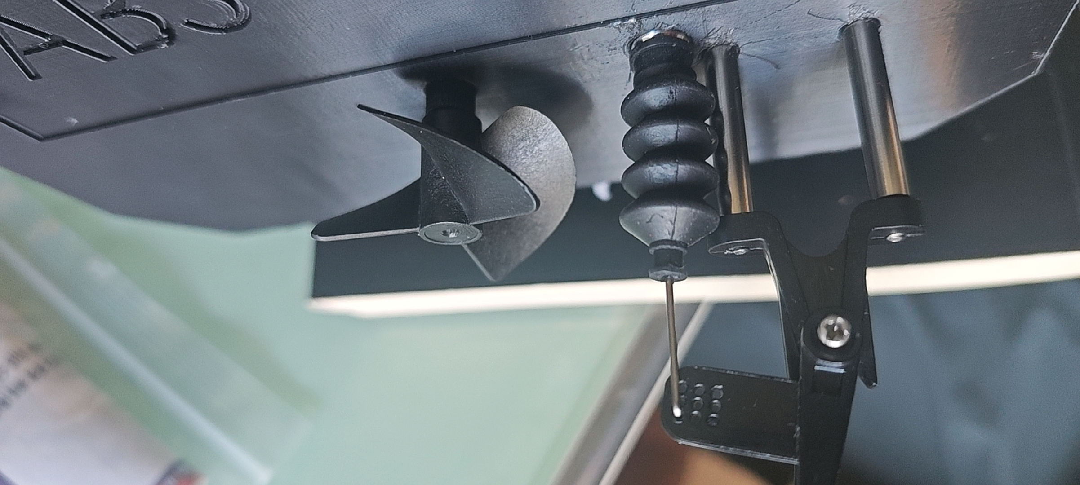

Structural Design:​​

Front/rear hull reinforcement
3mm slots for modular expansion
Waterproof wiring and motor fixation
Tail stabilization
Control tower slot integration
2.3 Concept diagram of hardware architecture:

Tower design&reference：

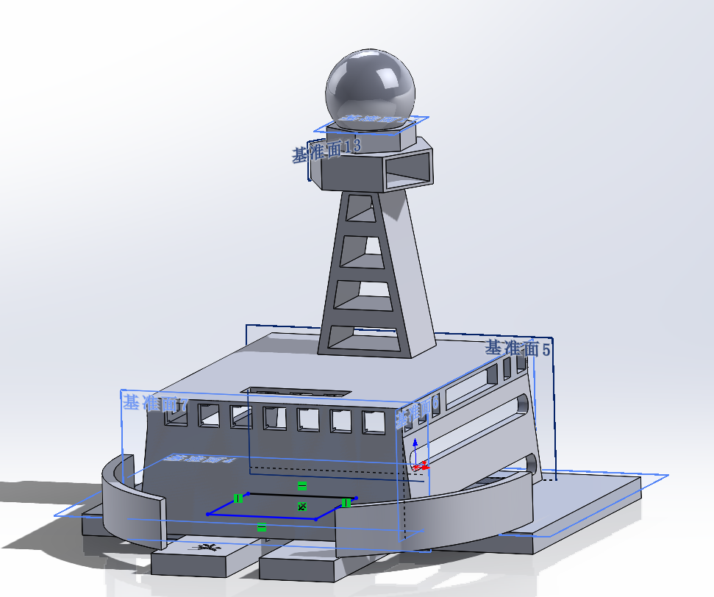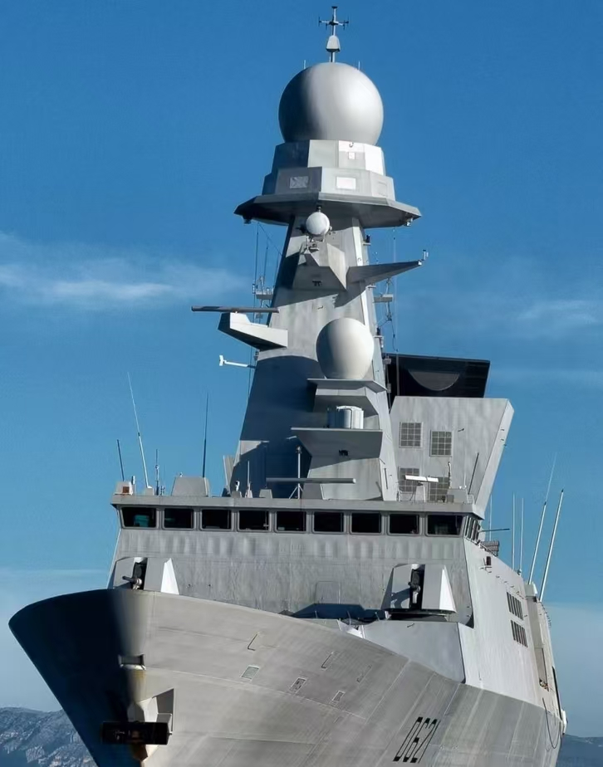
2-1 Comparison between the control tower and the reference image
The interior of the control tower is equipped with navigation lights to protect the ships.

Control tower slot integration：
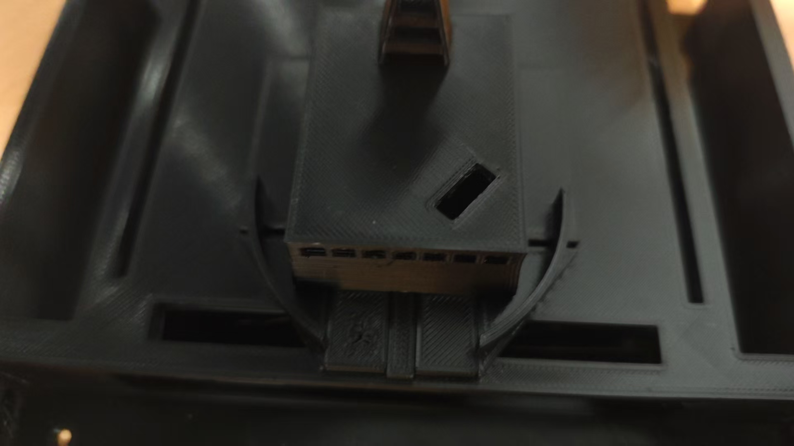
Slot-fixed tower design, facilitating disassembly and installation

Fore-deck design:
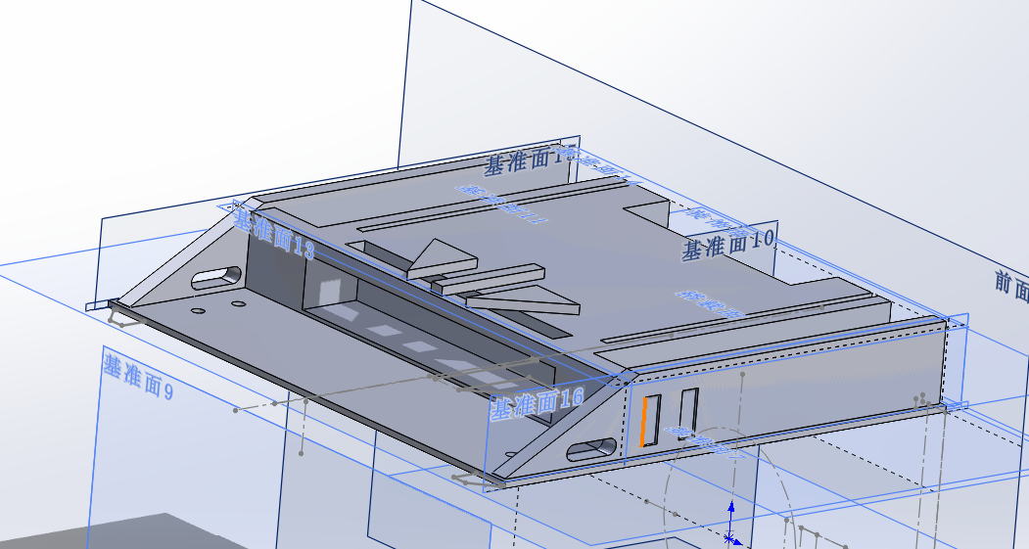

Reserved space for cable routing:

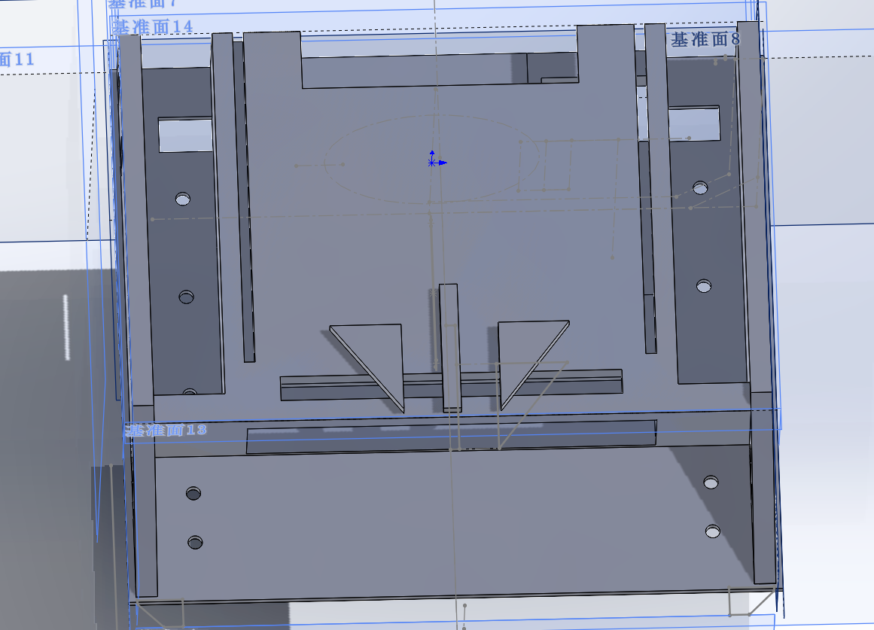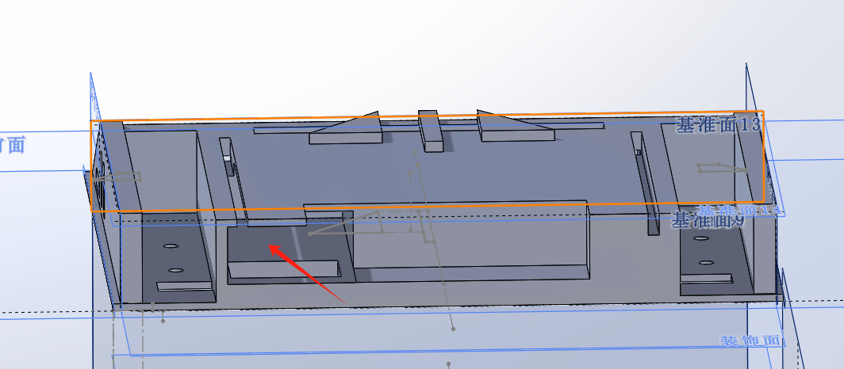
3mm long slots (similar to breadboard design, and supporting post-installation module addition)

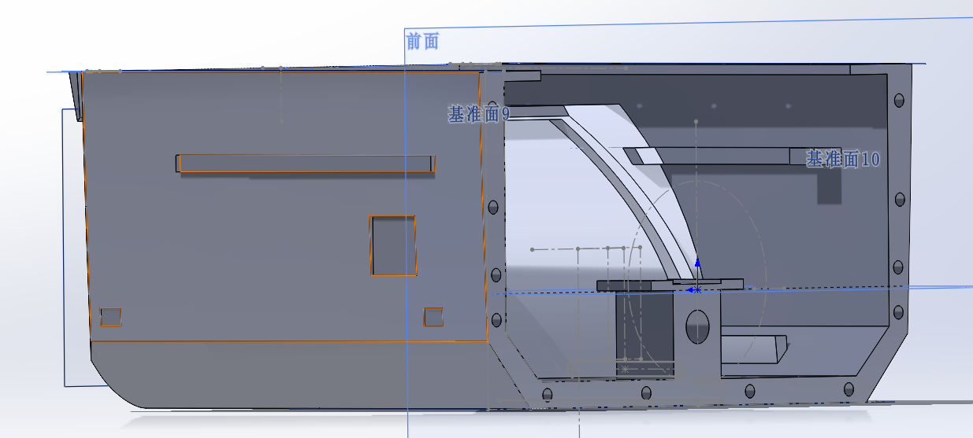
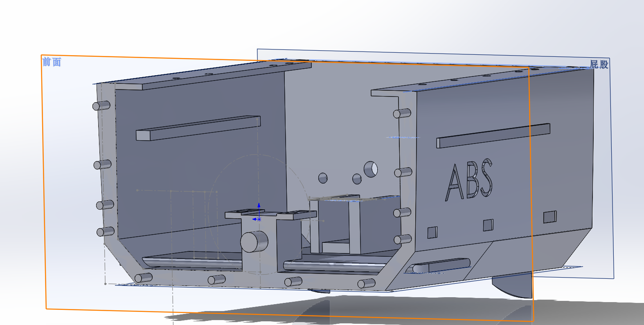

Combined design of front and rear hull stiffeners:

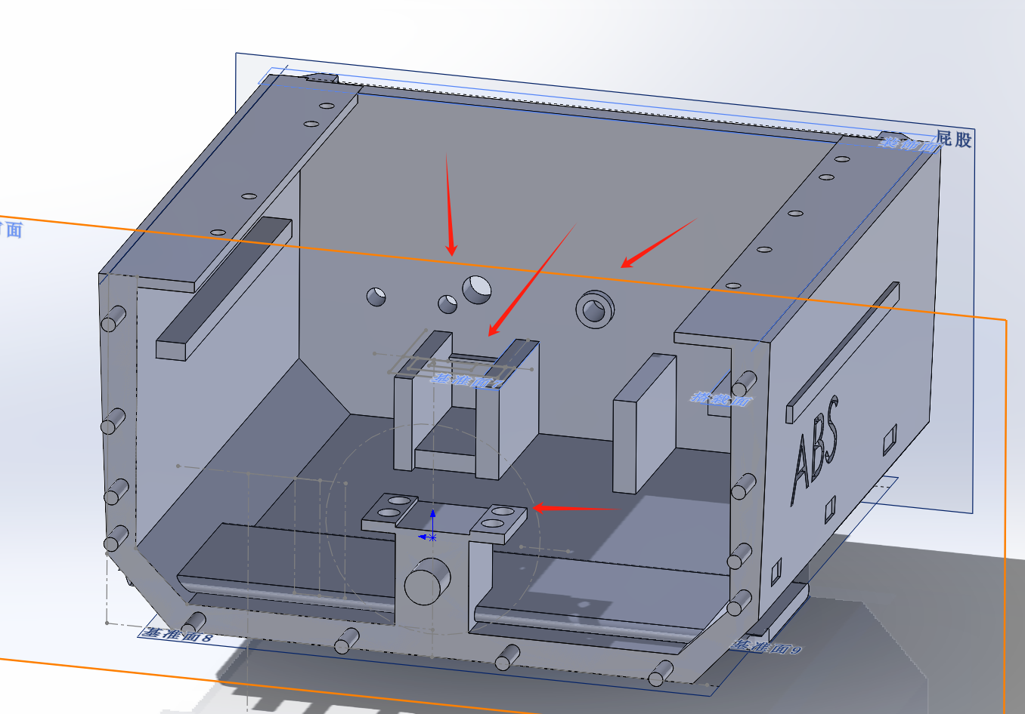

Rear hull motor fixing, servo fixing, waterproof interface design ：

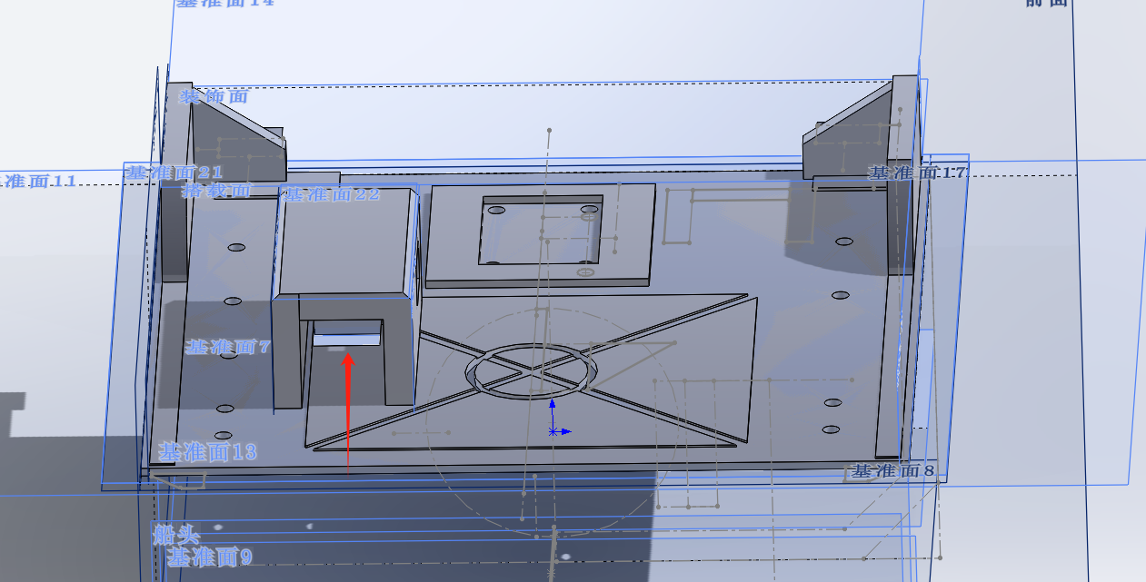

Rear hull waterproof cable routing and motor fixing design ：

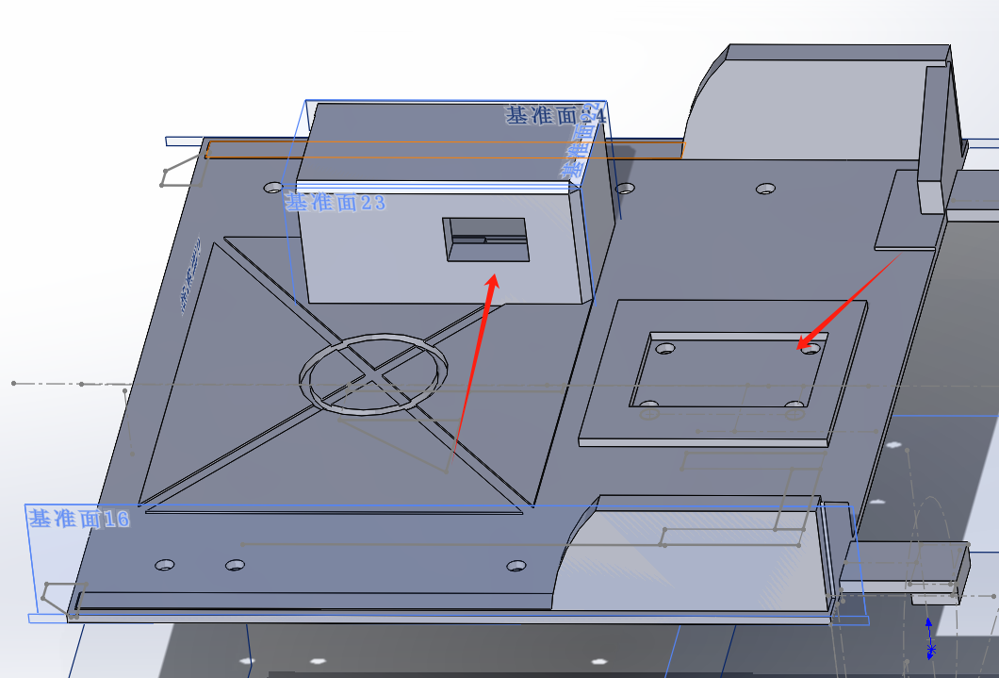

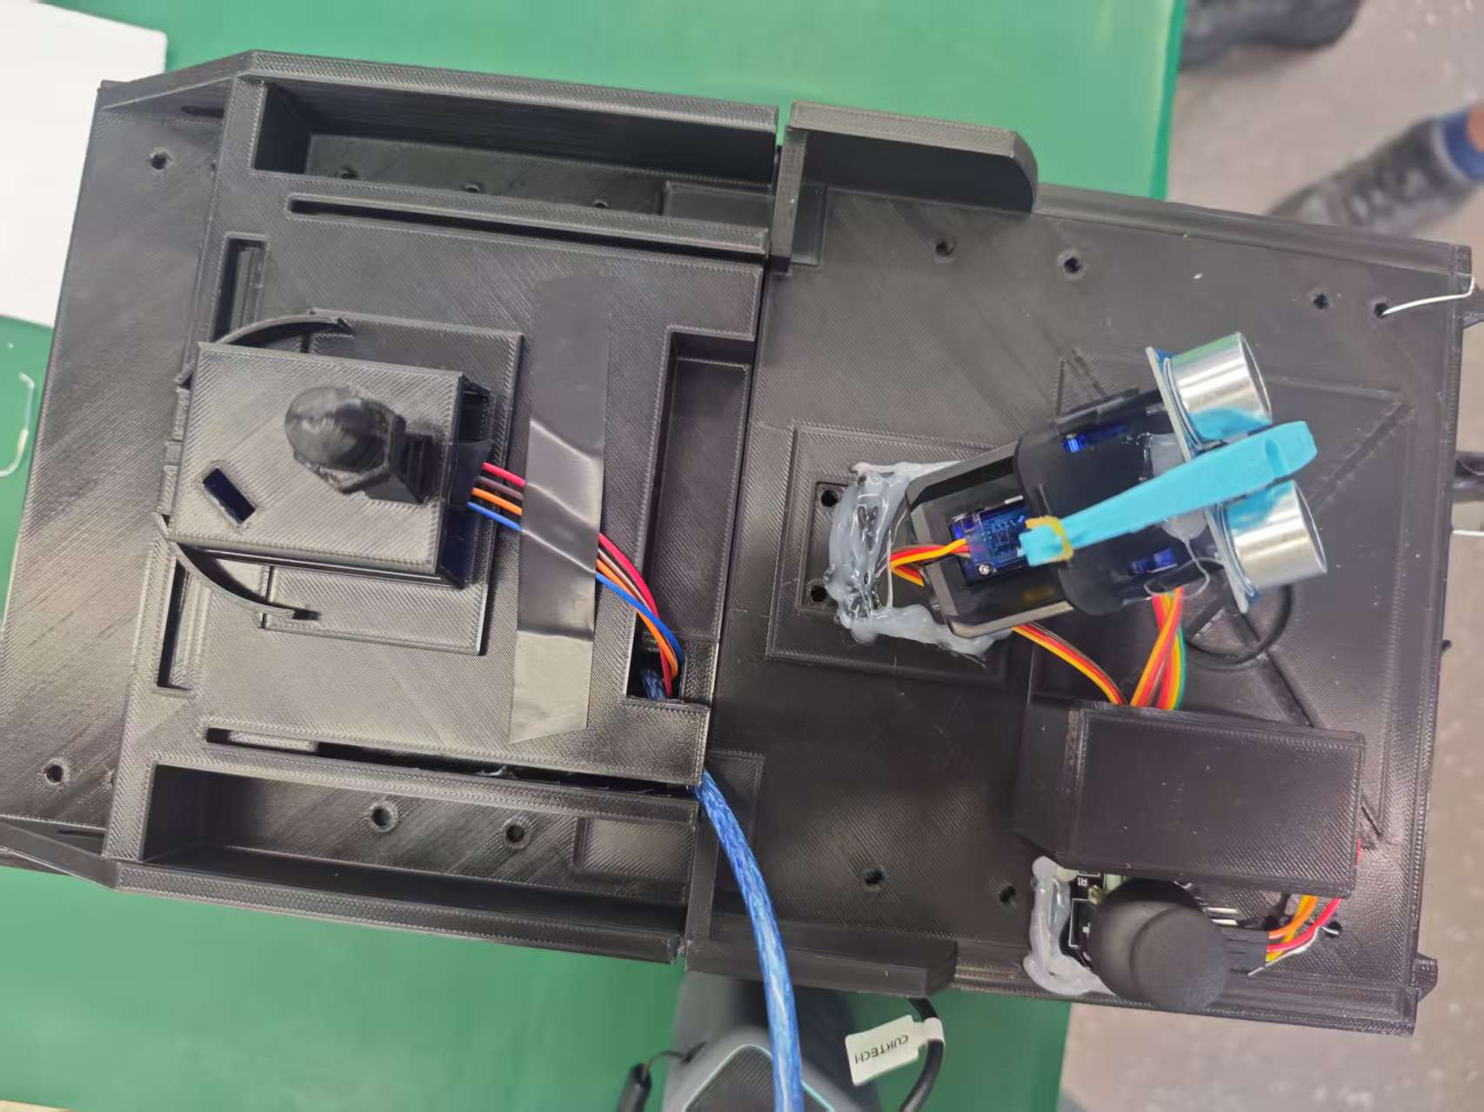
2-2 Final completion result

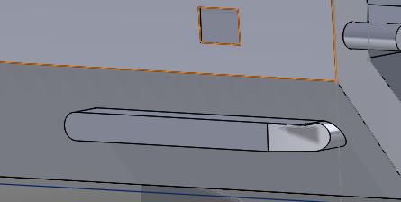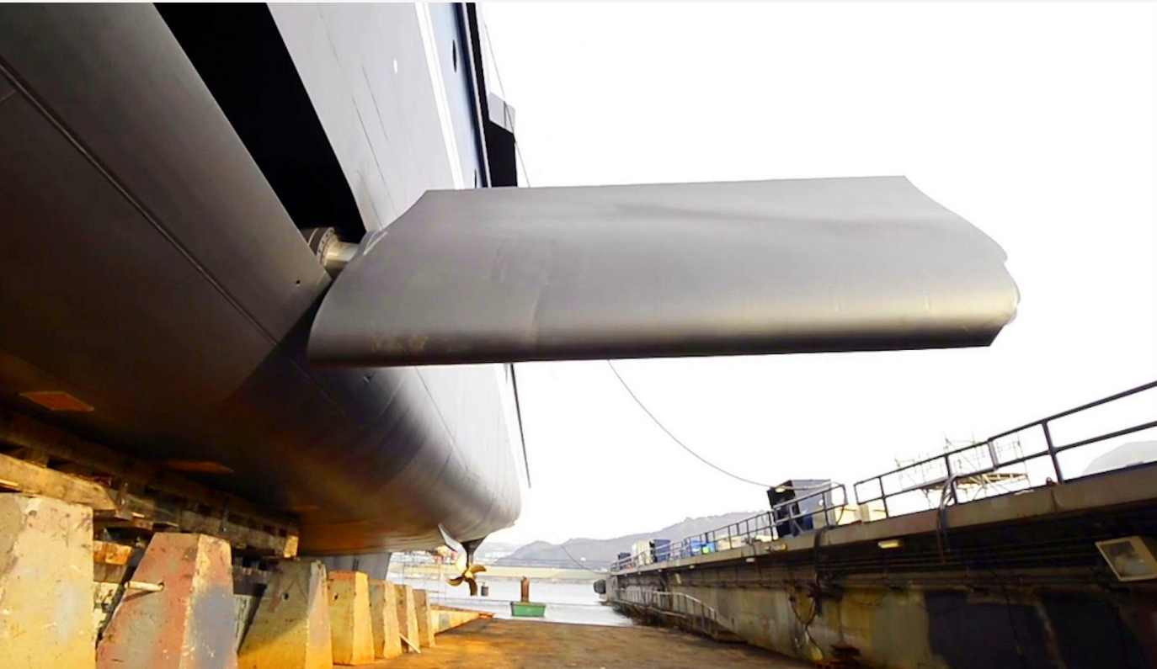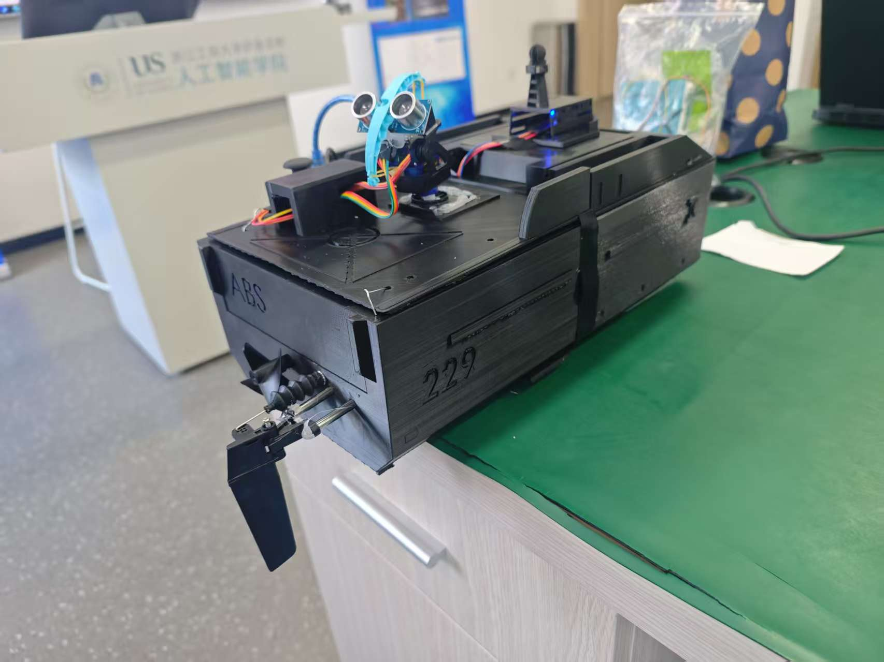
2-3 Anti-side-overturning fin design reference and final effect

Tail design:

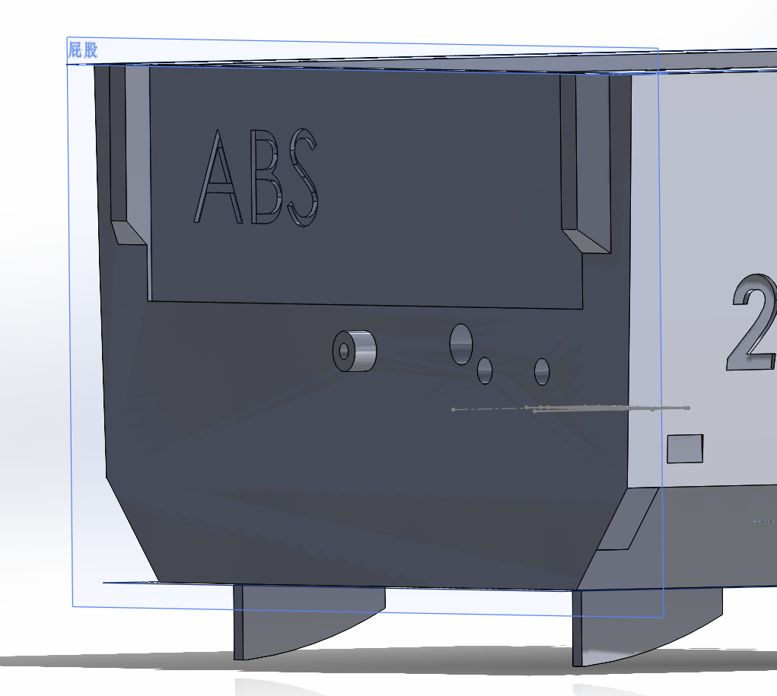

- Control Logic Details​​
3.1 Status Indication Subsystem​

Device | Control Pin | Logic
RGB Light | 3/5/6 | Normal: Red→Green→Blue cycle (1s interval)  Abnormal: Solid red (obstacle/high humidity)
Buzzer | 8 | Low-triggered; continuous sound during anomalies

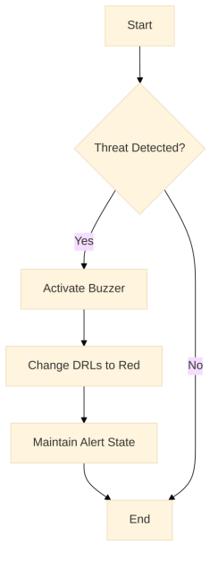
3-1 Enemy Encounter Flowchart

3.2 Multi-Servo Coordination​​

Cpp

void updateAllServos() {
if(s1.motionEnabled) updateServo(s1); // Auto servo 1
if(s2.motionEnabled) updateServo(s2); // Auto servo 2
if(s3.motionEnabled) updateJoystickServo(s3); // Manual servo
}
​​Non-blocking timestamps:​​ lastUpdate variables avoid system freeze.
​​Motion sync:​​ Obstacles trigger toggleMotion(false) to freeze all servos.
​​3.3 Safety Mechanisms
Dual-stage interlock:
Both the ultrasonic obstacle (10cm threshold) and high humidity (≥100%) are triggered: Three-color daytime running lights with alternating colors

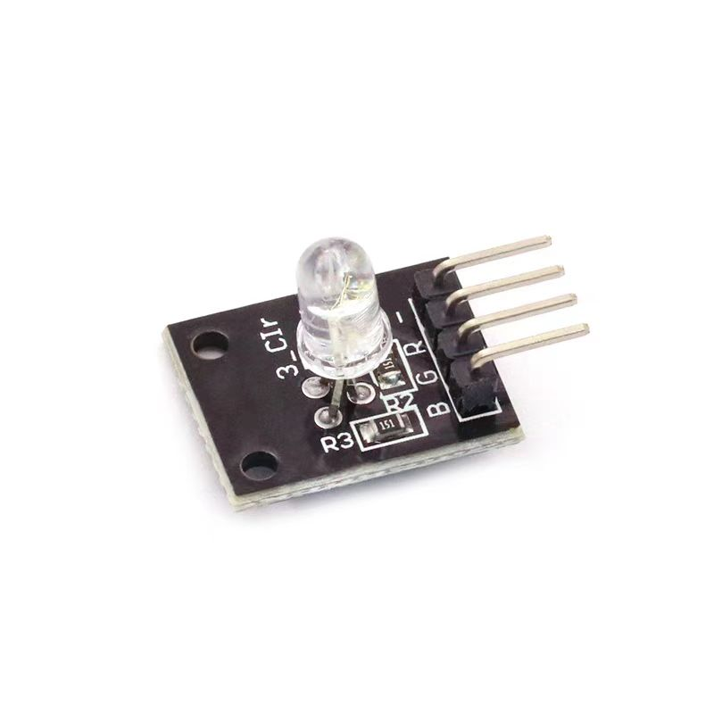
3-2 The RGB device

Servo movement freeze：when the ship hits an obstacle, it turns red and enters the RGB abnormal state.
RGB light abnormal state: when in contact with an obstacle (enemy), it enters the combat state, and the RGB light switches to red and stays on.

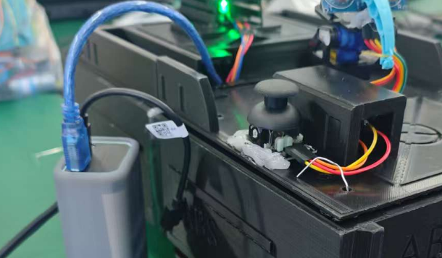
Rudder control by joystick for steering the vessel.
4. Software Design Highlights​​
​​Time-sliced scheduling:​​Main loop runs at 20ms cycles (if(currentTime - lastLoopTime < 20) delay(...))
Independent timers for DHT reads, servo updates, and status displays.
​​Modular functions:​​Dedicated handlers (e.g., updateJoystickServo() for smooth joystick control).
State display/log separation (showSystemStatus() + logEvent()).
​​Resource optimization:​​PWM pin reuse: Servos on pins 3/5/6/9/10/13 (Arduino UNO compatibility).
Memory efficiency: ServoController struct minimizes global variables.
5. Typical Application Scenarios​​
​​Security Robots:​​Ultrasonic obstacle avoidance + servo-controlled camera gimbal.
Environmental anomalies (humidity/temperature) trigger alarms.
​​Greenhouse Automation:​​DHT11 humidity feedback adjusts ventilation servo angles.
RGB lights indicate plant growth stages.
​​Educational Tools:​​Joystick-controlled robotic arm (servo3).
Auto mode demonstrates periodic motion (servo1/servo2).
WiFi Control Module Architecture​​
1 .Hardware Integration​​
Core:ESP8266 (communicates via SoftwareSerial: RX→D4, TX→D7).
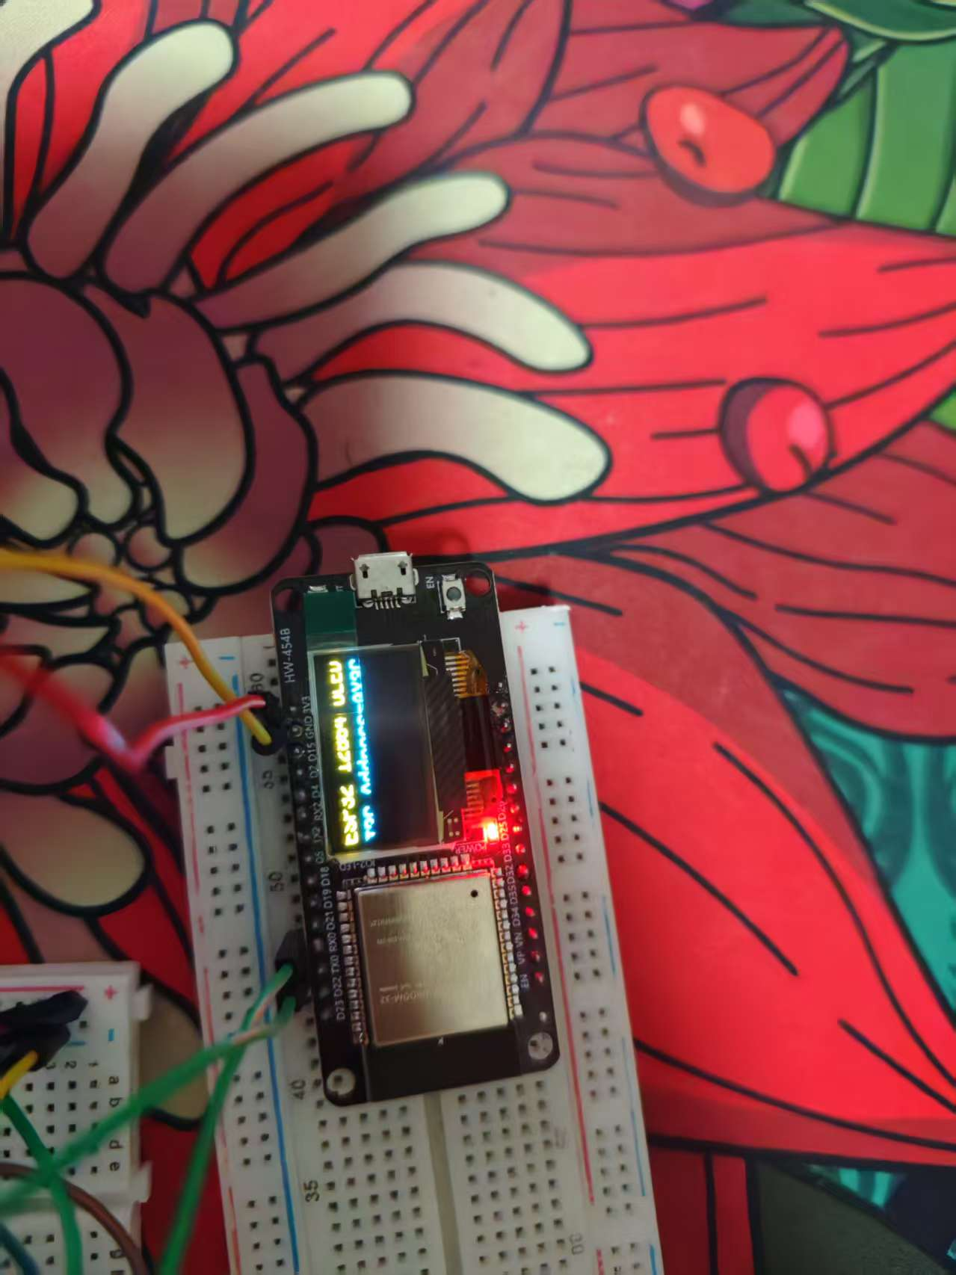
Protocol:AT commands (AT+CWMODE=1, AT+CWJAP for WiFi).
Power optimization:ESP8266 independent power supply (prevents 5V overload).
1kΩ resistors on data pins (level conflict prevention).
2.Network Protocol
cpp
// HTTP command examples:
GET /servo1/75 // Set servo1 to 75°
GET /servo2/30 // Set servo2 to 30°

​​Parsing:indexOf("/servo1/") locates prefixes; substring(8).toInt() extracts angles.
​​Safety:constrain() limits angles to servo ranges.
​​3. Multi-Mode Control Logic​

Mode | Trigger | Mechanism
Network | HTTP request | Sets networkControl=true; overrides auto mode
Joystick | Joystick > deadzone | Updates targetAngle (servo3 only)
Auto | No external input | Executes preset motion logic

Algorithm Comparison:​​
Servo control algorithms benchmarked for latency/responsiveness.
4. Key Code Optimizations​​
​​Non-blocking network handling:​​
Cpp

void handleNetworkControl() {
WiFiClient client = server.available();
if(!client) return; // Exit immediately if no request
String request = client.readStringUntil('\r');
client.print("HTTP/1.1 200 OK\r\n"); // Fast response
}
Processing time <2ms ensures real-time performance.
​​Multi-servo sync:​​
Cpp
void updateAllServos() {
if(s1.motionEnabled) {
if(s1.networkControl) updateNetworkServo(s1); // Network priority
else updateServo(s1); // Auto mode
}
// [...]
}
Servo3 reserved for joystick to avoid conflicts.
5. Safety & Stability​​
​​Fail-safes:WiFi auto-reconnect (connectWiFi() with 5s timeout).
Servo angle clamping (constrain(angle, 0, 100)).
DHT11 errors disable servos (prevents overheating).
​​Performance metrics:​​
Module | Memory | Time/cycle | Optimization
WiFi | 15% | 1-15ms | Non-blocking + fast HTTP
3-Servo Control | 8% | 6ms | Timestamp management
Sensors | 5% | 3ms | Async reads (2s intervals)

6. Application Expansion​​
​​Industrial IoT (IIoT):Remote servo angle/temperature monitoring.
Predictive maintenance via servo wear analytics.
​​Educational Robotics:Scratch integration for GUI-based control.
WiFi Mesh networks for multi-device synchronization.
7. Optimization Roadmap​​
​​Security:HTTP basic authentication.
AES-128 encrypted commands.
​​Performance:UDP instead of HTTP (90% latency reduction).
S-curve acceleration for servo trajectories.
​​Power Management:ESP8266 deep sleep (idle current: 0.1mA).
Dynamic servo power disable when inactive.

​​Conclusion​​
This system achieves precise multi-sensor/actuator coordination through dynamic speed algorithms, state-machine management, and hardware optimization. Its modular design supports robotics, environmental monitoring, and beyond. Key innovations include deadzone filtering, non-blocking schedulers, and dual safety interlocks. Future work focuses on power efficiency and trajectory planning.
Recommended Hardware Upgrades​​
Power: External regulators (e.g., LM2596) for servo stability.
Scalability:PCA9685 driver for 16-channel servo control.
Algorithms:Acceleration-based joystick control + obstacle-avoidance strategies.

