Robot Design Document Based on a Five-Bar Planar Parallel Mechanism

2025.11.10

Contents
1. Introduction 3
2. Robot Design Requirements and Parameter Analysis 3
3. Kinematic Design of the Robot 5
2.1 Forward Kinematics Solution Equations of the Robotic Arm 5
2.2 Forward Kinematics Simulation of the Robotic Arm in MATLAB 7
2.3 Inverse Kinematics Solution Equations of the Robotic Arm 10
2.4 Inverse Kinematics Simulation of the Robotic Arm in MATLAB 11
3. CAD Modeling and Engineering Drawings of the Robot 14
3.1 The 3D model diagram of the robot 14
3.2 Engineering drawings of the robot 15
4. Code Design and System Implementation 18
4.1 Overall Control Flow 18
4.2 Overall System Architecture 18
4.3 Image Processing and Egg Recognition (OpenCV) 19
4.4 Coordinate Transformation 20
4.5 Inverse Kinematics Implementation 20
4.6 Suction Cup and Relay Control 21
4.7 Final results display 22
5. Conclusion 22

Introduction
With the rapid development of automation and intelligent manufacturing, industrial robots have been increasingly applied in agriculture, food processing, and poultry farming to reduce human labor and improve operational efficiency. In modern large-scale poultry farms, egg collection is still often carried out manually or relies on simple mechanical systems, which can lead to low productivity, high labor intensity, and a higher risk of damaging fragile eggs. Therefore, the design of an intelligent, precise, and low-cost robotic egg-picking system has significant practical value and engineering relevance.
This project focuses on the design and analysis of a planar parallel robot based on a five-bar linkage mechanism. Compared with traditional serial robotic arms, the five-bar planar mechanism offers several advantages, including high stiffness, better load distribution, lower accumulated error, and faster dynamic response. These characteristics make it particularly suitable for applications that require repetitive point-to-point (PTP) motion, moderate precision, and operation over a small to medium-sized workspace, such as sorting and collecting eggs in a defined area.
By integrating theoretical analysis, simulation verification, and practical mechanical design, this document provides a complete and systematic approach to developing a functional five-bar planar parallel robot for egg collection. The outcomes of this project not only serve the specific application in poultry farming but also contribute a reference design for other light-duty pick-and-place robotic systems in industrial automation.

Robot Design Requirements and Parameter Analysis
The primary objective of this project is to design an efficient robotic automation solution to replace the manual labor associated with egg collection in industrial poultry farms. As outlined in the project specifications, the system is tasked with retrieving eggs that have rolled down a sloped floor and placing them precisely into a collection tray. The core design utilizes a 5-bar planar parallel mechanism driven by two stationary motors, which must provide two degrees of freedom in the vertical plane to execute flexible Point-to-Point motions. The most critical geometric constraint for the design is the physical dimension of the collection tray, which measures 30 cm in width and 25 cm in height (as shown in Figure 1). To satisfy functional requirements, the robot’s effective workspace must fully encompass this rectangular area while ensuring sufficient maneuverability and stability of the end-effector to prevent damage to the fragile eggs.
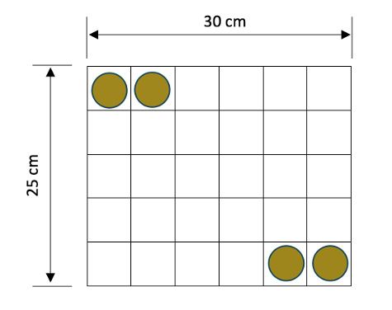
Figure 1. A layout of the chicken egg tray
To determine the optimal geometric parameters, a Cartesian coordinate system was defined strictly according to the kinematic diagram (as shown in Figure 2): the left motor pivot, labeled as Point A, is fixed at the origin (0,0). The right motor pivot, labeled as Point B, is located along the positive X-axis at coordinates (d,0), where d is the motor spacing. The Y-axis is defined perpendicular to the line AB. In this design configuration, the operational workspace (the tray location) is positioned in the positive Y region (above the line segment AB). We selected the horizontal distance d to be 20 cm. This value, representing approximately two-thirds of the tray width, ensures a substantial overlap between the workspaces of the left arm (Chain A-C-E) and the right arm (Chain B-D-E), optimizing performance in the central region.
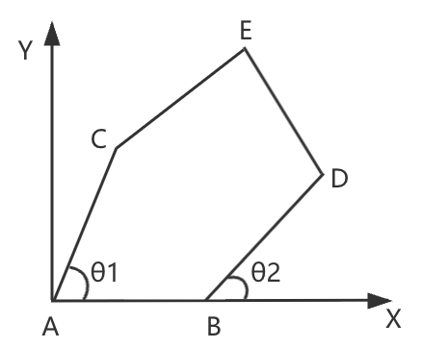
Figure 2. Kinematic diagram
Assuming the tray is centered horizontally at x=d/2 (x=10) and positioned vertically above the motors to suit the specific facility layout, the operational height ranges from approximately y=10 cm to 35 cm. By applying the Pythagorean theorem to the triangle formed by the origin A, the horizontal limit, and the highest vertical point, the distance to the furthest corner of the tray (coordinates approx. x=25, y=35) was calculated. The maximum theoretical reach required for a single arm chain (R_max = L_AC+L_CE) was determined to be approximately 43.0 cm.
$$R_{max}=\sqrt{\left\{{25}^{\left\{2\right\}}+{\left(35\right)}^{\left\{2\right\}}\right\}}=\sqrt{\left\{625+1225\right\}}=\sqrt{\left\{1850\right\}}≈43.0 cm$$
When the robot's linkage is fully extended, it enters a singular configuration (in which joint motion can no longer alter the end-effector's position, potentially causing control failure or mechanical jamming). To avoid this, a safety margin of 20% should be reserved beyond the "maximum reach" to enhance kinematic flexibility.
$$\left(L_{AC}+ L_{BD}\right)≈43 ×1.2 ≈51.6 cm$$
Consequently, the team selected a symmetric link length configuration where the drive links (L_AC, L_BD) and the coupler links (L_CE, L_DE) are all set to 28 cm. This configuration provides a total maximum extension of 56 cm per arm, significantly exceeding the required 43 cm limit, ensuring that the end-effector E can reach all points within the 30×25 cm tray area in the upper workspace with high dexterity. The final dimension selection is shown in Figure 3.

Linkage Designation | L_AC | L_BD | L_CE | L_DE | d(L_AB)
Dimensions (cm) | 28 | 28 | 28 | 28 | 20
Figure 3. Parameter Table

Kinematic Design of the Robot

2.1 Forward Kinematics Solution Equations of the Robotic Arm
(1). Definitions
The mechanism consists of two active drive links, AC and BD, with lengths denoted as L_AC and L_BD, respectively. Their orientations relative to the positive X-axis are governed by the input joint angles θ1 and θ2. These drive links are connected to the end-effector E via two passive coupler links, CE and DE, with lengths L_CE and L_DE. The objective of the forward kinematics formulation is to determine the Cartesian coordinates (x_E, y_E) of the end-effector E based on the known link lengths and the input angles θ1 and θ2.
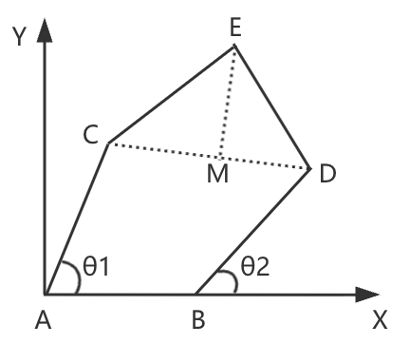
Figure 4. Forward Kinematics
(2). Derivation
Step 1: Calculate the coordinates of the active joints C and D.
Coordinates of point C (relative to point A at (0, 0)):
$$x_{C}= L_{\left\{AC\right\}}⋅cos\left(θ_{1}\right)$$
$$y_{C}= L_{\left\{AC\right\}}⋅sin\left(θ_{1}\right)$$
Coordinates of point D (relative to point B at (d, 0)):
$$x_{D}= d + L_{\left\{BD\right\}}⋅cos\left(θ_{2}\right)$$
$$y_{D}= L_{\left\{BD\right\}}⋅sin\left(θ_{2}\right)$$
Step 2: Construct triangle △CDE and solve for the intersection point.
Point E lies on a circle centered at C with radius L_CE, and also on a circle centered at D with radius L_DE. This forms a "intersection of two circles" problem.
Calculate the distance dist between points C and D:
$$\left\{dist\right\}= \sqrt{\left\{{\left(x_{D}− x_{C}\right)}^{2}+ {\left(y_{D}− y_{C}\right)}^{2}\right\}}$$
Introduce auxiliary variables a and h:
We drop a perpendicular from point E to the line segment CD, with foot at point M, such that (EM ⊥ CD).
Let a denote the distance from C to M (|CM|).
Let h denote the height from M to E (|ME|).
Apply the Pythagorean theorem in triangles (△CME) and (△DME):
$$h^{2}= L_{\left\{CE\right\}}^{2}− a^{2}$$
$$h^{2}= L_{\left\{DE\right\}}^{2}− {\left(dist − a\right)}^{2}$$
$$L_{\left\{CE\right\}}^{2}− a^{2}= L_{\left\{DE\right\}}^{2}− \left({dist}^{2}− 2 ⋅dist ⋅a + a^{2}\right)$$
$$a = \left\{L_{\left\{CE\right\}}^{2}− L_{\left\{DE\right\}}^{2}+ {dist}^{2}\right\}/\left\{2 ⋅dist\right\}$$
Solve for the height h:
$$h = \sqrt{\left\{L_{\left\{CE\right\}}^{2}− a^{2}\right\}}$$
Step 3: Calculate the coordinates of point E using the vector method.
Coordinates of the base point M (using the ratio (a / dist)):
$$x_{M}= x_{C}+ a ⋅\left\{x_{D}− x_{C}\right\}/\left\{dist\right\}$$
$$y_{M}= y_{C}+ a ⋅\left\{y_{D}− y_{C}\right\}/\left\{dist\right\}$$
Coordinates of point E:
The perpendicular vector must be added. For a 2D vector (d_x, d_y), its perpendicular vectors are (-d_y, d_x) or (d_y, -d_x).
$$x_{E}= x_{M}− h ⋅\left\{y_{D}− y_{C}\right\}/\left\{dist\right\}$$
$$y_{E}= y_{M}+ h ⋅\left\{x_{D}− x_{C}\right\}/\left\{dist\right\}$$

2.2 Forward Kinematics Simulation of the Robotic Arm in MATLAB
To validate the geometric derivation presented in Section 2.1 and to visualize the robot's motion, a simulation environment was developed using MATLAB. The implementation is divided into two functional modules: a computational function for solving the kinematics equations and a visualization function for rendering the robot's pose.
(1). MATLAB Implementation
The simulation consists of three main script files:
- fwd_kin_5bar.m: This function implements the geometric equations derived in Section 2.1. It accepts the input joint angles (θ1, θ2) and geometric parameters (L, d) as arguments and returns the Cartesian coordinates of the end-effector and intermediate joints.
- plot_robot.m: This function handles the graphical representation. It calls the forward kinematics function to obtain the joint positions and plots the links (AC, CE, BD, DE) and the end-effector (E) in a 2D coordinate system.
- run_simulation.m: The main execution script that defines the specific test cases required by the project specifications and iterates through them to generate the results.
(The source code is provided in the attached file.)
(2). Simulation Results
We performed forward kinematics simulations for the four sets of input joint angles as required. The resulting robot configurations are shown in Figures. The corresponding end-effector coordinates (x_E, y_E) computed by the program are listed below.
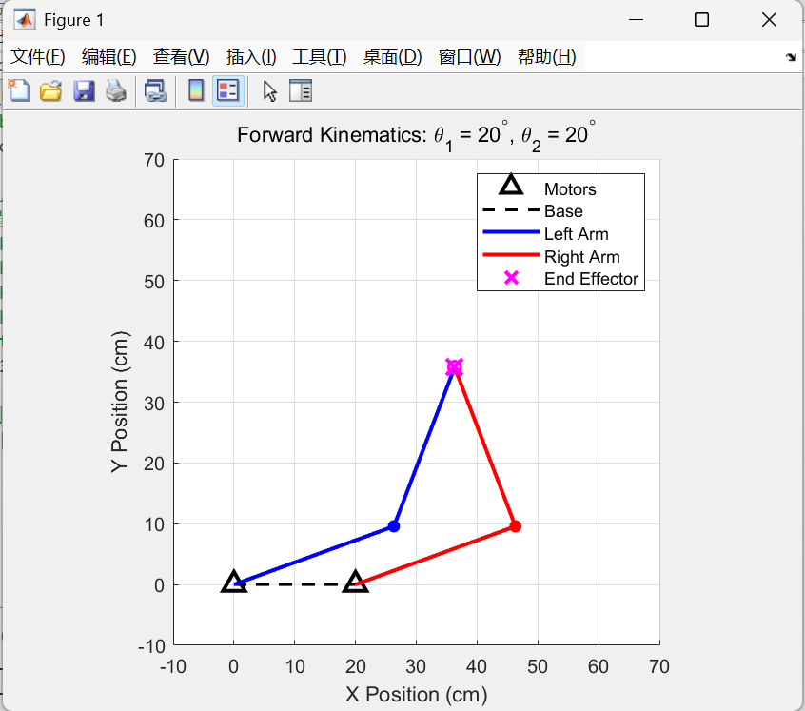
Figure 5. Case 1: θ1=20∘, θ2​=20∘
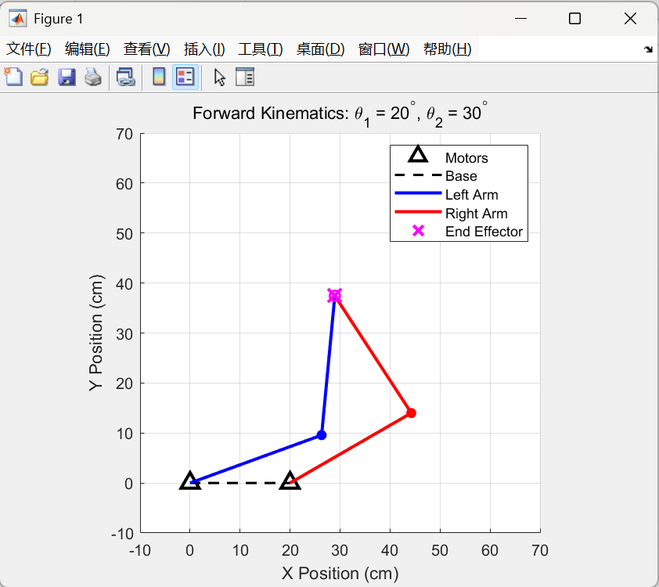
Figure 6. Case 2: θ1=20∘, θ2​=30∘
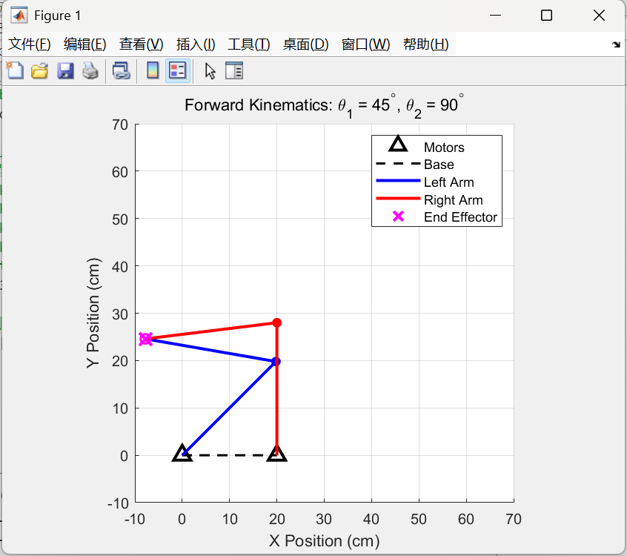
Figure 7. Case 3: θ1=45∘, θ2​=90∘
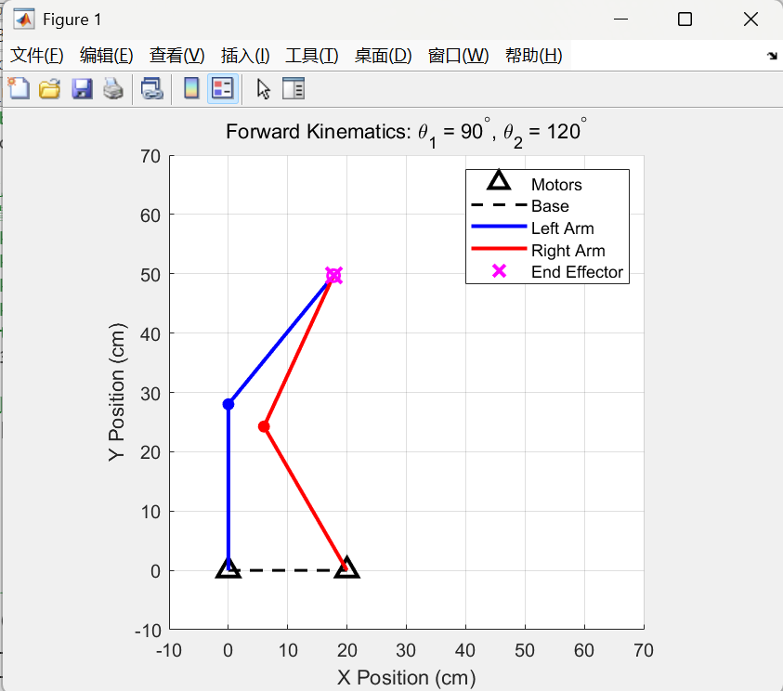
Figure 8. Case 4: θ1=90∘, θ2​=120∘

2.3 Inverse Kinematics Solution Equations of the Robotic Arm
(1). Definitions
To facilitate the geometric solution for inverse kinematics, auxiliary lines are introduced to decouple the closed-loop mechanism into two independent triangular structures for analysis. Specifically, a virtual line segment connecting the origin A to the end-effector E is defined as AE, with a length denoted by r_AE. Similarly, a line segment connecting the second base B to the end-effector E is defined as BE, with a length denoted by r_BE​. These auxiliary segments serve as the closing sides for the left triangle △ACE and the right triangle △BDE, respectively.
Regarding angular parameters, α1​ and α2​ are defined as the polar angles (or base angles) of the vectors AE⃗ and BE⃗ relative to the positive X-axis. Furthermore, intermediate angles β1​ and β2​ are introduced to represent the internal angles formed between the drive links and these auxiliary lines, specifically ∠CAE for the left chain and ∠DBE for the right chain. These geometric definitions provide the necessary framework for applying the Law of Cosines to determine the required input joint angles θ1 and θ2. The final coordinate system diagram is shown in the figure 9.
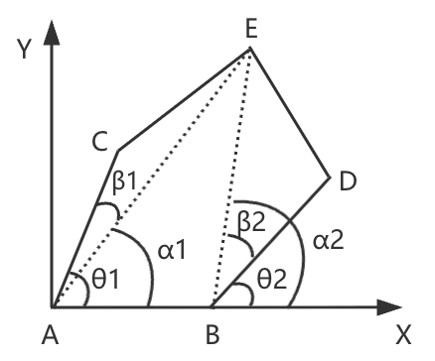
Figure 9. Inverse Kinematics Coordinate System Diagram
(2). Derivation
Step 1: Solve for the left joint angle θ1.
Calculate the length and angle of the auxiliary line AE:
$$r_{\left\{AE\right\}}= \sqrt{\left\{x^{2}+ y^{2}\right\}}$$
$$α_{1}= atan2\left(y, x\right)$$
Use the Law of Cosines to solve for the internal angle ∠CAE (denoted as β1):
$$L_{\left\{CE\right\}}^{2}= L_{\left\{AC\right\}}^{2}+ r_{\left\{AE\right\}}^{2}− 2 L_{\left\{AC\right\}}r_{\left\{AE\right\}}\cos\left(β_{1}\right)$$
$$β_{1}= arccos\left.\left(\left\{L_{\left\{AC\right\}}^{2}+ r_{\left\{AE\right\}}^{2}− L_{\left\{CE\right\}}^{2}\right\}/\left\{2 L_{\left\{AC\right\}}r_{\left\{AE\right\}}\right\}\right.\right)$$
Calculate θ1:
$$θ_{1}= α_{1}+ σ_{1}⋅β_{1}$$
(Where σ1 = ±1, depending on whether the elbow at point C is oriented upward or downward.)
Step 2: Solve for the right joint angle θ2.
Coordinate transformation and the length and angle of the auxiliary line BE:
$$r_{\left\{BE\right\}}= \sqrt{\left\{{\left(x − d\right)}^{2}+ y^{2}\right\}}$$
$$α_{2}= atan2\left(y, x − d\right)$$
Use the Law of Cosines to solve for the internal angle ∠DBE (denoted as β2):
$$L_{\left\{DE\right\}}^{2}= L_{\left\{BD\right\}}^{2}+ r_{\left\{BE\right\}}^{2}− 2 L_{\left\{BD\right\}}r_{\left\{BE\right\}}\cos\left(β_{2}\right)$$
$$β_{2}= arccos\left.\left( \left\{L_{\left\{BD\right\}}^{2}+ r_{\left\{BE\right\}}^{2}− L_{\left\{DE\right\}}^{2}\right\}/\left\{2 L_{\left\{BD\right\}}r_{\left\{BE\right\}}\right\}\right.\right)$$
Calculate θ1:
$$θ_{2}= α_{2}+ σ_{2}⋅β_{2}$$
(Where σ1 = ±1. Depending on the position of point D in the diagram, the sign is typically chosen as + or - based on the specific assembly configuration defined.)
Step 3: Summary equations.
The final inverse kinematics equations are as follows:
$$θ_{1}= atan2\left(y, x\right)±arccos\left.\left( \left\{L_{\left\{AC\right\}}^{2}+ \left(x^{2}+ y^{2}\right)− L_{\left\{CE\right\}}^{2}\right\}/\left\{2 L_{\left\{AC\right\}}\sqrt{\left\{x^{2}+ y^{2}\right\}}\right\}\right.\right)$$
$$θ_{2}= atan2\left(y, x−d\right)±arccos\left.\left( \left\{L_{\left\{BD\right\}}^{2}+ \left({\left(x − d\right)}^{2}+ y^{2}\right)− L_{\left\{DE\right\}}^{2}\right\}/\left\{2 L_{\left\{BD\right\}}\sqrt{\left\{{\left(x − d\right)}^{2}+ y^{2}\right\}}\right\}\right.\right)$$

2.4 Inverse Kinematics Simulation of the Robotic Arm in MATLAB
(1). MATLAB Implementation
A MATLAB function named inverse kinematics was developed to implement the equations derived in Section 2.3. This function accepts the desired end-effector coordinates (x,y) and linkage geometric parameters as inputs, and outputs the required motor angles. To enhance robustness, the function also includes a workspace validity check based on the triangle inequality to ensure the target point is physically reachable.
(The source code is provided in the attached file.)
(2). Simulation Results
Circular Trajectory:
The first test scenario involved tracking a circular path. The diameter of the circle was set to 8 cm, corresponding to the group number. The trajectory was generated using parametric equations with the center located within the central workspace. Figure 10 illustrates the robot's configuration at four distinct positions along the circular path. The simulation demonstrated smooth continuous motion, confirming that the inverse kinematics solution correctly solved for the "Elbows Out" configuration without singularities or self-collisions.
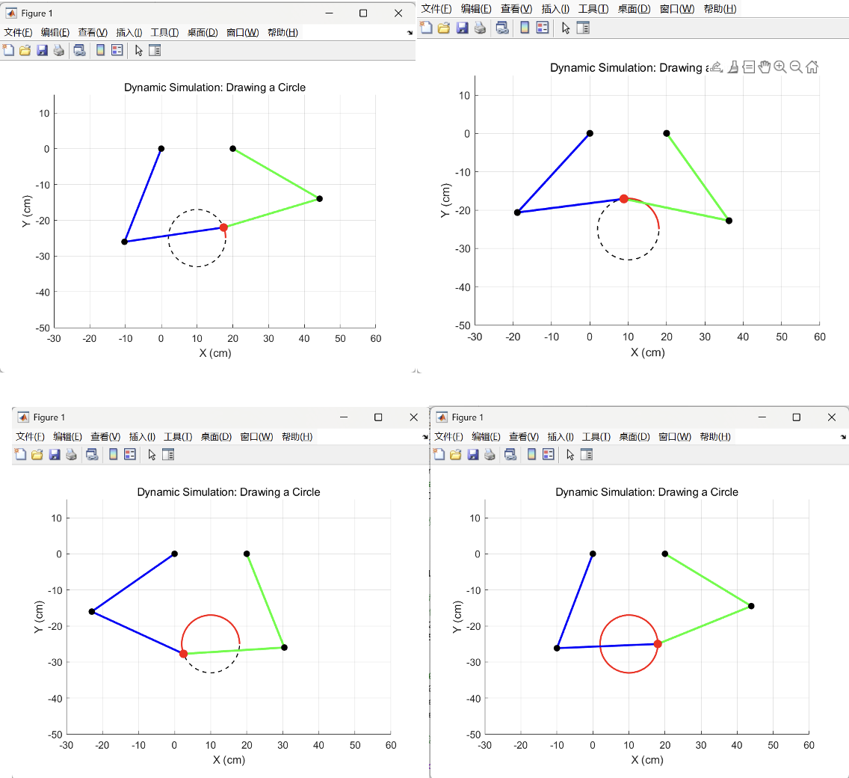
Figure 10. Circular trajectory
Square Trajectory:
The second test scenario required tracking a square path with a side length of 8 cm (group number). The path was generated by interpolating linear segments between the four corner coordinates. Unlike the circle, the square path requires sharp turns at the corners, which tests the algorithm's ability to handle non-smooth directional changes. Figure 11 shows the robot execution at four distinct points along the sides of the square. The end-effector accurately followed the linear segments and maintained the correct kinematic constraints throughout the operation.
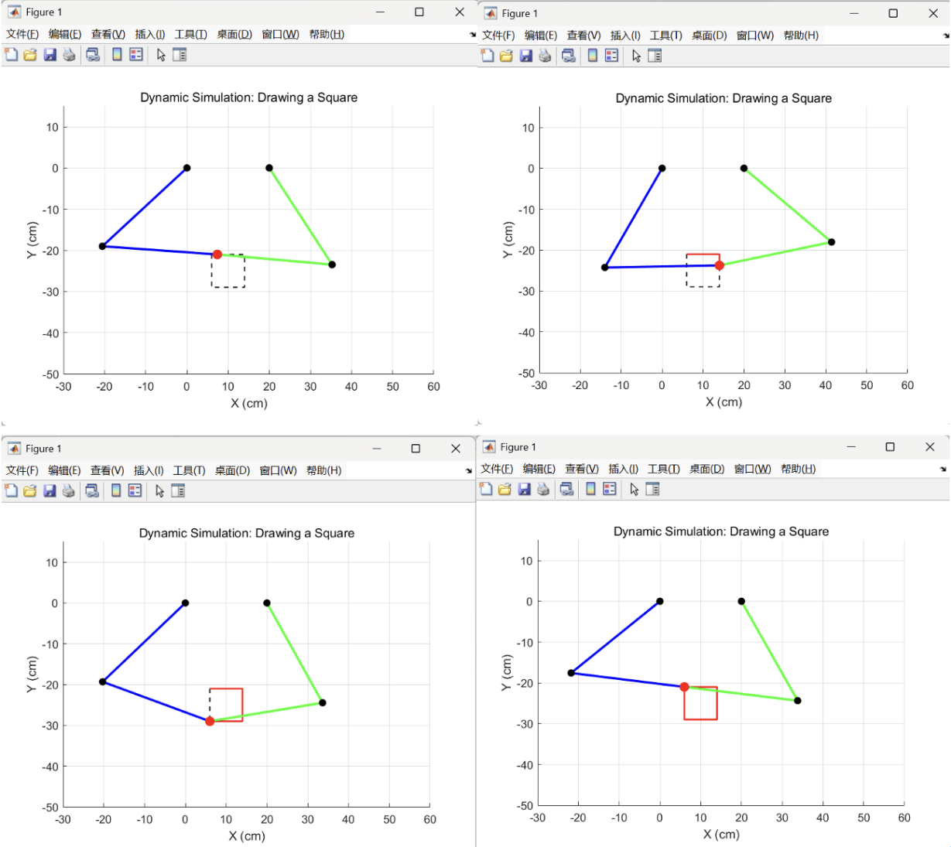
Figure 11. Square trajectory

3. CAD Modeling and Engineering Drawings of the Robot

3.1 The 3D model diagram of the robot
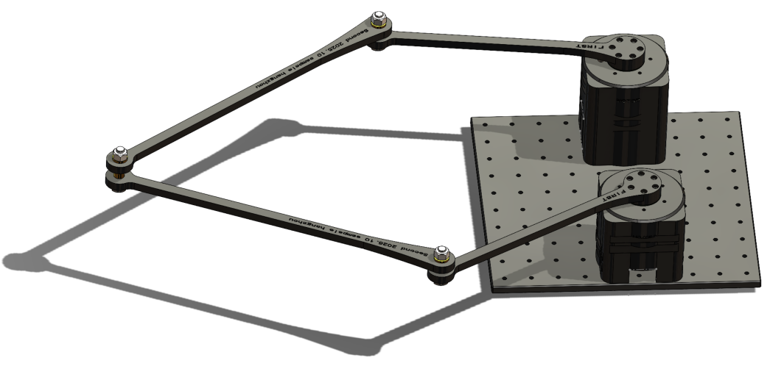
Figure 12. The 3D model diagram of the robot

3.2 Engineering drawings of the robot
The views of the robot engineering drawings are shown below.
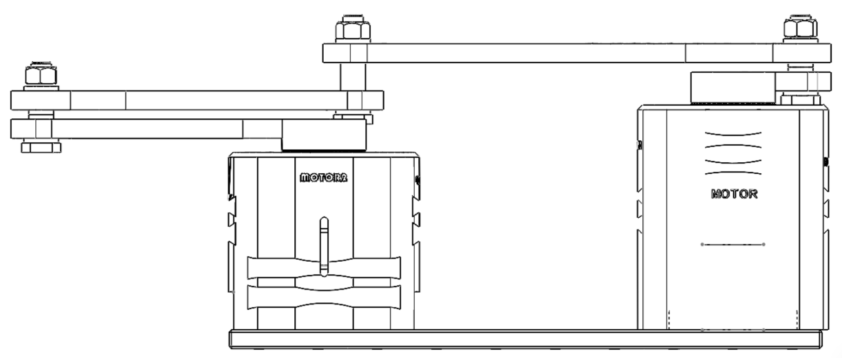
Figure 13. Front view

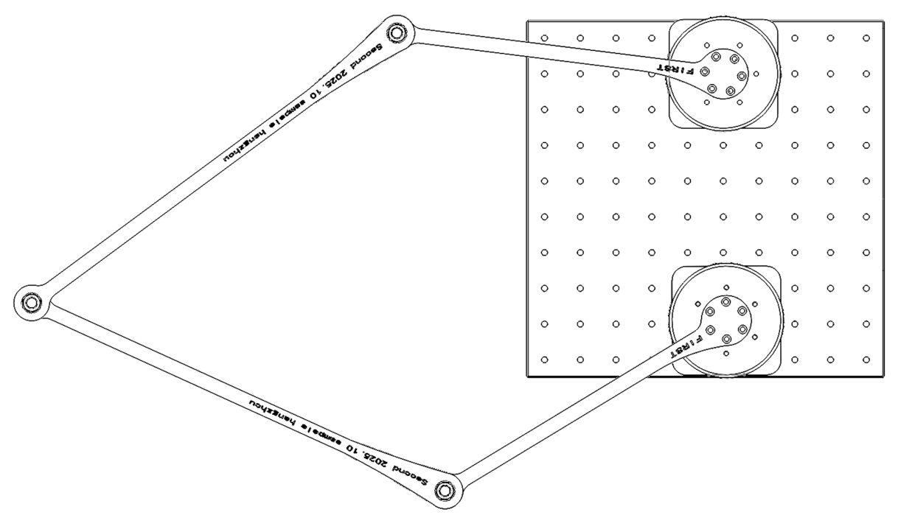
Figure 14. Top view

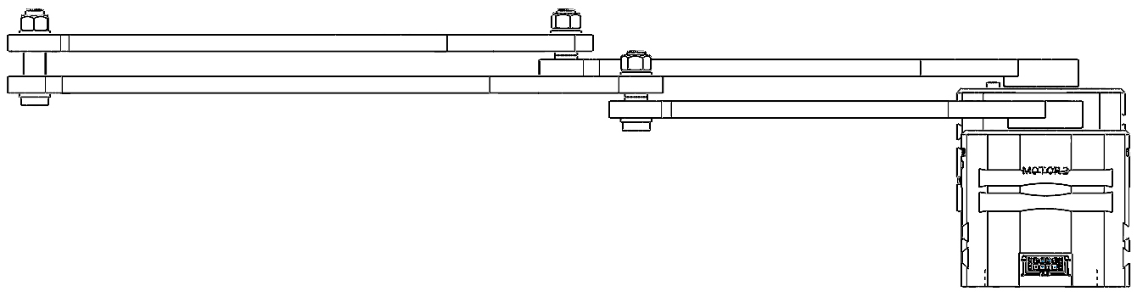
Figure 15. Left view
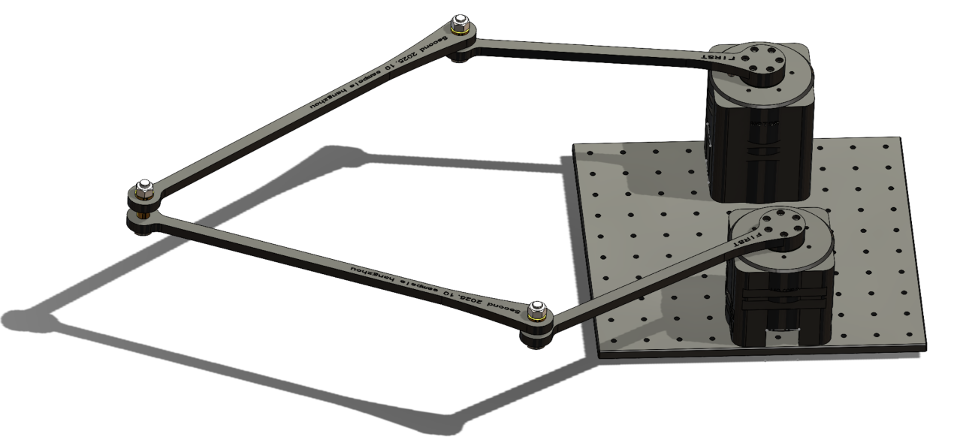
Figure 16. isometric views

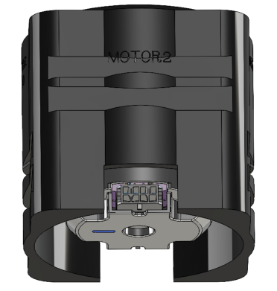
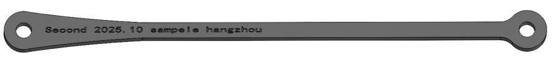
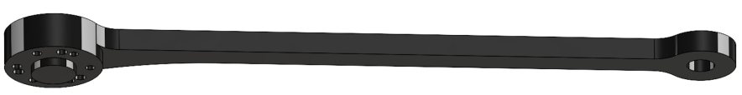
Figure 17. 3D views of some parts
The exploded view of the robot is shown in the figure.
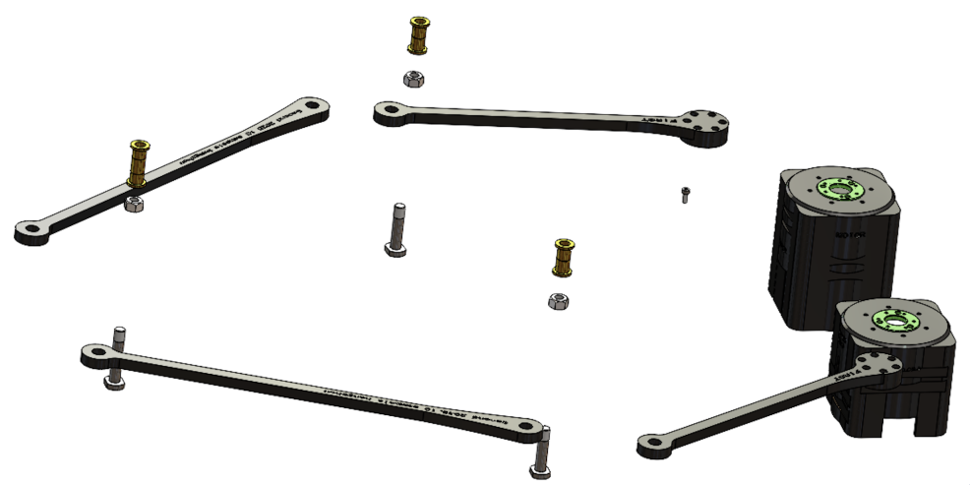
Figure 18. Exploded view
The Bill of Materials (BOM) for the robot is shown in the Figure 19.
ID | Component Name | Specification / Description | Quantity | Source
A | Electronics & Control
1 | Arduino Uno R3 | Microcontroller board, ATmega328P, 5V Logic | 1 | Off-the-shelf
2 | MG996R Servo Motor | Metal gear, High torque (11kg·cm), 180° rotation | 2 | Off-the-shelf
3 | DC Vacuum Pump | DC 3V–5V diaphragm pump (370/555 motor type) | 1 | Off-the-shelf
4 | Relay Module | 5V 1-Channel (Required to switch the pump On/Off) | 1 | Off-the-shelf
5 | External Power Source | 6V Battery pack or 5V/3A Power Adapter (For servos) | 1 | Off-the-shelf
6 | Jumper Wires | Male-to-Male, Male-to-Female connecting wires | 1 Set | Off-the-shelf
B | Mechanical Parts
7 | Robot Base | Custom design, mounts servos at distance d = 20cm | 1 | Fabricated (3D Print)
8 | Drive Links (Arms) | Custom design, Length = 280mm, PLA/PETG | 2 | Fabricated (3D Print)
9 | Coupler Links (Forearms) | Custom design, Length = 280mm, PLA/PETG | 2 | Fabricated (3D Print)
10 | End-Effector Mount | Custom design, holds suction cup and links | 1 | Fabricated (3D Print)
C | Hardware & Accessories
11 | Suction Cup | Soft silicone/rubber, suitable for egg surface | 1 | Off-the-shelf
12 | Silicone Tubing | Flexible air hose, ID 4mm, connects pump to cup | ~1 m | Off-the-shelf
13 | Ball Bearings | 608ZZ or similar (For smooth joint rotation) | 5 | Off-the-shelf
14 | Fasteners | M3/M4 Screws and Nuts (Assorted lengths) | 1 Set | Off-the-shelf
Figure 19. BOM

Code Design and System Implementation
This chapter presents the software architecture and code design of the five-bar planar parallel mechanism robot. The system integrates computer vision, coordinate transformation, inverse kinematics calculation, and hardware control to realize an intelligent, closed-loop egg-picking process.
The overall software system follows the principle of “perception → computation → execution”, forming a stable and efficient control loop that enables the robot to accurately locate, pick up, and place eggs.

4.1 Overall Control Flow
The final process of the whole system is:
- Capture image using camera
- Detect eggs via OpenCV
- Extract centroid positions
- Transform coordinates to robot base
- Send coordinates to Arduino
- Calculate inverse kinematics
- Move servos to target location
- Turn on vacuum pump to pick egg
- Move to tray position
- Turn off vacuum pump
This complete loop forms an intelligent automated egg-picking process.
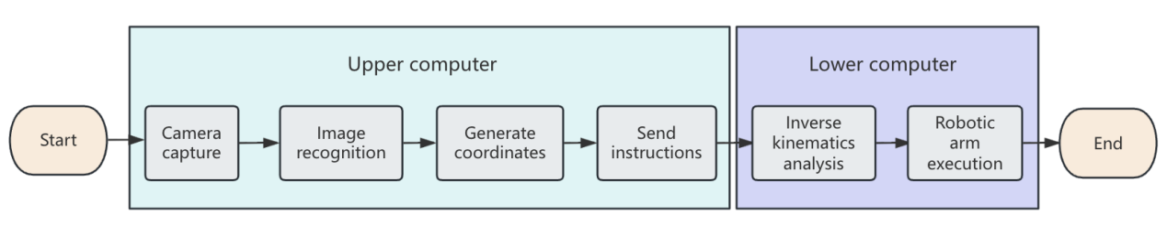
Figure 20. Overall System Flow

4.2 Overall System Architecture
The software system is divided into two main parts:
- Upper Computer (PC Side)
  - Image acquisition
  - Image preprocessing
  - Egg recognition
  - Coordinate extraction and transformation
  - Communication with Arduino
- Lower Computer (Arduino Side)
  - Inverse kinematics calculation
  - Servo motor control
  - Vacuum pump control
  - Motion execution
The upper computer performs complex image and data processing tasks, while the lower computer is responsible for real-time motion control. This layered structure improves computational efficiency and system stability.
The complete control chain is:
Camera → OpenCV Image Processing → Coordinate Mapping → Serial Communication → Inverse Kinematics → Servo Control → Suction Operation

4.3 Image Processing and Egg Recognition (OpenCV)
To accurately detect eggs on the working surface, OpenCV is used for image preprocessing and feature extraction. The main processing steps are as follows:
- Convert the input image to grayscale
- Apply Gaussian filtering to reduce noise
- Perform binary thresholding to highlight the target objects (eggs)
- Detect contours and calculate the centroid of each egg
Key OpenCV Code Example
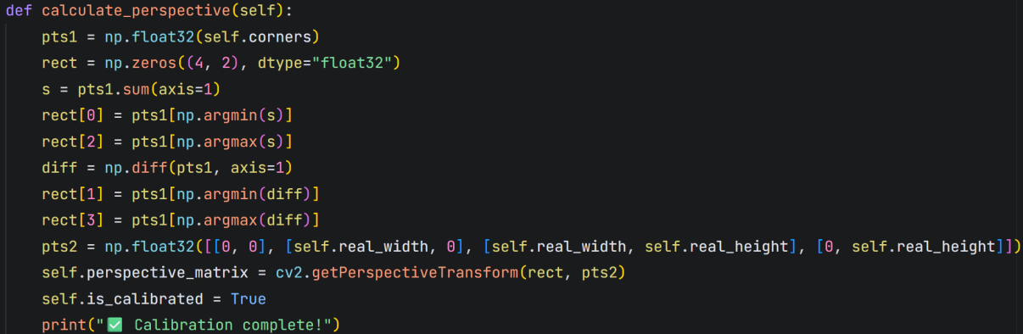
Figure 21. Calibration and rectification

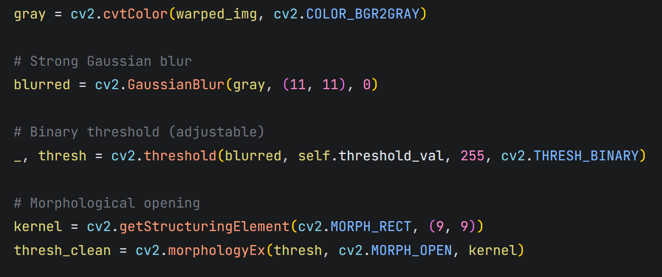
Figure 22. Image preprocessing
This code segment performs contour detection and extracts the centroid of each egg, which is used as the target position for the robot end-effector.

4.4 Coordinate Transformation
The centroid coordinates obtained from the image are in the image coordinate system. In order to be used by the robot, these coordinates must be converted into the robot base coordinate system.
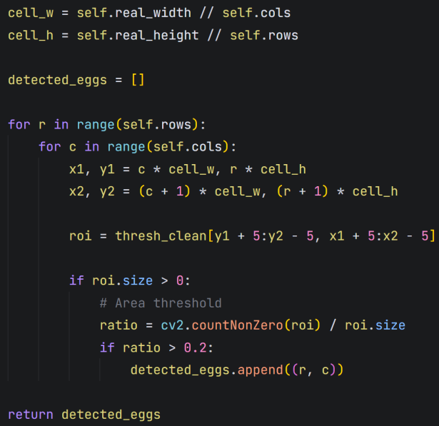
Figure 23. Coordinate conversion
This transformation is obtained through camera calibration and perspective correction. After conversion, the target point can be passed to the Arduino for inverse kinematics calculation.

4.5 Inverse Kinematics Implementation
The inverse kinematics equations derived in Chapter 2 are implemented on the Arduino. After the target (x, y) position is received, the corresponding joint angles ( \theta_1 ) and ( \theta_2 ) are calculated using the law of cosines.
Key Arduino Inverse Kinematics Code Example
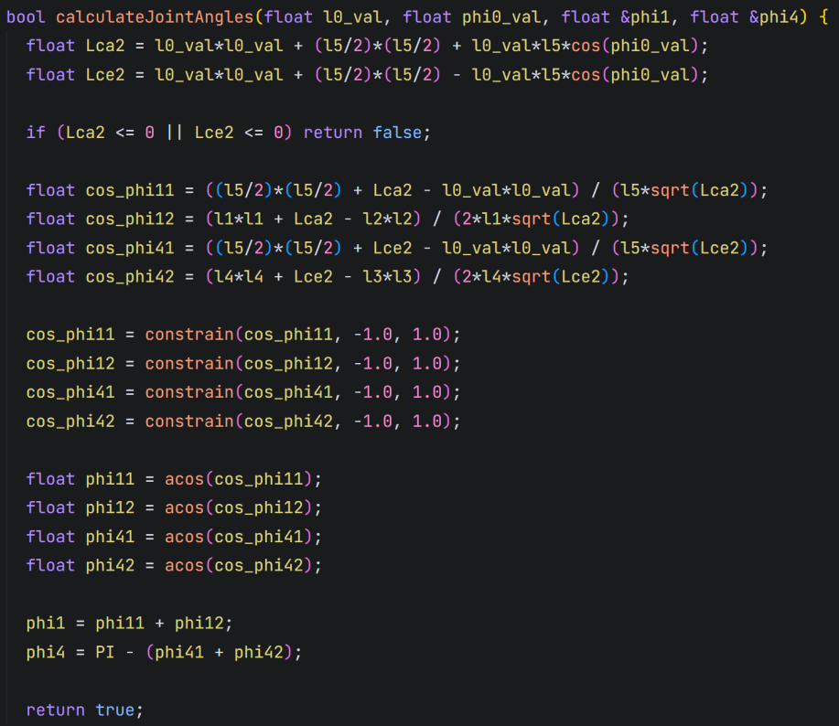
Figure 24. Inverse solution calculation
This code enables the robot to convert spatial coordinates into motor angles and then control the motion of the two servos in real time.

4.6 Suction Cup and Relay Control
The suction system is controlled by a relay module connected to the Arduino. The relay switches the vacuum pump on and off.
Suction Control Code Example
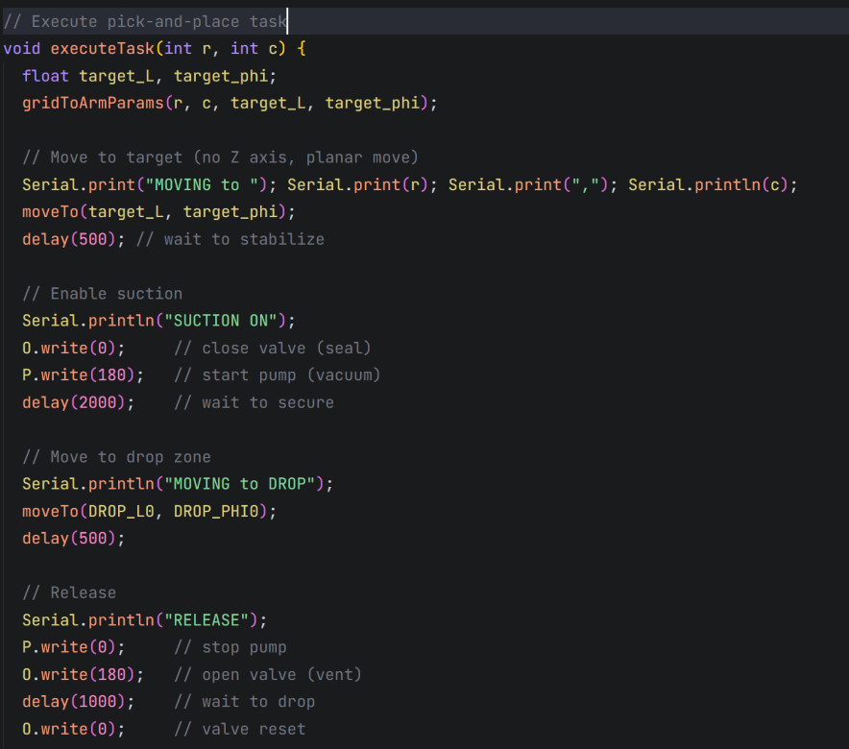
Figure 25. Suction cup control
This method ensures that the egg can be picked up and released safely and reliably.

4.7 Final results display
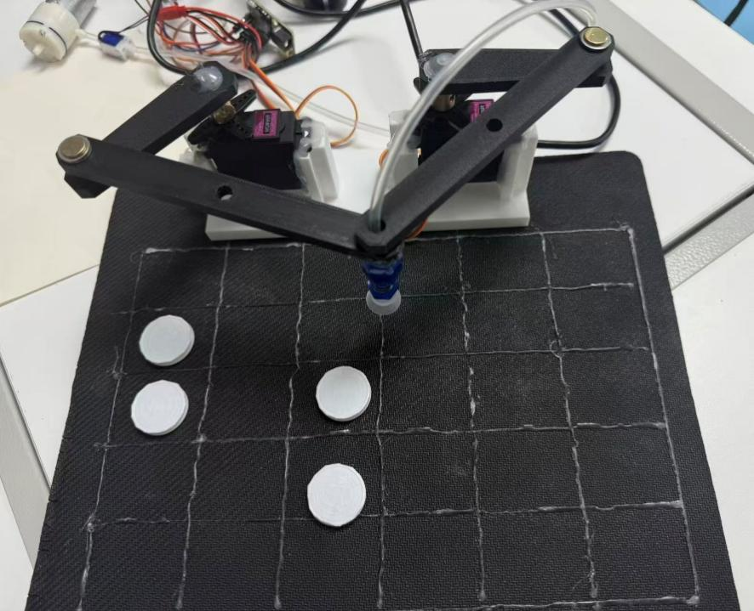
Figure 26. Results display

Conclusion
This project focused on the development of a lightweight robotic system based on a five-bar planar parallel mechanism, designed to address the inefficiencies and high risk of egg damage associated with manual collection in modern poultry farms. By integrating kinematic analysis, computer simulation, mechanical modeling, and embedded control, the team successfully implemented a fully functional, compact, and cost-effective prototype for automated egg picking.
In terms of mechanism design, a symmetric five-bar parallel configuration was adopted (with link lengths and motor spacing). This layout ensures full coverage of the target workspace—30 cm wide by 25 cm high—while maintaining a 20% safety margin to avoid singular configurations, thereby guaranteeing both dexterity and structural stability. The forward and inverse kinematics models were rigorously derived and validated through MATLAB simulations across multiple test cases, including circular and square trajectories. Results confirmed the robot’s excellent reachability, smooth motion capability, and accurate path-following performance.
On the hardware side, the system employs an Arduino Uno as the central controller, driving two high-torque MG996R servo motors for joint actuation. A miniature vacuum pump coupled with a soft silicone suction cup serves as the end-effector, enabling gentle and reliable egg handling. All structural components were custom-fabricated via 3D printing, balancing light weight with mechanical precision. The complete Bill of Materials (BOM) is well-documented, facilitating replication and future upgrades.
The software architecture follows a coordinated “upper-computer/lower-computer” approach: the upper computer (PC) uses OpenCV for image acquisition, preprocessing, and egg detection, extracting centroid coordinates and transforming them from the image coordinate system to the robot’s base frame. The lower computer (Arduino) receives these target coordinates, computes the required joint angles in real time using the inverse kinematics solution, and controls both servo motion and vacuum pump activation. This closed-loop workflow demonstrates robustness, responsiveness, and suitability for real-world deployment.
In summary, this project not only validates the practical applicability of five-bar parallel mechanisms in light-duty pick-and-place tasks but also provides a scalable reference design for low-cost automation solutions in agriculture, food processing, and similar domains. Future work may focus on improving visual localization accuracy, incorporating force feedback for safer grasping, and exploring multi-robot coordination to enhance overall system throughput.

