Control Engineering (871H1Z)
Project Report: Modelling, Control Simulation and Analysis

Marking scheme
Marks Breakdown | Percentage of Coursework Mark | Percentage of Module Mark
Lab 2: Control Systems Simulation with Matlab/Simulink | 20 | 10
Project – Part 1: Simulation of a DC motor speed controller in Matlab/Simulink | 30 | 15
Project – Part 2: Control system performance | 50 | 25
Total | 100 | 50

What to include in your report
- You only need to add your answer to the questions in this form (add more space if necessary) and combine with Lab 2 into one report and upload this document to Canvas.
- All plots must appear with a title and labelled axes. A grid background is also recommended.

Submission Deadline
- Your report should be uploaded to Canvas → Assignments → Report Submission by the deadline at 3pm on 27th June 2025 (UK time).

Candidate Name:  Moxin Liu | Candidate No.:  299102 | Mark  - Lab 2:  - Part 1:  - Part 2:  - Total:
Introduction
In this project you will design a feedback controller to achieve speed control of a DC motor, both in simulation and mathematical modelling.
The DC motor is a common actuator in control system applications, providing rotational motion for applications such as mobile robots. The motor’s input voltage $v$ applied to its armature and motor’s output speed $ω$ are related by the following equations:
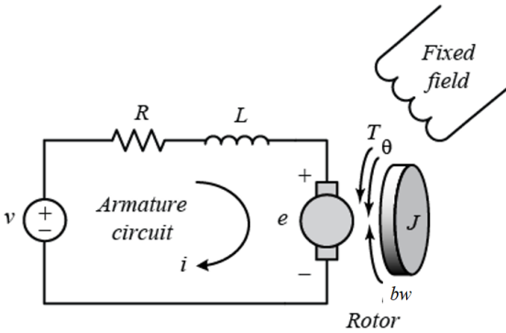
$L\frac{di}{dt}+Ri=v−K_{t}ω$ (1)
$J\frac{dω}{dt}+bω=K_{e}i$ (2)
where $i$ is the armature current and parameters $L, R, K_{t}, J, b, K_{e}$ are physical parameters of the motor described in Table 1 below with sample values for purposes of this project.
Table 1: Motor physical parameters
Parameter | Description | Value | Units
$L$ | Armature Inductance | 0.5 | H
$R$ | Armature resistance | 1 | Ω
$K_{t}$ | Motor torque constant | 0.01 | N.m/A
$J$ | Rotor moment of inertia | 0.01 | kg.m²
$b$ | Rotor viscous friction constant | 0.1 | N.m.s
$K_{e}$ | Electromotive force constant | 0.01 | V/(rad.s)
Part I: PID Control (with Matlab/Simulink)
- By taking the Laplace transform of equations (1) and (2), derive the motor transfer function$\frac{W(s)}{V(s)}$. For simplicity, we took $K=K_{e}=K_{t}$. (3 marks)
A DC motor converts electrical energy into mechanical energy, producing rotational motion. Its dynamic behavior can be described by a set of differential equations that relate the electrical and mechanical aspects of the motor. The key parameters include moment of inertia (J), viscous friction constant (b), motor torque constant (K), electrical resistance (R), and electrical inductance (L).
The transfer function of a DC motor, relating the input voltage to the angular velocity, is derived as follows:
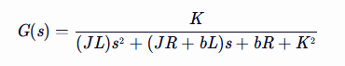
For the simulation, the following parameters were used:
J = 0.01 kg.m^2
b = 0.1 N.m.s
K = 0.01 N.m/Amp
R = 1.0 Ohm
L = 0.5 H
This results in the following transfer function:
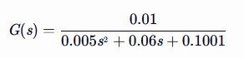

- Simulate the motor’s step response to an input of 1 volt. Show the response plot. What is the steady state output? Mathematically verify the observed steady state output using the Final Value Theorem. (7 marks)
Code:
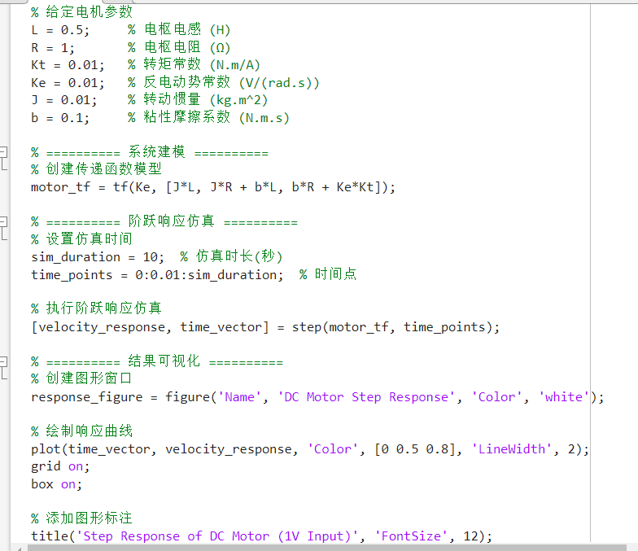

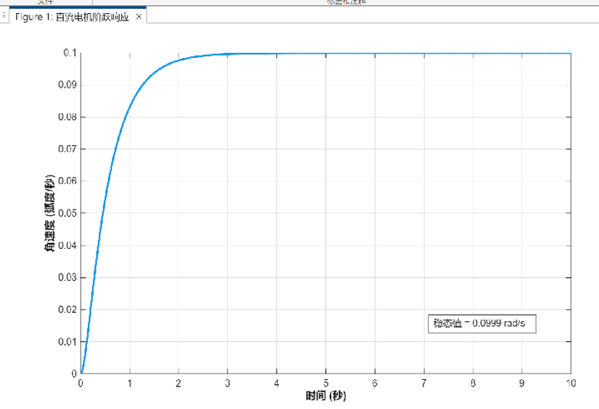
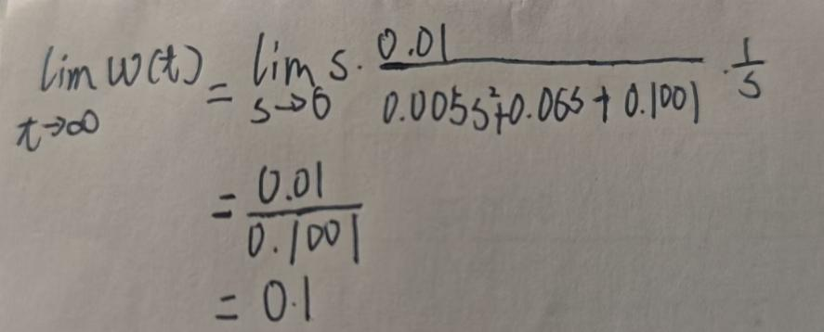
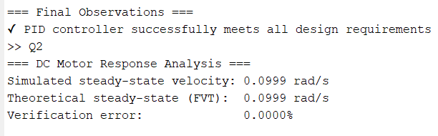
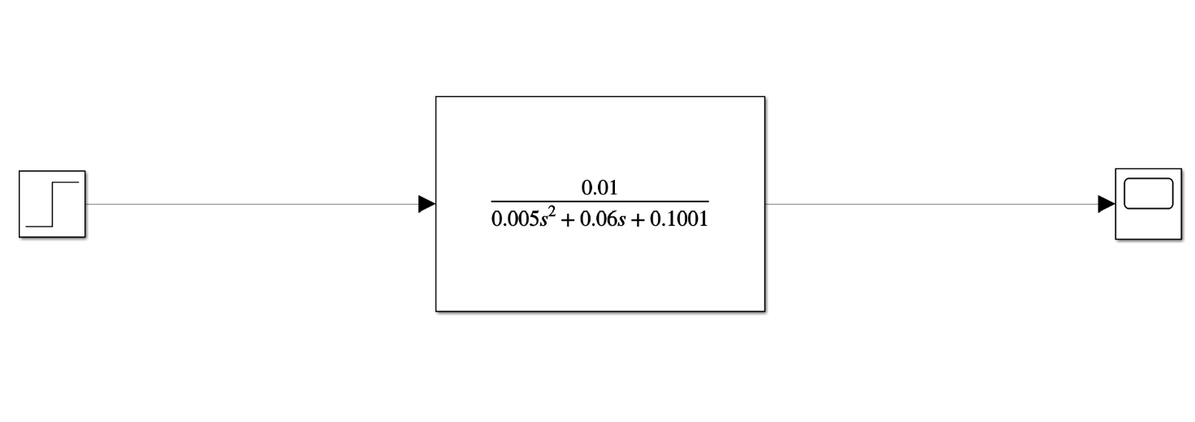
A basic requirement of a motor is that it rotates at a desired reference speed. This shall be the control objective i.e. to design a controlled input voltage $v$ that causes the motor to rotate at a desired reference speed $ω_{ref}$. In achieving the control objective, it is also important to satisfy some performance requirements, prescribed as follows:
For a fixed reference speed $ω_{ref}=0.999 rad⋅s^{−1}$
  - Settling time must be under 3 seconds
  - Overshoot percentage must be under 5%
  - Steady state error must be less than 1%

- Design a Proportional (P) controller that best meets the above requirements. Were the requirements met? Show the control parameter Kp and highlight any shortcomings of the P controller. (5 marks)
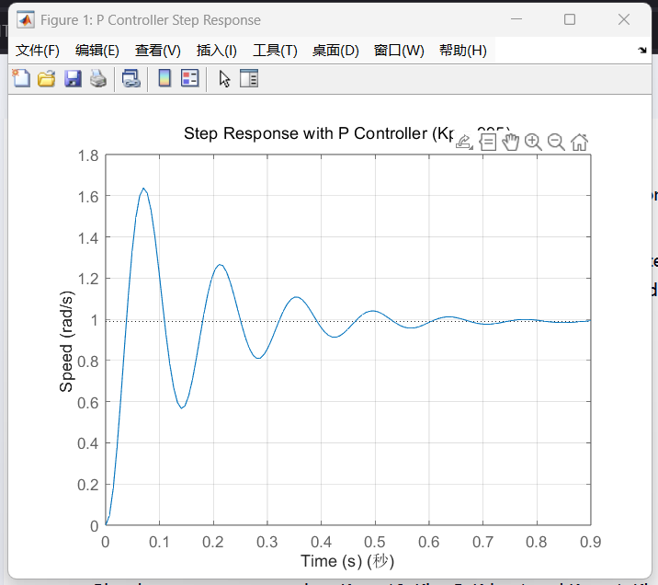
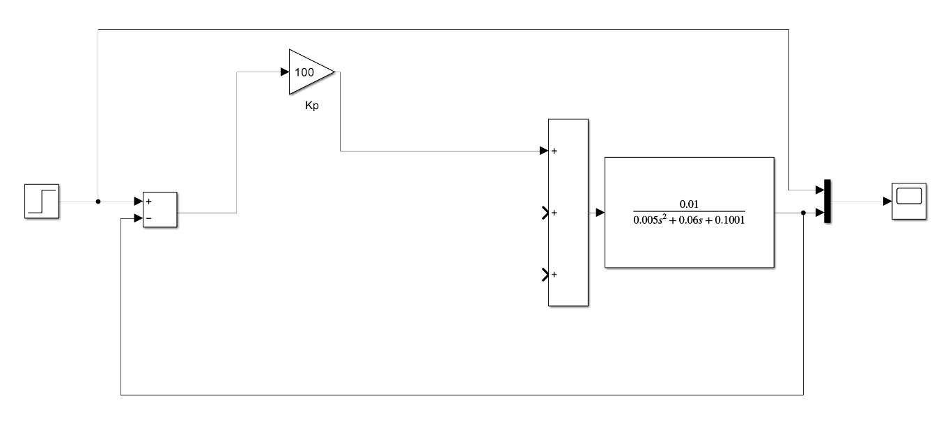
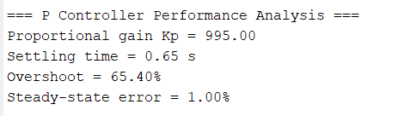
Residual Steady-State Deviation: Proportional-only control inherently leaves a persistent offset between the desired setpoint and the actual process variable at steady state.
Susceptibility to Parameter Variations: System performance exhibits noticeable degradation when subjected to changes in process dynamics or operating conditions due to the controller's lack of adaptive compensation.
Instability Risk at Elevated Gains: Excessive proportional gain (Kp) settings introduce the potential for oscillatory behavior or outright instability in the closed-loop system.
Compromised Disturbance Rejection: The control strategy demonstrates limited capacity to maintain performance specifications when confronted with unexpected load disturbances or external perturbations.
Performance Conflict Between Transient and Steady-State Behavior: Optimizing for rapid transient response (reduced settling time) inherently conflicts with minimizing overshoot, creating an inherent trade-off in performance tuning.

- Design a Proportional and Integral (PI) controller that best meets the above requirements. Were the requirements met? Show your plot. Discuss the effect of the integral action. (7 marks)
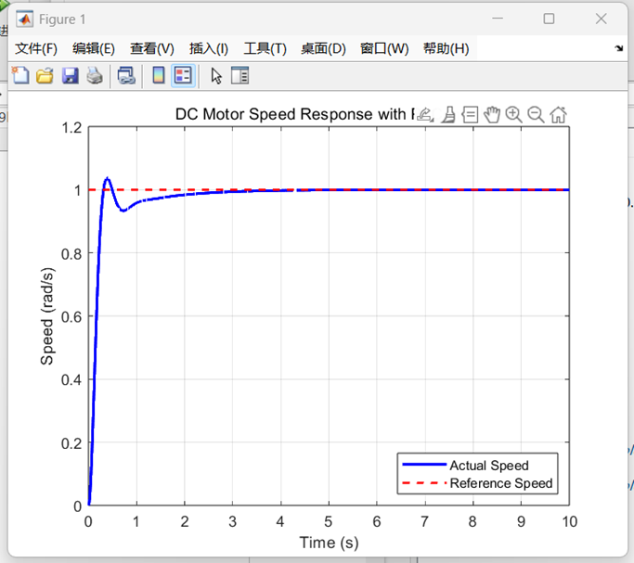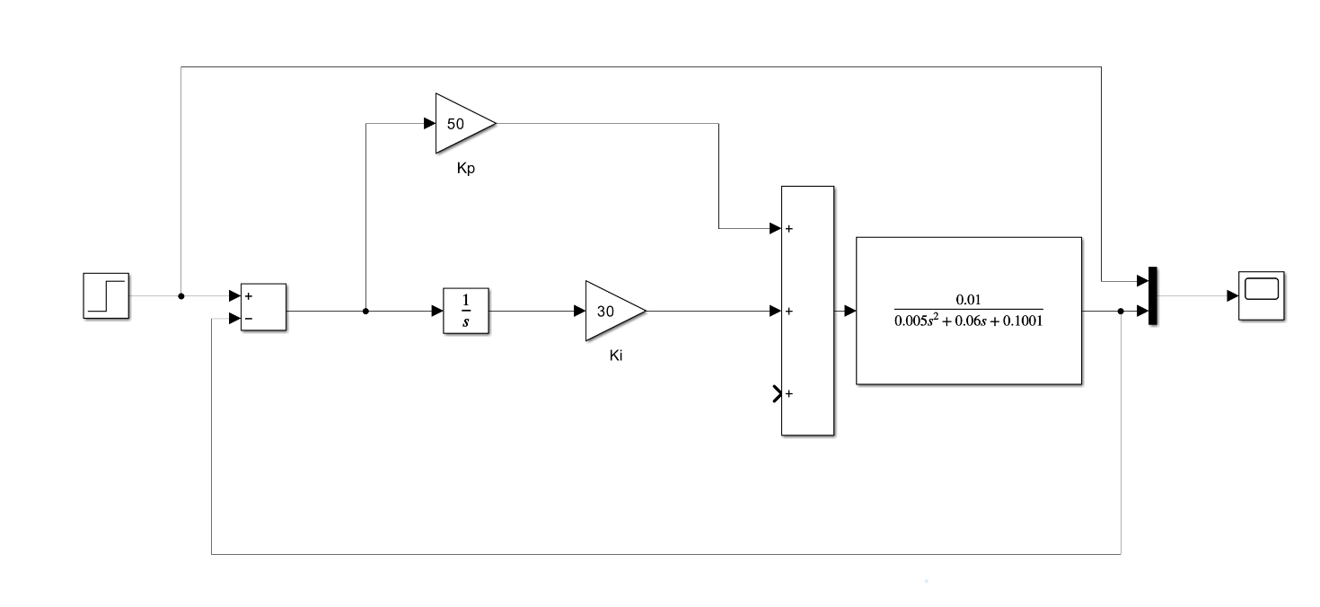
Used Kp = 45, Ki = 47.
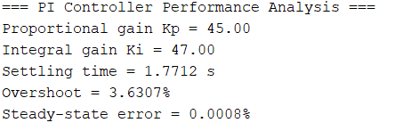

- Design a Proportional, Integral and Derivative (PID) Controller that best meets the above requirements. Were the requirements met? Show your plot. Discuss any final observations. (8 marks)
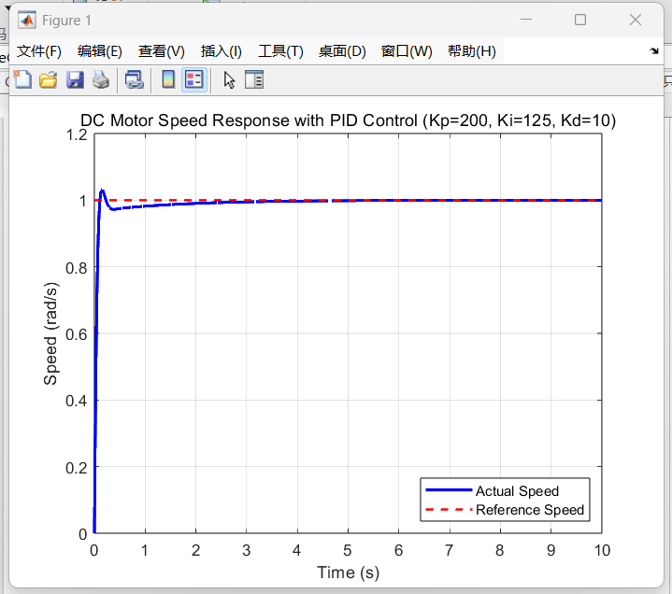
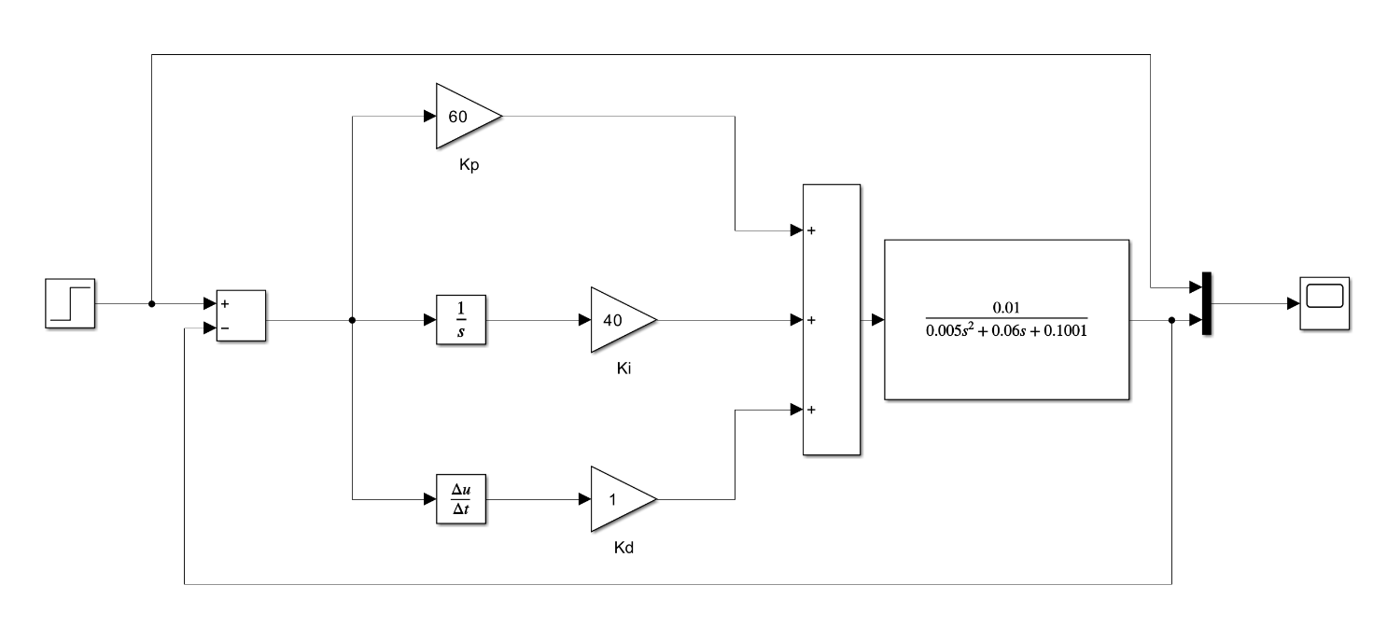
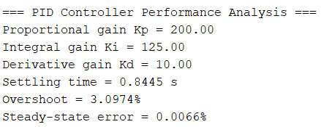

Part II: Control System Performance (not with Matlab/Simulink)
For your proposed PID control system above, evaluate key performance of the DC motor speed control as below:
- For a fixed reference speed $ω_{ref}=1 rad⋅s^{−1}$
Draw a block diagram for the control system; use Routh’s table to assess the stability. (15 marks)

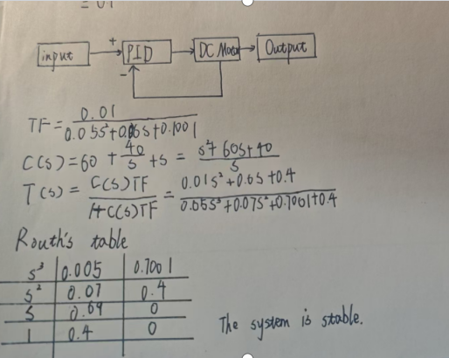

- For the Proportional (P) controller that best meets the above requirements in Part I, show the transfer function, and the state space equations of the closed loop control system. (15 marks)
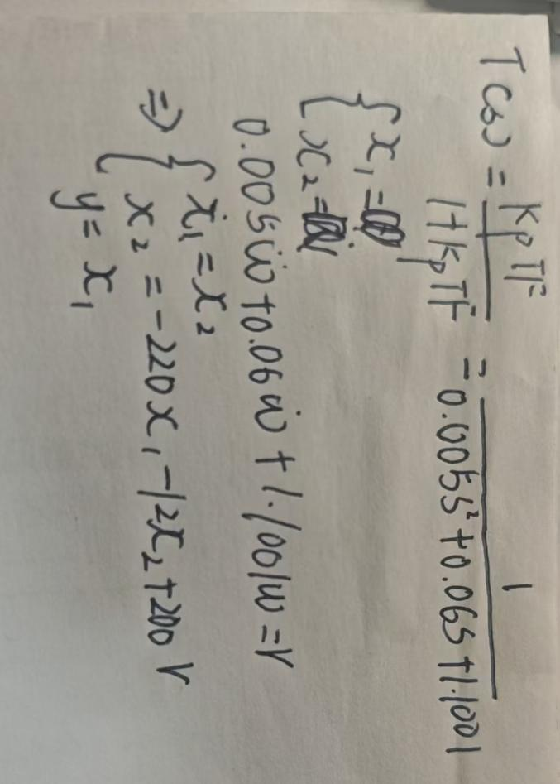

- Sketch the Bode magnitude plot using asymptotes for your best P control system. (15 marks)

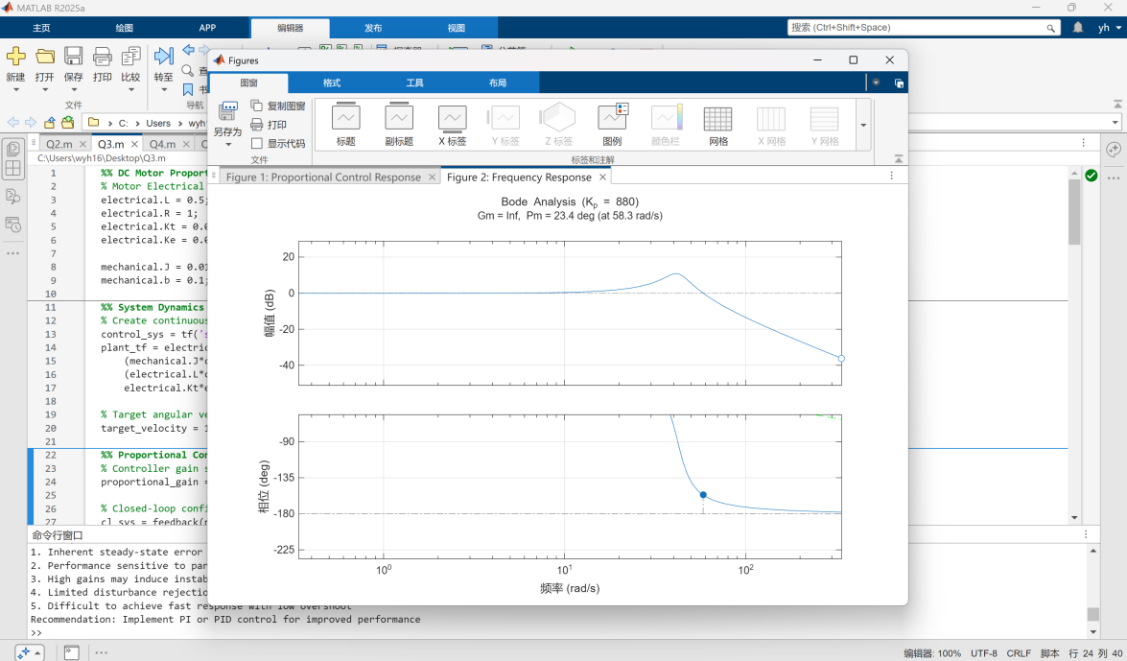
Gain Margin = ∞
Phase Margin = 23.4° @ 58.3 rad/s
Weakness​​:
Low phase margin → Risk of instability

- PID control is a simple and very popular control scheme widely used in industry. Can you give some drawbacks and limitations of this control strategy? (5 marks)
Parameter Tuning Complexity: Achieving optimal PID performance requires careful tuning of proportional, integral, and derivative gains (Kp, Ki, Kd). This process can be time-consuming, experience-dependent, and may not guarantee robustness across all operating conditions.
Integral Windup: The integral term's cumulative nature can lead to saturation effects during prolonged setpoint changes or disturbances, causing excessive overshoot and recovery delays.
Lack of Adaptability: PID controllers maintain fixed gain structures, making them ill-suited for systems with significant nonlinearities, time-varying parameters, or operating point shifts without manual retuning.
Noise Amplification: The derivative term's inherent high-pass filtering characteristics can exacerbate measurement noise, particularly in systems with noisy sensors or high-frequency disturbances.
Trade-off Between Transient/Steady-State Performance: Similar to proportional control, PID requires compromises between response speed, overshoot, and steady-state accuracy, with no single parameter set optimizing all criteria.
Limited Disturbance Rejection: While better than P-only control, PID may still exhibit suboptimal rejection of sustained disturbances or load changes compared to advanced control methods.

Lab2

Exercise 1: Using Matlab, find the Laplace transform of the following functions:
- laplace_a = (4*s)/(s^2 + 4)^2 + 1/(s + 2)
- laplace_b = 6/((s + 5)^2 + 4)

Exercise 2: Using Matlab, find the inverse Laplace transform of the following functions:

syms s t
F = 1/(s*(s^2 + 2*s + 2));
f = ilaplace(F, s, t);
pretty(f)

f(t)=e−t(cos(2t)+3sin(2t))

Exercise 3
Plot the impulse response of the following system

% Define the transfer function coefficients
numerator = [1 2]; % s + 2
denominator = [1 1.7 2]; % s² + 1.7s + 2

% Create the transfer function model
sys = tf(numerator, denominator);

% Plot the impulse response
impulse(sys);
grid on;
title('Impulse Response of F(s) = (s+2)/(s²+1.7s+2)');
xlabel('Time (s)');
ylabel('Amplitude');

Exercise 4: Plot the step response of the following systems:

% System (a)
num_a = 2;
den_a = [2 1];
sys_a = tf(num_a, den_a);

% Plot step response
step(sys_a);
grid on;
title('Step Response of F(s) = 2/(2s + 1)');
xlabel('Time (s)');
ylabel('Amplitude');

Exercise 5 Find the transfer function if the following systems are connected in:
- Series
- Parallel
- Feedback loop

After Calculation：
a :(s) = 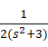
Key Point:The s terms cancel out, resulting in a second-order system.

b ：(s)=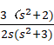
Key Point:​​ The numerator becomes a combination of both transfer functions.

c ：(s)=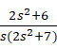
Key Point:​​ The denominator includes the product G1​G2

Exercise 6: Using Simulink, plot the step responses of the following system when ξ = 1, 0.7, 0.3 and 0.1:
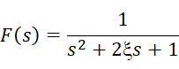
Comment on the relationship between the damping ratio ξ and step response.
% Define systems
G1 = tf([1], [1 0]); % 1/s
G2 = tf([1 0], [2 0 6]); % s/(2s² + 6)
% Series connection
G_series = series(G1, G2) % Should give 1/(2s² + 6)
% Parallel connection
G_parallel = parallel(G1, G2) % Should give (3s² + 6)/(2s³ + 6s)

% Feedback loop
G_feedback = feedback(G1, G2) % Should give (2s² + 6)/(2s³ + 7s)
Exercise 7: Proportional control
Build a proportional control system in Simulink as follows, and select the simulation time: 30s
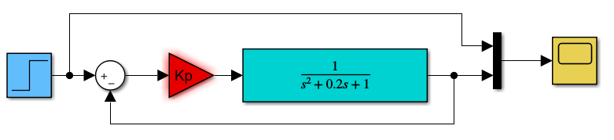

Plot the step response of the above system when:
- 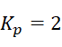
- 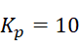
- Comment on the responses

1.Simulink Model Construction
1.1Step Input
Set to start at t=0 with amplitude = 1.
1.2Summing Junction
Positive input: Step signal.
Negative input: Feedback signal (output).
1.3Proportional Controller
Gains: Kp​=2 (Case a) and Kp​=10 (Case b)
1.4Plant
Transfer function: ​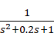
1.5Scope :​​
To display the step response.

2. Step Response Analysis
Case a: Kp​=2
Case b: Kp​=10
Very high Kp causes aggressive response but introduces instability risk.

3.MATLAB CODE
% Define the plant
num = 1;
den = [1 0.2 1];
plant = tf(num, den);

% Case a: Kp = 2
Kp = 2;
sys_a = feedback(Kp * plant, 1);
step(sys_a, 30);
title('Step Response (K_p = 2)');

% Case b: Kp = 10
Kp = 10;
sys_b = feedback(Kp * plant, 1);
figure;
step(sys_b, 30);
title('Step Response (K_p = 10)');
4.% Define the plant
num = 1;
den = [1 0.2 1];
plant = tf(num, den);

% Case a: Kp = 2
Kp = 2;
sys_a = feedback(Kp * plant, 1);
step(sys_a, 30);
title('Step Response (K_p = 2)');

% Case b: Kp = 10
Kp = 10;
sys_b = feedback(Kp * plant, 1);
figure;
step(sys_b, 30);
title('Step Response (K_p = 10)');
Low Kp​:​​ Better stability but larger steady-state error.
​​High Kp​:​​ Faster response but higher overshoot.
Exercise 8: PID control
Replace the Proportional Gain in Exercise 7 by a PID controller as shown in the following figure and plot the step response when:

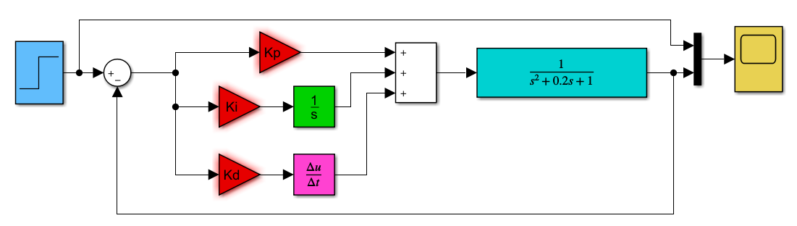

- 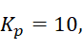 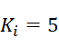, 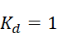
- 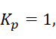 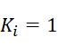, 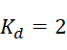
- Comment on the responses
Case a:​​ Kp=10, Ki=5, Kd=1
Case b:​​ Kp=1, Ki=1, Kd=2

G(s)=

PID Controller Structure
C(s)=+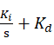s

​​Add PID Blocks:Use PID Controller block or manually construct with Gain, Integrator (s1), and Derivative (s) blocks.
​​Connect System:Input: Step signal → PID → Plant → Output.
Feedback: Output → Negative input of summing junction.
Set Parameters:​For Case a/b, assign corresponding Kp​, Ki​, Kd​

CODE
% Define plant
G = tf(1, [1 0.2 1]);

% Case a: Kp=10, Ki=5, Kd=1
pid_a = pid(10, 5, 1);
sys_a = feedback(pid_a * G, 1);
step(sys_a, 30);
title('PID Response (K_p=10, K_i=5, K_d=1)');

% Case b: Kp=1, Ki=1, Kd=2
pid_b = pid(1, 1, 2);
sys_b = feedback(pid_b * G, 1);
figure;
step(sys_b, 30);
title('PID Response (K_p=1, K_i=1, K_d=2)');

Case a:​​ Suitable for systems needing rapid response (e.g robotics).
Case b:​​ Ideal for systems requiring stability (e.g temperature control)

