Embedded Systems and Sensors
Laboratory protocol

PROTOCOL NAME : Embedded Alarm Clock Design
Name/Candidate number:Liu Moxin/299102
Group member:Zhou zhuoli
DATE : 2024/1/30

1.Objectives:
(Briefly describe the task: What's the problem to solve or what are you supposed to create?)
Design an electronic clock.Desired functions are chronograph, stopwatch, alarm clock.
Design feature：
Try to use optical line sensor to realize multi-hardware combination.
Improvement direction：
1.Improve the function, ensure that every part of the function is normal and smooth operation,
2.Use UI and icon Settings to make it easy for users to understand how to use.
2.Materials:
(This is a simple list of the components you intend to use.)
1.Optical line sensor
2.Single chip microcomputer

3.Plan / Procedure / Results & Analysis (Main Part):
(Here, describe the conceptual elements of your envisaged solution and the technical implementation, e.g. how is it supposed to work and how do you intend to build the circuit? What stm32 pins do you use for what purpose? What inputs and outputs must be handled by the components such as shift registers and microcontroller? You can also include details about your review of a subject, e.g. technical drawings or summaries. This is the most important part, please write in detail.)
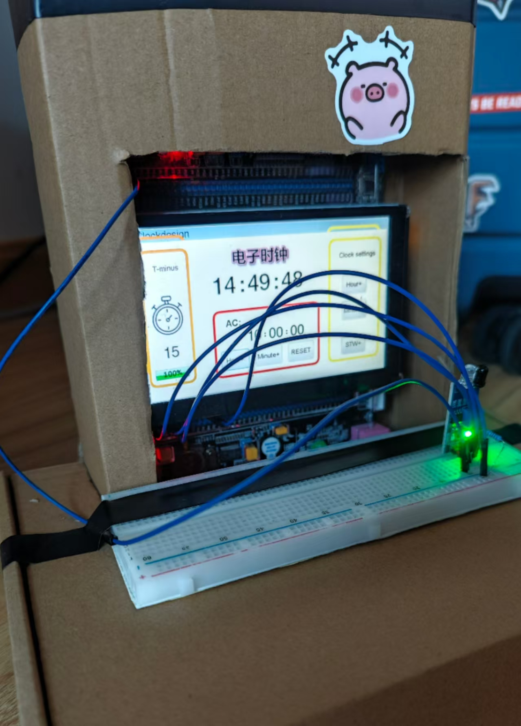
Final rendering after adding the shell
1.Reasons for choosing the project:
The electronic clock project is highly scalable. Once the basic production method is mastered, the learner can further experiment with adding more functions, such as alarm clock function, temperature display (the thermistor mentioned in class, previously discussed with the teacher), date display, day and night indication (the photoresistor project discussed in class).
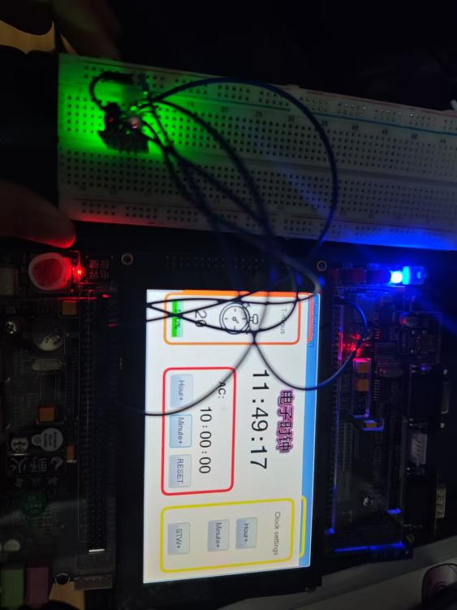
3-1 Actual project drawing

2.Module introduction:
·Stopwatch module: Provides timing function, allowing users to quickly start, stop, and reset the timer to meet the timing needs in specific scenarios.
·Alarm clock module: allows users to set, edit, and manage alarms, including alarm time, repetition period, ringtone, and more.
·Current time module: Real time display of the current time, which users can view at any time without entering other applications or interfaces.

3.Modular design concept:
Each module has its own independent operation area and logic, allowing users to quickly access and perform related operations, improving usage efficiency.
For developers, modular design makes code clearer, easier to manage, and maintain. If a module has a problem, it can be located and fixed faster.
4.Design concept
Because it uses a multitasking parallel system alarm clock. Therefore, choosing the RTOS system, the core of RTOS design is to ensure real-time performance and be able to respond to external events within a strictly defined time. RTOS supports multitasking concurrent execution, with each task having its own priority. Through priority scheduling algorithms, RTOS can ensure that high priority tasks are executed first, meeting the real-time requirements of the system. RTOS supports multitasking concurrent execution, with each task having its own priority. Through priority scheduling algorithms, RTOS can ensure that high priority tasks are executed first, meeting the real-time requirements of the system.
STemWin is a graphical user interface library based on emWin, which provides rich controls and functions such as buttons, checkboxes, text boxes, etc., making it convenient for developers to quickly build beautiful and easy-to-use graphical interfaces.
RTOS supports multitasking concurrent execution, and STemWin provides a graphical interface. Developers can create multiple tasks in RTOS, each responsible for different functions such as data collection, processing, display, etc. Through communication and synchronization mechanisms between tasks, complex multitasking applications can be achieved.
Appropriately increase the content learned in class and add logic for blocking and turning off alarms:
In daily home life, alarm clocks are often placed on bedside tables or other places that are difficult for people to reach. When the alarm clock rings, people often need to manually touch it to turn it off because they have just woken up. This is quite difficult for some workers or students who often work, so the function of "covering the end alarm clock" has been added. In order to facilitate people to turn off the alarm clock, they only need to sit up or reach out to cover it, which can be very convenient for some scenarios.
The function of detecting occlusion and triggering cancellation through components such as photosensitive sensors or infrared sensors is relatively simple and cost-effective. This design can enhance the functionality and user experience of the product without adding too much cost.
5.Reference to the Wildfire Operation Manual section:
The internal clock CK-INT comes from within the chip and is equal to 216M. Generally, we use the internal clock. When from
When the SMS bit of the mode control register TIMx_SMCR is equal to 000, the internal clock is used.
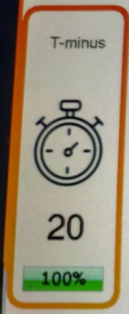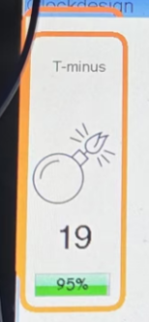
3-2 Stop watch start and non start icons.

6.Design concept of stopwatch module
Choose the bomb burning as the stopwatch start prompt. This design directly conveys the state of "urgency" or "timing start" after the stopwatch is started through visual elements. The image of a bomb burning is often associated with concepts such as "time is running out" and "imminent", which can quickly attract users' attention and make them realize that the stopwatch has started timing.
Linking a stopwatch with "T-minus" is actually a creative and symbolic expression. Although "T-minus" originally originated in the aerospace field to refer to the countdown phase before rocket launch, over time, this term has gradually been widely used in various situations that require precise timing, including sports competitions, project management, and countdown needs in daily life. As a timing tool, the stopwatch coincides with the meaning of "time is urgent and about to begin" implied by "T-minus".
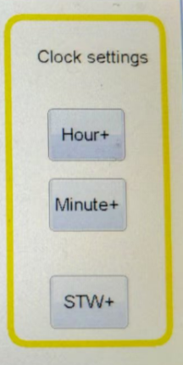
3-3 Display diagram of time setting module

7.Design concept for reducing misoperation:
The current time setting and the stopwatch upper limit time setting are two completely different functions. Expanding the gap between them can significantly reduce the possibility of confusion or accidental touch by users during operation. This design makes each setting option clearer and more independent, making it easier for users to find and accurately make the desired settings.

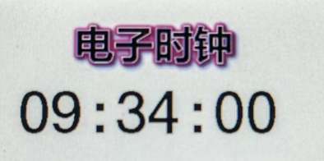
3-4 Current time module display diagram
8.Design ideas for the current time module
On the clock interface, the current time is the most important and frequently viewed information. Highlighting with the largest font ensures that users can see the time at a glance without having to search through numerous pieces of information, improving the efficiency of information retrieval.

4.Notes (successes, problems, lessons learnt):
(This is about documenting your reflection of your own creative process. Use this section to make (however brief) notes on anything interesting that happened during your experiments. Was there anything that took you a while to get working, and how did you crack the problem? Was there a particular insight that helped you proceed to the next stage? Sometimes, you might not be able to get the solution working in full / on time - then, you could write about what made it difficult and say what kinds of things you’ve tried in finding a solution. It is enough to briefly talk about this.)
During the design process, we continuously communicated with the teacher.
1.Listen to the teacher's suggestion to modify the content:
·The countdown time should be controllable.
·The current time setting should be increased.
·Change the Chinese content to ensure it aligns with the theme of electronic clocks.
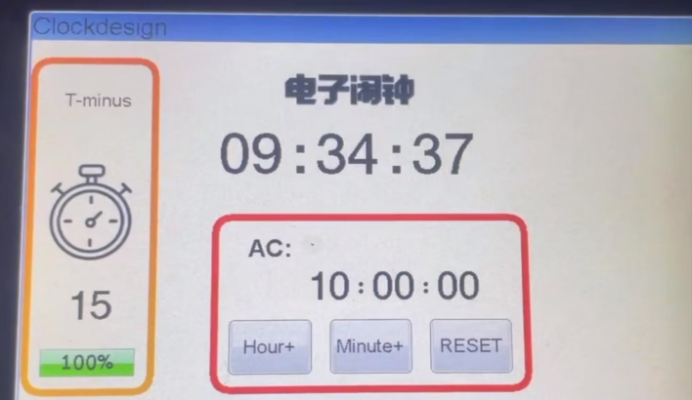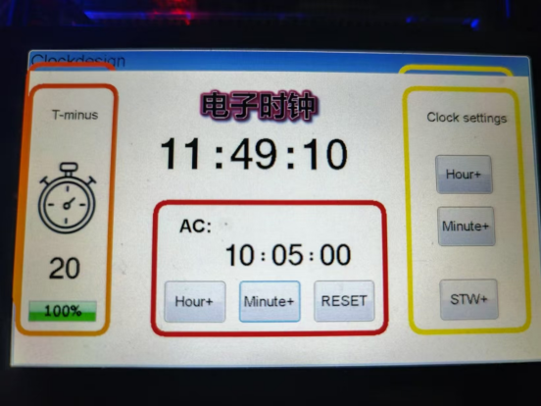
4-1Comparison chart before and after modification
Inspired by the teacher's ideas:
I heard the teacher's suggestion in class for students who are working on MP3 projects:
To ensure that tasks are not blocked when multitasking occurs
One main program, one mid-range, the mid-range does a part, and the main program does a part. When more tasks are needed, an operating system needs to be added.Code sample:
Add logic:
Create a new alarm clock every day
After occlusion detection, it becomes 25 hours, and the time will never arrive unless the alarm is reset.
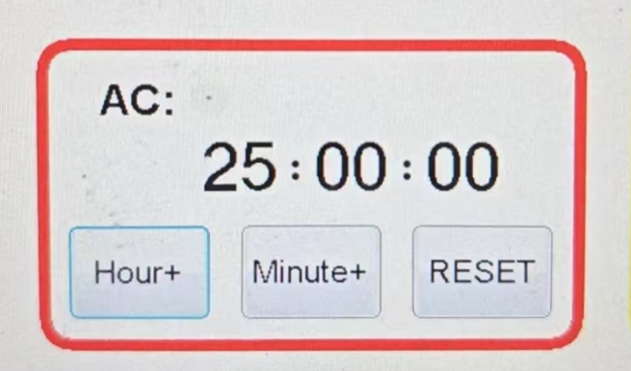

5.Code sample:
(Comment on important/new instructions you have learned from your code. Comment on the key codes, and show your own ideas. Do not copy all of the source code.)
File Framework：
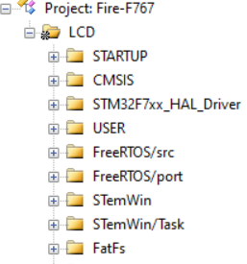
Clock source configuration：
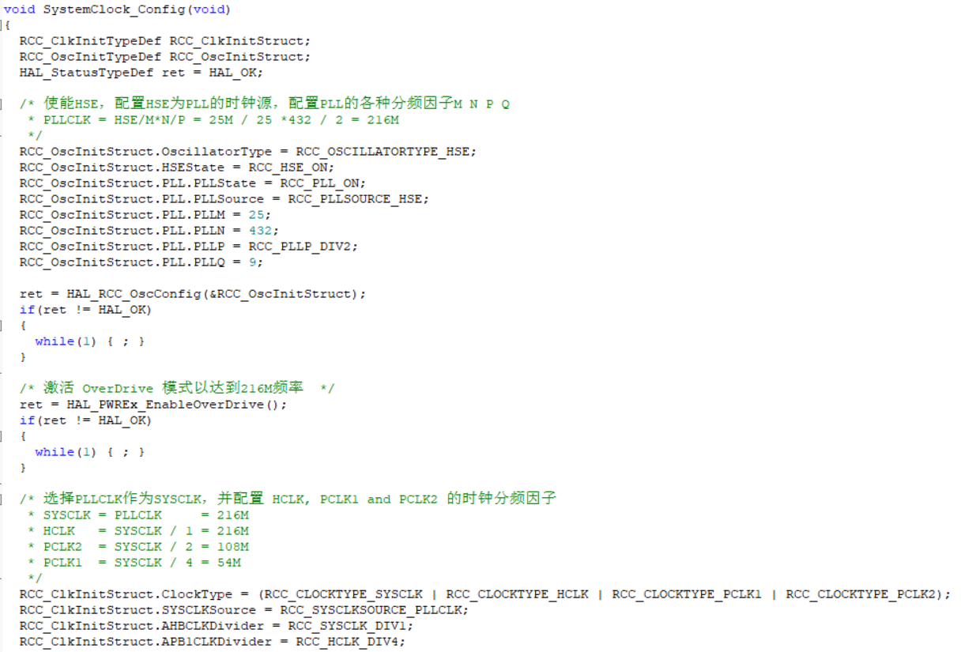
The self-learning progress bar displays:
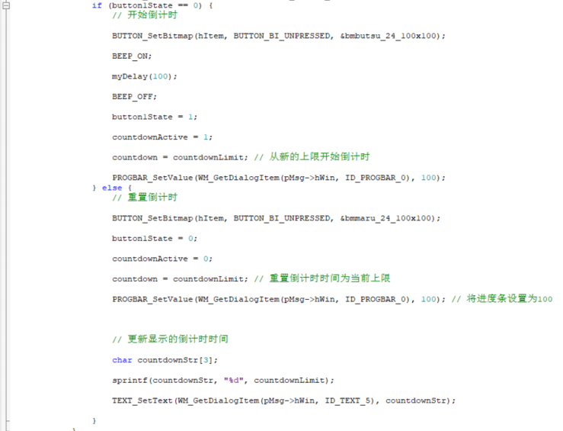

Button corresponding function:
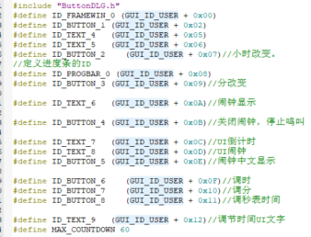
Refer to the classroom code to configure the USART (Universal Synchronous/Asynchronous Receiver/Transmitter) interface of STM32 for communication via serial port.
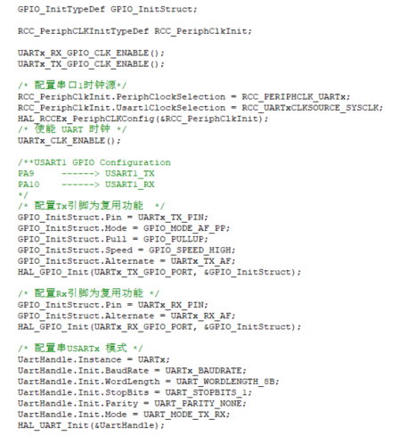

6.References (sources used, incl. Web):
Code:
supplement10_1_emWin_window
supplement10_1_emWin_framewin
supplement9_2_emWin_GUIBuilder_new
supplement8_4_start_FreeRTOS
seminar5_4 按键软件消抖
PDF:
03 emWin应用开发实战指南—基于STM32 original(1)
Seminar5_Interrupts_2024(1)

7.thank:
Thank you for your timely help and patient guidance during class break. Ask me to replace the machine as soon as it is damaged. Only then did we finally achieve the current results.

