/***************************************************************

*@brief for TLSR chips

* @date April 28, 2021

***************************************************************/

Method 1：

In order to use the SDK you need to do the following things:

1. replace file "**827x_BLE_SDK** **\ble_sdk_multimode\vendor\common\** **blt_common.c**" with " **blt_common.c** "
2. replace file “**827x_BLE_SDK** **\ble_sdk_multimode\vendor\common\** **blt_common.h**”with “**blt_common.h**”
3. replace file "**827x_BLE_SDK\ble_sdk_multimode\drivers\8278\flash.h**" with "**flash.h**"
4. replace file "**827x_BLE_SDK\ble_sdk_multimode\drivers\8278\flash.c**" with "**flash.c**"
5. place folder "flash" to path "**827x_BLE_SDK\ble_sdk_multimode\drivers\8278\**”

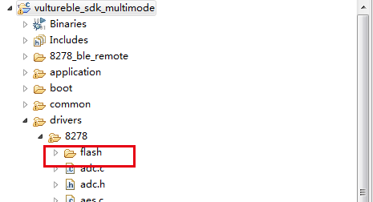

1. replace file "**827x_BLE_SDK\ble_sdk_multimode\drivers\8278\compiler.h**" with " **compiler.h**"
2. Modify project setting

Project ->properties -> Settings -> directories ->Add ->Workspace ->Select you path

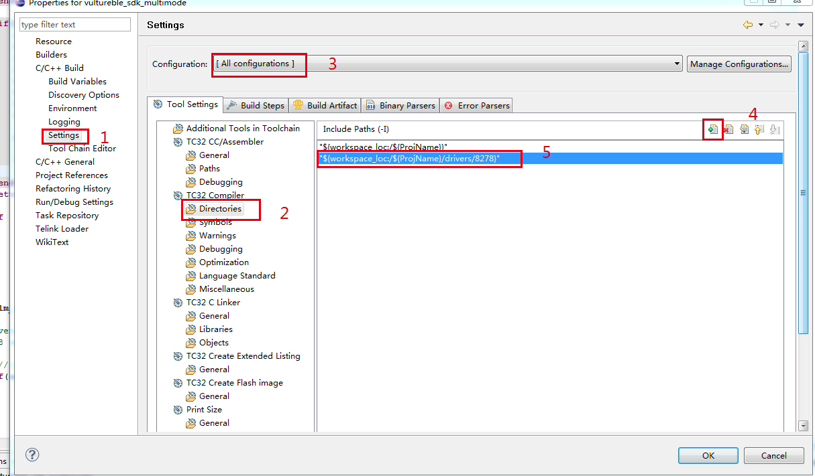

1. replace file “**827x_BLE_SDK** **\ble_sdk_multimode\proj_lib\** **liblt_8278.a**”with “**liblt_8278.a**”