Unit 1
- What kind of test heads does V93000 platform has? How many card cage and slot do these test heads have? Which cards can be put in the test head with Smartest 8 platform? （for both SmartScale and EXA Scale）
- Please introduce the specification of PS1600 & PS5000 and its pogo blocks.
- PS1600 Instrument View的介绍。
- PS1600 Vector Memory的介绍
- Please introduce the specification of DPS128 and its pogo blocks.
- DPS128 Instrument View的介绍。

Unit 2
- What is the function of model file and how do you start your smartest offline?
- 请介绍offline tester上，smartest 8使用的model file。

Unit 3
- Please introduce the structure of Smartest8 project.

Unit 4
- Please introduce the test program file (.prog). What parts does this file consist of?
- Please introduce the building blocks of test program.

Unit 5
- How to define signal pin, dps pin in dbd file, and in which tab can you check these information?
- What is the function of ‘@disable’ in dbd file.
- What is fixture delay and how to do fixture delay in smartest 8?
- When ganging DPS channel, how to design the loadboard and define in the dbd file?
- Offline Demo: Lab中dbd文件的设定

Unit 6
- How to setup and execute test flow and test suite. (code, test flow view, flow chat view)
- Offline Demo: 演示test flow file以及对应的test flow view和flow chart view

Unit 7
- What is the function of operating sequence? In which situation will we use parallel group?
- 什么是COGO？何时需要使用？请结合示例代码讲解。
- Offline Demo: 演示如何在Operating sequence中设断点，进行debug

Unit 8
- How to setup and program digInOut instrument?
- How to setup and program dcVI instrument?
- The concept of instrument. If there is a digital device and you want to run a functional test, what instrument will you use for the power and signal pins?

Unit 9
- 说明page 5：Overview: Pattern & Timing & Level Setup
- Timing Edge的介绍
- Termination的介绍
- Active Load的介绍
- Please explain the wavetable in the specification file.
- Please explain the Level/Timing settings in the specification file.

Unit 10
- Specification file中定义哪些设置。你的程序中specification文件拆分为了几个文件，调用关系是怎样的？

Unit 11
- What is interruptive and non-interruptive action?
- What is x-mode, how to set x-mode in the test program? Please confirm device cycle and tester cycle.
- Offline Demo: test suite SpecFileLab
- What is the function of parameter “syscAccuracy”?

Unit 13
- Test Flow代码的讲解(page 6)
- How to define the branch of the test flow. For example, if test suite A pass, then go to test suite B. If fail, then go to test suite C.
- Test flow parameter的作用，如何设定。

Unit 14
- Test Method的结构 (page 5, page 6)
- What is the concept of “measurement”?
- There are four methods in the test method, what is the function for each of them? And how will they execute when you run a test program.
- IMeasurement 和ILocalMeasurement的区别。

Unit 15
- MultiSite Data Types的介绍
- MultiSite Data Types的运算如何实现。
- Context的作用？
- How to do error handing in testmethod?
- Offline Demo: 演示及讲解DcViMeasurements测试项

Unit 16
- “releaseTester()”的作用
- test descriptors的作用
- 说明evaluate()的使用
- Please explain following code.
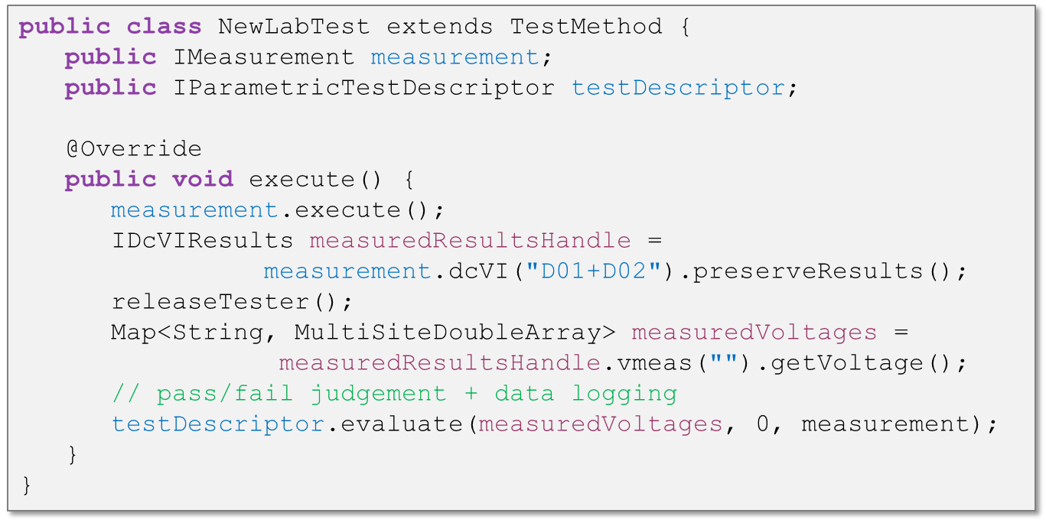
- Offline Demo: DcViMeasurements3V, 讲解对应的test method。

Unit 17
- 解释“Example: Data Logging for Functional Tests”（page 7）
- What is logLevel? How to set logLevel?
- How to view the datalog and what kind of datalog format can you set?

Unit 18
- Bin Table, Bin List, Final Bin 分别代表什么意思？
- Default Bin的介绍
- What is the purpose of binning and how to decide the “final bin”?

Unit 19
- In which stage does test table be invoked?
- PreBind flow中，importTestTable和exportTestTable的作用，以及每个参数的含义。

Unit 20
- Test table里每个表单的介绍。
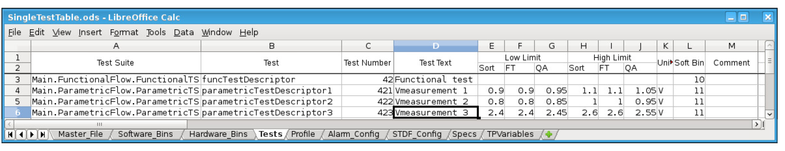
- 什么是 Fully Qualified Name？
- Please explain the test table you used in your lab.

Unit 21
- 调试工具的demo： test flow view, flow chart view, run configuration

Unit 22
- Please explain the whole sequence for execution. （page 16）
- Production 阶段的执行过程。（page 25）

Unit 23
- When will you use DSA to generate test setup, what is the advantage compare with the static files?
- How to setup level, timing, action and operating sequence with DSA? （结合实验）

Unit 24
- 讲解课程中的示例 (page 12~16)

Unit 25
- What is the purpose of shmoo and margin, and how to setup shmoo and margin? (demo shmoo 和margin)
- How to setup shmoo flow? (demo)

Unit 26
- What is the recommended file structure?

Unit 33
- What is the utility line hardware in Smart Scale.
- What is the utility line hardware in EXA Scale and its specifications.
- EXA Scale dut interface introduction with Utility Card.
- How to setup utility line for static and dynamic control?

