

**中国科大-德清阿尔法创新研究院**

**干部教育量化管理项目**

**算法自测报告**

**中国科大-德清阿尔法创新研究院**

**2022年2月25**日

目录

1 算法简介 3

2 算法流程 3

3 算法测试 5

3.1方案设计 5

3.2测试记录 6

4 结论 19

4.1测试结果 19

4.2分析与建议 21

## 1 算法简介

党校干部教育量化管理算法通过读取党校课堂的实时监控，对视频流定时抽帧进行智能数据分析。算法采用OpenPose人体骨架预测模型得到学员骨架结果，用于进行人座匹配和行为识别。前期通过现场的布置调试，最终部署确定的摄像头角度对于人体骨架结果的检测相对准确和清晰，保证了后续算法的叠加和改进。在骨架结果的基础上，人座匹配算法首先确定了到课学员与座位的匹配，行为识别算法根据人座匹配结果，进一步分析学员的多种课堂行为。这些结果的统计分析，可作为评价该班级所开设的课堂以及学员学情的指标，对提高课堂教学水平，评估学员听课质量有很大的参考价值。

算法通过该教室中预设的8个摄像监控视角，主要从在堂率、缺席率、抬头率、低头率、互动率、睡觉率指标对教学课堂进行学情分析：

（1）在堂率/缺席率：在基于骨骼识别的技术上进行人座匹配，计算视频监控中的真实到课数，得到该课程中所有学员的在堂率和缺席率，有助于管理者追踪班级每位学员的到课情况和学习积极性，并对缺席率较高的学员给予提醒警示；

（2）抬头率/低头率：面向视频监控数据，采用多视角骨架提取技术进行高精度行为识别，分析上课过程中学员的抬头或低头情况，为教学督导对教学过程分析提供量化数据支持，以便于改善教学方法，提升教学质量；

（3）互动率/睡觉率：同样基于骨架检测的结果，对课堂其他行为，即睡觉、玩手机、记笔记、举手进行分类统计，推测学员对该课程的感兴趣程度和积极性，有助于管理者和教学督导了解学员兴趣，提升课堂效率。

## 2 算法流程

当课程开始后，算法首先将从教室部署的8个摄像头监控视频流中按照一定时间间隔抽帧，将图像缓存；之后使用OpenPose骨骼预测模型对每张图像进行人体骨架提取，得到图像中的全部人体骨架及位置信息；然后使用监控视频区域内座位预标注文件以及该监控区域内的学员骨架信息进行人座匹配，得到座位-学员匹配结果，给识别到的学员赋予唯一的学员ID；最后使用学员骨架进行动作识别，最终将学员ID及其动作识别结果返回后端进行学情分析。动作识别包含两类，低头/抬头识别与课堂行为识别。低头/抬头识别使用学员骨架中脖子与脊椎夹角设置阈值进行识别，课堂行为采用SVM分类模型，识别学员上课玩手机、睡觉、互动行为。算法核心包含人座匹配算法以及行为识别，算法流程如表2.1表2.2所示，算法整体流程图如图2.1所示。

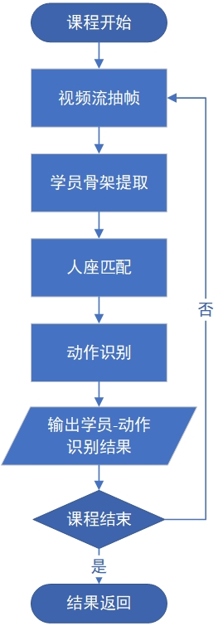

图2.1 党校干部教育量化管理算法流程图

表2.1 人座匹配算法流程表

|  |
| --- |
| 算法1：人座匹配 |
| 输入：监控区域内的座位标注文件及对应的人体骨架信息  输出：[骨架ID,学员ID]  1. 获取消息队列中报文的坐标信息，按标注的座位区域进行划分，比如6行4列；  2. 映射骨架，补全未检测到的人体骨架；  3. 在划分好的座位上，遍历所有骨架点，若该骨架点落在该座位内，则匹配成功；  4. 对于第一次未匹配成功且骨架点落在座位区域附近的进行重匹配，追加到匹配结果中；  5. 反之，统计未匹配成功的学员数，作为学员学情分析时对缺席率的参考。 |

表2.2 行为识别算法流程表

|  |
| --- |
| 算法2：行为识别 |
| 输入：人体骨架信息  输出：[学员ID，行为]  1. 根据骨架结果，设定角度阈值，计算统计学员抬头、低头的行为；  2. 结合人座匹配算法，采用SVM分类算法，对[骨架,行为标签]的数据集训练测试，行为标签主要为玩手机、记笔记、睡觉和举手；  3.根据训练得到的权重文件，通过映射算法结果，统计课程及学员的行为，作为学情分析时抬头率、低头率、互动率和睡觉率的参考。 |

## 3 算法测试

### 3.1方案设计

算法测试分为场景测试与性能测试两部分进行。场景测试采用真实课堂视频数据进行模拟分析，分别统计人座匹配、出勤、抬头、低头、睡觉、互动结果并与人工统计出的真实结果进行比较计算，计算人座匹配率以及动作识别率，作为算法评价指标。人座匹配率计算方法见公式3-1公式3-2；由于低头/抬头为一组互斥动作，可将抬头作为正标签，将低头作为负标签采用二分类混淆矩阵计算抬头/低头动作识别率，计算方法如公式3-3所示，其中：

* TP(true positive)：算法识别为抬头且真实情况为抬头；
* FN(false negative)：算法识别为低头但真实情况为抬头；
* FP(false positive)：算法识别为抬头但真实情况为低头；
* TN(true negative)：算法识别为低头且真实情况为低头；

（3-1）

（3-2）

（3-3）

算法性能测试在测试服务器上选取真实课堂视频数据，统计算法在高视频分辨率、高并发处理下的数据处理耗时，作为性能评价指标。

#### 3.1.1 场景测试

针对干部集训量化管理系统中“2022年德清县招大引强专题培训班“里的三堂课程分别进行了算法测试.依次对“以苏州为例进行招商引才实战演练“（10号上午）、”招商工作中的谈判技巧与人际沟通（10号下午）“、”招商引资与招才引智（11号）“三堂课得人座匹配率和行为识别率进行统计。

#### 3.1.2 性能测试

基于三堂课程的测试，统一分析在自定长达90秒的视频内，每隔1秒抽1帧，共抽10帧，视频帧的分辨率为2580*1440，帧率为8fps，在8个监控摄像头的并发处理下，共抽取了80帧图片进行算法分析。

### 3.2测试记录

#### 3.2.1 人座匹配测试统计

（1）“以苏州为例进行招商引才实战演练“课程的8个视角下的匹配率统计如下表3.1-3.8所示。结果可视化展示如图3.1所示。

表3.1 一列前（IP:168）的匹配统计表

|  |  |  |
| --- | --- | --- |
| **单帧图片（.jpg）** | **检测匹配数/**  **实际匹配数** | **匹配率(%)** |
| 20220215165700_bf50d0faab9f9714bb60a7f0ad16c0fb | 7 / 9 | 77.8 |
| 20220215165701_bf50d0faab9f9714bb60a7f0ad16c0fb | 9 / 9 | 100 |
| 20220215165702_bf50d0faab9f9714bb60a7f0ad16c0fb | 8 / 9 | 88.9 |
| 20220215165703_bf50d0faab9f9714bb60a7f0ad16c0fb | 8 / 9 | 88.9 |
| 20220215165704_bf50d0faab9f9714bb60a7f0ad16c0fb | 8 / 8 | 100 |
| 20220215165705_bf50d0faab9f9714bb60a7f0ad16c0fb | 8 / 8 | 100 |
| 20220215165706_bf50d0faab9f9714bb60a7f0ad16c0fb | 8 / 8 | 100 |
| 20220215165707_bf50d0faab9f9714bb60a7f0ad16c0fb | 9 / 9 | 100 |
| 20220215165708_bf50d0faab9f9714bb60a7f0ad16c0fb | 9 / 8 | 100 |
| 20220215165709_bf50d0faab9f9714bb60a7f0ad16c0fb | 8 / 8 | 100 |
| **总体匹配率** |  | **95.56%** |

表3.2 一列后（IP:172）的匹配统计表

|  |  |  |
| --- | --- | --- |
| **单帧图片（.jpg）** | **检测匹配数/**  **实际匹配数** | **匹配率(%)** |
| 20220215165700_1aebaac76ce9f9e8791109a7bc0b7d4d | 9 / 9 | 100 |
| 20220215165701_1aebaac76ce9f9e8791109a7bc0b7d4d | 9 / 9 | 100 |
| 20220215165702_1aebaac76ce9f9e8791109a7bc0b7d4d | 9 / 9 | 100 |
| 20220215165703_1aebaac76ce9f9e8791109a7bc0b7d4d | 9 / 9 | 100 |
| 20220215165704_1aebaac76ce9f9e8791109a7bc0b7d4d | 9 / 9 | 100 |
| 20220215165705_1aebaac76ce9f9e8791109a7bc0b7d4d | 9 / 9 | 100 |
| 20220215165706_1aebaac76ce9f9e8791109a7bc0b7d4d | 8 / 8 | 100 |
| 20220215165707_1aebaac76ce9f9e8791109a7bc0b7d4d | 8 / 8 | 100 |
| 20220215165708_1aebaac76ce9f9e8791109a7bc0b7d4d | 9 / 9 | 100 |
| 20220215165709_1aebaac76ce9f9e8791109a7bc0b7d4d | 8 / 8 | 100 |
| **总体匹配率** |  | **100%** |

表3.3 二列前（IP:167）的匹配统计表

|  |  |  |
| --- | --- | --- |
| **单帧图片（.jpg）** | **检测匹配数/**  **实际匹配数** | **匹配率(%)** |
| 20220215165700_0da59fd5217d2bbf09b31ccdf4455bb5 | 9 / 9 | 100 |
| 20220215165701_0da59fd5217d2bbf09b31ccdf4455bb5 | 11 / 11 | 100 |
| 20220215165702_0da59fd5217d2bbf09b31ccdf4455bb5 | 11 / 11 | 100 |
| 20220215165703_0da59fd5217d2bbf09b31ccdf4455bb5 | 11 / 11 | 100 |
| 20220215165704_0da59fd5217d2bbf09b31ccdf4455bb5 | 11 / 11 | 100 |
| 20220215165705_0da59fd5217d2bbf09b31ccdf4455bb5 | 11 / 11 | 100 |
| 20220215165706_0da59fd5217d2bbf09b31ccdf4455bb5 | 11 / 11 | 100 |
| 20220215165707_0da59fd5217d2bbf09b31ccdf4455bb5 | 9 / 11 | 81.8 |
| 20220215165708_0da59fd5217d2bbf09b31ccdf4455bb5 | 10 / 10 | 100 |
| 20220215165709_0da59fd5217d2bbf09b31ccdf4455bb5 | 10 / 10 | 100 |
| **总体匹配率** |  | **98.18%** |

表3.4 二列后（IP:171）的匹配统计表

|  |  |  |
| --- | --- | --- |
| **单帧图片（.jpg）** | **检测匹配数/**  **实际匹配数** | **匹配率(%)** |
| 20220215165700_336a9e32b30a87130ad2ea4a5a70c213 | 11 / 11 | 100 |
| 20220215165701_336a9e32b30a87130ad2ea4a5a70c213 | 10 / 10 | 100 |
| 20220215165702_336a9e32b30a87130ad2ea4a5a70c213 | 11 / 11 | 100 |
| 20220215165703_336a9e32b30a87130ad2ea4a5a70c213 | 11 / 12 | 91.7 |
| 20220215165704_336a9e32b30a87130ad2ea4a5a70c213 | 11 / 11 | 100 |
| 20220215165705_336a9e32b30a87130ad2ea4a5a70c213 | 12 / 12 | 100 |
| 20220215165706_336a9e32b30a87130ad2ea4a5a70c213 | 12 / 12 | 100 |
| 20220215165707_336a9e32b30a87130ad2ea4a5a70c213 | 12 / 12 | 100 |
| 20220215165708_336a9e32b30a87130ad2ea4a5a70c213 | 12 / 12 | 100 |
| 20220215165709_336a9e32b30a87130ad2ea4a5a70c213 | 11 / 11 | 100 |
| **总体匹配率** |  | **99.17%** |

表3.5 三列前（IP:165）的匹配统计表

|  |  |  |
| --- | --- | --- |
| **单帧图片（.jpg）** | **检测匹配数/**  **实际匹配数** | **匹配率(%)** |
| 20220215165700_b0a14bc5f5632383d21a60d44f8b1078 | 12 / 12 | 100 |
| 20220215165701_b0a14bc5f5632383d21a60d44f8b1078 | 12 / 12 | 100 |
| 20220215165702_b0a14bc5f5632383d21a60d44f8b1078 | 12 / 12 | 100 |
| 20220215165703_b0a14bc5f5632383d21a60d44f8b1078 | 12 / 12 | 100 |
| 20220215165704_b0a14bc5f5632383d21a60d44f8b1078 | 11 / 12 | 91.7 |
| 20220215165705_b0a14bc5f5632383d21a60d44f8b1078 | 10 / 12 | 83.3 |
| 20220215165706_b0a14bc5f5632383d21a60d44f8b1078 | 12 / 12 | 100 |
| 20220215165707_b0a14bc5f5632383d21a60d44f8b1078 | 12 / 12 | 100 |
| 20220215165708_b0a14bc5f5632383d21a60d44f8b1078 | 12 / 12 | 100 |
| 20220215165709_b0a14bc5f5632383d21a60d44f8b1078 | 12 / 12 | 100 |
| **总体匹配率** |  | **97.5%** |

表3.6 三列后（IP:170）的匹配统计表

|  |  |  |
| --- | --- | --- |
| **单帧图片（.jpg）** | **检测匹配数/**  **实际匹配数** | **匹配率(%)** |
| 20220215165700_0b1de073dcf17a7423b6dbb7dd836215 | 7 / 8 | 87.5 |
| 20220215165701_0b1de073dcf17a7423b6dbb7dd836215 | 9 / 10 | 90 |
| 20220215165702_0b1de073dcf17a7423b6dbb7dd836215 | 10 / 10 | 100 |
| 20220215165703_0b1de073dcf17a7423b6dbb7dd836215 | 10 / 9 | 100 |
| 20220215165704_0b1de073dcf17a7423b6dbb7dd836215 | 10 / 10 | 100 |
| 20220215165705_0b1de073dcf17a7423b6dbb7dd836215 | 10 / 10 | 100 |
| 20220215165706_0b1de073dcf17a7423b6dbb7dd836215 | 10 / 10 | 100 |
| 20220215165707_0b1de073dcf17a7423b6dbb7dd836215 | 10 / 10 | 100 |
| 20220215165708_0b1de073dcf17a7423b6dbb7dd836215 | 10 / 10 | 100 |
| 20220215165709_0b1de073dcf17a7423b6dbb7dd836215 | 10 / 10 | 100 |
| **总体匹配率** |  | **97.75%** |

表3.7 四列前（IP:166）的匹配统计表

|  |  |  |
| --- | --- | --- |
| **单帧图片（.jpg）** | **检测匹配数/**  **实际匹配数** | **匹配率(%)** |
| 20220215165700_128f8d02f888a4f99ebf3f9923c3f406 | 11 / 11 | 100 |
| 20220215165701_128f8d02f888a4f99ebf3f9923c3f406 | 9 / 11 | 81.8 |
| 20220215165702_128f8d02f888a4f99ebf3f9923c3f406 | 9 / 9 | 100 |
| 20220215165703_128f8d02f888a4f99ebf3f9923c3f406 | 9 / 9 | 100 |
| 20220215165704_128f8d02f888a4f99ebf3f9923c3f406 | 10 / 10 | 100 |
| 20220215165705_128f8d02f888a4f99ebf3f9923c3f406 | 10 / 10 | 100 |
| 20220215165706_128f8d02f888a4f99ebf3f9923c3f406 | 10 / 10 | 100 |
| 20220215165707_128f8d02f888a4f99ebf3f9923c3f406 | 11 / 11 | 100 |
| 20220215165708_128f8d02f888a4f99ebf3f9923c3f406 | 10 / 10 | 100 |
| 20220215165709_128f8d02f888a4f99ebf3f9923c3f406 | 10 / 10 | 100 |
| **总体匹配率** |  | **98.18%** |

表3.8 四列后（IP:169）的匹配统计表

|  |  |  |
| --- | --- | --- |
| **单帧图片（.jpg）** | **检测匹配数/**  **实际匹配数** | **匹配率(%)** |
| 20220215165700_b6deed9e6041a5d16a24ea99065e6cea | 5 / 5 | 100 |
| 20220215165701_b6deed9e6041a5d16a24ea99065e6cea | 7 / 7 | 100 |
| 20220215165702_b6deed9e6041a5d16a24ea99065e6cea | 7 / 7 | 100 |
| 20220215165703_b6deed9e6041a5d16a24ea99065e6cea | 7 / 7 | 100 |
| 20220215165704_b6deed9e6041a5d16a24ea99065e6cea | 7 / 7 | 100 |
| 20220215165705_b6deed9e6041a5d16a24ea99065e6cea | 7 / 7 | 100 |
| 20220215165706_b6deed9e6041a5d16a24ea99065e6cea | 7 / 7 | 100 |
| 20220215165707_b6deed9e6041a5d16a24ea99065e6cea | 6 / 7 | 85.7 |
| 20220215165708_b6deed9e6041a5d16a24ea99065e6cea | 7 / 7 | 100 |
| 20220215165709_b6deed9e6041a5d16a24ea99065e6cea | 7 / 7 | 100 |
| **总体匹配率** |  | **98.57%** |

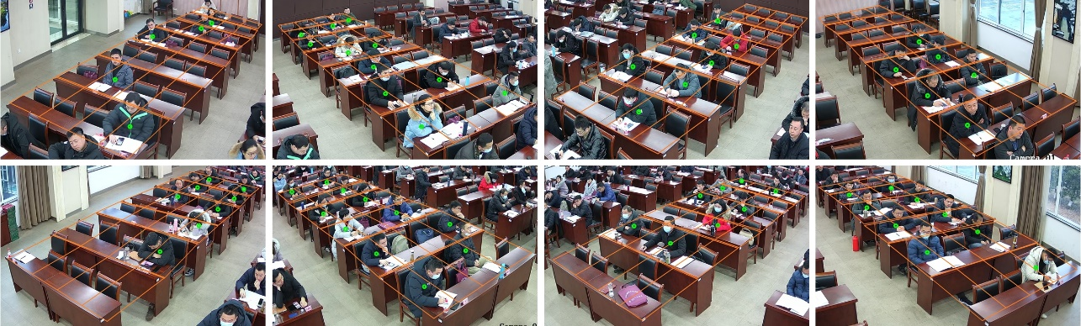

图3.1 人座匹配结果

（2）“招商工作中的谈判技巧与人际沟通“课程的8个视角下的匹配率统计如下表3.9-3.16所示。

表3.9 一列前（IP:168）的匹配统计表

|  |  |  |
| --- | --- | --- |
| **单帧图片（.jpg）** | **检测匹配数/**  **实际匹配数** | **匹配率(%)** |
| 20220216095100_bf50d0faab9f9714bb60a7f0ad16c0fb | 8 / 8 | 100 |
| 20220216095101_bf50d0faab9f9714bb60a7f0ad16c0fb | 9 / 9 | 100 |
| 20220216095102_bf50d0faab9f9714bb60a7f0ad16c0fb | 9 / 9 | 100 |
| 20220216095103_bf50d0faab9f9714bb60a7f0ad16c0fb | 9 / 9 | 100 |
| 20220216095104_bf50d0faab9f9714bb60a7f0ad16c0fb | 9 / 9 | 100 |
| 20220216095105_bf50d0faab9f9714bb60a7f0ad16c0fb | 8 / 9 | 88.9 |
| 20220216095106_bf50d0faab9f9714bb60a7f0ad16c0fb | 9 / 9 | 100 |
| 20220216095107_bf50d0faab9f9714bb60a7f0ad16c0fb | 9 / 9 | 100 |
| 20220216095108_bf50d0faab9f9714bb60a7f0ad16c0fb | 9 / 9 | 100 |
| 20220216095109_bf50d0faab9f9714bb60a7f0ad16c0fb | 9 / 9 | 100 |
| **总体匹配率** |  | **98.89%** |

表3.10 一列后（IP:172）的匹配统计表

|  |  |  |
| --- | --- | --- |
| **单帧图片（.jpg）** | **检测匹配数/**  **实际匹配数** | **匹配率(%)** |
| 20220216095100_1aebaac76ce9f9e8791109a7bc0b7d4d | 4 / 4 | 100 |
| 20220216095101_1aebaac76ce9f9e8791109a7bc0b7d4d | 4 / 4 | 100 |
| 20220216095102_1aebaac76ce9f9e8791109a7bc0b7d4d | 4 / 4 | 100 |
| 20220216095103_1aebaac76ce9f9e8791109a7bc0b7d4d | 4 / 4 | 100 |
| 20220216095104_1aebaac76ce9f9e8791109a7bc0b7d4d | 4 / 4 | 100 |
| 20220216095105_1aebaac76ce9f9e8791109a7bc0b7d4d | 3 / 3 | 100 |
| 20220216095106_1aebaac76ce9f9e8791109a7bc0b7d4d | 4 / 4 | 100 |
| 20220216095107_1aebaac76ce9f9e8791109a7bc0b7d4d | 4 / 4 | 100 |
| 20220216095108_1aebaac76ce9f9e8791109a7bc0b7d4d | 4 / 4 | 100 |
| 20220216095109_1aebaac76ce9f9e8791109a7bc0b7d4d | 4 / 4 | 100 |
| **总体匹配率** |  | **100%** |

表3.11 二列前（IP:167）的匹配统计表

|  |  |  |
| --- | --- | --- |
| **单帧图片（.jpg）** | **检测匹配数/**  **实际匹配数** | **匹配率(%)** |
| 20220216095100_0da59fd5217d2bbf09b31ccdf4455bb5 | 10 / 10 | 100 |
| 20220216095101_0da59fd5217d2bbf09b31ccdf4455bb5 | 10 / 10 | 100 |
| 20220216095102_0da59fd5217d2bbf09b31ccdf4455bb5 | 10 / 10 | 100 |
| 20220216095103_0da59fd5217d2bbf09b31ccdf4455bb5 | 10 / 10 | 100 |
| 20220216095104_0da59fd5217d2bbf09b31ccdf4455bb5 | 7 / 10 | 70 |
| 20220216095105_0da59fd5217d2bbf09b31ccdf4455bb5 | 10 / 10 | 100 |
| 20220216095106_0da59fd5217d2bbf09b31ccdf4455bb5 | 10 / 10 | 100 |
| 20220216095107_0da59fd5217d2bbf09b31ccdf4455bb5 | 9 / 10 | 90 |
| 20220216095108_0da59fd5217d2bbf09b31ccdf4455bb5 | 9 / 10 | 90 |
| 20220216095109_0da59fd5217d2bbf09b31ccdf4455bb5 | 9 / 10 | 90 |
| **总体匹配率** |  | **94%** |

表3.12 二列后（IP:171）的匹配统计表

|  |  |  |
| --- | --- | --- |
| **单帧图片（.jpg）** | **检测匹配数/**  **实际匹配数** | **匹配率(%)** |
| 20220216095100_336a9e32b30a87130ad2ea4a5a70c213 | 10 / 10 | 100 |
| 20220216095101_336a9e32b30a87130ad2ea4a5a70c213 | 10 / 10 | 100 |
| 20220216095102_336a9e32b30a87130ad2ea4a5a70c213 | 9 / 10 | 90 |
| 20220216095103_336a9e32b30a87130ad2ea4a5a70c213 | 10 / 10 | 100 |
| 20220216095104_336a9e32b30a87130ad2ea4a5a70c213 | 10 / 10 | 100 |
| 20220216095105_336a9e32b30a87130ad2ea4a5a70c213 | 10 / 10 | 100 |
| 20220216095106_336a9e32b30a87130ad2ea4a5a70c213 | 9 / 9 | 100 |
| 20220216095107_336a9e32b30a87130ad2ea4a5a70c213 | 7 / 8 | 87.5 |
| 20220216095108_336a9e32b30a87130ad2ea4a5a70c213 | 9 / 9 | 100 |
| 20220216095109_336a9e32b30a87130ad2ea4a5a70c213 | 9 / 9 | 100 |
| **总体匹配率** |  | **97.75%** |

表3.13 三列前（IP:165）的匹配统计表

|  |  |  |
| --- | --- | --- |
| **单帧图片（.jpg）** | **检测匹配数/**  **实际匹配数** | **匹配率(%)** |
| 20220216095100_b0a14bc5f5632383d21a60d44f8b1078 | 8 / 8 | 100 |
| 20220216095101_b0a14bc5f5632383d21a60d44f8b1078 | 8 / 8 | 100 |
| 20220216095102_b0a14bc5f5632383d21a60d44f8b1078 | 8 / 8 | 100 |
| 20220216095103_b0a14bc5f5632383d21a60d44f8b1078 | 8 / 8 | 100 |
| 20220216095104_b0a14bc5f5632383d21a60d44f8b1078 | 8 / 8 | 100 |
| 20220216095105_b0a14bc5f5632383d21a60d44f8b1078 | 8 / 8 | 100 |
| 20220216095106_b0a14bc5f5632383d21a60d44f8b1078 | 8 / 8 | 100 |
| 20220216095107_b0a14bc5f5632383d21a60d44f8b1078 | 8 / 8 | 100 |
| 20220216095108_b0a14bc5f5632383d21a60d44f8b1078 | 7 / 7 | 100 |
| 20220216095109_b0a14bc5f5632383d21a60d44f8b1078 | 7 / 7 | 100 |
| **总体匹配率** |  | **100%** |

表3.14 三列后（IP:170）的匹配统计表

|  |  |  |
| --- | --- | --- |
| **单帧图片（.jpg）** | **检测匹配数/**  **实际匹配数** | **匹配率(%)** |
| 20220216095100_0b1de073dcf17a7423b6dbb7dd836215 | 8 / 8 | 100 |
| 20220216095101_0b1de073dcf17a7423b6dbb7dd836215 | 3 / 3 | 100 |
| 20220216095102_0b1de073dcf17a7423b6dbb7dd836215 | 7 / 8 | 87.5 |
| 20220216095103_0b1de073dcf17a7423b6dbb7dd836215 | 7 / 8 | 87.5 |
| 20220216095104_0b1de073dcf17a7423b6dbb7dd836215 | 7 / 8 | 87.5 |
| 20220216095105_0b1de073dcf17a7423b6dbb7dd836215 | 7 / 7 | 100 |
| 20220216095106_0b1de073dcf17a7423b6dbb7dd836215 | 6 / 7 | 85.7 |
| 20220216095107_0b1de073dcf17a7423b6dbb7dd836215 | 6 / 7 | 85.7 |
| 20220216095108_0b1de073dcf17a7423b6dbb7dd836215 | 3 / 3 | 100 |
| 20220216095109_0b1de073dcf17a7423b6dbb7dd836215 | 6 / 7 | 85.7 |
| **总体匹配率** |  | **91.96%** |

表3.15 四列前（IP:166）的匹配统计表

|  |  |  |
| --- | --- | --- |
| **单帧图片（.jpg）** | **检测匹配数/**  **实际匹配数** | **匹配率(%)** |
| 20220216095100_128f8d02f888a4f99ebf3f9923c3f406 | 0 / 0 | 100 |
| 20220216095101_128f8d02f888a4f99ebf3f9923c3f406 | 3 / 3 | 100 |
| 20220216095102_128f8d02f888a4f99ebf3f9923c3f406 | 3 / 3 | 100 |
| 20220216095103_128f8d02f888a4f99ebf3f9923c3f406 | 2 / 3 | 66.7 |
| 20220216095104_128f8d02f888a4f99ebf3f9923c3f406 | 3 / 3 | 100 |
| 20220216095105_128f8d02f888a4f99ebf3f9923c3f406 | 3 / 3 | 100 |
| 20220216095106_128f8d02f888a4f99ebf3f9923c3f406 | 3 / 3 | 100 |
| 20220216095107_128f8d02f888a4f99ebf3f9923c3f406 | 0 / 0 | 100 |
| 20220216095108_128f8d02f888a4f99ebf3f9923c3f406 | 4 / 5 | 80 |
| 20220216095109_128f8d02f888a4f99ebf3f9923c3f406 | 4 / 4 | 100 |
| **总体匹配率** |  | **94.67%** |

表3.16 四列后（IP:169）的匹配统计表

|  |  |  |
| --- | --- | --- |
| **单帧图片（.jpg）** | **检测匹配数/**  **实际匹配数** | **匹配率(%)** |
| 20220216095100_b6deed9e6041a5d16a24ea99065e6cea | 7 / 7 | 100 |
| 20220216095101_b6deed9e6041a5d16a24ea99065e6cea | 7 / 7 | 100 |
| 20220216095102_b6deed9e6041a5d16a24ea99065e6cea | 7 / 7 | 100 |
| 20220216095103_b6deed9e6041a5d16a24ea99065e6cea | 7 / 7 | 100 |
| 20220216095104_b6deed9e6041a5d16a24ea99065e6cea | 7 / 7 | 100 |
| 20220216095105_b6deed9e6041a5d16a24ea99065e6cea | 7 / 7 | 100 |
| 20220216095106_b6deed9e6041a5d16a24ea99065e6cea | 7 / 7 | 100 |
| 20220216095107_b6deed9e6041a5d16a24ea99065e6cea | 7 / 7 | 100 |
| 20220216095108_b6deed9e6041a5d16a24ea99065e6cea | 7 / 7 | 100 |
| 20220216095109_b6deed9e6041a5d16a24ea99065e6cea | 7 / 7 | 100 |
| **总体匹配率** |  | **100%** |

（3）“招商工作中的谈判技巧与人际沟通“课程的8个视角下的匹配率统计如下表3.17-3.24所示。

表3.17 一列前（IP:168）的匹配统计表

|  |  |  |
| --- | --- | --- |
| **单帧图片（.jpg）** | **检测匹配数/**  **实际匹配数** | **匹配率(%)** |
| 20220216095200_bf50d0faab9f9714bb60a7f0ad16c0fb | 9 / 9 | 100 |
| 20220216095201_bf50d0faab9f9714bb60a7f0ad16c0fb | 9 / 9 | 100 |
| 20220216095202_bf50d0faab9f9714bb60a7f0ad16c0fb | 7 / 8 | 87.5 |
| 20220216095203_bf50d0faab9f9714bb60a7f0ad16c0fb | 8 / 8 | 100 |
| 20220216095204_bf50d0faab9f9714bb60a7f0ad16c0fb | 8 / 8 | 100 |
| 20220216095205_bf50d0faab9f9714bb60a7f0ad16c0fb | 8 / 8 | 100 |
| 20220216095206_bf50d0faab9f9714bb60a7f0ad16c0fb | 9 / 9 | 100 |
| 20220216095207_bf50d0faab9f9714bb60a7f0ad16c0fb | 9 / 9 | 100 |
| 20220216095208_bf50d0faab9f9714bb60a7f0ad16c0fb | 9 / 9 | 100 |
| 20220216095209_bf50d0faab9f9714bb60a7f0ad16c0fb | 9 / 9 | 100 |
| **总体匹配率** |  | **98.75%** |

表3.18 一列后（IP:172）的匹配统计表

|  |  |  |
| --- | --- | --- |
| **单帧图片（.jpg）** | **检测匹配数/**  **实际匹配数** | **匹配率(%)** |
| 20220216095200_1aebaac76ce9f9e8791109a7bc0b7d4d | 7 / 7 | 100 |
| 20220216095201_1aebaac76ce9f9e8791109a7bc0b7d4d | 7 / 7 | 100 |
| 20220216095202_1aebaac76ce9f9e8791109a7bc0b7d4d | 6 / 7 | 85.7 |
| 20220216095203_1aebaac76ce9f9e8791109a7bc0b7d4d | 6 / 7 | 85.7 |
| 20220216095204_1aebaac76ce9f9e8791109a7bc0b7d4d | 6 / 7 | 85.7 |
| 20220216095205_1aebaac76ce9f9e8791109a7bc0b7d4d | 6 / 7 | 85.7 |
| 20220216095206_1aebaac76ce9f9e8791109a7bc0b7d4d | 7 / 7 | 100 |
| 20220216095207_1aebaac76ce9f9e8791109a7bc0b7d4d | 6 / 7 | 85.7 |
| 20220216095208_1aebaac76ce9f9e8791109a7bc0b7d4d | 6 / 7 | 85.7 |
| 20220216095209_1aebaac76ce9f9e8791109a7bc0b7d4d | 7 / 7 | 100 |
| **总体匹配率** |  | **91.42%** |

表3.19 二列前（IP:167）的匹配统计表

|  |  |  |
| --- | --- | --- |
| **单帧图片（.jpg）** | **检测匹配数/**  **实际匹配数** | **匹配率(%)** |
| 20220216095200_0da59fd5217d2bbf09b31ccdf4455bb5 | 12 / 12 | 100 |
| 20220216095201_0da59fd5217d2bbf09b31ccdf4455bb5 | 12 / 12 | 100 |
| 20220216095202_0da59fd5217d2bbf09b31ccdf4455bb5 | 12 / 12 | 100 |
| 20220216095203_0da59fd5217d2bbf09b31ccdf4455bb5 | 12 / 12 | 100 |
| 20220216095204_0da59fd5217d2bbf09b31ccdf4455bb5 | 12 / 12 | 100 |
| 20220216095205_0da59fd5217d2bbf09b31ccdf4455bb5 | 12 / 12 | 100 |
| 20220216095206_0da59fd5217d2bbf09b31ccdf4455bb5 | 12 / 12 | 100 |
| 20220216095207_0da59fd5217d2bbf09b31ccdf4455bb5 | 12 / 12 | 100 |
| 20220216095208_0da59fd5217d2bbf09b31ccdf4455bb5 | 11 / 11 | 100 |
| 20220216095209_0da59fd5217d2bbf09b31ccdf4455bb5 | 11 / 11 | 100 |
| **总体匹配率** |  | **94%** |

表3.20 二列后（IP:171）的匹配统计表

|  |  |  |
| --- | --- | --- |
| **单帧图片（.jpg）** | **检测匹配数/**  **实际匹配数** | **匹配率(%)** |
| 20220216095200_336a9e32b30a87130ad2ea4a5a70c213 | 12 / 12 | 100 |
| 20220216095201_336a9e32b30a87130ad2ea4a5a70c213 | 11 / 11 | 100 |
| 20220216095202_336a9e32b30a87130ad2ea4a5a70c213 | 9 / 11 | 81.8 |
| 20220216095203_336a9e32b30a87130ad2ea4a5a70c213 | 10 / 11 | 90.9 |
| 20220216095204_336a9e32b30a87130ad2ea4a5a70c213 | 10 / 11 | 90.9 |
| 20220216095205_336a9e32b30a87130ad2ea4a5a70c213 | 12 / 13 | 92.3 |
| 20220216095206_336a9e32b30a87130ad2ea4a5a70c213 | 12 / 13 | 92.3 |
| 20220216095207_336a9e32b30a87130ad2ea4a5a70c213 | 12 / 13 | 92.3 |
| 20220216095208_336a9e32b30a87130ad2ea4a5a70c213 | 12 / 13 | 92.3 |
| 20220216095209_336a9e32b30a87130ad2ea4a5a70c213 | 13 / 13 | 100 |
| **总体匹配率** |  | **93.28%** |

表3.21 三列前（IP:165）的匹配统计表

|  |  |  |
| --- | --- | --- |
| **单帧图片（.jpg）** | **检测匹配数/**  **实际匹配数** | **匹配率(%)** |
| 20220216095200_b0a14bc5f5632383d21a60d44f8b1078 | 8 / 8 | 100 |
| 20220216095201_b0a14bc5f5632383d21a60d44f8b1078 | 7 / 8 | 87.5 |
| 20220216095202_b0a14bc5f5632383d21a60d44f8b1078 | 8 / 8 | 100 |
| 20220216095203_b0a14bc5f5632383d21a60d44f8b1078 | 7 / 8 | 87.5 |
| 20220216095204_b0a14bc5f5632383d21a60d44f8b1078 | 8 / 8 | 100 |
| 20220216095205_b0a14bc5f5632383d21a60d44f8b1078 | 7 / 8 | 87.5 |
| 20220216095206_b0a14bc5f5632383d21a60d44f8b1078 | 8 / 8 | 100 |
| 20220216095207_b0a14bc5f5632383d21a60d44f8b1078 | 8 / 8 | 100 |
| 20220216095208_b0a14bc5f5632383d21a60d44f8b1078 | 8 / 8 | 100 |
| 20220216095209_b0a14bc5f5632383d21a60d44f8b1078 | 8 / 8 | 100 |
| **总体匹配率** |  | **96.25%** |

表3.22 三列后（IP:170）的匹配统计表

|  |  |  |
| --- | --- | --- |
| **单帧图片（.jpg）** | **检测匹配数/**  **实际匹配数** | **匹配率(%)** |
| 20220216095200_0b1de073dcf17a7423b6dbb7dd836215 | 6 / 7 | 85.7 |
| 20220216095201_0b1de073dcf17a7423b6dbb7dd836215 | 7 / 7 | 100 |
| 20220216095202_0b1de073dcf17a7423b6dbb7dd836215 | 7 / 7 | 100 |
| 20220216095203_0b1de073dcf17a7423b6dbb7dd836215 | 7 / 7 | 100 |
| 20220216095204_0b1de073dcf17a7423b6dbb7dd836215 | 7 / 7 | 100 |
| 20220216095205_0b1de073dcf17a7423b6dbb7dd836215 | 7 / 7 | 100 |
| 20220216095206_0b1de073dcf17a7423b6dbb7dd836215 | 7 / 7 | 100 |
| 20220216095207_0b1de073dcf17a7423b6dbb7dd836215 | 7 / 7 | 100 |
| 20220216095208_0b1de073dcf17a7423b6dbb7dd836215 | 7 / 7 | 100 |
| 20220216095209_0b1de073dcf17a7423b6dbb7dd836215 | 7 / 7 | 100 |
| **总体匹配率** |  | **98.57%** |

表3.23 四列前（IP:166）的匹配统计表

|  |  |  |
| --- | --- | --- |
| **单帧图片（.jpg）** | **检测匹配数/**  **实际匹配数** | **匹配率(%)** |
| 20220216095200_128f8d02f888a4f99ebf3f9923c3f406 | 10 / 10 | 100 |
| 20220216095201_128f8d02f888a4f99ebf3f9923c3f406 | 9 / 10 | 90 |
| 20220216095202_128f8d02f888a4f99ebf3f9923c3f406 | 9 / 10 | 90 |
| 20220216095203_128f8d02f888a4f99ebf3f9923c3f406 | 10 / 10 | 100 |
| 20220216095204_128f8d02f888a4f99ebf3f9923c3f406 | 10 / 10 | 100 |
| 20220216095205_128f8d02f888a4f99ebf3f9923c3f406 | 10 / 10 | 100 |
| 20220216095206_128f8d02f888a4f99ebf3f9923c3f406 | 10 / 10 | 100 |
| 20220216095207_128f8d02f888a4f99ebf3f9923c3f406 | 10 / 10 | 100 |
| 20220216095208_128f8d02f888a4f99ebf3f9923c3f406 | 10 / 10 | 100 |
| 20220216095209_128f8d02f888a4f99ebf3f9923c3f406 | 10 / 10 | 100 |
| **总体匹配率** |  | **98%** |

表3.24 四列后（IP:169）的匹配统计表

|  |  |  |
| --- | --- | --- |
| **单帧图片（.jpg）** | **检测匹配数/**  **实际匹配数** | **匹配率(%)** |
| 20220216095200_b6deed9e6041a5d16a24ea99065e6cea | 7 / 7 | 100 |
| 20220216095201_b6deed9e6041a5d16a24ea99065e6cea | 7 / 7 | 100 |
| 20220216095202_b6deed9e6041a5d16a24ea99065e6cea | 7 / 7 | 100 |
| 20220216095203_b6deed9e6041a5d16a24ea99065e6cea | 7 / 7 | 100 |
| 20220216095204_b6deed9e6041a5d16a24ea99065e6cea | 7 / 7 | 100 |
| 20220216095205_b6deed9e6041a5d16a24ea99065e6cea | 7 / 7 | 100 |
| 20220216095206_b6deed9e6041a5d16a24ea99065e6cea | 7 / 7 | 100 |
| 20220216095207_b6deed9e6041a5d16a24ea99065e6cea | 7 / 7 | 100 |
| 20220216095208_b6deed9e6041a5d16a24ea99065e6cea | 6 / 6 | 100 |
| 20220216095209_b6deed9e6041a5d16a24ea99065e6cea | 6 / 6 | 100 |
| **总体匹配率** |  | **100%** |

#### 3.2.2 行为识别测试统计

（1）以苏州为例进行招商引才实战演练（10号上午）

|  |  |  |  |  |  |  |  |  |  |  |  |
| --- | --- | --- | --- | --- | --- | --- | --- | --- | --- | --- | --- |
| **摄像头（IP） 帧采样** | | **1** | **2** | **3** | **4** | **5** | **6** | **7** | **8** | **9** | **10** |
| **一列前**  **（IP:168）** | **出勤（识别数/真实数）** | 7/9 | 9/9 | 8/9 | 8/9 | 8/8 | 8/8 | 8/8 | 9/9 | 9/8 | 8/8 |
| **抬头（识别数/真实数）** | 3/4 | 4/3 | 4/3 | 2/2 | 1/1 | 1/1 | 1/2 | 4/3 | 4/4 | 2/3 |
| **低头（识别数/真实数）** | 4/5 | 5/6 | 4/6 | 6/7 | 7/7 | 7/7 | 7/6 | 5/6 | 5/4 | 6/5 |
| **睡觉（识别数/真实数）** | 0/0 | 0/0 | 0/0 | 0/0 | 0/0 | 0/0 | 0/0 | 0/0 | 0/0 | 0/0 |
| **互动（识别数/真实数）** | 0/0 | 0/0 | 0/0 | 0/0 | 0/0 | 0/0 | 0/0 | 0/0 | 0/0 | 0/0 |
| **一列后**  **（IP:172）** | **出勤（识别数/真实数）** | 9/9 | 9/9 | 9/9 | 9/9 | 9/9 | 9/9 | 8/8 | 8/8 | 9/9 | 8/8 |
| **抬头（识别数/真实数）** | 3/0 | 3/3 | 2/1 | 4/3 | 2/2 | 2/1 | 3/3 | 3/0 | 1/2 | 2/4 |
| **低头（识别数/真实数）** | 6/9 | 6/6 | 7/8 | 5/6 | 7/7 | 7/8 | 5/5 | 5/8 | 8/7 | 6/4 |
| **睡觉（识别数/真实数）** | 0/0 | 0/0 | 0/0 | 0/0 | 0/0 | 0/0 | 0/0 | 0/0 | 0/0 | 0/0 |
| **互动（识别数/真实数）** | 0/0 | 0/0 | 0/0 | 0/0 | 0/0 | 0/0 | 0/0 | 0/0 | 0/0 | 0/0 |
| **二列前**  **（IP:167）** | **出勤（识别数/真实数）** | 9/9 | 11/11 | 11/11 | 11/11 | 11/11 | 11/11 | 11/11 | 9/9 | 10/10 | 10/10 |
| **抬头（识别数/真实数）** | 4/2 | 2/2 | 1/1 | 1/0 | 4/5 | 3/3 | 2/3 | 0/1 | 2/3 | 2/3 |
| **低头（识别数/真实数）** | 5/7 | 9/9 | 10/10 | 10/11 | 7/6 | 8/8 | 9/8 | 9/8 | 8/7 | 8/7 |
| **睡觉（识别数/真实数）** | 0/0 | 0/0 | 0/0 | 0/0 | 0/0 | 0/0 | 0/0 | 0/0 | 0/0 | 0/0 |
| **互动（识别数/真实数）** | 0/0 | 0/0 | 0/0 | 0/0 | 0/0 | 0/0 | 0/0 | 0/0 | 0/0 | 0/0 |
| **二列后**  **（IP:171）** | **出勤（识别数/真实数）** | 11/11 | 10/10 | 11/11 | 11/12 | 12/12 | 12/12 | 12/12 | 12/12 | 12/12 | 11/11 |
| **抬头（识别数/真实数）** | 3/2 | 0/2 | 2/2 | 2/2 | 4/3 | 1/1 | 2/1 | 3/3 | 4/5 | 2/2 |
| **低头（识别数/真实数）** | 8/9 | 10/8 | 9/9 | 9/10 | 7/8 | 11/11 | 10/11 | 9/9 | 8/7 | 9/9 |
| **睡觉（识别数/真实数）** | 0/0 | 0/0 | 0/0 | 0/0 | 0/0 | 0/0 | 0/0 | 0/0 | 0/0 | 0/0 |
| **互动（识别数/真实数）** | 0/0 | 0/0 | 0/0 | 0/0 | 0/0 | 0/0 | 0/0 | 0/0 | 0/0 | 0/0 |
| **三列前**  **（IP:165）** | **出勤（识别数/真实数）** | 12/12 | 12/12 | 12/12 | 12/12 | 11/12 | 10/12 | 12/12 | 12/12 | 12/12 | 12/12 |
| **抬头（识别数/真实数）** | 1/1 | 2/1 | 4/0 | 1/0 | 3/2 | 2/0 | 4/5 | 2/1 | 2/2 | 5/2 |
| **低头（识别数/真实数）** | 11/11 | 10/11 | 8/12 | 11/12 | 8/10 | 8/12 | 8/7 | 10/11 | 10/10 | 7/10 |
| **睡觉（识别数/真实数）** | 0/0 | 0/0 | 0/0 | 0/0 | 0/0 | 0/0 | 0/0 | 0/0 | 0/0 | 0/0 |
| **互动（识别数/真实数）** | 0/0 | 0/0 | 0/0 | 0/0 | 0/0 | 0/0 | 0/0 | 0/0 | 0/0 | 0/0 |
| **三列后**  **（IP:170）** | **出勤（识别数/真实数）** | 7/8 | 9/10 | 10/10 | 10/9 | 10/10 | 10/10 | 10/10 | 10/10 | 10/10 | 10/10 |
| **抬头（识别数/真实数）** | 3/4 | 1/1 | 3/2 | 3/2 | 1/1 | 2/3 | 4/3 | 2/5 | 2/3 | 2/2 |
| **低头（识别数/真实数）** | 4/4 | 8/9 | 7/8 | 7/7 | 9/9 | 8/7 | 6/7 | 8/5 | 8/7 | 8/8 |
| **睡觉（识别数/真实数）** | 0/0 | 0/0 | 0/0 | 0/0 | 0/0 | 0/0 | 0/0 | 0/0 | 0/0 | 0/0 |
| **互动（识别数/真实数）** | 0/0 | 0/0 | 0/0 | 0/0 | 0/0 | 0/0 | 0/0 | 0/0 | 0/0 | 0/0 |
| **四列前**  **（IP:166）** | **出勤（识别数/真实数）** | 11/11 | 9/9 | 9/9 | 9/9 | 10/10 | 10/10 | 10/10 | 11/11 | 10/10 | 10/10 |
| **抬头（识别数/真实数）** | 6/5 | 4/2 | 6/6 | 4/3 | 4/2 | 2/3 | 5/4 | 6/5 | 4/3 | 4/3 |
| **低头（识别数/真实数）** | 5/6 | 5/7 | 3/3 | 5/6 | 6/8 | 8/7 | 5/6 | 5/6 | 6/7 | 6/7 |
| **睡觉（识别数/真实数）** | 0/0 | 0/0 | 0/0 | 0/0 | 0/0 | 0/0 | 0/0 | 0/0 | 0/0 | 0/0 |
| **互动（识别数/真实数）** | 0/0 | 0/0 | 0/0 | 0/0 | 0/0 | 0/0 | 0/0 | 0/0 | 0/0 | 0/0 |
| **四列后**  **（IP:169）** | **出勤（识别数/真实数）** | — | 7/7 | 7/7 | 7/7 | 7/7 | 7/7 | 7/7 | 6/6 | 7/7 | 7/7 |
| **抬头（识别数/真实数）** | — | 2/3 | 1/1 | 4/4 | 4/4 | 2/2 | 3/3 | 1/1 | 0/2 | 0/1 |
| **低头（识别数/真实数）** | — | 5/4 | 6/6 | 3/3 | 3/3 | 5/5 | 4/4 | 5/ | 7/5 | 7/6 |
| **睡觉（识别数/真实数）** | 0/0 | 0/0 | 0/0 | 0/0 | 0/0 | 0/0 | 0/0 | 0/0 | 0/0 | 0/0 |
| **互动（识别数/真实数）** | 0/0 | 0/0 | 0/0 | 0/0 | 0/0 | 0/0 | 0/0 | 0/0 | 0/0 | 0/0 |

（2）招商工作中的谈判技巧与人际沟通（10号下午）

|  |  |  |  |  |  |  |  |  |  |  |  |
| --- | --- | --- | --- | --- | --- | --- | --- | --- | --- | --- | --- |
| **摄像头（IP） 帧采样** | | **1** | **2** | **3** | **4** | **5** | **6** | **7** | **8** | **9** | **10** |
| **一列前**  **（IP:168）** | **出勤（识别数/真实数）** | 8/8 | 9/9 | 9/9 | 9/9 | 9/9 | 8/9 | 9/9 | 9/9 | 9/9 | 9/9 |
| **抬头（识别数/真实数）** | 4/5 | 4/6 | 2/2 | 4/5 | 4/1 | 4/4 | 2/2 | 2/2 | 2/1 | 2/1 |
| **低头（识别数/真实数）** | 4/3 | 5/3 | 7/7 | 5/4 | 5/8 | 4/5 | 7/7 | 7/7 | 7/8 | 7/8 |
| **睡觉（识别数/真实数）** | 0/0 | 0/0 | 0/0 | 0/0 | 0/0 | 0/0 | 0/0 | 0/0 | 0/0 | 0/0 |
| **互动（识别数/真实数）** | 0/0 | 0/0 | 0/0 | 0/0 | 0/0 | 0/0 | 0/0 | 0/0 | 0/0 | 0/0 |
| **一列后**  **（IP:172）** | **出勤（识别数/真实数）** | 4/4 | 4/4 | 4/4 | 4/4 | 4/4 | 3/3 | 4/4 | 4/4 | 4/4 | 4/4 |
| **抬头（识别数/真实数）** | 1/2 | 1/2 | 0/2 | 0/0 | 1/0 | 1/0 | 0/0 | 0/0 | 1/1 | 1/1 |
| **低头（识别数/真实数）** | 3/2 | 3/2 | 4/2 | 4/4 | 3/4 | 2/3 | 4/4 | 4/4 | 3/3 | 3/3 |
| **睡觉（识别数/真实数）** | 0/0 | 0/0 | 0/0 | 0/0 | 0/0 | 0/0 | 0/0 | 0/0 | 0/0 | 0/0 |
| **互动（识别数/真实数）** | 0/0 | 0/0 | 0/0 | 0/0 | 0/0 | 0/0 | 0/0 | 0/0 | 0/0 | 0/0 |
| **二列前**  **（IP:167）** | **出勤（识别数/真实数）** | 10/10 | 10/10 | 10/10 | 10/10 | 10/10 | 10/10 | 10/10 | 9/9 | 9/9 | — |
| **抬头（识别数/真实数）** | 7/9 | 9/9 | 6/7 | 6/7 | 4/9 | 7/6 | 5/6 | 6/7 | 7/7 | — |
| **低头（识别数/真实数）** | 3/1 | 1/1 | 4/3 | 4/3 | 3/1 | 3/4 | 5/4 | 3/2 | 2/2 | — |
| **睡觉（识别数/真实数）** | 0/0 | 0/0 | 0/0 | 0/0 | 0/0 | 0/0 | 0/0 | 0/0 | 0/0 | 0/0 |
| **互动（识别数/真实数）** | 0/0 | 0/0 | 0/0 | 0/0 | 0/0 | 0/0 | 0/0 | 0/0 | 0/0 | 0/0 |
| **二列后**  **（IP:171）** | **出勤（识别数/真实数）** | 10/10 | 10/10 | 9/10 | 10/10 | 10/10 | 10/10 | 9/9 | 7/8 | 9/9 | 9/9 |
| **抬头（识别数/真实数）** | 8/7 | 4/7 | 4/5 | 4/4 | 5/7 | 5/5 | 3/4 | 4/3 | 2/2 | 5/6 |
| **低头（识别数/真实数）** | 2/3 | 6/3 | 5/5 | 6/6 | 5/3 | 5/5 | 6/5 | 3/5 | 7/7 | 4/3 |
| **睡觉（识别数/真实数）** | 0/0 | 0/0 | 0/0 | 0/0 | 0/0 | 0/0 | 0/0 | 0/0 | 0/0 | 0/0 |
| **互动（识别数/真实数）** | 0/0 | 0/0 | 0/0 | 0/0 | 0/0 | 0/0 | 0/0 | 0/0 | 0/0 | 0/0 |
| **三列前**  **（IP:165）** | **出勤（识别数/真实数）** | 8/8 | 8/8 | 8/8 | 8/8 | 8/8 | 8/8 | 8/8 | 8/8 | 7/7 | 7/7 |
| **抬头（识别数/真实数）** | 6/8 | 7/8 | 7/7 | 8/4 | 5/6 | 6/7 | 7/5 | 6/5 | 3/4 | 4/5 |
| **低头（识别数/真实数）** | 2/0 | 1/0 | 1/1 | 3/4 | 3/2 | 2/1 | 1/3 | 2/3 | 4/3 | 3/2 |
| **睡觉（识别数/真实数）** | 0/0 | 0/0 | 0/0 | 0/0 | 0/0 | 0/0 | 0/0 | 0/0 | 0/0 | 0/0 |
| **互动（识别数/真实数）** | 0/0 | 0/0 | 0/0 | 0/0 | 0/0 | 0/0 | 0/0 | 0/0 | 0/0 | 0/0 |
| **三列后**  **（IP:170）** | **出勤（识别数/真实数）** | 8/8 | 3/3 | 7/8 | 7/8 | 7/8 | 7/7 | 6/7 | 6/7 | 3/3 | 6/7 |
| **抬头（识别数/真实数）** | 2/2 | 2/0 | 3/1 | 2/4 | 4/5 | 2/2 | 3/4 | 3/2 | 2/1 | 3/3 |
| **低头（识别数/真实数）** | 6/6 | 1/3 | 4/7 | 5/4 | 3/3 | 5/5 | 3/3 | 3/5 | 1/2 | 3/4 |
| **睡觉（识别数/真实数）** | 0/0 | 0/0 | 0/0 | 0/1 | 0/1 | 0/1 | 0/1 | 0/1 | 0/1 | 0/1 |
| **互动（识别数/真实数）** | 0/0 | 0/0 | 0/0 | 0/0 | 0/0 | 0/0 | 0/0 | 0/0 | 0/0 | 0/0 |
| **四列前**  **（IP:166）** | **出勤（识别数/真实数）** | — | 3/3 | 3/3 | 2/3 | 3/3 | 3/3 | 3/3 | — | — | 4/4 |
| **抬头（识别数/真实数）** | — | 2/0 | 1/0 | 0/0 | 0/0 | 0/0 | 1/0 | — | — | 2/3 |
| **低头（识别数/真实数）** | — | 1/3 | 2/3 | 2/3 | 3/3 | 3/3 | 2/3 | — | — | 2/1 |
| **睡觉（识别数/真实数）** | 0/0 | 0/0 | 0/0 | 0/0 | 0/0 | 0/0 | 0/0 | 0/0 | 0/0 | 0/0 |
| **互动（识别数/真实数）** | 0/0 | 0/0 | 0/0 | 0/0 | 0/0 | 0/0 | 0/0 | 0/0 | 0/0 | 0/0 |
| **四列后**  **（IP:169）** | **出勤（识别数/真实数）** | 7/7 | 7/7 | 7/7 | 7/7 | 7/7 | 7/7 | 7/7 | 7/7 | 7/7 | 7/7 |
| **抬头（识别数/真实数）** | 1/1 | 3/3 | 3/4 | 1/3 | 1/3 | 2/4 | 1/1 | 3/3 | 0/1 | 2/3 |
| **低头（识别数/真实数）** | 6/6 | 4/4 | 4/3 | 6/4 | 6/4 | 5/3 | 6/6 | 4/4 | 7/6 | 5/4 |
| **睡觉（识别数/真实数）** | 0/0 | 0/0 | 0/0 | 0/0 | 0/0 | 0/0 | 0/0 | 0/0 | 0/0 | 0/0 |
| **互动（识别数/真实数）** | 0/0 | 0/0 | 0/0 | 0/0 | 0/0 | 0/0 | 0/0 | 0/0 | 0/0 | 0/0 |

（3）招商引资与招才引智（11号）

|  |  |  |  |  |  |  |  |  |  |  |  |
| --- | --- | --- | --- | --- | --- | --- | --- | --- | --- | --- | --- |
| **摄像头（IP） 帧采样** | | **1** | **2** | **3** | **4** | **5** | **6** | **7** | **8** | **9** | **10** |
| **一列前**  **（IP:168）** | **出勤（识别数/真实数）** | 9/9 | 9/9 | 7/8 | 8/8 | 8/8 | 8/8 | 9/9 | 9/9 | 9/9 | 9/9 |
| **抬头（识别数/真实数）** | 4/4 | 1/0 | 2/1 | 3/1 | 3/2 | 1/5 | 1/0 | 2/3 | 0/0 | 3/4 |
| **低头（识别数/真实数）** | 5/5 | 8/9 | 5/7 | 5/7 | 5/6 | 7/3 | 8/9 | 7/6 | 9/9 | 6/5 |
| **睡觉（识别数/真实数）** | 0/0 | 0/0 | 0/0 | 0/0 | 0/0 | 0/0 | 0/0 | 0/0 | 0/0 | 0/0 |
| **互动（识别数/真实数）** | 0/0 | 0/0 | 0/0 | 0/0 | 0/0 | 0/0 | 0/0 | 0/0 | 0/0 | 0/0 |
| **一列后**  **（IP:172）** | **出勤（识别数/真实数）** | 7/7 | 7/7 | 6/7 | 6/7 | 6/7 | 6/7 | 7/7 | 6/7 | 6/7 | 7/7 |
| **抬头（识别数/真实数）** | 2/3 | 2/1 | 1/0 | 1/0 | 1/1 | 2/5 | 3/3 | 1/1 | 1/0 | 1/2 |
| **低头（识别数/真实数）** | 5/4 | 5/6 | 5/7 | 5/7 | 5/6 | 4/2 | 4/4 | 5/6 | 5/7 | 6/5 |
| **睡觉（识别数/真实数）** | 0/0 | 0/0 | 0/0 | 0/0 | 0/0 | 0/0 | 0/0 | 0/0 | 0/0 | 0/0 |
| **互动（识别数/真实数）** | 0/0 | 0/0 | 0/0 | 0/0 | 0/0 | 0/0 | 0/0 | 0/0 | 0/0 | 0/0 |
| **二列前**  **（IP:167）** | **出勤（识别数/真实数）** | 12/12 | 12/12 | 12/12 | 12/12 | 12/12 | 12/12 | 12/12 | 12/12 | 11/11 | 11/11 |
| **抬头（识别数/真实数）** | 4/4 | 3/5 | 6/4 | 4/5 | 5/8 | 8/9 | 4/3 | 4/2 | 1/0 | 4/6 |
| **低头（识别数/真实数）** | 8/8 | 9/7 | 6/8 | 8/7 | 7/4 | 4/3 | 8/9 | 8/10 | 10/11 | 7/5 |
| **睡觉（识别数/真实数）** | 0/0 | 0/0 | 0/0 | 0/0 | 0/0 | 0/0 | 0/0 | 0/0 | 0/0 | 0/0 |
| **互动（识别数/真实数）** | 0/0 | 0/0 | 0/0 | 0/0 | 0/0 | 0/0 | 0/0 | 0/0 | 0/0 | 0/0 |
| **二列后**  **（IP:171）** | **出勤（识别数/真实数）** | 12/12 | 11/11 | 9/11 | 10/11 | 10/11 | 12/13 | 12/13 | 12/13 | 12/13 | 13/13 |
| **抬头（识别数/真实数）** | 2/3 | 3/3 | 3/2 | 1/1 | 4/2 | 7/8 | 2/2 | 1/2 | 2/1 | 4/6 |
| **低头（识别数/真实数）** | 10/9 | 9/8 | 6/9 | 9/10 | 6/9 | 5/5 | 10/11 | 11/11 | 10/12 | 9/7 |
| **睡觉（识别数/真实数）** | 0/0 | 0/0 | 0/0 | 0/0 | 0/0 | 0/0 | 0/0 | 0/0 | 0/0 | 0/0 |
| **互动（识别数/真实数）** | 0/0 | 0/0 | 0/0 | 0/0 | 0/0 | 0/0 | 0/0 | 0/0 | 0/0 | 0/0 |
| **三列前**  **（IP:165）** | **出勤（识别数/真实数）** | 8/8 | 7/8 | 8/8 | 7/8 | 8/8 | 7/8 | 8/8 | 8/8 | 8/8 | 8/8 |
| **抬头（识别数/真实数）** | 5/5 | 5/2 | 4/3 | 3/3 | 4/3 | 4/4 | 2/3 | 3/2 | 1/0 | 4/5 |
| **低头（识别数/真实数）** | 3/3 | 2/6 | 4/5 | 4/5 | 4/5 | 3/4 | 6/5 | 5/6 | 7/8 | 4/3 |
| **睡觉（识别数/真实数）** | 0/0 | 0/0 | 0/0 | 0/0 | 0/0 | 0/0 | 0/0 | 0/0 | 0/0 | 0/0 |
| **互动（识别数/真实数）** | 0/0 | 0/0 | 0/0 | 0/0 | 0/0 | 0/0 | 0/0 | 0/0 | 0/0 | 0/0 |
| **三列后**  **（IP:170）** | **出勤（识别数/真实数）** | 6/7 | 7/7 | 7/7 | 7/7 | 7/7 | 7/7 | 7/7 | 7/7 | 7/7 | 7/7 |
| **抬头（识别数/真实数）** | 3/3 | 2/4 | 2/2 | 3/3 | 1/2 | 2/2 | 0/0 | 2/2 | 0/0 | 3/3 |
| **低头（识别数/真实数）** | 3/4 | 5/3 | 5/5 | 4/4 | 6/5 | 5/5 | 7/7 | 5/5 | 7/7 | 4/4 |
| **睡觉（识别数/真实数）** | 0/0 | 0/0 | 0/0 | 0/0 | 0/0 | 0/0 | 0/0 | 0/0 | 0/0 | 0/0 |
| **互动（识别数/真实数）** | 0/0 | 0/0 | 0/0 | 0/0 | 0/0 | 0/0 | 0/0 | 0/0 | 0/0 | 0/0 |
| **四列前**  **（IP:166）** | **出勤（识别数/真实数）** | 10/10 | 9/9 | 9/10 | 10/10 | 10/10 | 10/10 | 10/10 | 10/10 | 10/10 | 10/10 |
| **抬头（识别数/真实数）** | 5/6 | 6/4 | 4/5 | 9/7 | 7/7 | 9/9 | 6/6 | 2/1 | 2/2 | 6/8 |
| **低头（识别数/真实数）** | 5/4 | 3/5 | 5/5 | 1/3 | 3/3 | 1/1 | 4/4 | 8/9 | 8/8 | 4/2 |
| **睡觉（识别数/真实数）** | 0/0 | 0/0 | 0/0 | 0/0 | 0/0 | 0/0 | 0/0 | 0/0 | 0/0 | 0/0 |
| **互动（识别数/真实数）** | 0/0 | 0/0 | 0/0 | 0/0 | 0/0 | 0/0 | 0/0 | 0/0 | 0/0 | 0/0 |
| **四列后**  **（IP:169）** | **出勤（识别数/真实数）** | 7/7 | 7/7 | 7/7 | 7/7 | 7/7 | 7/7 | 7/7 | 7/7 | 6/6 | 6/6 |
| **抬头（识别数/真实数）** | 2/2 | 1/1 | 2/2 | 2/1 | 3/3 | 3/3 | 1/2 | 2/2 | 0/0 | 1/1 |
| **低头（识别数/真实数）** | 5/5 | 6/6 | 5/5 | 5/6 | 4/4 | 4/4 | 6/5 | 5/5 | 6/6 | 5/5 |
| **睡觉（识别数/真实数）** | 0/0 | 0/0 | 0/0 | 0/0 | 0/0 | 0/0 | 0/0 | 0/0 | 0/0 | 0/0 |
| **互动（识别数/真实数）** | 0/0 | 0/0 | 0/0 | 0/0 | 0/0 | 0/0 | 0/0 | 0/0 | 0/0 | 0/0 |

## 4 结论

### 4.1测试结果

算法测试统计得到基于三堂课的人座匹配率、行为识别率及运行耗费时间如下表4.1所示。根据测试统计，算法总体匹配率达到97.18%，总体识别率为89.45%，单帧平均处理时间为1.17秒。

表4.1 算法测试结果

|  |  |  |  |
| --- | --- | --- | --- |
| **课程** | **匹配率(%)** | **识别率(%)** | **运行耗时(s)** |
| 以苏州为例进行招商引才实战演练 | 98.11 | 90.94 | 12.66 |
| 招商工作中的谈判技巧与人际沟通 | 97.16 | 86.71 | 15.75 |
| 招商引资与招才引智 | 96.28 | 90.71 | 6.28 |
| **平均** | **97.18** | **89.45** | **11.56** |

这三门课最终由算法得到的学情分析结果显示为抬头率和互动率，经过统计得到百分比经前后端处理显示如下图4.1和图4.2所示。

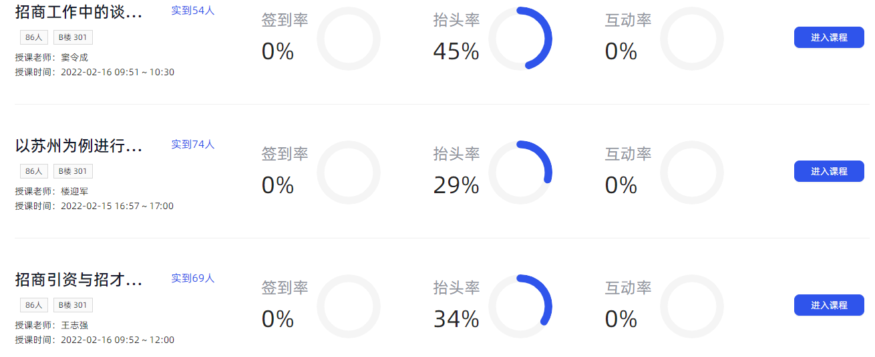

图4.1 三门课程的学情分析结果展示



图4.2 所开课程所在班级的学情分析结果展示

针对学员进行学情分析时由算法统计结果经前后端处理显示如下图4.3和图4.4所示。

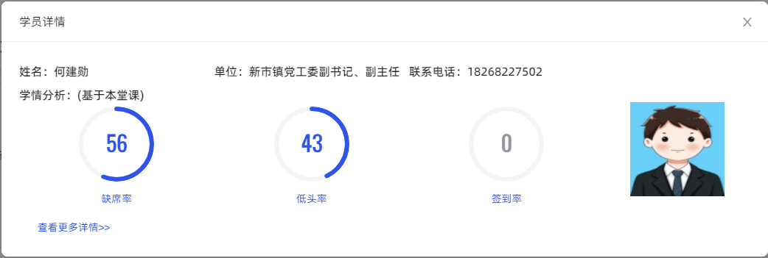

图4.3 学员基于本堂课得学情分析结果展示

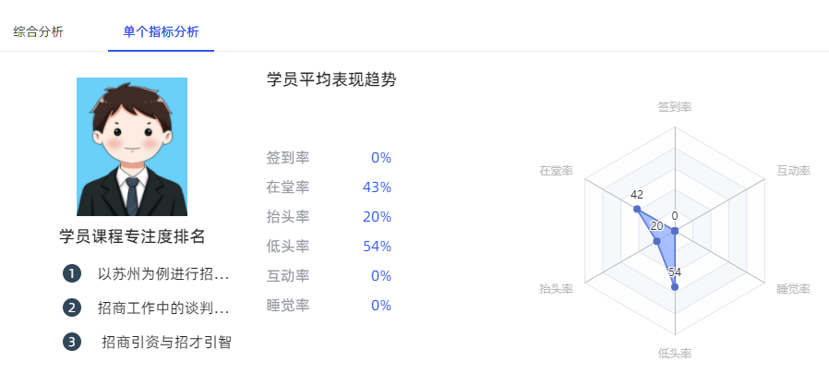

图4.4 学员平均学情分析结果展示

### 4.2分析与建议

经统计分析，算法整体达到可用要求，在以下三方面仍存在问题或待改进之处：

（1）学员骨架识别：骨架识别作为后续人座匹配算法与动作识别算法的先序工作，其识别精度直接影响后续算法工作的准确性。在实际情况中，不可避免出现学员相互遮挡、学员走动形成模糊重影等影响因素，如图4.5所示。针对实际场景中出现的干扰因素，可采取增大抽样帧数量的方式，尽可能将影响因素降至最低。

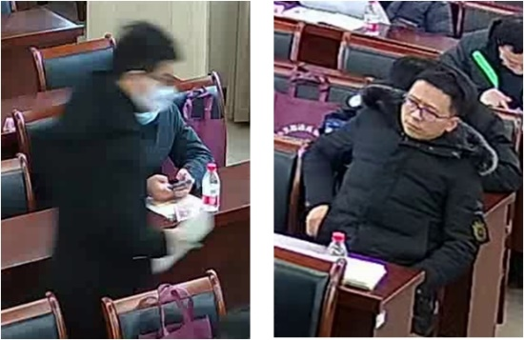

图4.5 图像模糊（左）及学员遮挡（右）影响因素

（2）人座匹配：人座匹配算法作为统计学员出勤率以及动作识别的输入，如果有学员人座匹配未成功，那么后续出勤率计算与动作识别将无法将该学员纳入计算，该学员状态记为缺勤。造成该情况有两方面原因：一是未能识别该学员骨架，此时一般是发生了遮挡或学员特征模糊；二是人座匹配时使用的座位标定不好，因为人座匹配算法需要将学员骨架与课程开始时预设的座位标记点进行匹配，如果座位标记点发生错误或偏移则会造成无法匹配的情况，如10号上午课程，165摄像头第6帧图像实际出席12人，人座匹配返回出席人数为10人，经过调整座位标定框后，算法再次匹配结果为12，成功匹配全部学员，如图4.6所示，其中橙色框为座位预标定框，绿色圈为匹配结果。

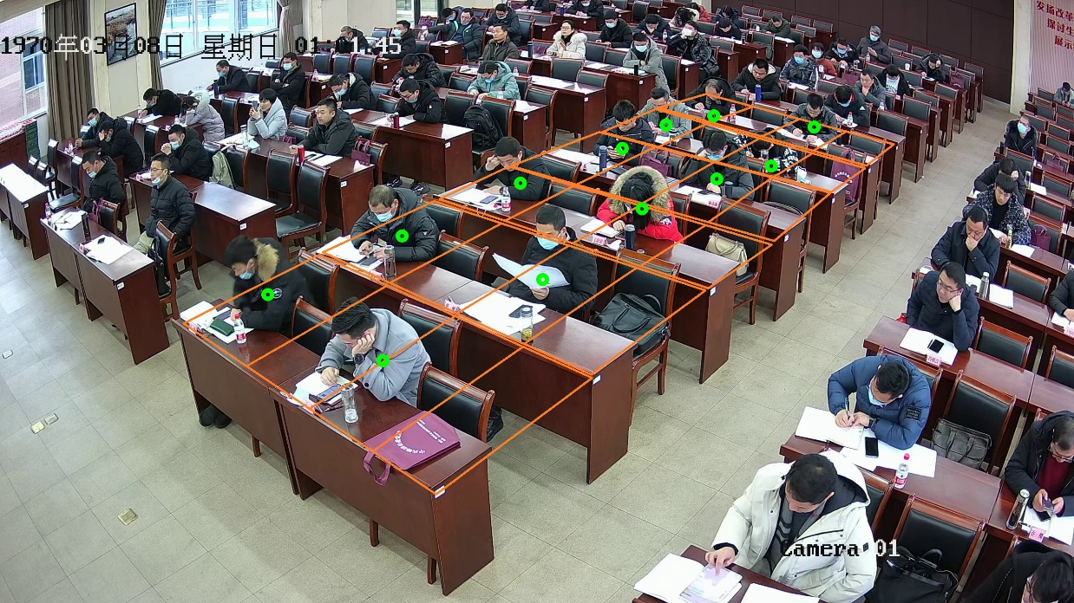

图4.6 座位标定清晰下的人座匹配结果

实际使用场景中，影响人座匹配主要以第二种情况为主，所以应在导入课程进行人工座位预标定时尽可能考虑到后续人座匹配问题，保证座位标定的清晰与正确。

（3）课堂行为识别：课堂行为识别统计包含了学员课上互动、睡觉等正/负反馈，由于测试样本中缺少这些行为，所以无法对识别率进行统计。在统计10号下午课程170摄像头第4至10帧中出现了睡觉行为，但算法无法正确识别该行为。在实际使用场景中，学员的行为是复杂多变的，对于睡觉行为，可能存在不同的表现，如图4.7所示，这增加了行为识别的难度，后续考虑训练采用更优的机器学习算法进行识别，尽可能提高识别成功率。

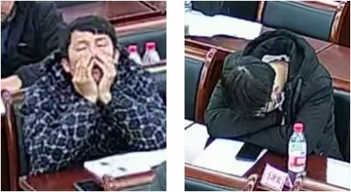

图4.7 不同睡觉行为存在特征差异