Supplementary Material

Figure S1. The Ground State structures of TMCa₈. The average distances between the Ca atoms of each layer of Ca atoms (the layers of Ca atoms are perpendicular to the principal axes of symmetry C₄ ,which is also perpendicular to the page). The average distances between the TM (Sc, Ti, V, Cr, Mn, Fe, Co, Ni, Cu, Zn) and the Ca atoms of each layer. All ground states structures belong to the D_{4d} point group with the exception of Cr and Co with D₄ symmetry, Ni with C_{2v}, and Cu with D_{2d} symmetry. All the distances are reported in Angstroms, Å.
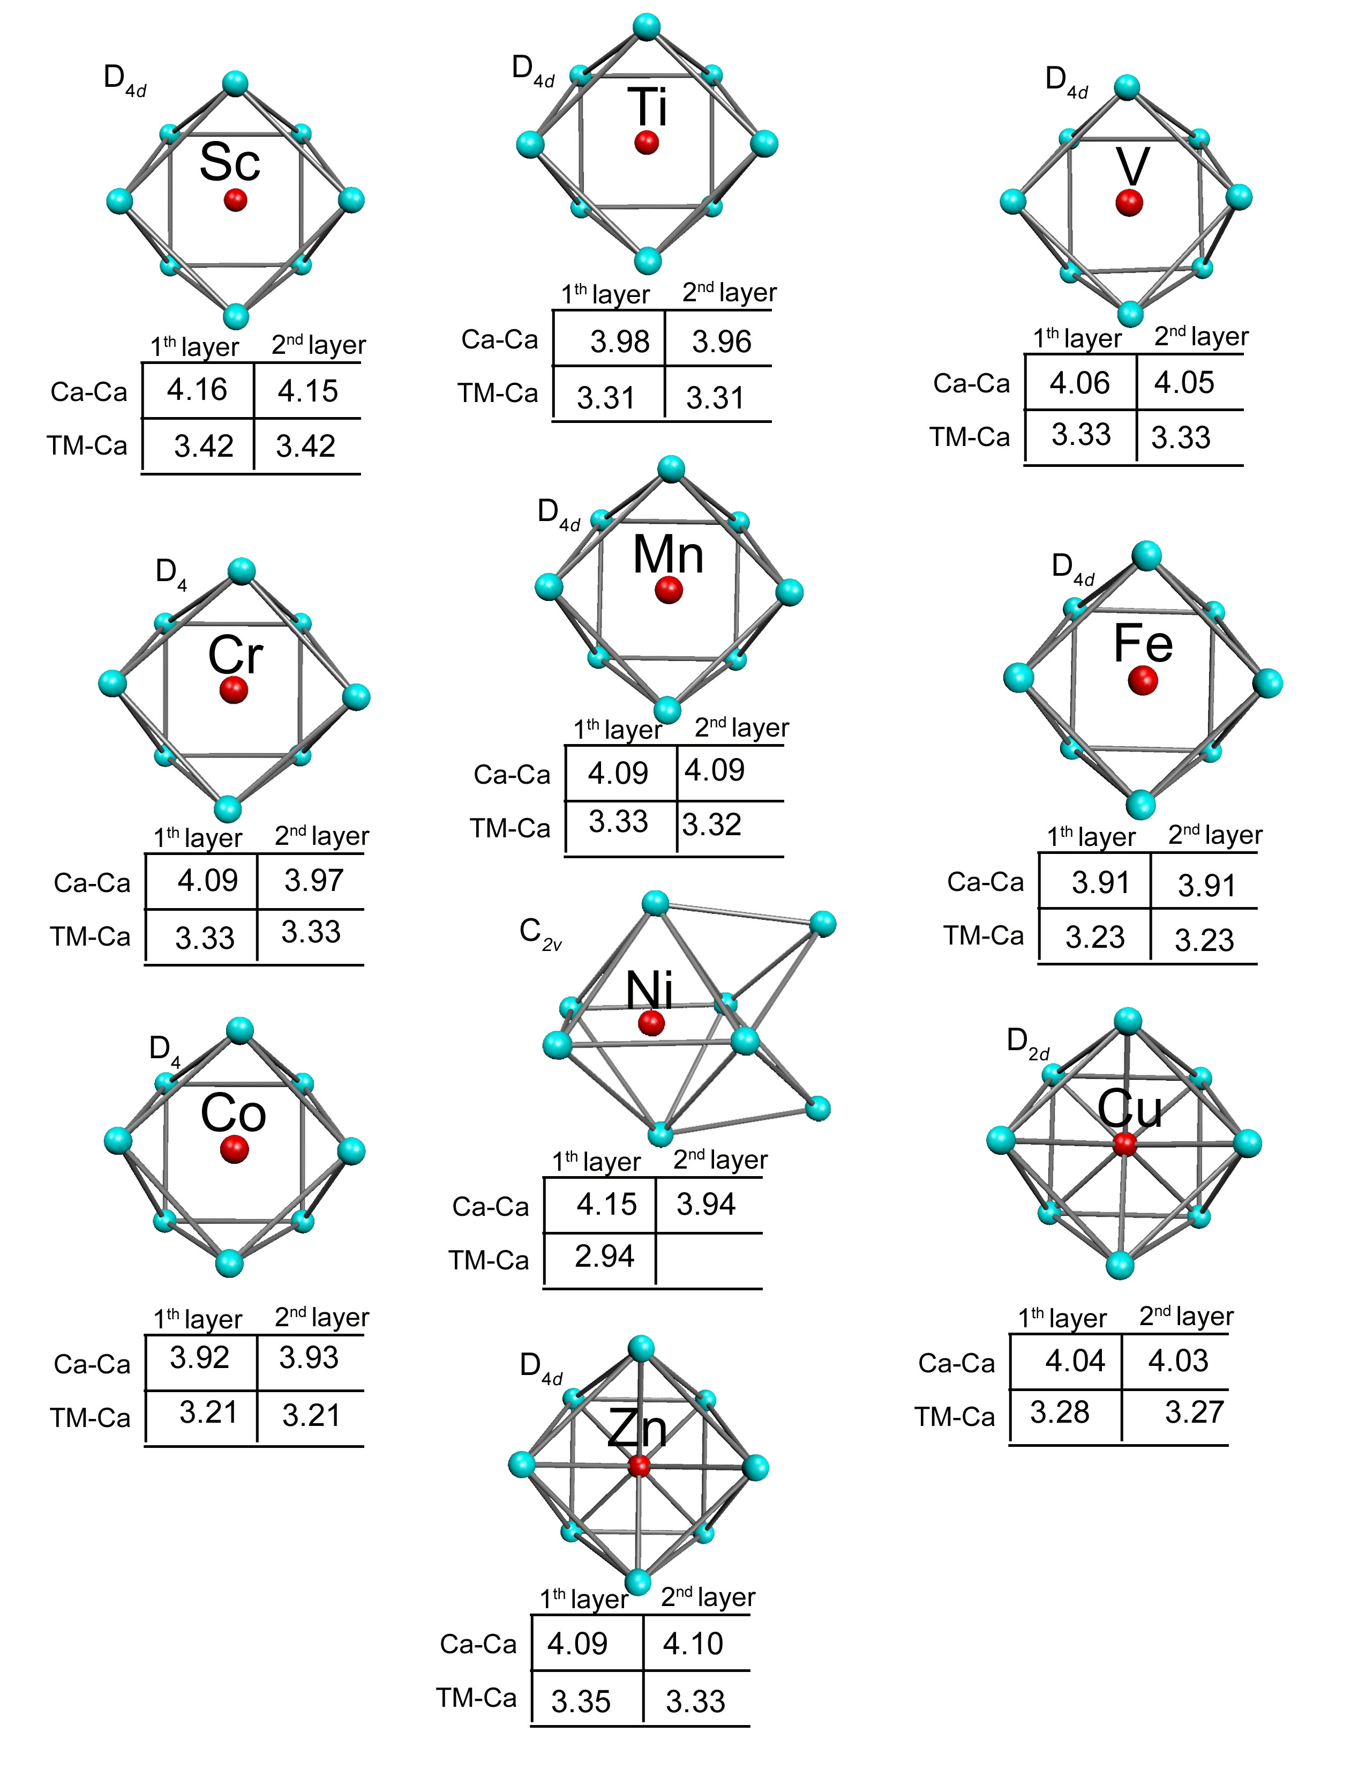

Figure S2. The lowest energy structure and next spin isomer of the (FeCa₈)₂ dimer. (A) The ferromagnetic (FM) and (B) the antiferromagnetic (AF) state. Arrows indicate the direction of Fe local spin moments. The relative energies are given in eVs.
