Figure 1. The lowest-energy structures and low-lying isomers with the spin multiplicities (SM) and relative energies (in eV) of VLi_{n} (n=1-13) clusters. The ground-state and metastable geometries of the corresponding bare Li_{n+1} clusters are also given on the left. See Table 2 for the corresponding energetic and structural information. The V atom is represented by the purple sphere.

n=1

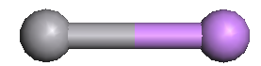
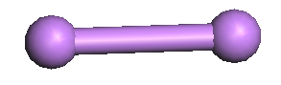
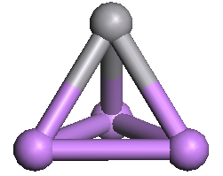
D_{infh}

SM=5, C_{infv}
n=2
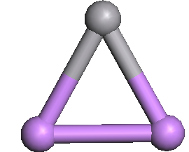
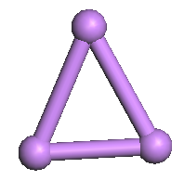

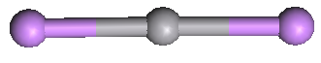

SM=6, C_{2v}

C_{2v}

SM=6, D_{infh}, 0.26eV早晨升起，傍晚降下早晨升起，傍晚降下早晨升起，傍晚降下

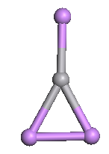
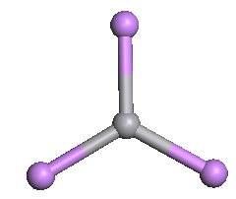
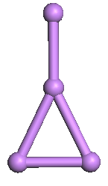
n=3
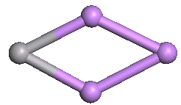
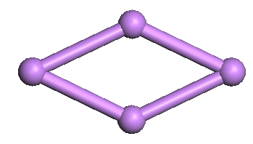

SM=7, C_{3v}

SM=5, C_{2v}, 0.19eV

SM=5, C_{s}, 0.49eV

SM=7, D_{3h}, 0.95eV

D_{2h}

C_{2v}, 0.43eV

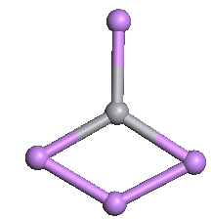
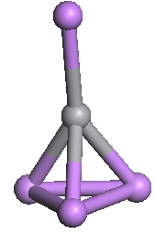
n=4
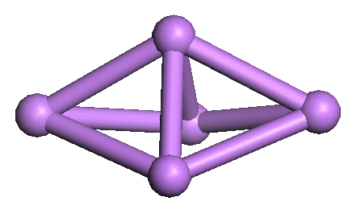
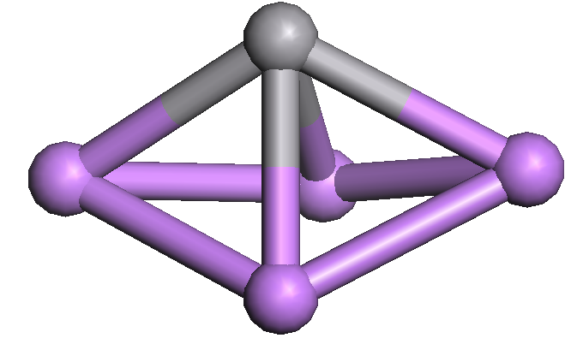
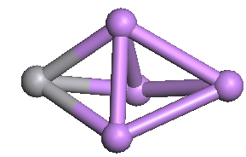
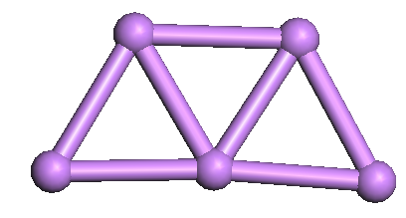

C_{2v}

C_{2v}, 0.09eV

SM=4, C_{2v}

SM=6, C_{s}, 0.06eV

SM=6, C_{3v}, 0.42eV

SM=4, C_{2v}, 0.45eV

n=5
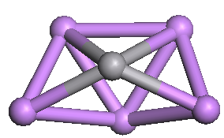
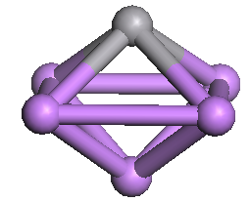
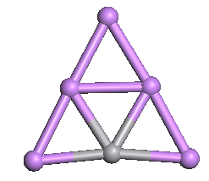
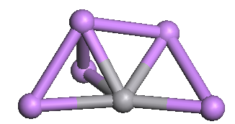
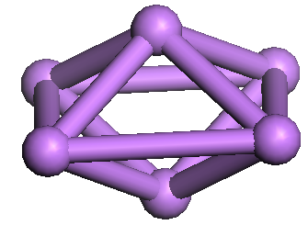
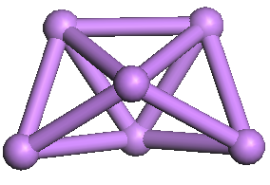

D_{4h}

C_{2v}, 0.09eV

SM=3, C_{s}
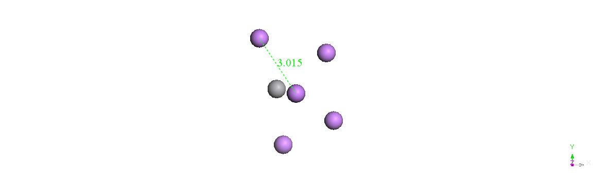

SM=3, C_{4v}, 0.07eV

SM=1, C₁, 0.19eV

SM=5, C_{2v}, 0.59eV

n=6
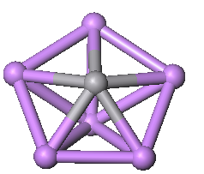
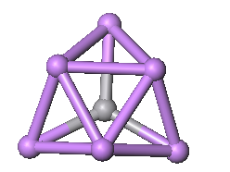
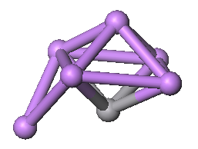
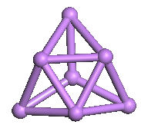
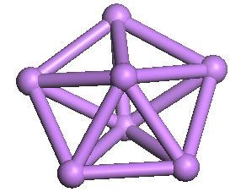
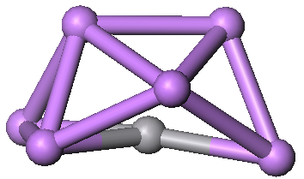

D_{5h}
SM=4, C_{5v}
C_{3v}, 0.17eV

SM=6, C_{3v}, 0.24eV

SM=4, C_{s}, 0.33eV

SM=4, C₂, 0.36eV

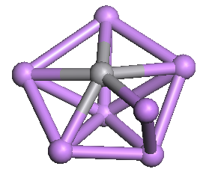
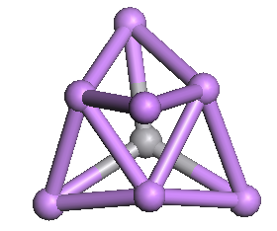
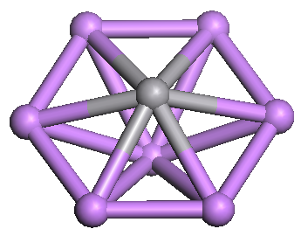
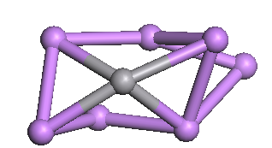
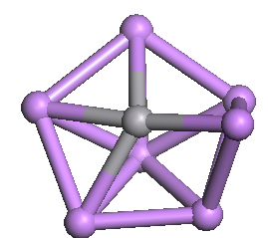
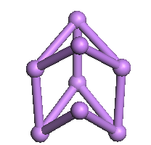
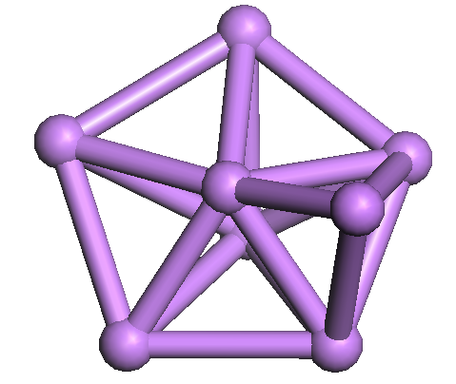
n=7

D_{2d}
C_{s}, 0.02eV

SM=5, C_{s}
SM=5, C₁, 0.47eV

SM=5, C_{6v}, 0.57eV

SM=5, C₁, 0.96eV

SM=1, C₁, 1.01eV

n=8
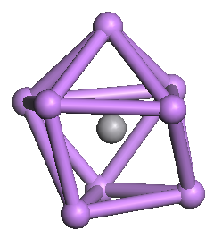
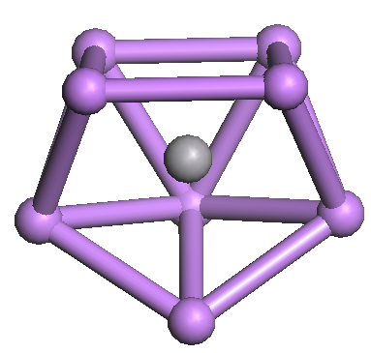
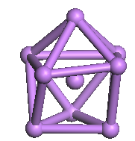
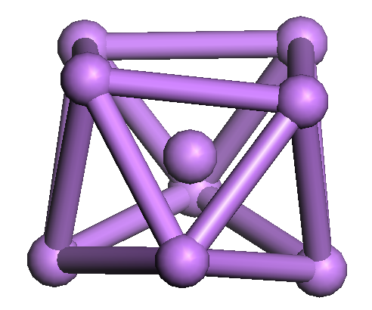
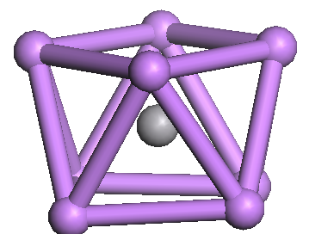
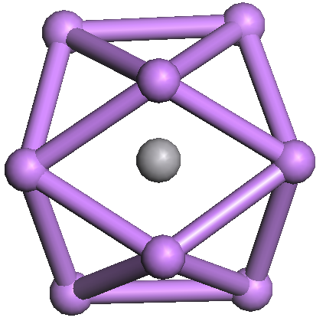
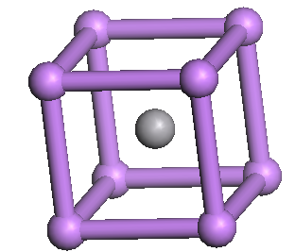

C₂
C₂, 0.008eV

SM=6, C₁, 0.04eV

SM=6, C_{s}, 0.05eV

SM=6, C_{2v}, 0.32eV

SM=6, O_{h}, 0.41eV

SM=6, D_{4d}

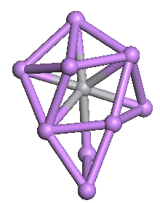
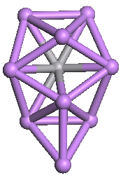
n=9
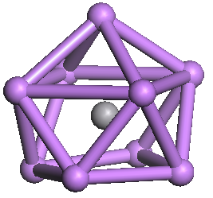
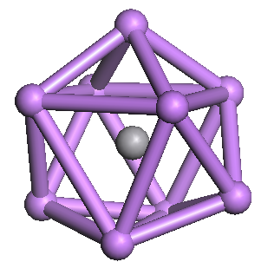
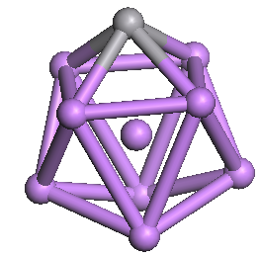
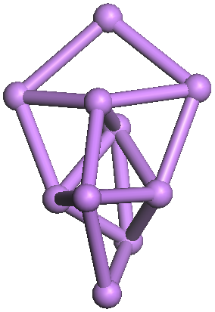
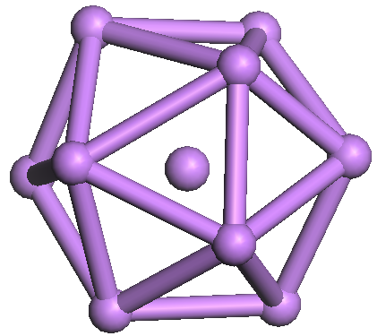

D₂
SM=5, C_{2v}
C_{3v}, 0.19eV

SM=5, C_{s}, 0.05eV

SM=5, C₁, 0.67eV

SM=5, C_{2v}, 0.88eV

SM=0, C_{s}, 0.89eV

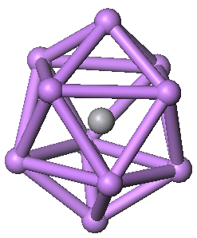
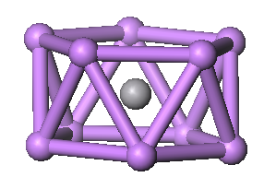
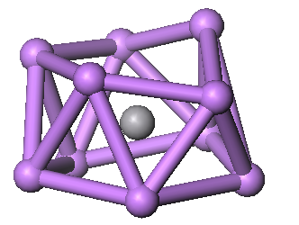
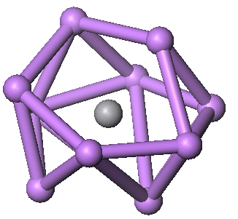
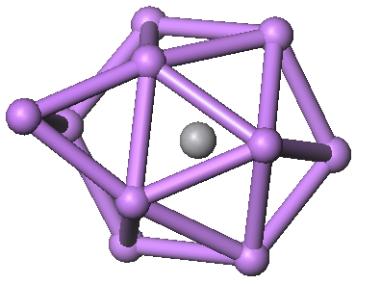
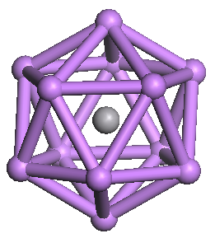
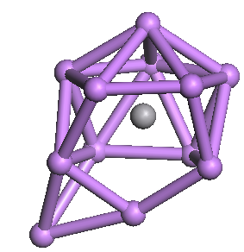
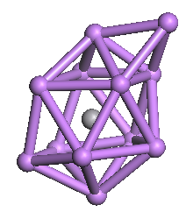
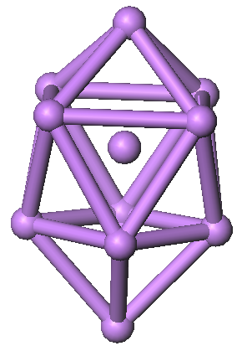
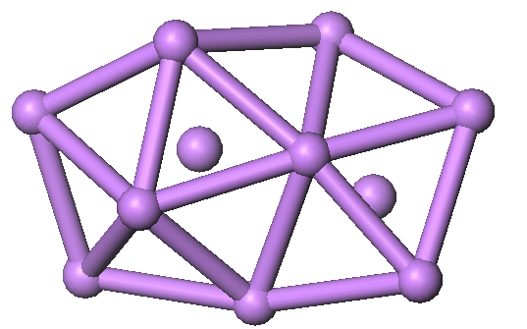
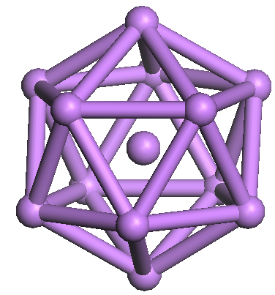
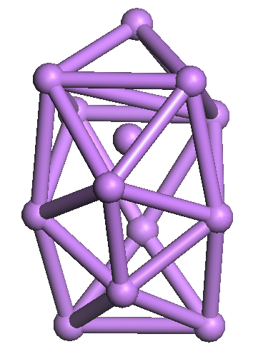
C₁, 0.004eV

n=10

C_{2v}
SM=4, D₂
SM=4, D_{5d}, 0.23eV

SM=2, C₁, 0.31eV

SM=4, C₁, 0.32eV

SM=4, C₁, 0.49eV

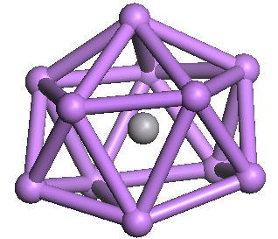
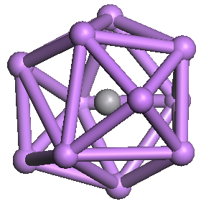
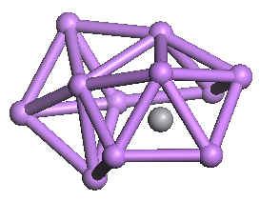
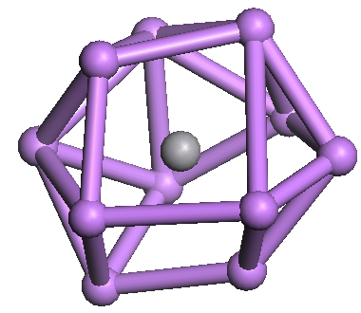
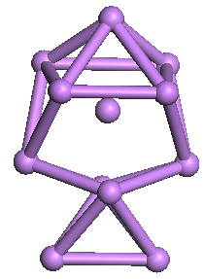
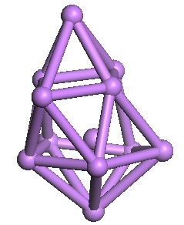
C_{s}
C₁, 0.005eV

n=11
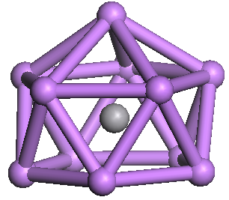

SM=1, C₁, 0.20eV

SM=1, C₁, 0.35eV

SM=3, C ₁, 0.39eV

SM=1, C₁, 1.82eV

SM=3, C_{5v}
n=12
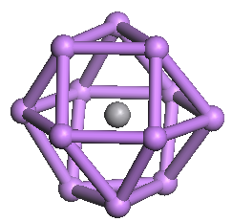
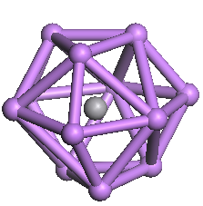

I_{h}
SM=2, I_{h}
C_{s}, 0.13eV

SM=2, O_{h}, 0.70eV

SM=4, C₁, 0.76eV

SM=2, D₃, 0.78eV

SM=4, C₁, 0.94eV

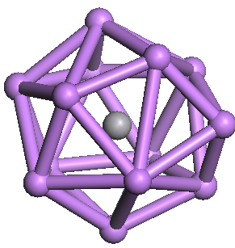
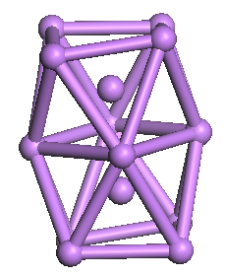
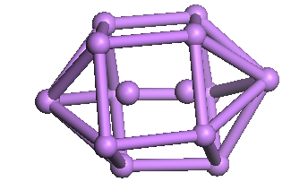
C₁, 0.09eV

n=13
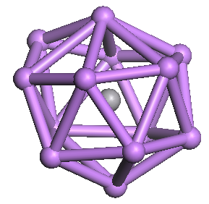
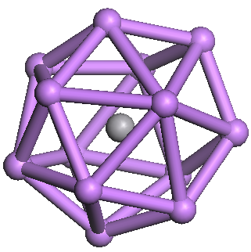
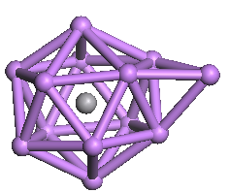
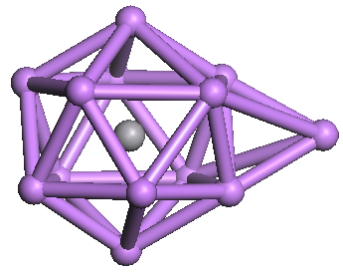

D_{2h}
SM=1, C_{2v}
SM=1, C₁, 0.02eV

SM=1, C_{3v}, 0.10eV

SM=3, C_{2v}, 0.17eV

SM=1, C₁, 0.37eV

