Outline

**Part 1: London’s underground resilience**

Section 1: Measures

1. Introduce briefly the 3 centrality measures(1h)

Firstly, the betweenness centrality of each node is the number of times that the shortest path of any two nodes in the network passes through the node. Its represents the node's ability to control network information transmission and reflects the importance of node v as a "bridge". For example, the transfer station in the subway network.

(formula)

Secondly, closeness centrality. It calculates the average length of the shortest path from each node to other nodes. In other words, for a node, the closer it is to other nodes, the higher its centrality. Therefore, the nodes with high centrality are usually in the center of the network, and appear as stations in the central area of the city in the subway network.

(formula)

Thirdly, degree centrality calculates the directly connected nodes of each node, which represents the number of neighbors owned by the node, and is divided into out-degree and in-degree for directed graphs. In the subway network, it appears as a point connected to more stations.

2.Node removal criteria

* 1. 2 measures of nodes removal

1. Sequential removal: First, sort according to the centrality of the London subway from high to low, then remove the node with the highest centrality, and finally recalculate the centrality of the subway and loop the above steps until 10 nodes are removed.
2. Non-sequential removal: Sorted the centrality of the London Underground from high to low, and the ten nodes with the highest centrality are directly removed without recalculating centrality.

2.2 Results

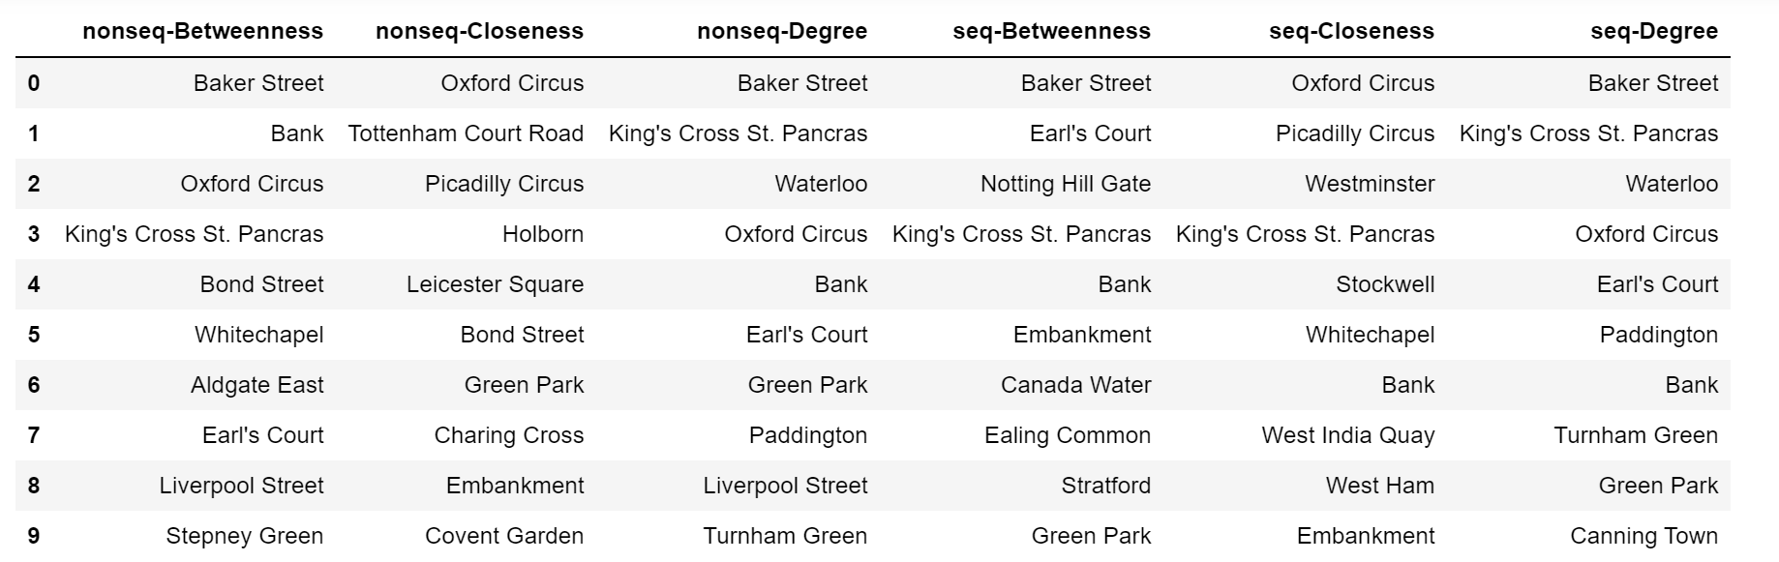

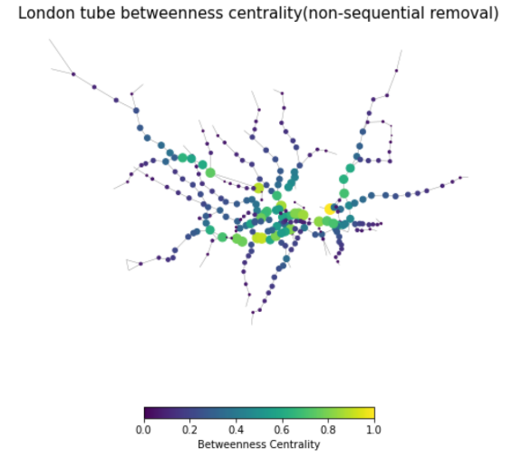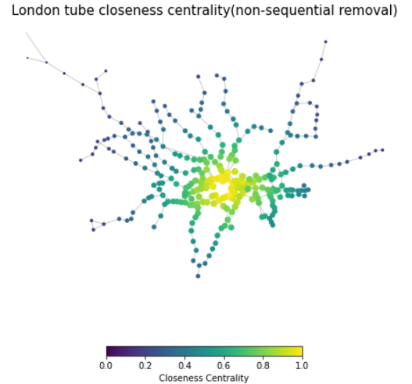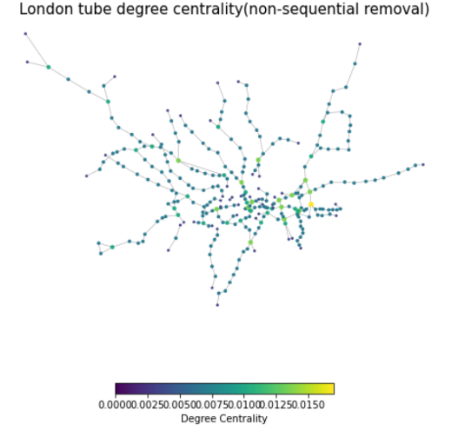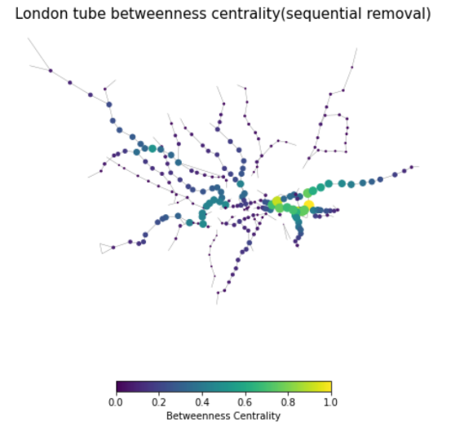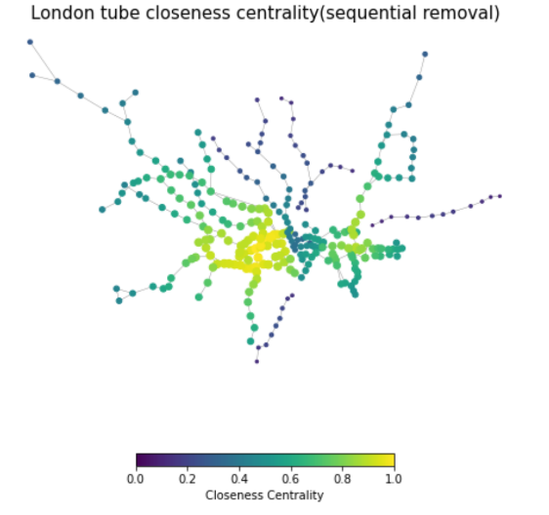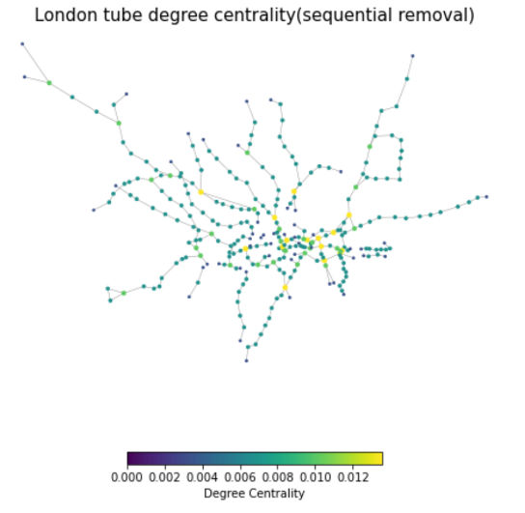

1. 2 measures to evaluate the impact
2. explains the measures

The operation of the network will be affected by the removal of nodes, especially the removal of some key nodes will seriously damage the network. This paper uses the efficiency measure and the largest component ratio to evaluate the impact of node removal on the vulnerability of the London Underground network.

Network efficiency (E) is a measure of the efficiency of information exchange between any nodes in the network. Its calculation formula is as follows. The higher the E, the higher the overall efficiency of the network. After removing some nodes from the network, the larger the ∆E, the more important the node is to the network, that is, the greater the vulnerability. Nodes with greater vulnerability have greater impact on the overall efficiency of the network and are regarded as key nodes.

Largest connected component ratio (LCC): It is used to measure the global connectivity of the network. When the number of removed nodes in the network exceeds a certain number, the originally fully connected network will be split into multiple disconnected sub-networks, of which the one with the largest area is called the largest connected sub-graph： MCC 定义如下。N and N1 being number of nodes of the network and of its largest component correspondingly.

1. Applicability of these two methods to other network vulnerability assessments

In principle, network efficiency evaluates the efficiency of information exchange and network connectivity at the network level. According to the formula, network efficiency needs to calculate the shortest distance between nodes and the total number of nodes, while the other needs to consider the number of the largest subset and the total number of nodes. Simple calculation conditions and important network evaluation results make these two methods not only useful to evaluate the vulnerability of the traffic system, but also be useful to evaluate the resilience of any other network. For example, the use of targeted attack and random attack, evaluation of social networks, Biological networks and communication networks the changes in the information exchange efficiency and connectivity of network nodes after removing nodes.

Section 2: Analysis.

1. Results of 2 different strategies (‘sequential’ vs ‘non-sequential’)

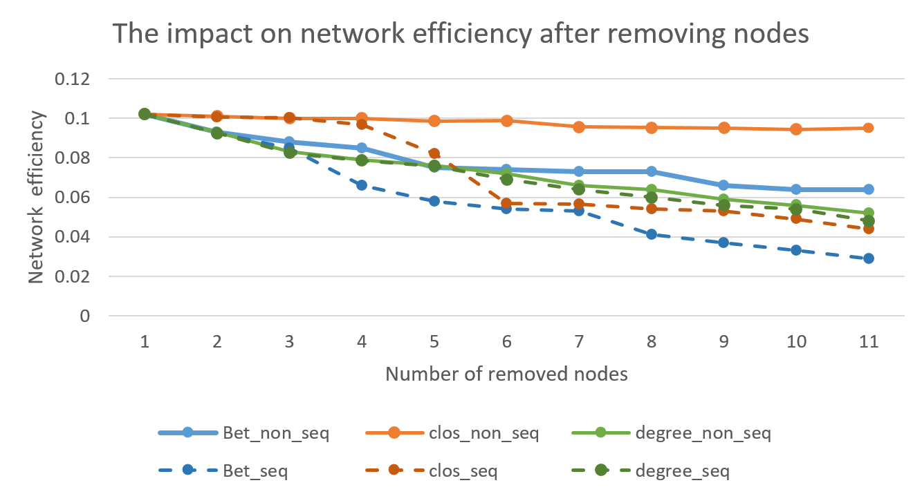

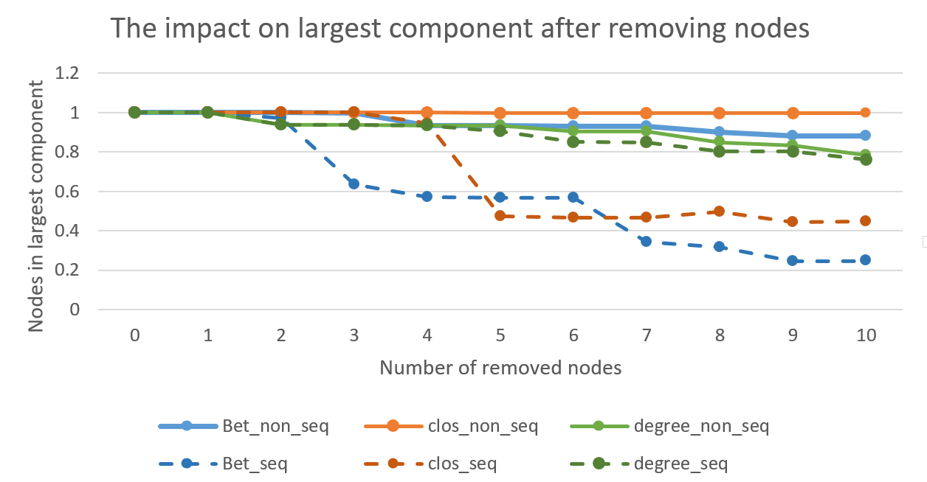

1. Discuss whether the two different measures to evaluate the impact give the same results and justify whether the findings were expected.

Fg.1 shows the network efficiency changes in 6 scenarios. 在两种结点去除方式的比较上，同种中心度的方法中，顺序去除结点使网络效率显著下降，而非顺序去除结点下的网络效率下降则十分平缓，当去除10个点时，顺序去除后的网络效率比非顺序去除的网络效率要低50%左右，这说明按照顺序去除节点的方法能更好的识别网络的关键节点，对网络造成更大破坏。

在三种中心度的比较上，在顺序去除的情况下（因为顺序去除更有效），介数中心性的攻击最有效，在去除十个点后，仅为原来的23%。它仅需去除6个点就可以使网络效率降低为原来的一半，而closeness和degree则需要分别去除8个和10个才能达到同样的效果。closeness centrality的网络效率在去除3-5个节点时快速下降，其余时候基本保持不变，在第五个节点后仅由6%下降到了4.4%；degree centrality的网络效率全程平缓下降，去除10个点的网络效率为4.8%，whereas we only need to remove 6 nodes to achieve the same performance if one uses betweenness measure.

Fig. 1 displays the largest component changes when remove nodes. 相似的，按照顺序去除节点的网络攻击要比非顺序去除更有效，非顺序去除10个节点时，closeness based去除方式最大联通子图的比例几乎不变，betweeness和degree based分别为88%和78%，对网络的攻击效果差。

在三种中心度的比较上，在顺序去除的情况下，基于介数的去除点方式最有效的减小了largest component，去除3个点时LCC降低到63%，去除十个点时LCC降低为24.7%。closeness在去除第四个节点后显著下降，并保持在45%左右。

两种方法都表明，sequential-removal是更有效的去除节点方式，基于betweenness的去除点方式对网络的攻击最大，基于Degree的则不能有效的减小the efficiency and the largest component size.

Degree based node removal is not effective in reducing the largest component size, which suggests that although removing nodes with the highest degree seems to be quite intuitive, the highdegree nodes do not necessarily play a key role in topological vulnerability. In addition, despite the fact that betweenness is a widely adopted measure for evaluating node centrality, it can not fully identify the most vulnerable nodes whose removal maximally reduces the largest component size.

Section 3: Discussions

1. About centrality measure

从定义上，

从评价结果上，根据网络效率和最大联通子集去除节点的影响结果，betweeness centrality能够有效识别系统的重要节点，与伦敦市地铁网络高度相关。

1. About evaluation measures
2. Explain whether different centrality measures would be expected for different networks, and comment on the limitations of the approach to evaluate the “resilience” of London’s underground.

**Part 2: Networks with flows and Spatial Interaction models.**

Section 1:

1. The flows impact
2. Re-compute the centrality with flows inverted

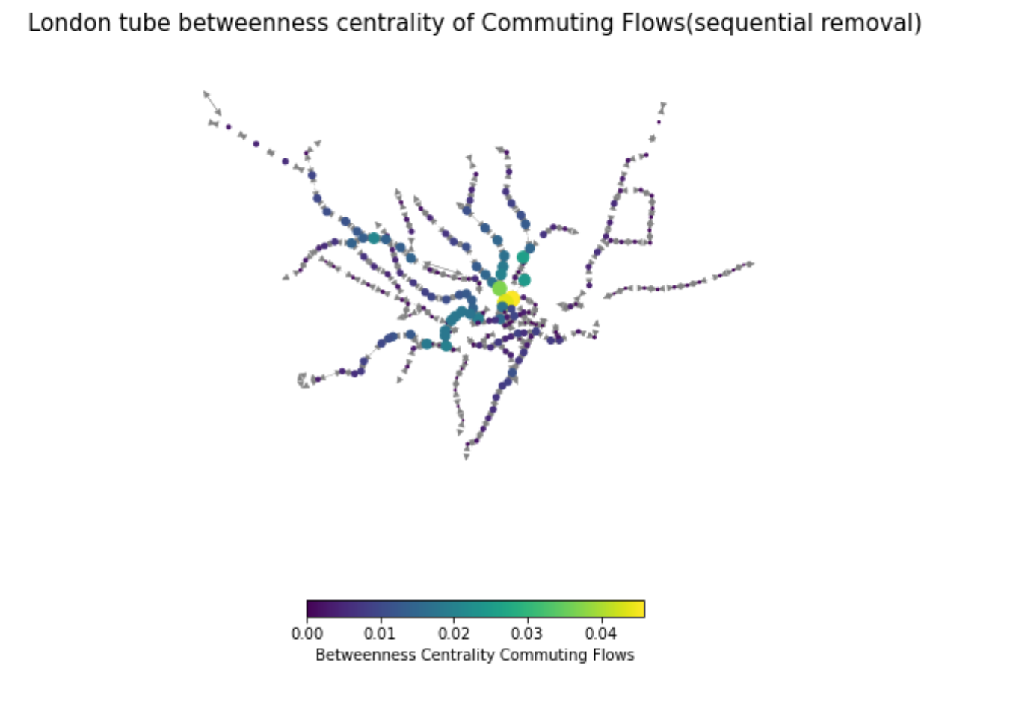

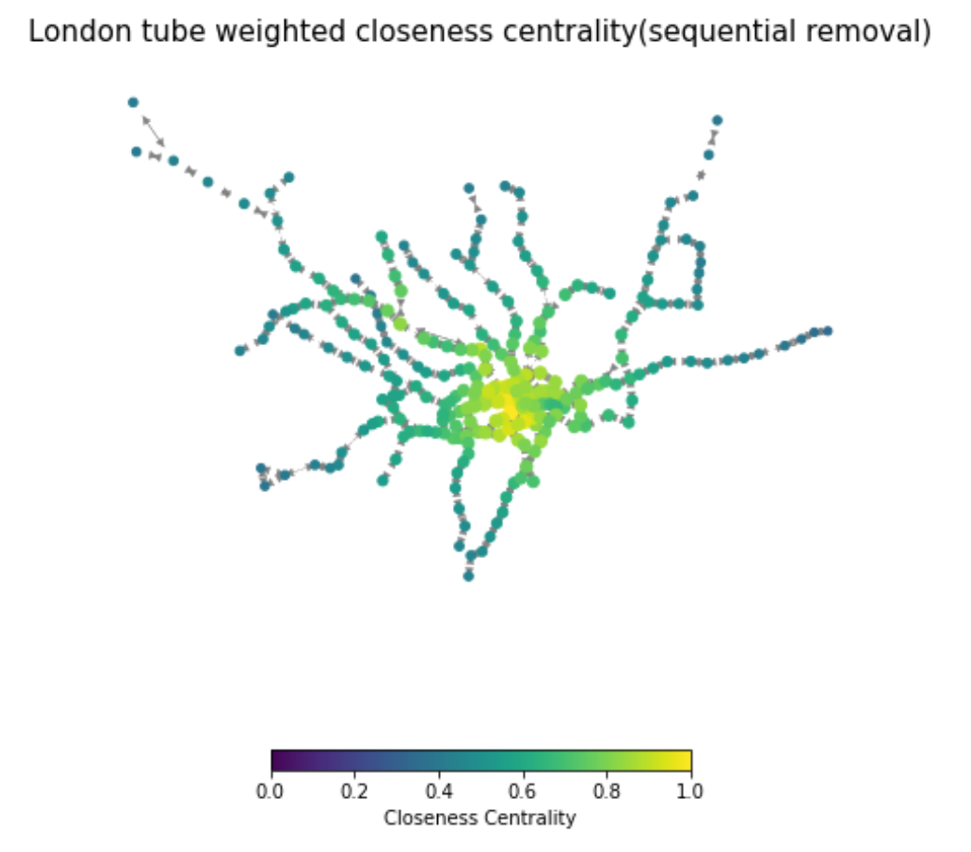

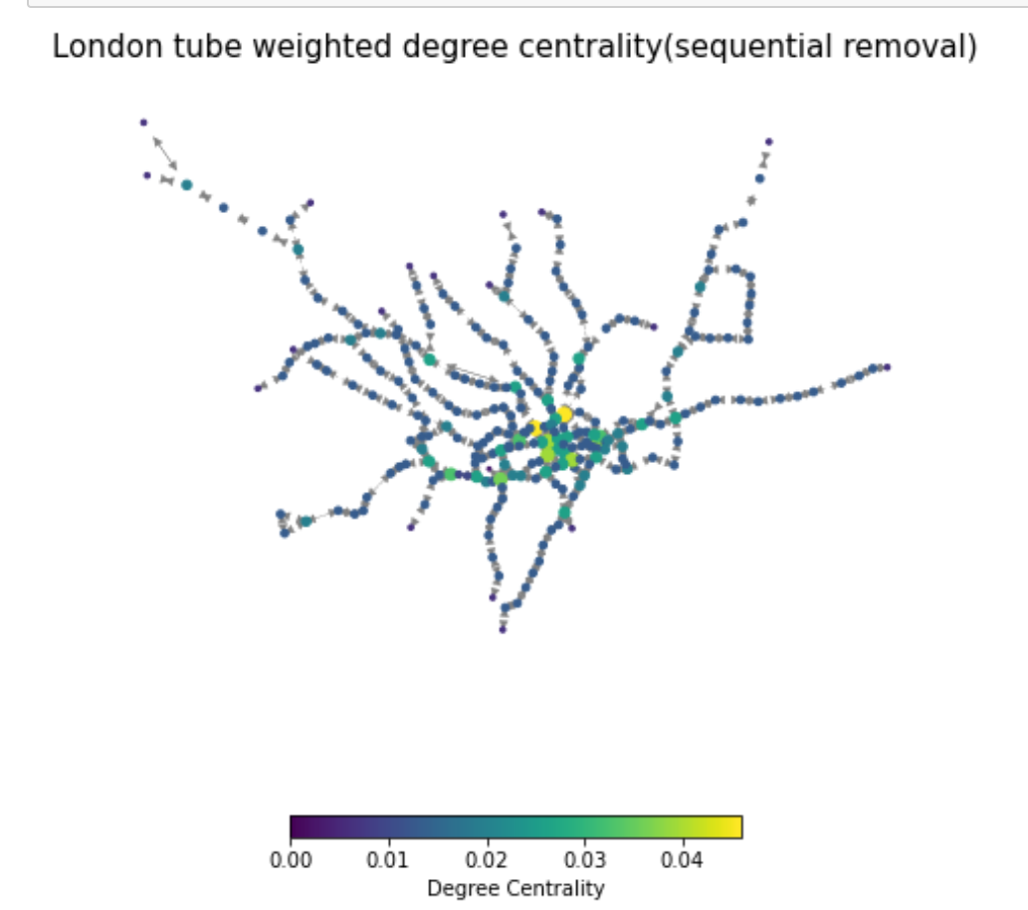

1. Discuss whether the centrality measures that make the network more vulnerable are the same as in the previous section, and how your measure to evaluate the impact of node removal needed to be adjusted.

Section 2: Spatial interaction model

1. Briefly introduce the spatial interaction models covered in the lectures using equations and defining the terms, in particular explaining the role of the parameters.
2. Using the information of population, jobs and flows, select a spatial interaction model and calibrate the parameter beta. Make sure to justify your selection of model.

Section 3：Scenarios

1. Results of AB1B2
2. Comment on the change in flows for the different stations given the 3 different situations . Which scenario would have more impact for the redistribution of flows? Explain and justify your answers using the results of the analysis.

**Discussion**

Imagine you were a consultant for the TfL (Transport for London) asking you to evaluate the resilience of the London’s underground. Explain how this type of analysis could be used, and its limitations.

**Literature**

**Appendix**