Computer Vision: Algorithms and Applications

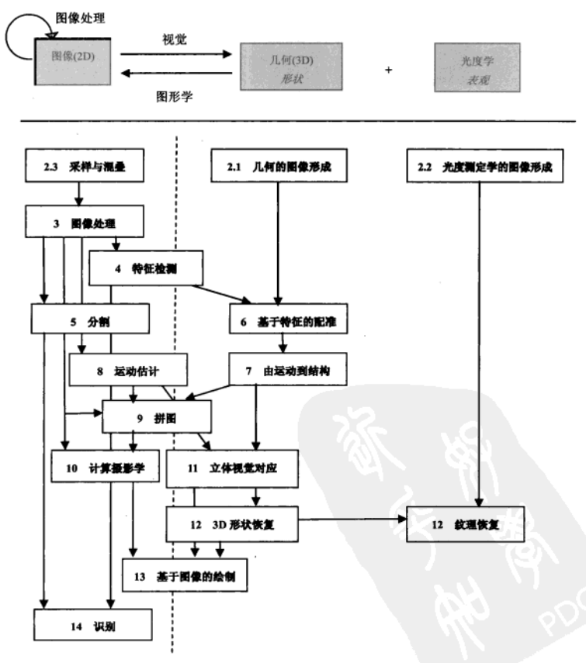
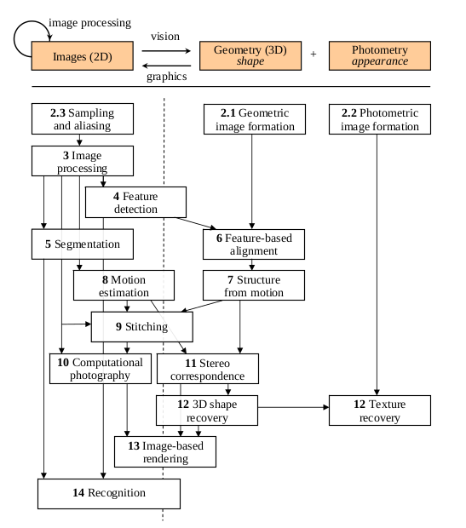

Image formation
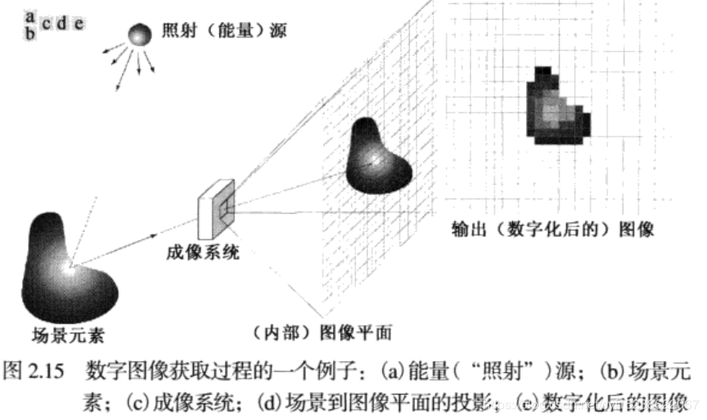
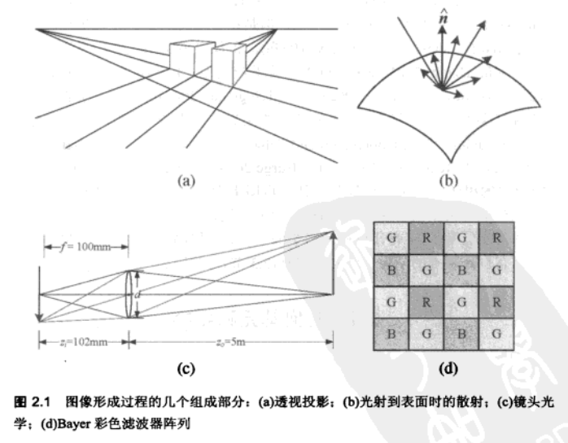

1.1 Geometric primitives and transformations

1.1.1 Geometric primitives

基本的2D和3D基元：点；线；面。
投放过程：3D特征投影到2D特征。

2D points. 也是 pixel coordinates in an image（图中的像素坐标），can be denoted using a pair of values, x = (x, y) ∈$R^{2}$,
or alternatively（以另一种方式）：
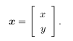
2D points can also be represented using homogeneous coordinates（齐次坐标）, ,where vectors that differ only by scale are considered to be equivalent. is called the 2D projective space

