  For office use only
  T1 | ________________
  T2 | ________________
  T3 | ________________
  T4 | ________________
  Team Control Number
  86792
  Problem Chosen
  E
  For office use only
  F1 | ________________
  F2 | ________________
  F3 | ________________
  F4 | ________________
2018 MCM/ICM summary sheet
Climate Change Influences Regional Instability
Climate change plays an increasingly important role in the stable development of cities.
First, the thing is to measure the country's fragility. We build a fragile state model, consisting of five sub-systems: climate, economy, society, politics and coordination. The measurement of country's fragility in the subsystem is based on the classical mechanics of the spring force model: pressure -- the influence on the state (which is positively related to the vulnerability); Resilience - national adaptive capacity (negative correlation).Different indexes are selected to measure the pressure and elasticity of the different subsystem. With the method of k-means clustering, the representative country can be chosen .Then use the formula to solve the classification criteria. Besides, the direct and indirect effects of climate are analyzed based on the relationship between total state and subsystem.
Next, we select Chad as objects we focus on. We calculate the fragility value of the subsystem and the whole by use of related data collected from authority websites. Based on the data calculated, relevant analysis is carried out to explore the impact of climate on state fragility. We conclude lots-- the negative correlation between climate and economy, the opposite movement with the social subsystem, the lag effect in climate impact. Finally, we conclude short term and long term impact of climate change. In this question, we also define exotic countries, one or some of whose subsystems deviates from normal values, but the overall fragility is normal.
Then, we select Botswana (belongs to “vulnerable”) and process the country's data for 20 years. By virtue of multiple statistical regression (considering the lag effect), the important indicators are finally determined -- temperature difference, rainfall, annual GDP and population. The impact path and analysis of these indicators are in figure 8.These four indicators directly affect three measures--population density, rainfall, average GDP. Three measures also constitute the tipping point where a country’s fragility move from one state to another. In order to see when climate change push state to become more fragile and define a tipping point, we have a Super real time simulation. To figure out the exact value, use important indicators to return to other indicators. The 1997 value is the initial state. What’s more, data about Climate and population goes through the process of deterioration. In this case, the conditions of fragility are judged according to the formula. Finally, after the 1509 effective simulation, the country was determined to collapse between 2075 and 2100.
Also, build the bi-targets cost model. We hope that government intervention will reduce the country's fragility by 2050. From the above analysis, three key indicators(population density, rainfall, average GDP) should be adjusted to change the country's fragility. But these three indicators cannot be changed directly, so five interventions can be found. Better to describe the degree of realization of these indicators, there are four factors that are most affected by these factors (agricultural output, infrastructure spending, public health spending and water value). These factors can also be characterized by money. Finally, the final cost is calculated by using the bi-targets model .The total cost of state intervention ranges from $469.1 to $70.69 billion.
Finally, we find that if our model is used in smaller ’state’, we need to consider that climate change may be affected by the surrounding states. Therefore, multi-entity interactive simulation is required in simulation. If our model is applied to larger ‘state’, we need to split the country in accordance with the economy, climate, to calculate the fragility of different areas. Meanwhile, A new weight will be constructed.

Contents
1 Introduction 4
1.1 Background 4
1.2 Problem Statement and Analysis 4
1.3 General Assumptions 5
2 Task1 5
2.1 Develop the Model 5
2.2 Potential Indicators for a Fragile State 6
2.3 State classification 8
2.4 Climate Impacts 9
3 Task2 10
3.1 City Selection and Data Description 10
3.2 Path Analysis of Climate Impact 10
3.3 Modification of the model 12
4 Task3 13
4.1 City Selection and Data Processing. 13
4.2 Identify the possible definitive indicators 14
4.3 A tipping Point 16
4.4 Single Entity Simulation 17
5 Task 4 19
5.1 Intervention Analysis 19
5.2 Bi-targets Cost Model 20
6 Task 5 22
7 Strengths and Weakness 23
8. References 24
9 Appendix 25

1 Introduction

1.1 Background
Notwithstanding the fact that state fragility as a theoretical construct has now become an important part of the international political discourse, it nonetheless remains an elusive concept for both academics and policymakers. [1]Determinants of State Fragility and Implications for Aid Allocation .Someone thinks that a fragile state is a low-income country characterized by weak state capacity and/or weak state legitimacy leaving citizens vulnerable to a range of shocks.
Last few years, much attention has been paid to four part: Policy, Economy, Society and Security. Even the world bank, who defines the notable index -- CIPA, shows little interest in the climate change. Fortunately, environmental effect becomes popular. Climate change will stress the world’s economic, social, and political systems. Where institutions and governments are unable to manage the stress or absorb the shocks of a changing climate, the risks to the stability of states and societies will increase. [2] So, in our paper, we make more efforts to figure out the definition of the fragile state and the different performance varying from the climate change and city characteristics.

1.2 Problem Statement and Analysis
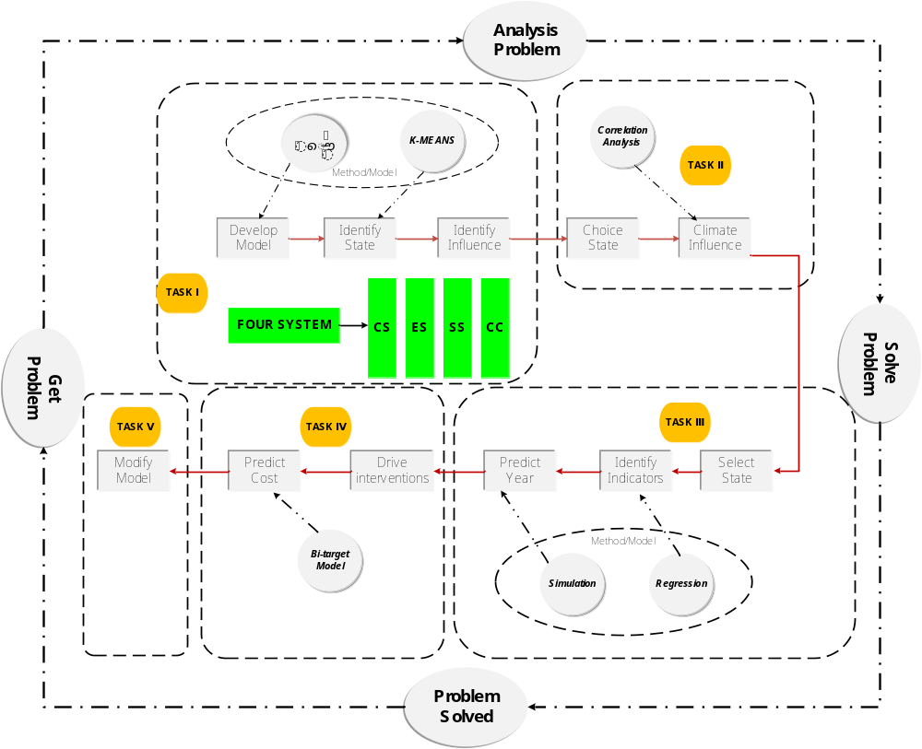Fig.1 Flow chart of model

1.3 General Assumptions
- The selected object is an unrefined independent entity.
- There is a direct or indirect promotion/constraint relationship between the selected study objects, and these relationships can be described using a simplified mathematical model.
- Among the many indicators selected, there are several basic indicators, which can directly or indirectly affect all indexes in the whole index system.
- There is no positive/negative feedback effect relationship between indicators.
- The chosen subjects will not experience devastating disasters or man-made disasters, including earthquakes, pestilence, nuclear war, and so on.
- The policies proposed by the state can be effectively implemented
- Most data of the selected subjects will not change dramatically in the next 100 years.

2 Task1

2.1 Develop the Model
In the last decade，a new term is emerged --a fragile state. The concept of fragility is a highly abstract concept. The concept has not been defined uniformly since it has not appeared for a long time. Besides, the criteria for measuring the fragility vary from organization to organization. Existing research also defines "fragile States" in broad and narrow terms. ln a narrow sense, fragility refers to the attributes of a political system, and a "fragile State" cannot afford to assume its responsibilities as a provider of basic services and public goods. The result is a loss of legitimacy. Broadly speaking, a social community is entangled in various violent conflicts, political, social or economic instability, so that fragility is defined as “fragility of the social situation”.
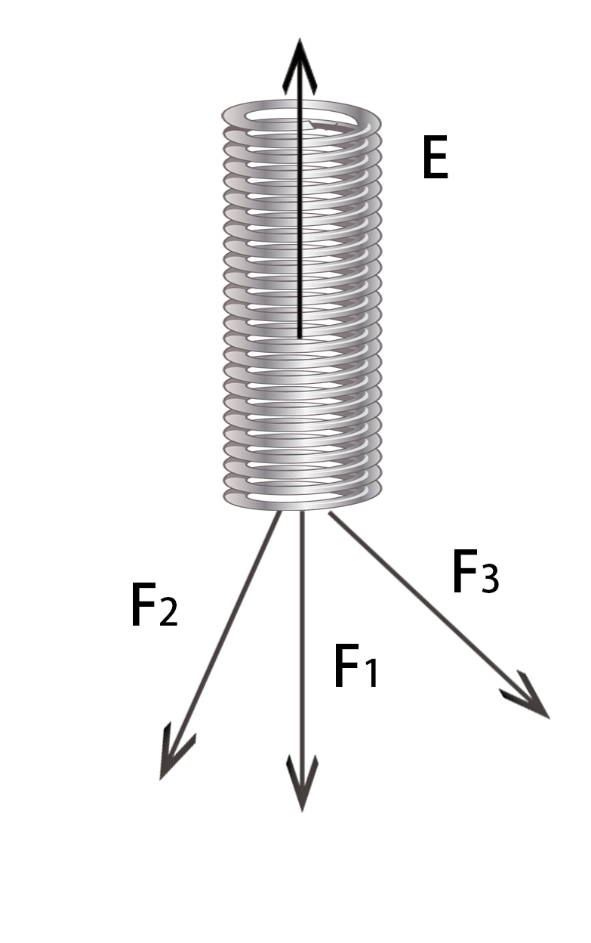
We think that fragility of a state means the possibility--a state will collapse under adverse conditions, the risk that it takes under external pressure. The worse the internal and external environment the country faces, the greater the pressure will be withstood. So the fragility of this country will increase. Based on our definition, introduce the law of spring pressure formula in mechanics. Give a fragility formula:
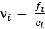 (1)
Where: denotes the fragility in subsystem .The higher the value of is, the greater the degree of fragility will be. denotes the stress on the state in subsystem . denotes the elasticity in subsystem（Resilience or adaptability of countries under external pressure）When countries suffer more pressure and have a worse self-elastic ,the possibility to be fragile will be higher.
Taking the analysis of the climate subsystem as example, the climate change can have an influence on national by rainfall, temperature difference and natural disasters. In particular, we call a risk factor. Natural climate and man-made climate change determine the likelihood of risk. The resilient can also be regarded as a risk body, and is determined by the state's current nature. Ultimately, the combined effect of stress and resilience determines the fragility of the country in the climate subsystem.
Generally, if climate changes alone, or some subsystem fluctuates, it does not necessarily lead to collapse. However, after the five systems interact and balance each other, collapse may be produced. For any country, the ultimate comprehensive fragility indicator is:
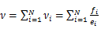 (2)
Where, the bigger the score is, the greater the fragility t of the country. is the fragility level in the subsystem. N is the number of subsystems that affect national fragility.

2.2 Potential Indicators for a Fragile State
Although a large number of indicators are currently used to describe fragile states, scholars have not come to a unified conclusion. Different indicators have different concerns. But what is now unified is that the dimensions of the concept of fragile are roughly divided into two categories - functional and structural. The functional dimension, such as the Oxford University CRISE index, the Carleton university CIFP index, emphasizes the authority and legitimacy of the government. The structural dimension,such as the fragile index of the system peace research center, emphasize four aspects -- security, politics, economy and society. There are few indicators forcing on climate influence. According to the literature review and analysis, we summarized the five subsystems affecting the vulnerable cities -- climate, economy, political, society and coordination subsystem (n=5).
- Climate subsystem
Table 1 Indicators in climate subsystem
climate | Indicators
pressure | rainfall
pressure | Temperature difference
pressure | The number of natural disasters
pressure | Land area below 5 meters above sea level (% of land area)
elasticity | Forest area (% of land area)
elasticity | Land and Marine protected areas. (% of land area)

- Non-climate subsystems
Economy subsystem ：Economic development is the lifeblood of the state. Whether to maintain the stable development or to reverse the current situation
In the economic subsystem, there are 3 pressure indicators and 2 elastic indicators
Social subsystem ：The social subsystem focuses on people's living standards. A harmonious society is bound to lead to a rich and powerful country. In the social subsystem, there are 4 pressure indicators and 2 elastic indicators.
Political subsystem：The state is a collective noun. The national agent is the government. The effectiveness of the government's work, the implementation of the government's function and the government's plan a vital role in the long-term development of the country. In the government subsystem, there are 2 pressure indicators and 2 elastic indicators.
Coordination subsystem：Coordination is mainly to depict the integration of various resources within the country and the complexity of the external countries. The coordination subsystem has 3 pressure indicators and 2 elastic indicators.
In the end, the five subsystems are constructed, with a total of 26 indicators. We show the Non-climate subsystems indicators in table 2.
Table 2 Indicators in non-climate subsystems
 | Notation | Indicators
Economic | pressure | Agricultural added value (percentage of GDP).
Economic | pressure | Inflation, consumer prices
Economic | pressure | Economy index(EC)
Economic | elasticity | Average GDP
Economic | elasticity | Net foreign direct investment (BOP, current price).
Society | pressure | Gini coefficient
Society | pressure | Demographic Pressures(DP)
Society | pressure | Refugees and IDPs(RD)
Society | pressure | Population aged 15-64 years (percentage of total population)
Society | elasticity | Public health expenditure (percentage of total medical expenditure)
Society | elasticity | enrollment rate
Political | elasticity | deficit budget
Political | elasticity | State Legitimacy(SL)
Political | elasticity | External Intervention(EX)
Political | elasticity | Number of visa-free countries
Coordination | pressure | Number / area complexity of bordering countries
Coordination | pressure | Improved water sources, cities (percentage of population share)
Coordination | pressure | Per capita food deterioration
Coordination | pressure | Single entity simulation
Coordination | elasticity | Factionalized Elites(FE)
Coordination | elasticity | Human Rights(HR)

2.3 State classification
Based on the above indicators, the value can be calculated according to the established the fragility formula. However, due to the limitations of data and other conditions, the fragility of all countries cannot be obtained. In view of this, the CPIA index of the world bank is used to cluster by the k-means methods for 178 sovereign countries. Then, the critical countries in each category are selected according to the rank. Finally, use the fragility formula and find corresponding indicators. The calculated value can be regarded as the threshold of fragility.
The idea of k-mean clustering is to gather each sample into its most recent form. It experiences:
The sample is roughly divided into K initial classes.
Make a correction by assigning samples to their most recent average class (the Euclimax distance). Recalculate the shape of the class that accepts the new sample and the class that loses the sample.
Iterate to no element in and out.
As showed in table 3
Table 3 Final cluster center
 | cluster
 | 1 | 2 | 3
Total | 96.0 | 37.6 | 73.2
C1: Security Apparatus | 8.0 | 2.7 | 6.2
C2: Factionalized Elites | 8.6 | 3.3 | 6.8
C3: Group Grievance | 7.8 | 4.3 | 6.3
E1: Economy | 7.7 | 3.9 | 5.7
E2: Economic Inequality | 7.8 | 3.7 | 6.5
E3: Human Flight and Brain Drain | 7.2 | 3.0 | 6.0
P1: State Legitimacy | 8.4 | 2.9 | 6.7
P2: Public Services | 8.3 | 2.7 | 5.8
P3: Human Rights | 8.0 | 2.8 | 6.2
S1: Demographic Pressures | 8.4 | 3.1 | 6.1
S2: Refugees and IDPs | 7.9 | 2.3 | 4.8
X1: External Intervention | 8.1 | 2.8 | 6.2
We know that the bigger the value is, the more vulnerable the country will be. The first is the most fragile, the second least fragile. At the same time, the number of countries in each category can be estimated in the cluster: the second class has 49 countries (stable) in the second class; 76 countries in the three class;43 countries (fragile)in the first class.
- Fragility classification
We chose the representative critical countries in the "vulnerable" - Botswana, and in the 'fragile' - Iraq. At the same time, consult data from websites such as the world bank. Using fragility formulate, draw classification standard in our model. (specific solvation will be illustrated in question 2).
Table 4 Critical value of urban classification
 | notation | Category | CPIA(2015) | score(2015)
Italy | 2 | stable | 43.2 | 0.481
Iraq | 3 | fragile | 104.4 | 2.528
Finally, we can also get our classification function:
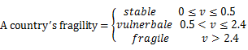 （3）

2.4 Climate Impacts
- Direct impacts of climate change
Climate change is mainly reflected in rainfall, temperature difference, and the number of natural disasters per year. These will directly affect the risk factors, that is. increased pressure. If the internal ecosystem (the risk body) cannot adapt to the external environment, that is, the elastic force is not big enough in the climate subsystem, the country will fall into partial fragility..
- Indirect impacts of climate change
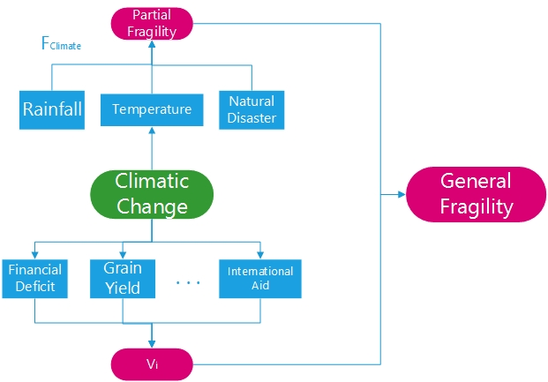
Nothing is an isolated existence. There is no exception. The development of the country is a dynamic process, so the climate change will surely influence other subsystems, such as the effect of on ,the influence of climate subsystem on non - climate influence of subsystem. For example, climate change will have an impact on agricultural production in agricultural countries (developing countries), in which case ,it negatively affects the economic system. The deterioration of climate can also lead to population movements, disease outbreaks and other problems, so that the financial expenditure, international assistance and other factors will increase inevitably. If it can’t be fixed well, partial fragility can be bound to cause general fragility. The impact of climate change is shown in figure 2 below:
Fig.2 The impact of climate change

3 Task2

3.1 City Selection and Data Description
- Data sources
Chad has been chosen as our force. In the last 10 years Chad is always in the top 10 (6th in 2015, descending order). We need to collect about 26 kinds of data of the indicators. Collect a lot of websites for statistical data, most of which are from world bank.
- Weight determination
Accounting for the different national conditions(the degree of fragility) as well as the direct or indirect climate effects on the nation, different weights should be given according to different countries. The assignment of different weights is to distinguish the influence of different subsystems on the state. For the stable or vulnerable states, partical fragility does not cause general fragility. For the fragile states, any change in indicators could lead to the collapse of the whole country.
Table 5 Weights depending on type
type | Climate | Economic | Society | Political | Coordination
fragile | 0.2 | 0.25 | 0.2 | 0.25 | 0.1
stable /vulnerable | 0.1 | 0.3 | 0.2 | 0.3 | 0.1
- Data processing
Among these indicators, some of data are incomplete, while others are far less sufficient to meet our needs. Meanwhile, it is found that there is a different dimension of data. The data of different dimensions are standardized, and the missing data are interpolated or filled subjectively.

3.2 Path Analysis of Climate Impact
Based on the above analysis, we collect data about chad. Calculate the fragile value of the five subsystems and the total fragility of the country in 10 years,
- Correlation Analysis
Sort out the fragile values of the five subsystems. Then, calculate the correlation coefficients between each system. The correlation coefficient is drawn as follows:
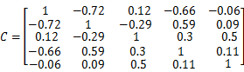
.
In this correlation coefficient matrix, it is found that the climate subsystem is negatively correlated with the economic and political subsystems. From the perspective of correlation coefficient, the climate subsystem is not an independent system. The whole country is affected by each other negative correlation, which may have the lag effect.
- Path Analysis
In order to analyze how the climate affects the vulnerability of the state, we have mapped the subsystem distribution of Chad in recent years.
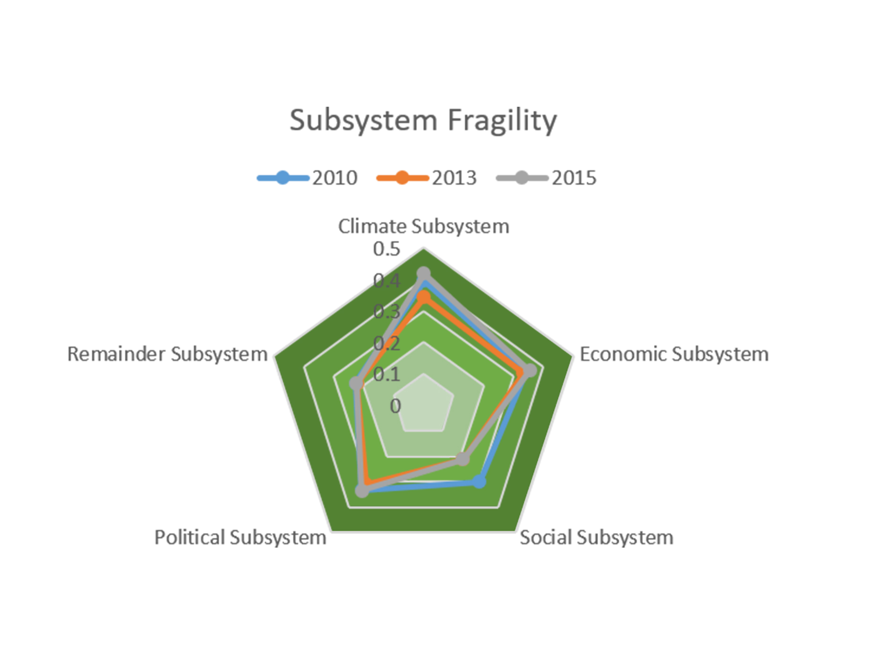
Fig.3 Subsystem’s score of Chad
It can be found that the fragility of political and economic subsystems has not changed significantly, but the fragility of climate and social subsystems has fluctuated significantly. In this regard, chances are that the overall macro-environment of Chad was not improved timely. At this time, the deterioration of the climate exacerbates the fear among the country. In the social subsystem, its index has a close relationship with economical and coordination subsystem.
Map the score of five subsystem and total fragility in the last10 years, As showed in figure4：
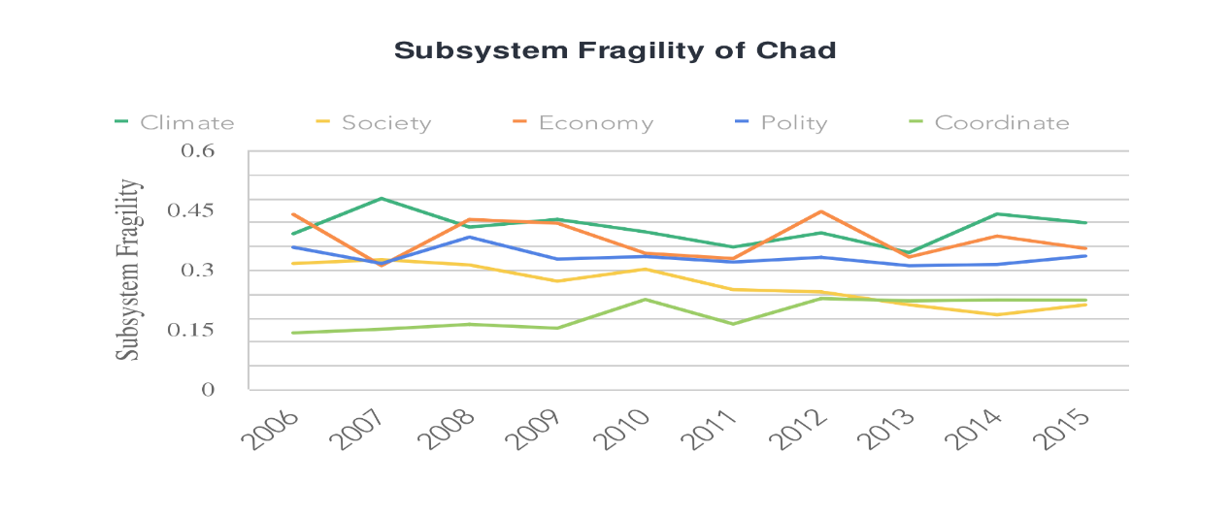
Fig.4 Fragility of subsystem -- chad
We can see in the picture above:
 The score gap between climate subsystem and social subsystem enlarges in the recent five years, and the annual change trend is reversed.
 The curve which stands for the climate fragility is at the top of the image. Apparently, climate may be a catalyst to state fragility.

The final path: climate change will immediately worsen the climate subsystem, resulting in reduced fragility. In the short term, due to the high correlation between the climate subsystem and the economic subsystem, the climate will affect the economy. In the medium to long term, there is a lag in the impact of climate .If the economy cannot adjust in time, it will drive the deterioration of the social system. So, if not properly handled, a vicious circle will happen.

3.3 Modification of the model
After consulting the literature, it’s reported that few researches focus on indicators in regard to climate. As the climate problem becomes more and more serious, it is urgent to solve the climate threat. The failure to consider climate change means missing an important factor, inevitably leading to a decline in state fragility.
In the analysis of countries that are already in a fragile state, we note that fragile states always have a higher score in our model. However, there are some exceptions in some countries ---value of in some subsystem is much bigger than the other systems，while the sum of value or other system value is normal。That is to say, there are still possibility to worsen the system. If other systems can’t fully compensate for the fragility, the overall will collapse. We refer to these countries as the exotic countries.
The exotic countries, if is less than 2.5 but , will also belong to ’fragile‘. We can't find enough data to figure out the except value, but the possible shape of exotic country’s fragile distribution is as follows in figure5:
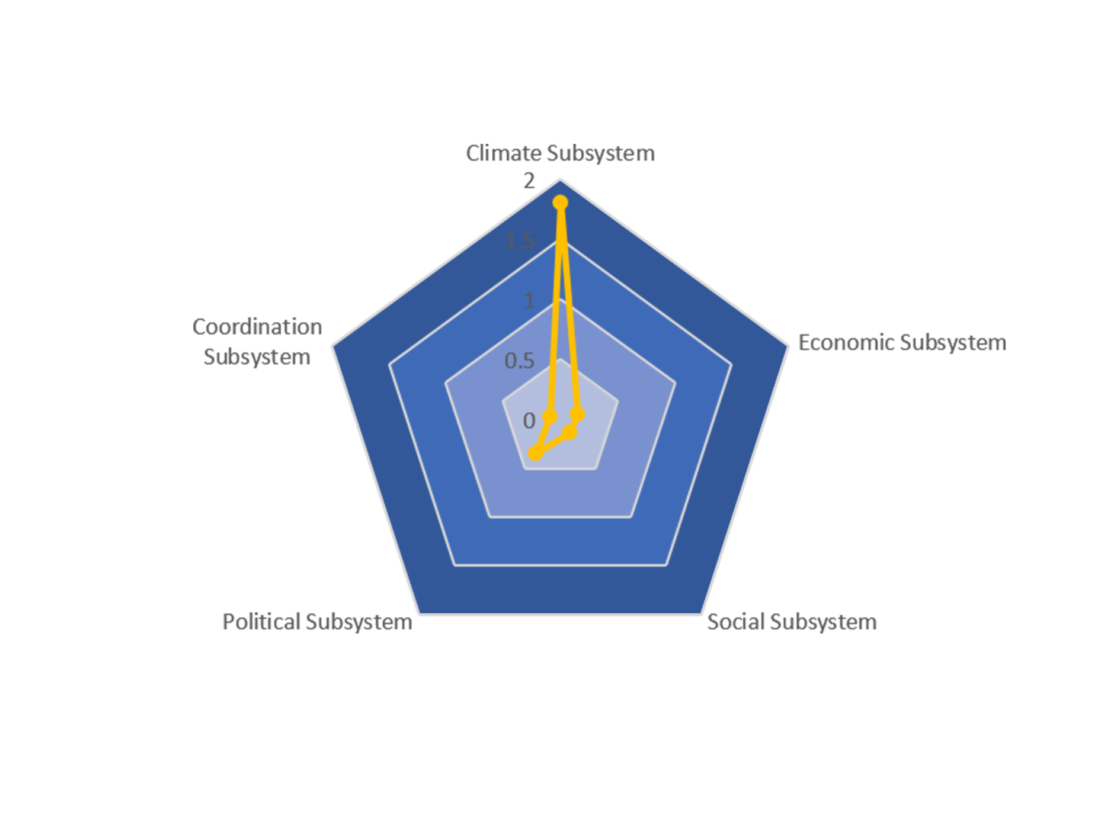
Fig.5 Exotic country’s Possible

4 Task3

4.1 City Selection and Data Processing.
- City selection ：The city not in the top list—Botswana, is selected as our force
The ranking of Botswana is about 120 in the definition of the Fragile State Index[].In the model that we established, the Botswana’s value was about 0.67.。Botswana belongs to the vulnerable station. The fragility distribution of the five systems is showed in figure 6 :
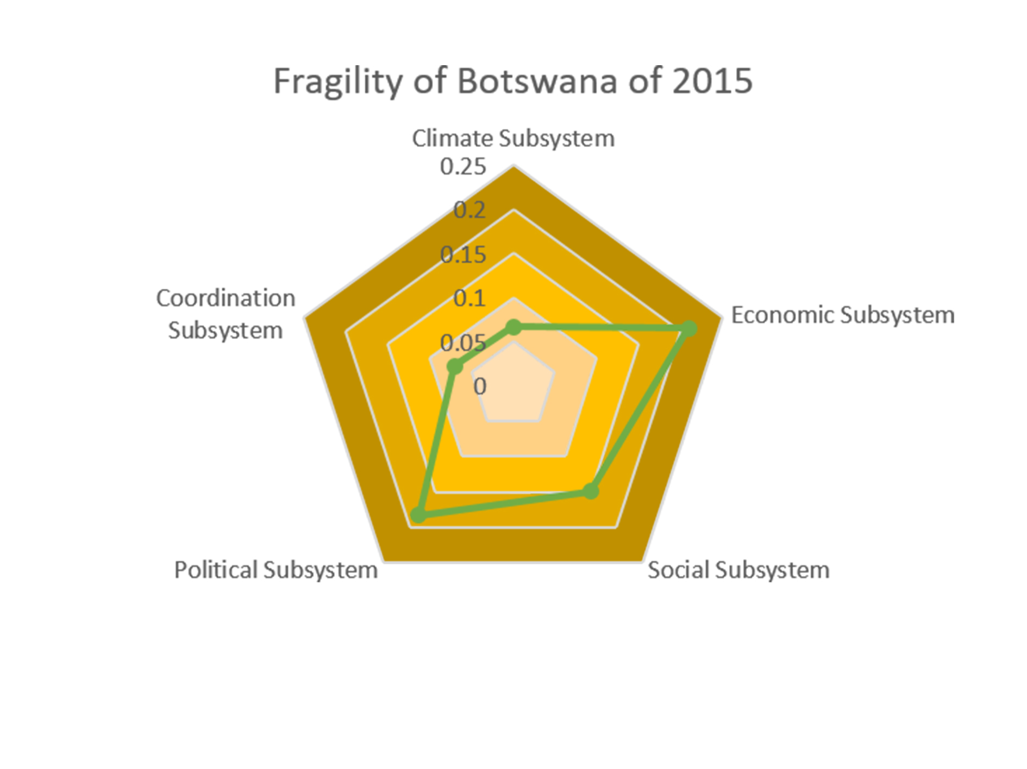
Fig.6 The fragility of the five subsystems (2015)
As can be seen from the figure, the station of the five subsystems is basically stable. In comparison, the station of the economic subsystem is relatively weak and the climate subsystem is in good condition.
From the ranking of the five system scores, it is clear that the current state may need to change economic development and government support. Preliminary concluded that the important indicators affecting state fragility may be in these two subsystems.
- Data processing
We collected data on the indicators for nearly 20 years and plotted the changes over time. After drawing and classifying, we found that 26 indicators can be divided into three types: Steady but downward trend, rising trend and Volatility change
There are seven indicators of steady decline, such as the gini coefficient and net migration. There are nine indicators of rising trend, such as per capita GDP, enrollment rate, population, agricultural proportion, etc. The index of Volatility change includes inflation, precipitation, temperature difference, public health expenditure proportion and so on. Each indicator change over time is shown in figure 7:
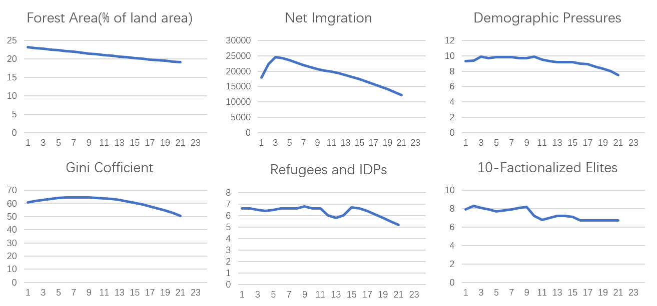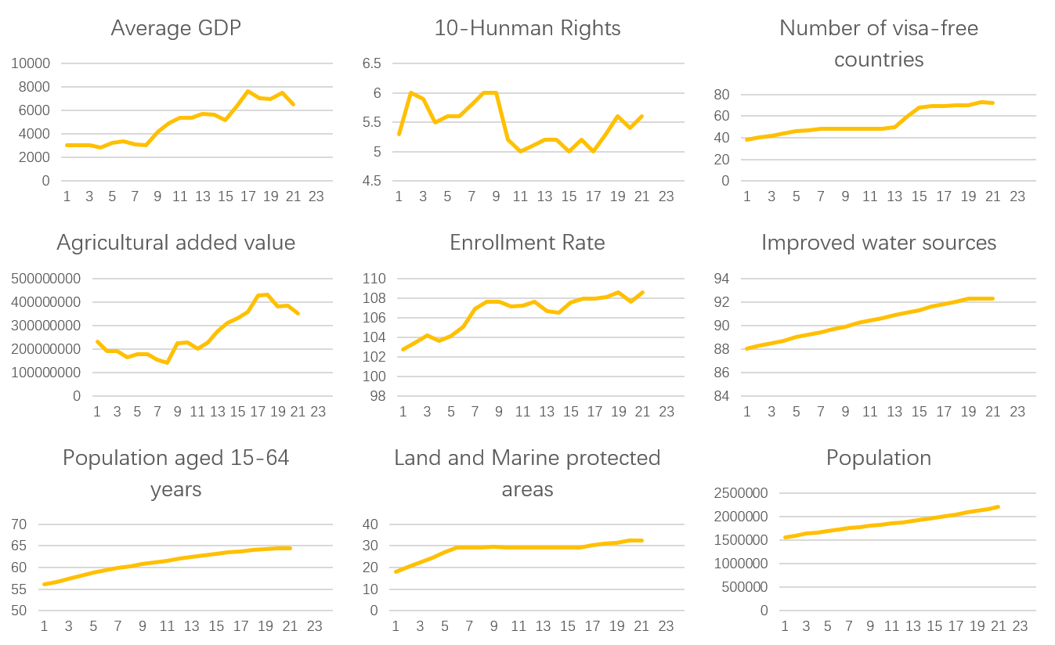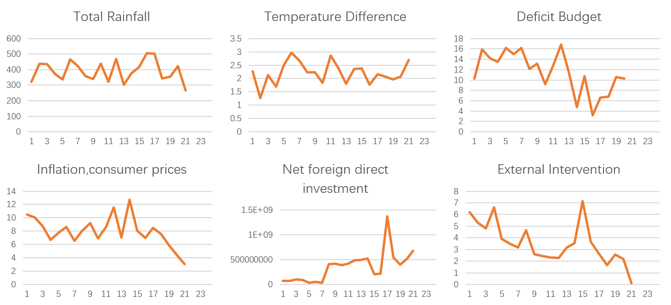
Fig.7 Summary of indicator trend over time

4.2 Identify the possible definitive indicators
To explore the influence of climate and other important indexes, we summarize the possible indicators as well as affect indicator variables: rainfall, rainfall, annual GDP, population.
- Quantitative relationship between climate and other subsystems
We get the regression equation by constantly changing functions, filtering independent variable and adding the lag. Finally we get:
(0.004) (0.057)
(4)
(0.002) (0.002)
Where, in the brackets are P-values. As it shows, each P-value is significantly less than 0.05. At the same time, it indicates high correlation (> 0.7). indicates the last phase of temperature difference.

It is found that the change of temperature and rainfall in normal years is a stable quantity, so that the change of GPD is stable. But in exceptional years, fluctuations in temperature difference and rainfall can have an impact on GDP. Specifically, temperature and rainfall have an impact on national economic development, especially agricultural development. Changes in the economy will inevitably lead to the deterioration of economic and political systems. In the end, it will affect the social subsystems.
- The regression between the indicators
There are three types of indicators. First, use rainfall, temperature difference, annual GDP and population to fit the important indexes of the three types. Second, choose the better regressed indexes, which are also called by us as passive indexes. Finally, Use these passive indicators and the four major indicators to explore the relationship between the remaining indicators
The final relationship of the indexes shows in the table 6:
Table 6 Partial regression equation
regression equation
0.778
0.927
0.999
0.799
0.652
0.712
0.676
0.892
- The climatic impact in the Botswana
The climate subsystem is closely related to rainfall, temperature difference, inflation, and public health expenditure. The relationship between variables is progressive:
Precipitation and temperature affect GDP.
GDP and population together affect agricultural development. The development of agriculture is related to the economic index and enrollment rate.
GDP and population also affect fiscal expenditure, refugee Numbers, GINI coefficient, etc.
The number of refugees, national legitimacy and population pressure is related.
Finally, map the climate impact path in the figure 8:
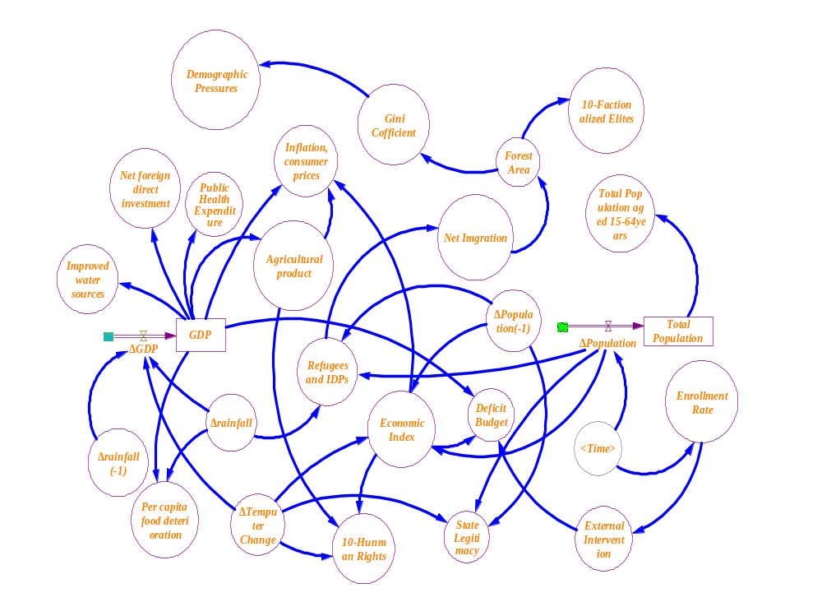
Fig.8 Path Analysis of Climate impact

4.3 A tipping Point
Botswana now belongs to vulnerable station。If it goes into a fragile state, there must be a certain factor or some combination of factors. From the point of view of the system, it may be that the partial fragility causes general fragility, or that several subsystems jointly contribute to fragility of the state.
The vector space that is made up of the indicators, which transform the country from non-fragile to fragile, is called the tipping point. Based on the above analysis, we can get the key factors: population, rainfall and GDP. The corresponding indicators in our model are population pressure, rainfall, and average GDP. So the tipping point is:
=
Among them, the value of b has two values. When the rainfall is too little, the value is .When the rainfall is too much, the value is . Too much and too little both affect state fragility
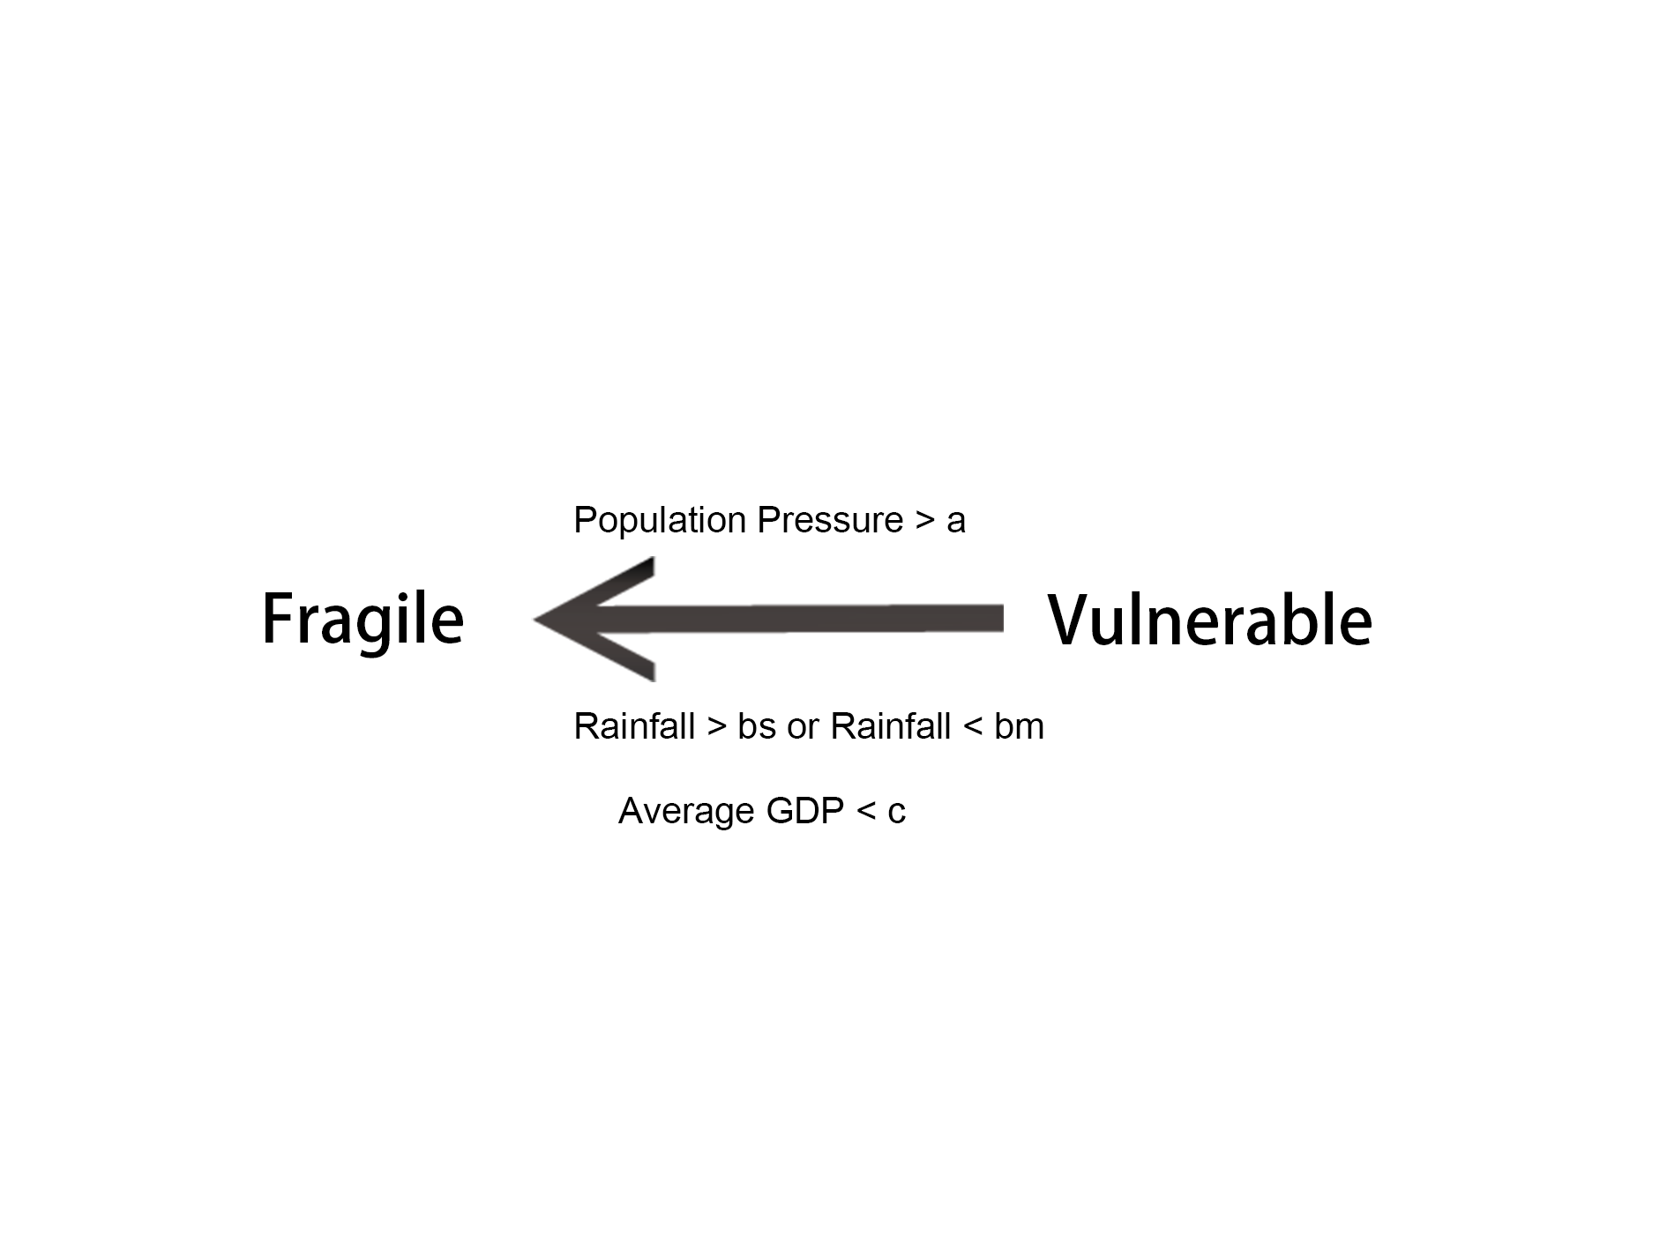
Fig.9 State transition

4.4 Single Entity Simulation
- The theory and Necessary instructions
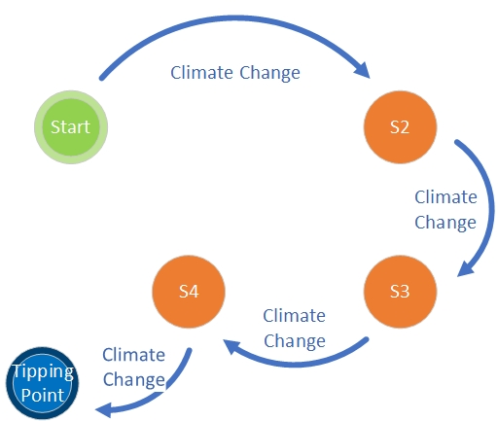
Fig.10 Our arithmetic: A simulation algorithm based on the finite automaton
Definite the five-dimensional vector, which consists of the climate subsystem, the economic subsystem, the social subsystem, the political subsystem and the coordination subsystem, as a first-order state
(5)
Each component (partial vulnerability) in the first-order state can be obtained by the linear addition of indicators. We refer to the higher-dimensional vector consisting of all 26 original indicators as a secondary state.
(6)
Consider the influence of climate factors on the system vulnerability. Through analyzing a large amount of historical data, gradually build a secondary state construction system which makes climate indexes (mainly for the difference in temperature, precipitation, a natural disaster probability) as the main basis
Establish basic index prediction model, and choose one year is the unit time .Continue Super real-time simulation until the system reaches a critical conditions, when the simulation ends, it’s easy to obtain the critical time node and the key indicators.
In fact, the simulation process can be modeled by finite automata theory. The state vector iteration corresponds to a state transition. The initial state corresponds to the initial node. The critical state corresponds to the termination node. The change of climate index causes the transition of state nodes.
- "deteriorate" processing
In this experiment, we need to focus on selecting Critical indicators (these increase fragility to the system)and a tipping point of system simulation. Therefore, we need intentionally to aggravate some key indicators in the simulation system. Properly control the change direction of system fragility in order to obtain effective simulation results. With the simulation progresses, every once in a while, dynamically reduce the slope of the population fitting line and slow population growth, considering the s-shaped curve model of population growth.
(7)
- The simulation process
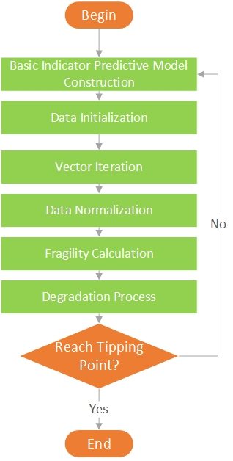
- Data initialization
the starting year of simulation:1997
Population base: 1604060.
Total GDP: 4847752843.
Precipitation change: 114.6941.
Change in temperature: 0.8675
- Prediction of key indicators.
The Prediction of population use the regression equation.
The prediction of rainfall and temperature difference builds probability distribution function using periodic and historical data.
- According to the critical point definition, determine if it is more than 2.5, exit. Otherwise, enter the next iteration.
- Repeat simulation, note critical time interval and critical index value
Fig.11 The simulation process
- Result
In this experiment, a total of 1509 valid simulations were performed. A critical time node can be obtained at the end of each valid simulation. After processing and analyzing the data, we found that there are 1284 time nodes located between 2075~2100.As shown in the figure, 85.1% of the points are between 2075 and 2100
: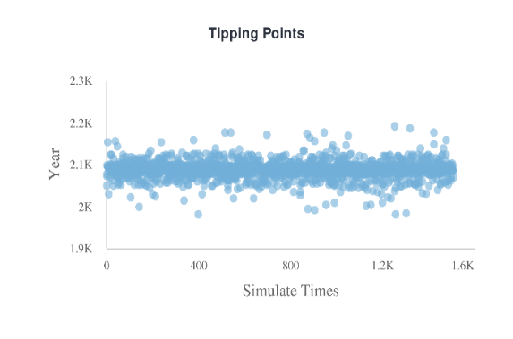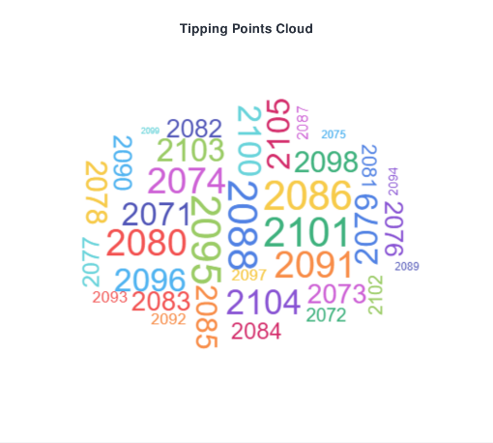
Fig.12 Prediction
Regardless of singular states, we can generally agree that the critical time nodes are between 2075 and 2100.The key indicators are population pressure, precipitation and per capita GDP. And by averaging all the data of the effective simulation, It can be approximated that the critical value is obtained.
The tipping point is:
The first is that there is too much precipitation. The second is less rainfall. The precipitation unit is millimeters. The unit of GDP is the dollar.
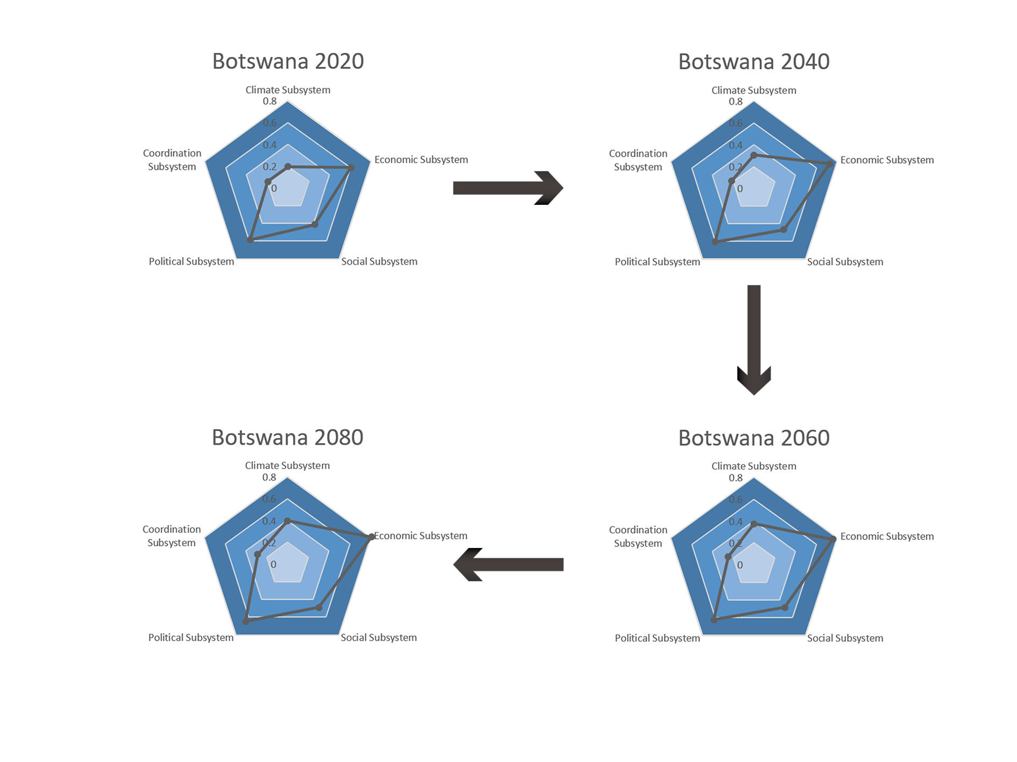
Fig.13 State of the simulation over the time

5 Task 4

5.1 Intervention Analysis
- The point of government intervention：
According to the definition of the fragility formula, in order to reduce the country's fragility, the intervention measures adopted by the state are mainly about three aspects: ①Reduce pressure,
②Increase elasticity, ③ reduce sensitivity.

Sensitivity refers to the interaction among these subsystems.
Most directly, we can see that different types of countries have different weights. From the task 2, it can be seen that the correlation among the five subsystems will also be different , due to internal development. Our model itself analyzes country's fragility from five subsystems. This provides the direction for policy intervention.
Table 7 Subsystem’s score of Botswana
General | Climate | Economic | Social | Political | Coordination
0.678 | 0.067 | 0.209 | 0.149 | 0.1822 | 0.070
Economic, political, and social scores were found to be high in 2015.The current situation is not fragile, but if we want to achieve sustainable development, we should make the three aspects of fragility fall. In the third question, we know that the critical factors are rainfall, population density and average GDP. But the three indicators are not directly controlled by the government. The average GDP is related to national development. Population density is related to the social environment. So we introduce the national interventions as follows:
 build an ecological-protecting system to increase the area of forest and land reserves.
 Build infrastructure, increase net official aid, and public health spending.
● strengthen friendly cooperation with other countries and attract foreign investment.
❍ improve the welfare policies of the people, narrow the gap between the rich and the poor, raise education levels, and improve the cleanliness of water sources.
 Encourage the development of secondary and tertiary industries , reduce the percentage of agriculture as a percentage of GDP.
The first two measures improve people's lives and ultimately affect population density. The latter three directly affect the country's economic development. At the same time, through the influence path, the interaction of the subsystem is utilized to realize the optimization of the whole country.

5.2 Bi-targets Cost Model
- Targets
Government intervention requires efficiency. In the third question, the simulation shows that if the environment deteriorates, or other conditions worsen, it will arrive at the fragile station in 2075~2085.Clearly, no one wants a fragile state. At the same time, considering the time lag of policy, it is not a short time to reverse the situation. So we hope that if we implement our policies, the fragility of countries will be reduced by 2050.We also propose a second goal. If we can achieve the cost minimization, we also want to achieve faster, that is, the rate of growth is more likely to be greater.
- Cost quantification
To better quantify the cost of policy intervention and to measure the effectiveness of policy interventions, we quantify these objectives. Using the regression equation and related literatures, the quantitative equation of government intervention measures is written:
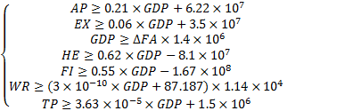(8)
- the objective function
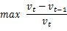
(9)
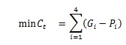
(10)
The lower target (9)we choose the key indexes, mainly affected by rainfall, population density and average GDP. They are agricultural output, infrastructure spending, public health spending, water value. The government cost is calculated by the minimum difference between the policy target (2050) and the simulation prediction (2050). The implication is obvious: the minimum amount of input needed to achieve a goal.
The upper goal (10) is to achieve goals faster.
- Solve the cost
In general, three key indicators should be adjusted to change the country's vulnerability. But because the three indicators cannot be changed directly, five interventions can be found. Better to describe the degree of realization of these indicators, there are four factors that are most affected by these factors. These factors can be characterized by money. Finally, the final cost is calculated by using two target models.
Table 8 Total government intervention costs
Notations | Cost($)
Agricultural output, | 59.7~81.3
Infrastructure spending, | 112.6~139.6
Public health spending, | 96.5~121.2
Water resource value | 200.3~364.8
total | 469.1~706.9
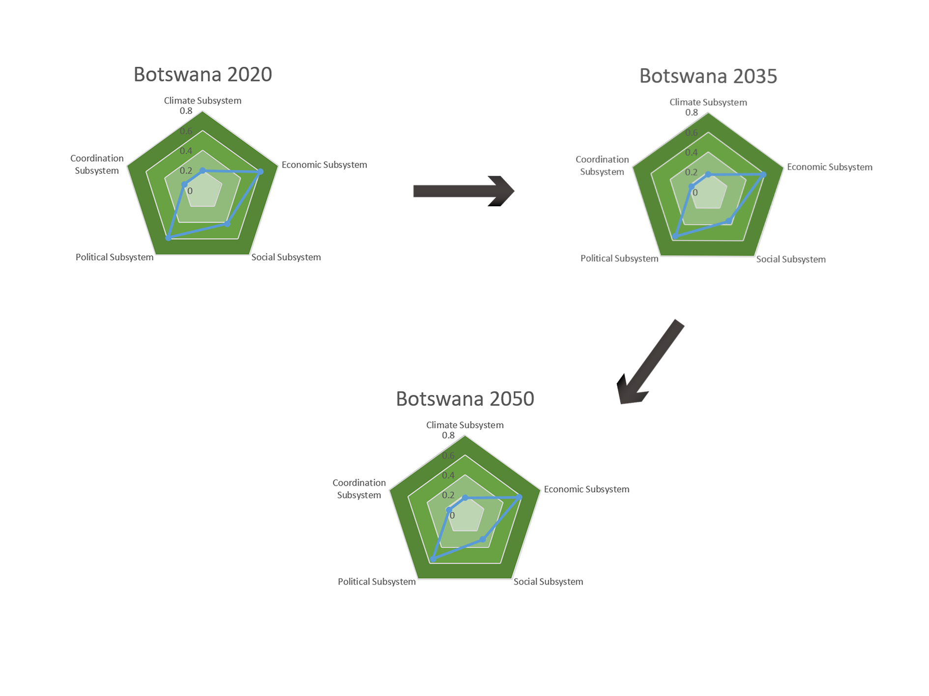
Fig.14 State of the simulation over the time

6 Task 5
We can divide the country or region into three categories:
smaller 'state', Moderate 'state' and larger 'state'.
The classification is based on the area of the region. Our model is based on Moderate 'state' for fragility. It is obvious that our model is suitable for Moderate 'state' like medium countries or regions. For smaller 'state' and larger 'state', the robustness of our model is likely to be affected.
- smaller ‘state’： In model, we have not considered the interaction between countries. The process of fragility change, which caused by the interplay among countries, is called “fragility shift”. The country's negative impact will bring to its neighbor, and the development of its neighbor will radiate to its own country. In smaller Spaces, the climate affects far more than the country, and is bound to have an impact on other countries as well. There is a chain reaction among countries. Similarly, Indicators effect, including political fluctuations, economic downturns, population movements and international trade ,transfers between countries. To solve this problem in the future, we can adopt multi-entity simulation. Construct the relationship between country and country, region and region to modify model.

- larger ‘state’: For the larger area, for example, Russia is the largest country in the world, located in the north of Eurasia, with a land area of 17075,400 square kilometers. It's 9,000 kilometers long, across 11 time zones. The width of the north and south is 4,000 kilometers across four climatic zones. Within a country, the climate is different. At the same time, the economic development level of the east and west or the north and south are not consistent. Within the country, it is difficult to unify. For this reason, we can divide the larger region or country according to the climate, economy and other conditions. The regional fragility is calculated separately. Finally, total fragility is determined by weight.

7 Strengths and Weakness
Strengths
- A classical mechanical model based on the interaction between pressure and elasticity is creatively introduced to depict the national vulnerability, which clearly expresses the influencing factors of a country's fragility.
- The system is divided into five parts-- climate, social, political, economic and coordination, respectively to describe the different dimensions of fragility, and the five dimensional radar map is used to visualize the fragility.
- When considering the relationship between indicators, it is found that some indexes have a lag effect on other indexes, making the simulation results more accurate.
- The complex system evolution is abstracted into a finite automaton state transition process, corresponding to the program --the state vector's iterative process. Simplify the complexity and describe the evolution of the system efficiently.
- The forecast considers not only the government's minimum cost, but also about making the country easy to leave the tipping point.
Weakness
- In the process of simulation, not fully consider the indicators that may be affected by the neighboring countries and global atmospheric movement.
- There is a partial absence of data in the countries we choose. The missing data is obtained by interpolation, estimation and other methods, which has certain inaccuracy.

8. References
[1] Ofipcc W G I. Climate Change 2013: The Physical Science Basis.[J]. Contribution of Working, 2013, 43(22):866-871.
[2]Reinman S L. Intergovernmental Panel on Climate Change (IPCC)[J]. Encyclopedia of Energy Natural Resource & Environmental Economics, 2013, 26(2):48-56.
[3]Climate O N. Intergovernmental panel on climate change[J]. Environmental Science & Pollution Research, 1996, 3(1):52-57.
[4]Yohe G. A globally coherent fingerprint of climate change impacts across natural systems.[J]. Nature, 2003, 421(6918):37-42.
[5]Yohe G. A globally coherent fingerprint of climate change impacts across natural systems.[J]. Nature, 2003, 421(6918):37-42.
[6]Lofts K. Mainstreaming climate resilience into goverment: The Philippines’ Climate Change Act[J]. Climate & Development Knowledge Network, 2012.
[7]Oyekale A S, Adesanya Y A. Climate change and urban children's health: A case study of Ibadan south west local goverment, Nigeria[J]. Life Science Journal, 2012, 9(3):894-899.
[8]Bulkeley H, Kern K. Local Government and the Governing of Climate Change in Germany and the UK[J]. Urban Studies, 2006, 43(12):2237-2259.
[9]Bank W. Social Resilience and State Fragility in Haiti[J]. World Bank Publications, 2010(10).
[10]David Carment, Yiagadeesen Samy, Stewart Prest. State Fragility and Implications for Aid Allocation: An Empirical Analysis[J]. Conflict Management & Peace Science, 2008, 25(4):349-373.
[11]Marshall M G, Cole B R. Global Report on Conflict, Governance and State Fragility 2008[J]. Foreign Policy Bulletin, 2008, 18(1):3-21.
[12]Hannan U, Besada H. Dimensions of state fragility: A review of the Social Science literature[J]. Centre for International Governance Innovation, 2007.
[13]Cilliers J, Sisk T D. Assessing Long-Term State Fragility in Africa: Prospects for 26 'More Fragile' Countries[J]. Social Science Electronic Publishing, 2013.
[14]Tonwe D A, Eke S J. State fragility and violent uprisings in Nigeria[J]. African Security Review, 2013, 22(4):232-243.
[15]Grävingholt J, Ziaja S, Kreibaum M. Disaggregating state fragility: a method to establish a multidimensional empirical typology[J]. Social Science Electronic Publishing, 2015, 36(7).

9 Appendix
Notations | Explanation

