**Key Exchange Client UI App Menu**

**Version_0.1**

**02/01/2021**

**Prepared by Dr.XuJia, Dr.YiWen Gao, Yeo Shi Jing, LiuYuancheng**

Key Exchange Client App is an Android App which is used to package Dr.YiWen’s Quantum key exchange program into a JNI function to save the exchanged server’s key-pair into the phone local DownLoad folder. This menu contents two main sections:

Section 1: Project Development Setup - This section will show how to setup the development environment on your computer and build the project.

Section 2: App Setup and Usage - This section will show how to install & setup the App in your android phone and test whether it can work normally.

**Section 1: Project Development Setup**

This section will show the detail setup steps If you want to do any change of the Key Exchange Client App source and rebuild the project. The Key Exchange Client can be built under Linux / Windows system. The whole process needs about 0.76 GB diskspace, it will be better if your Computer has more than 5GB free space.

1. Install and setup Android Studio and install Cmake and NDK with the below version:

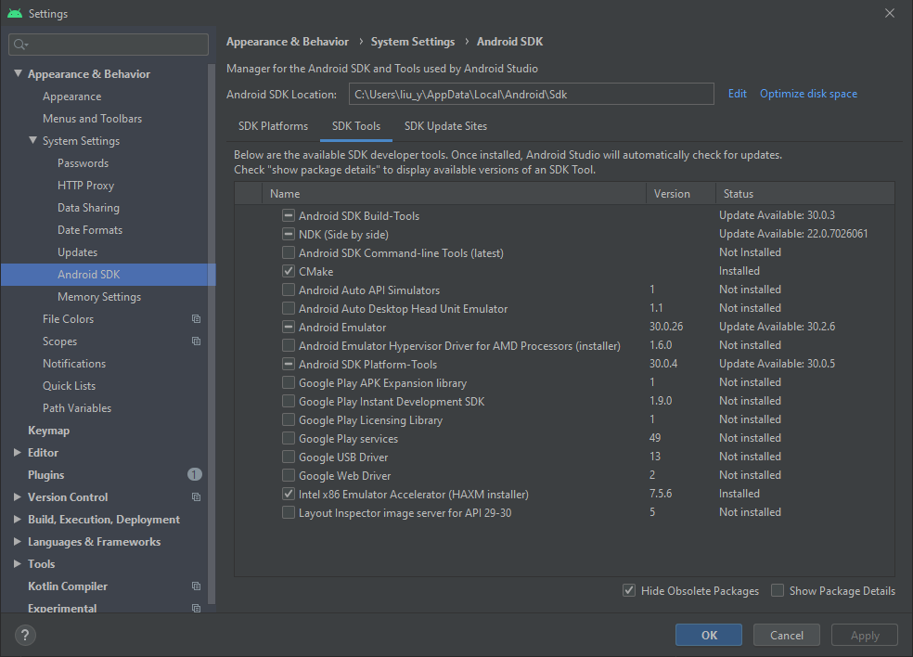

2. Rebuild the Key Exchange Client App:

Clone the source file from QS_WGVPN Github repository from folder:

repository=> QS_WGVPN\WireGuard_Client\KeyExchangeApp

Open the project with Android Studio, select “Sync Project with Gradle Files” and with the in the “File” dropdown menu

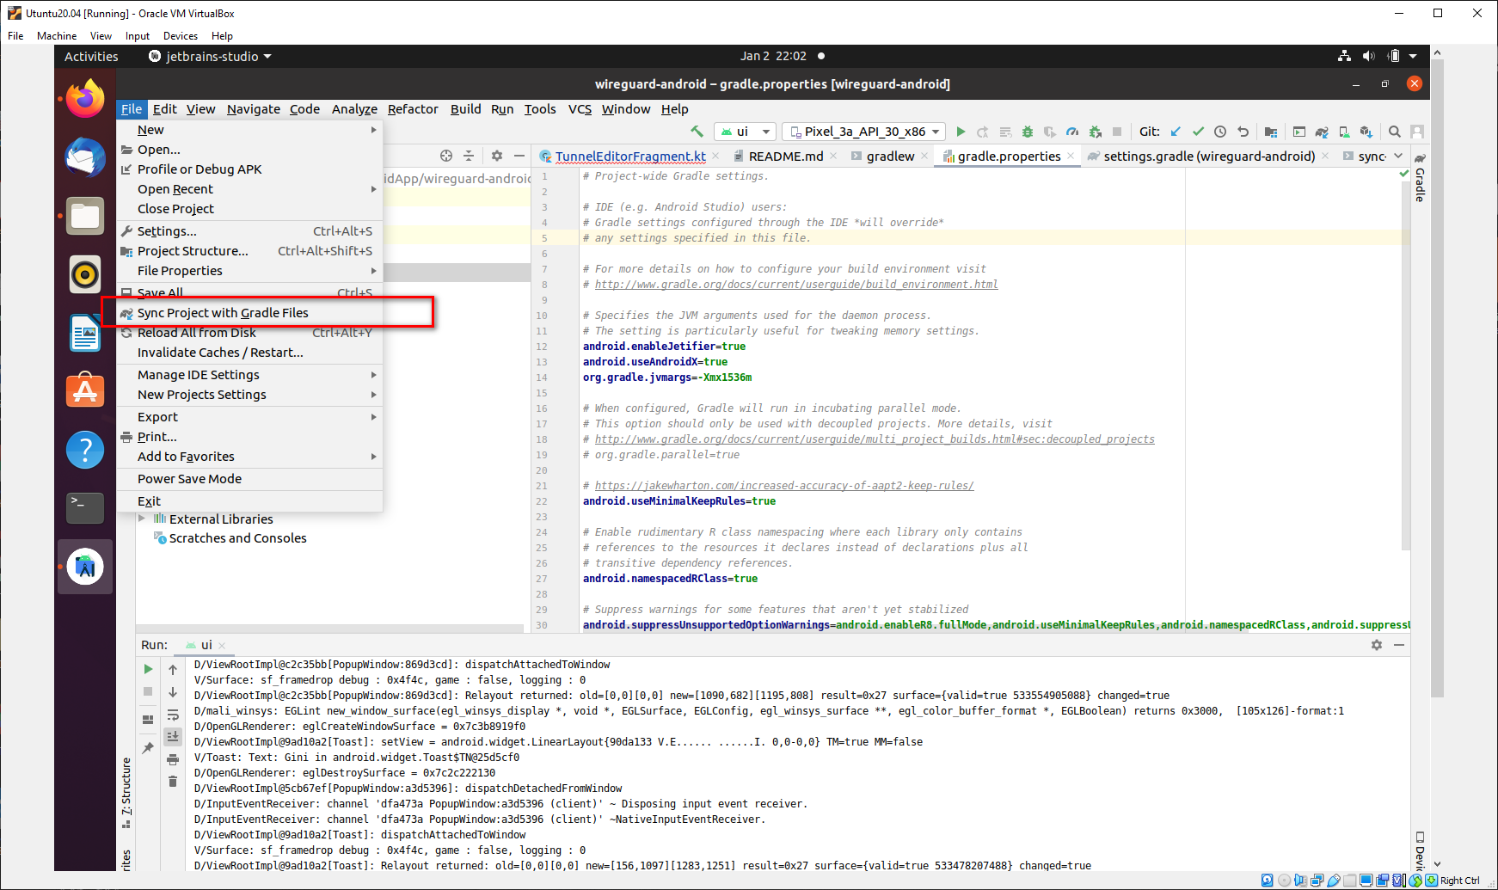

When the synchronization finished. Select “Build-> Rebuild project” to build and check whether got any errors. Select “Build > Build Bundles/APKs > build APK” to generate the apk file. Then Copy the APK file out from folder ui/build/outputs/apk/debug

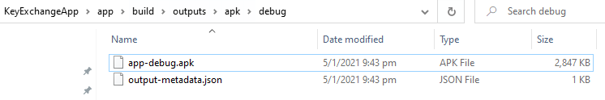

**Section 2: Setup the Key Exchange UI on Android Phone**

In this section we install the App to your Android phone and test whether it can work normally.

1.Install the APK file created in the previous section and copy the Peer IP Config Table file [IPTable.cfg] the Peer Key information file [gw_cli_xxx.cfg] and the whole “Keyfiles” folder (From YIwen’s KeyManagement project in generic_service\KeyFiles folder) in the android phone’s “Download” folder. The App’s name will be “Key Exchange App”:

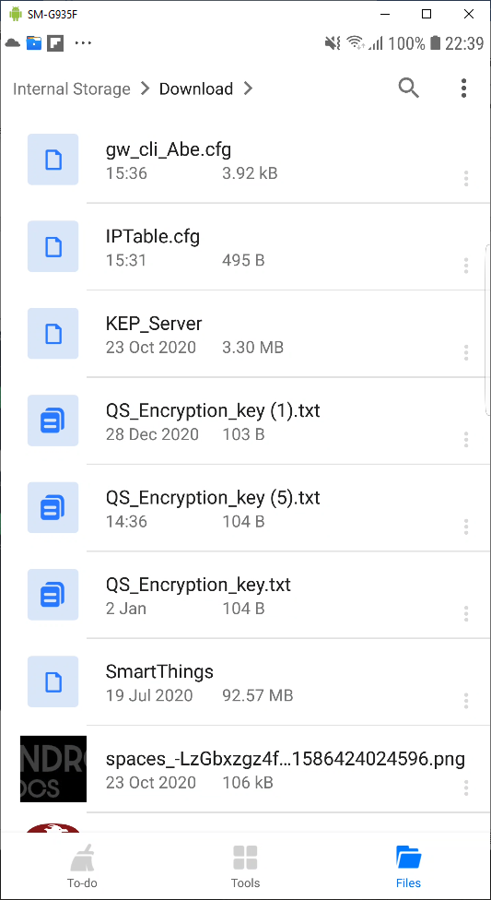-------------------🡪 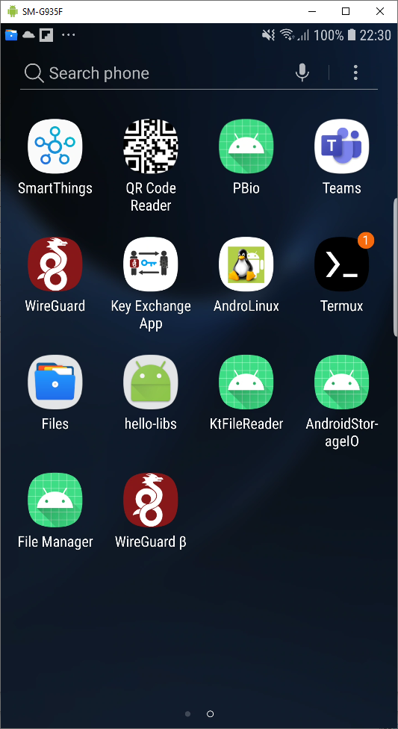

2. In the Android phone SETTING > APPS > CmkCppApp > Permissions > enable the internal storage access permission:

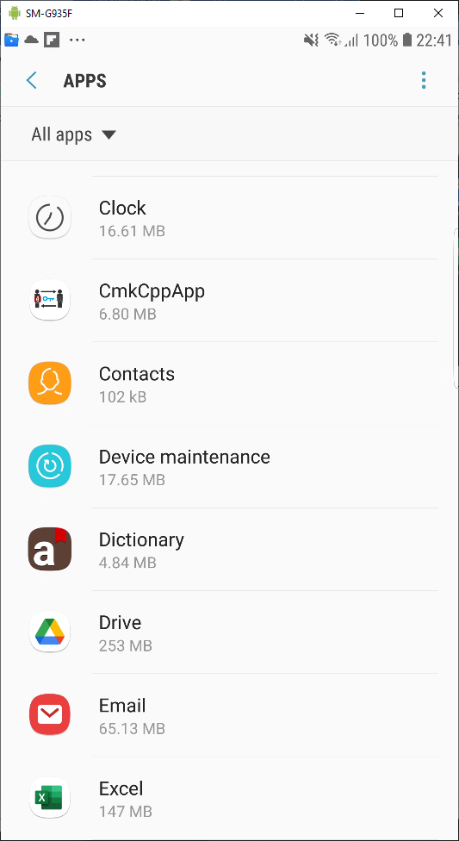-------------------🡪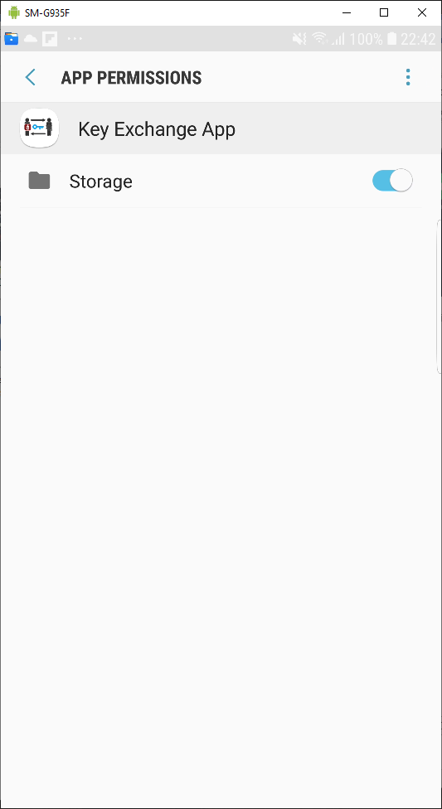

3. Run the App and test load the config file: press the “Load IP CONFIG” button when the progress bar get to the end and a message will pop up and show the IP config table.

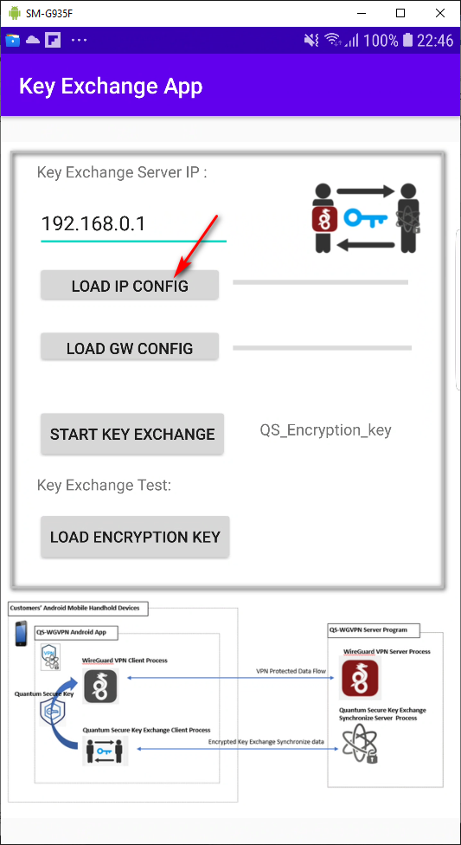-------------------🡪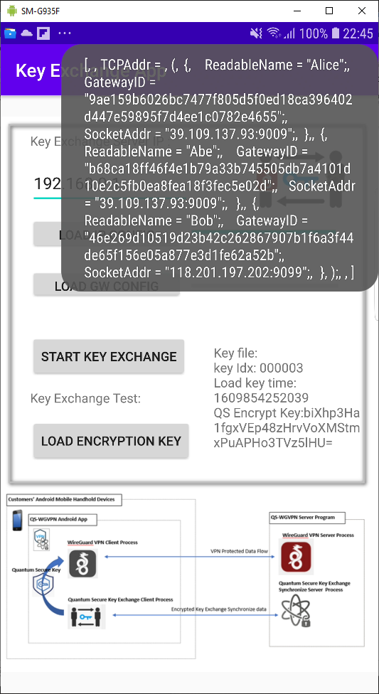

Press the “Load GW CONFIG” button during the time period when the progress bar getting to the end and every time a new file is load message will pop up to show config file’s name.

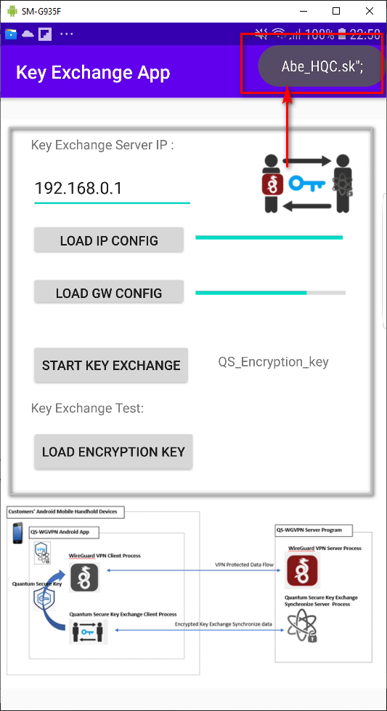-------------------🡪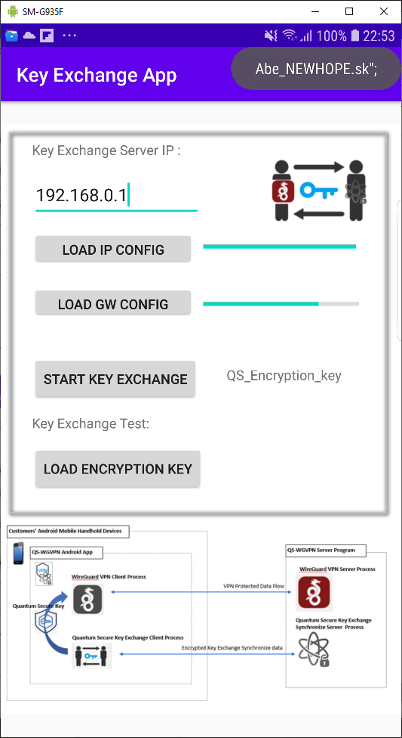

3.Test key file save and load:

Press the start the “Start key Exchange” Button and the key file save page will pop up, after save the key the message “Create key file QS_Encryption_key successfully” will show in the log text field.

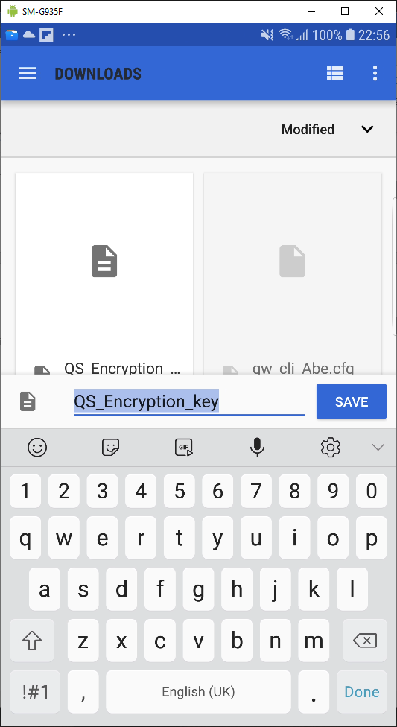-------------------🡪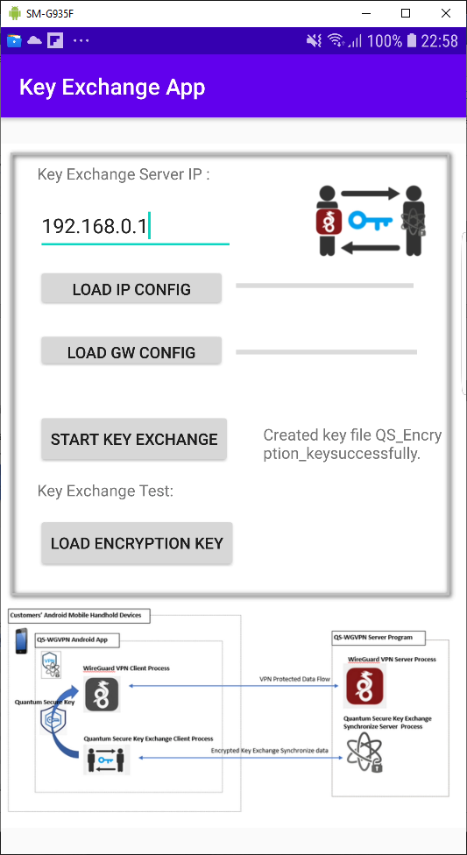

Press the “Load Encryption Key” button and the saved encryption key file data will be shown in the Log Text field. The go to WireGuard-β App to check whether can load the key.

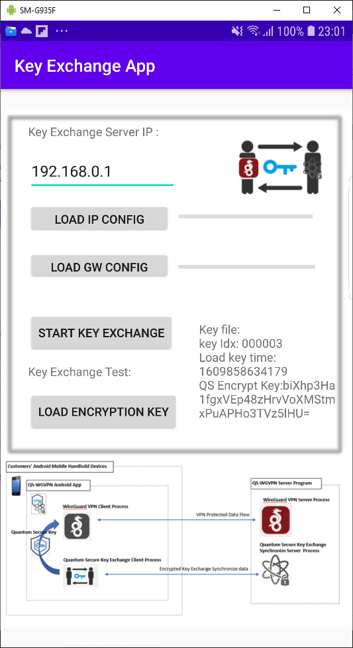-------------------🡪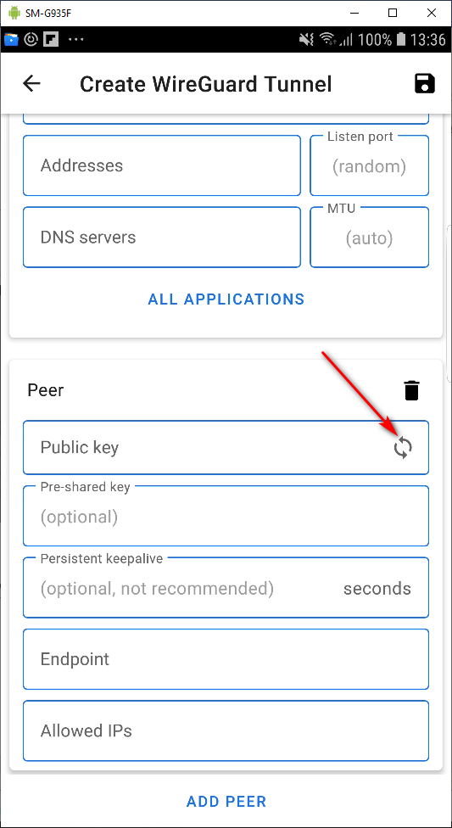

During running the project, you can also check the entire config file data in the Android Studio “Run” terminal by searching tag “>>”

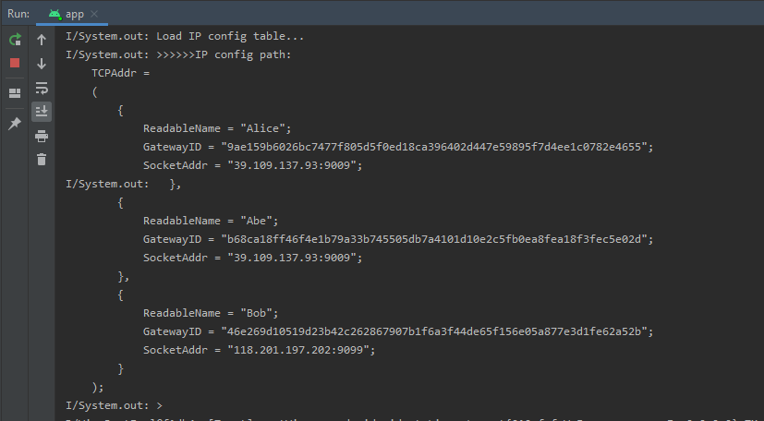

END<last edited 05/01/2021>