**WireGuard Quantum Safe Client Menu**

**Version_0.1**

**29/12/2020**

**Prepared by: Dr.XuJia, Dr.YiWen Gao, Yeo Shi Jing, LiuYuancheng**

WireGuard Quantum Safe Client is an Android App which is integrated the quantum safe message encryption key in the wireGuard VPN App. This menu contents two main section:

Section 1: Project Development Setup - This section will show how to setup the development environment on your computer and build the project.

Section 2: App Setup and Usage - This section will show how to install & setup the App in your android phone and test whether it is working normally.

**Section 1: Project Development Setup**

This section will show the detail setup steps If you want to do any change of WireGuard_android_QS client source and rebuild the project/App. The WireGuard_Android_QS Client can only be built under Linux system which same as the official WireGuard_VPN App. In this document I am using Ubuntu 20.04. The whole process needs about 8.6 GB diskspace, it will be better if your Computer have more than 20GB free space.

1. Install and Setup Android Studio:

Follow the below link to setup JDK, JVM and Android Studio on your Ubuntu 20.04:

> <https://linuxhint.com/install_android_studio_ubuntu>

After finish all the installation, in the Android Studio SDK setup page ( File > Setting > System Setting > Android SDK ) install Cmake and NDK 21.0.611369. This part needs about 6.8GB disk Space.

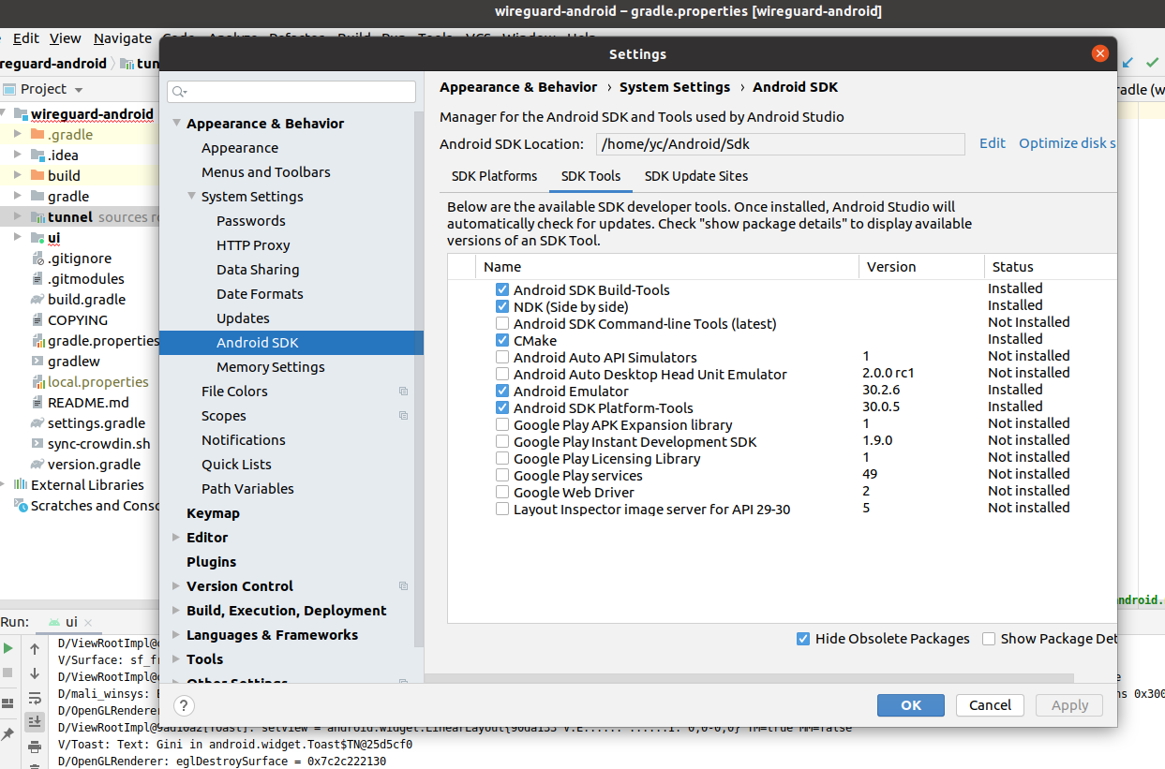

* The detail steps to setup NDK: <https://developer.and9roid.com/studio/projects/install-ndk>

2. Install WireGuard_VPN Project Offical Toolchain:

Follow the below link to download the cross-platform userspace tools to configure WireGuard implementations. Make sure the wg(8) and wg-quick(8) are both installed.

> <https://git.zx2c4.com/wireguard-tools/about/>

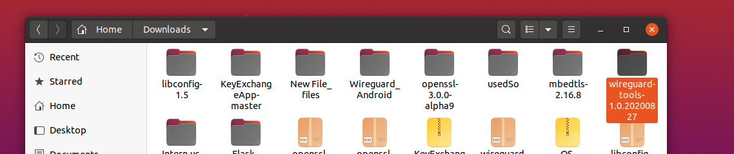

> In current project we are using toolchain version 1.0.2020827 which release on Aug 2020.

3. Rebuild the WireGuard-QS project:

Download the project from the Link and un-zip it to a folder (will use about 560MB diskspace):

> <https://drive.google.com/file/d/1L4y-DTcFeKEvPjvRtTLejXGaaKCPQt3H/view?usp=sharing>

Open the project with Android Studio, select “Sync Project with Gradle Files” and with the in the “File” dropdown menu:

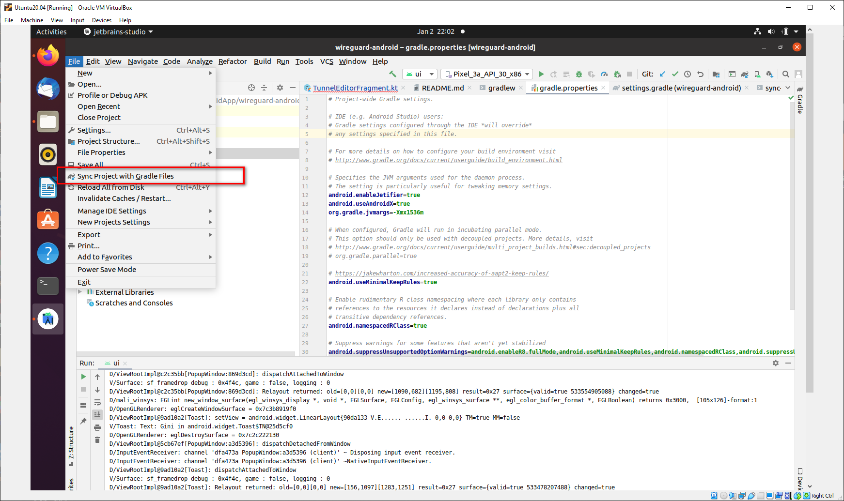

When the synchronization finished. Select “Build-> Rebuild project” to build and check whether got any errors. Select “Build > Build Bundles/APKs > build APK” to generate the apk file. Then Copy the APK file out from folder ui/build/outputs/apk/debug :

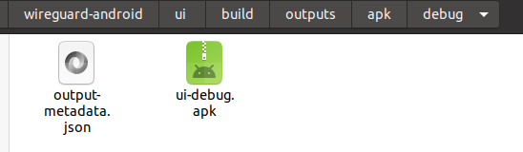

**Section 2: Server Peer Encryption Key Inserting Test**

In this section we install the App to your Android phone and test whether we can insert the key from the key file correctly.

1.Install the APK file created in the previous section and copy the test Encryption Key file in the android phone’s “Download” folder. The App’s name will be “WireGuard-β”

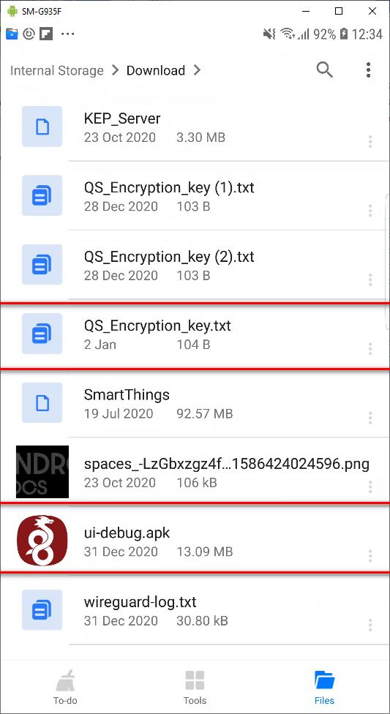 ---------------🡪 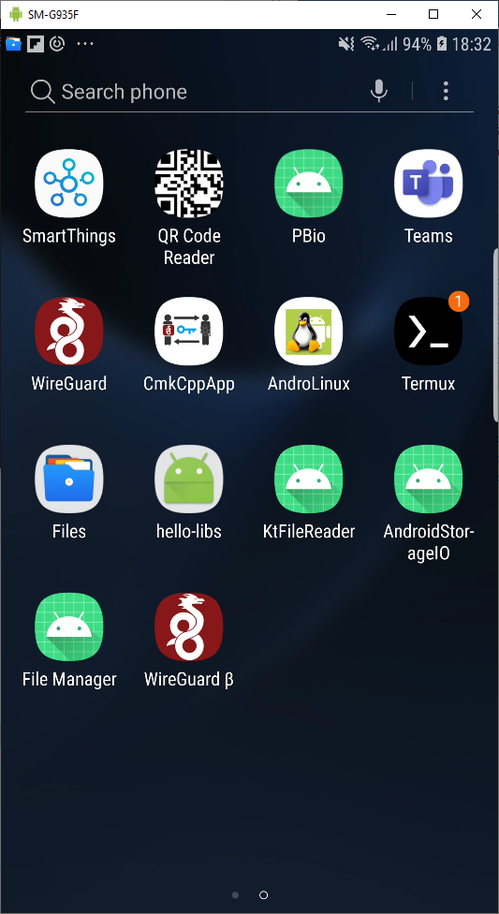

2. In the Android phone SETTING > APPS >WireGuard-β > Permissions > enable the internal storage access permission:

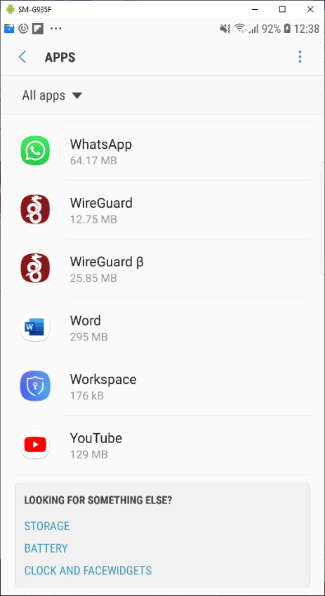--------------------🡪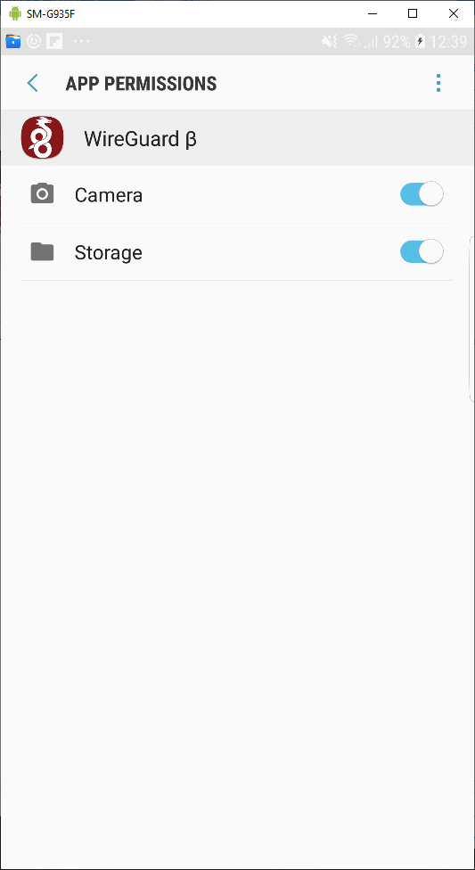

3. Run the WireGuard-β App and click the “+” icon to add an VPN interface:

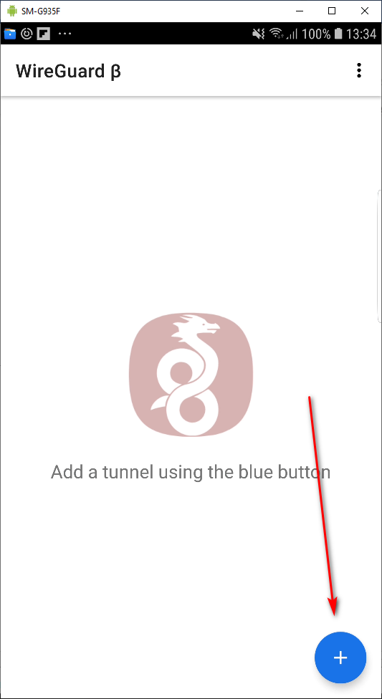 ---------------- ---🡪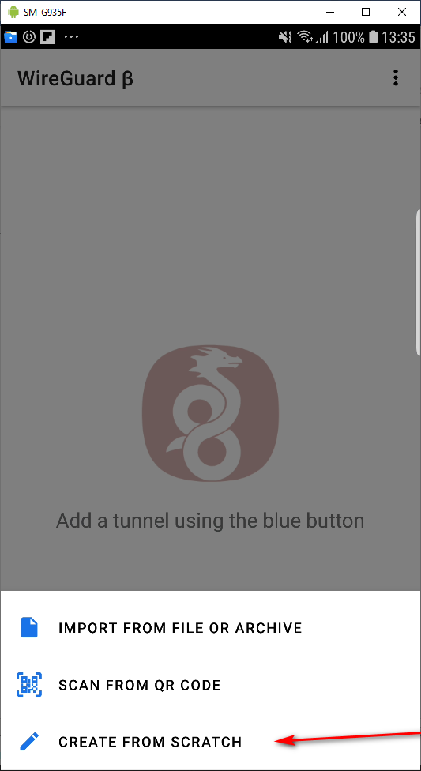

4. Click the “Add Peer” button and the peer detail setup page will show. Press the “Refresh” icon under peer’s “Public key” text field.

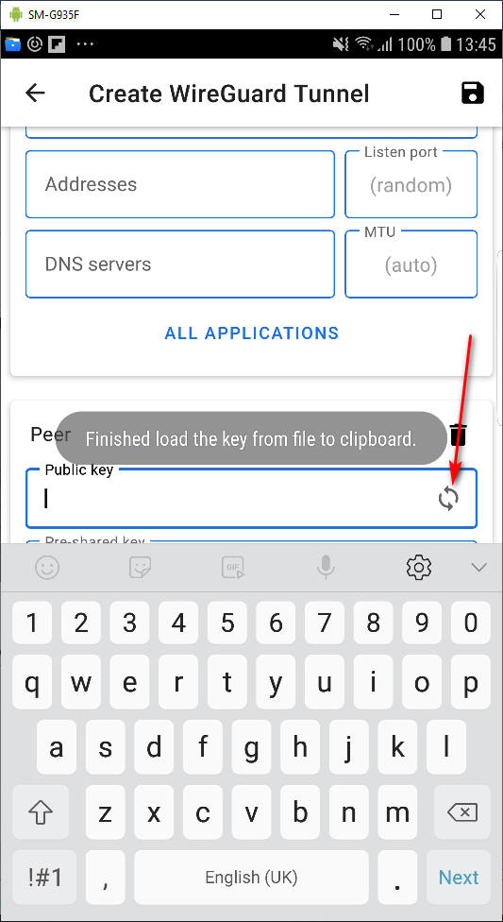> When the message “ Finished load the key from file to clipboard”, which means the program has successfully load the key string from the key file to the Clipboard.

5. Paste the key string to the public key field, then the key load test finished.

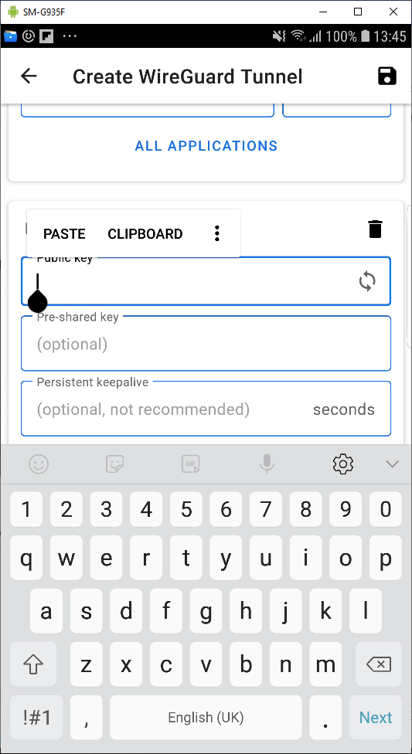--------------------------🡪 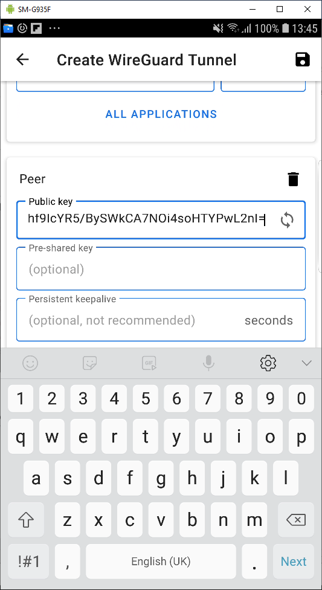

END<last editted 02/01/2021>