Software Requirements Specification

for

Mentor Caring System (MCS)
Version 3.0 approved
Prepared by
Wei Wenxuan | Full
Wu Siyu | Full
Liu Zihao | Full
Wang Yanxi | Full
Zhu Guangshuo | Full
Sun Zhelin | Full
A08
2026.3.28

Table of Contents
1. Introduction 1
1.1 Purpose 1
1.2 Document Conventions 1
1.3 Intended Audience and Reading Suggestions 1
1.4 Project Scope 2
1.5 References 2
2. Overall Description 3
2.1 Product Perspective 3
2.2 Product Features 4
2.3 User Classes and Characteristics 7
2.4 Operating Environment 7
2.5 Design and Implementation Constraints 7
2.6 User Documentation 7
2.7 Assumptions and Dependencies 7
3. System Features 8
3.1 Search Student Information 8
3.1.1 Description and Priority 8
3.1.2 Stimulus/Response Sequences 8
3.1.3 Functional Requirements 8
3.2 Edit Interview Record 8
3.2.1 Description and Priority 8
3.2.2 Stimulus/Response Sequences 8
3.2.3 Functional Requirements 9
3.3 Search Mentor Information 9
3.3.1 Description and Priority 9
3.3.2 Stimulus/Response Sequences 9
3.3.3 Functional Requirements 10
3.4 Import Excel List 10
3.4.1 Description and Priority 10
3.4.2 Stimulus/Response Sequences 10
3.4.3 Functional Requirements 11
3.5 Export Student’s Information 11
3.5.1 Description and Priority 11
3.5.2 Stimulus/Response Sequences 11
3.5.3 Functional Requirements 11
3.6 Change Mentors 11
3.6.1 Description and Priority 11
3.6.2 Stimulus/Response Sequences 11
3.6.3 Functional Requirements 12
3.7 Update Mentor Group 12
3.7.1 Description and Priority 12
3.7.2 Stimulus/Response Sequences 12
3.7.3 Functional Requirements 13
3.8 Designate Coordinators 13
3.8.1 Description and Priority 13
3.8.2 Stimulus/Response Sequences 13
3.8.3 Functional Requirements 14
3.9 View Log Information and Reply to Users’ Questions 14
3.9.1 Description and Priority 14
3.9.2 Stimulus/Response Sequences 14
3.9.3 Functional Requirements 15
3.10 Normal Messages Communication 15
3.10.1 Description and Priority 15
3.10.2 Stimulus/Response Sequences 15
3.10.3 Functional Requirements 16
3.11 Teacher’s Interview Arrangements 16
3.11.1 Description and Priority 16
3.11.2 Stimulus/Response Sequences 16
3.11.3 Functional Requirements 17
3.12 Student’s Interview Arrangements 17
3.12.1 Description and Priority 17
3.12.2 Stimulus/Response Sequences 17
3.12.3 Functional Requirements 17
3.13 Forward Special Cases to MCP Coordinator 17
3.13.1 Description and Priority 17
3.13.2 Stimulus/Response Sequences 18
3.13.3 Functional Requirements 18
3.14 Setting Up Faculty Consultants 18
3.14.1 Description and Priority 18
3.14.2 Stimulus/Response Sequences 18
3.14.3 Functional Requirements 19
3.15 Setting Up Faculties and Departments 19
3.15.1 Description and Priority 19
3.15.2 Stimulus/Response Sequences 19
3.15.3 Functional Requirements 20
3.16 Setting Up Supporting Staff 20
3.16.1 Description and Priority 20
3.16.2 Stimulus/Response Sequences 20
3.16.3 Functional Requirements 20
3.17 Forward 21
3.17.1 Description and Priority 21
3.17.2 Stimulus/Response Sequences 21
3.17.3 Functional Requirements 21
4. External Interface Requirements 21
4.1 User Interfaces 21
4.1.1 Search student information 21
4.1.2 Edit interview record 22
4.1.3 Search mentor information 22
4.1.4 Import excel list 22
4.1.5 Export student’s information 22
4.1.6 Change Mentors 22
4.1.7 Update Mentor Group 23
4.1.8 Designate Coordinators 23
4.1.9 View Log Information and Reply to Users’ Questions 23
4.1.10 Normal messages communication 23
4.1.11 Teacher’s Interview arrangements 23
4.1.12 Student’s Interview arrangements 23
4.1.13 Forward special cases to MCP coordinator 24
4.1.14 Setting Up Faculty Consultants 24
4.1.15 Setting Up Faculties and Departments 24
4.1.16 Setting Up Supporting Staff 24
4.1.17 Feedback 24
4.2 Hardware Interfaces 25
4.3 Software Interfaces 25
4.4 Communications Interfaces 25
5. Other Nonfunctional Requirements 25
5.1 Performance Requirements 25
5.2 Software Quality Attributes 25
6. Other Requirements 26

Revision History
Name | Date | Reason For Changes | Version
Wei Wenxuan  Wu Siyu  Liu Zihao  Wang Yanxi  Zhu Guangshuo  Sun Zhelin | 2026/3/12 | Initial version | 1.0
Wei Wenxuan  Wu Siyu  Liu Zihao  Wang Yanxi  Zhu Guangshuo  Sun Zhelin | 2026/3/20 | Add features | 2.0
Wei Wenxuan  Wu Siyu  Liu Zihao  Wang Yanxi  Zhu Guangshuo  Sun Zhelin | 2026/3/28 | Add other left features | 3.0
Wei Wenxuan  Wu Siyu  Liu Zihao  Wang Yanxi  Zhu Guangshuo  Sun Zhelin | 2026/4/3 | Add Appendix B: Analysis Models | 4.0
Wei Wenxuan  Wu Siyu  Liu Zihao  Wang Yanxi  Zhu Guangshuo  Sun Zhelin | 2026/4/17 | Change Appendix B: Analysis Models | 5.0

Introduction

Purpose
The purpose of this SRS is to describe the requirements, features, external interfaces, and constraints of the Mentor Caring System (MCS), which supports the university’s Mentor Caring Program (MCP) by managing mentor-student relationships, interview records, appointment scheduling, and user communication; it defines the requirements for the first release and serves as a reference for developers, testers, project managers, and stakeholders throughout design, implementation, and testing.

Document Conventions
This document follows several conventions to ensure consistency and readability.
- The document uses “Times New Roman” as a consistent font style throughout the document for clarity and consistency.
- The document uses a consistent font style throughout the document. First-level headings use 18-point font, second-level headings use 14-point font, and the main body text uses 11-point font.
- Section headings may be formatted in bold to distinguish them from normal text.
- The term “TBD” (To Be Determined) indicates information that will be defined later.
- Bullet points are used to present grouped information such as user roles and system descriptions to improve readability.
- Numbered lists are used to represent ordered steps or sequences.

Intended Audience and Reading Suggestions
This document is intended for different groups of stakeholders involved in the development and use of the MCS.
- User: Students, mentors, faculty consultants, and MCP coordinators who will use the system to manage mentoring activities, schedule meetings, record interviews, and communicate within the MCP.
- Developer: Software engineers responsible for designing, implementing, and maintaining the Mentor Caring System based on the requirements specified in this document.
- Project manager: Responsible for overseeing the project progress, coordinating development activities, managing resources, and ensuring that the project is completed according to the schedule and requirements.
- Tester: Quality assurance personnel who will verify and validate whether the implemented system satisfies the functional and non-functional requirements described in this document.
- Documentation writer: Responsible for preparing user manuals, technical documentation, and helpful materials based on the system requirements and features described in this document.
This document is organized as follows.
Section 1 introduces the purpose and structure of the document.
Section 2 provides an overall description of the system, including system perspective, product features, and user characteristics.
Section 3 describes the detailed system features and functional requirements.
Section 4 specifies the external interface requirements.
Section 5 describes other non-functional requirements such as performance, safety, and security.

Project Scope
The BNBU MCS supports the BNBU MCP by managing student-mentor interactions and administrative processes, enabling efficient mentor allocation, interview recording and tracking, communication, appointment scheduling, and report generation.
Benefits:
Automates mentor-student management, reducing manual workload.
- Centralizes data and communication for better accessibility and accountability.
- Provides actionable insights through summary and exportable reports.
- Enhances coordination among administrators, faculty consultants, mentors, MCP coordinators, and students.
Objectives and Goals:
- Enable administrators to manage faculty consultants, supporting staff, and university organizational structures.
- Allow faculty consultants to import student data, assign mentors, and manage MCP coordinators.
- Empower mentors to maintain student records, communicate effectively, and escalate special cases.
- Allow students to access mentor information, communicate, and schedule appointments.
- Support MCP coordinators in monitoring mentoring activities and forwarding cases.
Alignment with Corporate Strategy:
The system directly supports BNBU’s strategic goals of improving student integration, enhancing academic support, and fostering a responsive mentoring environment. By automating administrative and mentoring workflows, it strengthens operational efficiency, data-driven decision-making, and overall student experience.

References
SE_SDW_Project Long Description 2025-2026-2 V1.0
User_Interface.docx

Overall Description

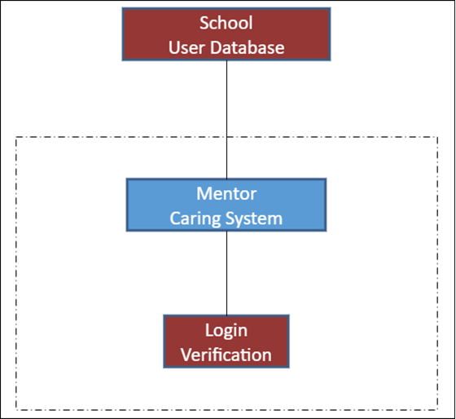
Product Perspective

The BNBU MCS is a centralized system designed to support the BNBU Mentor Caring Programme. As shown in the context model, the MCS works with an internal Mentor Caring Database and interacts with external systems including the BNBU Email Communication System, Login Verification, and the School Database. The system replaces the current Excel-based manual management by providing a unified platform for managing mentoring activities and related information.

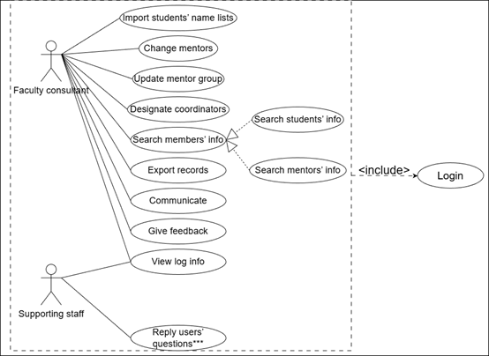
Product Features
This diagram presents the use cases and functional permissions of two user classes in the MCS: Faculty Consultant and Supporting Staff. All functional operations of the two roles are based on the precondition of system login, which is defined as an included mandatory behavior for all function access.
For the Faculty Consultant, the core available operations include importing students' name lists, changing mentors for student groups, updating mentor groups, designating MCP coordinators, searching members' information (including searching students' info and searching mentors' info as extended sub-operations), exporting programme records, internal communication, submitting system feedback, and viewing system log information.
For the Supporting Staff, the available functions are viewing system log information and replying to users' questions, to provide system operation and maintenance support, with limited access permissions and no authority to modify mentoring-related core data.
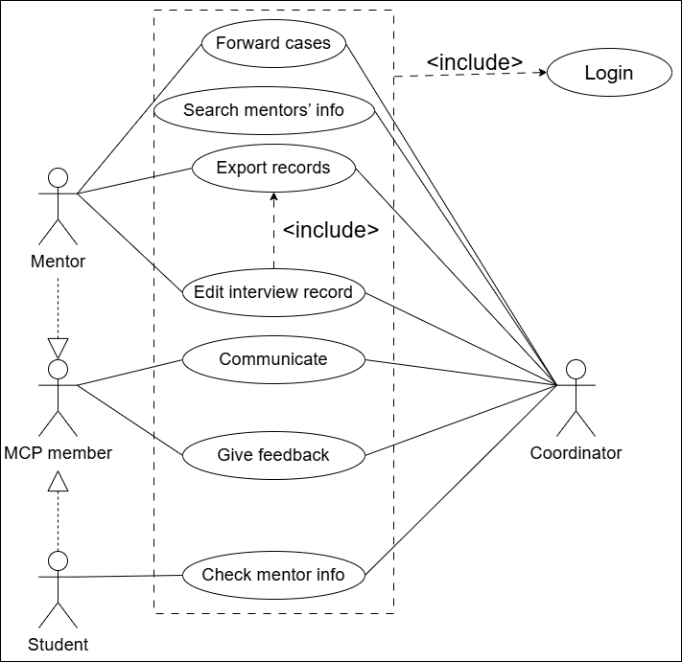
This diagram illustrates the use cases, role relationships, and functional permissions of Mentor, Student (MCP member), and Coordinator (MCP coordinator) in the MCS. All functional operations of the three roles must be completed after system login, which is a mandatory included precondition for accessing all system functions.
The diagram defines the role inheritance relationship: Student inherits the identity of MCP member, and establishes an association with Mentor, which corresponds to the mentor-student matching management mechanism of the MCP.
For the Mentor role, the available core functions include forwarding special cases to the coordinator, searching mentors' information, editing interview records (exporting interview records is an included operation based on interview record editing), internal communication, and submitting system feedback.
For the Student (MCP member) role, the available functions include internal communication with other users, submitting system feedback, and checking the basic information of the assigned mentor.
For the Coordinator role, the available functions include forwarding special cases, searching mentors' information, and other programme coordination-related operations, to assist in the management of the MCP and the handling of special cases reported by mentors.
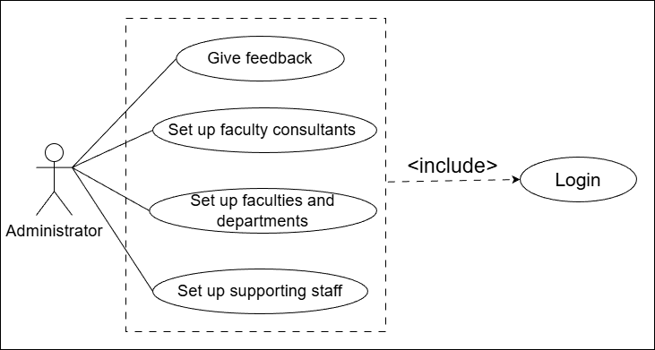
This diagram illustrates the use cases and core functional permissions of the System Administrator in the MCS. All functional operations of the System Administrator are based on the mandatory precondition of system login, which is defined as an included behavior for all administrator function access.
As the user with the highest system privileges, the System Administrator is responsible for the underlying configuration and management of the system. The core available operations include setting up the university's organizational structure (including faculties and departments), configuring system staff roles (including setting up faculty consultants and supporting staff), and submitting system feedback. This set of functions supports the administrator to complete the full configuration of the system's organizational architecture and user permission framework, to support the normal operation of the MCP.

Basic Scenario:
- Search Student’s Info use case includes the Login Verification included use case. The user (Mentor / Coordinator) completes identity authentication through the login function, and enters the system homepage after passing the verification.
The user enters the student information query page, inputs the target student ID and initiates a search request. The system verifies the input validity, then displays the matched student basic information and associated files. Coordinator users have read-only access, and Mentor users can proceed to the interview record editing function. After the user finishes viewing, they return to the query page.
- Edit Interview Record use case includes two included use cases: Login Verification and Search Student’s Info. The user (Mentor) completes login identity authentication first, then finishes the student information search process to enter the target student’s information page.
The user enters the interview record editing mode, completes the add/modify/delete operations of the interview record, and submits the complete information. The system saves the updated content and returns the operation result. The user confirms the result and returns to the student information page.
- Search Mentor Info use case includes the Login Verification included use case. The user (Faculty Consultant / Coordinator) completes identity authentication through the login function, and enters the system homepage after passing the verification.
The user enters the mentor information query page, inputs the target group ID and initiates a search request. The system displays the matched mentor name and associated group information. The user clicks the group ID to view the group member list, selects a student to view their complete records, then returns to the member list after viewing.

User Classes and Characteristics
The BNBU Mentor Caring System (MCS) supports several user classes with different responsibilities and access permissions.
1. System Administrator – Manages system configuration, including faculties, departments, majors, and staff assignments. Low-frequency user with the highest system privileges.
2. Faculty Consultant – Manages MCP activities within a faculty, including importing mentor–student groups and managing programme data. Medium-to-high frequency user.
3. Mentor – Faculty members responsible for mentoring students, managing interview records, scheduling meetings, and reporting special cases. High-frequency user with access limited to their assigned students.
4. Student – Can view mentor information, communicate with mentors, and schedule interviews. Medium-frequency user with access limited to personal information.
5. MCP Coordinator – Assists programme coordination and manages special case reports. Low-to-medium frequency user.
6. Supporting Staff – Provide system support by monitoring logs and handling user feedback. Limited permissions without access to mentoring data.

Operating Environment
The MCS will operate within the university’s information environment. Users such as administrators, MCP coordinators, mentors, and students will access the system mainly through desktop computers using web browsers. The system is expected to run on the university’s server infrastructure and coexist with existing campus information systems.

Design and Implementation Constraints
The system design must follow the university’s existing management process for the MCP. It needs to integrate with the university’s unified identity authentication system and existing databases. Role-based access control must be implemented to protect sensitive student information. In addition, the system should comply with relevant privacy and data protection regulations.

User Documentation
User documentation will be provided together with the software. The document will be a user manual explaining system functions and operations for different roles.

Assumptions and Dependencies
This SRS assumes that the university already provides the necessary IT infrastructure, including servers, databases, and network access. It is also assumed that user information and organizational data can be obtained from existing university systems.

System Features

Search Student Information

Description and Priority
Search for student information according to student ID. The interview record and other info of this student are displayed.

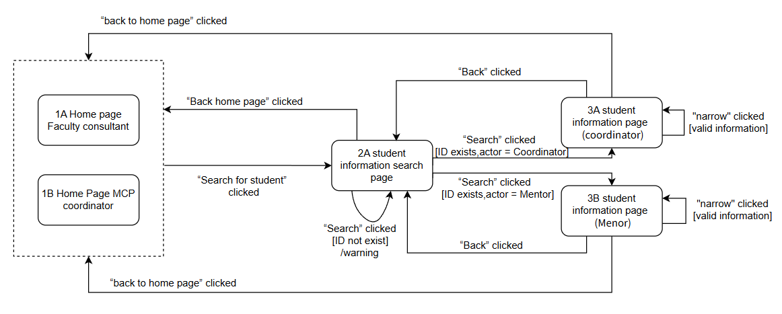
Stimulus/Response Sequences
Transition diagram is included in 3.2.2.
In the figure 4.1.1 of UserInterface.docx, after login and entering the 1A home page Faculty or 1B Home page MCP coordinator, user (Coordinator and Mentor) enters the student searching page. After inputting the target student ID, it will turn to the 3A student’s Info page, which will display the matched student basic information.

Functional Requirements
None.

Edit Interview Record

Description and Priority
The mentor edits the interview record of a student. Before editing, the mentor must first search for the student’s information as described in Section 3.1. After the student information page is displayed, the mentor can click Edit to manage the interview record. If the interview record already exists, the mentor can modify or delete it. If the interview record is empty, the mentor can create a new record. After editing, the mentor can click Save to store the changes or Cancel to discard them.

Stimulus/Response Sequences
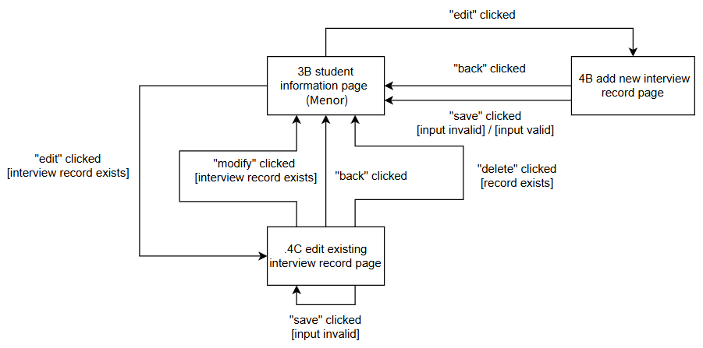
This transition diagram distinguishes two actors: Mentor and Coordinator. The coordinator can only search and view student information, while the mentor can also edit interview records.After logging in, the user enters the Search Student Info page and inputs a student ID. The system retrieves and displays the student’s information and interview record.If the user is a coordinator, they can only view the information and return. If the user is a mentor, they may edit the interview record: an existing record is shown for editing, otherwise a blank form is provided. The mentor can modify the record and choose to save or cancel. Saving stores the changes, while canceling discards them, both returning to the student information page.
.

Functional Requirements
None.

Search Mentor Information

Description and Priority
Faculty consultant and MCP coordinator login via university account and search for mentor information, the search result includes the mentor’s name and ID of the group for which the mentor cares. The member list can be displayed. The record of a student can be shown. For search mentor information, users can search mentor information via criteria. Then, users can check member list on that page.

Stimulus/Response Sequences
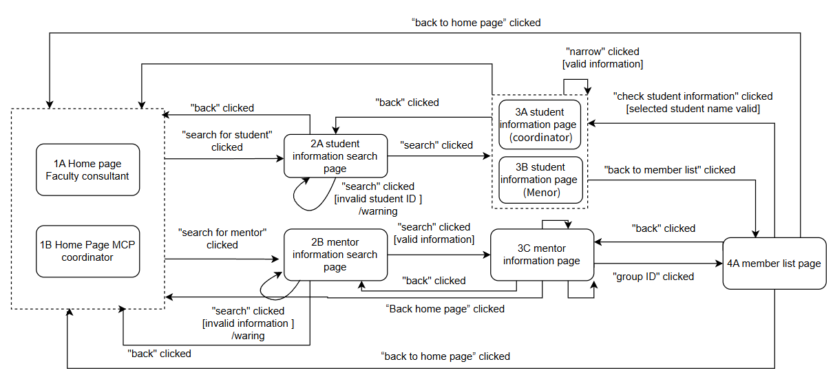
A faculty consultant or MCP coordinator can firstly search for students. After entering valid student ID, the system will display student information. Users can also search for mentors. After entering valid mentor criteria, the system will display mentor information. Users can also narrow student information and view member list through group ID.

Functional Requirements
None

Import Excel List

Description and Priority
Import student’s name list should be done before most of system’s functions. It provides the latest information of students.

Stimulus/Response Sequences
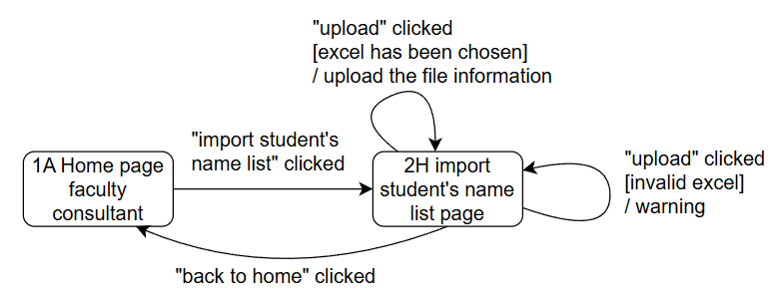
Faculty consultants apply the “import student’s name list” function, and drag or upload the excel file into the specific area, then it will upload successfully. If the excel file includes same information with system old records, then it will be kept. If there are updated information, then the old records will be covered.

Functional Requirements
None.

Export Student’s Information

Description and Priority
Student interview information will be exported in the form of word. By employing “export student’s information”, faculty consultants could acquire the interview information between mentors and students.

Stimulus/Response Sequences
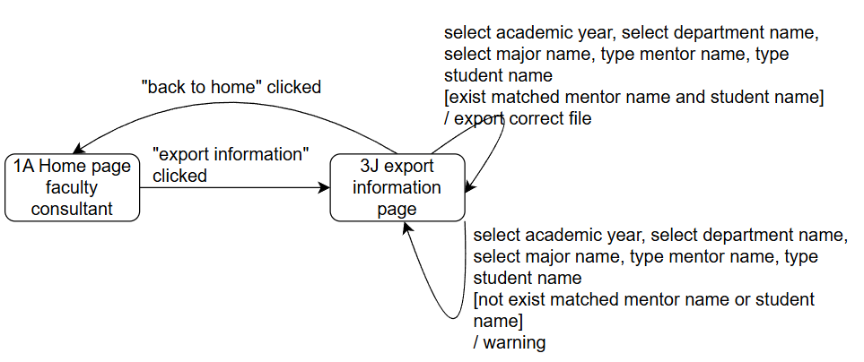
With suitable setting of academic year, department name, major name, mentor name, and student name, faculty consultants apply the “export information” to gain the detailed word file of student- and-mentor interview file. The exported file will be shown as different files according to different major.

Functional Requirements
When click the “triangle” button, it will show initial fixed setting, which will display as the list.

Change Mentors

Description and Priority
This function allows faculty to change mentors for mentor groups.

Stimulus/Response Sequences
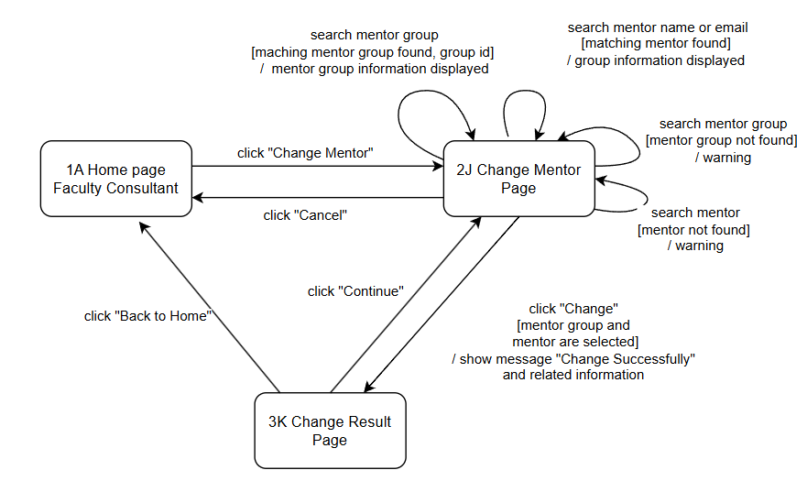
Faculty consultants apply the Change Mentor function. They search the target mentor group and mentor, and the system displays the matched information. After changing the mentor, and the system shows the message “Change Successfully” and the related information.

Functional Requirements
None.

Update Mentor Group

Description and Priority
This function allows faculty to add or remove students for the mentor groups.

Stimulus/Response Sequences
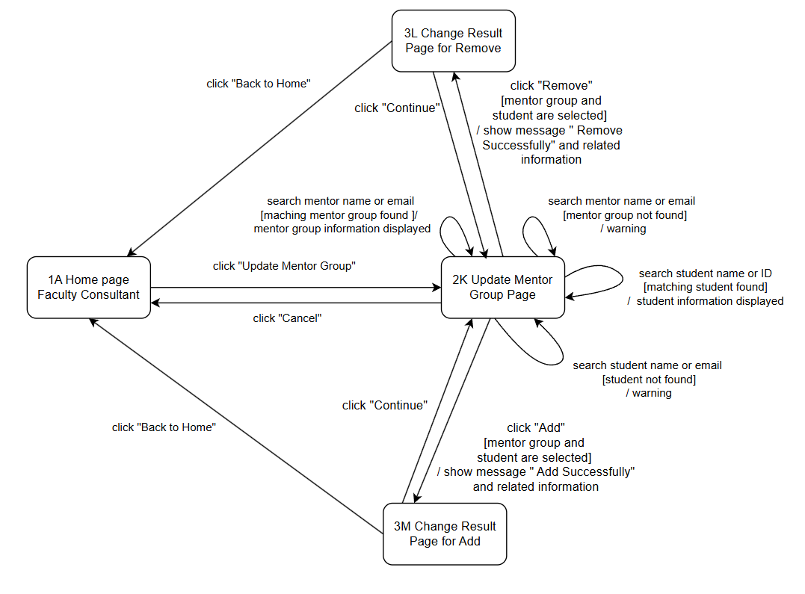
Faculty searches the target mentor group and student, and the system displays the matched information. Then they can add or remove students. Then the system shows the message “Add Successfully” or “Remove Successfully” and the related information.

Functional Requirements
None.

Designate Coordinators

Description and Priority
This function allows faculty to designate coordinates for departments.

Stimulus/Response Sequences
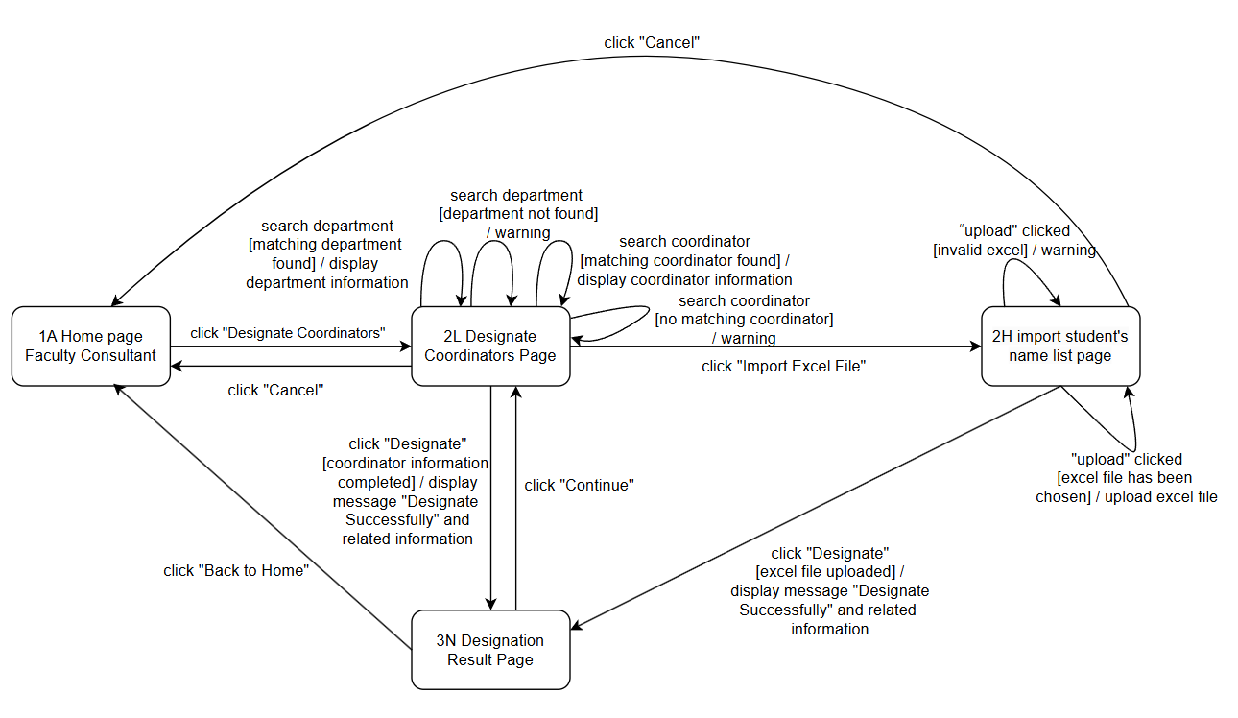
Faculty searches the target department and coordinator, and the system displays the matched information. After designating the system shows the message “Designate Successfully” and the related information. Faculty consultants can also import an Excel file to complete the designation.

Functional Requirements
None.

View Log Information and Reply to Users’ Questions

Description and Priority
This part describes how supporting staff use the system to view log information and reply to users’ questions. After entering the supporting staff home page, the user can check system log information and respond to users’ questions for system operation and maintenance.

Stimulus/Response Sequences
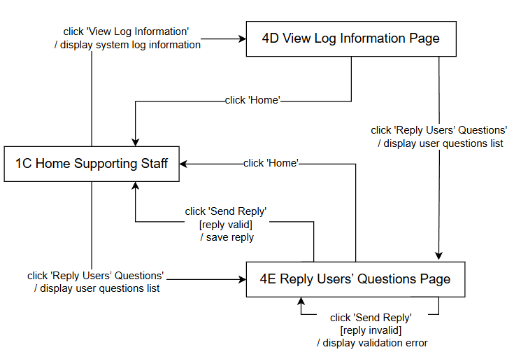
In the Figure, supporting staff apply the “view log information” function to check the system log information for system operation and maintenance. The system displays the relevant log information for review. Supporting staff can also apply the “reply users’ questions” function to check the submitted user questions. After selecting a specific question, the user enters the reply content.

Functional Requirements
None.

Normal Messages Communication

Description and Priority
Mentors and Faculty Consultants can exchange text messages with both Students and MCP Coordinators. MCP Coordinators can exchange text messages with Students.

Stimulus/Response Sequences
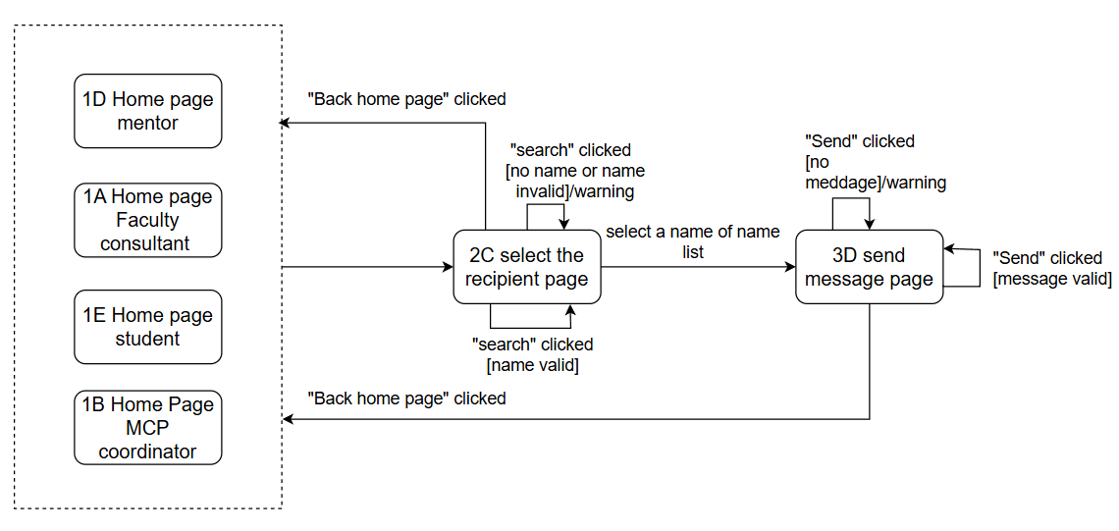
This function allows users to search for a recipient, select a valid contact, compose a message, and send it successfully. The system supports recipient name searching with input validation, displays matching results for selection, checks whether the message content is empty before sending, and provides warning prompts for invalid input or empty messages.

Functional Requirements
None.

Teacher’s Interview Arrangements

Description and Priority
Mentor should mark the available time slots (each slot: 30 minutes) for students to choose from. Once an appointment time is fixed, the teacher should input the interview venue, notifying both sides of the appointment time and venue.

Stimulus/Response Sequences
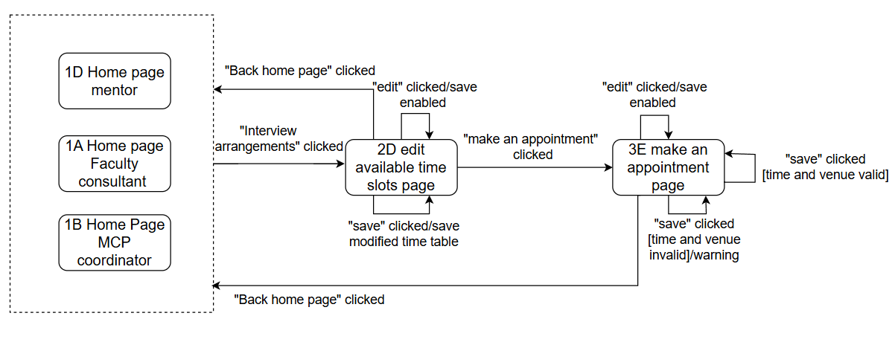

The user can manage interview arrangements by editing available time slots and saving changes. The user can also make an appointment by providing time and venue information, which will be validated by the system before saving. If the input is invalid, a warning message will be displayed.

Functional Requirements
None.

Student’s Interview Arrangements

Description and Priority
Students need to log in to the system to make an appointment. At this time, the teacher should mark out the available time slots(each slot: 30 minutes), and students should choose the time they prefer

Stimulus/Response Sequences
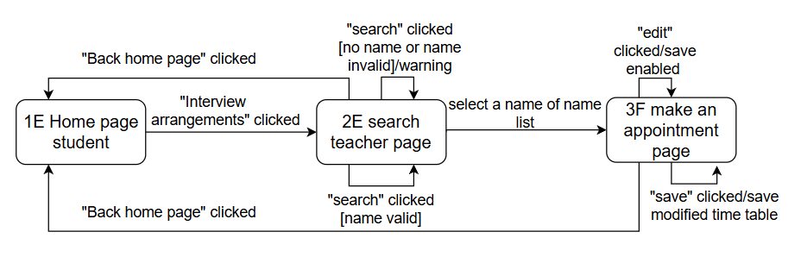
students can search for a teacher by entering a name and submitting a query. The system validates the input and displays matching results or a warning if the input is invalid. Students can then select a teacher to proceed with making an appointment. They are able to manage their availability by editing and saving time slots. If the teacher has provided time and venue information, it will be displayed. Students can return to the homepage at any time.

Functional Requirements
None.

Forward Special Cases to MCP Coordinator

Description and Priority
This function allows mentors to choose and forward student case description to MCP coordinator.

Stimulus/Response Sequences
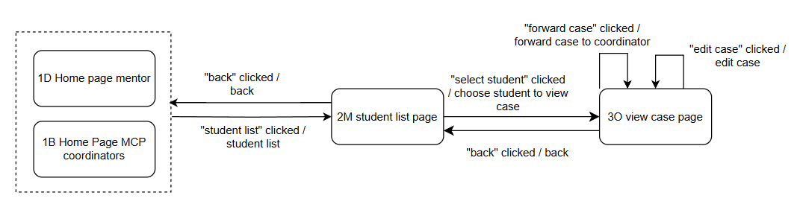
A mentor enters to student list page. The page displays student list. The mentor can view a student’s case. In view case page, the student can view and edit displayed student case and forward to MCP coordinator.

Functional Requirements
None.

Setting Up Faculty Consultants

Description and Priority
This function allows the administrator to configure roles and assignments for faculty consultants in the system.

Stimulus/Response Sequences
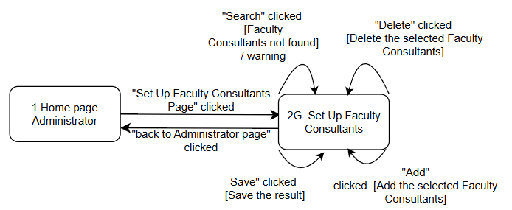
The administrator applies the set up faculty consultant’s function. They jump to the faculty consultant’s setup page. They search the target faculty, and the system displays the matched information in the search result block. They add for the target faculty consultant, and the system displays the added information in the list. They delete for the target faculty consultant, and the system removes the corresponding information from the list. They save the result, and the system saves the final configuration result.

Functional Requirements

Setting Up Faculties and Departments

Description and Priority
This function allows the administrator to configure the university’s faculties and their subordinate departments.

Stimulus/Response Sequences
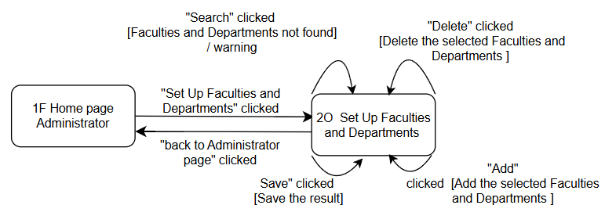
The administrator applies the set up faculties and department’s function. They search the target faculties and departments, and the system displays the matched information in the search result block. They add for the target faculties and departments, and the system displays the added information in the list. They delete for the target faculties and departments, and the system removes the corresponding information from the list. They save the result, and the system saves the final configuration result.

Functional Requirements
None.

Setting Up Supporting Staff

Description and Priority
This function allows the administrator to assign roles to supporting staff for system operation assistance.

Stimulus/Response Sequences
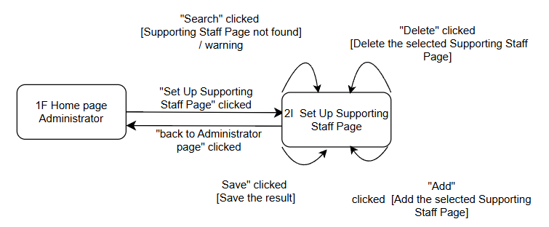
The administrator applies the supporting staff function. They search the target supporting staff, and the system displays the matched information in the search result block. They add for the target supporting staff, and the system displays the added information in the list. They delete for the target supporting staff, and the system removes the corresponding information from the list. They save the result, and the system saves the final configuration result.

Functional Requirements
None.

Forward

Description and Priority
Mentor, student, MCP coordinator, and Faculty Consultant can all send feedback messages through the feedback function.

Stimulus/Response Sequences
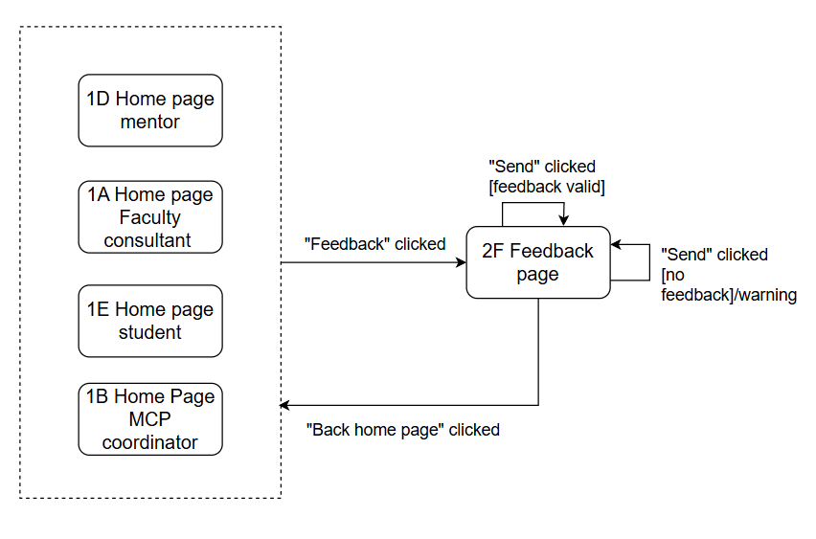
The user can submit feedback by entering a message and sending it to the administrator. The system validates the input and displays a warning if the message is empty. The user can return to the homepage at any time.

Functional Requirements
None.

External Interface Requirements

User Interfaces

Search student information
In the file UserInterface.docx, the figure 4.1.1 reads the “1A Home page Faculty consultant” or “1B Home Page MCP coordinator”. When the user (mentor or coordinator) clicks “Search for student”, the system turns to the “2 Searching page”. In the “2 Searching page”, if an MCP coordinator enters a specified student ID and the ID exists, the system turns to the “3A student information page (coordinator)”. If a mentor enters a specified student ID and the ID exists, the system turns to the “3B student information page (Menor)”. If the typed student ID does not exist, a warning message is displayed. In the “3B student information page (Menor)”, the mentor can click “Back” to return to the “2A student information search page”. In the “2A student information search page”, the user can click “Back” to return to the “1A Home page Faculty consultant” or “1B Home Page MCP coordinator”.

Edit interview record
The user interfaces are provided in UserInterface.docx. The UI diagrams correspond to the states in Section 3.2.2 and use the same labels (S3.2-1 to S3.2-5) for checking. From S3.2-1 Search Student Info Page, the user enters a student ID. If the ID is invalid, the system shows an error message and remains on the same page. If the student is found, the system displays the student information page. Coordinators can only view the information and return, while mentors can continue to edit the interview record. Mentors are directed to either the edit “4B add new interview record page” or the “4C edit existing interview record page”. They can click “Save” to save changes or “Cancel” to discard changes, and both operations return to the “3B student information page (Menor)”.

Search mentor information
A faculty consultant or MCP coordinator can click “Search for mentor” on the “1A Home page Faculty consultant” or “1B Home Page MCP coordinator” to enter the “2B mentor information search page”. After entering valid mentor criteria and clicking “Search”, the system displays the “3C mentor information page”, which shows the matched mentor information and related student list. The user can click “Group ID” to enter “4A member list page” and then view student information. The user can also click “Search for student” on the “1A Home page Faculty consultant” or “1B Home Page MCP coordinator” to enter the “2A student information search page”. After entering a valid student ID and searching, the system displays the student information page; if the input is invalid, the system shows a warning message.

Import excel list
When faculty consultants click the “Import student’s name list” button on the “1A Home page faculty consultant”, the system turns to the “2H import student's name list page”. The user can drag a specific file into the file box or upload the Excel file manually. After the file is selected, clicking the “upload” button uploads the file successfully. If the user clicks the “back to home” button, the system returns to the “1A Home page faculty consultant”.

Export student’s information
When faculty consultants click the “Export Information” button on the “1A Home page faculty consultant”, the system turns to the “3J export information page”. After setting conditions such as academic year, department name, major name, mentor name, and student name, the user can click “export”. If matching information exists, the corresponding Word file is exported. Otherwise, the system displays a warning message. Clicking the “back to home” button returns the user to the “1A Home page faculty consultant”.

Change Mentors
When faculty consultants click the “Change Mentor” button on the “1A Home page faculty consultant”, the system turns to the “2J Change Mentor Page”. After the target mentor group and mentor are searched, the matched information is displayed. If the faculty consultant clicks the “Change” button, the system turns to the “3K Change Result Page”. Clicking the “Continue” button returns to the “4 Change Mentor Page”, while clicking the “Back to Home” button returns to the “1A Home page faculty consultant”.

Update Mentor Group
When faculty consultants click the “Update Mentor Group” button on the “1A Home page faculty consultant”, the system turns to the “2K Update Mentor Group Page” page. After the target mentor group and student are searched, the matched information is displayed. If the faculty consultant clicks the “Add” button, the system turns to the “3M Change Result Page for Add”. If the faculty consultant clicks the “Remove” button, the system turns to the “3L Change Result Page for Remove”. Clicking the “Continue” button returns to the “6 Update Mentor Group” page, while clicking the “Back to Home” button returns to the “1A Home page faculty consultant”.

Designate Coordinators
When faculty consultants click the “Designate Coordinators” button on the “1A Home page faculty consultant”, the system turns to the “2L Designate Coordinators Page”. After the target department and coordinator are searched, the matched information is displayed. If the faculty consultant clicks the “Designate” button, the system turns to the “3N Designation Result Page”. The user can also click the “Import Excel File” button to complete the designation. Clicking the “Continue” button returns to the “2H import student's name list page”, while clicking the “Back to Home” button returns to the “1a Home Page Faculty Consultant”.

View Log Information and Reply to Users’ Questions
When supporting staff click the “View Log Information” button on the “1C Home Supporting Staff” page, the system turns to the “4D View Log Information Page”. On this page, the system log information is displayed. If the user clicks the “Reply Users’ Questions” button, the system turns to the “4E Reply Users’ Questions Page”, where the submitted user questions are displayed. After selecting a question and entering the reply content, the supporting staff can edit and submit the reply by clicking the “Send Reply” button. Clicking the “Home” button on either page returns the user to the “1C Home Supporting Staff” page.

Normal messages communication
After logging in, users can click “Normal messages” on the “1D Home page mentor”, “1A Home page Faculty consultant”, “1E Home page student”, or “1B Home Page MCP coordinator” to enter the “2C select the recipient page”. The user can enter the recipient’s name and click “Search”. If the name is invalid, the system displays a warning message; if the name is valid, the system displays a list of matched names for selection. After selecting a recipient, the system turns to the “3D send message page”. The user enters the message content and clicks “Send”. If the message is empty, the system shows a warning; otherwise, the message is sent successfully. Clicking the “Back home page” button returns the user to the corresponding home page.

Teacher’s Interview arrangements
After logging in, mentors can click the “Interview arrangements” button on the “1D Home page mentor”, “1A Home page Faculty consultant”, or “1B Home Page MCP coordinator” to enter the “2D edit available time slots page”. On this page, the user can click “Edit” to select or cancel time slots on the timetable, and click “Save” to save the updated timetable. The user can also click “Make an appointment” to enter the “3E make an appointment page”, where the time and venue information can be edited. If the entered time and venue are valid, the system saves the information; otherwise, it displays a warning message. Clicking the “Back home page” button returns the user to the corresponding home page.

Student’s Interview arrangements
After logging in, students can click the “Interview arrangements” button to enter the “2E search teacher page”. The user can enter the teacher’s name and click “Search”. If the name is invalid or empty, the system shows a warning message. If the name is valid, the system displays a list of matched teachers. After the student selects a teacher, the system turns to the “3F make an appointment page”. On this page, the student can click “Edit” to select or cancel available time slots and click “Save” to save the timetable. If the teacher has already published the time and venue information, it will be displayed in the corresponding box. Clicking the “Back home page” button returns the user to the “2E Home page student”.

Forward special cases to MCP coordinator
A mentor can click “Student list” on the “1D Home page mentor” or “1B Home Page MCP coordinator” to enter the “2M student list page”. On this page, the mentor can click the triangle beside a student name to choose which student case to view and forward. After clicking “Select student”, the system turns to the “3O view case page”. The mentor can view the displayed student case, edit the case description, and forward it to the MCP coordinator.

Setting Up Faculty Consultants
When the administrator clicks the “Set Up Faculty Consultants” button on the “1F Home page Administrator”, the system turns to the “2G Set Up Faculty Consultants” page. If the administrator clicks “Search” for the target faculty consultant, the matched information is displayed in the search result block. If the administrator clicks “Add”, the added information is displayed in the list. If the administrator clicks “Delete”, the corresponding information is removed from the list. If the administrator clicks “Save”, the system saves the result. Clicking the “Back to Administrator Page” button returns the user to the “1F Home page Administrator”.

Setting Up Faculties and Departments
When the administrator clicks the “Set Up Faculties and Departments” button on the “1F Home page Administrator”, the system turns to the “2O Set Up Faculties and Departments” page. If the administrator clicks “Search”, the matched information is displayed in the search result block. If the administrator clicks “Add” for the target faculty or department, the added information is displayed in the list. If the administrator clicks “Delete”, the corresponding information is removed from the list. If the administrator clicks “Save”, the system saves the result. Clicking the “Back to Administrator Page” button returns the user to the “1F Home page Administrator”.

Setting Up Supporting Staff
When the administrator clicks the “Set Up Supporting Staff” button on the “1F Home page Administrator”, the system turns to the “2I Set Up Supporting Staff Page”. If the administrator clicks “Search”, the matched information is displayed in the search result block. If the administrator clicks “Add” for the target supporting staff member, the added information is displayed in the list. If the administrator clicks “Delete”, the corresponding information is removed from the list. If the administrator clicks “Save”, the system saves the result. Clicking the “Back to Administrator Page” button returns the user to the “1F Home page Administrator”.

Feedback
After logging in, mentors, students, MCP coordinators, and faculty consultants can click the “Feedback” button to enter the “2F Feedback page”. The user can edit the feedback message in the feedback box and then click “Send”. If the feedback message is empty, the system displays a warning message. If the feedback message is valid, it is sent to the administrator successfully. Clicking the “Back to Home Page” button returns the user to the corresponding home page.

Hardware Interfaces
The MCS does not require any specialized hardware devices.

Software Interfaces
The MCS shall interface with the university’s existing software environment in order to support authentication, data management, and organizational coordination.
- Unified Identity Authentication System: The system shall integrate with the university’s identity authentication system to support secure login and role-based access control.
- University Databases / Information Systems: The system shall interface with university information systems to obtain and maintain user and organizational data, ensuring data consistency and reducing duplication.
- Data Import and Export Interfaces: The system shall support data import and export (e.g., Excel and Word) following predefined formats.
- Internal Application Modules: The system’s internal modules shall interact through shared services and a common database.

Communications Interfaces
The MCS shall communicate over the university network and the Internet using standard web-based communication protocols.
- Client–Server Communication: The system shall communicate over the university network and the Internet using standard web protocols (HTTP/HTTPS), with HTTPS for sensitive data.
- Notification Communication: The system shall support sending important notifications and reminders related to appointments, pending tasks, and mentoring activities. Notifications may be delivered through email.
- System Synchronization Communication: The system shall support data synchronization with university systems, either in real time or via scheduled updates.
- Security of Communication: The system shall ensure secure communication, preventing unauthorized access and applying session control and timeout mechanisms.

Other Nonfunctional Requirements

Performance Requirements
The system shall provide acceptable response time for all users.
- The system shall support at least 10000 users without significant performance degradation.
- Normal operations such as searching for student information, sending messages, and viewing interview records shall respond within 5 seconds.
- Importing an Excel file with up to 2000 records shall be completed within 10 seconds.
- Exporting interview reports to Word files shall be completed within 5 seconds.

Software Quality Attributes
Usability: The system shall be easy to use, allowing users to perform basic tasks with minimal training.
Reliability: The system shall ensure accurate and consistent data under concurrent access.
Maintainability & Scalability: The system shall support easy modification and extension through a modular design.
Robustness: The system shall handle invalid inputs gracefully and provide clear feedback.

Other Requirements
TBD
Appendix A: Glossary
Abbreviation | Full name
SRS | Software requirement specification
MCS | Mentor caring system
MCP | Mentor caring program
Appendix B: Analysis Models
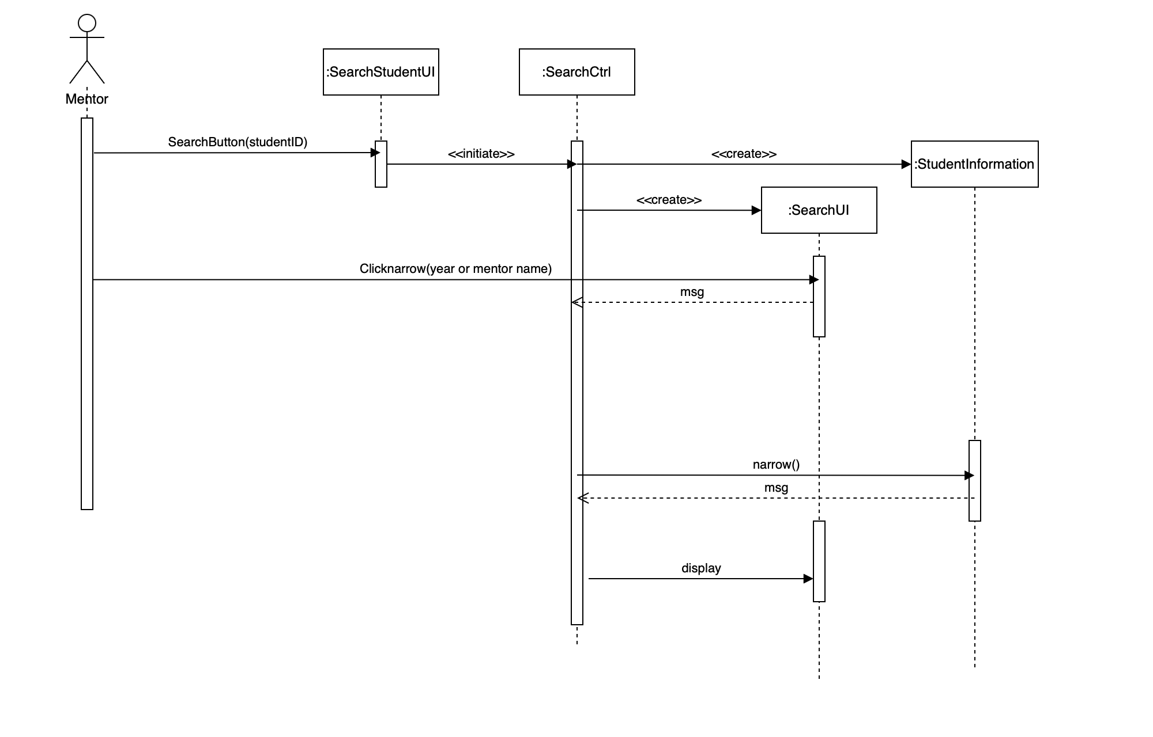
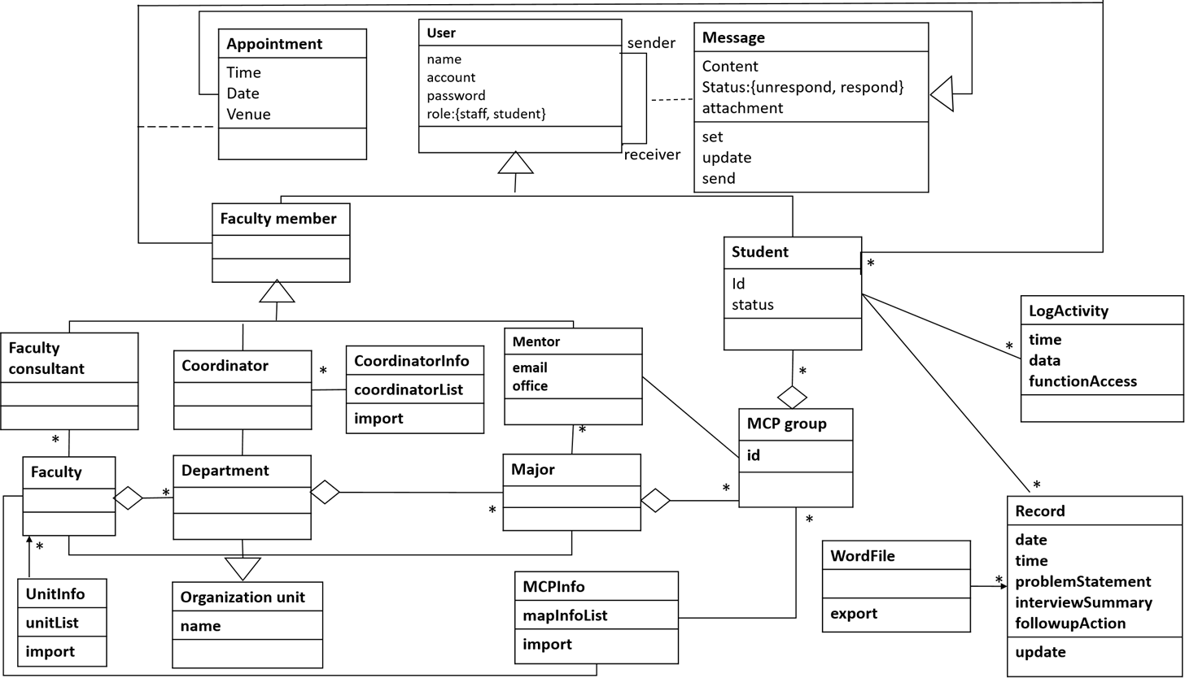

Appendix C: Issues List
TBD

