**MAEG5104 Materials Characterization Techniques**

**The Chinese University of Hong Kong**

**Laboratory 1: X Ray Diffractometer (XRD)**

**Objectives:**

In this laboratory, you will learn how to operate an X Ray Diffractometer to analyze the structure of materials.

The model used in this lab is SmartLab3kW (http://www.rigaku.com/en/products/xrd/smartlab).

Note1: The first major part of this lab sheet is about the operation of the XRD, and there are many pictures describing how a particular button works, there is NO wired internet connection in the lab, so you may have to print this lab sheet or to view it in your own electronic devices.

Note2: The measurement result will be in a form of a spectrum. To avoid computer virus infection the TA will send the measurement files to students’ representatives after the lab. NO USB DRIVE is allowed to be inserted into the equipment computer.

Caution: Although this XRD has passed safety examination about X-Ray emission to the environment during operation, students MUST operate the machine under technician’s / TA’s strict supervision. DO NOT OPEN the door of XRD or do operation on your own unless you are instructed by TAs/technicians.

Pictures are sourced from lectures notes and “Basics of X-Ray Diffraction” by Scott A Apeakman, Ph.D. (MIT) unless specified.

**Introduction:**

Sample

Crystalline materials are characterized by the orderly periodic arrangements of atoms. 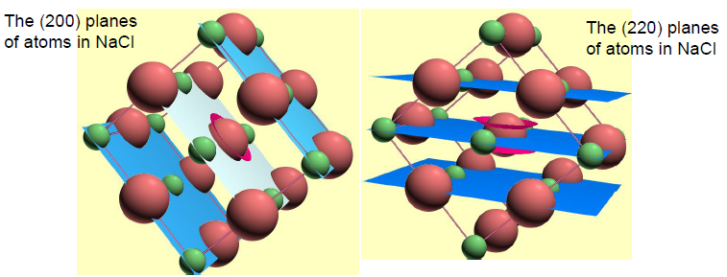

Parallel planes of atoms intersecting the unit cell are used to define directions and distances in the crystal (this is identified by Miller indices).

X-Ray diffraction is the phenomenon where the atomic planes of a crystal cause an incident beam of X-rays to interfere with one another as they leave the crystal.

Bragg’s law is a simplistic model to understand what conditions are required for diffraction:

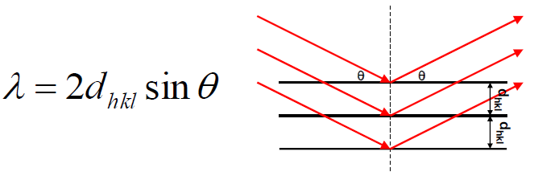

For parallel planes of atoms, with a space dhkl between the planes, constructive interference only occurs when Bragg’s law is satisfied. Consequently, a family of plane produces a diffraction peak only at a specific angle .

The Miller index notation, denoted by (h,k,l), is a convention used in crystallography in order to define the orientation a crystal plane with respect to a main crystallographic axis. They are a set of numbers which quantify the intercepts and can be used to uniquely identify planes of lattice structure. Miller indices are sufficient to specify both the orientation and the spacing of a set of parallel planes .For cubic crystals, the relationship between the lattices constant, a, which refers to the constant difference between unit cells in a lattice, the miller indices, and the interplanar spacing, d, is given by:

In our diffractometer, **the X-ray wavelength is fixed**

An X-Ray Diffractometer (XRD) is a type of equipment which measures the X-Ray diffraction from the samples with respect to the angular position of emitter and receiver. The measured result (usually in spectrum form) can be used to determine the crystallinity of the sample.

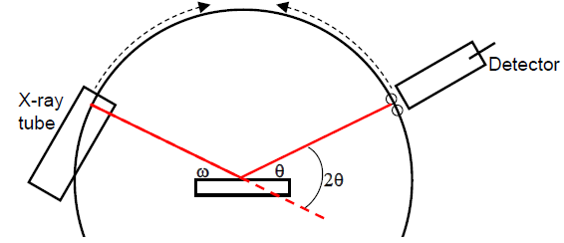

The incident angle, , is defined between the X-ray source and the sample.

The diffraction angle, , is defined between the incident beam and the detector angle.

The incident angle is always ½ of the detector angle .

A single crystal specimen in a Bragg-Brentano diffractometer would produce only one family of peaks in the diffraction pattern.

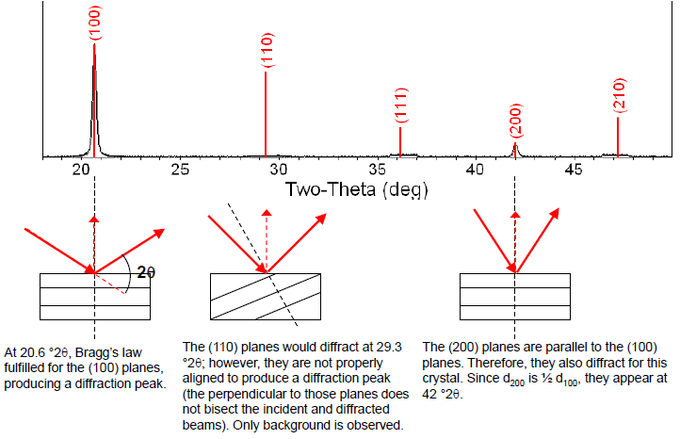

**The Equipment (SmartLab3kW):**

|  |  |  |
| --- | --- | --- |
| (a) Computer controlling the XRD and Chiller for cooling the X-Ray tube. | (b) XRD main station. DO NOT OPEN the door without pressing the “door” button! It will damage the lock! | (c) Inside the XRD chamber.  Left: X-Ray source; Middle: Sample holder stage (with Z-offset adjustment); Right: Detector; |

**Procedure (Example: Si-powder):**

** DO NOT open the door by yourselves! **

1. Wear suitable personal protective equipment before handling samples!
   1. One of the students may wear gloves to handle samples, he/she cannot touch the computer nor the XRD door. This is to avoid contamination to both of the equipment and the samples.
   2. Other students can operate the door-opening/closing and computers.
2. Prepare a sample from TAs and place it into the sample holder.
   1. If it is powder sample, use the glass sample holder with 0.5mm depth to store the powder; use a glass to flatten the top surface of the powder and remove excess materials.
   2. If it is bulk sample, e.g. a 5-cents coin, use the aluminum sample holder and blu-tack sticker to fix it, make sure the sample is on the same plane as the aluminum holder edge.
3. Press the yellow “door” button and wait for at least 3 seconds until the sound changes to about 1Hz beeping sound.
4. Open the door gently, if you feel large resistance.

(Caution: DO NOT attempt to increase the force! Ask the TA/technician for help.)

1. Place the sample holder into the stage, try to position it at the center of the sample stage.
2. Put down (rotate anti-clockwise) the knife edge and left about 1mm gap above the sample top surface.
3. In the software (near bottom-left hand corner) click the “4. General Measurement (BB)” to input the measurement settings:  
    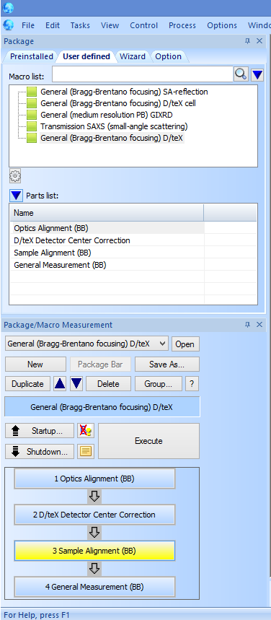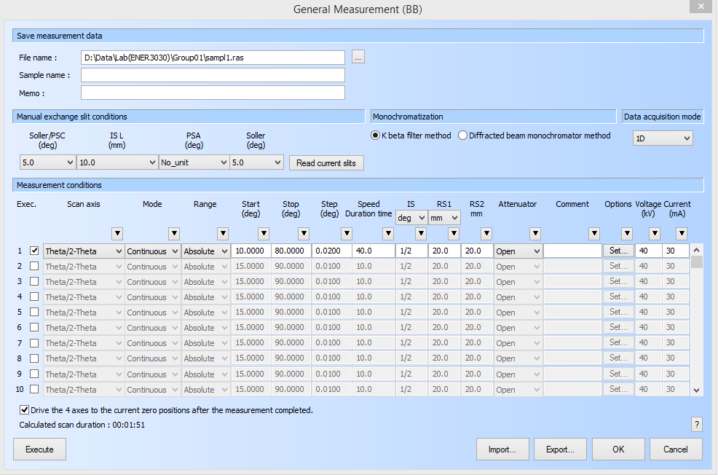
   1. Make sure the data path is “D:\Data\Lab\ENER3030\GroupXX\measurement_name.ras”, where GroupXX is your group ID and measurement_name.ras is your data file name.
   2. In the “Measurement conditions” settings you can set, for example:
      1. Start angle (deg): e.g. 10deg
      2. Stop angle (deg): e.g. 80 deg
      3. Speed (deg per min): e.g. 10 deg / min
   3. Leave other settings as default. DO NOT attempt to change other parameters.
4. Click “OK” to save the settings.
5. Click the “Execute” button to execute measurement.
6. Wait for the measurement to be executed. When the measurement finished, the “Measurement has been completed” pop-up window will show.

(Caution: DO NOT attempt to open the door until the measurement finished! It will break the door lock!)

1. The result will be in the form of a spectrum of signal intensity versus 2-theta (deg). You can use the mouse to zoom-in to locate the peak values.
2. To do measurement on the next sample, re-do step (3) – step (9), but in step (9) if the parameters are the same, you can simply change the sample name and click execute.