**Liudmila Mashkina** 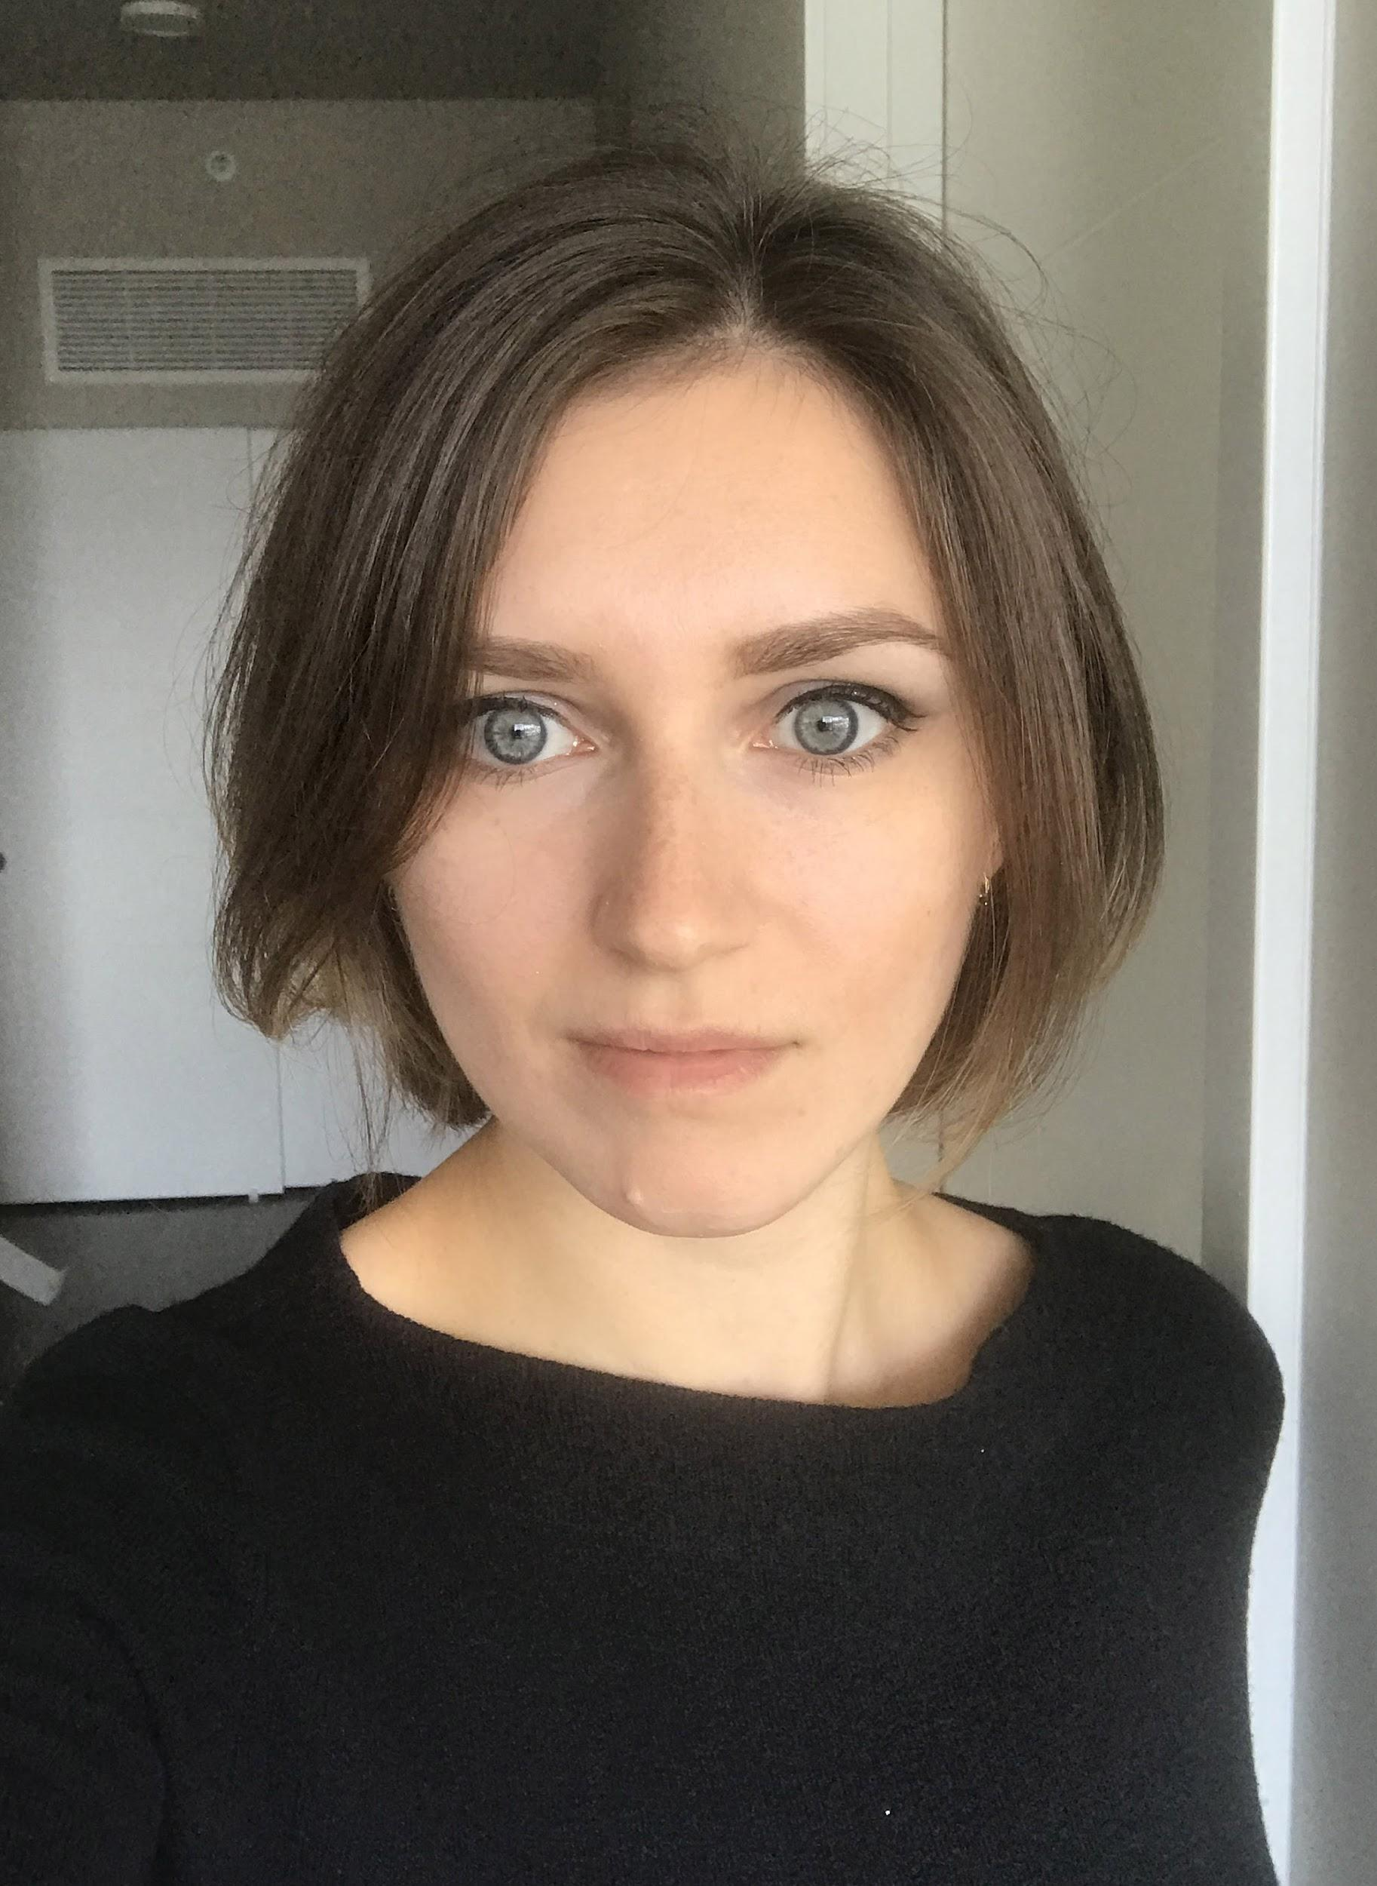

Software Developer

[liudmilamashkina@gmail.com](mailto:liudmilamashkina@gmail.com)

Summary

Through all my life I was keen on extending my knowledge and keep progressing. Knowledge gotten at school or at university was never enough and I always tried getting something new by myself. I suppose it’s the main reason I got my first job at the most famous Russian fashion company. And it was not a junior position. Even before the end of my probation I already was trusted to develop the main apparel line.

When, by the reason of moving to Prague, I got some free time, I decided to take that opportunity and study. I tried programming. As soon as I realized I like it, and it satisfies my requirements to get more intellectually demanding problems to solve, I decided to deep-dive.

Theory is theory. Practice is a different thing. In parallel with studying algorithms and design paradigms I was working on my own application to get real experience. After my application has became ready to be shown I started to look for a job in Prague to get more experience, I passed several interviews and the result of all of them was an offer, but it happened so that at the same time my husband has got an appealing offer in US. So I had to refuse all offers in Prague and we moved to another continent. Now, with new forces, I’m looking for a job again, for a job which will give me opportunities for growth and complex tasks to solve, a job where I will meet talented people to learn from.

Core skills

• Strong C++ (2 years of experience)

• Basic Python knowledge

• Strong algorithmic background

• Strong OOP understanding

• Software design

Experience

Oct 2015 – Present Self-employed software developer

Self-employed software developer working on C++ cross-platform game (currently supported iOS and Mac OS). Project is near completion with running demo available.

**Responsibilities:**

• Programming

• Gameplay design

• Graphic design

**Technologies used:**

• Cocos2d-x

• Box2D

• Blender +Python scripting

• CMake

• Git

• XCode, Sublime

Sep 2012 – Feb 2015 Fashion Designer | Ltd. Bosco Sport | Moscow

Fashion designer working on sport wear line.

**Responsibilities:**

• Creating collection concept

• Design (sketches, artworks of embroideries, prints and fabric patterns)

• Communication with partners and producers

• Trained and mentored junior designers

**Accomplishments:**

• Sport uniform for Russian team FW 2013-2014

• Sport uniform for Ukrainian team FW 2013-2014

• Sport uniform for Russian team SS 2014

• Sport uniform for Russian Olympic and Paralympic teams FW 2014-2015

• Official suits for Russian Olympic and Paralympic teams FW 2014-2015

• Olympic and Paralympic staff bibs for Sochi 2014

• Olympic and Paralympic athletic bibs for Sochi 2014

• Uniform for Flower ceremony Sochi 2014

• Uniform for Awards ceremony Sochi 2014

• Uniform for referees Sochi 2014

• Corporate sport uniform for Megafon company FW 2014-2015

• Corporate sport uniform for Sberbank company FW 2014-2015

• Corporate sport uniform for Sberbank company SS 2015

• Sport uniform for Russian team SS 2015

Education

• Moscow State University of Design and Technology (MSUDT)

• Specialist | 2012

• Fashion Designer

• Diploma with honors

Languages

• Russian – native

• English - fluent