RQ3

1. Time of interaction

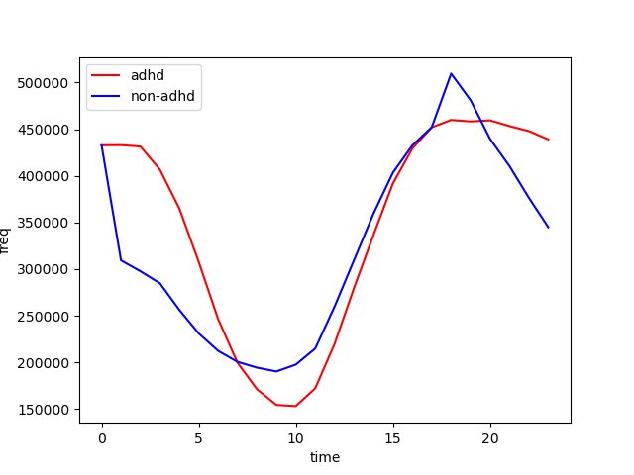

1. The number of interaction

* Number of group users

Adhd: 3135

Non-adhd: 3233

* Total user tweets:

ADHD: 8,300,768

Non-ADHD:7,692,811

ADHD

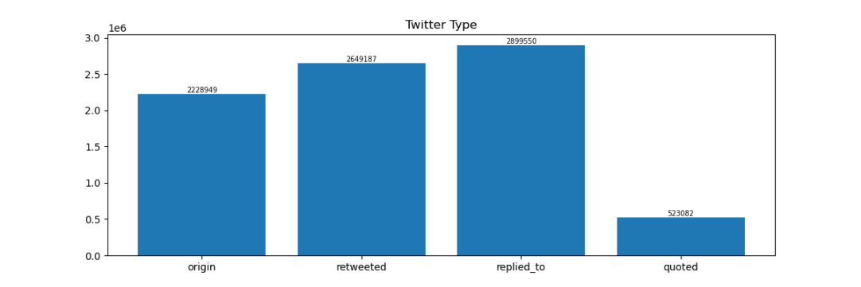

NON-ADHD

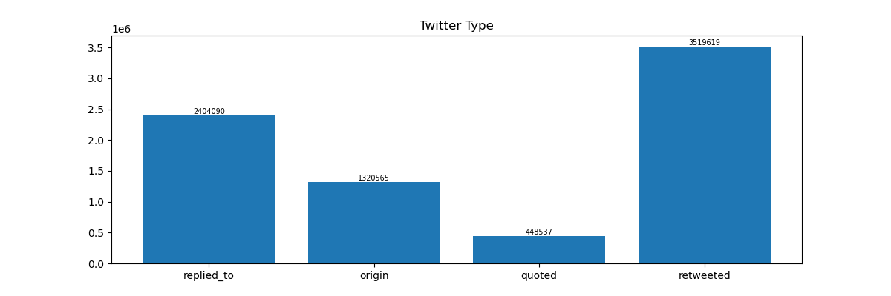

Individual Analysis (for future prediction)

