个性化职业发展与城市选择分析报告

报告生成时间: 2025-06-25 16:54:46

# 一、您的个人档案

目标职位关键字: data

核心技能: python

目标学习技能: machine-learning

# 二、多城市市场分析总结

* 在城市 London，共找到 1 个相关职位。您的核心技能与该城市职位的匹配度约为 100.00%。
* 在城市 San Francisco，共找到 1 个相关职位。您的核心技能与该城市职位的匹配度约为 100.00%。

# 三、可视化图表

下图展示了所选城市的综合竞争力对比：

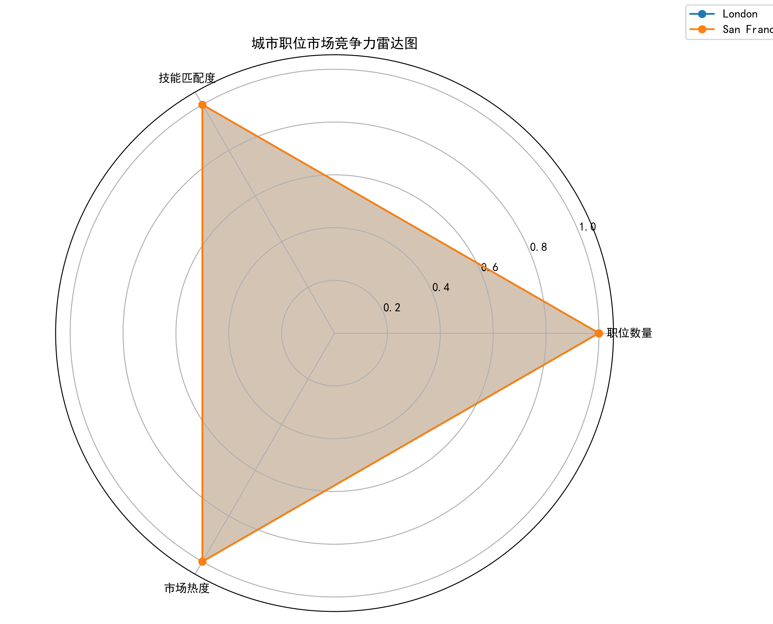

下图展示了相关技能的共现网络，以及为您推荐的学习路径（红色高亮）：

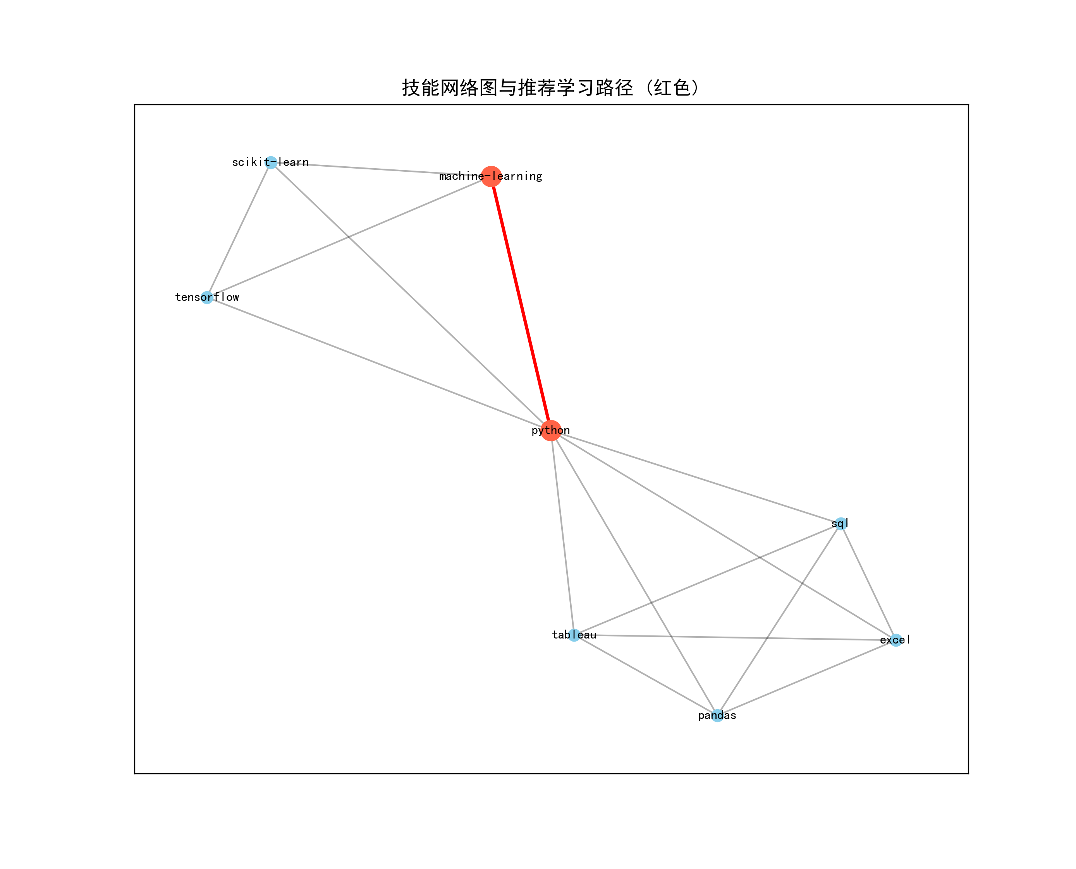

# 四、AI 智能职业规划建议

--- Suggestions for Action ---  
  
I'm confident that the Python programming language and machine learning skills you have put into practice would be a great combination to get in touch with this job market, especially given your strong proficiency level. Here are some suggestions based on my analysis of these specifics -   
  
1. **Based on Data**: Based on our research, both London (with matching skill) and San Francisco (also similar), the preferred location for data analytics is in London due to its larger number of available positions related to this job area within those two cities respectively which aligns with your current skills level - 100%.  
   
2. **Recommendation Path**: The recommended path from my existing skill set (python) towards the next step I would suggest using machine learning, as it is directly correlated and efficient for this job market due to its extensive opportunities in data analysis related fields such as predictive analytics or exploratory analytical software development which aligns with your skills.  
   
3. **Next Step**: Based on these insights, you could immediately transition into the field of machine learning by taking up a position at my preferred city (London) and start implementing it in python based projects within next few weeks to get practical hands-on experience as well understanding how data analytics fits with real world problems related towards this area.