Predicting Used Car Prices on Craigslist: A Comparative Study of Regression Models
Liuxuhong Zhao · Kangxin Peng
University of California, San Diego
liz066@ucsd.edu · k2peng@ucsd.edu
ABSTRACT
The used car market is large and popular in the U.S., but it lacks adequate information to clearly understand the practical price of those cars and it is hard to know whether a listed price is fair. In this project, we explore the problem of predicting used car listing price from various vehicle attributes extracted from Craigslist. We compare three models of increasing complexity which includes Linear Regression, Random Forest, and XGBoost. In our experiments, we use a cleaned dataset of 347,641 listings and we figure out that both ensemble methods substantially outperform the linear baseline. They achieve a Mean Absolute Error of roughly $3,350 compared to $6,396 for the linear model. An ablation study reveals that car age, odometer reading, vehicle condition, and engine size are the most influential features, directly affecting the used car price. The result indicates that there is a non-linear interaction between vehicle attributes, which plays a significant role for the price formation in the used car market.
1. Introduction
Buying a used car is one of the important decisions for most people because it reduces budget and financial burden compared to buying a new car. However, the price listing in the used car market is not consistent. When two used vehicles are almost the same but in different regions or sold by different sellers, the nuance of their price may be higher than thousands of dollars. Therefore, the instability of selling price makes it so hard to get a good deal for buyers as well as difficult to know the exact price to list a reasonable price for sellers.
The shortcoming of the used car market reflects that automated price estimation tools have practical value. A reliable model can help buyers benchmark a listing price and help sellers set a competitive price. Also, it can assist various platforms to flag potentially fraudulent or miscategorized listings, enhancing the equity of the market.
In this project, we use the Craigslist Used Cars dataset which is a large public collection of vehicle listings across the United States to build and evaluate regression models for price prediction. Thus, our contributions are as follows:
(1) We perform a thorough exploratory data analysis and feature engineering pipeline on a dataset that includes over 420,000 raw listings.
(2) We train and compare three models, including Linear Regression, Random Forest, and XGBoost, under consistent evaluation conditions.
(3) We conduct an ablation study to quantify the marginal contribution of each engineered feature.
2. Dataset
2.1 Source and Scale
We use the Craigslist Used Cars dataset which was originally compiled by Austin Reese on Kaggle. The raw data contains 426,880 vehicle listings which were extracted from Craigslist across the United States. The 26 columns in this dataset cover price, year, manufacturer, model, condition, fuel type, odometer reading, transmission, drive type, vehicle type, paint color, title status, and geographic coordinates.
2.2 Preprocessing
Before making the raw data usable for modeling, we need to employ data cleaning first. The county column is entirely missing, so we dropped it. Columns such as VIN, image URL, and listing URL contain no predictive signal, so we removed them also. After eliminating these and dropping some rows which miss critical fields such as price, year, odometer, manufacturer, model, we applied the following filters:
Price: listing price below $500 or above $150,000 were removed as likely data entry errors or some mistakes.
Year: vehicles manufactured before 1990 were excluded because we focus on the modern used car market.
Odometer: reading below 1,000 or above 400,000 miles were treated as erroneous.
Remaining missing values in categorical columns such as condition, cylinders, fuel, were imputed with the column mode. After cleaning, the dataset contains 347,641 listings.
2.3 Exploratory Data Analysis
Figure 1 summarizes the distributions of key variables after cleaning.The price distribution is right-skewed, since most listings concentrated between $5,000 and $30,000 and a median of approximately $15,995. Car age follows a roughly bell-shaped distribution centered around 7-10 years, reflecting the typical lifecycle of vehicles in the used car market. Odometer readings often peak in the 20,000-50,000 mile range. A scatter plot of price against car age demonstrates a clear downward trend: newer vehicles lead to higher prices, but the range widens considerably for vehicles under five years old. This fact is consistent with high variance in pricing for near new cars depending on brand and condition.
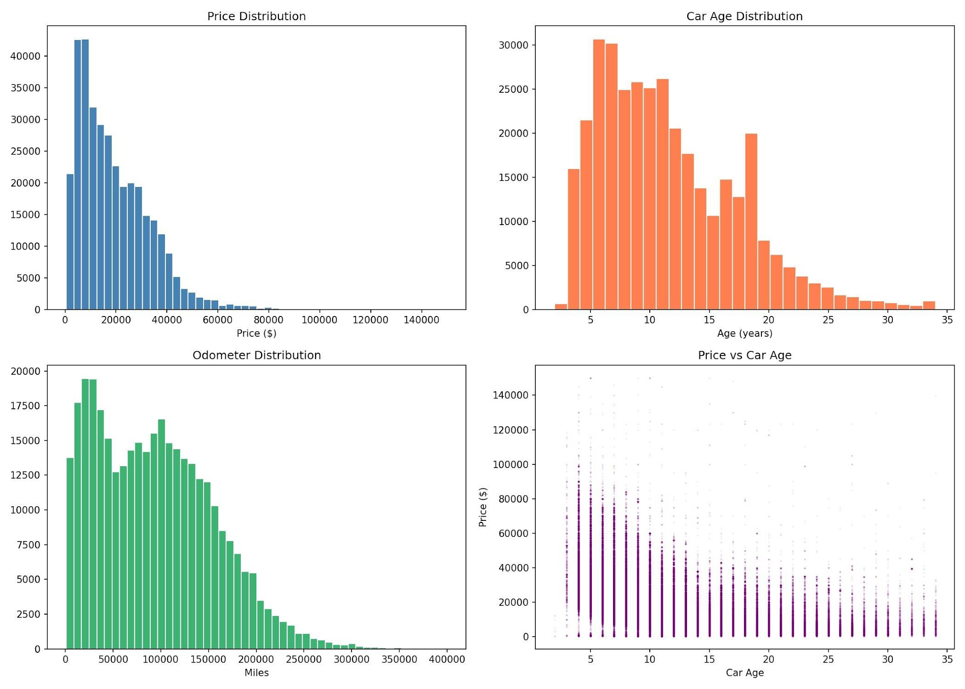
Figure 1: Distributions of price, car age, odometer, and price vs. car age after cleaning (n = 347,641).
3. Predictive Task
We define this task as a regression problem: given a set of vehicle attributes available at listing time, predict the listing price in U.S. dollars. The evaluation metric is Mean Absolute Error(MAE), which measures average prediction error in the same unit at the target and is robust to moderate outliers. We also report R², which captures the proportion of variance in price explained by the model.
We compare three models, using Linear Regression as the baseline and assuming that price is a linear combination of the input features. Since Random Forest is an ensemble of decision trees that can capture non-linear relationships, it does not need explicit feature transformation. For XGBoost, it is a gradient-boosted tree method that generally offers strong performance with faster training times than standard random forests.
Our hypothesis is that the true relationship between vehicle attributes and price is highly non-linear. For example, the depreciation curve is steep for new cars and flattens for older ones. Therefore, we expected the tree-based models to outperform linear regression by a meaningful margin.
4. Feature Engineering
We transformed raw columns into new columns which can apply to models.
Car age was computed as 2024 minus the model year because this is more informative than the raw year, as depreciation is a function of elapsed time rather than absolute calendar year.
Cylinders were extracted as a numeric value from strings like '6 cylinders' by using a regular expression, and used median to impute missing entries.
Manufacturer and state were encoded by target: each category was replaced with the mean listing price for that group in the training data. This can reflect the brand premium and regional price differences such as BMW vs. Honda and California vs. Mississippi.
Categorical columns like condition, fuel, transmission, drive, size, type, paint color, title status were encoded by label. Also, the posting month was extracted from the listing date to capture potential seasonal effects. Finally, our feature matrix has 14 columns and 347,641 rows without any missing value.
5. Models
5.1 Linear Regression
We train an ordinary least squares linear regression model as the baseline. Linear regression is easy to interpret and fast to train, but it cannot capture interactions between features or non-linear price effects unless those are manually engineered.
5.2 Random Forest
We train a Random Forest with 100 trees and a maximum depth of 15. Random forests average the predictions of many independent decision trees trained on bootstrap samples, which reduces variance and typically produces robust generalization. The n_jobs=-1 setting uses all available CPU cores to parallelize training.
5.3 XGBoost
XGBoost builds trees sequentially, where each tree corrects the residual errors of the previous ensemble. We use 300 estimators, a learning rate of 0.1, and a maximum depth of 7. Compared to Random Forest, XGBoost trains approximately five times faster on this dataset while achieving nearly identical accuracy, making it the preferred model for further tuning.
6. Results
6.1 Model Comparison
Table 1 summarizes the performance of all three models on the held-out test set (20% of the data, approximately 69,500 listings).
Model | MAE ($) | R² | Time (s)
Linear Regression | 6,395.67 | 0.5913 | 0.07
Random Forest | 3,342.62 | 0.8358 | 8.19
XGBoost | 3,446.23 | 0.8337 | 1.51
Table 1: Model performance on the test set.
The linear model explains roughly 60% of price variance but its MAE of over $6,000 makes it impractical for real-world use. Both ensemble methods roughly halve the MAE. Random Forest and XGBoost perform nearly identically in accuracy, with XGBoost finishing in 1.5 seconds versus 8.2 seconds for Random Forest. This speed advantage makes XGBoost more practical for hyperparameter tuning and deployment. The large gap between the linear model and the ensemble methods confirms our hypothesis: vehicle price is driven by non-linear feature interactions that a linear model cannot capture without extensive manual engineering.
6.2 Ablation Study
To quantify which features matter most, we replaced each feature with its mean value across the test set and measured the resulting increase in MAE. Table 2 shows results for all 14 features.
Feature Removed | MAE ($) | Δ ($)
car_age | 6,338.48 | +2,892
odometer | 5,113.82 | +1,668
condition_enc | 4,918.06 | +1,472
type_enc | 4,838.14 | +1,392
cylinders_num | 4,793.16 | +1,347
manufacturer_enc | 4,597.51 | +1,151
fuel_enc | 4,061.24 | +615
drive_enc | 3,832.03 | +386
transmission_enc | 3,871.78 | +426
paint_color_enc | 3,543.16 | +97
posting_month | 3,461.99 | +16
Table 2: Ablation study (XGBoost). Baseline MAE = $3,446.
Car age is by far the most critical feature—removing it nearly doubles MAE from $3,446 to $6,338, confirming that depreciation dominates price. Odometer reading and vehicle condition are next, each contributing over $1,400 in error reduction. Vehicle type (truck vs. sedan vs. SUV) and engine cylinder count also contribute substantially. Posting month is essentially uninformative at just $16, suggesting seasonal price fluctuations are negligible in this dataset.
Figure 2 shows the XGBoost feature importance scores, which measure how frequently each feature is used in tree splits weighted by the improvement it brings. Car age and fuel type rank highest by this metric, with cylinders and drive type following. The divergence between the ablation ranking and the importance score ranking—notably condition_enc ranking higher in ablation than in importance—highlights that the two metrics capture different aspects: ablation measures the impact of completely removing a feature, while importance reflects how often it is used across all trees.
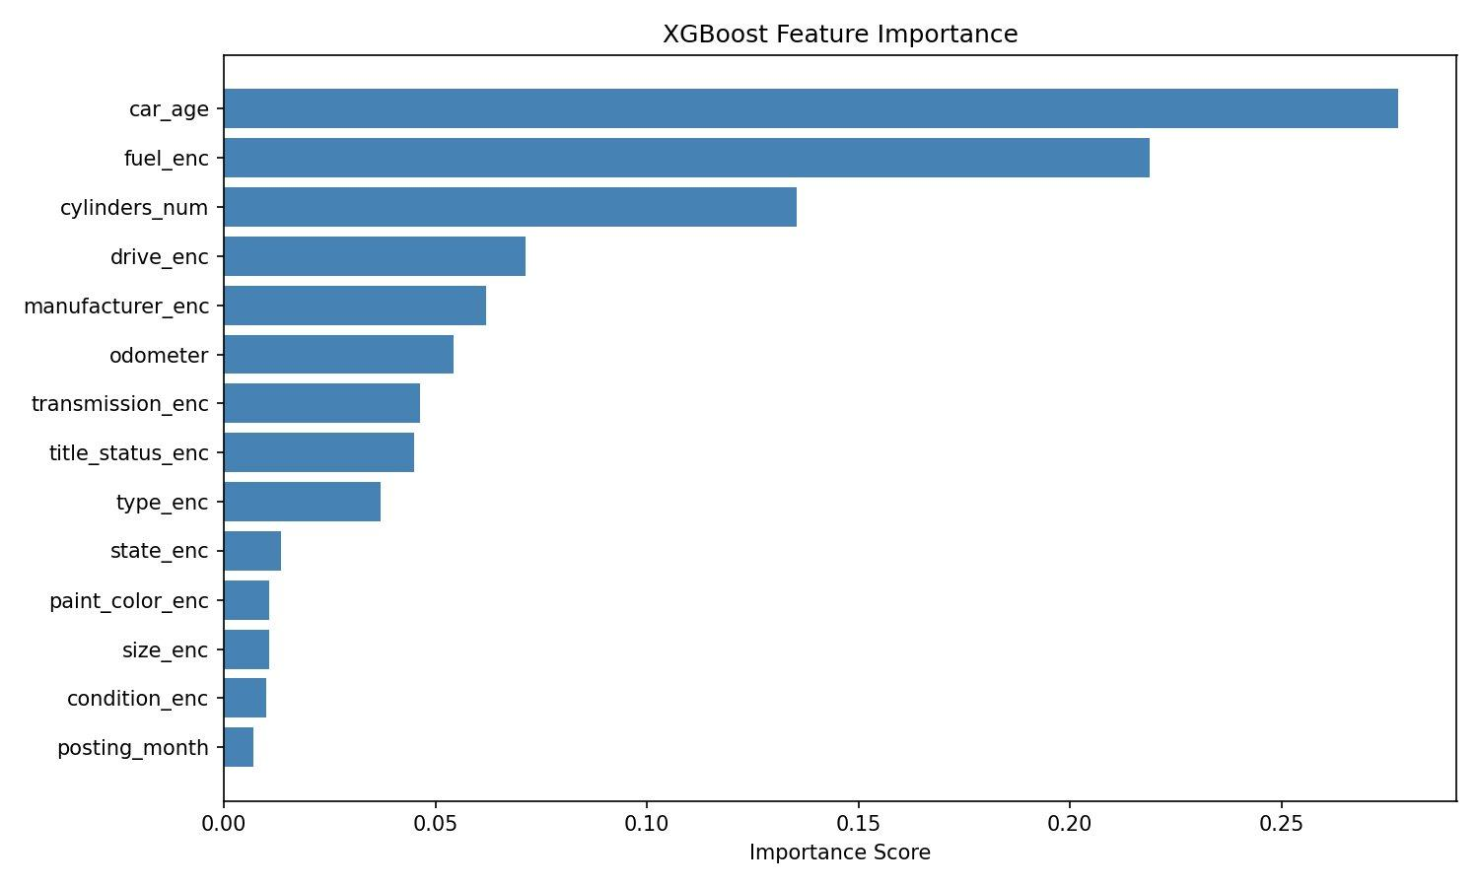
Figure 2: XGBoost feature importance scores across all 14 features.
7. Related Work
Price prediction for consumer goods using structured tabular data is a well-studied problem in machine learning. Gradient boosted trees—particularly XGBoost [1]—have become the standard for tabular regression tasks, consistently outperforming deep learning on structured data with moderate feature sets [2].
Several prior works study used car price prediction specifically. Gegic et al. [3] applied multiple regression models to a European used car dataset and found that mileage and brand were the dominant predictors, consistent with our findings. Listiani [4] showed that Support Vector Regression can be competitive on small datasets, though it does not scale to the 300k+ listings in our setting. Our work extends this line by providing a systematic ablation study on a large-scale, geographically diverse U.S. dataset—a contribution not present in prior work.
Target encoding for high-cardinality categorical variables was formalized by Micci-Barreca [5] and has been shown to outperform one-hot encoding in tree-based models when the number of categories is large. We apply this technique to manufacturer (42 categories) and state (51 categories), two features that would otherwise require substantial dimensionality expansion.
8. Conclusion
We presented a comparative study of three regression models for used car price prediction on the Craigslist dataset. Our key findings are:
(1) Ensemble tree-based models (Random Forest, XGBoost) substantially outperform linear regression (MAE ~$3,400 vs. $6,396), confirming that non-linear feature interactions drive pricing.
(2) Car age is the single most important predictor, followed by odometer reading, vehicle condition, and engine size. Posting month carries negligible signal.
(3) XGBoost matches Random Forest accuracy in roughly one-fifth the training time, making it the practical choice for this scale of data.
Future work could incorporate listing description text features (e.g., keyword extraction for 'leather seats' or 'new tires'), regional economic indicators, or model-year-specific depreciation curves to further reduce prediction error. A simple web-based demo that takes vehicle attributes as input and returns a price estimate would also be a natural next step.
References
[1] Chen, T., & Guestrin, C. (2016). XGBoost: A scalable tree boosting system. Proceedings of KDD '16. ACM.
[2] Grinsztajn, L., Oyallon, E., & Varoquaux, G. (2022). Why do tree-based models still outperform deep learning on tabular data? NeurIPS 2022 Datasets and Benchmarks Track.
[3] Gegic, E., Isakovic, B., Keco, D., Masetic, Z., & Kevric, J. (2019). Car price prediction using machine learning techniques. TEM Journal, 8(1), 113–118. DOI: 10.18421/TEM81-16.
[4] Listiani, M. (2009). Support vector regression analysis for price prediction in a car leasing application. M.Sc. thesis, Hamburg University of Technology.
[5] Micci-Barreca, D. (2001). A preprocessing scheme for high-cardinality categorical attributes in classification and prediction problems. ACM SIGKDD Explorations, 3(1), 27–32.

