**Task 1 –准备netlogo实验环境**

1. 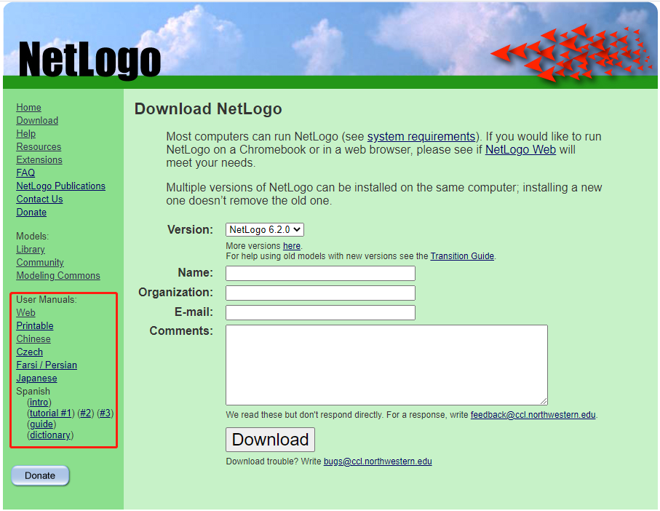模型库 - Code Example – Look Ahead Example。
2. NetLogo Dictionary：https://ccl.northwestern.edu/netlogo/docs/dictionary.html#patch

**提交的作业包括：**

1.《netlogo实验作业》文档中**橘色**标记的 **\*.nlogo** 文件；

2. Task 2-7 中的问答题，请分别写在对应的word文档中（Task2、Task3、……、Task7），并尽量出示相关的实验结果图；

3.作业格式 

**Task 2 – 完成模型 Wolf Sheep Predation 的相关操作**

**学习Tutorial #1完成下列操作**

1. 视图区域设置：x = 80； y = 60；嵌块大小：10
2. 改变populations 监视器中

代表sheep的线条颜色为：pink135

代表wolves的线条颜色为：blue105

1. 观察在初始条件下羊群的

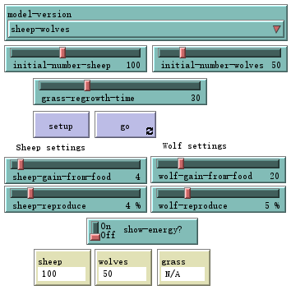

问：羊群怎么变化？

问：调整哪些其他开关、滑动条能帮助羊群?

1. 打开“grass“开关，与之前的模型有什么变化呐？

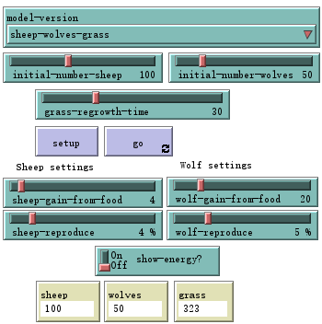

问：为什么会发生这样的改变？

**Save 2Wolf Sheep Predation.nlogo**

**Task 3– 完成模型 Traffic Basic 的相关操作**

1. 改变视图中 道路的颜色为green 9

turtle0的颜色为yellow 47

其他turtle颜色为pink 135

1. 判定发生堵车的条件是什么？
2. 在这个前提下，如果不发生堵车，车道上最多可以容纳多少辆小车？ 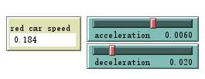

**Save 3Traffic Basic.nlogo**

**Task 4 – Procedures**

实现一个简单的生态系统模型。Patch为可再生草地，turtle可以移动、吃草和繁殖。创建界面来描述这个世界（包括按钮、滑动条、开关、监视器和绘图）

**save 4procedurece.nlogo**

**Task5 – Ants**

1. Load the **‘Ants’ model from the ‘Biology’** section of the NetLogo models library.

2. Run the simulation with the default parameters first, and then consider the following:

1. What happens when you alter the diffusion rate? What happens when the diffusion rate is very low, or very high? Why is this?

2. Do the same for the evaporation rate. Why do you see the results that you do?

3. Is there a tipping point in the size of the population where you do not observe the same emergent behaviour as you did at the start? If so, why do you think this is the case?

3. Edit the code to increase the number of food sources. What effect does this have on the system?( **Save 5.1Ants_addfood.nlogo**)

4. Try different placements for the food sources. What happens if two food sources are equidistant from the nest? **(Save 5.2Ants_equaldis.nlogo)**

**Task6** **– Flocking**

1. Load the ‘Flocking’ model from the ‘Biology’ section of the NetLogo models library.

2. If this model only implements the separation rule. What happen you will see? (**Save 6.1Flocking_onlyseparation.nlogo**)

3.Study the code until you understand how it works, then implement alignment and cohesion rules so that you observe emergent flocking behaviour at the collective level.

4.Currently the boids can ‘see’ all around them. What happens if boids can only see in front of them? (**6.2Save Flocking_onlyseeforward.nlogo**)

* The **in-cone** primitive can be used to implement a cone of vision. Parameterize this cone using a slider, and find a value that produces smooth flocking behaviour.

5.Add obstacles to the world, and implement an obstacle avoidance rule. How does a large aggregated flock react to obstacles that are only encountered by boids at the edge of the flock?( **6.3Save Flocking_obstacle.nlogo**)

* Random position and shape.

**(Extra Lab Work)Task 7 – Formations**

1. Open the “Flocking Vee formations” model (under the Biology section)

2. Study the code, and try and understand the rules that lead to the potential for the Vee formation. Try different parameter settings. What effect do you see when you change the following and what are their relative importance to the algorithm:

a. “too-close”

b. “max-turn”

c. “vision distance” and “vision cone”

3. Implement some obstacles for the boids to avoid. You will need to place an item across a series of patches and also implement a simple rule for a boid to avoid the obstacle. What if the effect of placing the obstacles and can you drive certain formations through the use of obstacles?

**7 Save Formations.nlogo**