Banking Book Interest Rate and Liquidity Stress Testing
  - Public data anchored synthetic portfolio study for Treasury Risk and ALM

Executive Summary
The book is more exposed to changes in long-term economic value than to the first year of interest income. A parallel increase of 200 basis points reduces EVE by USD 3.167 million and 12-month NII by USD 32.2 thousand. Treasury review should prioritize fixed-rate asset duration and the stability of deposit behavior.
Measure | Base or adverse result
Total assets and records | USD 100.0m across 938 synthetic records
Base 12-month NII | USD 2.568m
Worst Delta NII | USD -0.032m (-1.3%)
Base EVE | USD 12.927m
Worst Delta EVE | USD -3.167m (-33.6% of stylized equity proxy)
Combined liquidity result | No breach in 90 days; USD 1.017m terminal buffer

The modest default NII decline depends on assumed deposit pass-through. Setting all non-maturity deposit betas to 15% changes the +200 bps NII result to a gain, while a 55% beta produces a larger loss. The default projection therefore provides a scenario result, not a reliable forecast of realized earnings.
Combined stress consumes almost all available liquidity over the tested horizon. A survival statement of at least 90 days is justified; a longer survival estimate is not. The analysis should support review of deposit retention assumptions, liquid-asset eligibility and the timing of monetization before any limit or hedging decision.

Scope and evidence
Official Treasury par yields observed on 2026-10-22 anchor market rates. Federal Reserve H.8 released on 2026-10-16, with observations for 2026-10-07, anchors industry balance-sheet shares. All 938 contract/group records remain synthetic. This is an independent portfolio project, with internal illustrative shocks and liquidity proxies. It has not been deployed or approved for regulatory use.

Balance Sheet and Assumptions
The observed H.8 all-commercial-bank balance sheet is scaled to USD 100 million of assets. Category shares are preserved to within 0.01 percentage point. No single bank is represented. The public residual share supplies the H.8 residual-based equity proxy. It is not regulatory capital.
Side | Synthetic product | USD m | Records
Asset | Cash and liquid assets | 12.007 | 1
Asset | Consumer loans | 7.271 | 400
Asset | Fixed-rate mortgages | 29.085 | 160
Asset | Floating-rate corporate loans | 18.178 | 50
Asset | Government securities | 22.154 | 12
Asset | Other non-rate-sensitive assets | 11.305 | 1
Equity | H.8 residual-based equity proxy | 9.421 | 1
Liability | Non-maturity retail deposits | 55.703 | 220
Liability | Other non-rate-sensitive liabilities | 5.554 | 1
Liability | Term deposits | 20.256 | 80
Liability | Wholesale funding | 9.066 | 12

Observed inputs and modeled fields
Observed inputs are Treasury par yields and H.8 cash, securities, gross loans, deposits, borrowings, other liabilities, net due to foreign offices and residual balances. H.8 is not seasonally adjusted. XML levels in USD millions are converted to USD billions for calibration.
Model assumptions divide loans 40:25:10 across mortgages, corporate and consumer products, and deposits 55:20 across non-maturity and term products. Broad securities are represented by fixed-rate government proxies. Net other assets include the effect of loan-loss allowances and unmodeled asset categories; other liabilities include net due to foreign offices. Both other categories remain at carrying value and are not treated as liquid resources.
Remaining maturities, coupons, reset dates, amortization, reference spreads, deposit betas and runoff rates are simulated with seed 20261023. Contract weights are lognormal, normalized to calibrated product totals and rounded to cents. Record counts reflect manageable contract/group detail, not a claim about industry customer counts.

Behavior and contractual schedules
Mortgages and consumer loans amortize by equal principal. Corporate loans, securities and term funding are bullet instruments. Interest pays monthly on an ACT/365 basis. NMDs have legal demand maturity but a separate 24–60 month equal-principal behavioral runoff for IRRBB, with monthly betas between 15% and 55%. Their principal-weighted average life is 1.765 years; this is not an estimated market duration. Cash has zero modeled yield. These fields are not inferred from H.8.

Repricing Gap
Rate-sensitive principal is assigned to the first contractual reset, or final maturity for fixed-rate instruments. Non-maturity deposits reprice monthly and fall in the shortest bucket. Cash, other non-rate-sensitive items and equity are shown separately from RSA and RSL. This stock gap does not allocate every future amortization installment.
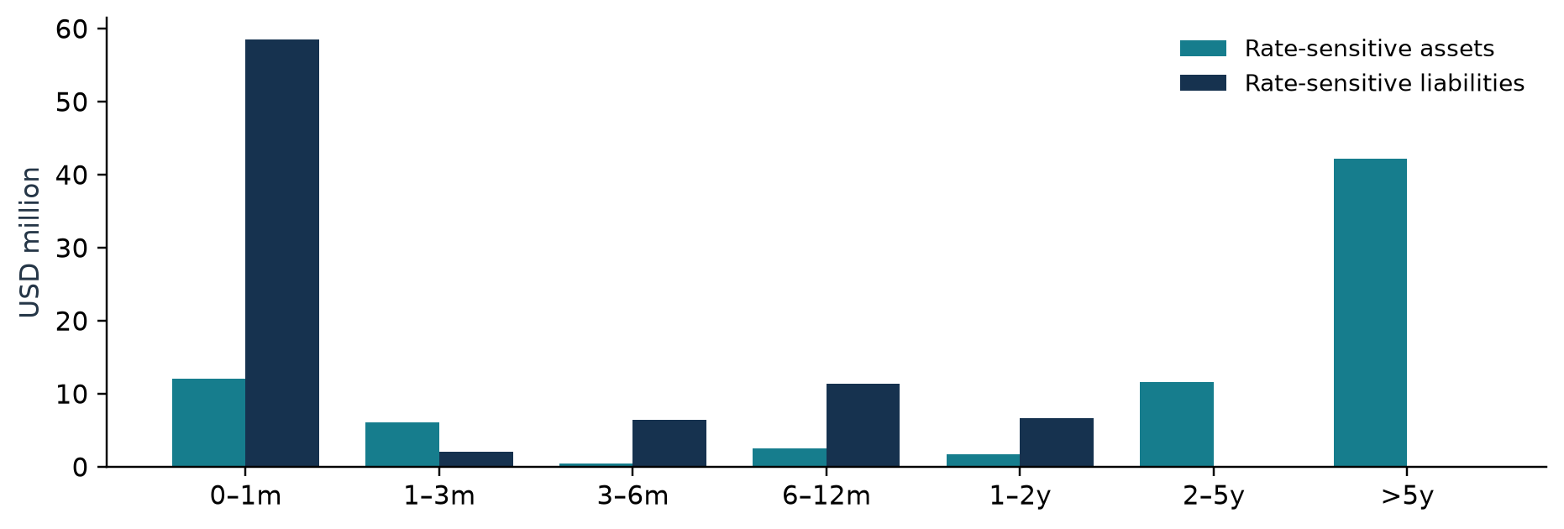
Figure 1 Rate-sensitive assets and liabilities by next repricing bucket
Bucket | RSA | RSL | Gap | Cumulative | Gap / assets
Overnight to 1 month | 12.14 | 58.55 | -46.42 | -46.42 | -46.4%
1 to 3 months | 6.15 | 2.06 | 4.09 | -42.33 | 4.1%
3 to 6 months | 0.44 | 6.45 | -6.01 | -48.34 | -6.0%
6 to 12 months | 2.49 | 11.34 | -8.85 | -57.19 | -8.9%
1 to 2 years | 1.73 | 6.62 | -4.89 | -62.08 | -4.9%
2 to 5 years | 11.60 | 0.00 | 11.60 | -50.48 | 11.6%
More than 5 years | 42.15 | 0.00 | 42.15 | -8.34 | 42.1%
Non-rate-sensitive | 0.00 | 0.00 | 0.00 | -8.34 | 0.0%

Amounts are USD million. Negative short-bucket gaps identify more immediately repricing funding than assets. A low deposit beta can offset part of that exposure, so the gap alone does not determine NII sensitivity. Longer fixed-rate asset cash flows are the principal reason economic-value sensitivity remains material.
Python and SQL assign buckets independently using exact one-, three-, six-, twelve-, twenty-four- and sixty-month anniversary cutoffs. Balance-sheet totals and each RSA/RSL bucket reconcile to a USD 0.01 tolerance.

NII Sensitivity
The 12-month simulation follows the existing book as it runs off. Fixed coupons remain unchanged until maturity. Floating corporate loans retain their current coupons until the scheduled reset and then use the shocked Treasury-implied forward proxy plus spread. Matured principal is not reinvested or replaced, so these results measure a run-off book rather than constant-balance-sheet earnings.
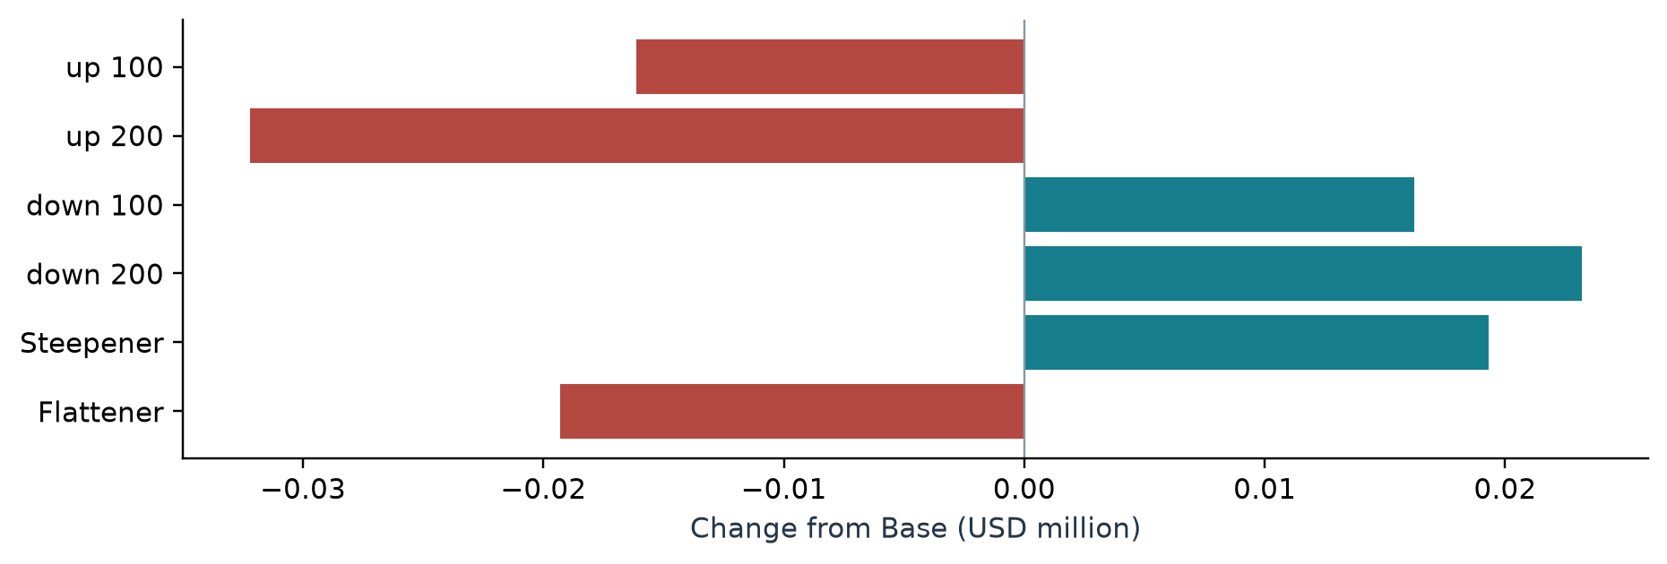
Figure 2 Twelve month Delta NII under internal illustrative scenarios
Internal scenario | NII USD m | Delta USD m | Delta / Base
Base | 2.568 | +0.000 | 0.0%
Parallel up 100 bps | 2.551 | -0.016 | -0.6%
Parallel up 200 bps | 2.535 | -0.032 | -1.3%
Parallel down 100 bps | 2.584 | +0.016 | 0.6%
Parallel down 200 bps | 2.591 | +0.023 | 0.9%
Steepener | 2.587 | +0.019 | 0.8%
Flattener | 2.548 | -0.019 | -0.8%

Why the default effect is small
Under +200 bps, floating corporate income contributes USD +0.281m while higher NMD expense contributes USD -0.313m. Fixed-rate products have zero Delta NII in the run-off model. The difference is a small net decline, not proof that the book is immunized.
NMD coupons equal initial coupon plus beta times the change in the one-month forward index, floored at zero. The initial index is frozen from the Base curve so shocks do not cancel. The Base case permits curve-implied future repricing; down shocks become asymmetric when deposit coupon floors bind.

EVE Sensitivity
EVE is the discounted value of asset cash flows less liability cash flows, excluding equity as a liability. Future principal and interest are generated over the full modeled remaining life. Floating coupons are reprojected under each stressed curve. NMD principal follows the behavioral maturity schedule rather than the legal demand maturity.
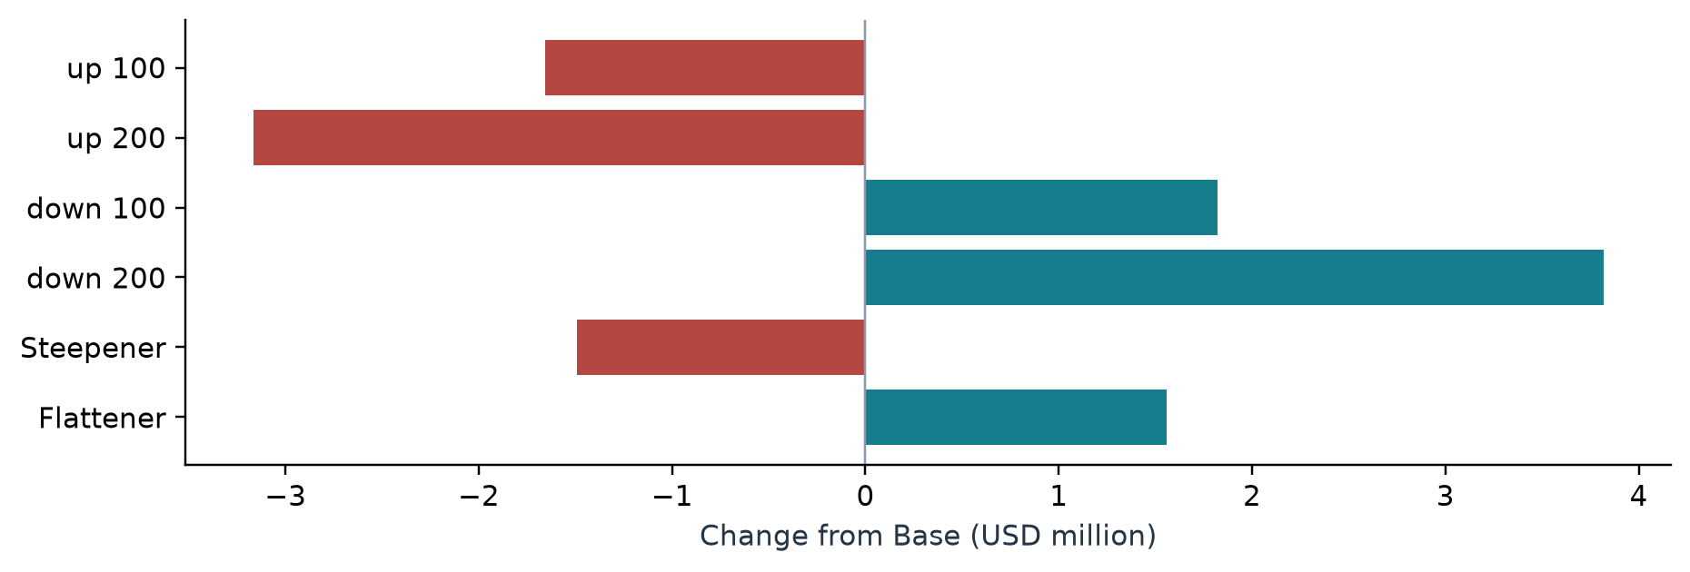
Figure 3 Delta EVE under internal illustrative scenarios
Internal scenario | Asset PV | Liability PV | EVE | Delta EVE | Delta / equity proxy
Base | 100.10 | 87.17 | 12.93 | +0.00 | 0.0%
Parallel up 100 bps | 97.68 | 86.41 | 11.27 | -1.66 | -17.6%
Parallel up 200 bps | 95.43 | 85.67 | 9.76 | -3.17 | -33.6%
Parallel down 100 bps | 102.70 | 87.95 | 14.75 | +1.82 | 19.3%
Parallel down 200 bps | 105.50 | 88.76 | 16.74 | +3.82 | 40.5%
Steepener | 98.79 | 87.36 | 11.44 | -1.49 | -15.8%
Flattener | 101.47 | 86.99 | 14.48 | +1.56 | 16.5%

Amounts are USD million. The worst tested change is USD -3.167m under Parallel up 200 bps, or -33.6% of the USD 9.421m H.8 residual-based equity proxy. This ratio is descriptive; it is not a regulatory capital ratio, a BCBS supervisory outlier test, or a capital-adequacy conclusion.

Curve construction and valuation boundary
Each scenario shocks observed par nodes before constructing a simplified discount-curve proxy. Short maturities use a simple annual-rate approximation. From six months onward, synthetic semiannual par bonds are bootstrapped on a half-year grid using linearly interpolated par rates. Discount factors interpolate log-linearly between grid points. The model does not calibrate a zero curve from coupon-instrument prices, and this proxy is not an official Treasury zero curve.
Cash and other non-rate-sensitive categories are carried at book value as time-zero valuation entries. No credit-spread shock, prepayment, embedded option, basis risk, hedge, or endogenous deposit migration is modeled. Monthly coupon conventions approximate securities and funding cash-flow timing.

Liquidity Stress and Survival Horizon
A daily 90-day ledger starts with cash and adds realized government-security monetization, recognized contractual loan inflows and stress outflows. Securities are monetized once at their Base EVE value after the scenario haircut. Their subsequent coupons and maturities are excluded, preventing double counting. Other assets contribute no monetization capacity.
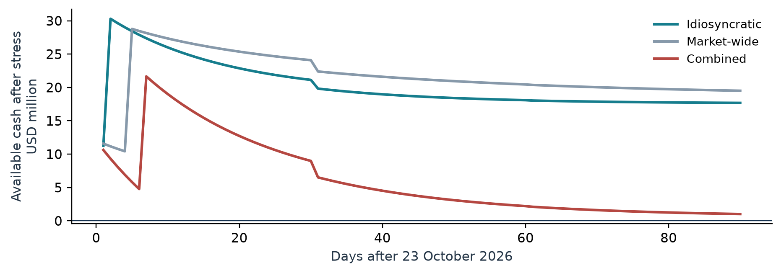
Figure 4 Available cash after stress flows and scheduled monetization
Scenario | Capacity | Outflows | Inflows | Peak need | End buffer | Survival
Idiosyncratic | 19.74 | 15.13 | 1.07 | 0.00 | 17.69 | At least 90d
Market-wide | 18.70 | 12.22 | 1.02 | 0.00 | 19.50 | At least 90d
Combined | 17.87 | 29.92 | 1.07 | 0.00 | 1.02 | At least 90d

Amounts are USD million. All scenarios survive the tested window, so none supports an estimate beyond 90 days. Combined terminal cash is the minimum buffer in that scenario. Counterbalancing capacity is potential sale proceeds before realization and a declining stock afterward; it is not added to cash a second time.
Assumption | Idiosyncratic | Market wide | Combined
Retail baseline runoff multiplier | 2.0x | 1.2x | 4.0x
Term nonrenewal / wholesale loss | 50% / 75% | 65% / 85% | 100% / 100%
Commitment draw / total haircut | 25% / 5% | 40% / 10% | 65% / 14%
Monetization day / collection rate | 2 / 95% | 5 / 85% | 7 / 80%

Retail runoff is 7.5–12.5% per record before the scenario multiplier, spread across days with normalized exponential weights. The internal daily cap recognizes inflows only up to 75% of the same-day outflow; excess inflows are discarded rather than carried forward. This conservative timing rule is not a regulatory LCR implementation. No NSFR is calculated.

Management Interpretation
The same +200 bps shock produces a small first-year earnings decline and a much larger economic-value decline. Treasury management should read both measures together: delayed repricing protects current coupons but leaves long-lived assets exposed to higher discount rates. A large accounting cash balance does not remove valuation risk.
Product | Delta NII USD m | Delta EVE USD m
Fixed-rate mortgages | +0.000 | -2.576
Floating-rate corporate loans | +0.281 | -0.081
Consumer loans | +0.000 | -0.182
Government securities | +0.000 | -1.827
Cash and liquid assets | +0.000 | +0.000
Non-maturity retail deposits | -0.313 | +1.101
Term deposits | +0.000 | +0.311
Wholesale funding | +0.000 | +0.088
Other non-rate-sensitive assets | +0.000 | +0.000
Other non-rate-sensitive liabilities | +0.000 | +0.000

Product contributions above reconcile to the +200 bps aggregate. Signs reflect net income and net economic value; a positive liability EVE contribution offsets asset losses. The table is a bridge of modeled results, not a proposed hedge allocation.

Validate deposit behavior before setting limits
At a uniform 15% NMD beta, +200 bps Delta NII is USD +0.140m; at 55% it is USD -0.234m. Halving behavioral maturities changes Delta EVE to USD -3.662m, while extending them by 50% changes it to USD -2.743m. Each comparison uses its own Base valuation. Deposit assumptions can change the earnings direction and materially alter EVE.

Review liquidity concentration and execution
Combined stress leaves approximately 1% of total assets in cash at day 90. Review the availability of unencumbered securities, realistic settlement delays and deposit runoff concentration. The current model assumes all government holdings are eligible for sale and excludes other-liability cash calls. Those assumptions require evidence before treating the terminal buffer as usable contingency capacity.
A next analytical step is to compare duration reduction, additional liquid resources and deposit-retention strategies under validated assumptions. No hedging cost, instrument eligibility or optimization has been modeled, so this report does not select a transaction.

Limitations and Next Steps

Public aggregates do not reveal contract risk
H.8 anchors an industry balance-sheet structure. It does not supply a bank-specific contractual maturity ladder, deposit beta, liquidity eligibility, regulatory capital or account-level behavior. The internal loan and deposit splits and the mapping of broad securities to government proxies simplify the published categories. Gross loans and the residual net-asset adjustment preserve the observed total without constructing a synthetic trading book.

Interest rate and valuation limitations
The model excludes mortgage prepayment, consumer early repayment, default, embedded options, derivative hedges, credit-spread changes, basis shocks and dynamic customer migration. Equal-principal amortization is not a standard annuity mortgage schedule. Treasury-implied forwards are a pricing proxy, not SOFR. Cash has zero yield. Other assets and liabilities are rate-insensitive at carrying value, which can understate their actual risk.
NII uses existing-book runoff rather than a constant or dynamic balance sheet. EVE includes contractual margins and projected floating coupons, so it is not a claim to any regulatory standardized implementation. Par-to-discount construction and monthly payments approximate market conventions. Only seven deterministic internal rate scenarios are tested; no probabilistic loss estimate is produced.

Liquidity and capital limitations
The stress framework does not model insurance status, depositor concentration, intraday settlement, collateral encumbrance, central-bank eligibility, reserve requirements, FX mismatches, derivative margin calls, or cash outflows from the other-liability proxy. Retail runoff and commitment draw schedules are imposed. Rolled funding principal is assumed to remain beyond 90 days, with ongoing interest expense. Newly drawn commitments generate no inflows within the window.
The daily inflow cap, loan collection discounts and asset haircuts are internal assumptions. Available market capacity is unlimited at the haircut price. A no-breach result is censored at 90 days, not evidence of indefinite survival. The H.8 residual is an accounting aggregate used solely as a stylized equity proxy and cannot support a capital-adequacy conclusion or supervisory outlier test.

Recommended development sequence
First replace behavior assumptions with a documented estimation and challenge process. Then add contractual instrument payment calendars, prepayment and basis-risk models. Extend liquidity to encumbrance, concentration and collateral channels and test cap conventions. Add hedges and costs only after the unhedged model is reconciled. A production workflow would require independent model validation, governance, controlled data feeds and an approved operating specification.

Validation completed
The engine passes 30 dataset controls. The full pytest suite includes source-lock attacks, independently expected contract examples, par-bond repricing, discount monotonicity, reset timing, principal conservation, beta sensitivity and liquidity stock accounting. Five Python/SQL controls pass at USD 0.01: balance and repricing are independent recomputations; liquidity, NII and EVE are partial recomputations using shared Python cash flows or discount inputs. These checks establish internal consistency within the stated assumptions; they do not validate the assumptions empirically.

Technical Appendix
Pipeline order: mandatory locked-source and observation-lineage validation, H.8 calibration, synthetic positions, shared cash-flow schedules, Python aggregation, DuckDB reconciliation, automated controls, figures and management artifacts. The frozen run is offline-reproducible; refresh is prohibited in the locked release. All figures and report numbers read the saved CSV and JSON outputs.
Measure | Implementation
Repricing gap | RSA minus RSL by first reset/fixed maturity; cumulative sum in bucket order
NII | Sum of 12-month asset interest less liability interest; Delta = scenario minus Base
EVE | Sum of signed discounted full-life principal and interest; equity excluded
Liquidity gap | Opening cash + cumulative recognized inflows - outflows + realized monetization
Survival | Last fully funded day before first negative daily gap; at least 90 if no breach
Shock definition | Parallels +/-100/200 bps; steepener 0.01(1-2 exp(-t/4)); flattener opposite

Official sources and acquisition record
US Treasury Daily Treasury Par Yield Curve Rates
https://home.treasury.gov/resource-center/data-chart-center/interest-rates/pages/xml?data=daily_treasury_yield_curve&field_tdr_date_value=2026
Observation 2026-10-22; selected feed updated 2026-10-23T04:00:43Z. Publication-date metadata is the Atom entry update date, not an independently observed market-close timestamp.
Federal Reserve H.8 official downloadable XML
https://www.federalreserve.gov/releases/h8/data/FRB_h8_xml.zip
Official release cross-check https://www.federalreserve.gov/releases/h8/current/default.htm
H.8 released 2026-10-16; observed 2026-10-07; all US commercial banks, not seasonally adjusted. Downloaded 2026-10-23T20:58:35.242778+08:00. XML source units are USD millions. No fallback source was used.
Frozen source file | SHA256
treasury_annual_source.xml | 8ca59afe0ed35054787ee256d5f384c3d3252f98eb5898caf0b105f665897bfe
treasury_selected_entry.xml | 4a16963604c4bf96bb0e14e1f3944ac9063e8e7370796ca77ebd8e640a36c5c8
treasury_yield_curve_2026-10-22.csv | 0178bc9acf0ba819f571f29f5ce5a7b9f52b5c4e0a18dc4341b38fea4ff211bd
federal_reserve_h8_current_source.html | 59ecf8e72e3c2bb3414edf8a36fab7116adbb17e6999bd5d32ca70976d700949
federal_reserve_h8_2026-10-16.csv | cb1f6d5d9dff0b8d469d254db2e502dd121f55b2782ba8ebf5ecefe73044d135
federal_reserve_h8_source.zip | 2ce2d425cdc21fe7fe3623aec6fe0dc273438e6887cdea813a69e188344c222b

Field mappings, source sizes and full paths: data/processed/public_data_lineage.json. Contract fields: data/processed/field_dictionary.csv. Reconciliation SQL: sql/. Control evidence: qa/.

