CS325 HW6

Yihong Liu

I’m using LINDO software to solve the question 1-3.

1.

a)

Lindo code below:

**max g**

**ST**

**a=0**

**h-g<=3**

**b-h<=9**

**a-h<=4**

**b-a<=8**

**f-a<=10**

**a-f<=5**

**b-f<=7**

**c-f<=3**

**c-b<=4**

**d-c<=3**

**f-d<=18**

**e-b<=10**

**d-e<=9**

**e-d<=25**

**d-g<=2**

**g-e<=7**

**e-f<=2**

**end**

the shortest path from A to G is 19, the result screenshot below:

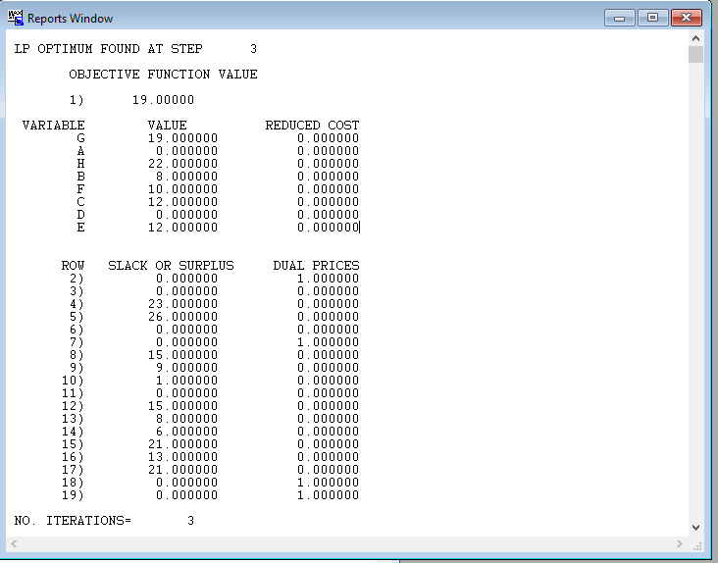

b)

the Lindo code below:

***max a+b+c+d+e+f+h***

***ST***

***a=0***

***h-g<=3***

***b-h<=9***

***a-h<=4***

***b-a<=8***

***f-a<=10***

***a-f<=5***

***b-f<=7***

***c-f<=3***

***c-b<=4***

***d-c<=3***

***f-d<=18***

***e-b<=10***

***d-e<=9***

***e-d<=25***

***d-g<=2***

***g-e<=7***

***e-f<=2***

***end***

the result is :

a to a is 0

a to b is 8

a to c is 12

a to d is 15

a to e is 12

a to f is 10

a to h is 22

a to g is 19

screenshot list below:

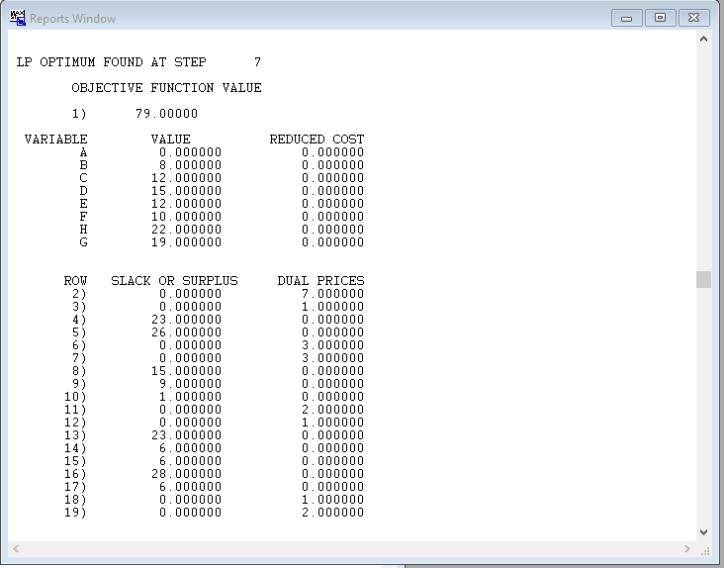

2.

type selling labor material Profit

silk s 6.75 0.75 0.125*20=2.5 6.75-0.75-2.5=3.5

polyester p 3.50 0.75 0.08*6=0.48 3.50-0.75-0.48=2.27

blend 1 b 4.31 0.75 0.05*6+0.05*12=0.9 4.31-0.75-0.9=2.66

blend 2 c 4.81 0.75 0.03*6+0.07*12=1.02 4.81-0.75-1.02=3.04

the Lindo code list below:

***max 3.5s+2.27p+2.66b+3.04c***

***ST***

***0.125s<=1000***

***0.08p+0.05b+0.03c<=2050***

***0.05b+0.07c<=1250***

***s>=6000***

***s<=7000***

***p>=10000***

***p<=14000***

***b>=14000***

***b<=16000***

***c>=6000***

***c<=8500***

***end***

***GIN s***

***GIN p***

***GIN b***

***GIN c***

The optimal number for s is 7000, for p is 13928, for b is 14001, for c is 7856. The result screenshot is below:

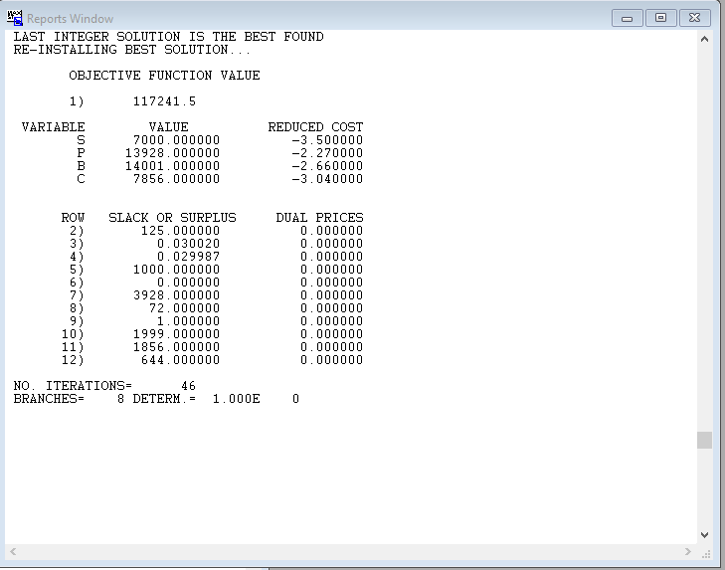

3.

a)

***min v1+v2+v3+v4***

***ST***

***v1+5v2+10v3+25v4=202***

***v1>=0***

***v2>=0***

***v3>=0***

***v4>=0***

***end***

***gin v1***

***gin v2***

***gin v3***

***gin v4***

2 ‘1’ value and 8 ‘25’ value will be used; the screenshot is below:

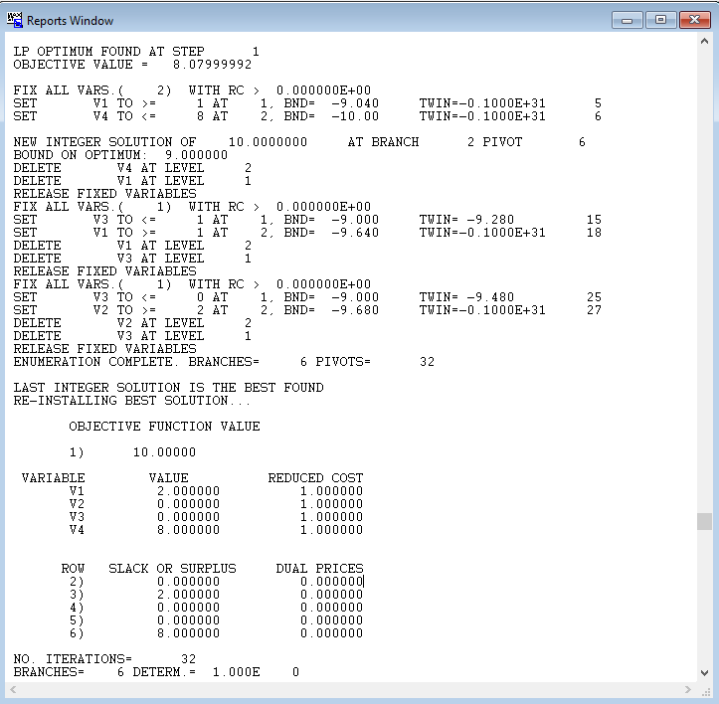

***b)***

***min v1+v2+v3+v4+v5***

***ST***

***v1+3v2+7v3+12v4+27v5=293***

***v1>=0***

***v2>=0***

***v3>=0***

***v4>=0***

***v5>=0***

***end***

***gin v1***

***gin v2***

***gin v3***

***gin v4***

***gin v5***

the optimal solution would be 2 ‘7’, 3 ‘12’, 9 ‘27’

the result is below:

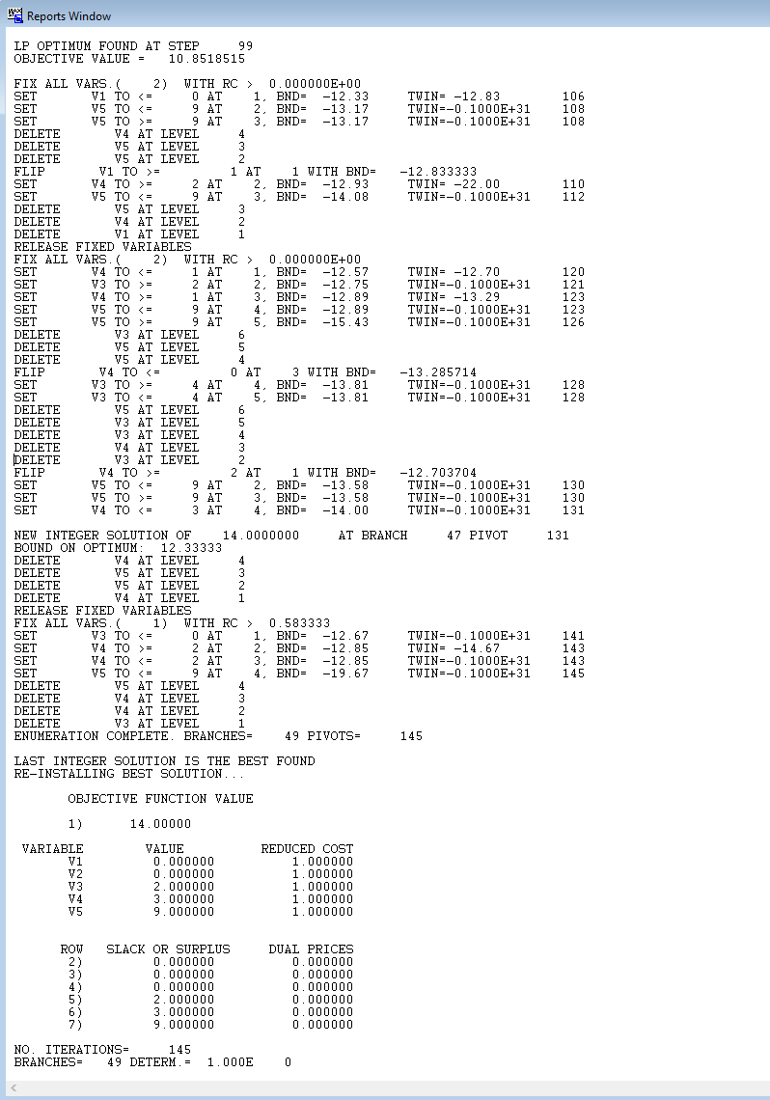

4.

x1 + x2 -x3 + s1 <= 14 (slack)

6x1 – x2 – s2 >= 8 (surplus)

-x1 + 2x2 + 2x3 - s3 >= 0 (surplus)

Slack form:

***Maximize 2x1 – 6x3***

***Subject to***

***S1 = 14 – x1 – x2 +x3***

***S2 = -8 + 6x1 -x2***

***S3 = -x1 + 2x2 + 3x3***

***X1 >= 0***

***X2 >= 0***

***X3 >= 0***

***S1 >= 0***

***S2 >= 0***

***S3 >= 0***

***End***

Basic variable: s1, s2 and s3. Non-basic variable: x1, x2 and x3.