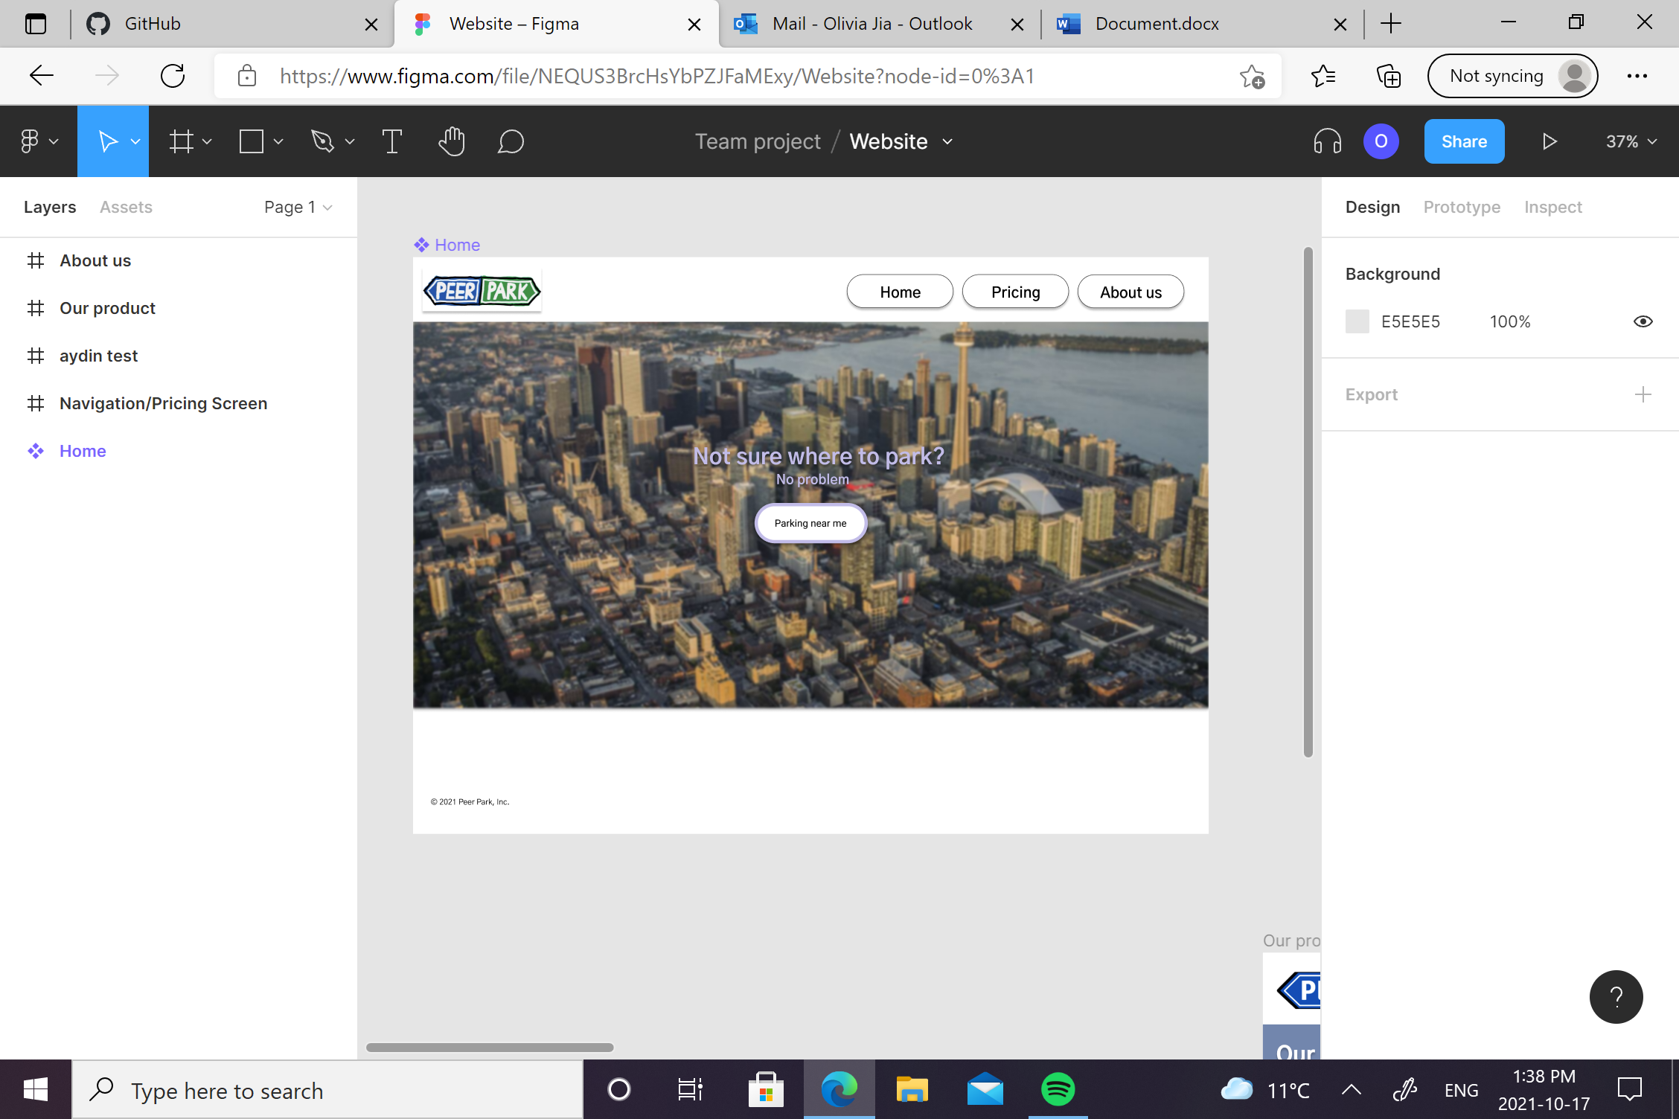

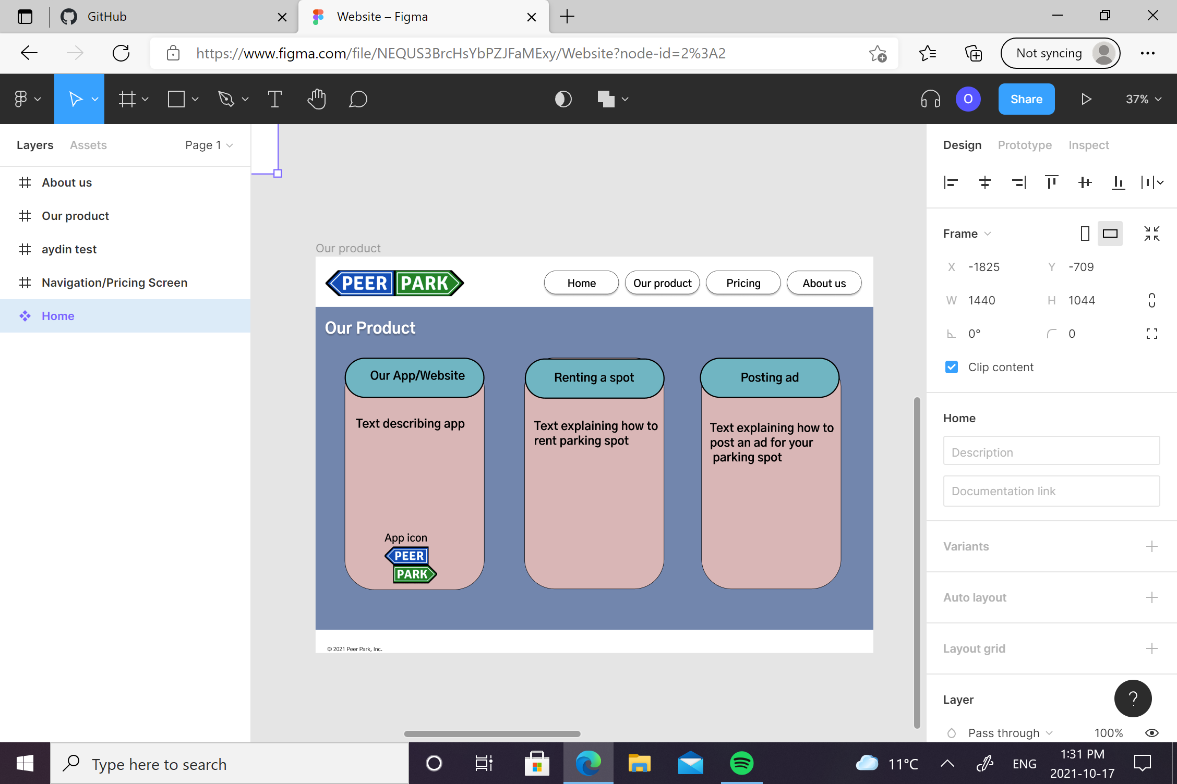

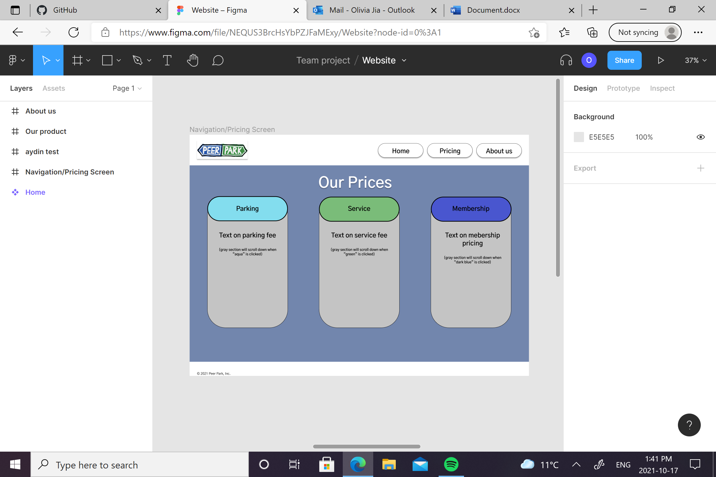

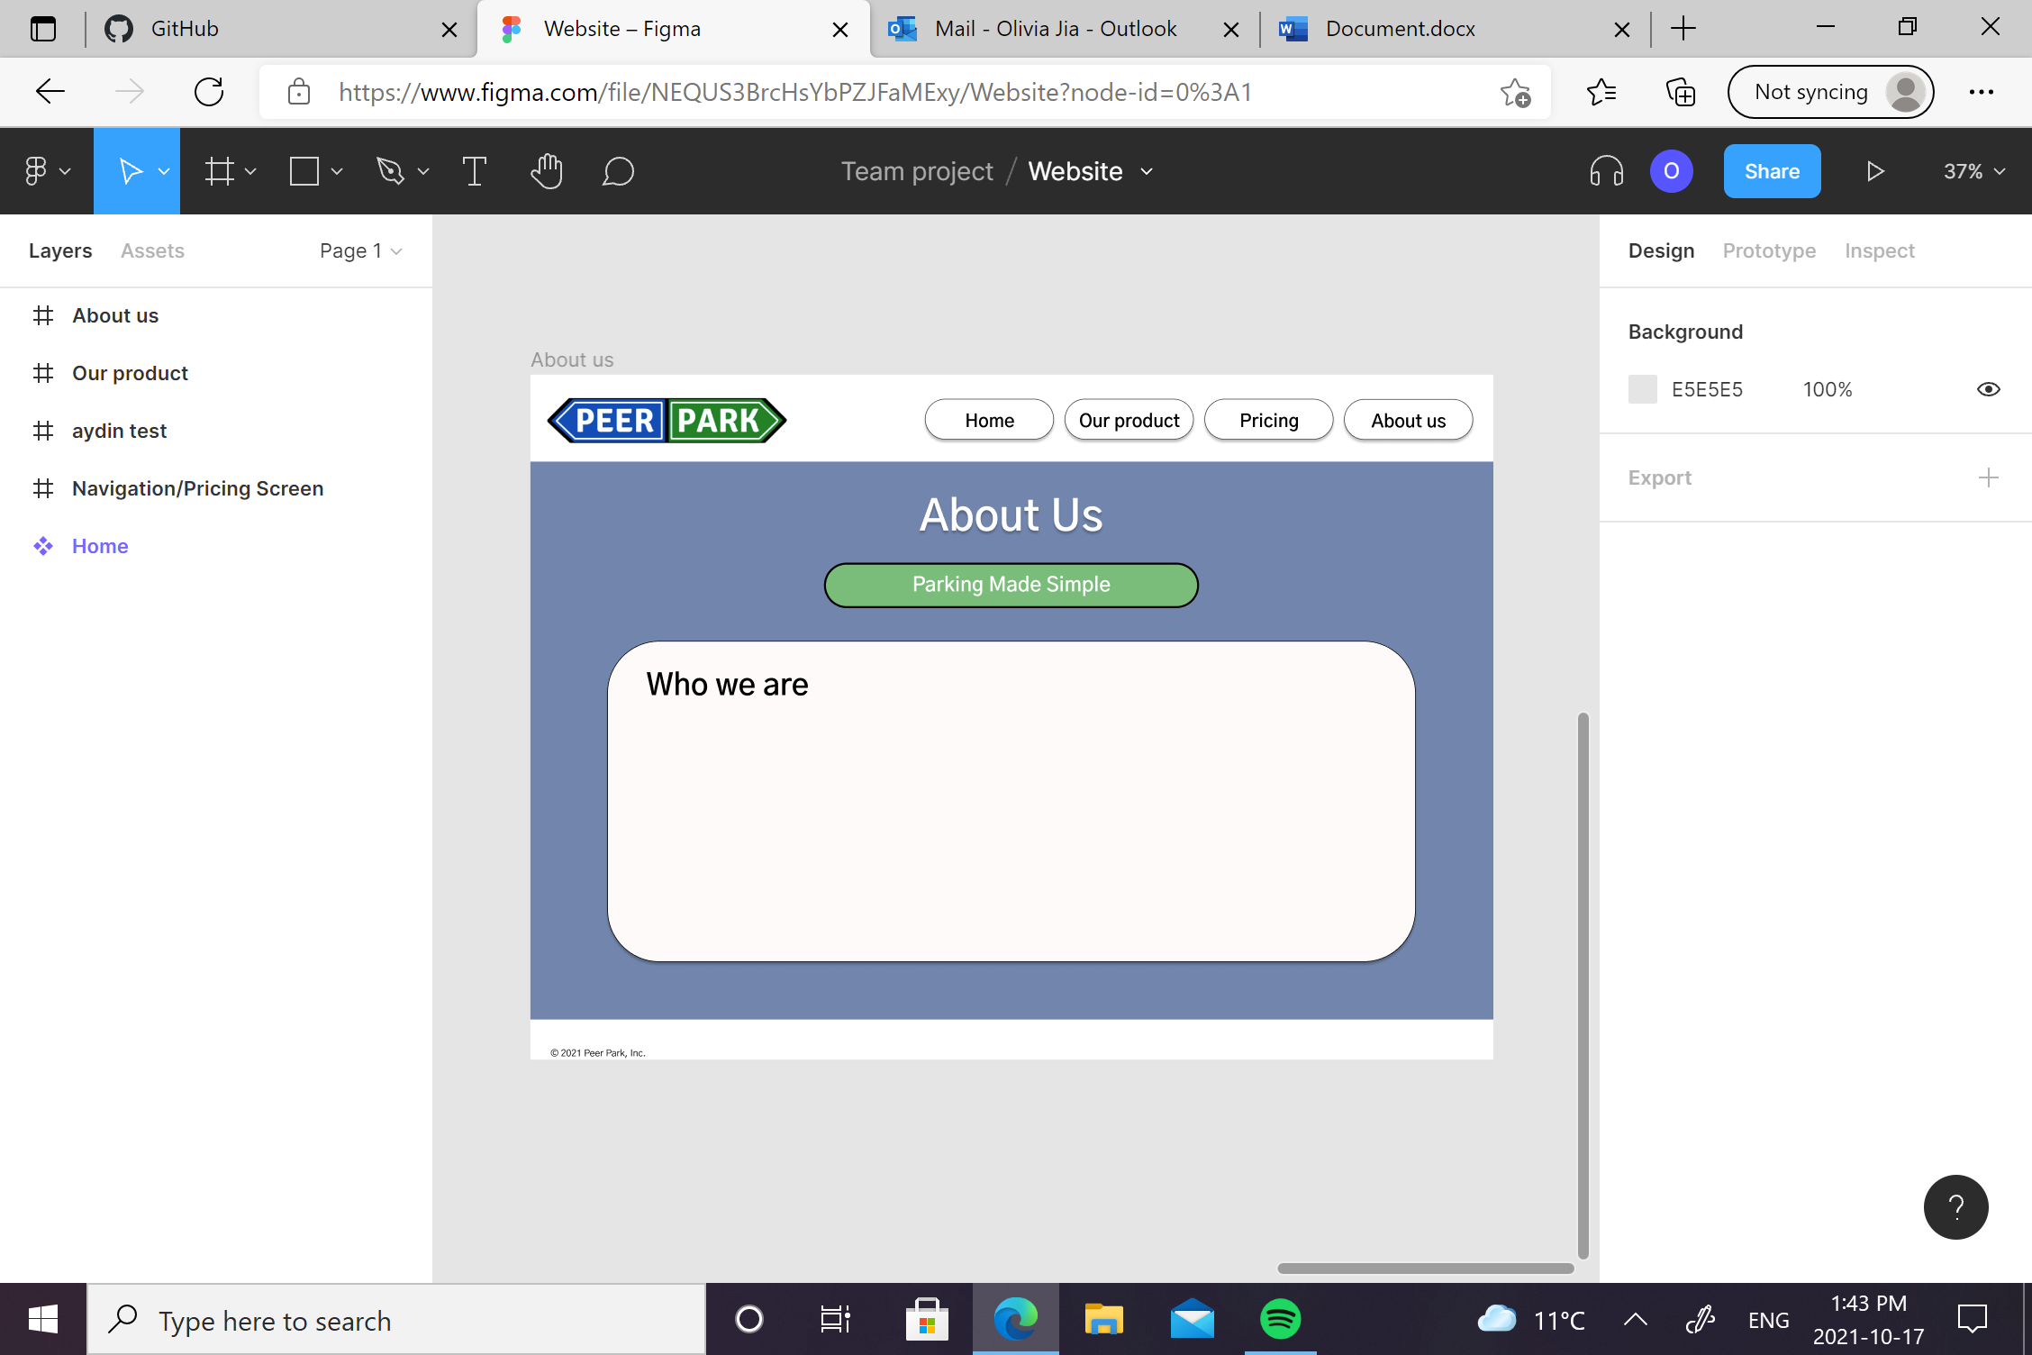

Link: [Website – Figma](https://www.figma.com/file/NEQUS3BrcHsYbPZJFaMExy/Website?node-id=0%3A1)