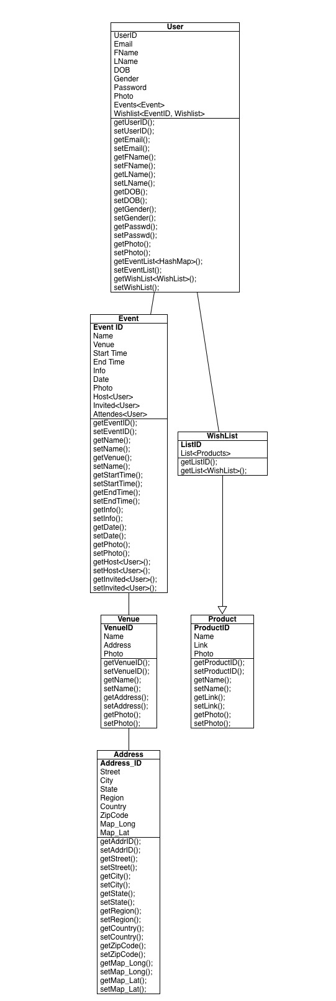
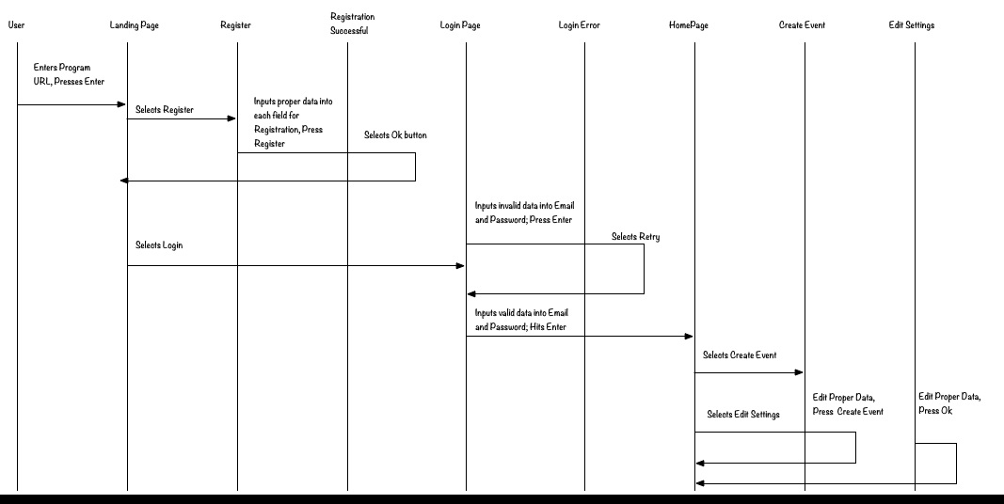
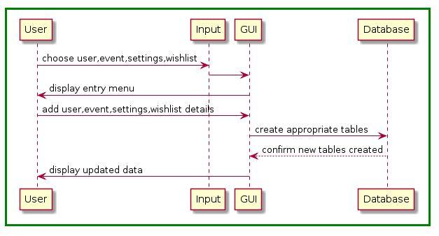
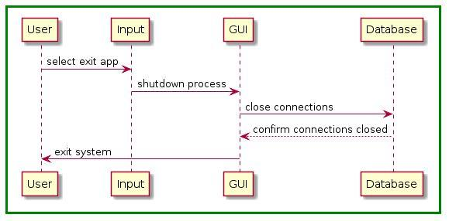
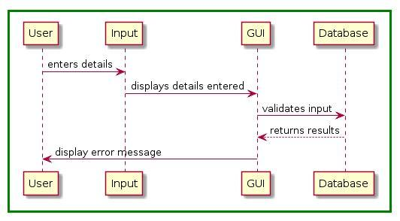
Project Design Document
Group 9:
Adam Beck-Budovec and Joe Dacheux
University of Maryland Global College
Author Note:
Revision: 1.0

Date: 09/15/2021

Class #: CMSC 495

Revision History

Revision | Date | Name of editor | Description
1 | 09/15/21 | Joe Dacheux | Original Document

Design

The project is to create an application that gives users who have no experience in crypto, entry level knowledge in order to maximize investing their crypto. This is not a get rich quick application but a means for people to receive large benefits that beat inflation. For example investing into stable coin that is equal to the US Dollar and does not change, and getting between 10% - 14% back a year beating the rate of inflation and benefiting the application users.

From the project analysis, we proceed with the following design:

Class Diagram
User
Aggressive
Long Term
Medium
Displays the investment
options for aggressive while
Still maximizing interest
and return on Investment
Shows new screen allowing the user
To input the amount they wish
To invest and what accounts
Are needed to maximize investment
Displays the investment
options for Long Term maximizing
interest and return of investment
Event Trace Diagram

Loading Page | Create GUI Page | Aggressive | Medium | Long Term

Normal Operation Diagram

Shut-down Diagram

Event Class Pseudocode:

package com.cryptoApp;
import java.awt.BorderLayout;
import java.awt.FlowLayout;
import java.awt.LayoutManager;
import java.awt.event.ActionEvent;
import java.awt.event.ActionListener;
import javax.swing.*;
import javax.swing.text.JTextComponent;
import java.awt.Dimension;
import javax.swing.BorderFactory;
import javax.swing.JFrame;
import javax.swing.JLabel;
import javax.swing.JPanel;
import javax.swing.WindowConstants;
class menuWindow {
public static void main(String[] args){
new loadingScreen();
createWindow();
}
public static void createWindow() {
JFrame frame = new JFrame("Investment Style");
frame.setDefaultCloseOperation(JFrame.EXIT_ON_CLOSE);
createUI(frame);
frame.setSize(560, 600);
frame.setLocationRelativeTo(null);
frame.setVisible(true);
}
private static void createUI(final JFrame frame) {
JPanel panel = new JPanel();
LayoutManager layout = new FlowLayout();
panel.setLayout(layout);
JButton aggButton = new JButton("Agressive");
Dimension size = aggButton.getPreferredSize();
aggButton.setBounds(40, 100, 100, 60);
JButton modButton = new JButton("Moderate");
JButton longButton = new JButton("Long Term");
aggButton.addActionListener(new ActionListener() {
public void actionPerformed(ActionEvent e) {
JOptionPane.showMessageDialog(frame, "Aggressive Investments");
}
});
modButton.addActionListener(new ActionListener() {
public void actionPerformed(ActionEvent e) {
JOptionPane.showMessageDialog(frame, "Medium Investments");
}
});
longButton.addActionListener(new ActionListener() {
public void actionPerformed(ActionEvent e) { JOptionPane.showMessageDialog(frame, "Low Risk Investments");
}
});
panel.add(aggButton);
panel.add(modButton);
panel.add(longButton);
frame.getContentPane().add(panel, BorderLayout.CENTER);
}
}

Unresolved risks

Risk 1: Getting most up to date knowledge from the online sources

Risk 2: Being able to convey years of knowledge and self teaching into user friendly application.
.

