Measures of uncertainty reduction that available information could provide.

Expected reduction in uncertainty, for a set of diseases, or disease versus no disease.
The uncertainty associated with one disease state (Coombs, Dawes, & Tversky, 1970).
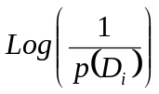 or 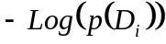.
The expected uncertainty associated with the prior probabilities of a set of diseases. The summation is over the possible diseases, or in the simplest case over having the disease and not having the disease.
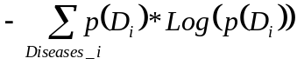
The expected uncertainty associated with the post-finding (sign, symptom, or test result) probability of a disease. (Post revelation of an unknown finding.) The outer summation is over the possible values of the finding. The inner summation is over the possible disease states, conditional on each finding.
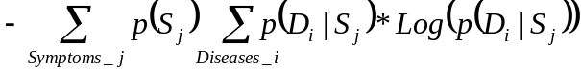
The difference between the last two is the change in the expected uncertainty about the disease state, that can be expected if we sought information about a finding or symptom (Benish, 1999, 2009). If several types of information or test are available, each costs the same, and there is a limited budget, it would be better to get the information that most reduces the uncertainty.
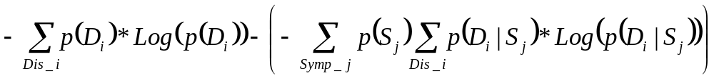

November 3, David asks about the post test expected uncertainty, could we change the position of the probabilities.

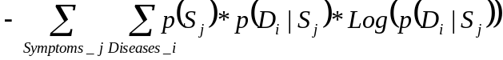

For the inverted tree, which would tell us the uncertainty about the symptom, it would be, assuming that it does not matter which order the sum signs are placed

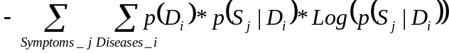

Benish, W. A. (1999). Relative entropy as a measure of diagnostic information. Med Decis Making, 19(2), 202-206.
Benish, W. A. (2009). Intuitive and axiomatic arguments for quantifying diagnostic test performance in units of information. Methods Inf Med, 48(6), 552-557.
Coombs, C. H., Dawes, R. M., & Tversky, A. (1970). Information theory (Chapter 10) Mathematical Psychology: An Elementary Introduction. Englewood Cliffs, NJ: Prentice-Hall, Inc.

