# BREAST CANCER REPORT

## Introduction

* Breast cancer is one of the most common cancers affecting women worldwide. Early detection and accurate diagnosis are critical for effective treatment and improving survival rates.
* This project aims to leverage data science and machine learning techniques to analyze a dataset containing various attributes of breast cancer cases.
* The dataset, sourced from the UCI Machine Learning Repository, consists of 574 instances and 32 attributes, including features computed from a digitized image of a fine needle aspirate (FNA) of a breast mass.

## The key objectives of this project are:

* To explore and preprocess the dataset, handling any missing values, duplicates, wrong datatypes, inconsistent data appropriately,.
* To engineer new features that could potentially improve the performance of predictive models.
* To visualize the data to uncover patterns and insights.
* To build and evaluate machine learning models for predicting the diagnosis of breast cancer.
* To draw conclusions and provide actionable insights based on the analysis.

## Exploring the Dataset

### Loading and Inspecting the Dataset:

* The breast cancer dataset was loaded and inspected to understand its structure and content.
* The dataset contains 574 rows and 32 columns. Each row represents a different instance of breast cancer, with features derived from a digitized image of a fine needle aspirate (FNA) of a breast mass.

### Identifying Missing Values

The missing values in the dataset were identified as follows:

|  |  |
| --- | --- |
| Features | Missing values |
| id | 8 |
| Concavity mean | 3 |
| concave points_mean | 2 |

### Calculating Missing Data Percentage

The percentage of missing data for each feature was calculated to understand the extent of missing values:

|  |  |
| --- | --- |
| Features | Percentage of missing values |
| id | 1.39% |
| Concavity mean | 0.52% |
| concave points_mean | 0.35% |

This analysis indicates that the percentage of missing data is relatively low, with all features having less than 2% missing data.

### Handling Missing Data

* **id Column:**
* is a unique identifier and missing values in this column do not affect the analysis.
* The **id** column serves as a unique identifier and is not required for the analysis or modeling process. Not Dropping rows with missing id values will not impact the quality of our analysis.
* **Concavity mean and concave points_mean columns:**
* We will use median imputation to fill in the missing values. This method is simple and effective for numerical data with a low percentage of missing values.
* median imputation is a suitable method. It is simple to implement and preserves the overall central tendency of the data.
* Evaluation:
* After handling the missing values, we verified that there were no missing values remaining in the dataset.
* The summary statistics for the imputed columns were examined to ensure that the overall distribution of the data was not adversely affected.
* The results confirmed that the imputation method preserved the integrity of the dataset.

### Handling inconsistent data

* **Diagnosis column:**
* it has categorical data of M and B.
* Found two inconsistent values of MM and BB in the diagnosis column.   
  Chose to use a dictionary to map the inconsistent values to the expected values and using a replace method the values MM and BB were replaced by M and B.
* Evaluation  
  After handling inconsistent data the instances in the diagnosis column had categorical data of M or B

### Handling Duplicate Data

* Five(5) instances had duplicated data, they had same records with same id with other five rows.
* Used a drop method to drop these rows, because this is unnecessary repetition of rows
* Evaluation  
  After handling duplicate data, the rows in the dataset reduced to 569

## Exploratory Data Analysis(EDA)

### Descriptive Statistics:

* To better understand the dataset, we calculated the descriptive statistics for each feature.   
  This provided us with insights into the central tendency, spread, and overall distribution of the features.
* **Central Tendency (Mean, Median, Mode)  
  The mean values indicate the average of each feature.  
  The median provides the middle value, showing the central point of the data distribution.  
  The mode indicates the most frequently occurring value in each feature.**
* **Dispersion (Standard Deviation, Min, Max, Quartiles)  
  Standard deviation shows the amount of variation or dispersion of the feature values.  
  Minimum and maximum values indicate the range of the data.  
  Quartiles (25%, 50%, 75%) provide information about the spread of the data around the median.**

### ****Skewness and Kurtosis:****

* ****Skewness**  
  Skewness measures the asymmetry of the data distribution. It tells us how much the distribution of a dataset deviates from a normal distribution.**
* ****Kurtosis**  
  Kurtosis measures the "tailedness" of the data distribution. It tells us how heavy or light the tails of the distribution are compared to a normal distribution.**

**High Skewness indicates a significant asymmetry in the distribution.**

**High Kurtosis points to heavy tails and potential outliers.**

**Low Skewness and Kurtosis near 0 imply a more normal-like distribution.**

**Negative Kurtosis indicates lighter tails compared to a normal distribution.**

* **Implications**
* **Features with High Skewness and Kurtosis May require transformation (e.g., log transformation) to normalize distributions and reduce the impact of outliers.**
* **Features with Low Skewness and Kurtosis: Generally well-behaved for many modeling techniques.**
* **Recommendations:  
  Consider applying log transformations to highly skewed features to improve model performance and interpretability.**

### ****Data Visualization****

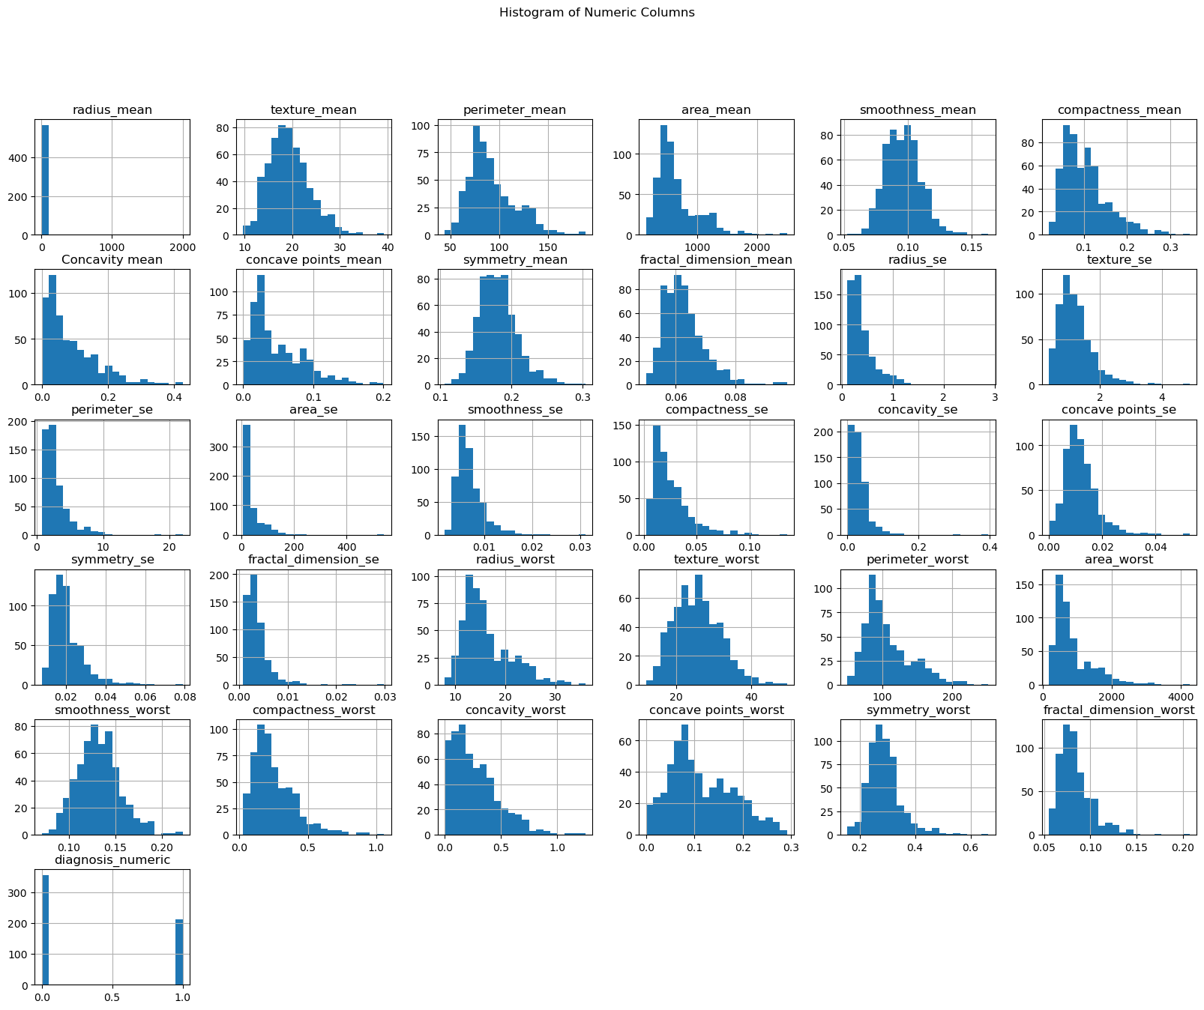

* **Distribution of a single Variable(Histogram):  
  The histograms reveal that many features exhibit right-skewed distributions, indicating that a majority of the values are concentrated on the lower end with a few extreme values on the higher end.**
* **Implications for Analysis  
  The skewness in many features suggests that transformations may be necessary to normalize the data before applying certain statistical models.**
* **Conclusion  
    
  Understanding the distribution of features through histograms is a crucial step in the data preprocessing phase.  
     
  It guides decisions on data transformations and helps in identifying any preprocessing steps needed to ensure robust and reliable model performance.**

### ****Count Plot : Distribution of diagnosis column(M, B)****

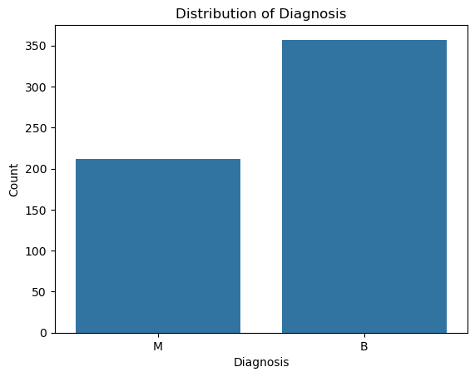

* **The count plot illustrates the distribution of the diagnosis variable, which indicates whether a tumor is malignant M or benign B.**
* **The count plot for the diagnosis column shows that there are more benign (B) cases compared to malignant (M) cases. Specifically, there are approximately 357 benign cases and 212 malignant cases in the dataset.**
* **This indicates an imbalance in the class distribution, with benign cases being more prevalent.**
* **Implications for Analysis.  
  The imbalance in the class distribution could affect the performance of machine learning models, particularly those that are sensitive to class imbalance.**

**Models might be biased towards the majority class (benign) and perform poorly on the minority class (malignant). To address this, techniques such as resampling (oversampling the minority class or undersampling the majority class) or using algorithms that handle class imbalance (e.g., SMOTE, balanced random forests) might be necessary.**

* **Conclusion  
  Understanding the distribution of the diagnosis variable is crucial for guiding subsequent data preprocessing and model selection steps.   
  Addressing the class imbalance will be an important step to ensure that the predictive models are accurate and reliable for both classes.**

### ****Boxplot(Identifying outliers):****

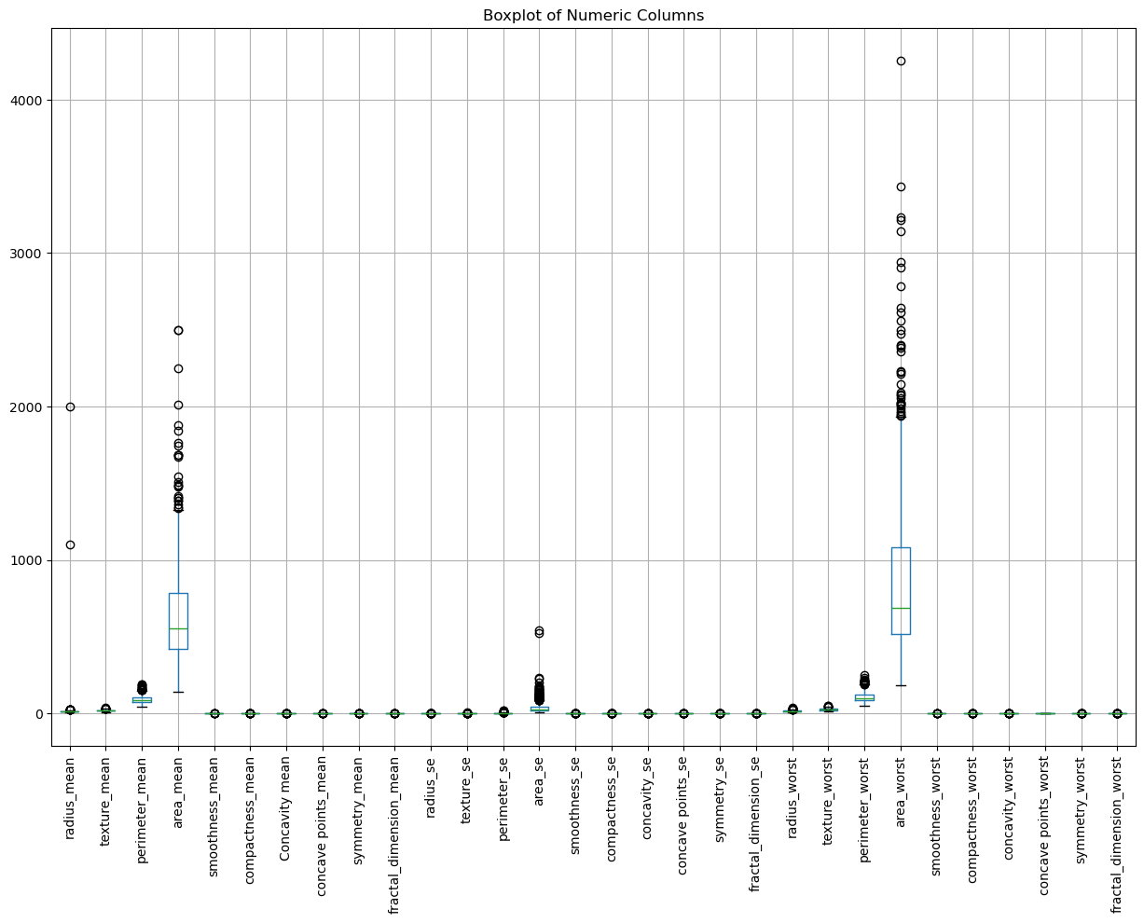

* **is a standardized way of displaying the distribution of data based on a five-number summary: minimum, first quartile (Q1), median, third quartile (Q3), and maximum.   
  Boxplots are useful for identifying outliers and understanding the spread and skewness of the data.**
* **Range and Interquartile Range (IQR): The IQR (the box) represents the middle 50% of the data, and the whiskers extend to show the range of the data.**
* **Median:** The line inside each box represents the median of the data.
* **Outliers:** Data points outside the whiskers are considered outliers.
* Implications for Analysis  
  The presence of outliers in certain columns suggests that there are some extreme values that may affect the performance of machine learning models. It is important to consider techniques for handling outliers, such as:

**Transformation:** Applying transformations (e.g., log transformation) to reduce the impact of extreme values.

#### Conclusion

#### The boxplot provides valuable insights into the distribution and presence of outliers in the dataset. Addressing the outliers is crucial to ensure that the models are not unduly influenced by extreme values and perform robustly.

### Correlation

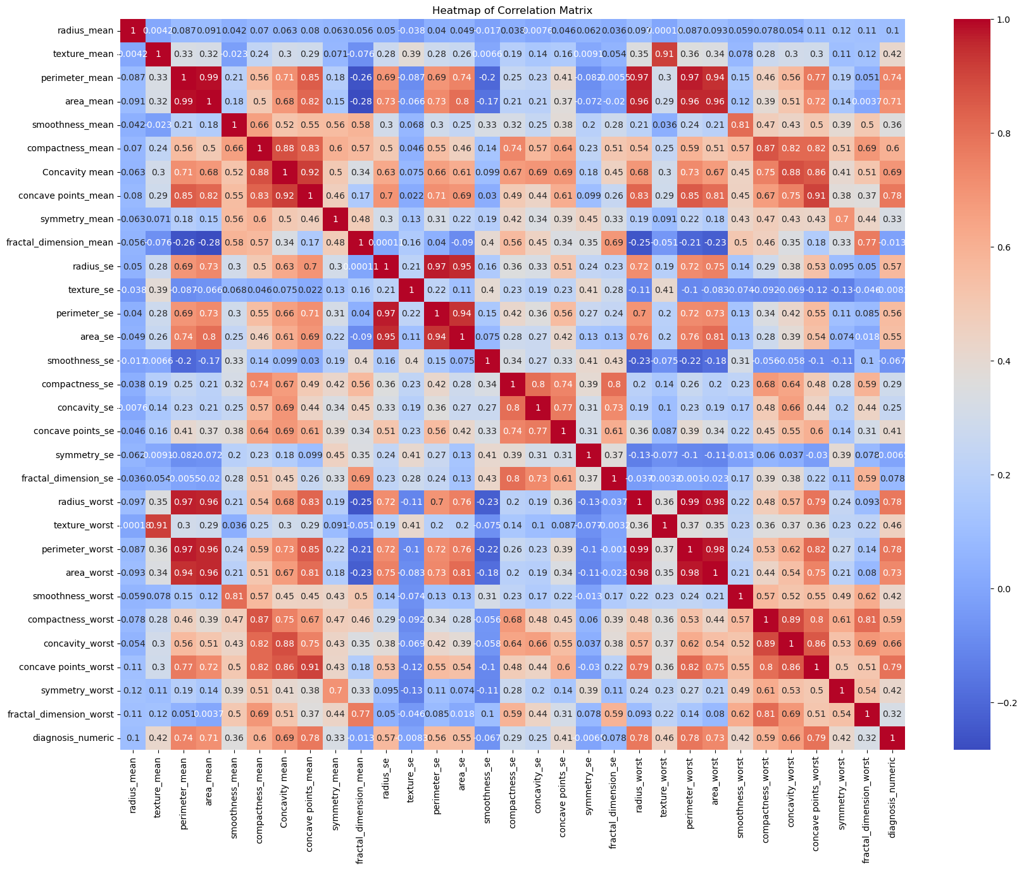The correlation heatmap visualizes the relationship between various features in the dataset.

* Strong Positive correlation:  
  High correlations (close to 1) among features suggest redundancy. An increase in one feature leads to an increase in another feature or a decrease in one feature leads to a decrease in another.  
  On the heatmap they are identified by dark red color.
* **Negative Correlations**:  
  Negative correlations indicate that as one feature increases, the other decreases.  
  High correlations (close to -1) among features suggest redundancy. An increase in one feature leads to an decrease in another feature or a decrease in one feature leads to a increase in another.  
  On the heatmap they are identified by dark dark blue color.
* No correlation:  
  No correlation indicate that features do not have any relationship, these are close to 0, and are assigned a light blue color or white.
* Implication of the analysis:  
  Feature Selection and Engineering  
  We use the correlation analysis to guide feature selection based on features that highly correlated with the target variable diagnosis, and those that form a cluster with high positive correlation among them.
* **Understanding Data Relationships  
  The correlation heatmap offers insights into how features relate to each other, aiding in feature engineering and the design of more robust models.**

## Feature Engineering

### Feature Selection

#### ANOVA Test

* This applied to assess the significance of continuous features with respect to the categorical target variable. This method identified key features based on their statistical significance (mean, median, mode).
* The ANOVA Test was applied to assess the significance of continuous features with respect to the categorical target variable. Higher scores indicate a stronger relationship between the feature and the target

#### Wrapper Method: Recursive Feature Elimination (RFE)

* Utilized to recursively eliminate the least significant features, helping to identify the most relevant continuous features for the model.

#### Embedded Method: Lasso Regression

* **Lasso Regression** further refine feature set by shrinking coefficients and eliminating less important features.

#### Summary of Findings:

* Features like concave points_worst, perimeter_worst, area_mean, Concavity mean, concave points_mean, radius_worst, area_worst, compactness_mean, concavity_worst, compactness_worst, perimeter_se, area_se, texture_mean, texture_worst were selected.
* These features were chosen because they appeared in the results of at least two of the three feature selection methods. This consistency across different methods underscores their relevance and potential impact on the model’s performance.

### Reducing Skewness in Data

**To address the skewness in numerical features and improve model performance, the following steps were undertaken:**

* **Log Transformation:** Applied log transformation to all numerical features. This approach was chosen to reduce the skewness and make the data distribution more normal.
* Handling Non-Positive Values During Log Transformation:  
  Log transformation is effective for normalizing data distributions and improving model performance. However, applying this transformation to non-positive values (zeros or negative values) can result in invalid or undefined results.
* Approach to Handle Non-Positive Values:  
  Check for Positive Values  
  Handle Non-Positive Values
* **Outlier Removal:** Implemented outlier removal using the Interquartile Range (IQR) method. Outliers were identified as data points lying outside 1.5 times the IQR from the quartiles, and these were excluded to reduce their influence on the model.

**Impact of Feature Transformation.**

* The transformation resulted in significant improvements in skewness and kurtosis of the features.
* After removing outliers the rows reduced to 507 from 569.
* Reduced Skewness: The skewness values are now closer to 0, indicating that the data distribution is less skewed. For most features, the skewness is relatively small, which means that the data is becoming more symmetric.
* Improved Kurtosis: The kurtosis values are generally closer to 0, indicating that the tails of the distribution are more in line with a normal distribution. Negative kurtosis values suggest that the data distribution has lighter tails than a normal distribution, which is common after log transformation.

**Observations**

* The log transformation effectively reduced skewness in most features, bringing them closer to normal distribution.
* Outlier removal contributed to a more stable range of feature values and improved the kurtosis of the features.
* These transformations enhance the model's ability to learn from data by mitigating the impact of extreme values and non-normal distributions.

**Feature Scaling and Normalization**

It ensure that features are on a similar scale which helps many machine learning algorithms perform better.

**Standardization (Z-score Normalization):**

* Standardization helps in comparing features on the same scale  
  Transforms features to have a mean of 0 and a standard deviation of 1.
* Best for algorithms that assume normally distributed data, such as Linear Regression, Logistic Regression, and SVM.

**Impact of Standardization:**

* **Feature Scales:** All selected features now have a mean of 0 and a standard deviation of 1, which allows for fair comparison across features.
* **Feature Values:** The values have been transformed, with the original units of the features being normalized.
* Standardizing the features ensures that no single feature dominates due to its scale, which improves the performance and stability of many machine learning algorithms.
* The standardized features are now ready for algorithms that are sensitive to the magnitude of features, such as Support Vector Machines (SVM) and Principal Component Analysis (PCA).

**Min-Max Scaling (Normalization):**

* Scales features to a fixed range, typically [0, 1].
* This method is useful for algorithms that are sensitive to the scale of features and need data to be on a consistent range. Best for algorithms that use distance metrics, like K-Nearest Neighbors and Neural Networks.

**Impact of Normalization:**

* **Feature Range:** All selected features are now scaled between 0 and 1. This ensures that no feature disproportionately influences the model due to its scale.
* **Uniformity:** The scaled data is uniform across features, which can improve the performance of machine learning algorithms that are sensitive to feature magnitudes.
* Min-Max Scaling ensures that all features contribute equally to the model’s performance, which can help in achieving more stable and reliable results.

## Data Splitting

The objective is to evaluate the performance of different machine learning models on standardized data.

### **Data Splitting with Standardized Data:**

Standardized features have a mean of 0 and a standard deviation of 1 which ensures that each feature contributes equally to the model especially for our data which had no specific range of values but continuous.

#### Training and evaluation of a model:

**Classification Report**

Precision: measures the proportion of true positive predictions out of all positive predictions made by the model.  
High precision indicates that when the model predicts a positive class, it is often correct.

Recall: measures the proportion of true positive predictions out of all actual positive instances in the dataset.  
High recall indicates that the model successfully identifies most of the positive instances.

F1-Score: The F1-Score is the harmonic mean of precision and recall. It balances the two metrics by providing a single score that considers both false positives and false negatives.  
The F1-Score is useful when you need a balance between precision and recall and is particularly valuable when there is an uneven class distribution or when both precision and recall are important.

Support: Support represents the number of actual occurrences of the class in the dataset.  
It provides context on the number of instances that were used to calculate the precision, recall, and F1-Score for each class. High support indicates more data points are available for evaluating the model's performance on that class.

Accuracy: measures the proportion of correctly classified instances (both true positives and true negatives) out of all instances in the dataset.  
High accuracy indicates that the model is performing well overall, correctly predicting the majority of instances.

Macro Average: The Macro Average calculates the average of the precision, recall, and F1-Score for each class, treating each class equally regardless of its frequency in the dataset.  
Macro Average provides a balanced measure of performance across all classes by giving each class equal weight.

Weighted avg: The Weighted Average calculates the average of the precision, recall, and F1-Score for each class, but takes into account the number of instances for each class.  
Weighted Average gives more importance to classes with more instances, reflecting their proportion in the dataset.

**Logistic Regression;**   
 Achieved the highest accuracy of 97%.  
 It demonstrated excellent precision and recall for both classes.  
 The confusion matrix shows very few misclassifications, indicating the model's robustness in classifying both classes correctly.

**Support Vector Machine (SVM)**;  
 Performed well with an accuracy of 96%.  
 It exhibited strong precision and recall recall.  
 The SVM model had a slightly higher misclassification rate for class 1 (positive cases) compared to Logistic Regression but still provided reliable results overall.

## Cross Validation

Cross-validation was performed using a 5-fold split to evaluate the performance of various machine learning models on standardized data.

**Logistic Regression:**  
**Cross-Validation Scores:** [0.9608, 0.9804, 0.9703, 0.9802, 0.9802]  
**Mean Accuracy:** 0.9744  
Logistic Regression demonstrated strong performance with high consistency across folds. The mean accuracy suggests it is a reliable model for this dataset.

**Support Vector Machine:**  
**Cross-Validation Scores:** [0.9510, 0.9706, 0.9703, 0.9802, 0.9802]  
**Mean Accuracy:** 0.9705  
The Support Vector Machine model yielded robust results with high mean accuracy and minimal variance across folds.  
  
**Implications:**  
The cross-validation results indicate that models like Logistic Regression, Support Vector Machine, are highly effective for this dataset, with Logistic Regression achieving the highest mean accuracy.

****Recommendations:****   
Given the high accuracy and stability of the Logistic Regression, Support Vector Machine, these models are recommended for further consideration in the analysis.

**Model Evaluation**

Model Training and Prediction:  
Each model is trained on the standardized training data and evaluated on the standardized test data.

**Classification Report:**   
Provides detailed metrics such as precision, recall, F1-score, and support for each class.

**Confusion Matrix:**   
Visual representation of prediction performance, showing true positives, false positives, true negatives, and false negatives.

**ROC Curve and AUC:**   
The ROC curve plots the true positive rate against the false positive rate, while the AUC provides a single metric of the model’s ability to distinguish between classes.

**Note:**  
True Positives (TP) : The number of instances where the model correctly predicted the positive class.  
False Positives (FP) : The number of instances where the model incorrectly predicted the positive class.  
True Negatives (TN) : The number of instances where the model correctly predicted the negative class.  
False Negatives (FN) : The number of instances where the model incorrectly predicted the negative class.

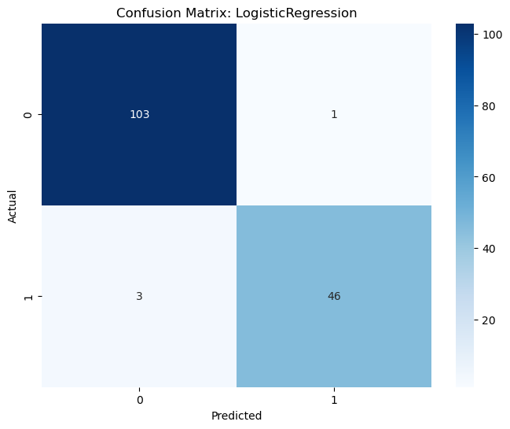

**Logistic Regression**  
**True Positives (TP):** 46 (Actual 1, Predicted 1)  
**False Positives (FP):** 1 (Actual 0, Predicted 1)  
**True Negatives (TN):** 103 (Actual 0, Predicted 0)  
**False Negatives (FN):** 3 (Actual 1, Predicted 0)

**Conclusion**  
Logistic Regression has a high accuracy with 46 true positives and only 3 false negatives, indicating it correctly identifies positive cases well. The model also has very few false positives, showing strong performance in predicting negatives correctly.

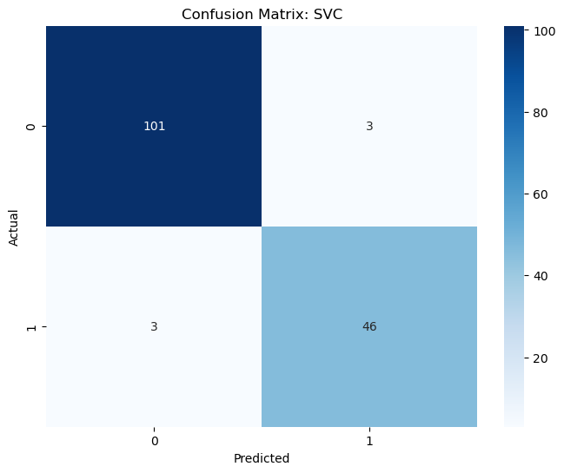

**Support Vector Machine**  
**True Positives (TP):** 46 (Actual 1, Predicted 1)  
**False Positives (FP):** 3 (Actual 0, Predicted 1)  
**True Negatives (TN):** 101 (Actual 0, Predicted 0)  
**False Negatives (FN):** 3 (Actual 1, Predicted 0)

**Conclusion**  
Support Vector Machine also demonstrates strong performance, with similar true positive and false negative counts as Logistic Regression. It correctly identifies a large number of negatives and has a low number of false positives, indicating effective separation between classes.

**Recommendation  
Both models show high accuracy and good performance metrics. Logistic Regression and Support Vector Machine both have strong capabilities in correctly classifying both positive and negative cases, with minimal errors. The choice between them could depend on specific needs such as model interpret-ability or computational efficiency.**