

2.2. Procedure

In this study, the tests of RT were performed two times (at the same hour of the day), one week apart to evaluate the inter-session test-retest reliability and construct validity. The data were collected by the same kinesiologist (with a large amount of experience in assessing physical performance in older adults) at both evaluation times. Both tests were performed individually at the long-term facilities, using a quiet room.

2.3. Instruments

2.3.1. Deary-Liewald reaction time task (DLRT)

The SRT and CRT were assessed by two subtests of the DLRT (Deary et al., 2011), which we named DLRT-S and DLRT-C, respectively. In the DLRT-S, participants had to press the space bar key in response to a single stimulus (a cross appeared inside a square on the computer screen, see Fig. 1). After pressing the key, the cross inside the square disappeared and reappeared after a short interval of time. The inter-stimulus interval ranged between 1 and 3 s and was randomized within these boundaries. The task involved 8 practice trials and 20 test trials and the median RT (ms) was computed for each participant. A bright paper was glued on the space bar key to better identify the response key.

Fig. 1

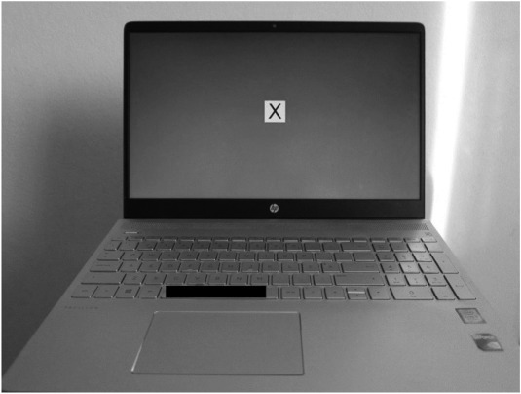

Fig. 1. Screen shot of the Deary-Liewald task for the simple reaction time task.

In the DLRT-C, there were four possible stimuli and one correct response for each one. Four white squares, centered and aligned horizontally, appeared on a blue computer screen (see Fig. 2). A different response key corresponded to each square: the square on the far left, the “z” key; the second square from the left, the “x” key; the second square from the right, the “comma” key; the square on the far right, the “full-stop” key. In each attempt, a cross appeared in one of the squares, randomly, and participants needed to press the corresponding key as quickly as possible. Due to the difficulty that participants had in selecting and keeping their fingers on the keys, it was decided to cover the entire keyboard, leaving only the keys that participants would have to select as visible (see Fig. 2). The cross disappeared when the participants pressed one of the four keys and another cross then appeared on the screen. The inter-stimulus interval ranged between 1 and 3 s and was randomized within these boundaries. The task involved 8 practice trials and 40 test trials. In particular, for the GCI some participants did not understand the test and more practice trials were provided. The median (ms) of the tests was used for data analysis.

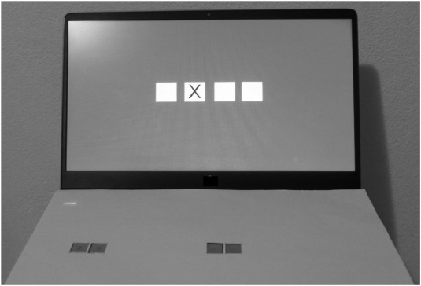

Fig. 2. Screen shot of the Deary-Liewald task for the choice reaction time task.