# Prerequisites

1. In order to be able to develop a good, functioning experiment using Builder, you should have some understanding of experimental design in Psychology. If you are a psychology student, then it can be assumed that experimental design will have been covered in classes that also teach data input and analysis, between-, within-participant designs and, statistics. There are many books available on research design and analyses. Some that I can recommend are
   1. Refs
2. Transferring knowledge of other software to PsychoPy. You will find that many of the commands are the same or similar to typical software packages and that you can apply previous skills to PsychoPy
3. A basic understanding of Excel is important. There are many Excel basics tutorials on YouTube and it is expected that you achieve at least a basic level of understanding, such as knowing what a cell/cell reference is, knowing how to copy and paste etc
4. The ability to persevere when things go wrong, which invariably they do
5. The ability to be resourceful, and find answers to questions and error codes online

# Chapter 1

## The PsychoPy Builder Graphical User Interface (GUI)

The PsychoPy Builder GUI is structured in a way such that it is quite simple to get started and develop your first experiment. Figure 1 shows the interface as it opens.

Figure

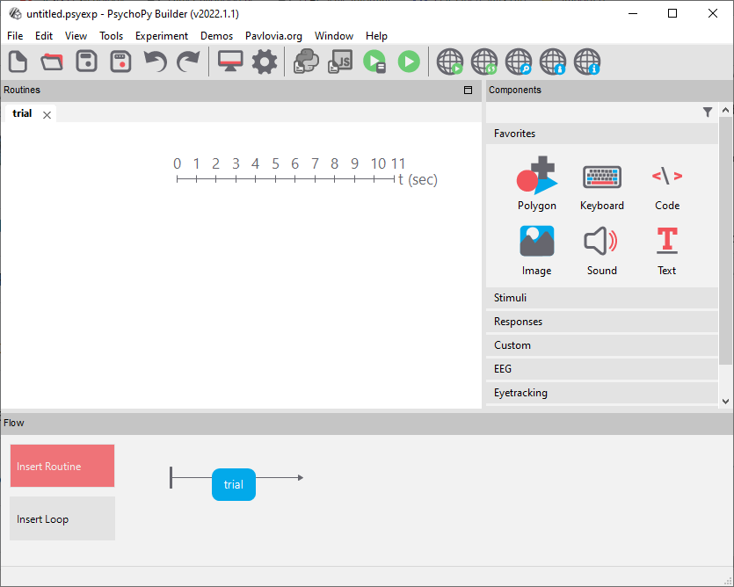

There are three main panels in the Builder GUI

1. Components Panel
2. Routines Panel
3. Flow Panel

You many only have one Flow, but you may have many routines, and many components within a routine

### Flow

The Flow panel is at the bottom of the Builder view. By default, it has a blue box on the timeline indicating a default trial Routine. The Flow is simply a flow chart and manages the order of Routines presented and if they repeat in Loops. You may have seen examples of visual representations of how a single trial would look in journal articles.

Here are some examples (Fig. 2 & 3) to illustrate how these may be presented, and how they improve your understanding of the task. These visualisations, or schematics can be translated to the Flow of your experiment to represent one trial, then later you will use a Loop to provide many iterations of the trial with all the appropriate conditions.

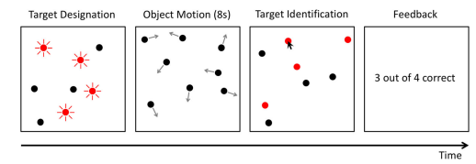

Figure Illustration of a multiple object tracking task (Meyerhoff & Papenmeier, 2020)

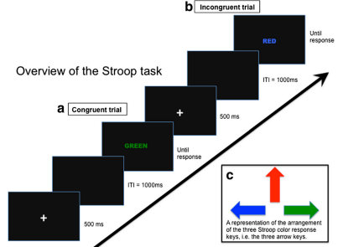

Figure Schematic of the computerised version of the Stroop task (Dimitrova et. al. 2017)

### Routines

The Routines panel shows a tab at the top that corresponds with the current routine. Routines can have many components, and these can also be determined using the schematics in Fig. 2 & 3. Each ‘box’ could represent a component on a routine for example.

### Components

The Components panel is by default on the right side of the interface, and components are the elements that you can apply to a Routine to build up an experiment. Usually they will relate to stimuli being presented, and some form of response, but they can also be used on Routines for instructions, distractors, or more complex functions such as connecting with eyetrackers, or other experimental equipment. Using the Stroop test in Fig. 2 we can see that a single trial consists of a fixation cross on screen for 500ms, followed by a blank screen (inter-stimulus interval ISI) for 1000ms, a piece of text until a response is made, and by deduction we can infer that there will be some kind of appropriate component to make a response (e.g. a keyboard or mouse). Hopefully you can appreciate the importance of designing your trial visualisation at the outset to aid your study development

### Loops

As mentioned earlier, we then use loops in the most basic function, to present iterations of the trial until such time the experiment should move to the next routine or to the end of the study. Loops then control repetition sequentially or randomly, there are other methods but sequential and random are the most commonly used. Loops can also be used to randomise participants to conditions among other features.

References

Dimitrova, J., Hogan, M., Khader, P., O’Hora, D., Kilmartin, L., Walsh, J. C., ... & Anderson-Hanley, C. (2017). Comparing the effects of an acute bout of physical exercise with an acute bout of interactive mental and physical exercise on electrophysiology and executive functioning in younger and older adults. *Aging clinical and experimental research*, *29*(5), 959-967.

Meyerhoff, H. S., & Papenmeier, F. (2020). Individual differences in visual attention: A short, reliable, open-source, and multilingual test of multiple object tracking in PsychoPy. *Behavior Research Methods*, *52*(6), 2556-2566.