Made fastqc reports for each file.
Too many k-mers in SRR292862.

Counting kmers

jellyfish count -m 31 -C -s 100M -o ~/ib/Project3/coli31.jf ~/ib/Project3/SRR292678sub_S1_L001_R?_001.fastq

jellyfish histo ~/ib/Project3/coli31 > ~/ib/Project3/hist.csv

Assembling
./spades.py -1 ~/ib/Project3/SRR292678sub_S1_L001_R1_001.fastq -2 ~/ib/Project3/SRR292678sub_S1_L001_R2_001.fastq -o ~/ib/Project3

Assembling three libraries

./spades.py -1 ~/ib/Project3/SRR292678sub_S1_L001_R1_001.fastq --mp4-1 ~/ib/Project3/SRR292862_1.fastq --mp2-1 ~/ib/Project3/SRR292770_1.fastq -2 ~/ib/Project3/SRR292678sub_S1_L001_R2_001.fastq --mp4-2 ~/ib/Project3/SRR292862_2.fastq --mp2-2 ~/ib/Project3/SRR292770_2.fastq -o ~/ib/Project3/1

Genome annotation was scipped and downloaded from http://public.dobzhanskycenter.ru/mrayko/Week3/PROKKA.zip.

Finding 16S genes

echo "export PATH=/Users/nediolus/bio/19_1/bio_projects/barrnap-0.6/bin:$PATH" >> ~/.zshrc
source ~/.zshrc
barrnap /output_dir/contigs.fasta

Then BLAST was used.
from Bio import SeqIO

rRNAS_labels = {
'NODE_14_length_117508_cov_91.829149':[3420, 4957],
'NODE_16_length_97481_cov_91.125480':[3512, 5049],
'NODE_21_length_75978_cov_83.375907':[46, 1583],
'NODE_31_length_49097_cov_85.510664':[492, 2029],
'NODE_40_length_27934_cov_115.763155':[26352, 27889],
'NODE_8_length_180977_cov_80.739927':[147390, 148927]
}

for record in SeqIO.parse("../bio_projects/project3/output_dir/contigs.fasta", "fasta"):
if record.id in rRNAS_labels.keys():
fasta_substring = str(record.seq)
positions = rRNAS_labels[record.id]
print("{}: {}".format(record.id, positions))
print(fasta_substring[positions[0]-1:positions[1]-1])
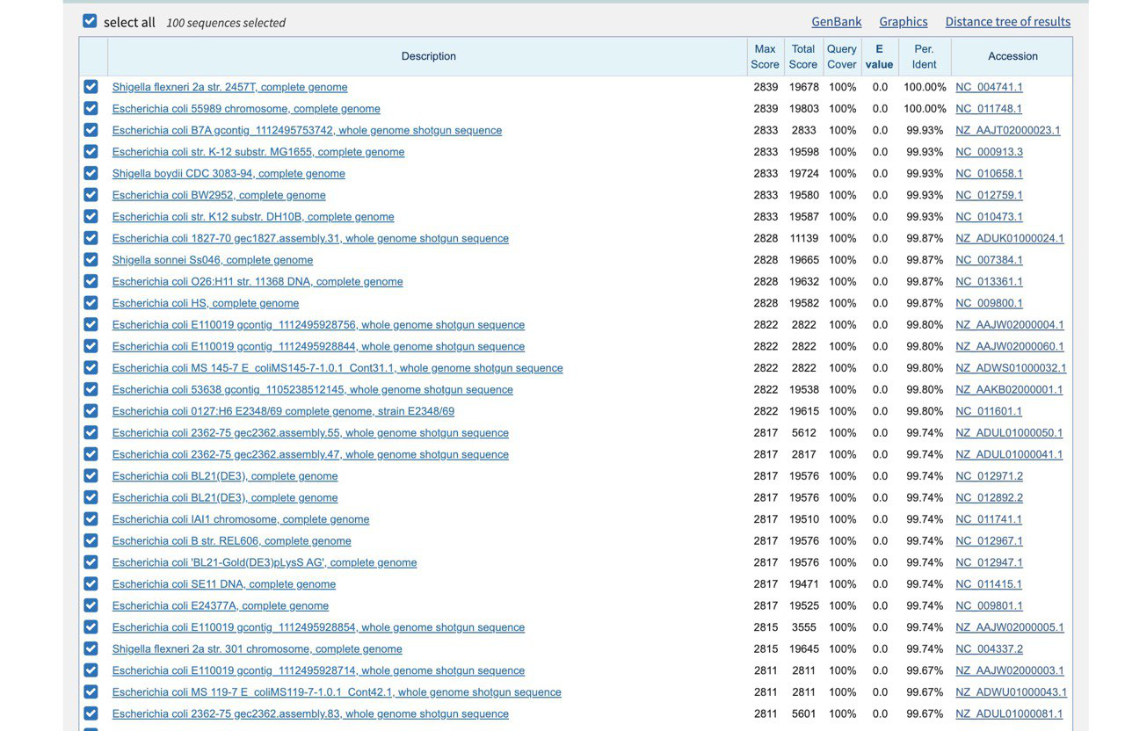
Full genome 55989 fasta was downloaded.

Shiga-toxin genes were found with Mauve.
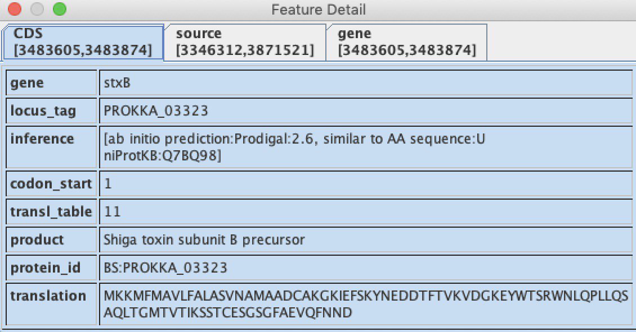

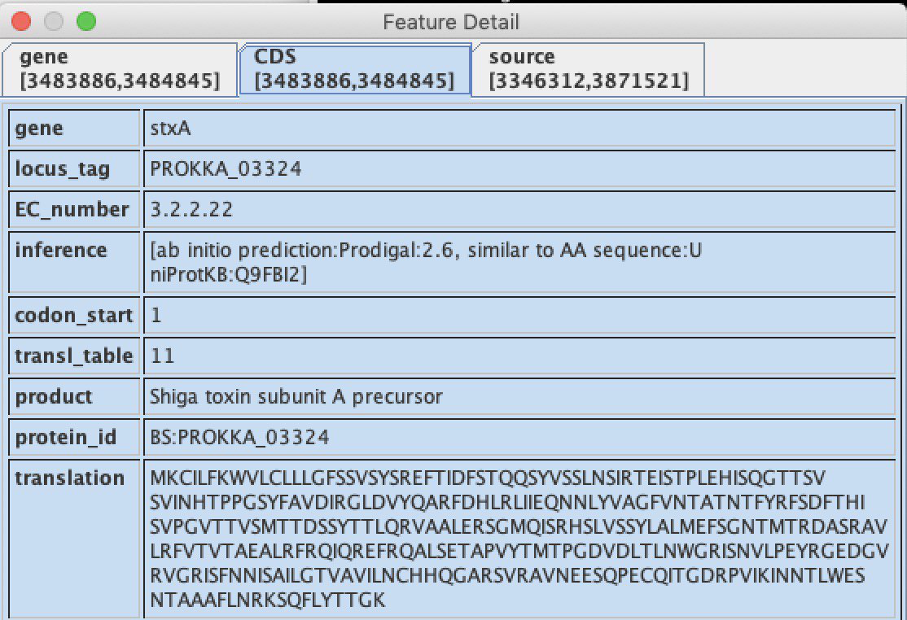
Antibiotic resistance genes were found by https://cge.cbs.dtu.dk/services/ResFinder/.

